### SDX-LC and OXP Integration

#### SDX-LC Rest APIs

Keep it generic and not depend on OXPs. The current version has following implemented

* 1. End points and data model schema defined in swagger.yaml
     1. /topology : for OXP to publish and update the topology
        1. post
        2. put
     2. /connection: for SDX-LC to send service request to the OXP
        1. post
        2. put
     3. /link: for OXP to update link state
        1. post
        2. put
     4. /node: for OXP to update node state
        1. post
        2. put
  2. End point backend processing: implemented in the controller functions
     1. receive the json from OXPs
     2. calling OXP API endpoint for connection request
     3. embedded swagger validation against the data model schema
     4. controller: (2.1) DB update (2.2) RabbitMQ publishing

#### SDX data model

The data model suite is defined and developed in order to communicate with different OXPs. Internally, SDX middleware does not need it and uses a graph representation for path computation and other provisioning, healing, and other autonomous functions.

Ideally we will work with OXPs to find the common ground to support it. As a matter of fact, it is currently defined with a minimum set of attributes for network functions. It is modular and each module comes with associated construction, parsing, and validation functions in the DataModel repo.

The OXP could provide their current topology description and update mechanism with corresponding syntax and semantic definitions. And we could use different mechanism to integrate as specified in the next section

#### OXP Site Software and SDX Integration

We can use one of the following three integration mechanisms. The deployment of the involving software components on the OXP site should be orchestrated by the docker-compose. Per-OXP specific configuration and functions should be customized in the site configuration file, for example, in the docker-compose file, so that no hard-coding or over-generalization is needed.

* 1. Option 1: Kytos netapp supports SDX data model schema
  2. Option 2: OXP does not support SDX data model schema
     1. Sdx-lc controller calls the plugin SDX data model conversion function specified in the configuration file.
  3. Option 3: OXP provides a static topology description file following the SDX data model schema. LC will read it at the startup.



For the common interest. We can take the second approach (yellow). We add a separate module inside sdx-lc, to be named as “oxp-sdx-topology-converter”. This module will be responsible for validating if the topology is a correct OXP topology, and convert into SDX topology.

In this case, when new connection is sent, LC will take the OXP (Kytos, OESS, …) topology json on the add_topology API, then call the oxp-sdx-topology-converter to translate into SDX compatible topology;

When a connection request reaches SDX controller, SDX controller breaks down the connection, sends connection breakdown from SDX controller to LC. LC will call the oxp-sdx-topology-converter to translate into OXP connection, and send to OXP's API.

Here’s a diagram that illustrates the process:

(It’s inside [AtlanticWave-SDX2.0/Design Documents] folder. Feel free to edit)

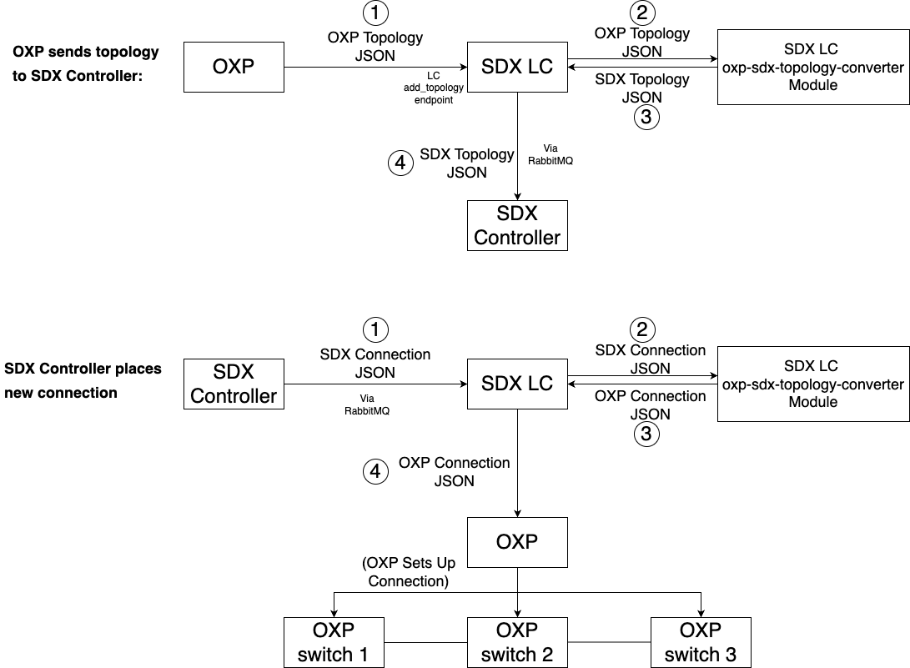

The code structure can look like this:

sdx-lc/swagger_server/controllers/

oxp-sdx-topology-converter/

jobs/

messaging/

... ...

The oxp-sdx-topology-converter will be on the same level with controllers, jobs, etc. This can minimize the changes to the existing LC endpoints. We only need to add a few lines in topology_controller.py, to convert OXP topology to SDX topology. Code here:

https://github.com/atlanticwave-sdx/sdx-lc/blob/d6fa0fd9185d1bc50a64bb06e2efcb8cafb0e3c4/swagger_server/controllers/topology_controller.py#L62

and in messaging/topic_queue_consumer.py to convert SDX connection to OXP connection. Code here: https://github.com/atlanticwave-sdx/sdx-lc/blob/d6fa0fd9185d1bc50a64bb06e2efcb8cafb0e3c4/swagger_server/messaging/topic_queue_consumer.py#L90