**GitHub:**

GitHub is a source code management (SCM) also called as version control system (VCS) used to store the code. GitLab and bit Bucket are the alternatives to GitHub.

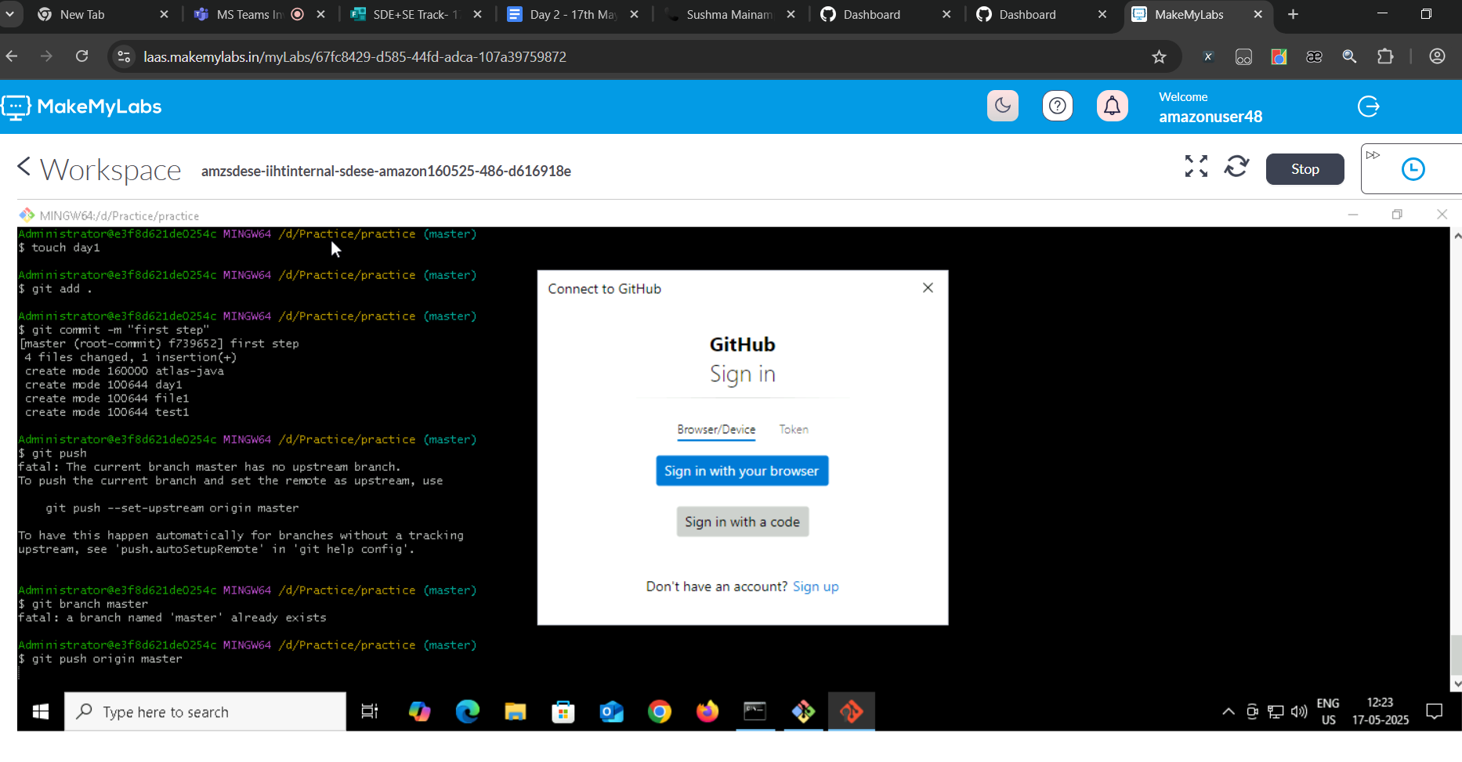

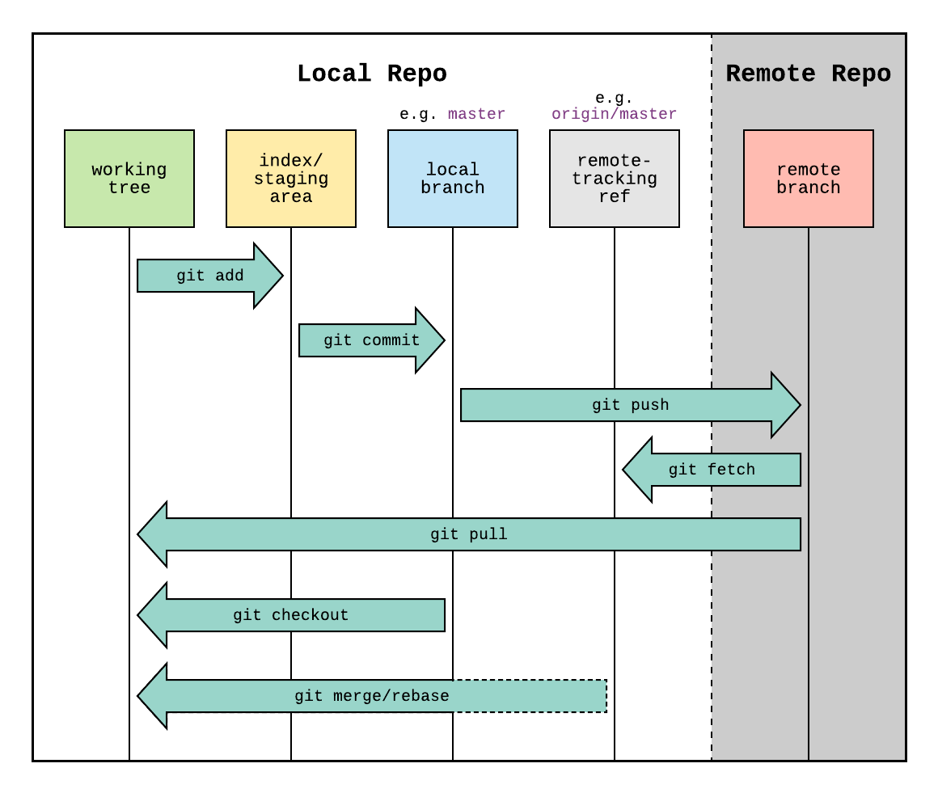

**Git to GitHub steps for VMs**

Commads to push a directory from working area to GitHub.

mkdir <directory_name>

cd <directory_name>

echo “Java training documentation” >> README.md

git init

git add README.md

git commit -m "first commit"

git branch -M main

git remote add origin <GitHub repo URL>

git push -u origin main

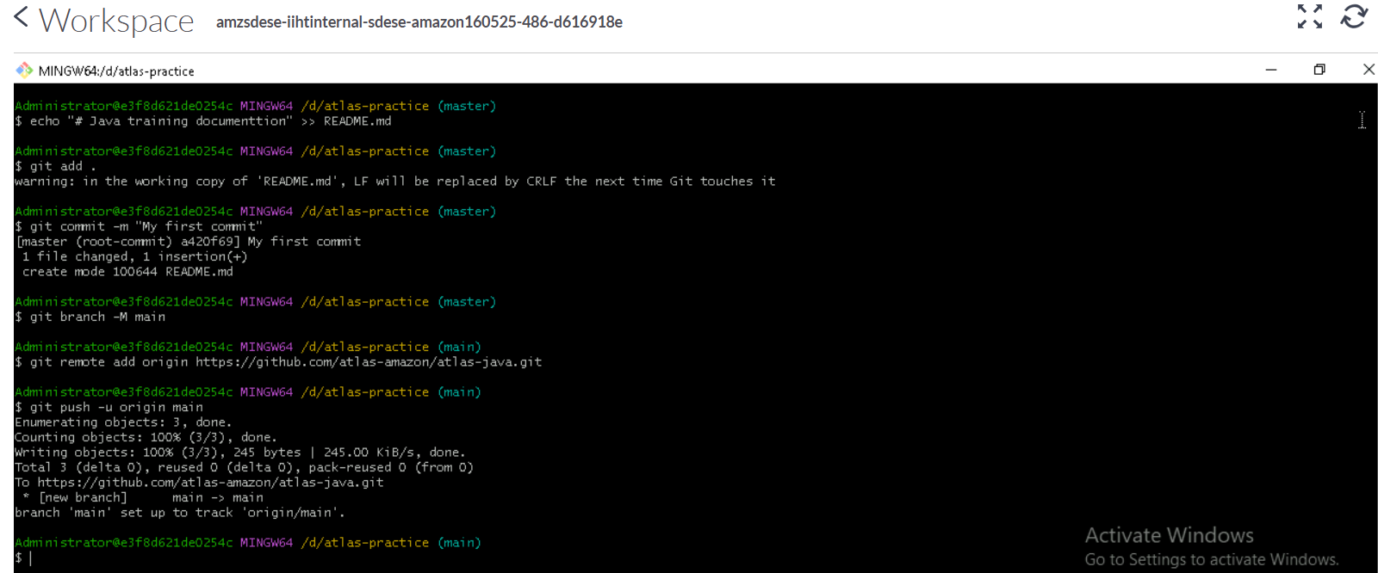

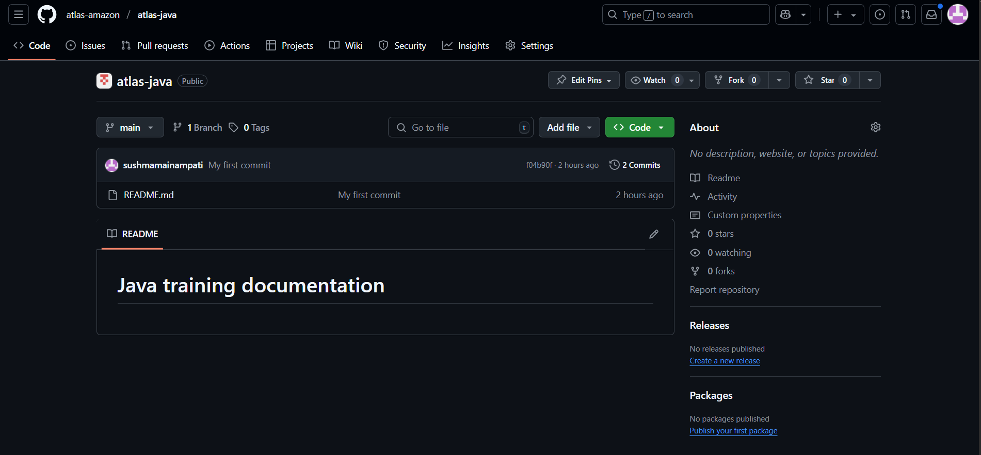

**Git Commands and its purpose**

|  |  |  |
| --- | --- | --- |
| **Git command** | **Purpose** | **Example** |
| git branch | Shows the list of all branches in the repository. | git branch |
| git branch <branch_name> | creates a new branch named “branch_name”. | git branch atlas-java |
| git checkout <branch name> | Switch to current branch to <branch name> branch | git checkout atlas-java |
| git branch -d <branch_name> | deletes the branch named “branch_name”. | git branch -d atlas-java |
| git checkout -b <branch_name> | Creates a new branch named “<branch_name>” and switches to it | git checkout -b atlas-java |
| git log | git log command displays the entire commit history of your current branch. | git log |
| git diff | Compare and show the difference between the file in working directory and staging area | git diff |
| git merge | Merges two branches | git merge main |
| git pull | It pulls the latest code in GitHub repository to working directory | git pull origin main |
| git clone | It clones the repository to working directory | git clone -b main https://github.com/atlas-amazon/atlas-java.com |

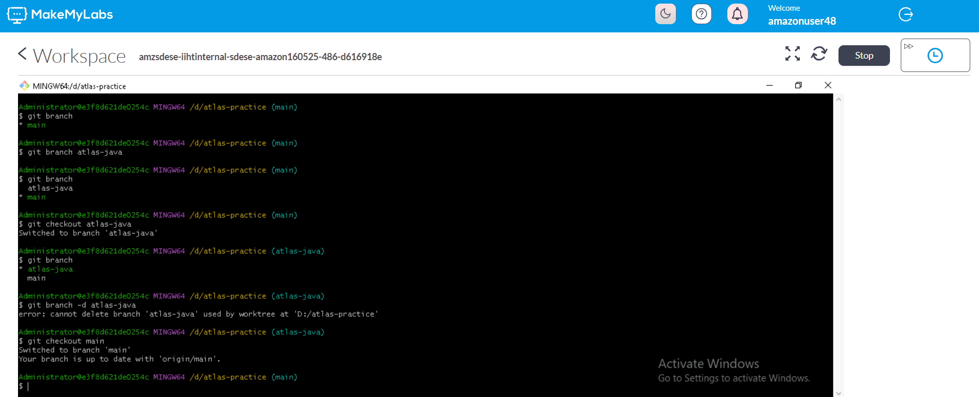

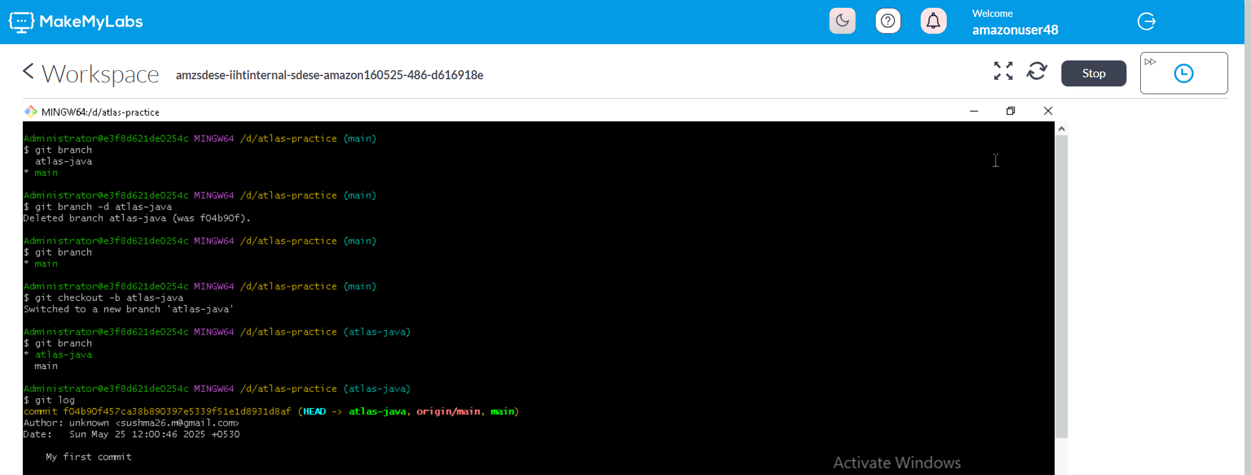

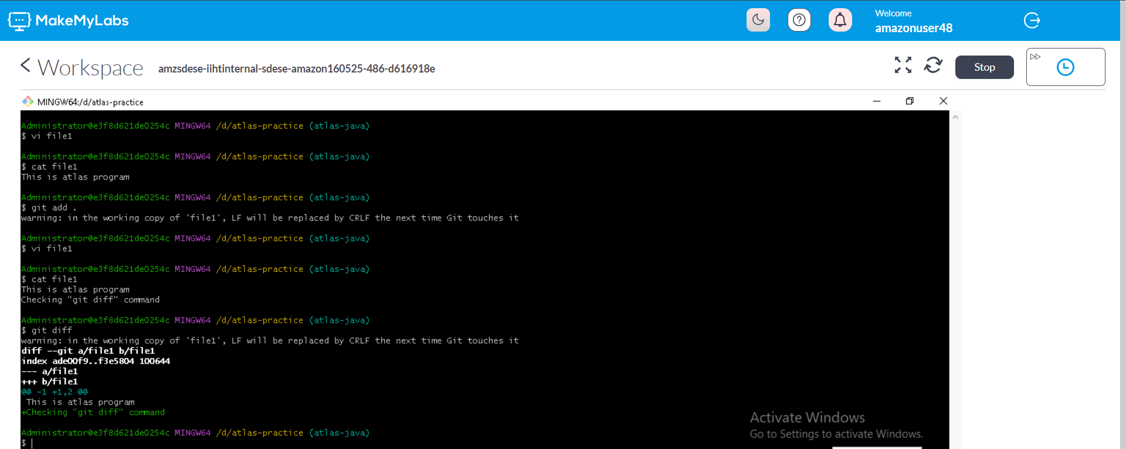

git diff command

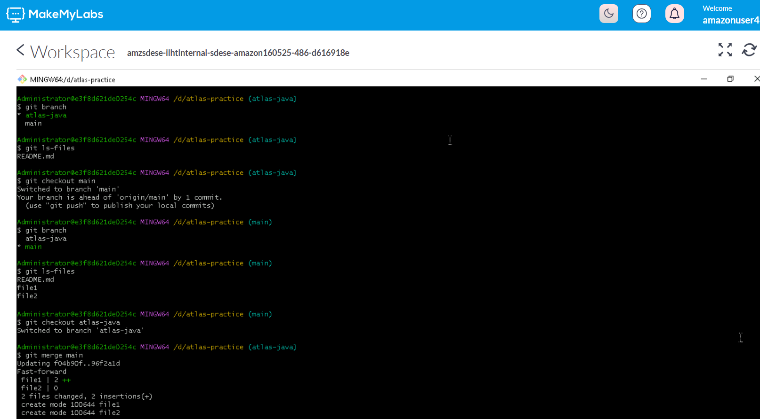

git merge command

What I did:

Added a file (git_commands_test.txt) directly in the GitHub

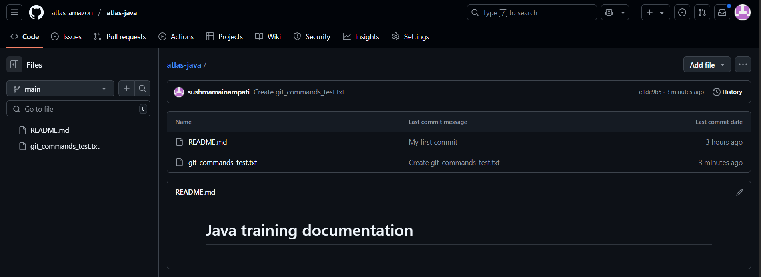

Added a file (file1) in the working directory

Now ran “git pull origin main”

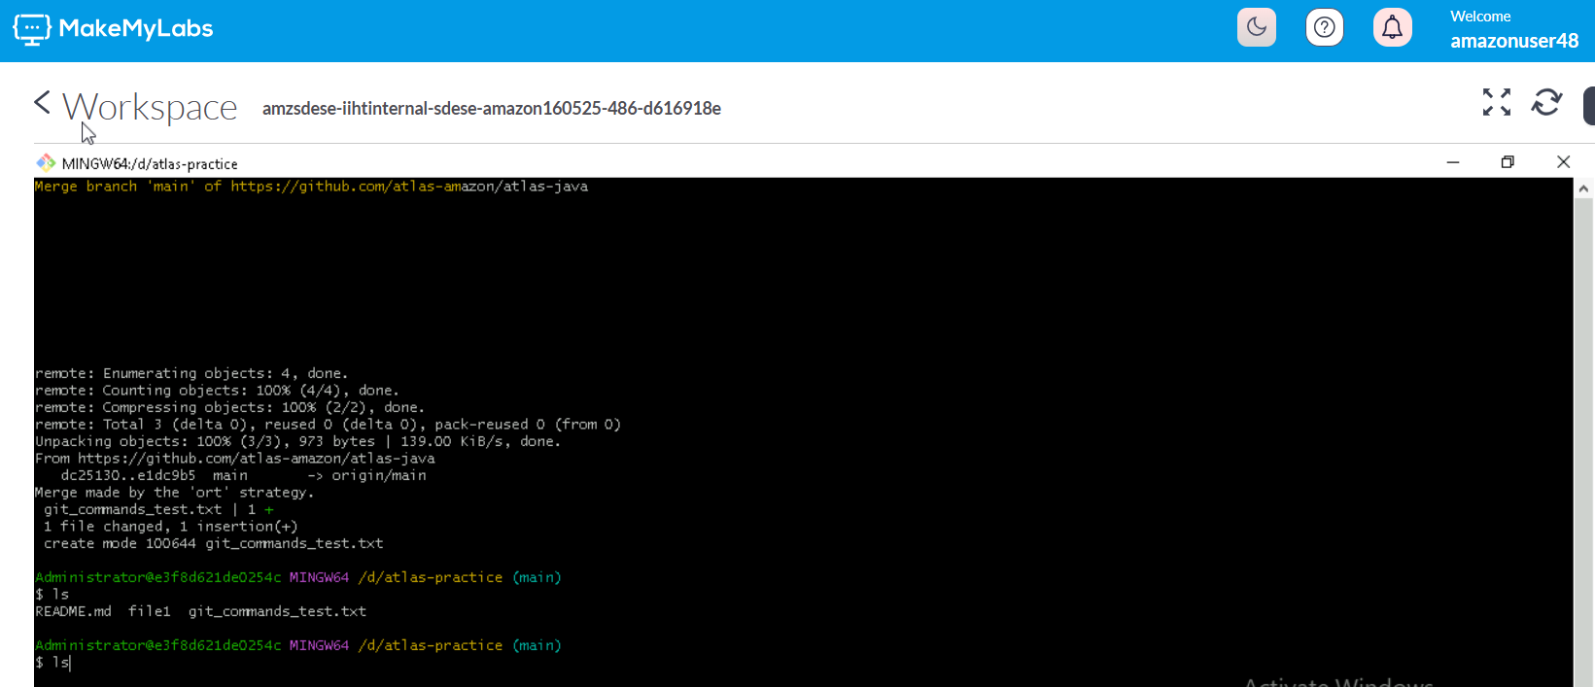

Observation: it does not modify the working directory, only the latest code from GitHub is pulled from GitHub.

Git Clone:

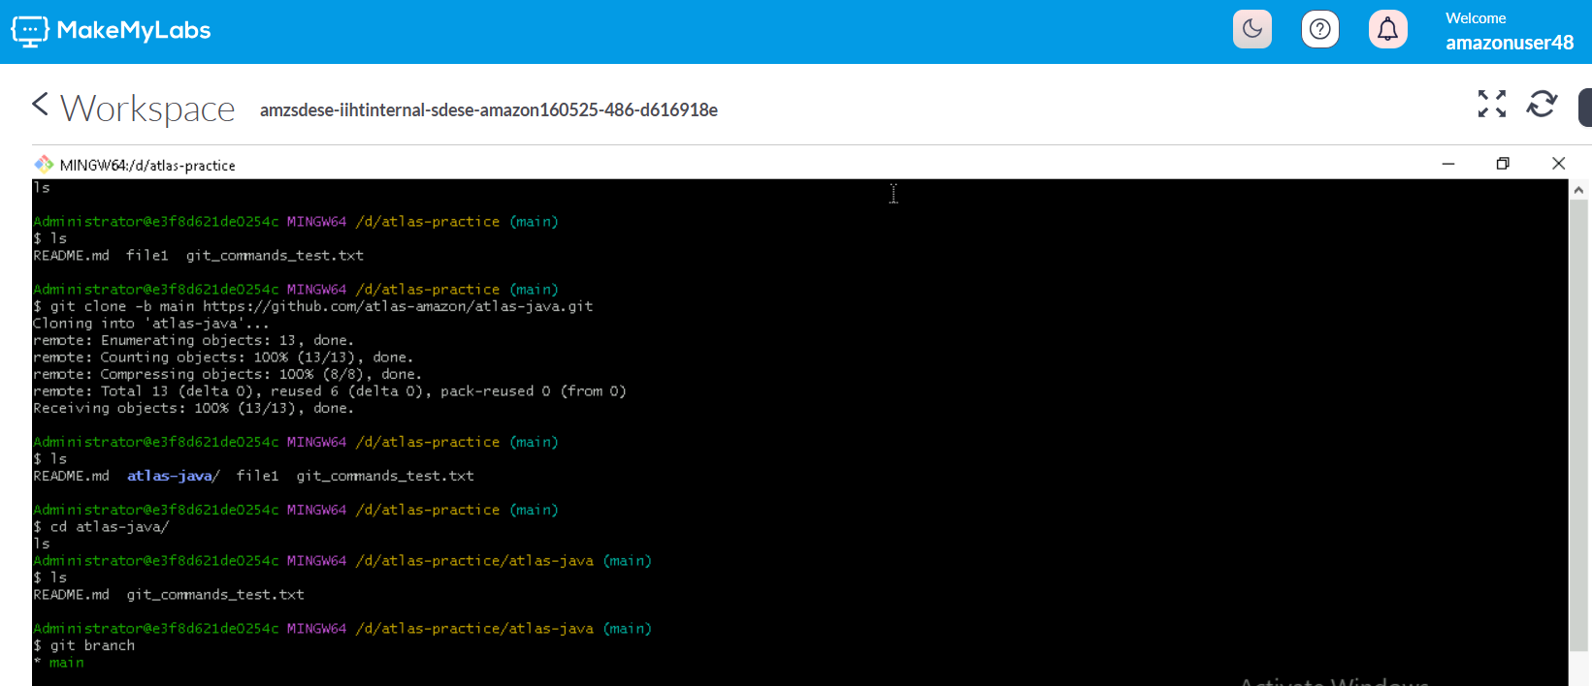

Git clone command clones the repository.

In the above screenshot, it clones the “atlas-java” repository.