**Regex:**

Regular expression contains a series of charecters that defines a pattern of text to match.

\ - quotes the character after it

. -Dot represents a single character

*- asterisk can represent any character and represents anywhere from zero to an infinite amount of characters.

$- The dollar sign at the end of a regular expression signifies the end of a line, and, therefore, any character immediately before it must be located at the end of the string. Anywhere else in a regular expression, it matches itself.

^- is the beginning of a line, and any characters immediately following it must be located at the very beginning of the string. Anywhere else in a regular expression, it matches itself.

+ indicates one or more occurrences of the preceding element. For example, ab+c matches "abc", "abbc", "abbbc", and so on, but not "ac".

{} to repeat the preceding character (or set of characters) for as many times as the value inside this bracket

**Linux-OS**

Linux is a operating system which manages communication between both hardware and software.

* It’s a open source
* Secure

Kernel: This is the core part of OS / interface between hardware and software. It loads the first and remains in the main memory.

**BASH in Linux**

Bourne Again SHell – it serves as a default shell in Linux environment distributions. It offers command line editing and advanced scripting capabilities. (Easy to create and edit files)

**Difference between Linux and Windows:**

Linux:

1.Open Source

2. Free software

3. Secure

4. Command line interface

5. Case Sensitive

Windows:

1.Not an open source

2. Insecure

3. Doesn’t provide free software

4. Graphic level interface

5. Case Insensitive

**Components of Linux-OS:**

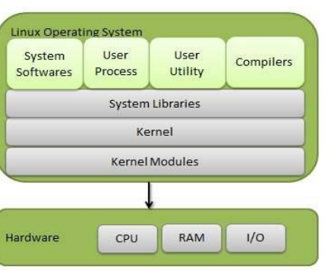

• Kernel - core part of Linux which is responsible for all major activities of this operating system. It consists of various modules and it interacts directly with the underlying hardware.

* provides the required abstraction to hide low level hardware details to system or application programs.

• System Library − System libraries are special functions or programs using which application programs or system utilities accesses Kernel's features. These libraries implement most of the functionalities of the operating system and do not require kernel module's code access rights.

• System Utility − System Utility programs are responsible to do specialized, individual level tasks.

**LILO:** Lilo handles some tasks such as locate the kernel, identify other supporting programs, load memory and starts the kernel.

1) If it displays nothing then it does not load any part of LILO.

2) L: This is the first stage of the bootloader that has been loaded. If the process stops here it denotes that there were problems in the second stage. This may occur due to some incorrect disk parameter specified in the configuration file of lilo or some media problems also.

3) LI: It indicates that the second stage boot loader has been loaded and could not be executed. It can occur due to problems similar to L.

4) LIL: At this stage, the second stage boot loader has been completed in its execution. If it fails, this stage indicates that there were media problems or map file specified in the configuration file has some problems.

5) LIL?: This means that the second stage boot loader loaded at an incorrect address.

6) LIL-: This indicates that the descriptor table is corrupted.

7) LILO: All parts are successfully loaded.

**Shell:**

Shell is a interface between users and an operating system

C-Shell: csh- It includes helpful programming features like built-in arithmetic and C-like expression syntax.

Bourne Shell: sh: Able to recall the previous commands, it is faster and more preferable.

Korn Shell: ksh: Superset of bourne shell, built-in arithmetic and C-like arrays, functions, and string-manipulation facilities.

GNU Bourne Again Shell: bash: it has features both both bourne and korn shell.

T shell: tsh

**Swap space:**

It’s a virtual memory and paging space, allows it to temporarily move inactive or less frequently used pages of memory from RAM to a designated area on the hard disk.(Mainly used when RAM is full)

Mount and unmount:

Mount involves connecting file system to the directory structure.(attaching file system to specific directory)

Unmount: remove the file system in existing directory

**is it legal to edit kernel?**

Yes (kernel source code in developer package) it can be edited during the process of development and maintenance.

chmod command:

It is used to change the permissions of files/directories

r-4 w-2 e-1

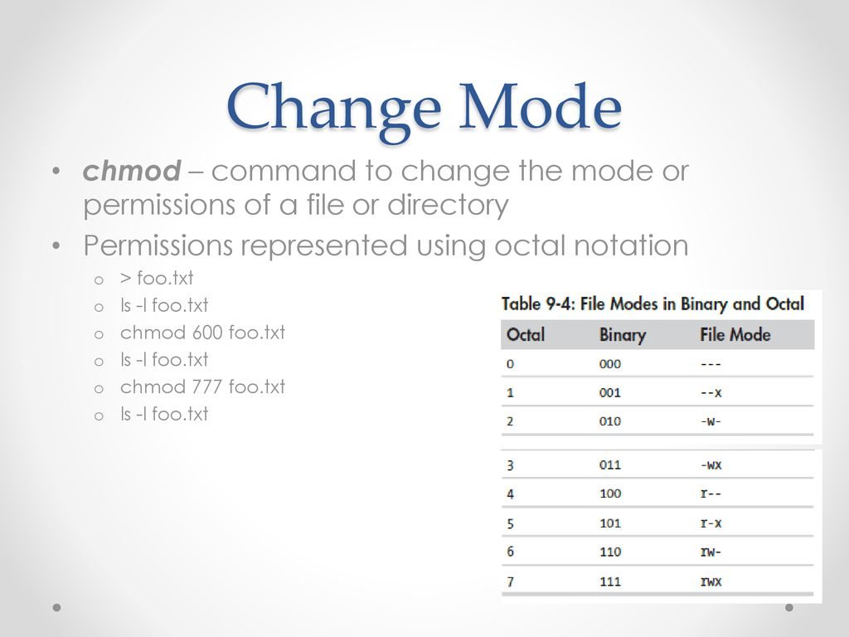

Add user in Linux:

useradd: a low-level, non-interactive utility that requires flags to configure user details

adduser: a higher-level script, often found in Debian-based distributions, that provides interactive prompts and a user-friendly interface

cat /etc/passwd | grep newuser

How to change the password:

passwd command followed by the username. If you are changing your own password, you can simply type passwd.

E.g., sudo passwd username

Difference between process and thread:

Process:

Owns memory and resources

Independent lifetime, if one process crashes, it won’t affect other EX: Independent projects

More expensive

Thread:

It is like a mini task within a process

Shares memory and resources within the parent process means multiple threads can run in a single process.

Dependent on parent process life time

Less expensive

MSYS=winsymlinks:nativestrict ln -s source target

