Task-1: Sample program

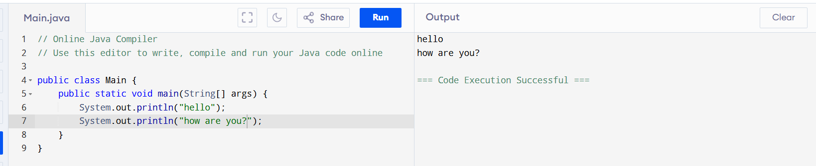

Task-2: addition of two numbers

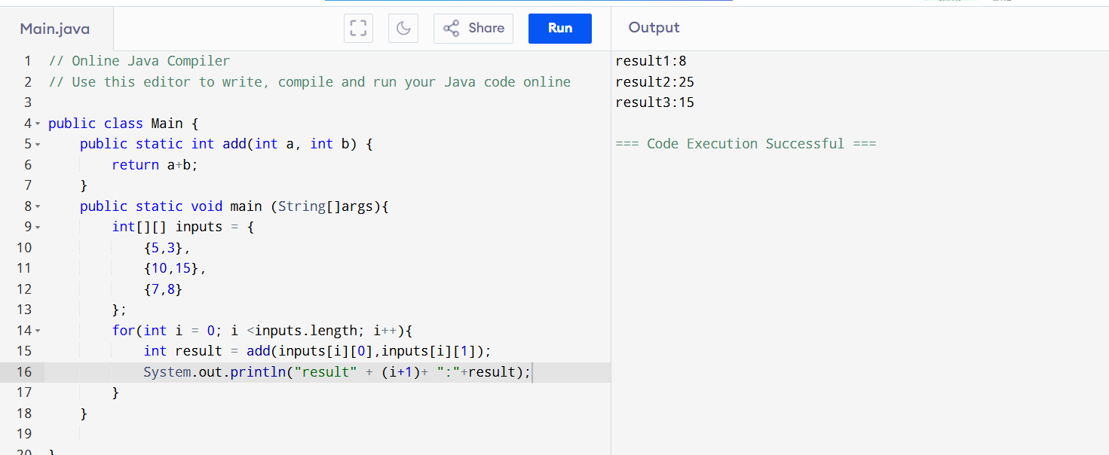

Calling add three times

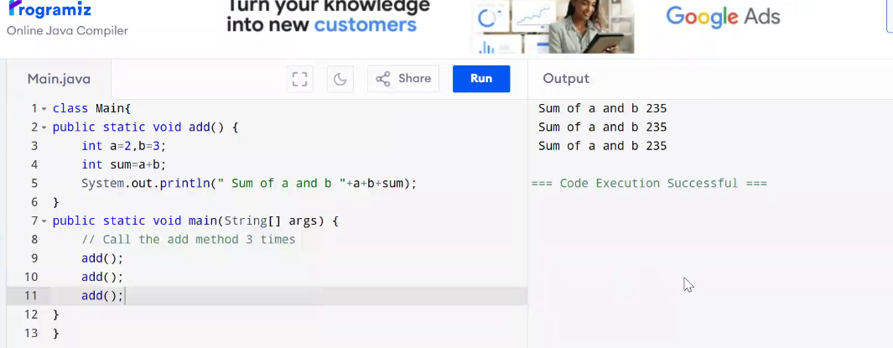

Task-3: Sum program

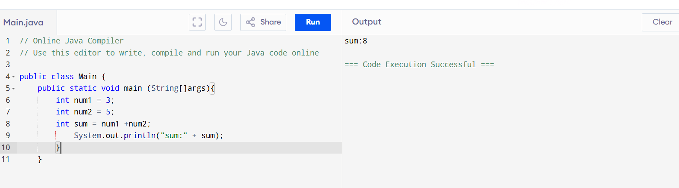

Task-4: Swapping Numbers

public class Main {

public static void main (String[]args){

int a = 3;

int b = 5;

System.out.println("Before swapping:");

System.out.println("a=" +a+",b="+b);

int temp =a;

a=b;

b = temp;

System.out.println("After swapping:");

System.out.println("a=" +a+",b="+b);

}

}

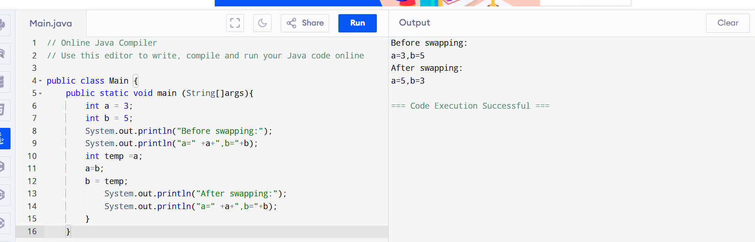

Task-5: Operators

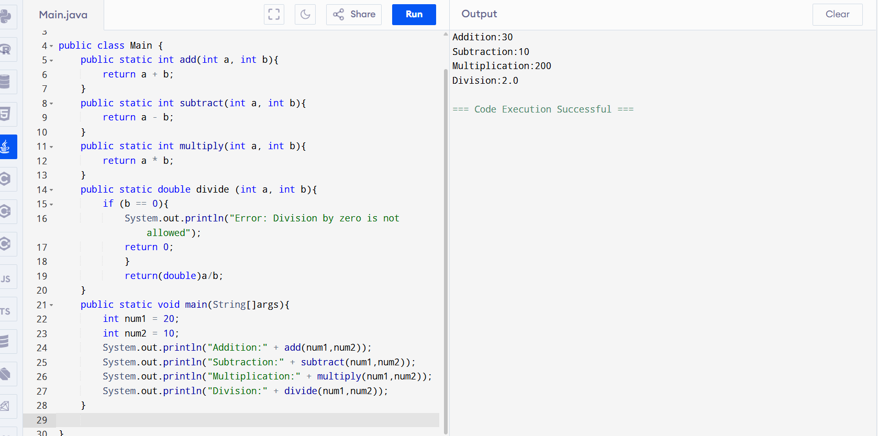

public class Main {

public static int add(int a, int b){

return a + b;

}

public static int subtract(int a, int b){

return a - b;

}

public static int multiply(int a, int b){

return a \* b;

}

public static double divide (int a, int b){

if (b == 0){

System.out.println("Error: Division by zero is not allowed");

return 0;

}

return(double)a/b;

}

public static void main(String[]args){

int num1 = 20;

int num2 = 10;

System.out.println("Addition:" + add(num1,num2));

System.out.println("Subtraction:" + subtract(num1,num2));

System.out.println("Multiplication:" + multiply(num1,num2));

System.out.println("Division:" + divide(num1,num2));

}

}

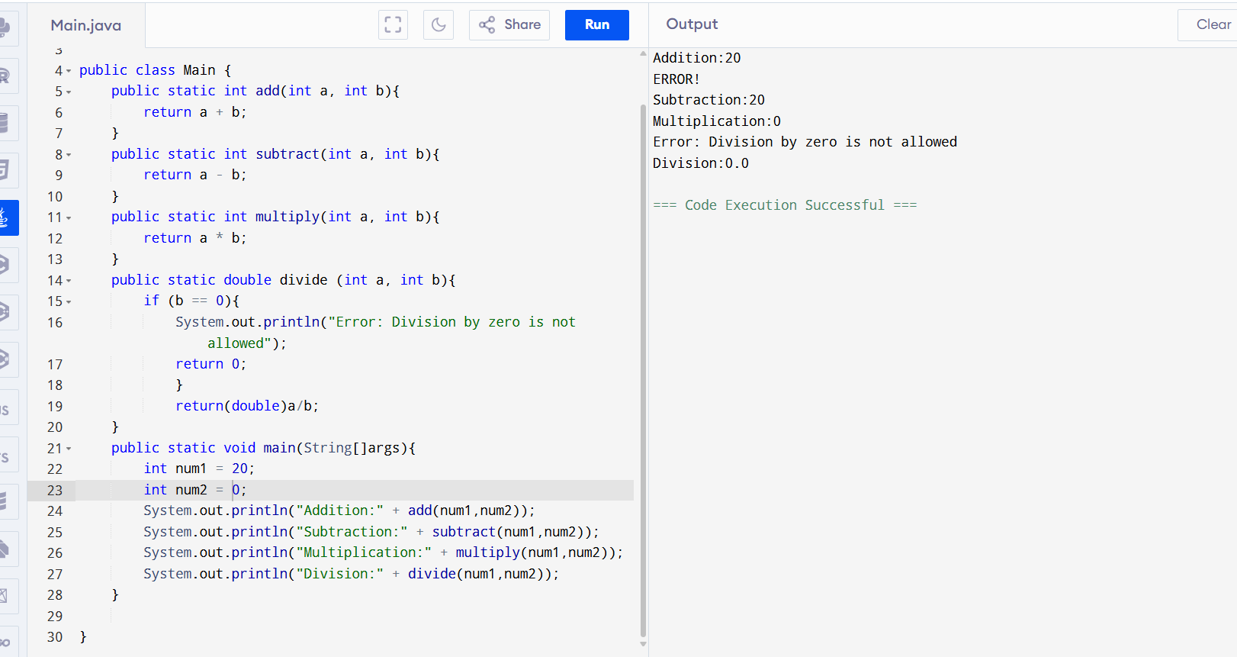

Task-6: Greater among two numbers

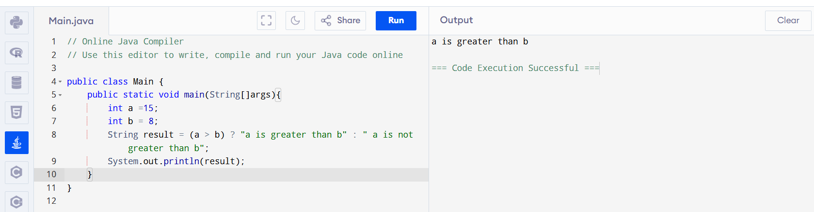

public class Main {

public static void main(String[]args){

int a =15;

int b = 8;

String result = (a > b) ? "a is greater than b" : " a is not greater than b";

System.out.println(result);

}

}

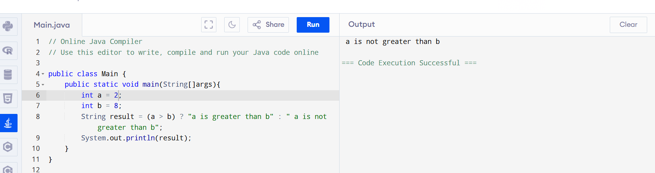

Task-7: Write a program to take input from the user and display it to the user

import java.util.Scanner;

public class Main {

public static void main(String[]args){

Scanner scanner = new Scanner(System.in);

System.out.print("Enter your username:");

String username = scanner.nextLine();

System.out.print("Enter your Id:");

String Id = scanner.nextLine();

scanner.nextLine();

System.out.print("Enter your password:");

String password = scanner.nextLine();

System.out.println("\n--- User Information---");

System.out.println("Username:" + username);

System.out.println("Id:"+Id);

System.out.println("Password:" + password);

scanner.close();

}

}

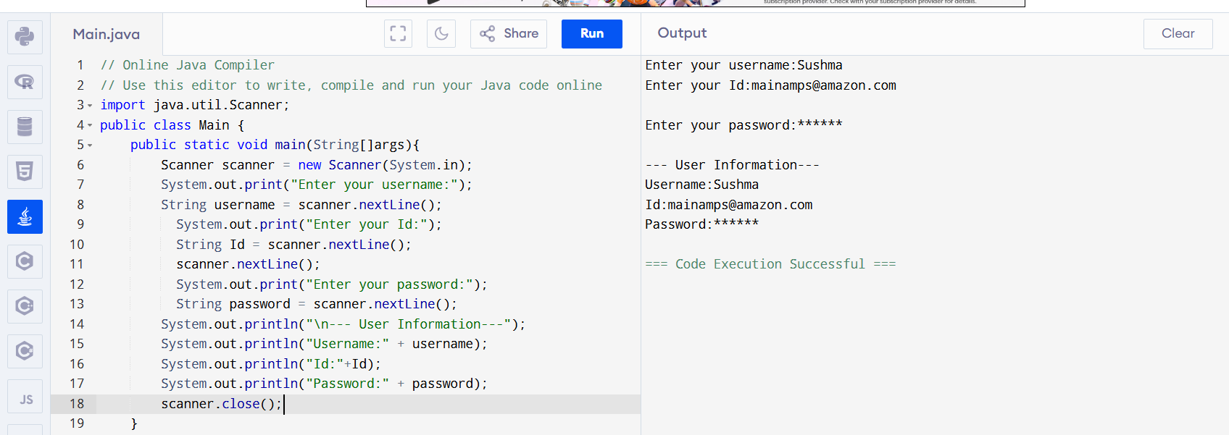

Task-8: Comparison of two numbers

import java.util.Scanner;

public class GreaterNumber{

public static void main(String[]args){

Scanner scanner = new Scanner(System.in);

System.out.print("Enter first number:");

int a = scanner.nextInt();

System.out.print("Enter second number:");

int b = scanner.nextInt();

if (a>b){

System.out.println(a + "is greater than" +b);

}else if (b>a){

System.out.println(b + "is greater than" +a);

}else{

System.out.println("Both numbers are equal");

}

scanner.close();

}

}

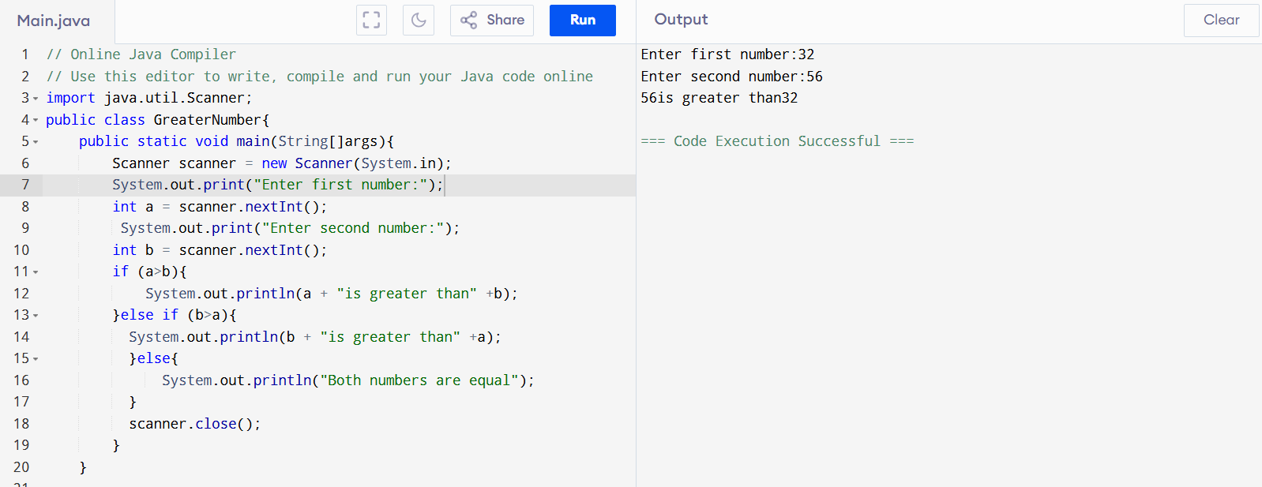

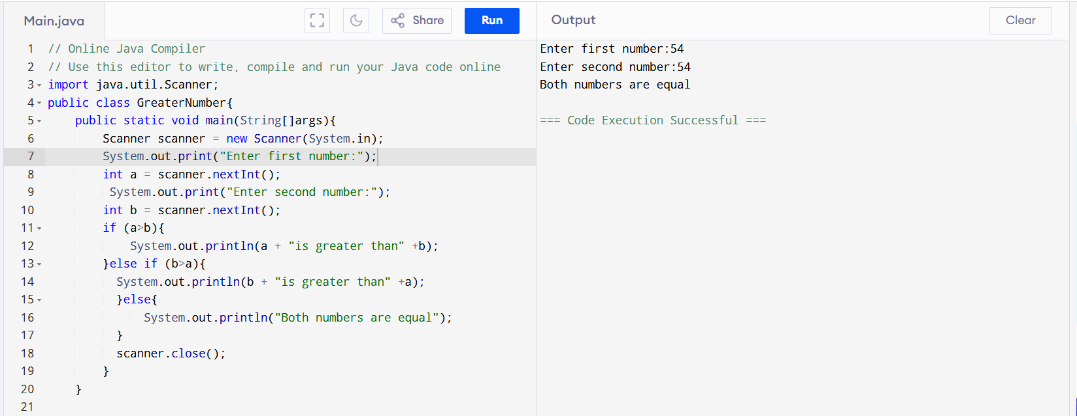

Task-9: Greatest number

import java.util.Scanner;

public class GreaterNumber{

public static void main(String[]args){

Scanner scanner = new Scanner(System.in);

System.out.print("Enter first number:");

int a = scanner.nextInt();

System.out.print("Enter second number:");

int b = scanner.nextInt();

System.out.print("Enter third number:");

int c = scanner.nextInt();

if (a>=b && a>=c){

System.out.println(a + "is the greatest");

}else if (b>=a && b>=c){

System.out.println(b + "is the greatest");

}else{

System.out.println(c + "is the greatest");

}

scanner.close();

}

}

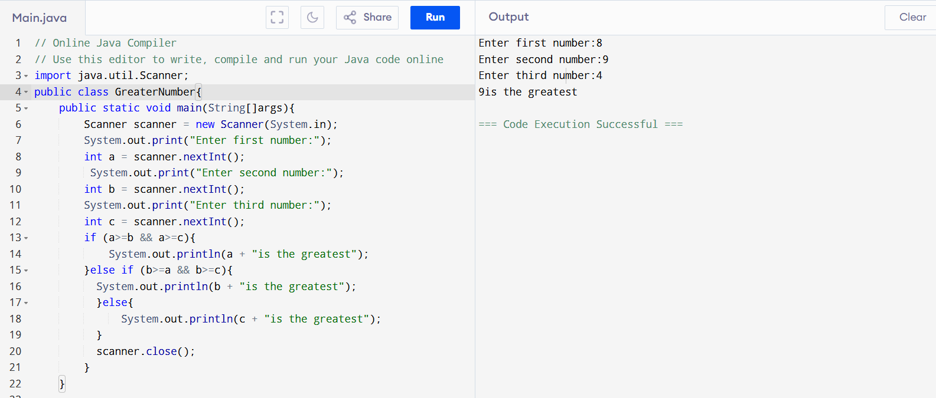

Task-10: Week days

import java.util.Scanner;

public class Weekdaychecker{

private static final String[] weekdays={"Sunday","Monday","Tuesday","wednesday","Thursday","Friday","Saturday"};

public static void main(String[]args){

Scanner scanner = new Scanner(System.in);

System.out.print("Enter a number(1 to 7):");

int day = scanner.nextInt();

if (day >=1 && day <= 7){

System.out.println("Day" + day + "is" + weekdays[day- 1]);

} else {

System.out.println("Invalid input! please enter number 1 to 7");

}

scanner.close();

}

}

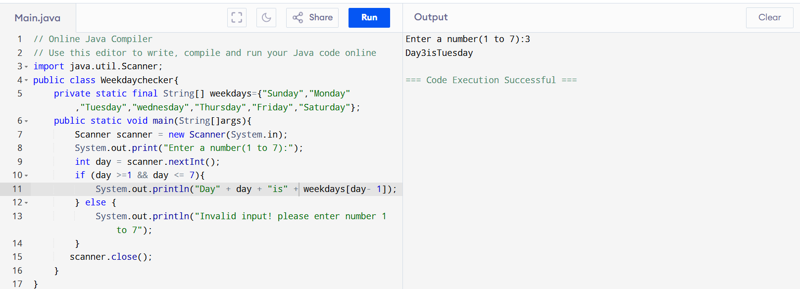

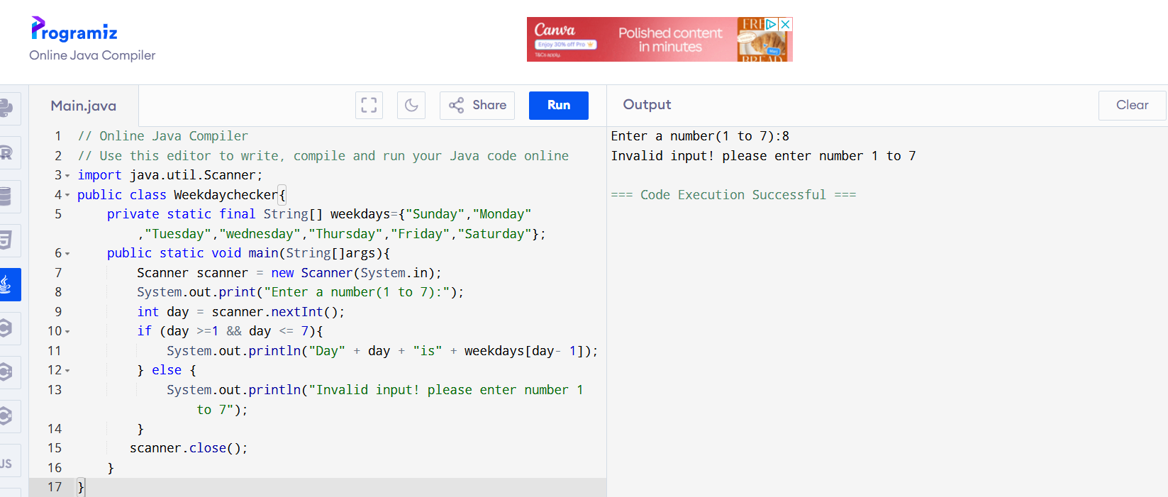

Task-11: Switch case for week days

import java.util.Scanner;

public class weekdayswitch{

public static void main(String[]args){

Scanner scanner =new Scanner(System.in);

System.out.print("Enter a number(1 to 7):");

int day = scanner.nextInt();

String weekday;

switch(day) {

case 1->weekday = "Monday";

case 2->weekday = "Tuesday";

case 3->weekday = "Wednesday";

case 4->weekday = "Thursday";

case 5->weekday = "Friday";

case 6->weekday = "Saturday";

case 7->weekday = "Sunday";

default -> weekday = "Invalid input, please enter 1 to 7";

}

System.out.println(weekday);

scanner.close();

}

}

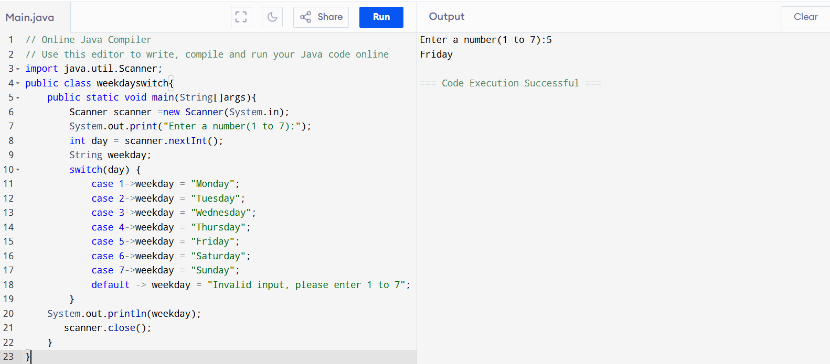

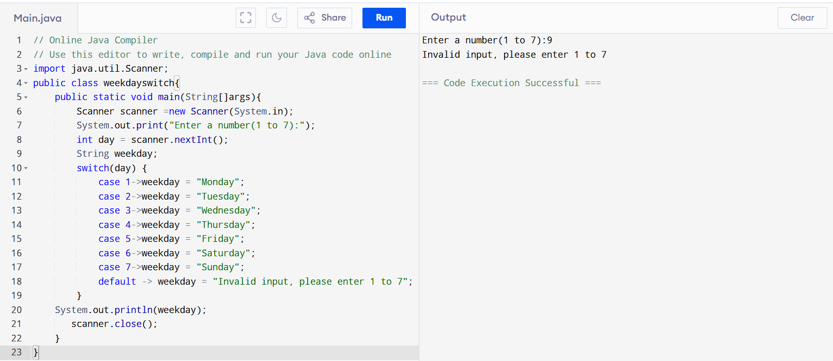

Task-12: Validating user and password

public class LoginValidation {

public static void main(String[] args) {

// Stored (valid) username and password

final String validUsername = "sushma";

final String validPassword = "4567";

Scanner scanner = new Scanner(System.in);

// Get user input

System.out.print("Enter username: ");

String inputUsername = scanner.nextLine();

System.out.print("Enter password: ");

String inputPassword = scanner.nextLine();

// Validate credentials

if (inputUsername.equals(validUsername) && inputPassword.equals(validPassword)) {

System.out.println("Login successful!");

} else {

System.out.println("Invalid username or password.");

}

scanner.close();

}

}

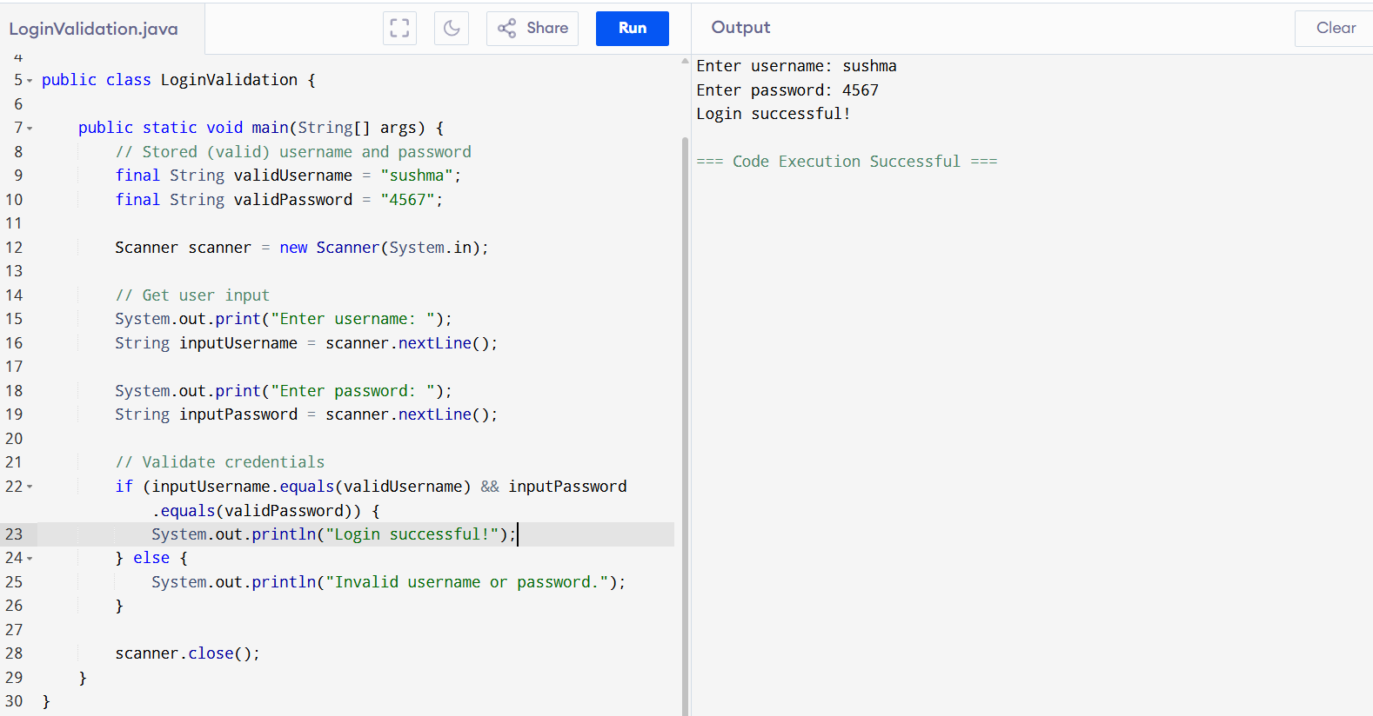

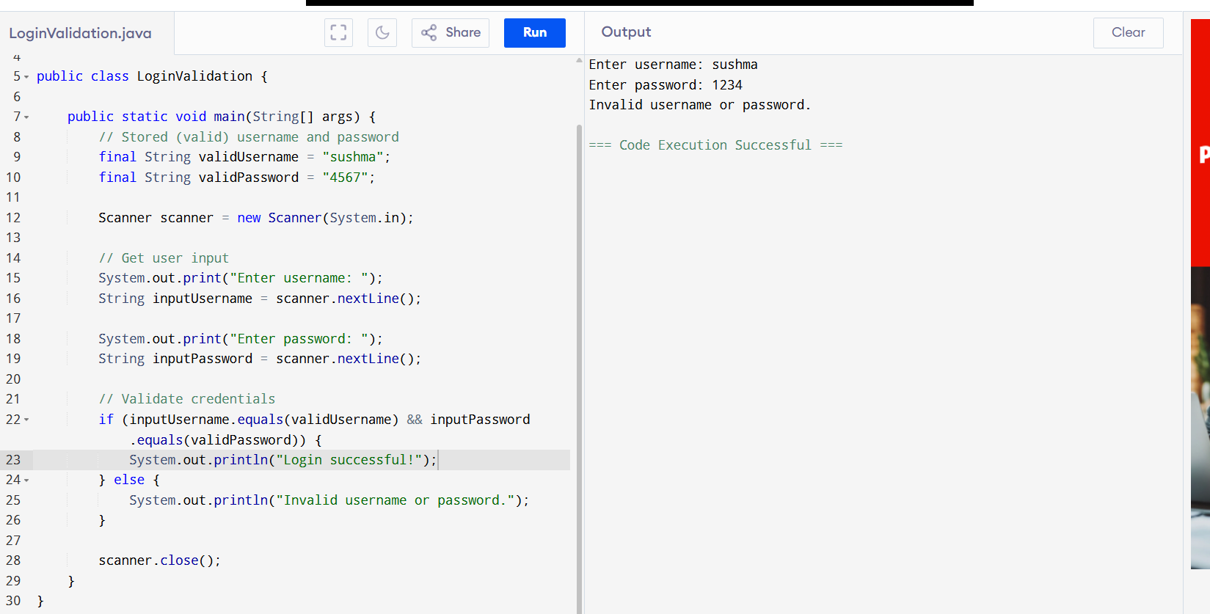

Task-13: Display num 10-1 skip 7,5

public class SkipNumbers {

public static void main(String[] args) {

for (int i = 10; i >= 1; i--) {

if (i == 7 || i == 5) {

continue;

}

System.out.println(i);

}

}

}

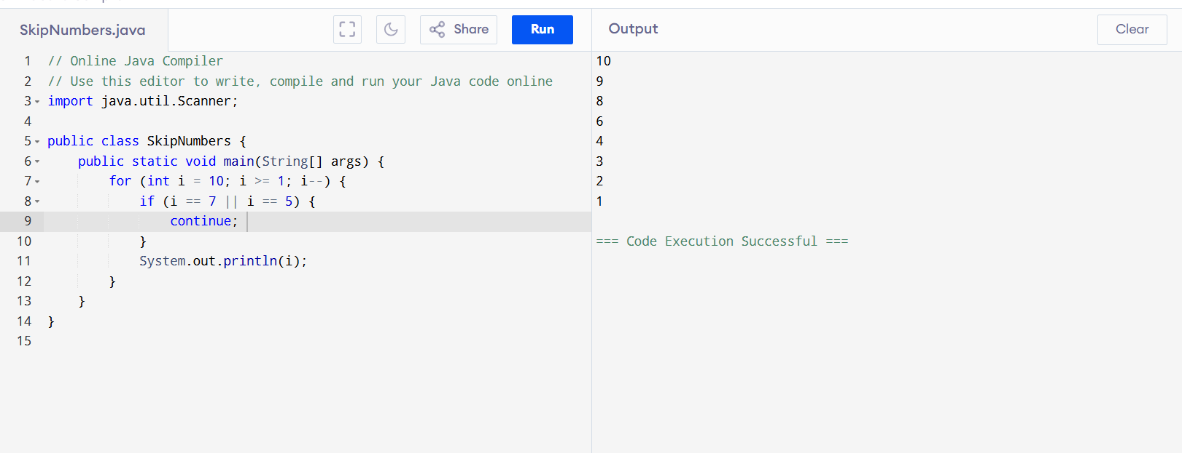

Task-14: Arrays

Try the below code and display the output…

Now play with it try to access array of 5th index and see the output…and try to access array of -1 index and see the output.

package Arrays;

public class Demo01 {

public static void main(String[] args) {

// TODO Auto-generated method stub

char[] arr = {'a','e','i','o','u'};

System.out.println(arr);

String[] names = {"Meena", "Tina", "Veena", "heena"};

System.out.println(names[0]);

names[1]= "Reena";

System.out.println(names[1]);

System.out.println(names.length);

System.out.println(names[4]);

//Exception in thread "main" java.lang.ArrayIndexOutOfBoundsException

}

}

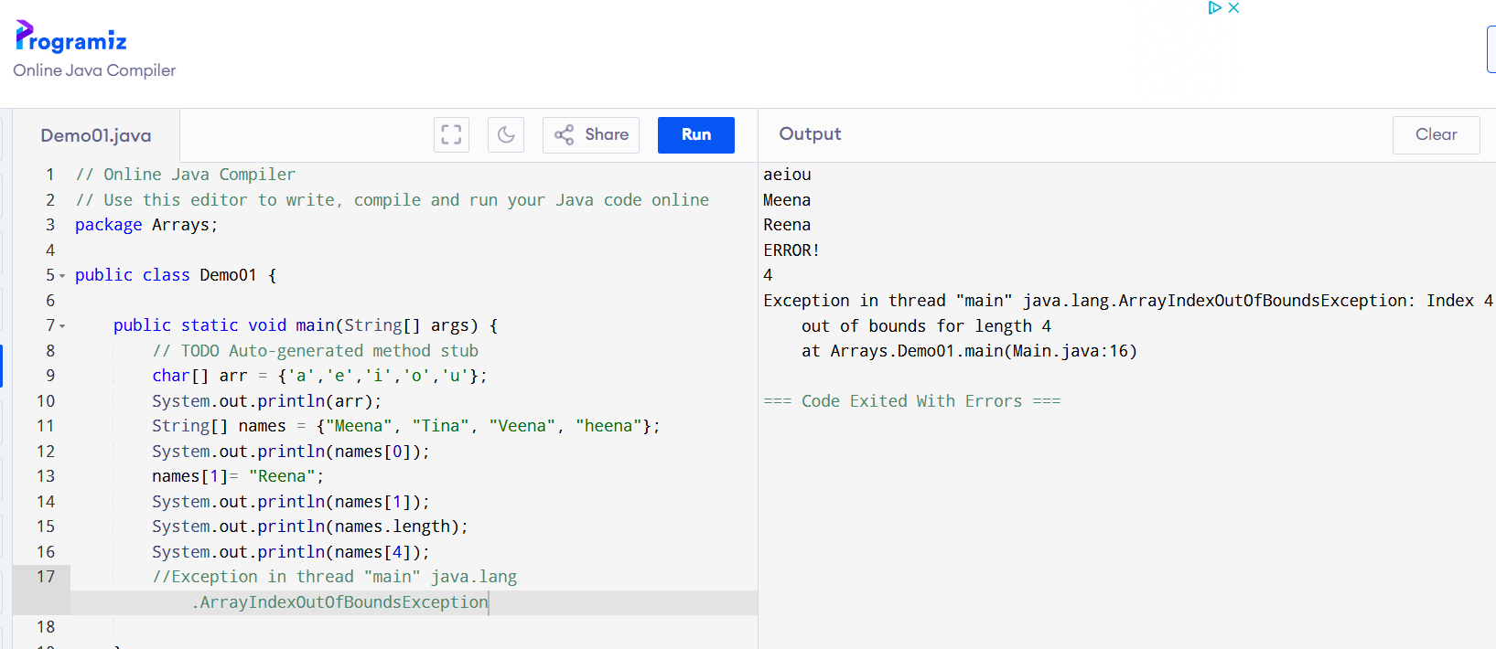

Task-15:

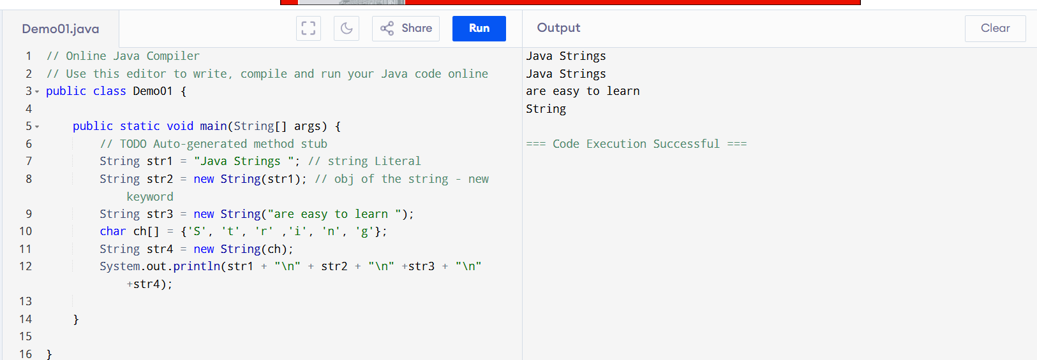

Task-16: Enums or Enumerations   – part of  collection framework

What is the output of the below code snippet

package Enumerations;

enum color{

red, blue, green, yellow

}

public class Demo01 {

public static void main(String[] args) {

color c1 = color.yellow;

System.out.println(c1);

}

}

package Enumerations;

enum Weekdays{

Sunday , Monday , Tuesday

}

public class Demo01 {

public static void main(String[] args) {

Weekdays c1 = Weekdays.Tuesday;

System.out.println(c1);

}

}

Task-16: ENUM

public class EnumExample {

enum Day {

MONDAY, TUESDAY, WEDNESDAY, THURSDAY, FRIDAY, SATURDAY, SUNDAY

}

public static void main(String[] args) {

Day today = Day.SUNDAY;

System.out.println("Today is: " + today);

switch (today) {

case SATURDAY, SUNDAY -> System.out.println("It's the weekend!");

default -> System.out.println("It's a weekday.");

}

}

}

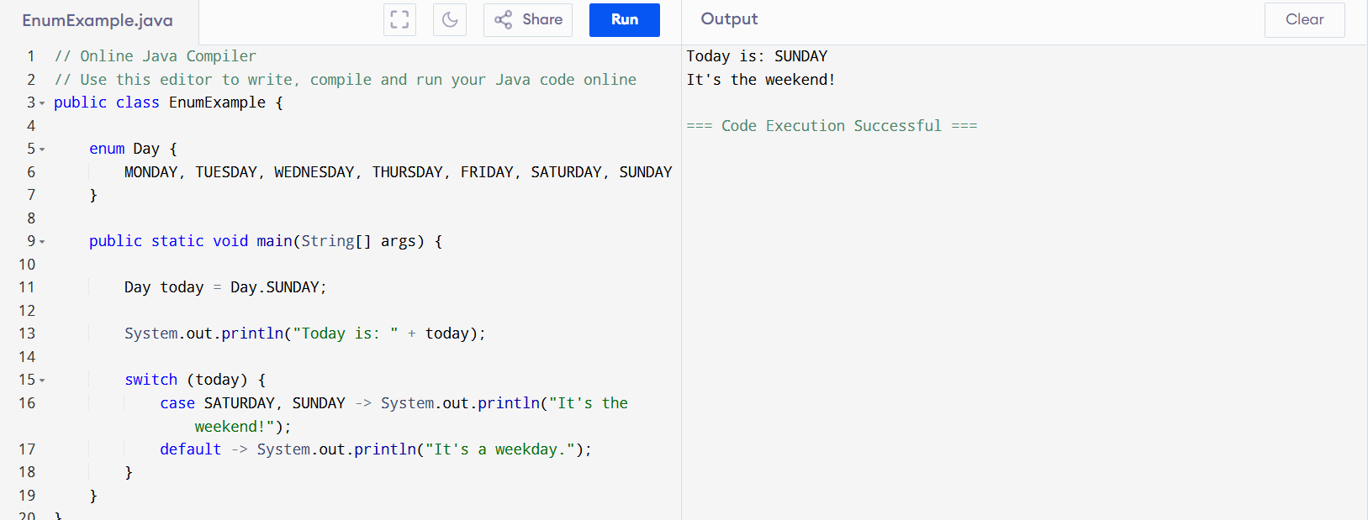

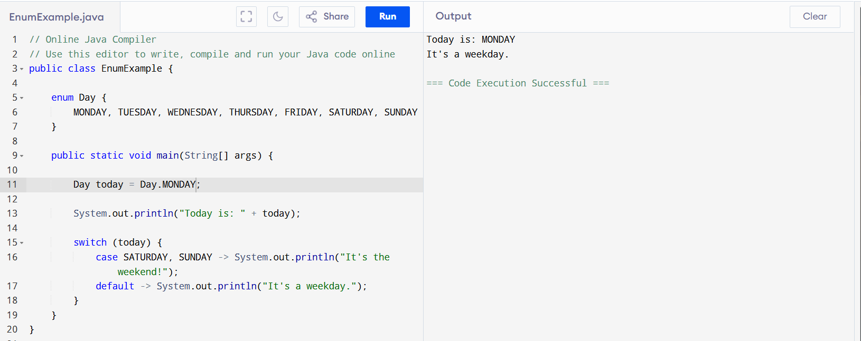

Task-17: using Get and Set

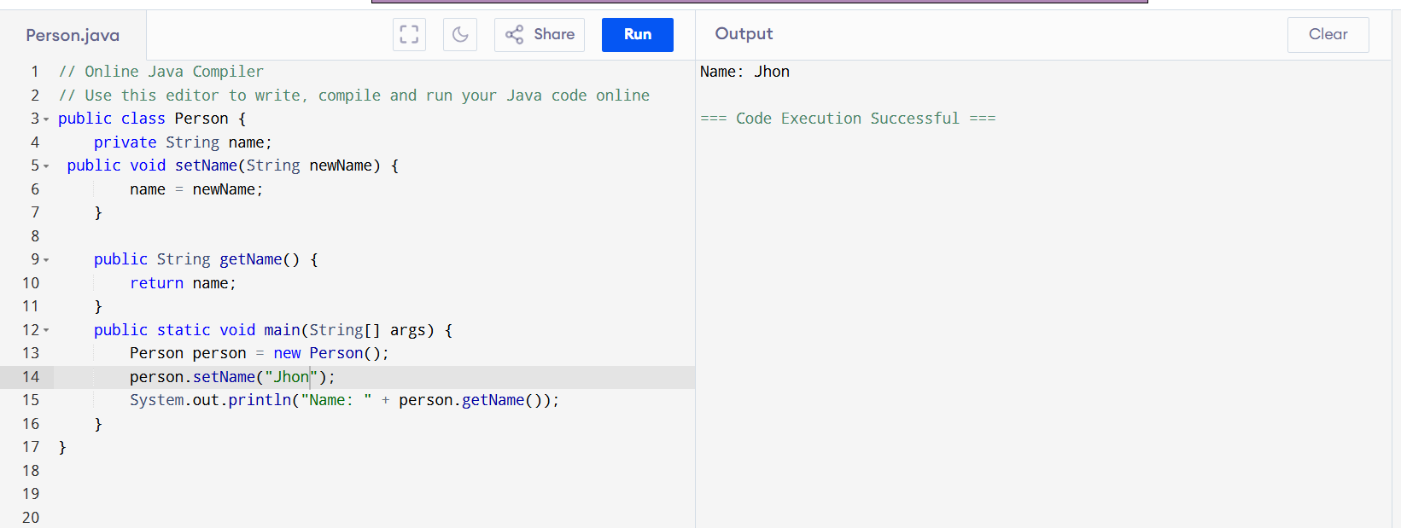

Task-18: ENUM

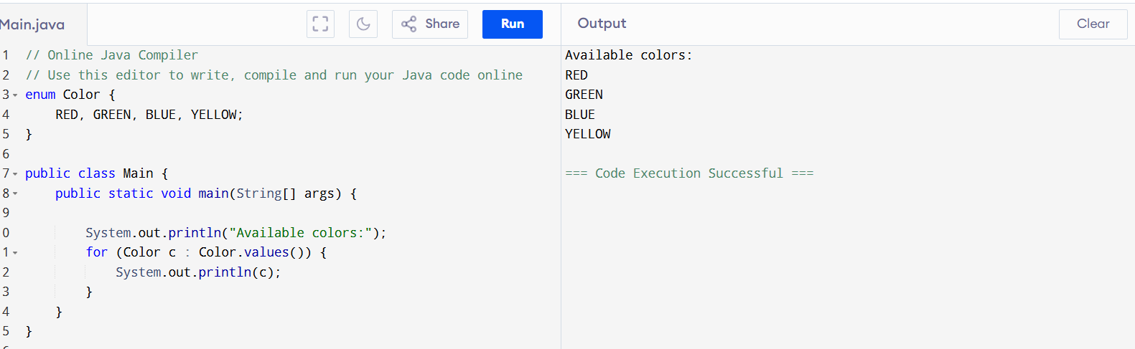

enum Color {

RED, GREEN, BLUE, YELLOW;

}

// Main class with main() method

public class Main {

public static void main(String[] args) {

// Loop through all values in the enum and print them

System.out.println("Available colors:");

for (Color c : Color.values()) {

System.out.println(c);

}

}

}

Task-19: ARRAY

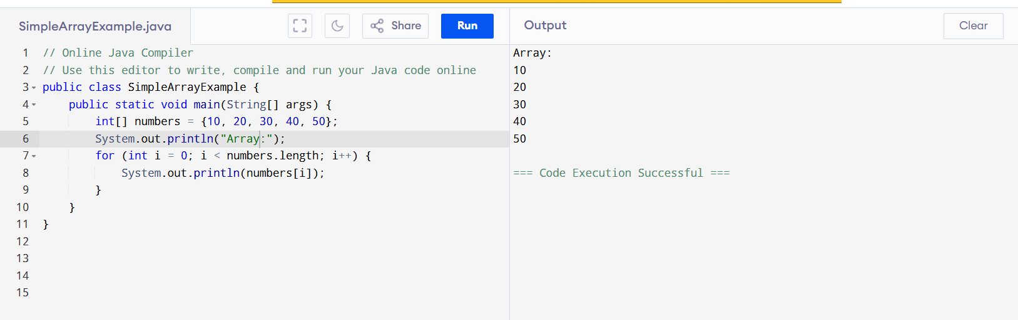

public class SimpleArrayExample {

public static void main(String[] args) {

int[] numbers = {10, 20, 30, 40, 50};

System.out.println("Array:");

for (int i = 0; i < numbers.length; i++) {

System.out.println(numbers[i]);

}

}

}

With names:

public class NameArray {

public static void main(String[] args) {

String[] names = {"Ram", "Anitha", "sitha", "Diana"};

System.out.println("Names in the array:");

for (int i = 0; i < names.length; i++) {

System.out.println(names[i]);

}

}

