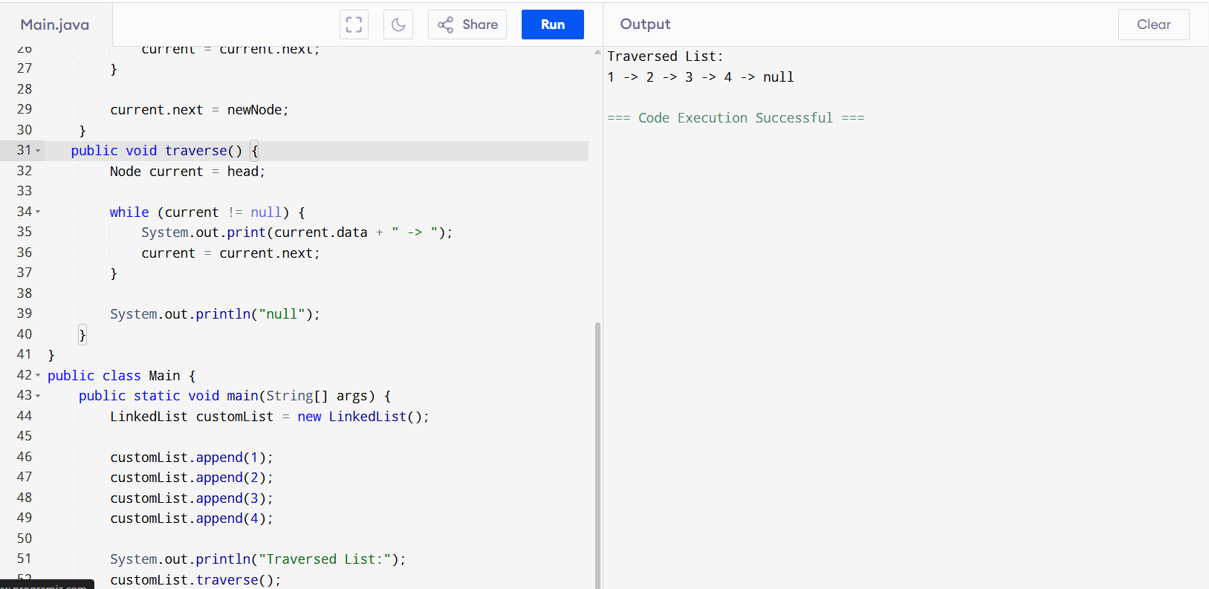
Singly linked list:

class Node {
int data;
Node next;

public Node(int data) {
this.data = data;
this.next = null;
}
}

class LinkedList {
private Node head;

public void append(int data) {
Node newNode = new Node(data);

if (head == null) {
head = newNode;
return;
}

Node current = head;
while (current.next != null) {
current = current.next;
}

current.next = newNode;
}
public void traverse() {
Node current = head;

while (current != null) {
System.out.print(current.data + " -> ");
current = current.next;
}

System.out.println("null");
}
}
public class Main {
public static void main(String[] args) {
LinkedList customList = new LinkedList();

customList.append(1);
customList.append(2);
customList.append(3);
customList.append(4);

System.out.println("Traversed List:");
customList.traverse();
}
}
Traversing:
Processing each element of data structure is accessed.this method is totally depends on which data structure is being used.
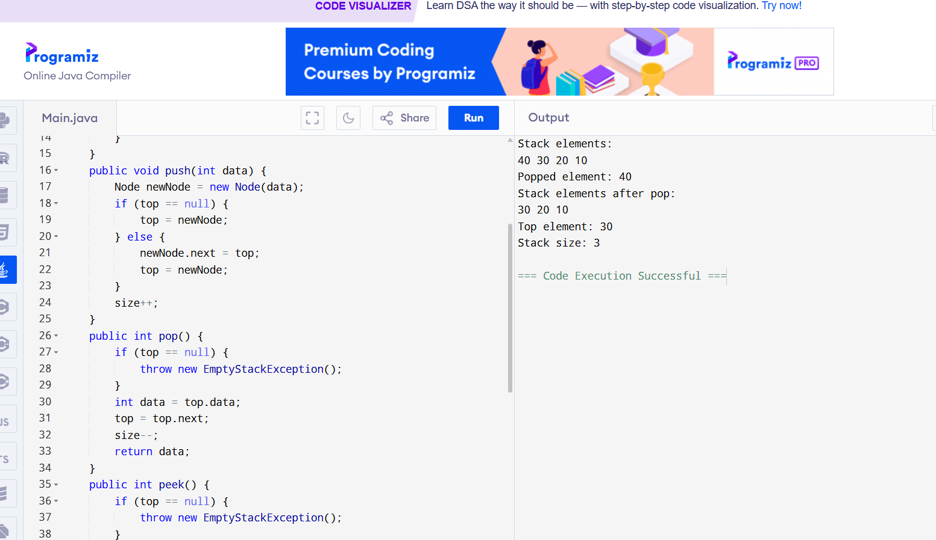

import java.util.EmptyStackException;

class Stack {
private Node top;
private int size;

private class Node {
int data;
Node next;

public Node(int data) {
this.data = data;
this.next = null;
}
}
public void push(int data) {
Node newNode = new Node(data);
if (top == null) {
top = newNode;
} else {
newNode.next = top;
top = newNode;
}
size++;
}
public int pop() {
if (top == null) {
throw new EmptyStackException();
}
int data = top.data;
top = top.next;
size--;
return data;
}
public int peek() {
if (top == null) {
throw new EmptyStackException();
}
return top.data;
}
public boolean isEmpty() {
return top == null;
}

public int size() {
return size;
}

public void printStack() {
Node current = top;
while (current != null) {
System.out.print(current.data + " ");
current = current.next;
}
System.out.println();
}
}

public class Main {
public static void main(String[] args) {
Stack stack = new Stack();
stack.push(10);
stack.push(20);
stack.push(30);
stack.push(40);

System.out.println("Stack elements:");
stack.printStack();

System.out.println("Popped element: " + stack.pop());
System.out.println("Stack elements after pop:");
stack.printStack();

System.out.println("Top element: " + stack.peek());
System.out.println("Stack size: " + stack.size());
}
}
Stack with position:
import java.util.EmptyStackException;

class Stack {
private Node top;
private int size;

private class Node {
int data;
Node next;

public Node(int data) {
this.data = data;
this.next = null;
}
}

public void push(int data) {
Node newNode = new Node(data);
if (top == null) {
top = newNode;
} else {
newNode.next = top;
top = newNode;
}
size++;
}

public int pop() {
if (top == null) {
throw new EmptyStackException();
}
int data = top.data;
top = top.next;
size--;
return data;
}

public int peek() {
if (top == null) {
throw new EmptyStackException();
}
return top.data;
}

public boolean isEmpty() {
return top == null;
}

public int size() {
return size;
}

public void printStack() {
Node current = top;
while (current != null) {
System.out.print(current.data + " ");
current = current.next;
}
System.out.println();
}

public int findPosition(int data) {
Node current = top;
int position = 1;
while (current != null) {
if (current.data == data) {
return position;
}
current = current.next;
position++;
}
return -1;
}
}

public class Main {
public static void main(String[] args) {
Stack stack = new Stack();
stack.push(10);
stack.push(20);
stack.push(30);
stack.push(40);

System.out.println("Stack elements:");
stack.printStack();

System.out.println("Popped element: " + stack.pop());
System.out.println("Stack elements after pop:");
stack.printStack();

System.out.println("Top element: " + stack.peek());
System.out.println("Stack size: " + stack.size());

System.out.println("Position of 20: " + stack.findPosition(20));
System.out.println("Position of 50: " + stack.findPosition(50));
}
}
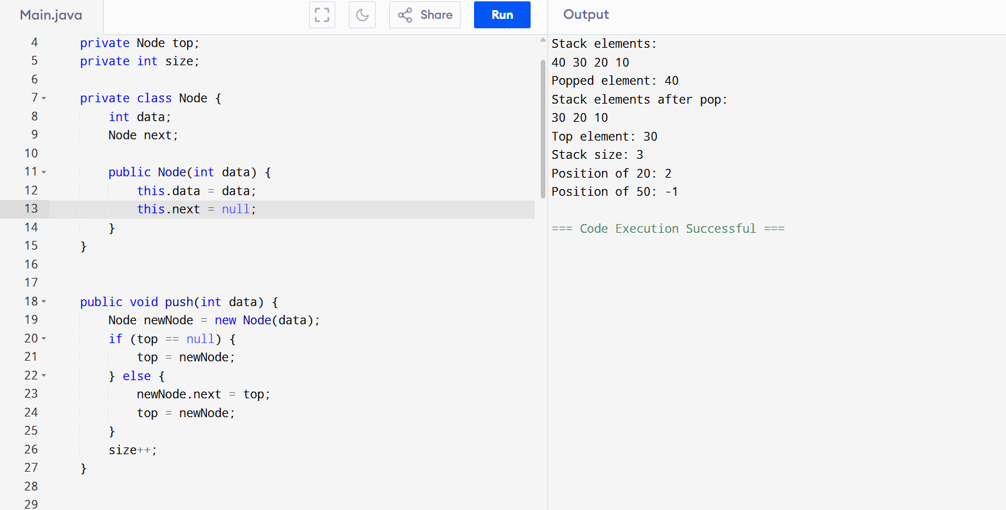

Stack with all elements popped:
import java.util.EmptyStackException;

class Stack {
private Node top;
private int size;

private class Node {
int data;
Node next;

public Node(int data) {
this.data = data;
this.next = null;
}
}

public void push(int data) {
Node newNode = new Node(data);
if (top == null) {
top = newNode;
} else {
newNode.next = top;
top = newNode;
}
size++;
}

public int pop() {
if (top == null) {
throw new EmptyStackException();
}
int data = top.data;
top = top.next;
size--;
return data;
}

public int peek() {
if (top == null) {
throw new EmptyStackException();
}
return top.data;
}

public boolean isEmpty() {
return top == null;
}

public int size() {
return size;
}

public void printStack() {
Node current = top;
while (current != null) {
System.out.print(current.data + " ");
current = current.next;
}
System.out.println();
}

public void popAll() {
while (!isEmpty()) {
System.out.println("Popped element: " + pop());
}
System.out.println("Stack is empty.");
}
}

public class Main {
public static void main(String[] args) {
Stack stack = new Stack();
stack.push(10);
stack.push(20);
stack.push(30);
stack.push(40);

System.out.println("Stack elements:");
stack.printStack();

System.out.println("Popping all elements:");
stack.popAll();

System.out.println("Stack size after popping all elements: " + stack.size());
}
}
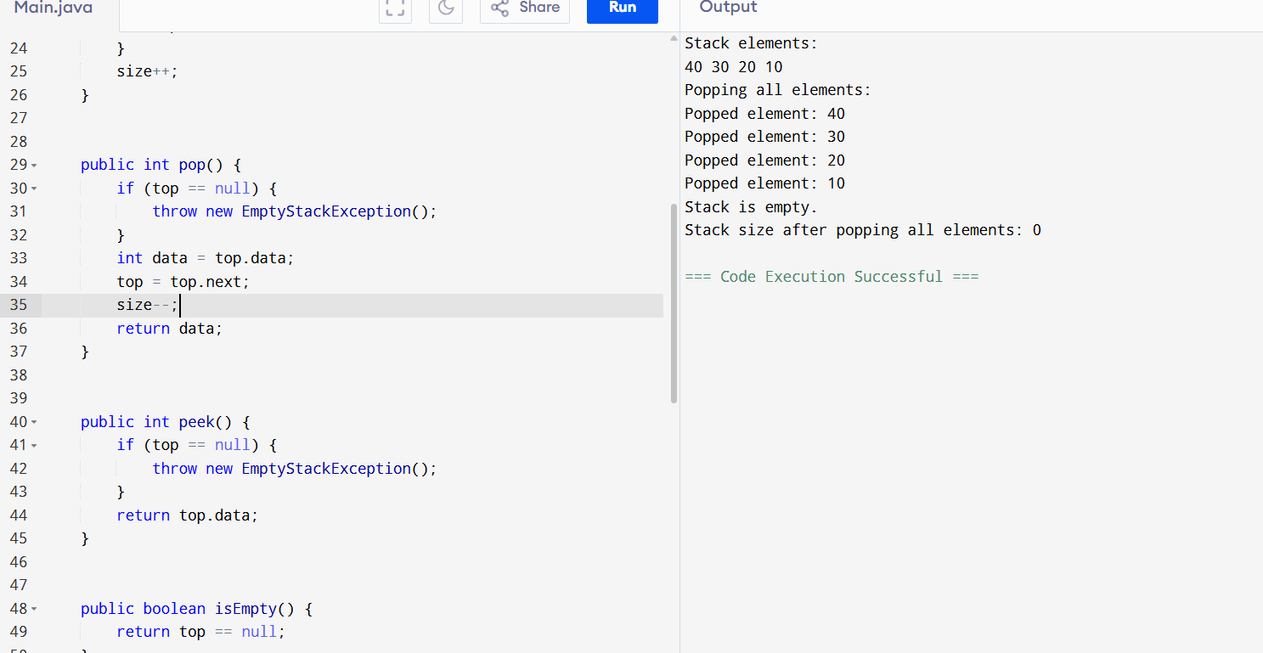

Task: list of methods in stack class
Push() – adds elements to pop of stack
Pop()-removes and returns the top element from stack
Peek()- returns the top element without removing
printStack- prints the elements of stack
popAll-pops all elements from stack
findPosition: finds the position of an element in stack

Task 10:
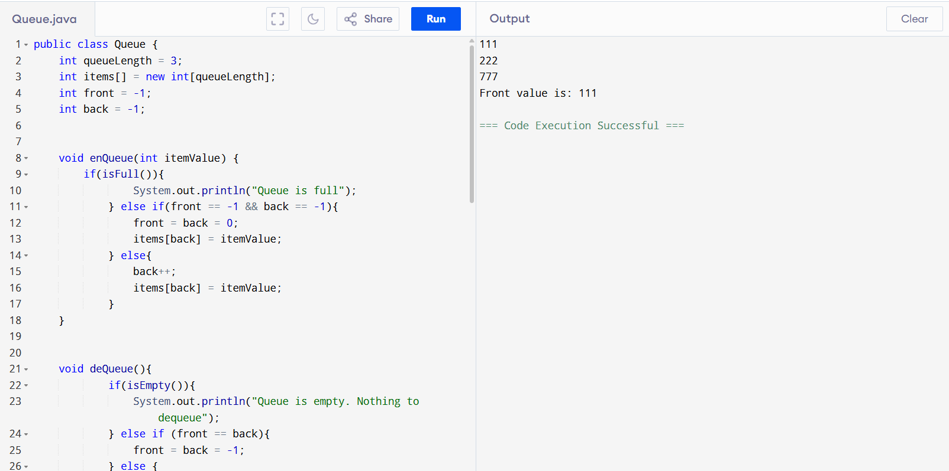
TASK:9
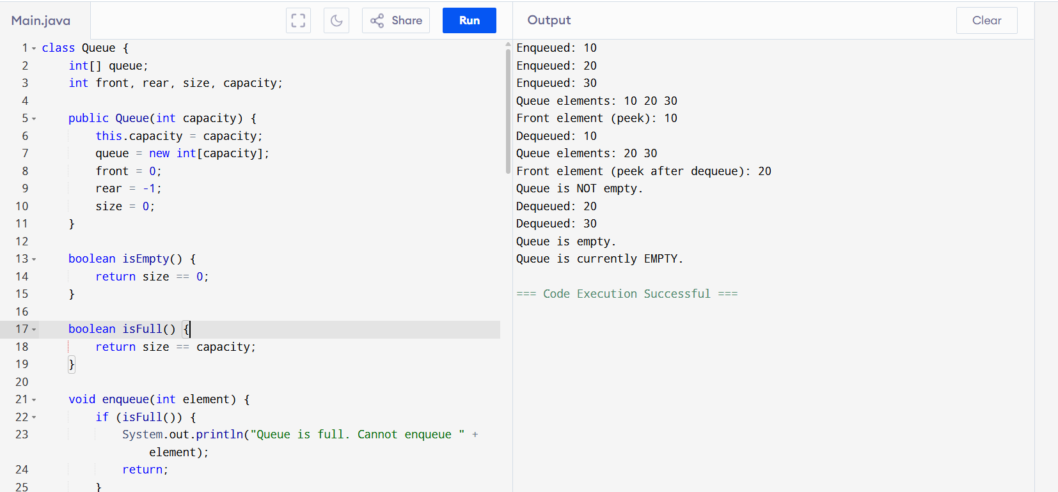
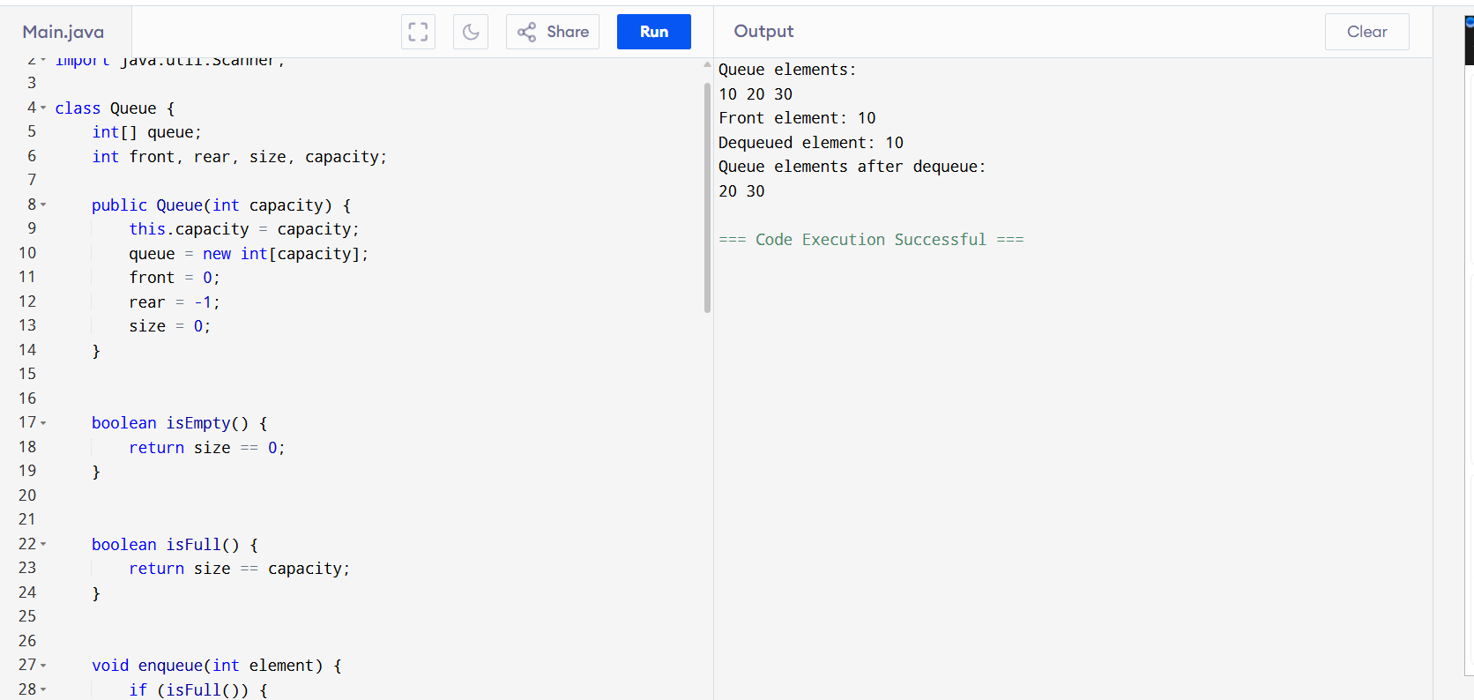
Iteration-implemted using loops where as recursion is calls functions, it reduces complexity and stack overflow doesn’t occurs.
Fibonacci:
public class Fibonacci {
public static void main(String[] args) {
int n = 10;
int a = 0;
int b = 1;
System.out.println("Fibonacci series up to " + n + " terms:");
for (int i = 0; i < n; i++) {
System.out.print(a + " ");
int temp = a;
a = b;
b = temp + b;
}
}
}
