Process:
Executing instance of a program/task
Steps and decisions involved in completing work.
Thread:
perform complicated tasks in the background without interrupting the main program, it’s a light weight
Task 3 and 4:
class TestThread1 {
public static void main(String args[]) {
Day10task001 R1 = new Day10task001( "Thread-1");
R1.start();
Day10task001 R2 = new Day10task001( "Thread-2");
R2.start();
}
} class Day10task001 implements Runnable {
private Thread t;
private String threadName;
Day10task001( String name){
threadName = name;
System.out.println("Creating " + threadName );
}
public void run() {
System.out.println("Running " + threadName );
try {
for(int i = 4; i > 0; i--) {
System.out.println("Thread: " + threadName + ", " + i);
// Let the thread sleep for a while.
Thread.sleep(5000);
}
} catch (InterruptedException e) {
System.out.println("Thread " + threadName + " interrupted.");
}
System.out.println("Thread " + threadName + " exiting.");

}
public void start ()
{
System.out.println("Starting " + threadName );
if (t == null)
{
t = new Thread (this, threadName);
t.start ();
}
}
}
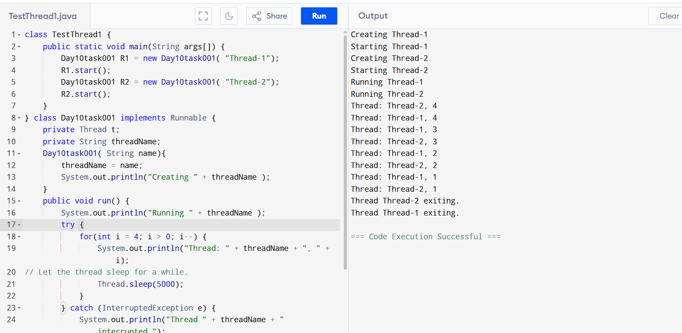
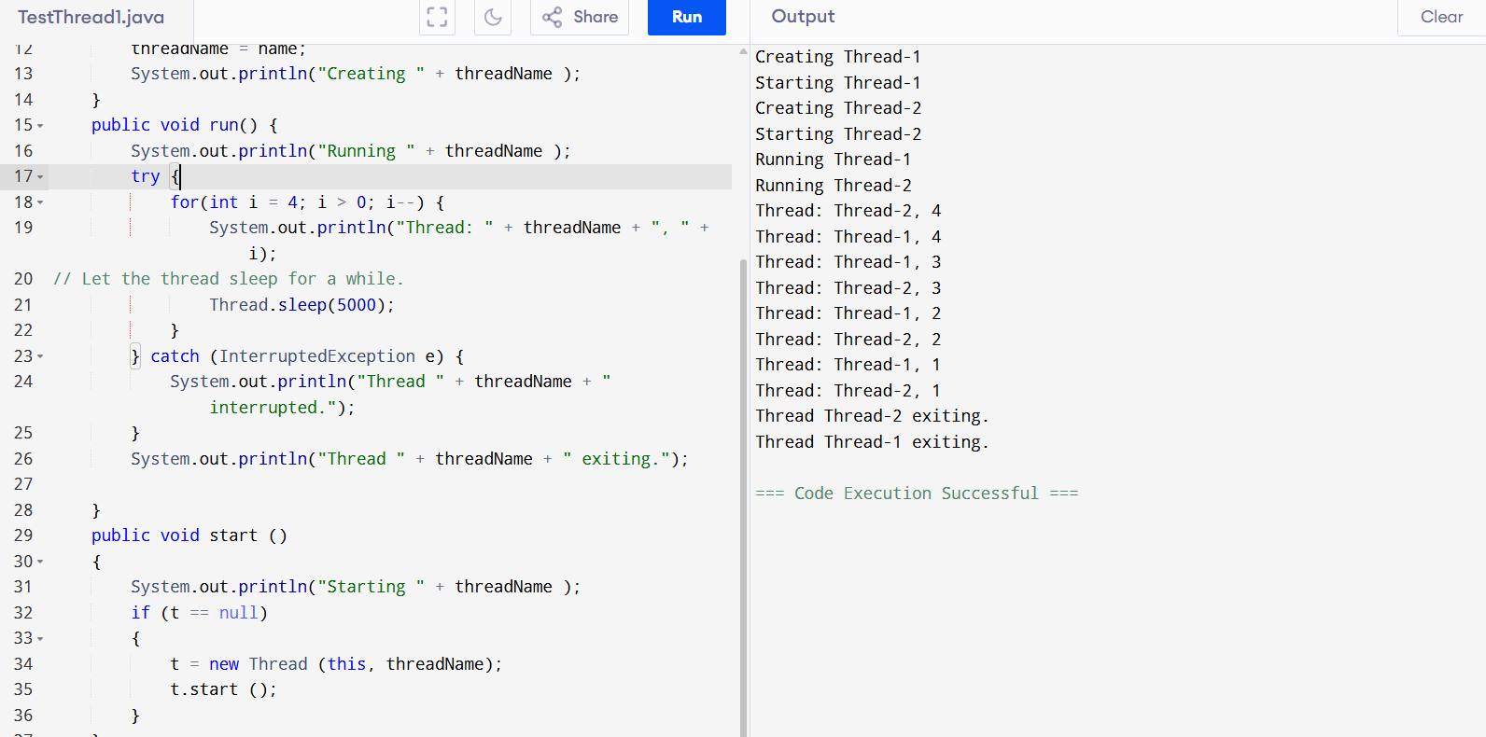
TASK 5:
// Online Java Compiler
// Use this editor to write, compile and run your Java code online
class Counter {
private int count = 0;

public void increment() {
count++;
}

public int getCount() {
return count;
}
}

class ThreadDemo extends Thread {
Counter counter;

ThreadDemo(Counter counter) {
this.counter = counter;
}

public void run() {
for (int i = 0; i < 10; i++) {
counter.increment();
}
}
}

public class Main {
public static void main(String[] args) {
Counter counter = new Counter();
ThreadDemo t1 = new ThreadDemo(counter);
ThreadDemo t2 = new ThreadDemo(counter);

t1.start();
t2.start();

try {
t1.join();
t2.join();
} catch (InterruptedException e) {
e.printStackTrace();
}

System.out.println("Final count: " + counter.getCount());
}
}

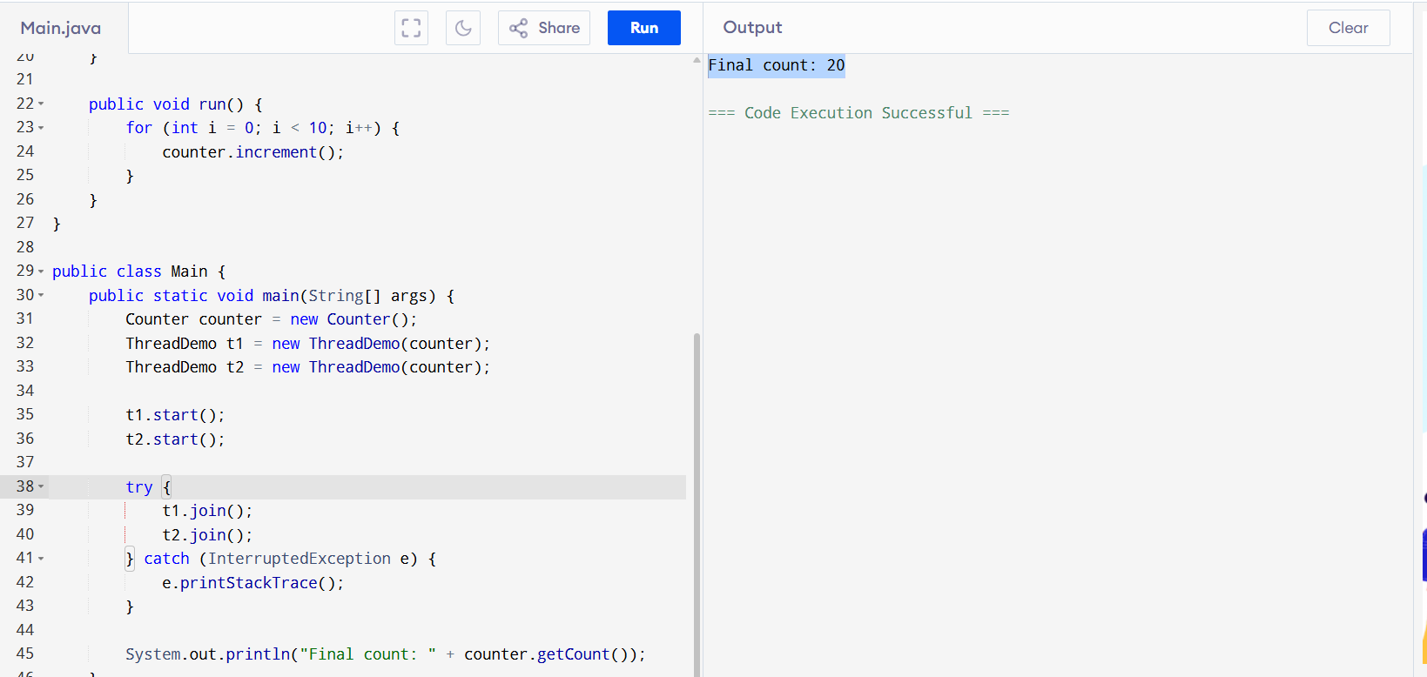
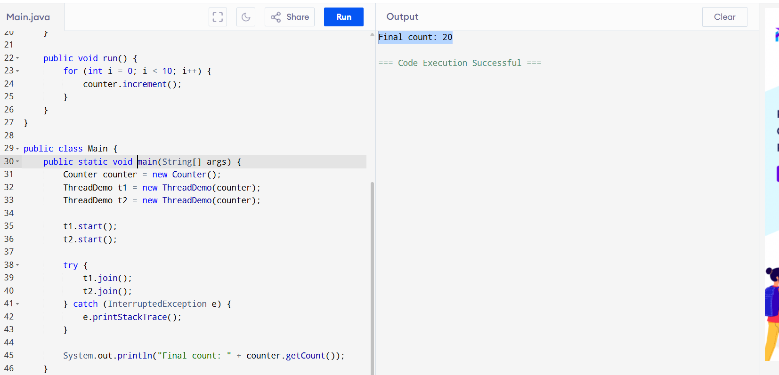

TASK:6
// Online Java Compiler
// Use this editor to write, compile and run your Java code online
class Counter {
private int count = 0;

public void increment() {
count++;
}

public int getCount() {
return count;
}
}

class ThreadDemo extends Thread {
Counter counter;

ThreadDemo(Counter counter) {
this.counter = counter;
}

public synchronized void run() {
for (int i = 0; i < 100; i++) {
counter.increment();
System.out.println(i);
}
}
}

public class Main {
public static void main(String[] args) {
Counter counter = new Counter();
ThreadDemo t1 = new ThreadDemo(counter);
ThreadDemo t2 = new ThreadDemo(counter);

t1.start();
t2.start();

try {
t1.join();
t2.join();
} catch (InterruptedException e) {
e.printStackTrace();
}

System.out.println("Final count: " + counter.getCount());
}
}

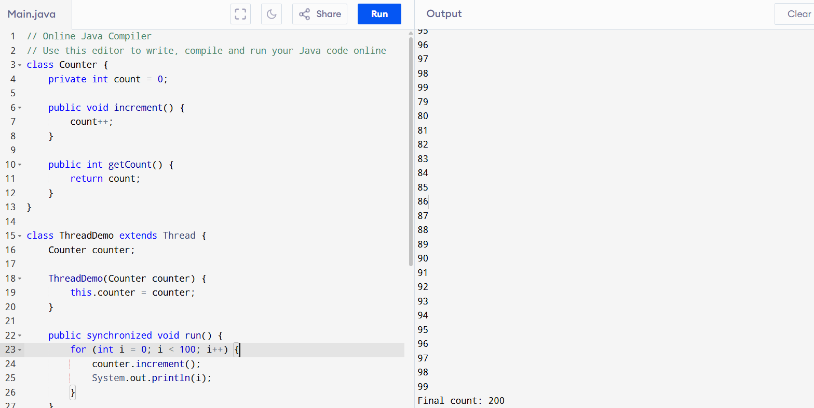

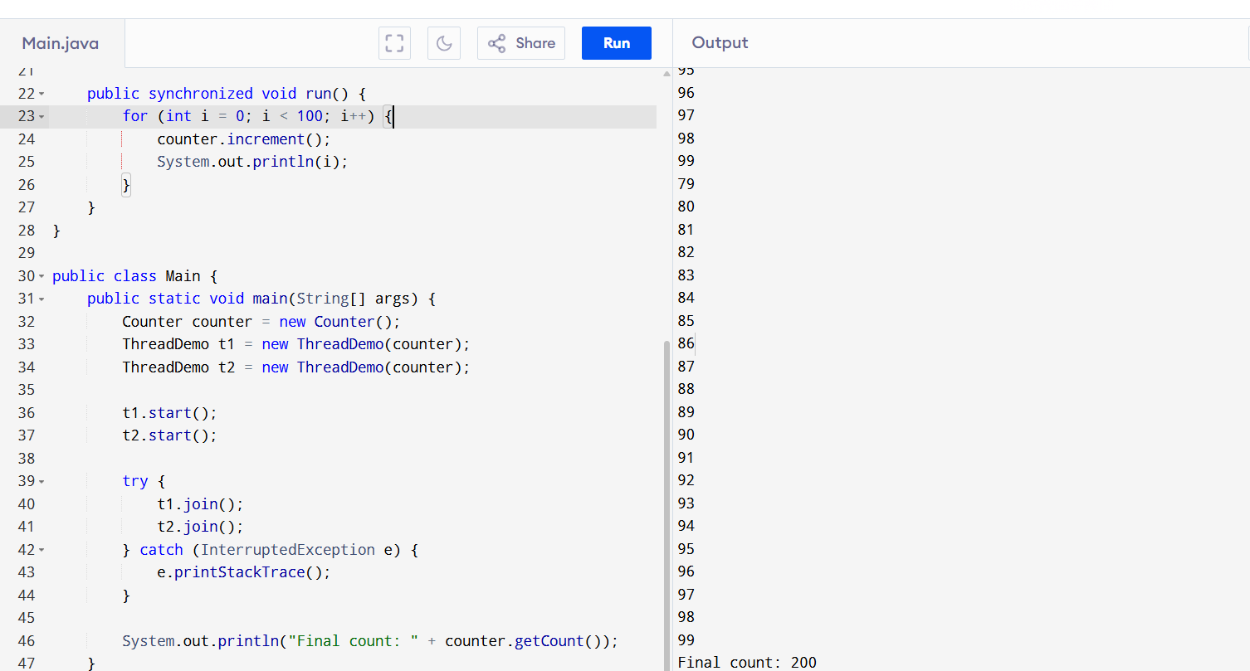
TASK:7
class Counter {
private int count = 0;

public void increment() {
count++;
}

public int getCount() {
return count;
}
}

class ThreadDemo extends Thread {
Counter counter;

ThreadDemo(Counter counter) {
this.counter = counter;
}

public synchronized void run() {
for (int i = 0; i < 15; i++) {
counter.increment();
System.out.println(i);
}
}
}

public class Main {
public static void main(String[] args) {
Counter counter = new Counter();
ThreadDemo t1 = new ThreadDemo(counter);
ThreadDemo t2 = new ThreadDemo(counter);

t1.start();
t2.start();

try {
t1.join();
t2.join();
} catch (InterruptedException e) {
e.printStackTrace();
}

System.out.println("Final count: " + counter.getCount());
}
}
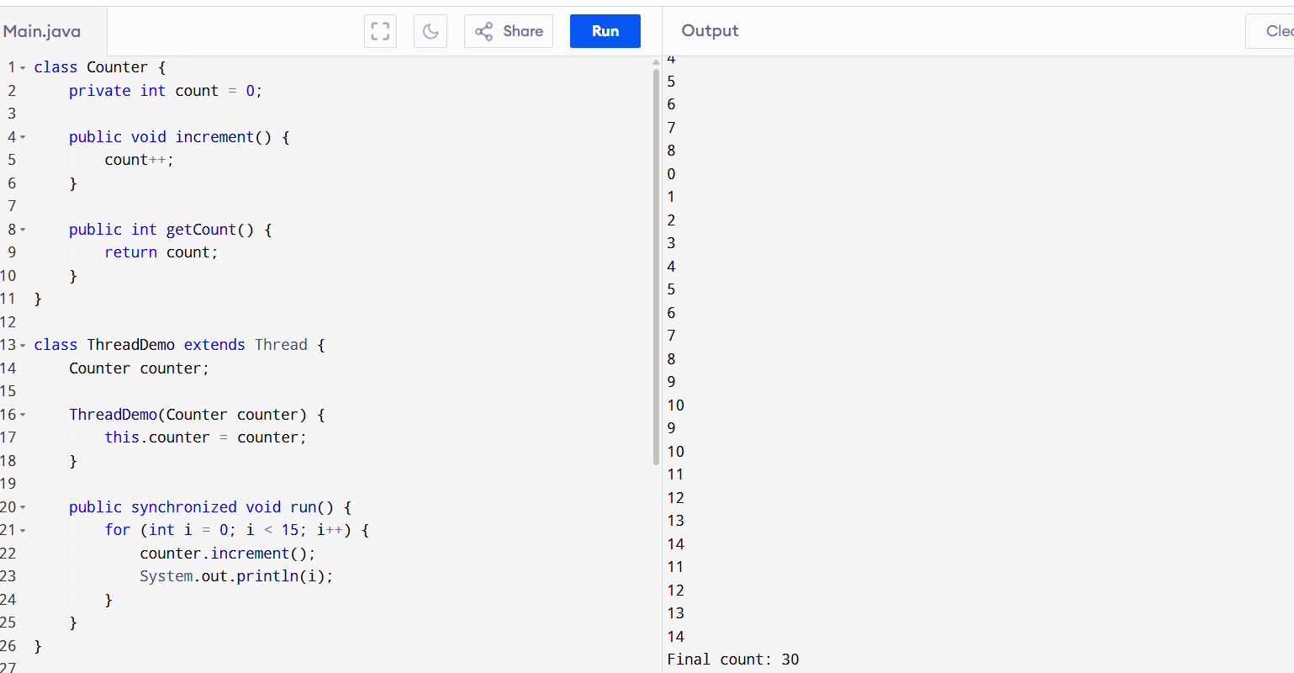
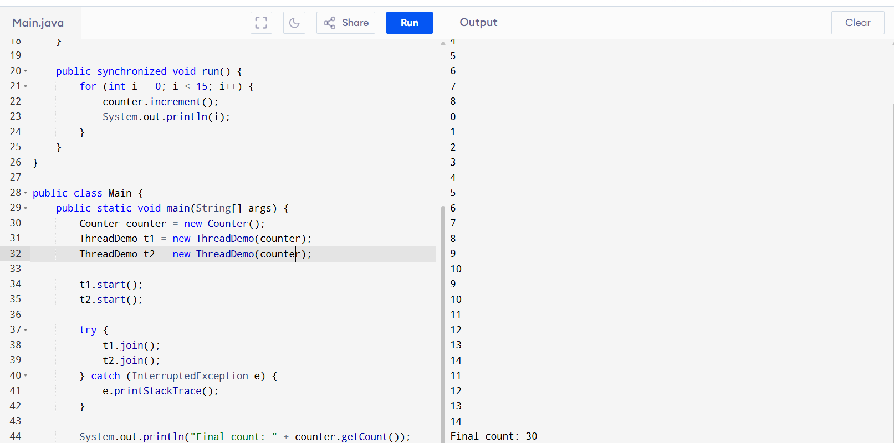
Imagine two processes, Process A and Process B, that need two resources, Resource 1 and Resource 2.
- Process A holds Resource 1 and requests Resource 2.
- Process B holds Resource 2 and requests Resource 1.
Neither process can proceed because:
- Process A is waiting for Resource 2, which is held by Process B.
- Process B is waiting for Resource 1, which is held by Process A.
Dead Lock:
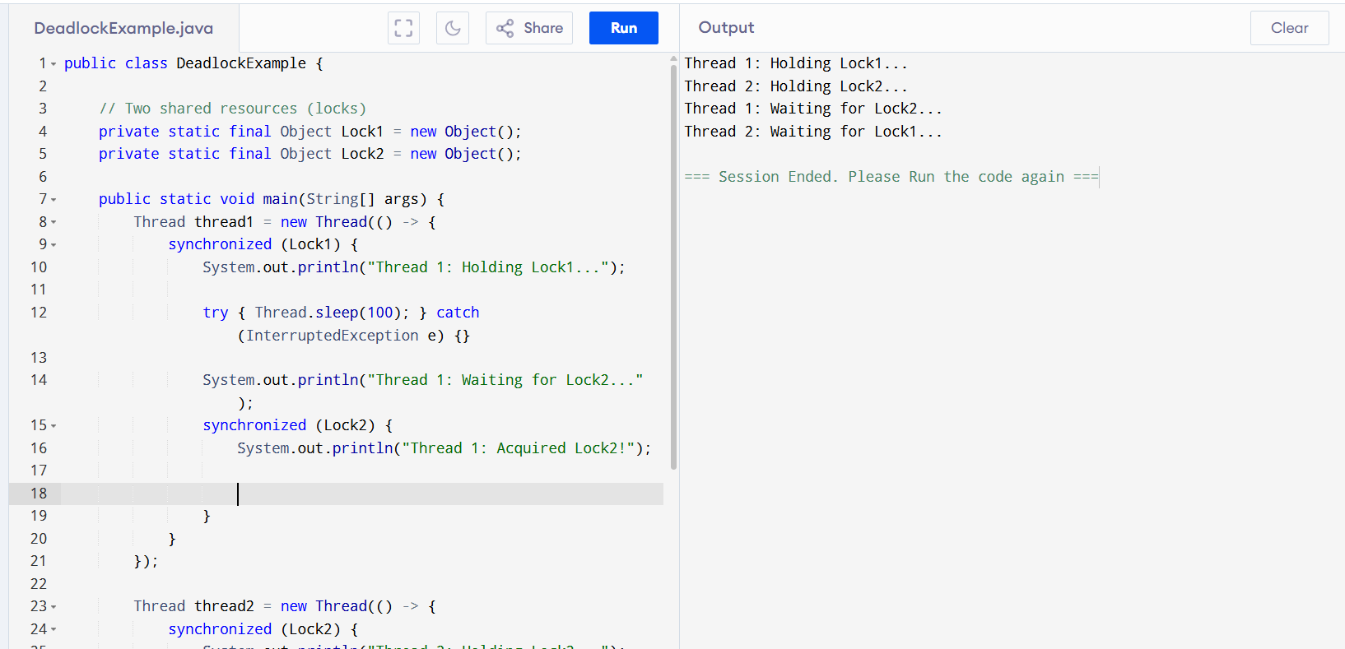
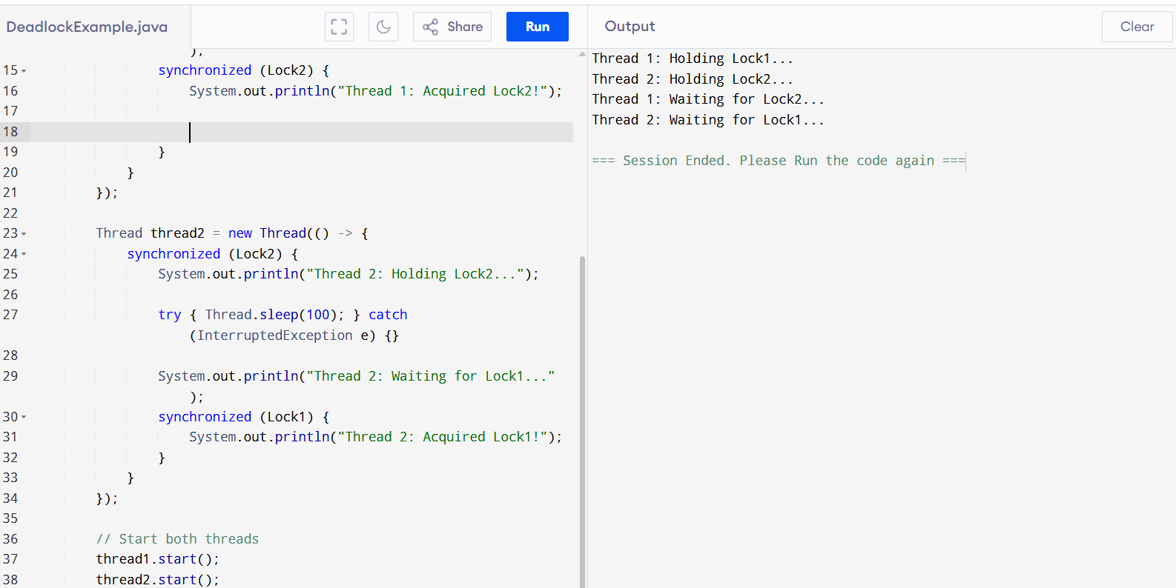

public class DeadlockExample {

// Two shared resources (locks)
private static final Object Lock1 = new Object();
private static final Object Lock2 = new Object();

public static void main(String[] args) {
Thread thread1 = new Thread(() -> {
synchronized (Lock1) {
System.out.println("Thread 1: Holding Lock1...");

try { Thread.sleep(100); } catch (InterruptedException e) {}

System.out.println("Thread 1: Waiting for Lock2...");
synchronized (Lock2) {
System.out.println("Thread 1: Acquired Lock2!");

}
}
});

Thread thread2 = new Thread(() -> {
synchronized (Lock2) {
System.out.println("Thread 2: Holding Lock2...");

try { Thread.sleep(100); } catch (InterruptedException e) {}

System.out.println("Thread 2: Waiting for Lock1...");
synchronized (Lock1) {
System.out.println("Thread 2: Acquired Lock1!");
}
}
});

// Start both threads
thread1.start();
thread2.start();
}
}

Multi threads:
public class MultiThreadDeadlock {

private static final Object Lock1 = new Object();
private static final Object Lock2 = new Object();
private static final Object Lock3 = new Object();

public static void main(String[] args) {
Thread t1 = new Thread(() -> {
synchronized (Lock1) {
System.out.println("Thread 1: Holding Lock1...");
try { Thread.sleep(100); } catch (InterruptedException e) {}
synchronized (Lock2) {
System.out.println("Thread 1: Acquired Lock2!");
}
}
});

Thread t2 = new Thread(() -> {
synchronized (Lock2) {
System.out.println("Thread 2: Holding Lock2...");
try { Thread.sleep(100); } catch (InterruptedException e) {}
synchronized (Lock3) {
System.out.println("Thread 2: Acquired Lock3!");
}
}
});

Thread t3 = new Thread(() -> {
synchronized (Lock3) {
System.out.println("Thread 3: Holding Lock3...");
try { Thread.sleep(100); } catch (InterruptedException e) {}
synchronized (Lock1) {
System.out.println("Thread 3: Acquired Lock1!");
}
}
});

t1.start();
t2.start();
t3.start();
}
}
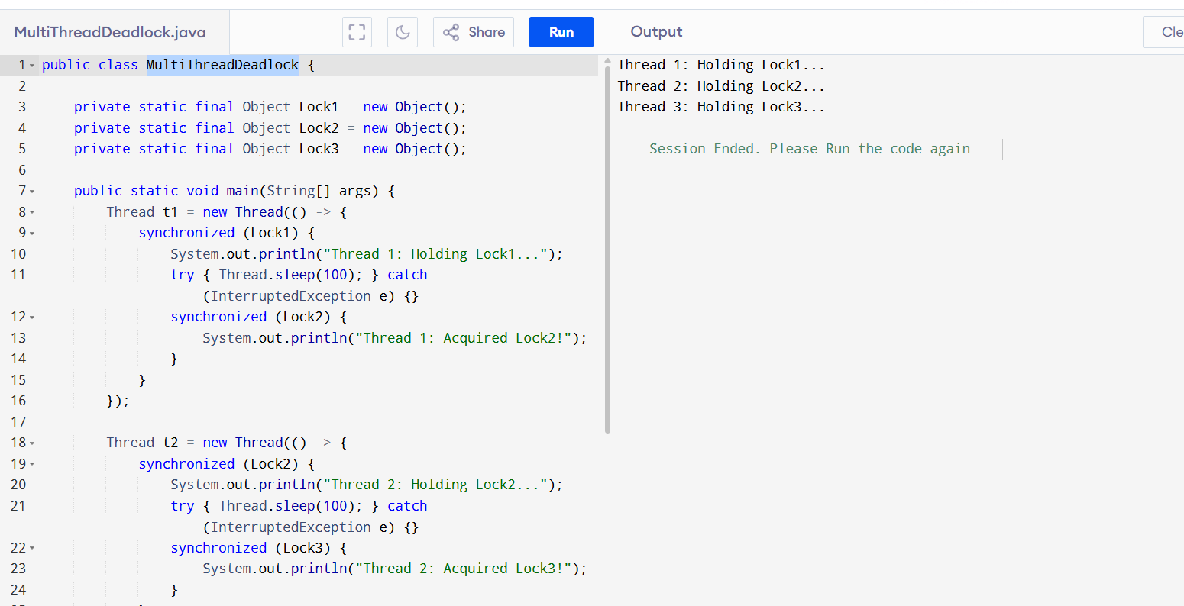
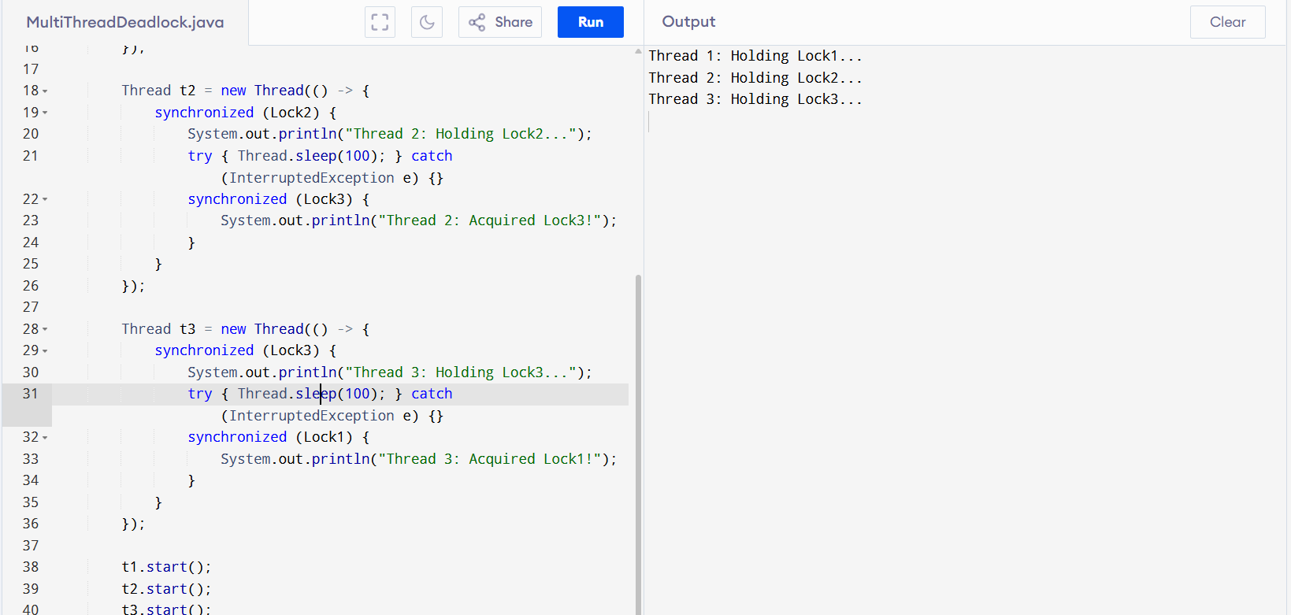

DeadlockFree:
// Online Java Compiler
// Use this editor to write, compile and run your Java code online

public class DeadlockFreeExample {

private static final Object Lock1 = new Object();
private static final Object Lock2 = new Object();
private static final Object Lock3 = new Object();

public static void main(String[] args) {
Runnable task = () -> {
synchronized (Lock1) {
synchronized (Lock2) {
synchronized (Lock3) {
System.out.println(Thread.currentThread().getName() + ": Acquired all locks");
}
}
}
};

Thread t1 = new Thread(task, "Thread A");
Thread t2 = new Thread(task, "Thread B");
Thread t3 = new Thread(task, "Thread C");

t1.start();
t2.start();
t3.start();
}
}
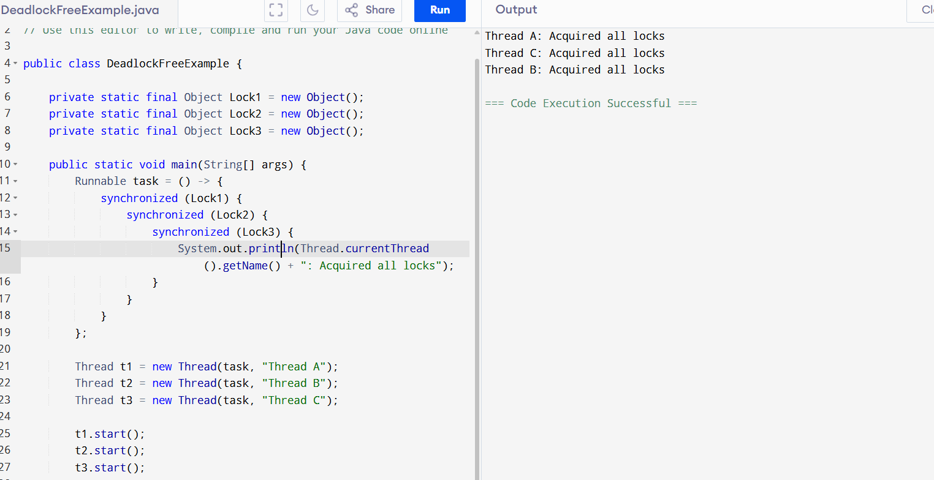

:: operator:
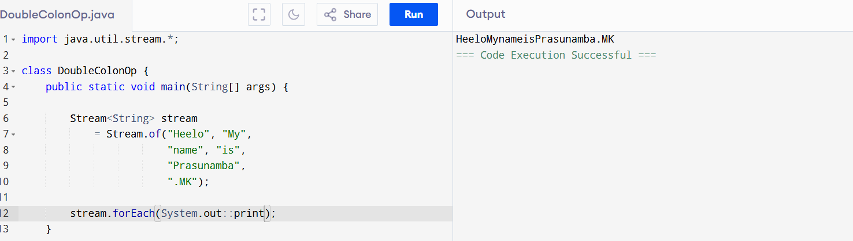
import java.util.stream.*;

class DoubleColonOp {
public static void main(String[] args) {

Stream<String> stream
= Stream.of("Heelo", "My",
"name", "is",
"Prasunamba",
".MK");

stream.forEach(System.out::print);
}
}
Daemon Example:
public class DaemonExample {
public static void main(String[] args) {
Thread daemonThread = new Thread(() -> {
while (true) {
System.out.println("Daemon thread is running...");
try {
Thread.sleep(1000);
} catch (InterruptedException e) {
System.out.println("Daemon thread interrupted");
}
}
});

daemonThread.setDaemon(true);
daemonThread.start();

System.out.println("Main thread is ending...");
}
}
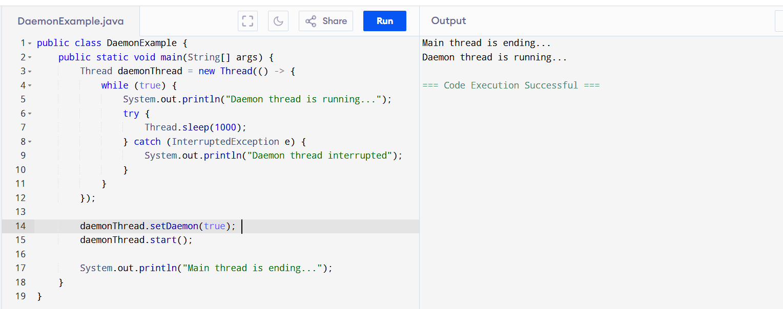
Debugging tools in java:
JDB- JAVA Debugger
Eclipse
VS Code
IntelliJ

Task 18:
public class task18 extends Thread {
public void run(){
System.out.println("thread started.");
}
public static void main(String args[]){

task18 th1 = new task18();
th1.start();

}
}
