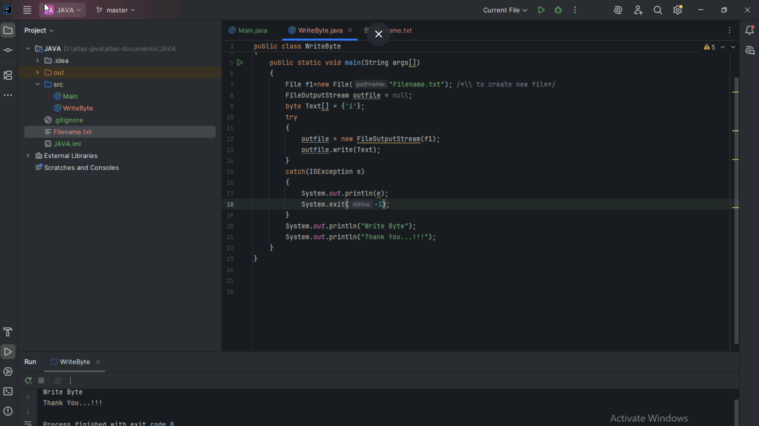

TASK10:
Reverse a string:
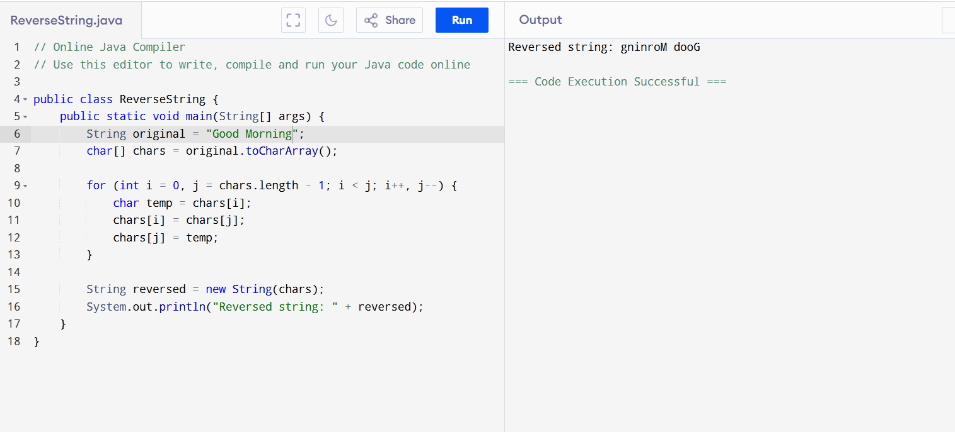

public class ReverseString {
public static void main(String[] args) {
String original = "Good Morning";
char[] chars = original.toCharArray();

for (int i = 0, j = chars.length - 1; i < j; i++, j--) {
char temp = chars[i];
chars[i] = chars[j];
chars[j] = temp;
}

String reversed = new String(chars);
System.out.println("Reversed string: " + reversed);
}
}
Array with five friend names:
import java.util.ArrayList;

public class FriendsListTraditional {
public static void main(String[] args) {
ArrayList<String> friends = new ArrayList<>();

friends.add("Ram");
friends.add("Ankit");
friends.add("Charlie");
friends.add("David");
friends.add("Klin");

for (String friend : friends) {
System.out.println(friend);
}
}
}
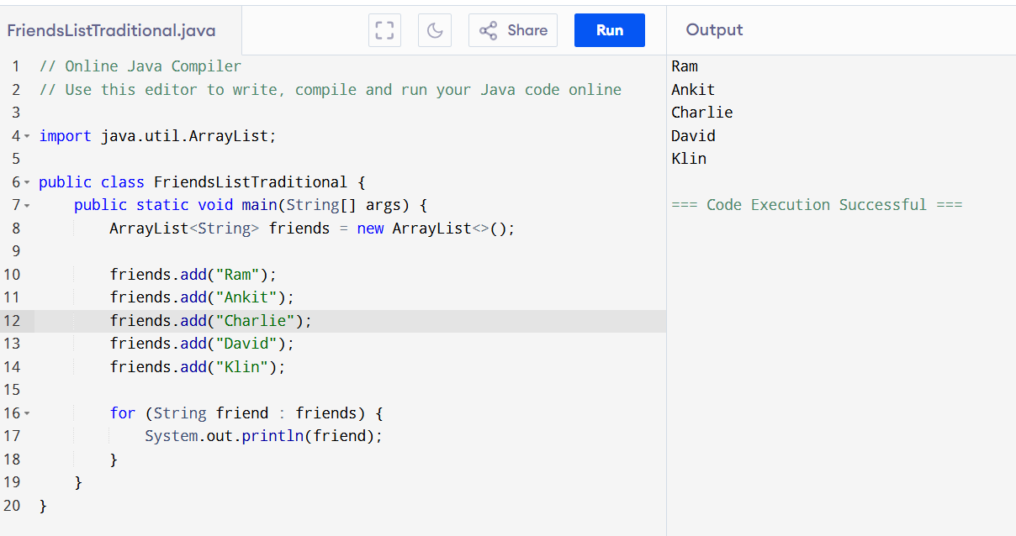

Array with first and last name:
import java.util.LinkedList; import java.util.List;

public class FullNameFriendsLinkedList {
public static void main(String[] args) {
List<String> firstNames = List.of(
"Sachin",
"Sushanth",
"David"

);
List<String> lastNames = List.of("Tendulkar", "Rajpoot", "Jones");

List<String> fullNames = new LinkedList<>();

for (int i = 0; i < firstNames.size(); i++) {
String firstName = firstNames.get(i);
String lastName = lastNames.get(i);
String fullName = firstName + " " + lastName;
fullNames.add(fullName);
}

System.out.println("My friends' full names are: " + fullNames);
}
}
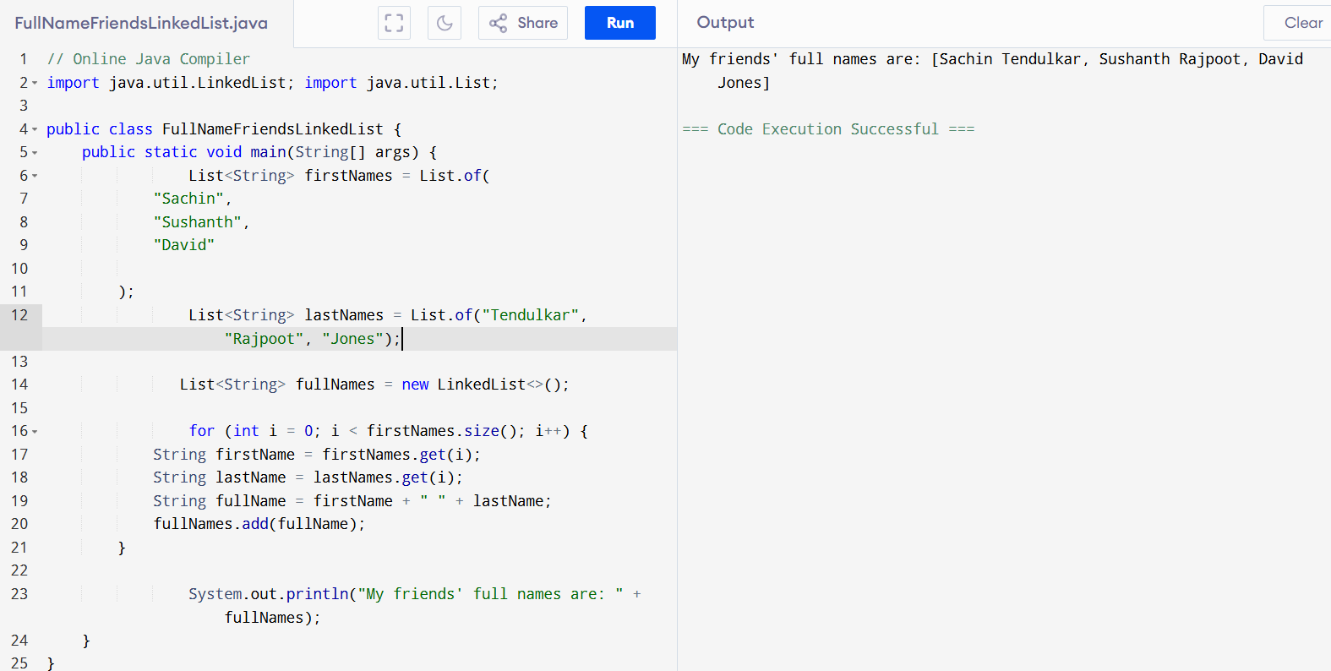

Squares of 5 numbers:
import java.util.ArrayList;
import java.util.List;
import java.util.Scanner;
import java.util.stream.Collectors;

public class SquareExample {
public static void main(String[] args) {
Scanner scanner = new Scanner(System.in);
List<Integer> numbers = new ArrayList<>();

System.out.println("Enter 5 integers:");
for (int i = 0; i < 5; i++) {
numbers.add(scanner.nextInt());
}

List<Integer> squares = numbers.stream()
.map(n -> n * n)
.collect(Collectors.toList());
System.out.println("Squares:");
squares.forEach(System.out::println);
}
}
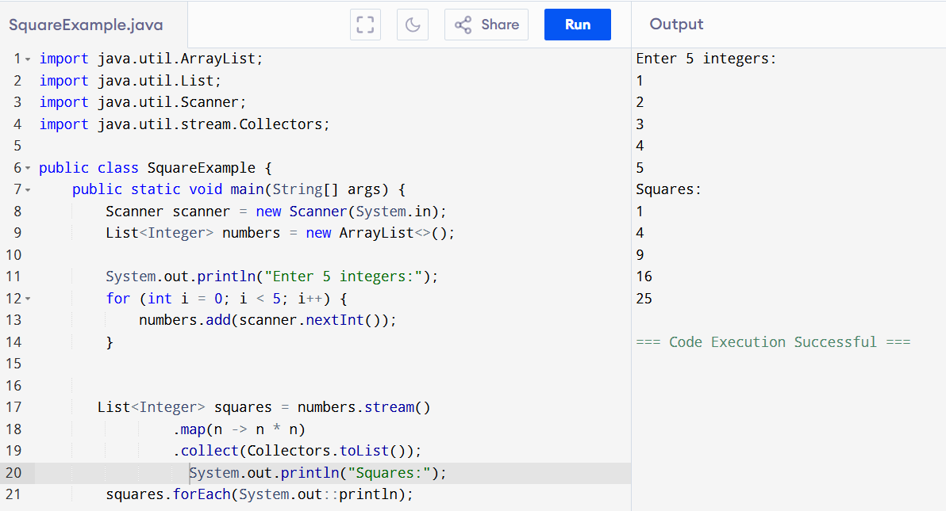
Square of odd numbers:
import java.util.ArrayList;
import java.util.List;
import java.util.Scanner;
import java.util.stream.Collectors;

public class SquareExample {
public static void main(String[] args) {
Scanner scanner = new Scanner(System.in);
List<Integer> numbers = new ArrayList<>();

System.out.println("Enter 5 integers:");
for (int i = 0; i < 5; i++) {
numbers.add(scanner.nextInt());
}

List<Integer> squares = numbers.stream()
.filter(n -> n%2!=0)
.map(n -> n * n)
.collect(Collectors.toList());
System.out.println("Squares:");
squares.forEach(System.out::println);
}
}
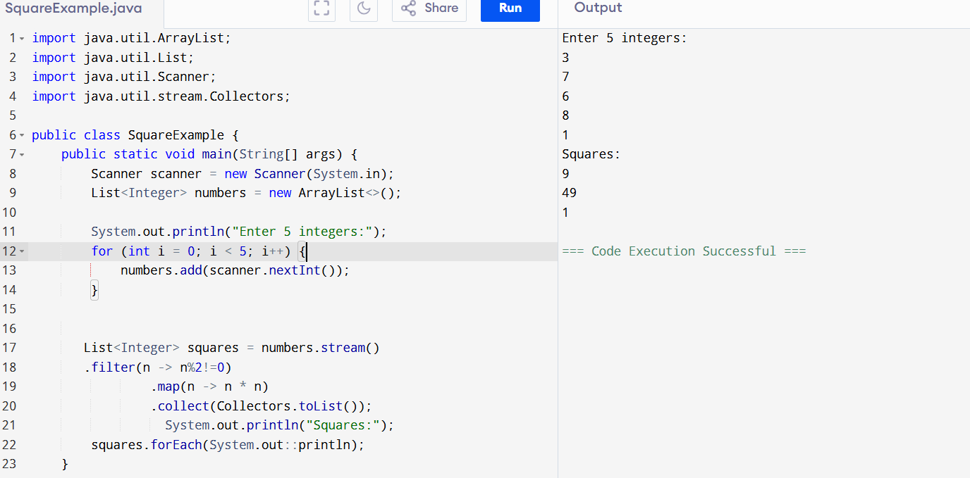

Remove duplicates in above code:

import java.util.ArrayList;
import java.util.List;
import java.util.Scanner;
import java.util.stream.Collectors;

public class SquareOddUniqueExample {
public static void main(String[] args) {
Scanner scanner = new Scanner(System.in);
List<Integer> numbers = new ArrayList<>();

System.out.println("Enter 5 integers:");
for (int i = 0; i < 5; i++) {
numbers.add(scanner.nextInt());
}

// Using Stream to filter odd numbers, calculate squares, and remove duplicates
List<Integer> squaresOfOddsUnique = numbers.stream()
.filter(n -> n % 2 != 0) // Filter odd numbers
.map(n -> n * n) // Calculate squares
.distinct() // Remove duplicates
.collect(Collectors.toList());

// Print results
System.out.println("Squares of odd numbers (unique):");
squaresOfOddsUnique.forEach(System.out::println);
}
}
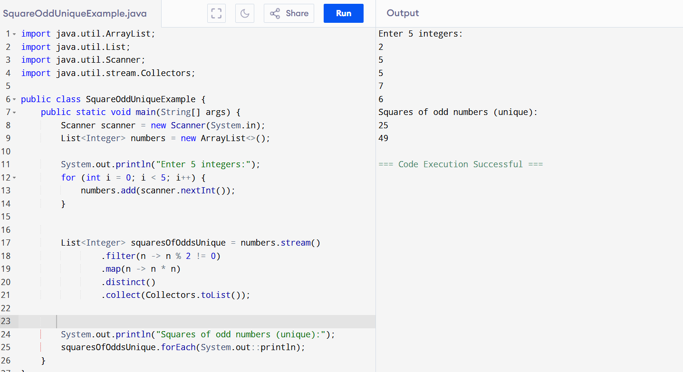

Limit()
mport java.util.stream.IntStream;

public class LoopExample {
public static void main(String[] args) {
IntStream.range(1, 11)
.forEach(i -> System.out.println("Iteration: " + i));

// Alternatively, using limit()
IntStream.iterate(1, i -> i + 1)
.limit(10)
.forEach(i -> System.out.println("Iteration: " + i));
}
}
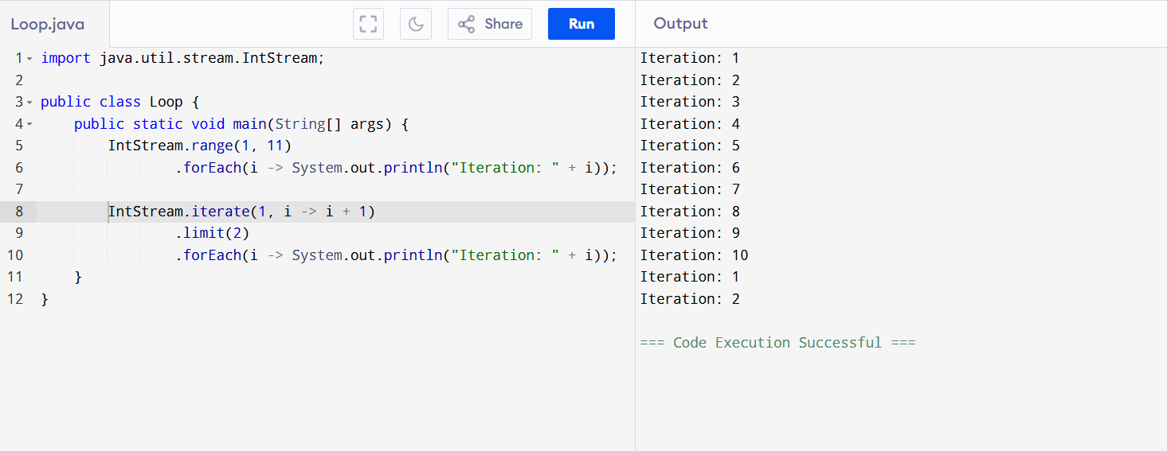
Reduce and collect:

import java.util.List;
import java.util.stream.Collectors;
import java.util.stream.IntStream;

public class ReduceCollectExample {
public static void main(String[] args) {

int sum = IntStream.range(1, 11)
.reduce(0, (a, b) -> a + b);

System.out.println("Sum: " + sum);

List<Integer> numbers = IntStream.range(1, 11)
.boxed()
.collect(Collectors.toList());

System.out.println("Numbers: " + numbers);
}
}
