Data structures:
Used to maintain/manage the code in such a way to reduce time complexity .
For large codes it is not scalable with out data structures, by using datas tructures we can organize the code.
Types of Data structures:
Array
Linked lists
Hash
Queue
Tree
Stack
Operations in data structures:
Addition
Deletion
Search
Access
Search

ASCII OF 65(A)
65/2- 1
32/2-0
16/2-0
8/2-0
4/2-0
2/2-0
-1
=1000001

Staic and Dynamic Arrays:
Featute | Static | Dynamic
Size | Fixed | Not Fixed
Memory | pre allocated | expands when needed
performance | Faster | Slight overhead
Insertion at end | Not possible | possibble
 | can be initialized not erased | After destroying cannot read or write

ASCII OF a: 01100001
Types of computer memory:
Primary- DRAM,SRAM
Secondary- PROM,EPROM,EEPROM
Reverse an array:
import java.util.Arrays;
import java.util.Collections;
import java.util.List;

public class ReverseArray {
public static void main(String[] args) {
Integer[] array = {1, 2, 3, 4, 5};
System.out.println("Original array: " + Arrays.toString(array));

List<Integer> list = Arrays.asList(array);
Collections.reverse(list);
System.out.println("Reversed array: " + list);
}
}
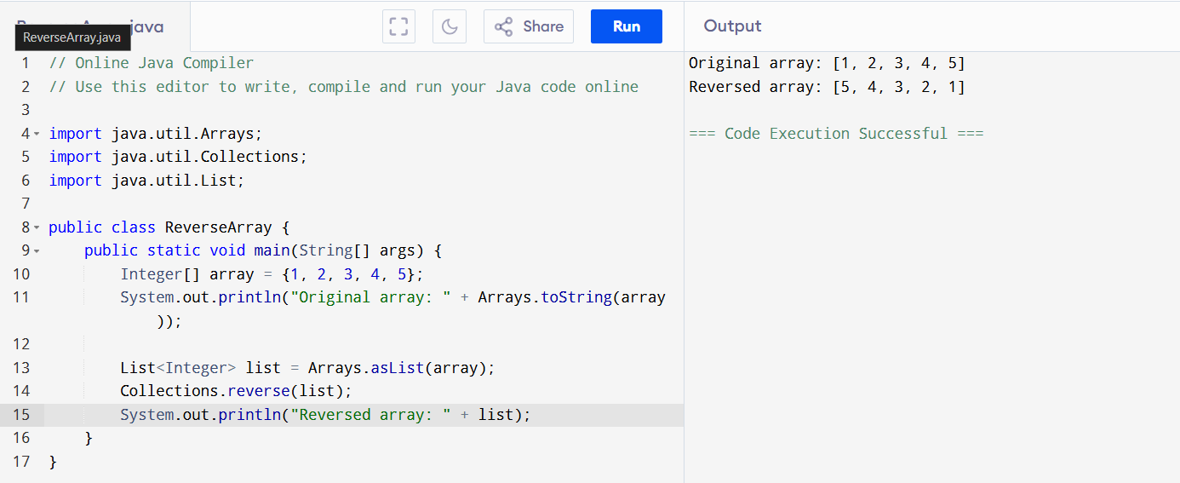
Reverse a string:
import java.util.Scanner;

public class ReverseString {
public static void main(String[] args) {
Scanner scanner = new Scanner(System.in);

System.out.print("Enter a string: ");
String input = scanner.nextLine();

System.out.println("Original string: " + input);

String reversed = reverseString(input);

System.out.println("Reversed string: " + reversed);

scanner.close();
}

public static String reverseString(String input) {
StringBuilder reversed = new StringBuilder();
for (int i = input.length() - 1; i >= 0; i--) {
reversed.append(input.charAt(i));
}
return reversed.toString();
}
}
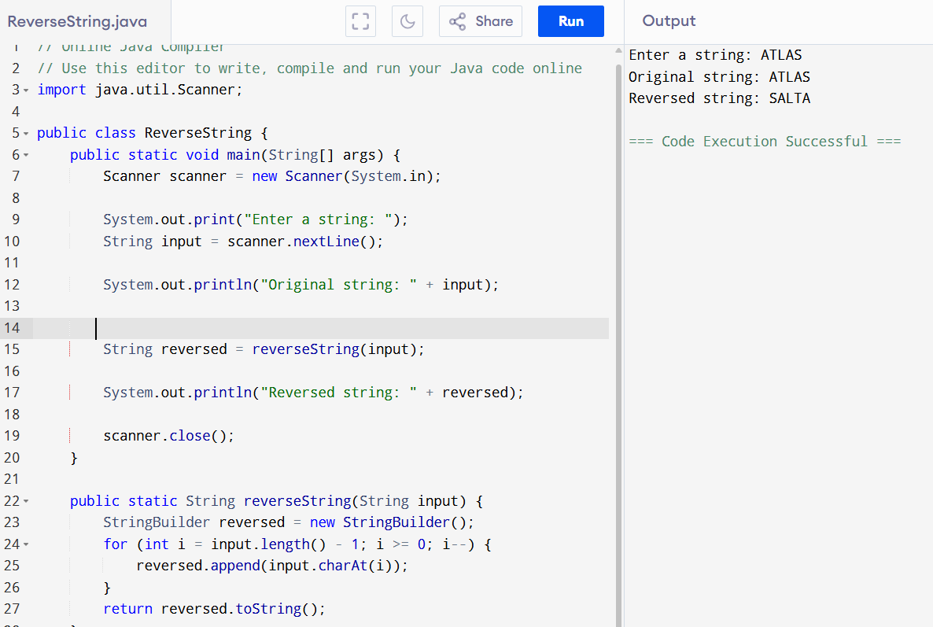

Merge:
public class Example {
public static void main (String[] args) {
int[] arr1 = {11, 34, 66, 75};
int n1 = arr1.length;
int[] arr2 = {1, 5, 19, 50, 89, 100};
int n2 = arr2.length;
int[] merge = new int[n1 + n2];
int i = 0, j = 0, k = 0, x;
System.out.print("Array 1: ");
for (x = 0; x < n1; x++)
System.out.print(arr1[x] + " ");
System.out.print("\nArray 2: ");
for (x = 0; x < n2; x++)
System.out.print(arr2[x] + " ");
while (i < n1 && j < n2) {
if (arr1[i] < arr2[j])
merge[k++] = arr1[i++];
else
merge[k++] = arr2[j++];
}
while (i < n1)
merge[k++] = arr1[i++];
while (j < n2)
merge[k++] = arr2[j++];
System.out.print("\nArray after merging: ");
for (x = 0; x < n1 + n2; x++)
System.out.print(merge[x] + " ");
}
}

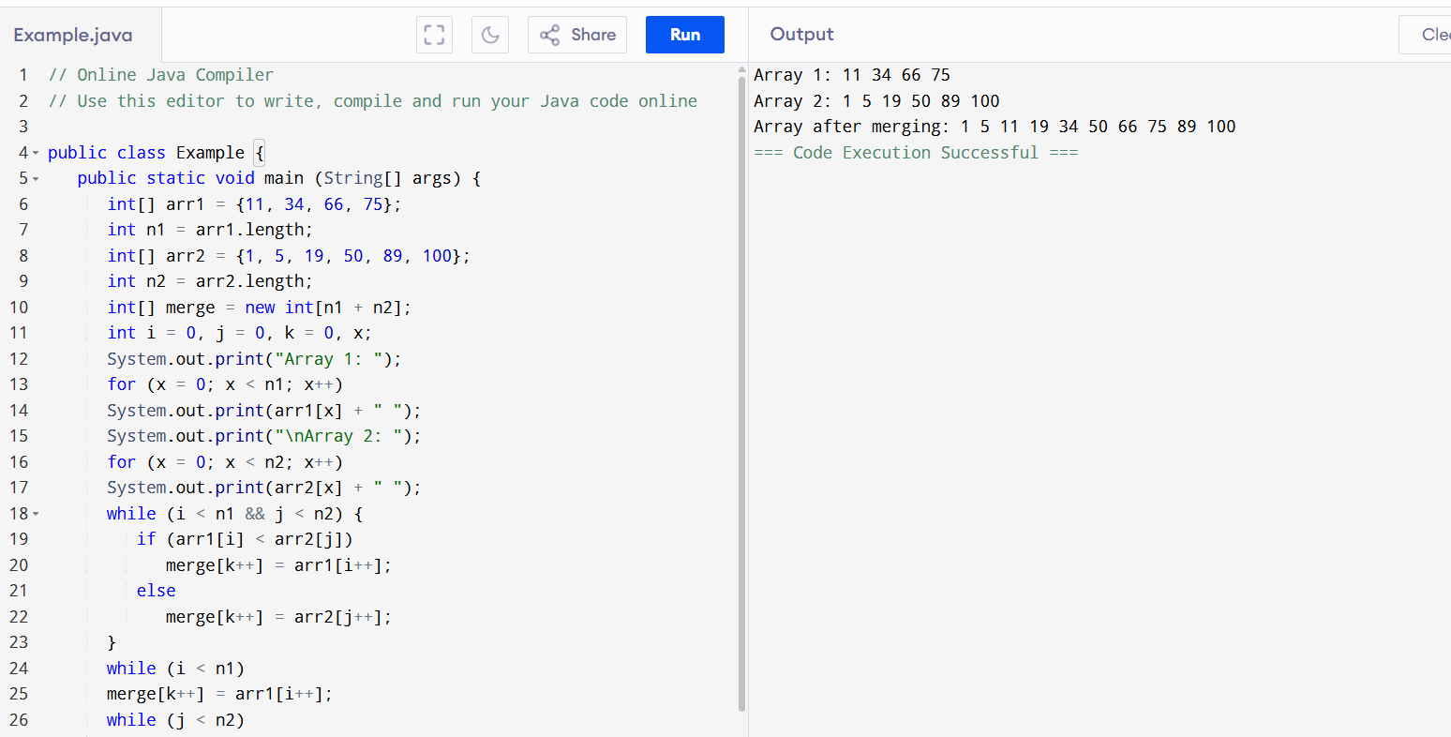
Here we are defined and initiated 2 arrays with static inputs and performed merge operation for those 2 arrays which gives to results as ascending order by using while loop.
Task 10 rewrite the code in such a way that it has to take unsorted list and then ,merge in an array the sorted list. Home task
Hash table:
-key value pair
- it handles collision ( when two keys maps to same index) -if collision occurs the table searches for next available slot.
-scalable
Eg: Authentications, networking apps to map-IP addresses
- Dynamically resizes when load exceeds(hash doubles in size)
- Efficient in memory usage.

Hash Table:
import java.util.Hashtable;
import java.util.Map;
public class Task012_DS_HashTable {
public static void main(String[] args) {
Hashtable<String, Integer> ht = new Hashtable<>();
ht.put("Anitha", 101);
ht.put("Kavitha", 102);
ht.put("Meera", 103);

for (Map.Entry<String, Integer> e : ht.entrySet())
System.out.println(e.getKey() + " " + e.getValue());
}
}
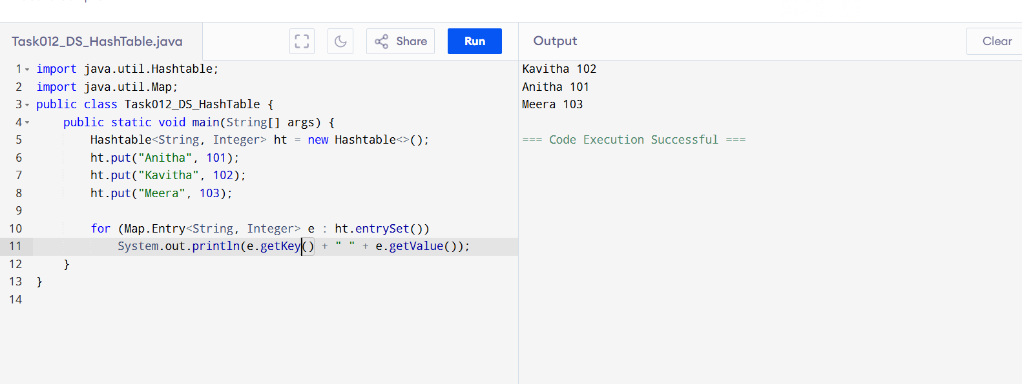
Hash Map:
import java.util.HashMap;
import java.util.Map;

public class Task012_DS_HashMap {
public static void main(String[] args) {
HashMap<String, Integer> hm = new HashMap<>();
hm.put("Anitha", 101);
hm.put("Kavitha", 102);
hm.put("Meera", 103);

for (Map.Entry<String, Integer> e : hm.entrySet())
System.out.println(e.getKey() + " " + e.getValue());
}
}
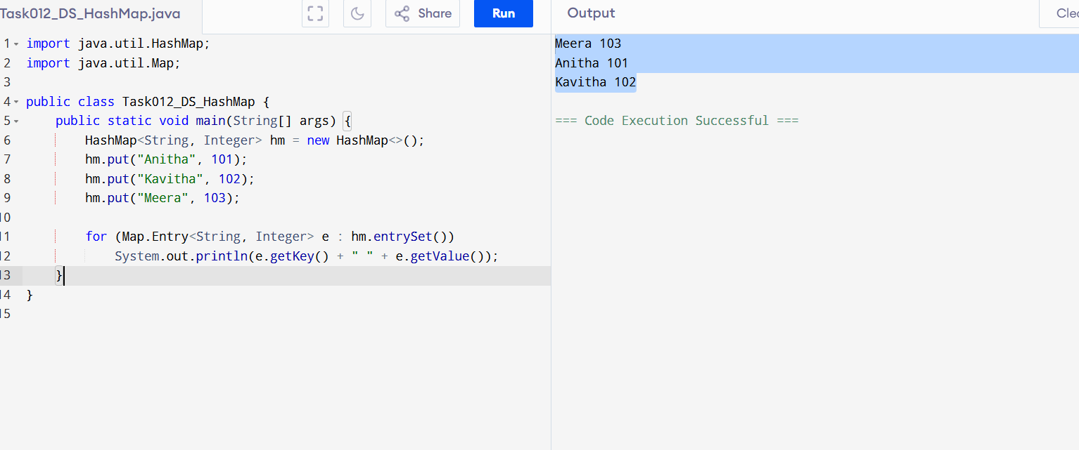

HashMap- Not synchronized,faster,allows one null key and multiple null values,thread safe
Hahtable- synchronized, not thread safe, due to lack of synchronization its in low performance, doesnot allow null keys or values

Hashmap using null:
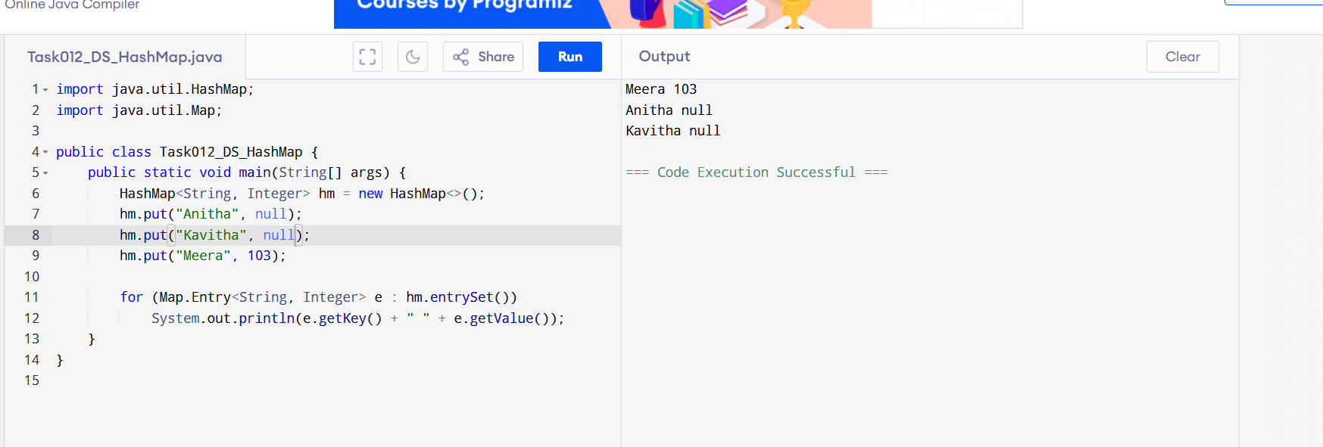
Hash table:
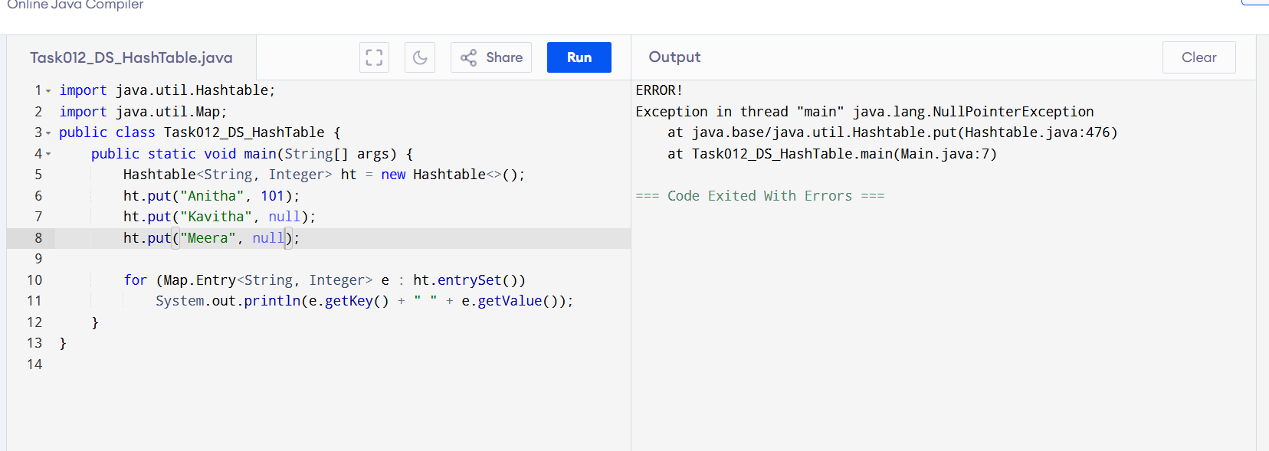

Concurrent Hashmap:
import java.util.concurrent.ConcurrentHashMap;

public class ConcurrentHashMapExample {
public static void main(String[] args) {
ConcurrentHashMap<String, Integer> map = new ConcurrentHashMap<>();

map.put("apple", 10);
map.put("banana", 5);
map.put("orange", 7);
map.put("orange", 7);
map.put("grapes", 2);
System.out.println("Apple count: " + map.get("apple"));

map.compute("banana", (key, val) -> (val == null) ? 1 : val + 1);

System.out.println("Final Map: " + map);

map.remove("7");

//System.out.println("Map after removing '7': " + map);
}
}
