TASK1:
// Online C compiler to run C program online
#include <stdio.h>
int method1() {
int age; // variable
int *ptr; // pointer variable

// assigning
age = 10;
ptr = &age;

printf("Value of age is %d\n", age);
printf("ptr is pointing to %d\n", *ptr);

printf("Address of age %p\n", (void *)&age);
printf("Value of ptr %p\n", (void *)ptr);
printf("value of &ptr %d\n",&ptr);
printf("value of *ptr %p\n", (void *)&ptr);
return 0;
}

int main() {
method1();
return 0;
}

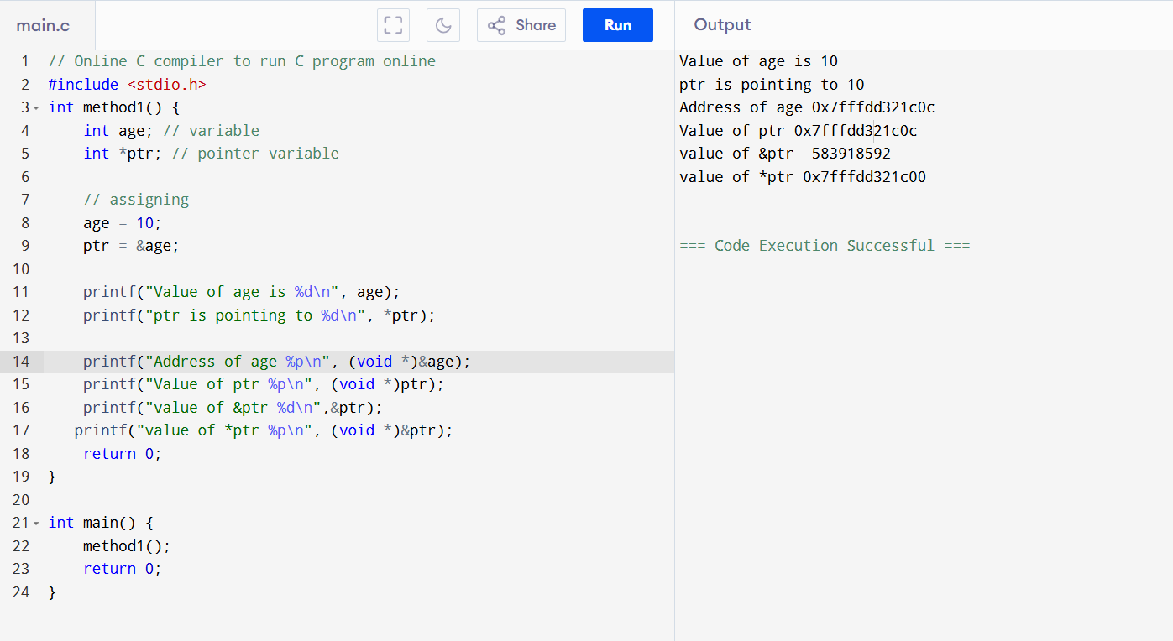
Linked list in java:
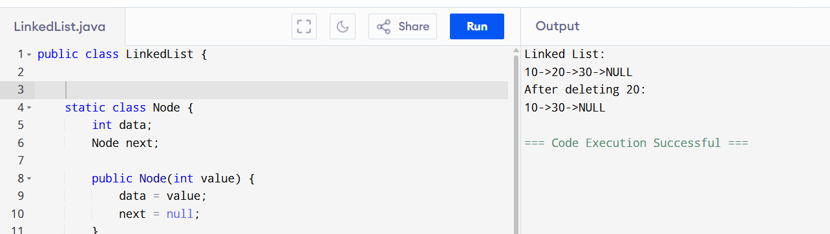
public class LinkedList {

static class Node {
int data;
Node next;

public Node(int value) {
data = value;
next = null;
}
}

Node head;

public LinkedList() {
head = null;
}

public void insertAtEnd(int value) {
Node newNode = new Node(value);
if (head == null) {
head = newNode;
} else {
Node temp = head;
while (temp.next != null) {
temp = temp.next;
}
temp.next = newNode;
}
}

public void display() {
Node temp = head;
while (temp != null) {
System.out.print(temp.data + "->");
temp = temp.next;
}
System.out.println("NULL");
}

public void deleteByValue(int value) {
if (head == null) return;

if (head.data == value) {
head = head.next;
return;
}

Node temp = head;
while (temp.next != null && temp.next.data != value) {
temp = temp.next;
}

if (temp.next != null) {
temp.next = temp.next.next;
}
}

public static void main(String[] args) {
LinkedList list = new LinkedList();
list.insertAtEnd(10);
list.insertAtEnd(20);
list.insertAtEnd(30);
System.out.println("Linked List: ");
list.display();
list.deleteByValue(20);
System.out.println("After deleting 20: ");
list.display();
}
}
Linked List:
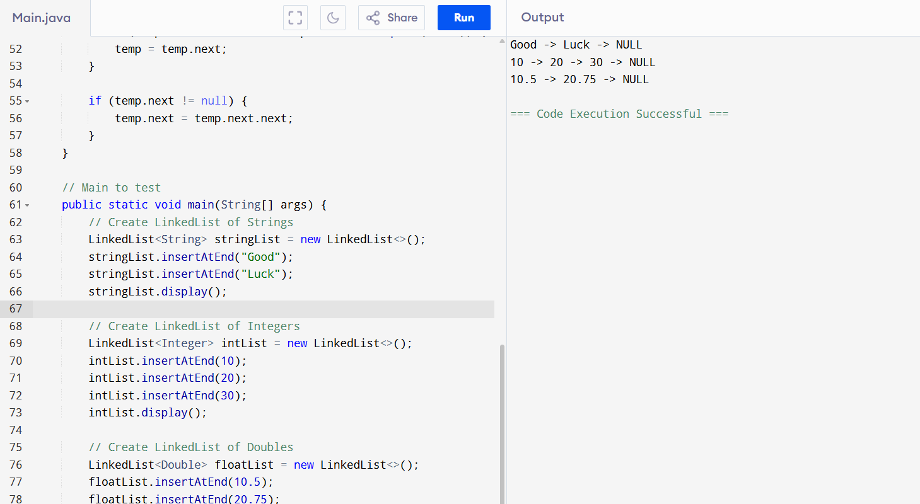
public class LinkedList<T> {
Node<T> head;

// Inner generic Node class
static class Node<T> {
T data;
Node<T> next;

public Node(T value) {
data = value;
next = null;
}
}

// Insert at end
public void insertAtEnd(T value) {
Node<T> newNode = new Node<>(value);
if (head == null) {
head = newNode;
} else {
Node<T> temp = head;
while (temp.next != null) {
temp = temp.next;
}
temp.next = newNode;
}
}

// Display the list
public void display() {
Node<T> temp = head;
while (temp != null) {
System.out.print(temp.data + " -> ");
temp = temp.next;
}
System.out.println("NULL");
}

// Delete by value
public void deleteByValue(T value) {
if (head == null) return;

if (head.data.equals(value)) {
head = head.next;
return;
}

Node<T> temp = head;
while (temp.next != null && !temp.next.data.equals(value)) {
temp = temp.next;
}

if (temp.next != null) {
temp.next = temp.next.next;
}
}

// Main to test
public static void main(String[] args) {
// Create LinkedList of Strings
LinkedList<String> stringList = new LinkedList<>();
stringList.insertAtEnd("Hello");
stringList.insertAtEnd("World");
stringList.display();

// Create LinkedList of Integers
LinkedList<Integer> intList = new LinkedList<>();
intList.insertAtEnd(10);
intList.insertAtEnd(20);
intList.insertAtEnd(30);
intList.display();

// Create LinkedList of Doubles
LinkedList<Double> floatList = new LinkedList<>();
floatList.insertAtEnd(10.5);
floatList.insertAtEnd(20.75);
floatList.display();
}
}

Try to create a node and add a value to it.. Which can take any kind of data in the Node..
Remove the node
Find size of the linked list
Try to add element at the end of the list
Find size of the linked list
Index out of bounds
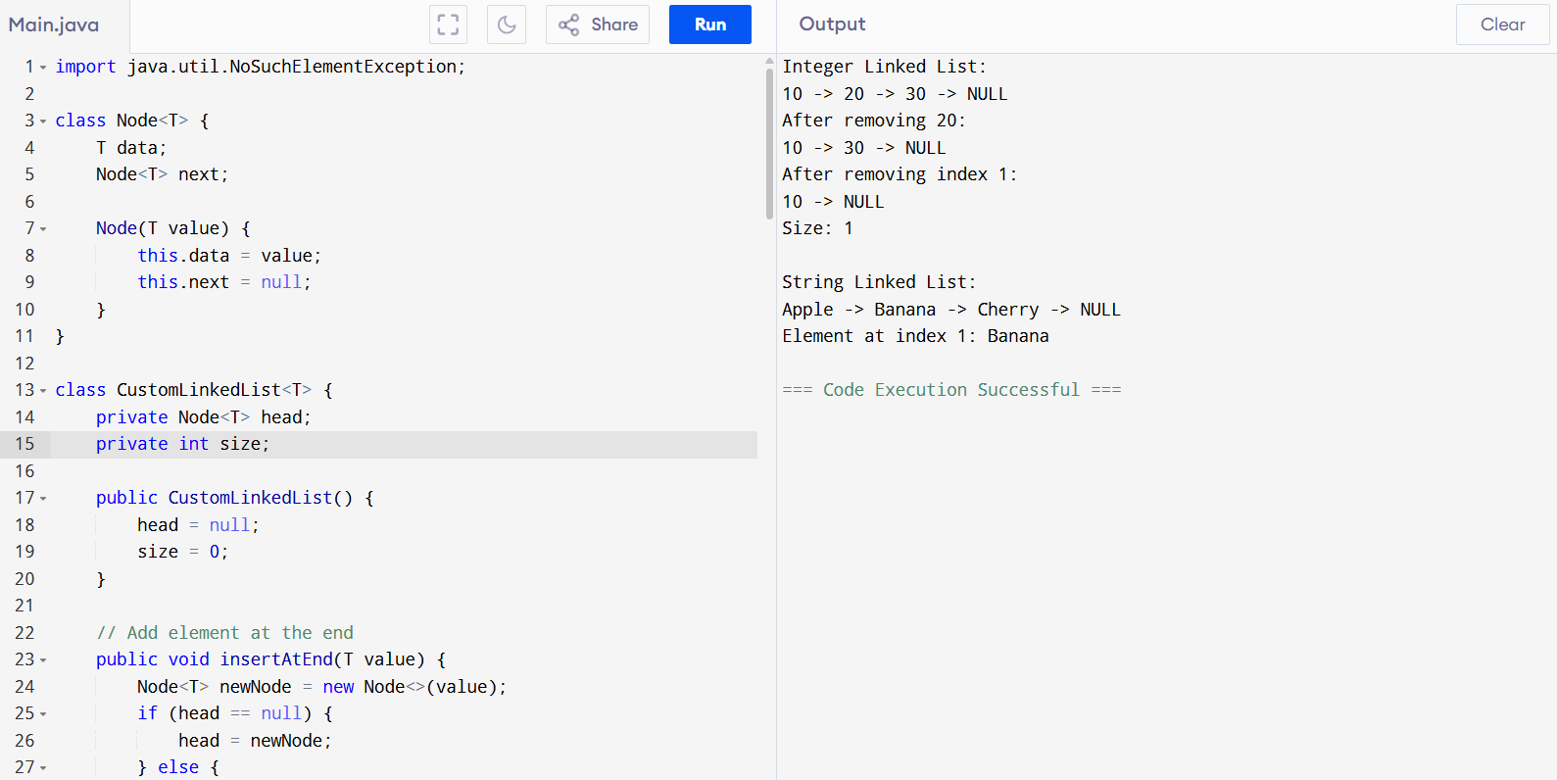
TASK6,7,8
Task 6: get first and get last elements and display all elements in the linked list

task 7:

remove first and remove last element and display all elements in the linked list Task 7

Task 8: in the list update the 1st element to a new value Hint: use set(1, "new value");
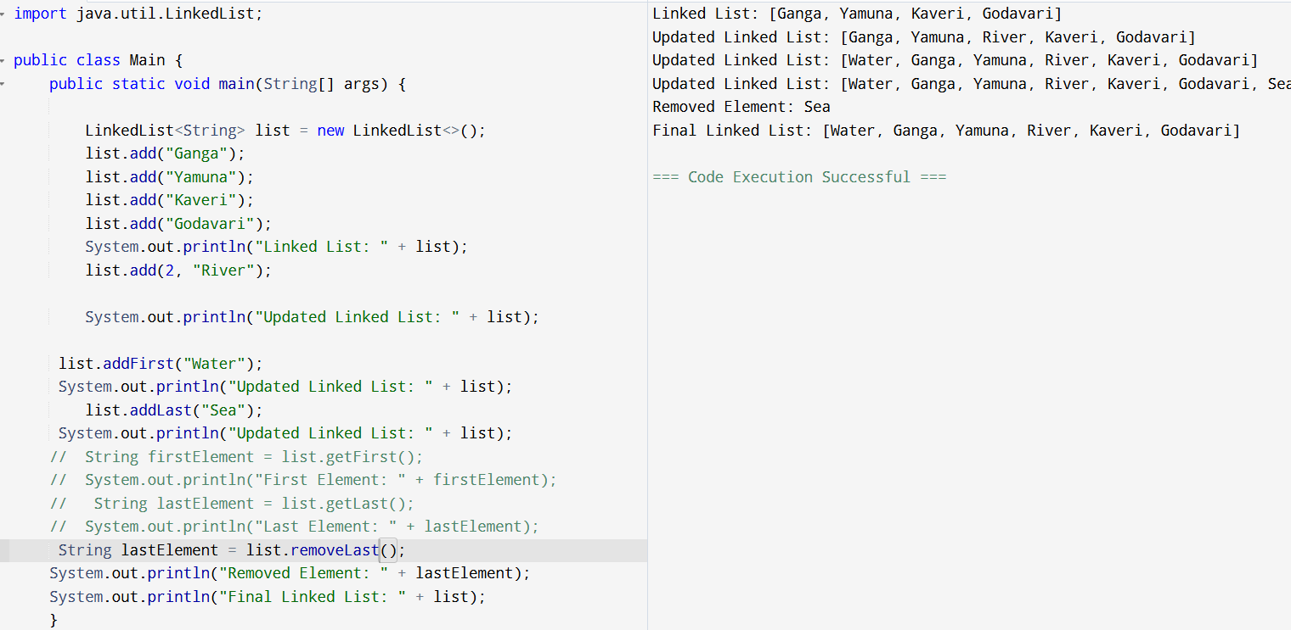
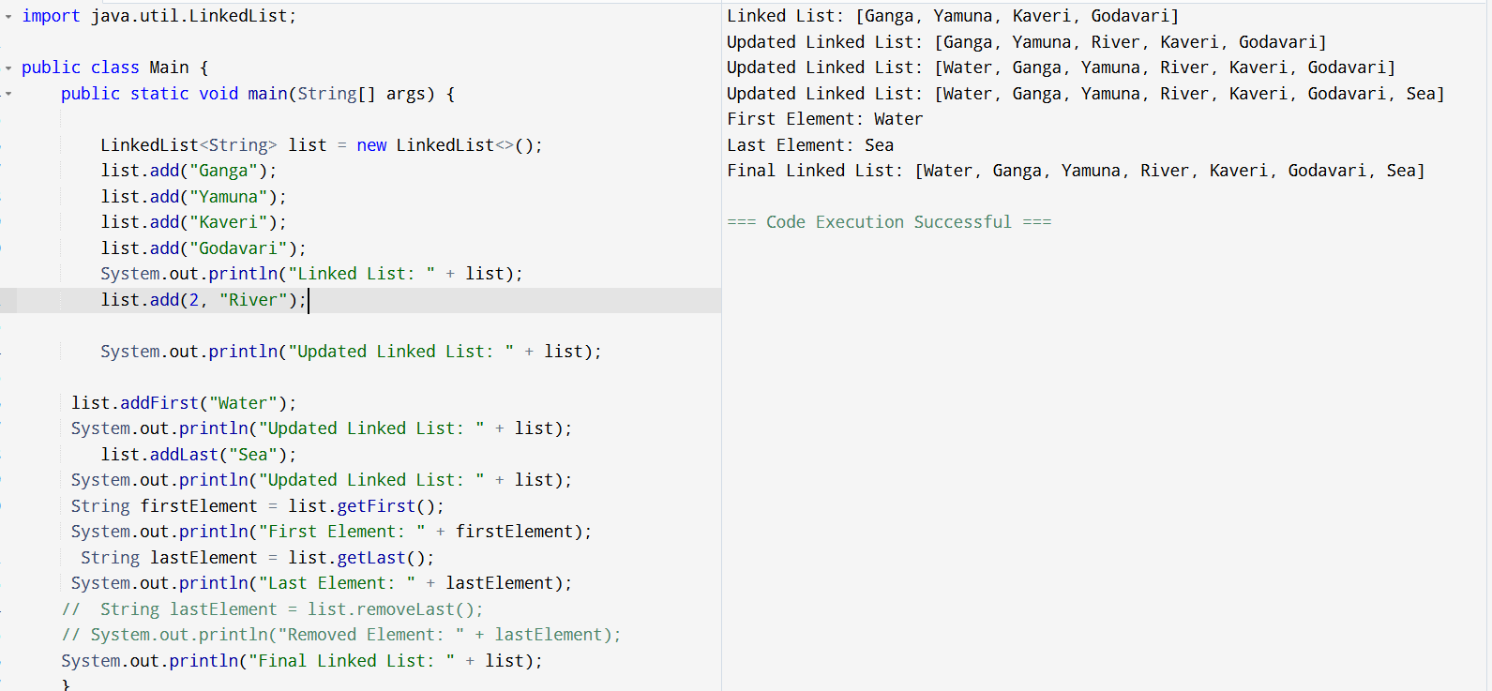
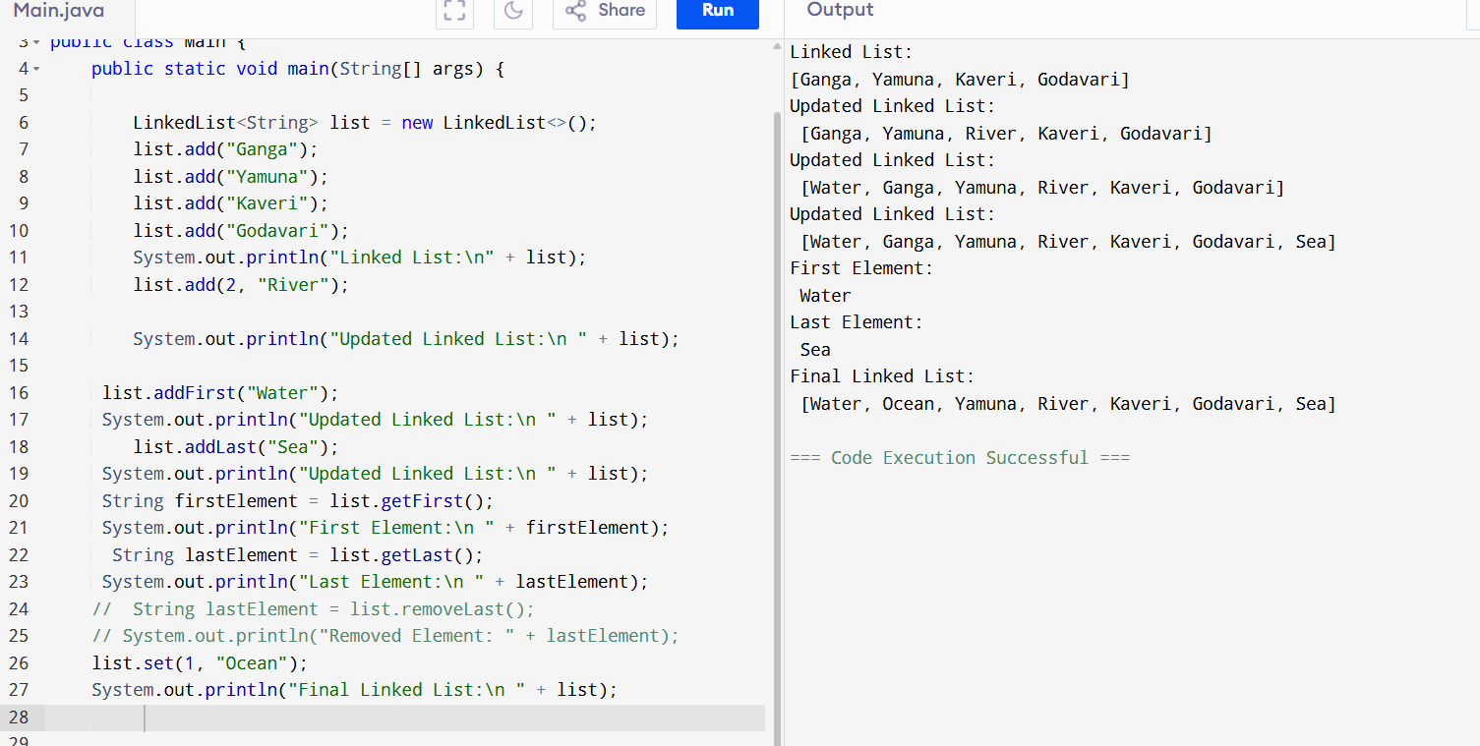
Linked to array:
import java.util.LinkedList;

public class Main {
public static void main(String[] args) {
// Create a new LinkedList
LinkedList<String> list = new LinkedList<>();

// Add elements to the LinkedList
list.add("Apple");
list.add("Banana");
list.add("Cherry");
list.add("Date");

// Print the LinkedList
System.out.println("LinkedList: " + list);

// Convert LinkedList to array
String[] array = list.toArray(new String[0]);

// Print the array
System.out.println("Array:");
for (String element : array) {
System.out.println(element);

// Clone the LinkedList
// LinkedList<String> clonedList = (LinkedList<String>) list.clone();

// // Print the cloned LinkedList
// System.out.println("Cloned LinkedList: " + clonedList);

// // Modify the original LinkedList
// list.add("Elderberry");

// // Print the original and cloned LinkedLists after modification
// System.out.println("Original LinkedList after modification: " + list);
// System.out.println("Cloned LinkedList after modification: " + clonedList);

}
}
}
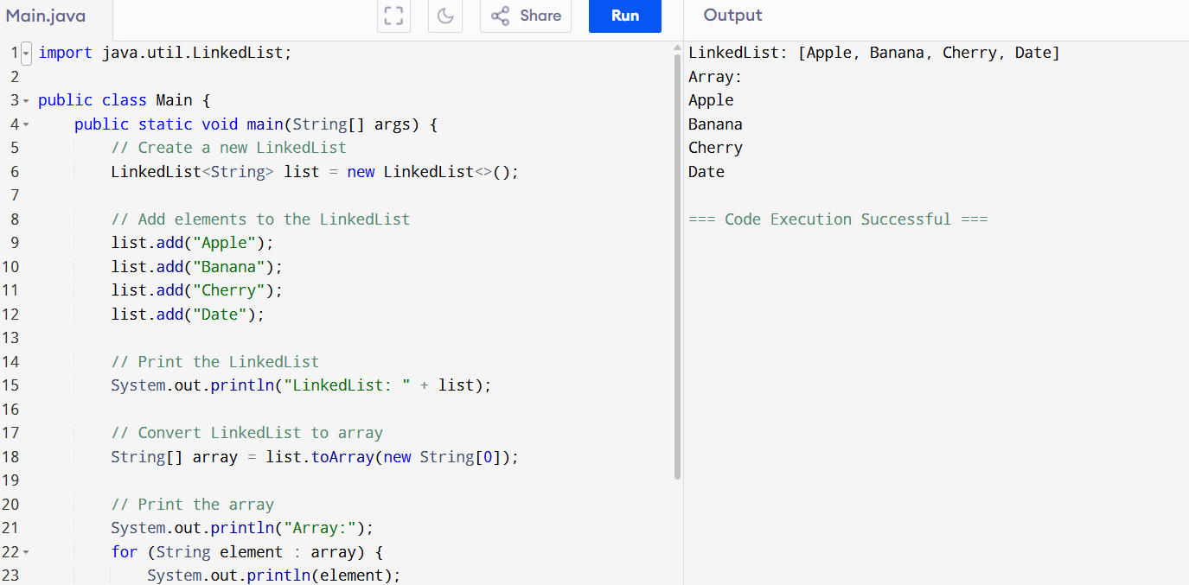

Clone:
import java.util.LinkedList;

public class Main {
public static void main(String[] args) {
// Create a new LinkedList
LinkedList<String> list = new LinkedList<>();

list.add("Apple");
list.add("Banana");
list.add("Cherry");
list.add("Date");

System.out.println("Original LinkedList: " + list);

LinkedList<String> clonedList = (LinkedList<String>) list.clone();

System.out.println("Cloned LinkedList: " + clonedList);

list.add("Elderberry");

System.out.println("Original LinkedList after modification: " + list);
System.out.println("Cloned LinkedList after modification: " + clonedList);
}
}
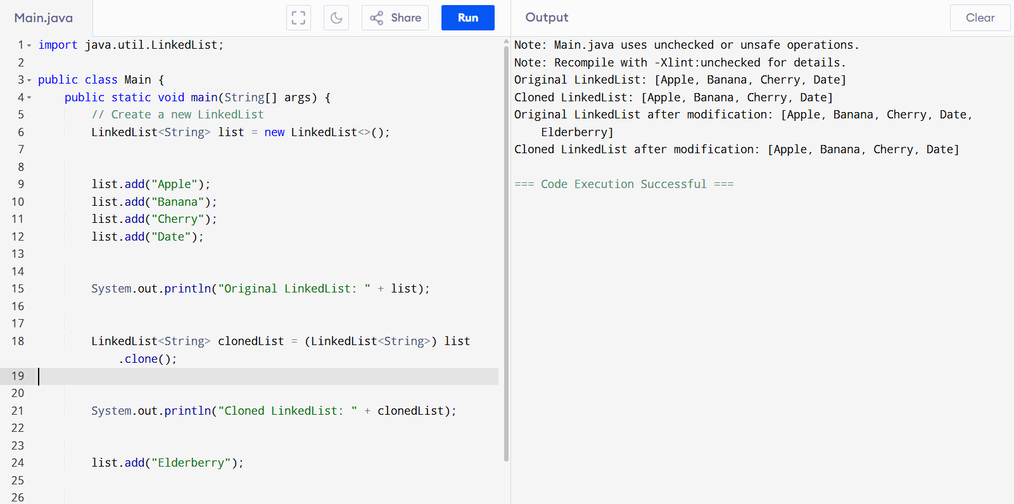
TryAdvance:
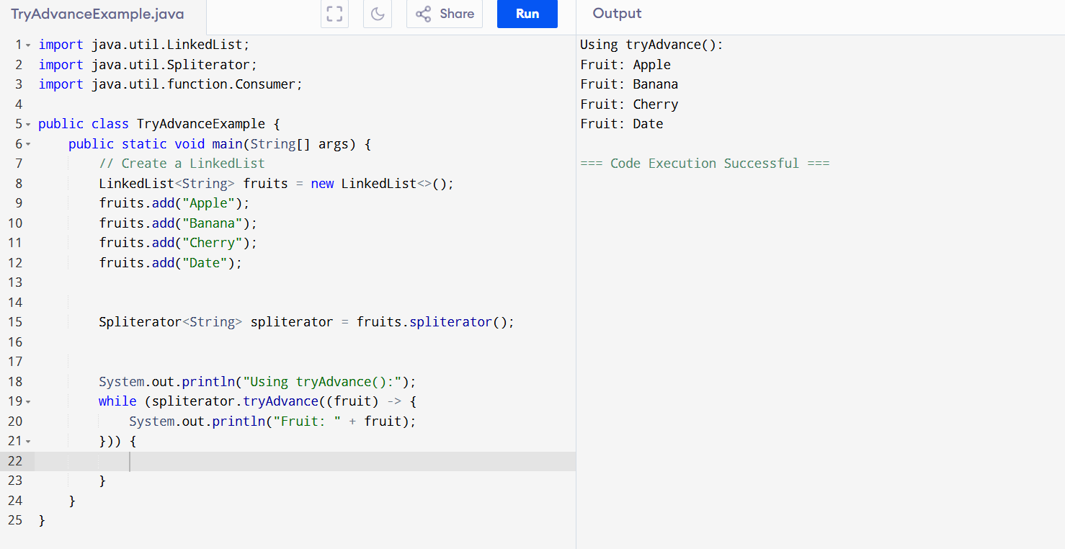
import java.util.LinkedList;
import java.util.Spliterator;
import java.util.function.Consumer;

public class TryAdvanceExample {
public static void main(String[] args) {
// Create a LinkedList
LinkedList<String> fruits = new LinkedList<>();
fruits.add("Apple");
fruits.add("Banana");
fruits.add("Cherry");
fruits.add("Date");

Spliterator<String> spliterator = fruits.spliterator();

System.out.println("Using tryAdvance():");
while (spliterator.tryAdvance((fruit) -> {
System.out.println("Fruit: " + fruit);
})) {

}
}
}

DoubleLinkedList:
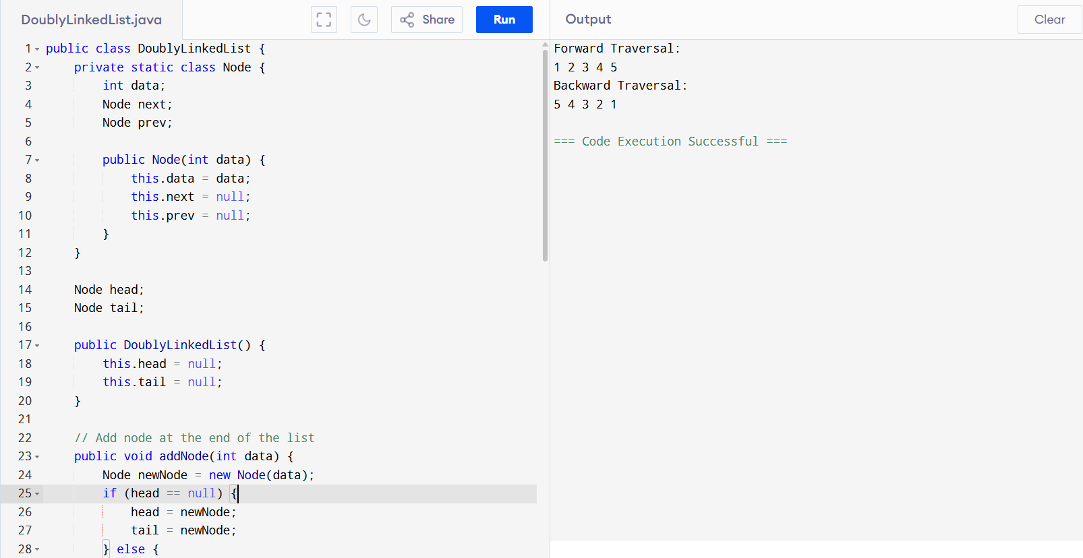
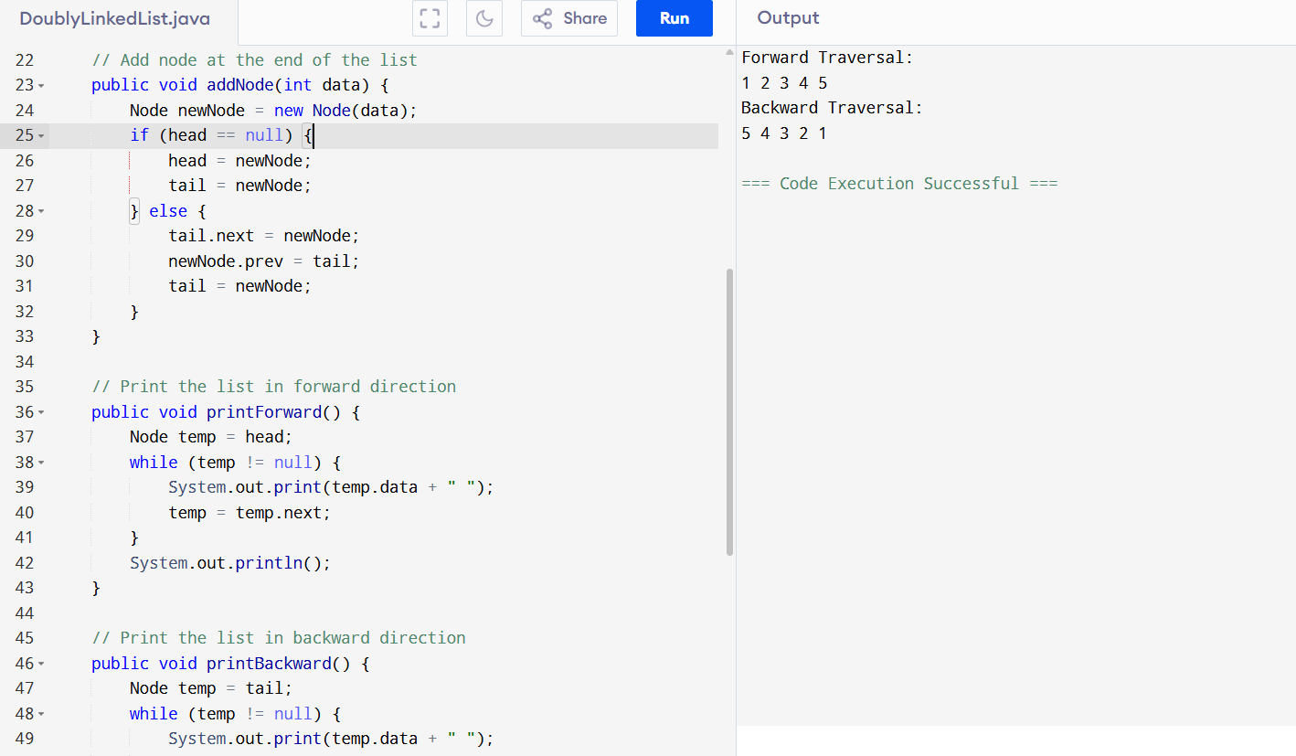
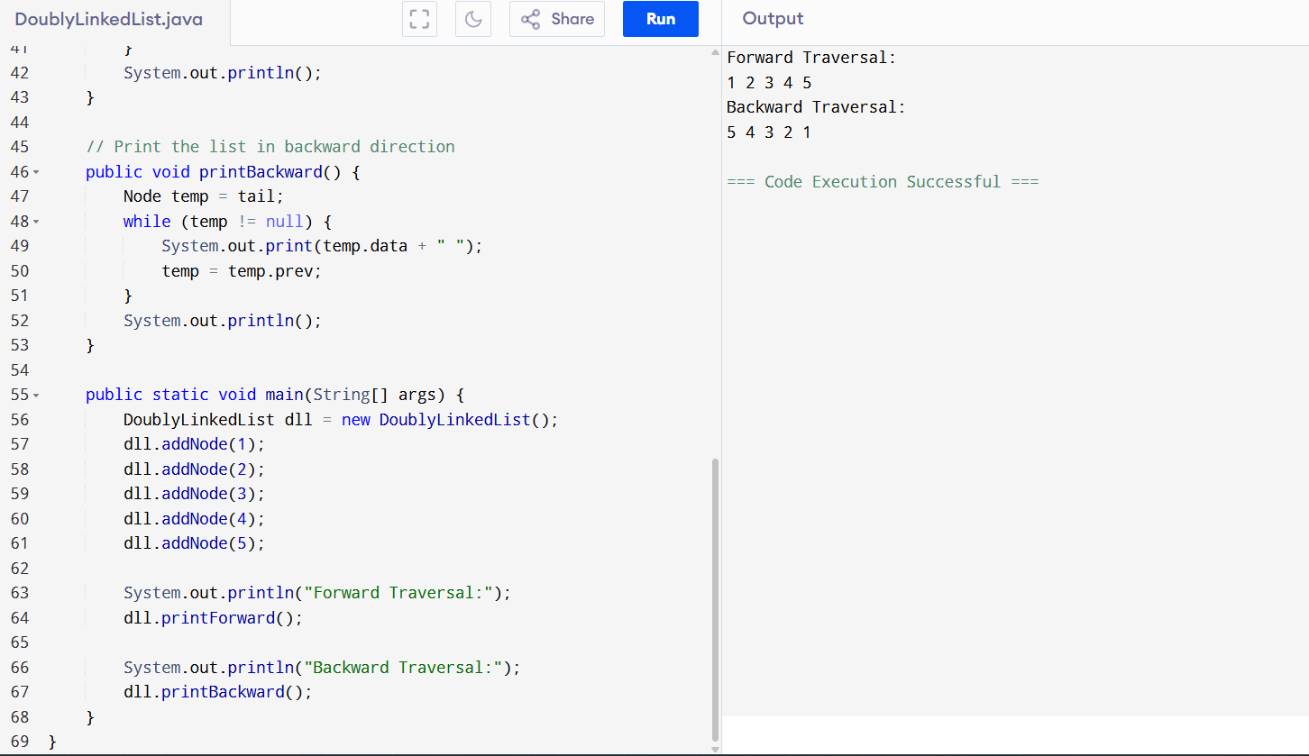
Split Iterator:
import java.util.*;
public class SplitIteraror01 {
public static void main(String[] args) {

LinkedList<String> l = new LinkedList<>();

l.add("Sushma");
l.add("Mainampati");
l.add("SM");

System.out.println(l);

Spliterator<String> it = l.spliterator();

System.out.println("Splitting the list:");
it.forEachRemaining(System.out::println);
}
}
Note: println is working to print in next line-need to revise
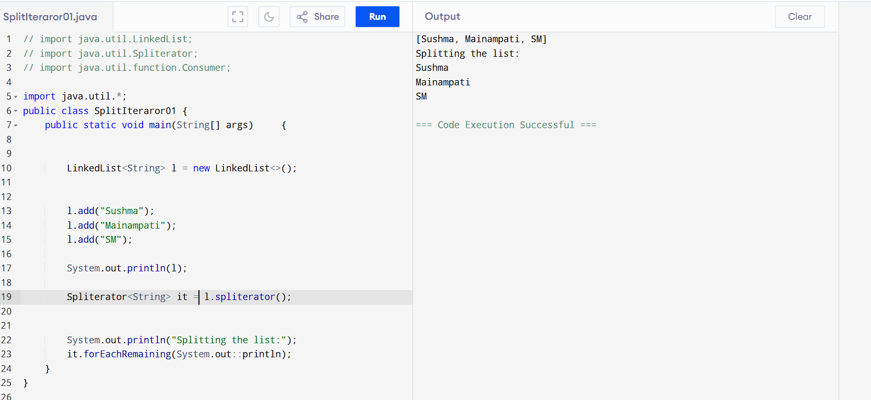
Create a Hash MAp of capacity 10.
import java.util.HashMap;

public class HashMapCapacityExample {
public static void main(String[] args) {

HashMap<Integer, String> map = new HashMap<>(10);

// Add some key-value pairs
map.put(1, "Apple");
map.put(2, "Banana");
map.put(3, "Cherry");

System.out.println("HashMap contents:");
for (Integer key : map.keySet()) {
System.out.println("Key: " + key + ", Value: " + map.get(key));
}

System.out.println("Current size: " + map.size());
}
}
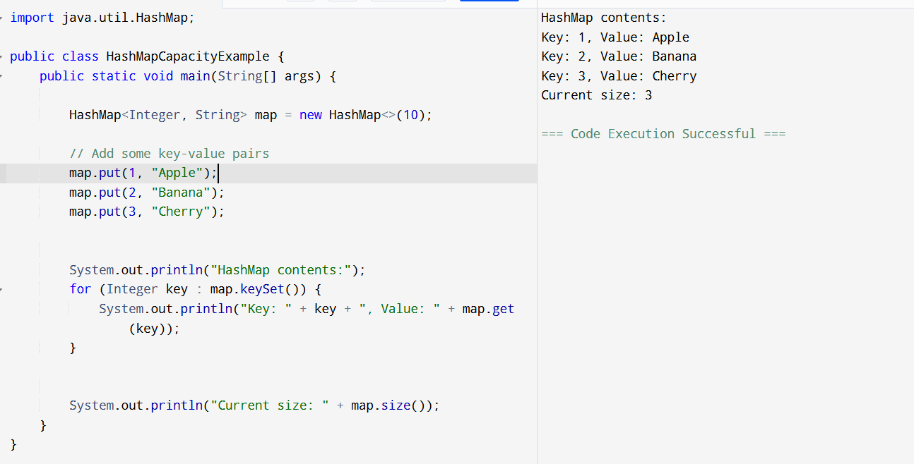

HashMap with loadfactor:
import java.util.HashMap;

public class HashMapCapacityExample {
public static void main(String[] args) {

float loadFactor = 0.75f;
HashMap<Integer, String> map = new HashMap<>(20, loadFactor);
map.put(1, "A");
map.put(2, "B");
map.put(3, "C");
map.put(4, "D");
map.put(5, "E");
map.put(6, "F");
map.put(7, "G");
map.put(8, "H");
map.put(9, "I");
map.put(10, "J");
map.put(11, "K");
map.put(12, "L");

System.out.println("HashMap contents:");
for (Integer key : map.keySet()) {
System.out.println("Key: " + key + ", Value: " + map.get(key));
}

System.out.println("Current size: " + map.size());
System.out.println("Initial capacity: 20");
System.out.println("Load factor: " + loadFactor);
System.out.println("Threshold before resize: " + (int)(20 * loadFactor));
}
}
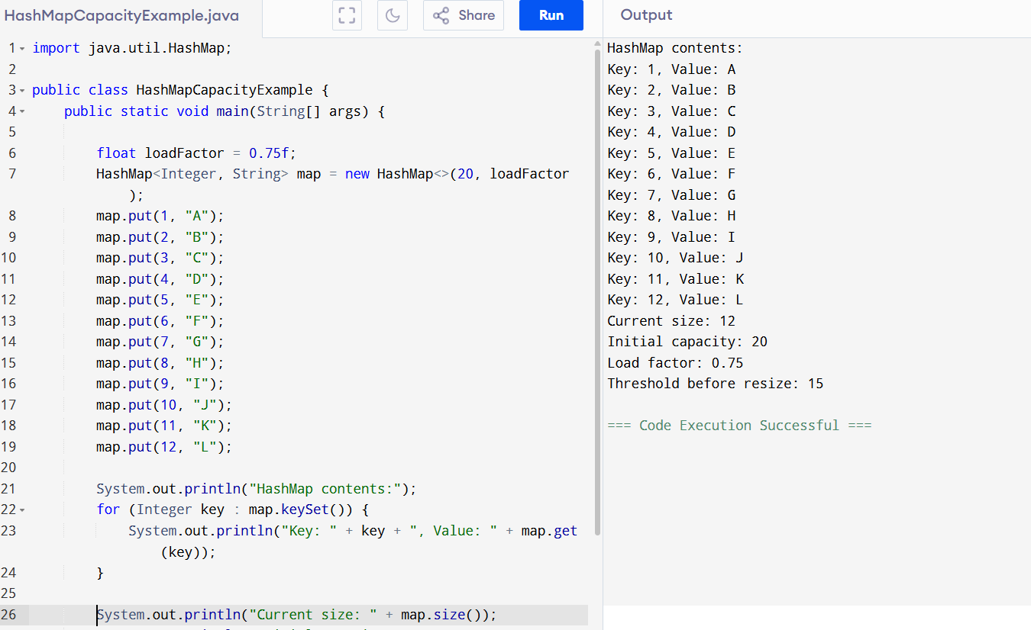

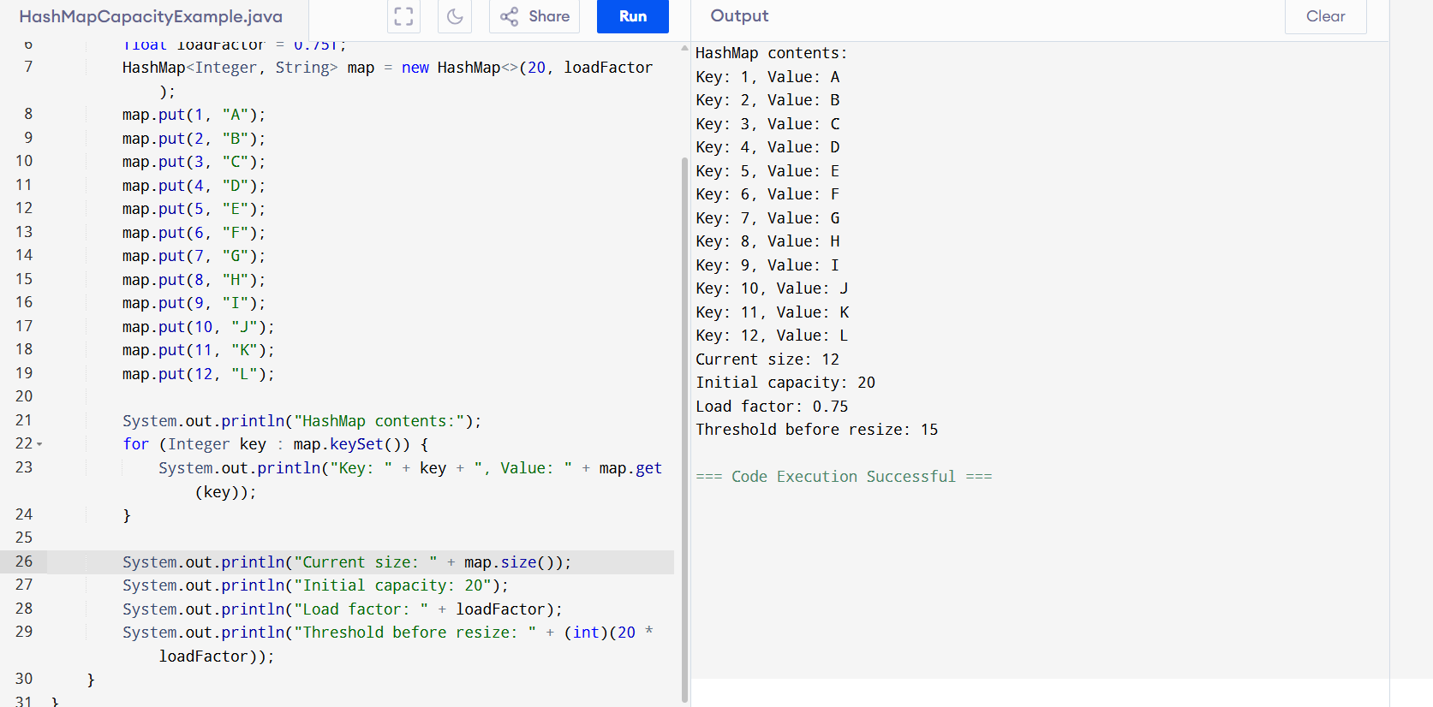

CopyHash:
import java.util.HashMap;

public class MapCopyExample {
public static void main(String[] args) {
// Original map
HashMap<Integer, String> originalMap = new HashMap<>();
originalMap.put(1, "Apple");
originalMap.put(2, "Banana");
HashMap<Integer, String> newMap = new HashMap<>();
newMap.putAll(originalMap);

System.out.println("Copied map: " + newMap);

}
}
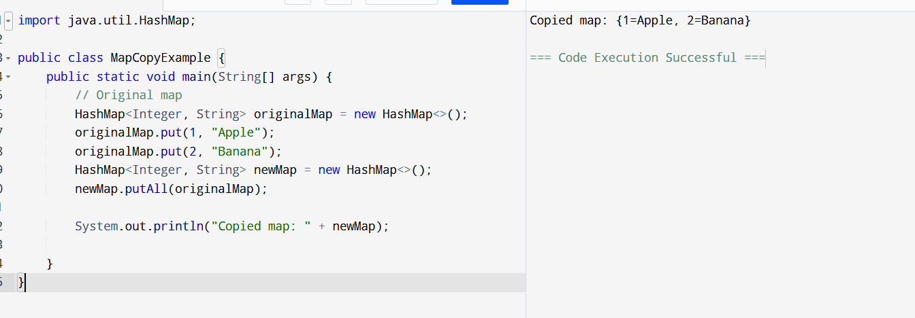
Circular Linkedlist:
public class CircularLinkedList {

static class Node {
int data;
Node next;

public Node(int data) {
this.data = data;
}
}

private Node head = null;
private Node tail = null;

public void add(int data) {
Node newNode = new Node(data);

if (head == null) {
head = newNode;
tail = newNode;
newNode.next = head;
} else {
tail.next = newNode;
tail = newNode;
tail.next = head;
}
}
public void display() {
if (head == null) {
System.out.println("List is empty.");
return;
}

Node current = head;
System.out.print("Circular Linked List: ");
do {
System.out.print(current.data + " ");
current = current.next;
} while (current != head);
System.out.println();
}
public static void main(String[] args) {
CircularLinkedList cll = new CircularLinkedList();
cll.add(10);
cll.add(20);
cll.add(30);
cll.add(40);
cll.display();

}
}
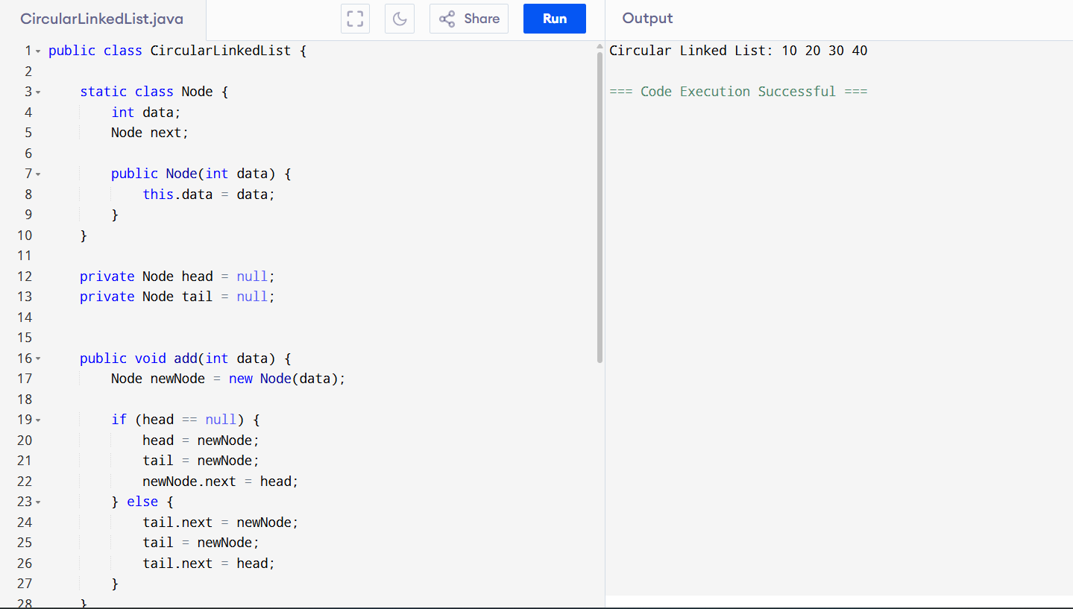
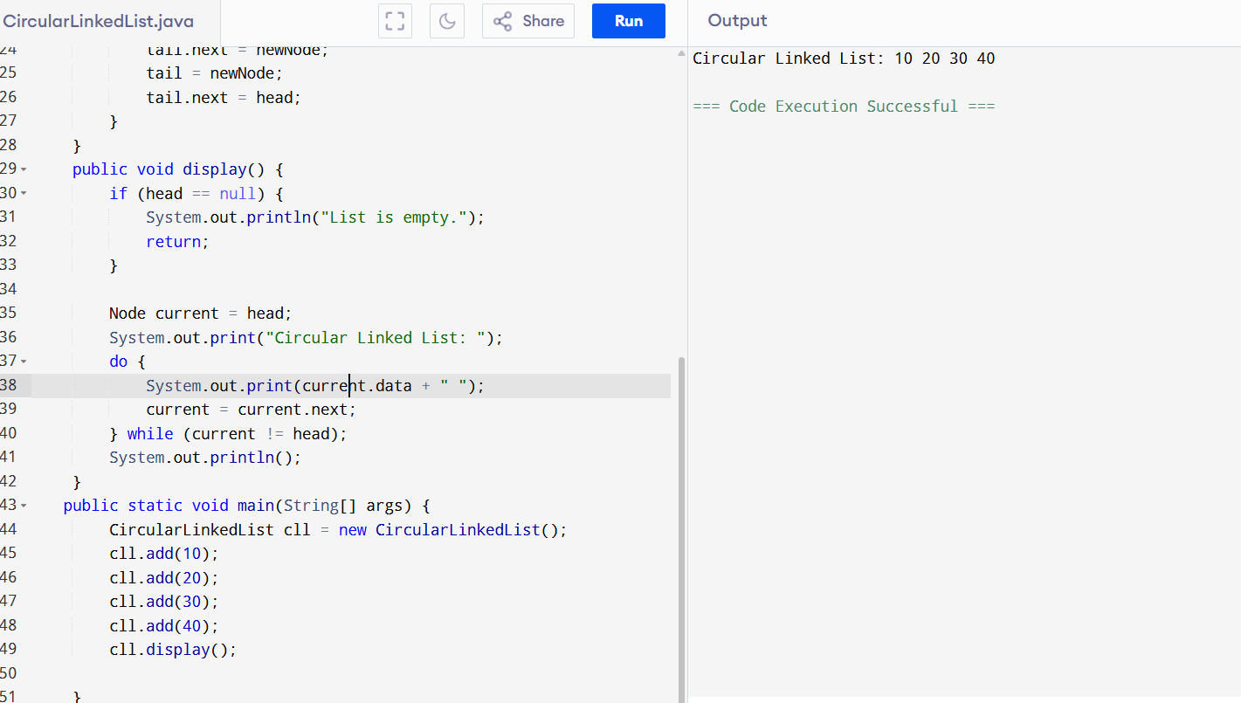
Circular with deletion:
public class CircularLinkedList {

// Node class
static class Node {
int data;
Node next;

public Node(int data) {
this.data = data;
}
}

private Node head = null;
private Node tail = null;

// Method to add a node
public void add(int data) {
Node newNode = new Node(data);

if (head == null) {
head = newNode;
tail = newNode;
newNode.next = head; // circular
} else {
tail.next = newNode;
tail = newNode;
tail.next = head;
}
}

// Method to display the list
public void display() {
if (head == null) {
System.out.println("List is empty.");
return;
}

Node current = head;
System.out.print("Circular Linked List: ");
do {
System.out.print(current.data + " ");
current = current.next;
} while (current != head);
System.out.println();
}

// Method to delete a node by value
public void delete(int value) {
if (head == null) {
System.out.println("List is empty.");
return;
}

Node current = head;
Node previous = tail;

do {
if (current.data == value) {
// Deleting the only node
if (head == tail && head.data == value) {
head = null;
tail = null;
}
// Deleting head
else if (current == head) {
head = head.next;
tail.next = head;
}
// Deleting tail
else if (current == tail) {
tail = previous;
tail.next = head;
}
// Deleting middle node
else {
previous.next = current.next;
}

System.out.println("Deleted value: " + value);
return;
}

previous = current;
current = current.next;
} while (current != head);

System.out.println("Value " + value + " not found.");
}

// Main method to test
public static void main(String[] args) {
CircularLinkedList cll = new CircularLinkedList();

cll.add(10);
cll.add(20);
cll.add(30);
cll.add(40);

cll.display(); // Before deletion

cll.delete(30); // Delete node with value 30
cll.display(); // After deletion

cll.delete(10); // Delete head
cll.display();

cll.delete(40); // Delete tail
cll.display();

cll.delete(20); // Delete last remaining node
cll.display(); // List is empty now
}
}
