DAY 1: PROJECT PLANNING & REQUIREMENTS ANALYSIS

Focus: Requirements Gathering and System Architecture Design

Requirements Analysis
Functional Requirements Identified:
1. User Management System
Customer registration with email validation
Secure authentication with password encryption
Session management and logout functionality
Password reset mechanism

2. Device Management System
Support for multiple IoT device types (TV, AC, Fan, etc.)
Device control operations (ON/OFF, status updates)
Device grouping and categorization
Realtime device status monitoring

3. Security Requirements
Password encryption using BCrypt
Session timeout management
Account lockout after failed login attempts
Secure password input handling

4. Data Persistence
Customer data storage
Device configuration persistence
Session state management
Data consistency and integrity

Nonfunctional Requirements:
1. Performance: Response time < 2 seconds for device operations
2. Security: Enterprise grade authentication and authorization
3. Scalability: Support for multiple concurrent users
4. Usability: Intuitive command line interface
5. Reliability: 99.9% uptime with robust error handling

System Architecture Design
Component Architecture:
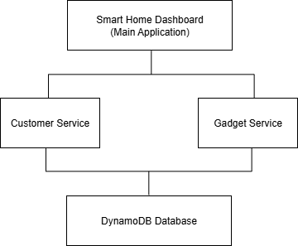

Database Schema Design:
Customer Table Schema
Customer {
email: String
fullName: String
password: String (BCrypt encrypted)
gadgets: List<Gadget>
failedLoginAttempts: Integer
accountLockedUntil: DateTime
lastFailedLoginTime: DateTime
}

Gadget Table Schema
Gadget {
type: String (TV, AC, FAN, ROBO_VAC_MOP)
model: String
roomName: String
status: String (ON, OFF)
createdAt: DateTime
lastModified: DateTime
}

Technology Stack Selection
Backend Framework:
Java 8+: Robust, enterprise grade language
Maven: Dependency management and build automation
AWS DynamoDB: NoSQL database for scalability
BCrypt: Password hashing and security

Development Tools:
IntelliJ IDEA: IDE for Java development
Git: Version control system
JUnit: Unit testing framework
PlantUML: Architecture documentation

Risk Assessment
Technical Risks:
1. Database Connection Issues Mitigation: Connection pooling and retry logic
2. Password Security Mitigation: BCrypt encryption and secure input
3. Session Management Mitigation: Timeout handling and cleanup
4. Scalability Concerns Mitigation: DynamoDB autoscaling

Business Risks:
1. User Experience Mitigation: Intuitive CLI design
2. Data Privacy Mitigation: Encryption and secure storage
3. Performance Mitigation: Optimized database queries

Development Timeline
Day 1: Requirements and Architecture (Today)
Day 2: Initial Setup and Basic Authentication
Day 3: Security Enhancements and Bug Fixes
Day 4 - 5: User Experience and Device Management
Day 6 - 7: Advanced Features and Automation
Day 8 - 10: Testing and Final Polish

Success Criteria
Technical Milestones:
1. Secure user authentication system
2. Complete device management functionality
3. Robust error handling and validation
4. Comprehensive test coverage
5. Productionready deployment

Conclusion Day 1:
Successfully completed comprehensive requirements analysis and system architecture design. Established clear technical roadmap with risk mitigation strategies. Ready to proceed with implementation phase starting Day 2.

Key Deliverables:
Requirements specification document
System architecture diagrams
Database schema design
Technology stack selection
Risk assessment and mitigation plan
10-day development timeline

