Heap sort:
Algorithm:
1.Bild a max heap from unsorted array
2.swap the root node(max element with last node in heap)
3. reduce heap size by 1 and heapify the root node
4.Repeat until heapsize is 1
Pseudo Code:
Procedure HeapSort(arr)
BuildMaxHeap(arr)
For i = arr.length - 1 to 1
Swap(arr[0], arr[i])
Heapify(arr, 0, i - 1)
Procedure BuildMaxHeap(arr)
For i = arr.length
Code:
public class HeapSort {
public static void heapSort(int[] arr) {
buildMaxHeap(arr);
for (int i = arr.length - 1; i > 0; i--) {
swap(arr, 0, i);
heapify(arr, 0, i - 1);
}
}

public static void buildMaxHeap(int[] arr) {
for (int i = arr.length / 2; i >= 0; i--) {
heapify(arr, i, arr.length - 1);
}
}

public static void heapify(int[] arr, int i, int heapSize) {
int largest = i;
int left = 2 * i + 1;
int right = 2 * i + 2;
if (left <= heapSize && arr[left] > arr[largest]) {
largest = left;
}
if (right <= heapSize && arr[right] > arr[largest]) {
largest = right;
}
if (largest != i) {
swap(arr, i, largest);
heapify(arr, largest, heapSize);
}
}

public static void swap(int[] arr, int i, int j) {
int temp = arr[i];
arr[i] = arr[j];
arr[j] = temp;
}

public static void printArray(int[] arr) {
for (int i = 0; i < arr.length; i++) {
System.out.print(arr[i] + " ");
}
System.out.println();
}

public static void main(String[] args) {
int[] arr = {4, 2, 9, 6, 5, 1, 8, 3, 7};
System.out.println("Original array:");
printArray(arr);
heapSort(arr);
System.out.println("Sorted array:");
printArray(arr);
}
}

Task 03:
Wap to take number from the user and display the no of digit it has
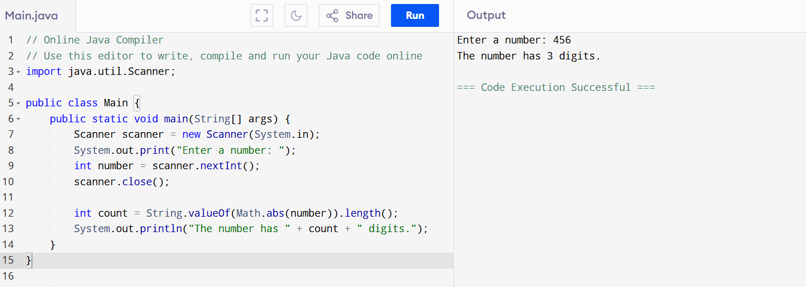
Code:
import java.util.Scanner;

public class Main {
public static void main(String[] args) {
Scanner scanner = new Scanner(System.in);
System.out.print("Enter a number: ");
int number = scanner.nextInt();
scanner.close();

int count = String.valueOf(Math.abs(number)).length();
System.out.println("The number has " + count + " digits.");
}
}

Task 02:
Wap to take input from the user a 5 digit no and display digit by digit in the output

Hint:
If input is 456897
Output:
units digit is 7
Ones digit is 9
Hundreds digit is 8
Thousands digit is 6
10 thousands digit is 5
Lakhs digit is 4
Code:
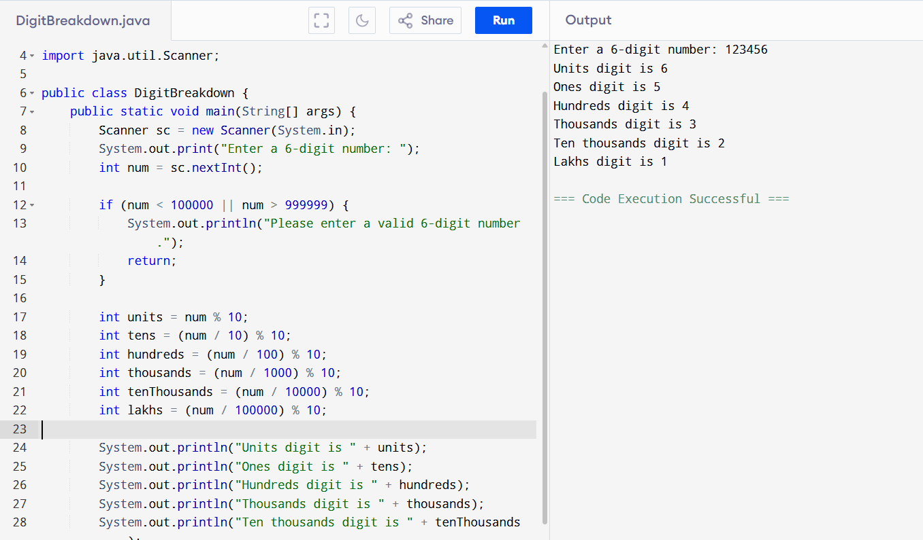
// Online Java Compiler
// Use this editor to write, compile and run your Java code online

import java.util.Scanner;

public class DigitBreakdown {
public static void main(String[] args) {
Scanner sc = new Scanner(System.in);
System.out.print("Enter a 6-digit number: ");
int num = sc.nextInt();

if (num < 100000 || num > 999999) {
System.out.println("Please enter a valid 6-digit number.");
return;
}

int units = num % 10;
int tens = (num / 10) % 10;
int hundreds = (num / 100) % 10;
int thousands = (num / 1000) % 10;
int tenThousands = (num / 10000) % 10;
int lakhs = (num / 100000) % 10;

System.out.println("Units digit is " + units);
System.out.println("Ones digit is " + tens);
System.out.println("Hundreds digit is " + hundreds);
System.out.println("Thousands digit is " + thousands);
System.out.println("Ten thousands digit is " + tenThousands);
System.out.println("Lakhs digit is " + lakhs);
}
}
Tsk 04:
What are the applications of heap sort?
- Priority queues
- Sorting algorithms
- Graph algorithms
Can you print the corner nodes of a binary search tree?

import java.util.*;

class BinaryTreeView {
static class Node {
int data;
Node left, right;

Node(int value) {
data = value;
left = right = null;
}
}

public static void printLeftView(Node root) {
System.out.println("Left view of the binary tree:");
if (root == null) return;

Queue<Node> queue = new LinkedList<>();
queue.add(root);

while (!queue.isEmpty()) {
int n = queue.size();

for (int i = 1; i <= n; i++) {
Node temp = queue.poll();

if (i == 1)
System.out.print(temp.data + " ");

if (temp.left != null)
queue.add(temp.left);
if (temp.right != null)
queue.add(temp.right);
}
}
System.out.println();
}

public static void printRightView(Node root) {
System.out.println("Right view of the binary tree:");
if (root == null) return;

Queue<Node> queue = new LinkedList<>();
queue.add(root);

while (!queue.isEmpty()) {
int n = queue.size();

for (int i = 1; i <= n; i++) {
Node temp = queue.poll();

if (i == n)
System.out.print(temp.data + " ");

if (temp.left != null)
queue.add(temp.left);
if (temp.right != null)
queue.add(temp.right);
}
}
System.out.println();
}

public static void main(String[] args) {
Node root = new Node(1);
root.left = new Node(2);
root.right = new Node(3);
root.left.left = new Node(4);
root.left.right = new Node(5);
root.right.right = new Node(6);
root.right.right.right = new Node(7);

printLeftView(root);
printRightView(root);
}
}
