Selection Sort: selects the smallest/largest element from the unsorted portion of list
Algorithm:
- Create an array
- Start the beginning of list
- Find the largest element in unsorted portion of list
- Swap with last number.
- Repeat the steps to find next largest number
- Repeat until entire list is sorted.
Pseudo Code:
procedure SelectionSort(arr)
For i = 0 to length(arr) - 1
minIndex = i
For j = i + 1 to length(arr) - 1
If arr[j] < arr[minIndex]
minIndex = j
Swap arr[i] and arr[minIndex]
End For
End Procedure
Code:
import java.util.Arrays;

public class SelectionSort {
public static void main(String[] args) {
int[] arr = {5, 2, 7, 3, 1, 0, 9};
System.out.println("Original array: " + Arrays.toString(arr));

selectionSort(arr);
System.out.println("Sorted array: " + Arrays.toString(arr));

if (isSorted(arr)) {
System.out.println("The list is sorted.");
} else {
System.out.println("The list is not sorted.");
}
}

public static void selectionSort(int[] arr) {
for (int i = 0; i < arr.length - 1; i++) {
int minIndex = i;
for (int j = i + 1; j < arr.length; j++) {
if (arr[j] < arr[minIndex]) {
minIndex = j;
}
}

int temp = arr[i];
arr[i] = arr[minIndex];
arr[minIndex] = temp;
}
}

public static boolean isSorted(int[] arr) {
for (int i = 0; i < arr.length - 1; i++) {
if (arr[i] > arr[i + 1]) {
return false;
}
}
return true;
}
}
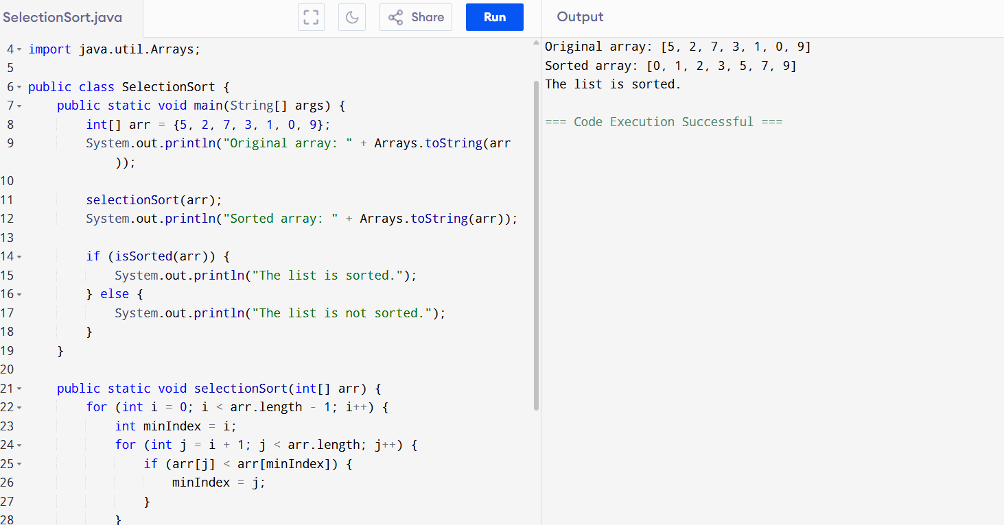
Bubble Sort:
It compares the adjacent element.
Algorithm:
- Create an array
- Start the beginning of list
- Compare the adjacent element.
- Swap if necessary.
- Move to the next element in list and repeat the comparison.
Pseudo code:
Procedure BubbleSort(arr)
n = length(arr)
For i = 0 to n-1
For j = 0 to n-i-1
If arr[j] > arr[j+1]
Swap arr[j] and arr[j+1]
End For
End Procedure
Code:
public class BubbleSort {
public static void main(String[] args) {
int[] arr = {5, 2, 8, 3, 1, 6, 4};
System.out.println("Original array:");
printArray(arr);

bubbleSort(arr);
System.out.println("Sorted array:");
printArray(arr);
}

public static void bubbleSort(int[] arr) {
int n = arr.length;
for (int i = 0; i < n - 1; i++) {
for (int j = 0; j < n - i - 1; j++) {
if (arr[j] > arr[j + 1]) {
// Swap arr[j] and arr[j+1]
int temp = arr[j];
arr[j] = arr[j + 1];
arr[j + 1] = temp;
}
}
}
}

public static void printArray(int[] arr) {
for (int i = 0; i < arr.length; i++) {
System.out.print(arr[i] + " ");
}
System.out.println();
}
}
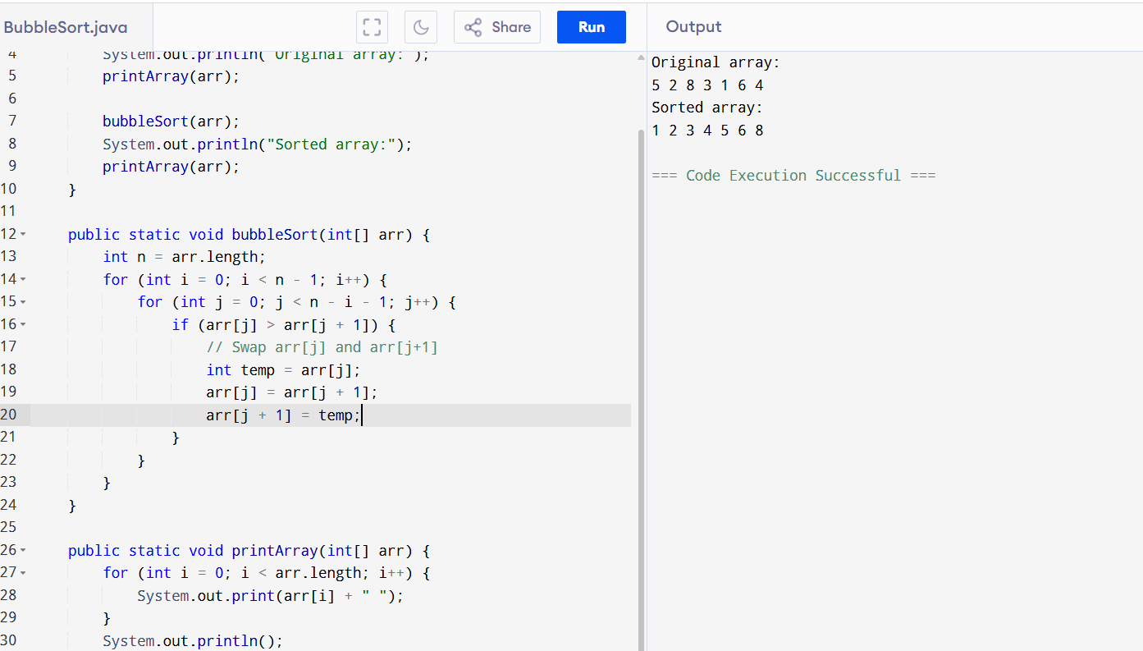

Insertion Sort:
Algorithm:
1. Start with the second element (index 1) of the array. The first element is already "sorted".
2. Set the current element as the key.
3. Compare the key with the elements before it (in the sorted portion of the array).
4. Shift all elements that are greater than the key one position to the right.
5. Insert the key into its correct position in the sorted portion.
6. Repeat steps 2–5 for all elements until the end of the array.
7. End when all elements are in sorted order.
Pseudo code:
Procedure InsertionSort(arr)
For i = 1 to length(arr)
key = arr[i]
j = i - 1
While j >= 0 and arr[j] > key
arr[j + 1] = arr[j]
j = j - 1
arr[j + 1] = key
End For
End Procedure
Java code:
public class InsertionSort {
public static void main(String[] args) {
int[] arr = {5, 2, 8, 3, 1, 6, 4};
System.out.println("Original array:");
printArray(arr);

insertionSort(arr);
System.out.println("Sorted array:");
printArray(arr);
}

public static void insertionSort(int[] arr) {
for (int i = 1; i < arr.length; i++) {
int key = arr[i];
int j = i - 1;
while (j >= 0 && arr[j] > key) {
arr[j + 1] = arr[j];
j--;
}
arr[j + 1] = key;
}
}

public static void printArray(int[] arr) {
for (int i = 0; i < arr.length; i++) {
System.out.print(arr[i] + " ");
}
System.out.println();
}
}

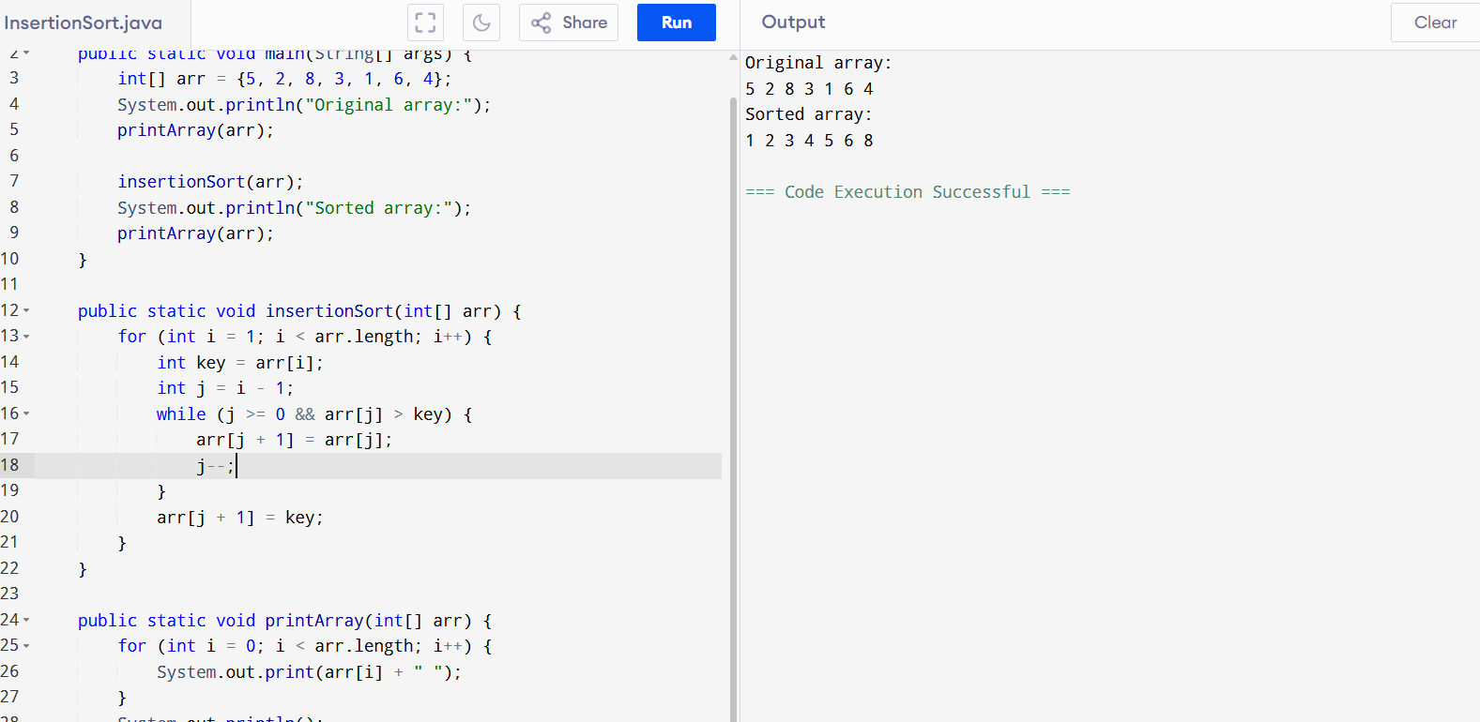
Advantages of bubble sort:
1.Simple to implement
2.space efficient
3. stable sorting algorithm
Disadvantages:
1.inefficient for large data sets
2.slow performance
3.not suitable for complex data structures
Task 11:

This code is going overflow of stack.. Can you plz help me fix it guys
public class StackOverflowFix {

public static void recursiveCall(int count) {
if (count == 0) {
return;
}

System.out.println("Recursion count: " + count);
recursiveCall(count - 1);
}

public static void main(String[] args) {
recursiveCall(10);
}
}
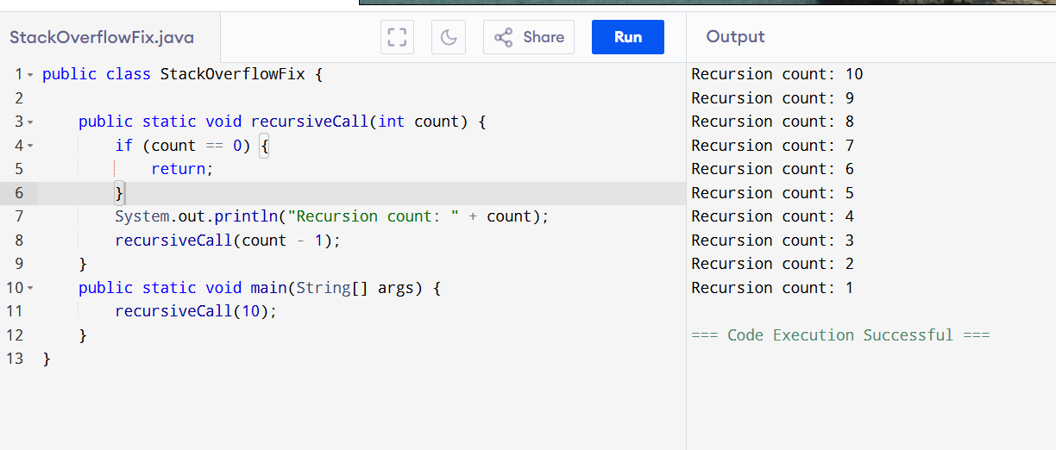
Causes over flow:
public class StackOverflowExample {

public static void recursiveCall() {

recursiveCall();
}

public static void main(String[] args) {
recursiveCall();
}
}
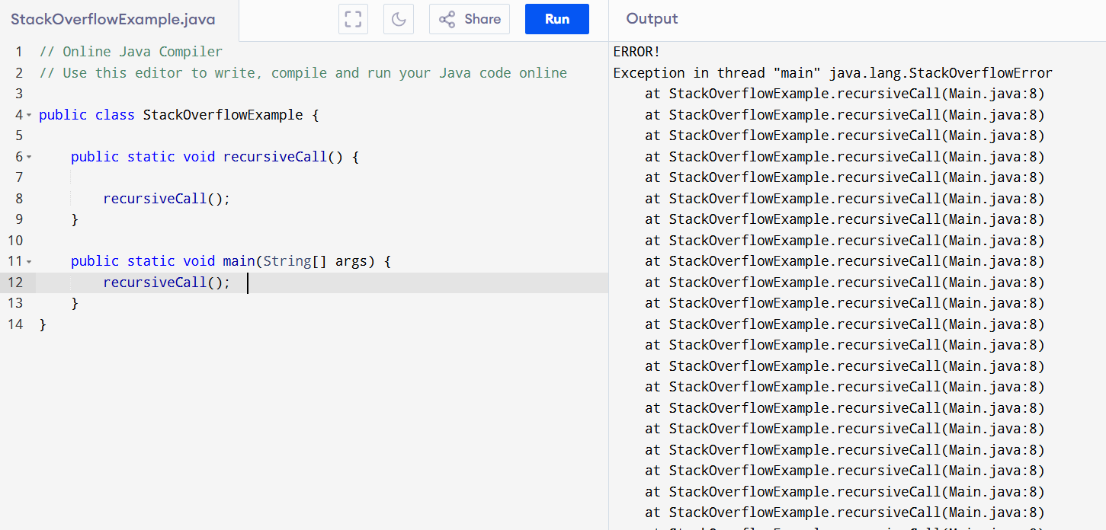
Merge Sort:
Algorithm:
1. Divide: Divide the array into two halves until each half has only one element.
2. Conquer: Merge the halves back together in sorted order.
3. Merge: Compare elements from the two halves and add the smaller element to the result array.
Pseudo Code:
Procedure MergeSort(arr)
If length(arr) <= 1
Return arr
mid = length(arr) / 2
left = MergeSort(arr[0..mid-1])
right = MergeSort(arr[mid..length(arr)-1])
Return Merge(left, right)
End Procedure

Procedure Merge(left, right)
result = new array
While left and right are not empty
If left[0] <= right[0]
result.add(left[0])
left.remove(0)
Else
result.add(right[0])
right.remove(0)
While left is not empty
result.add(left[0])
left.remove(0)
While right is not empty
result.add(right[0])
right.remove(0)
Return result
End Procedure
Code:
public class MergeSort {
public static void main(String[] args) {
int[] arr = {5, 2, 8, 3, 1, 6, 4};
System.out.println("Original array:");
printArray(arr);

arr = mergeSort(arr);
System.out.println("Sorted array:");
printArray(arr);
}

public static int[] mergeSort(int[] arr) {
if (arr.length <= 1) {
return arr;
}
int mid = arr.length / 2;
int[] left = new int[mid];
int[] right = new int[arr.length - mid];
System.arraycopy(arr, 0, left, 0, mid);
System.arraycopy(arr, mid, right, 0, arr.length - mid);
left = mergeSort(left);
right = mergeSort(right);
return merge(left, right);
}

public static int[] merge(int[] left, int[] right) {
int[] result = new int[left.length + right.length];
int i = 0, j = 0, k = 0;
while (i < left.length && j < right.length) {
if (left[i] <= right[j]) {
result[k++] = left[i++];
} else {
result[k++] = right[j++];
}
}
while (i < left.length) {
result[k++] = left[i++];
}
while (j < right.length) {
result[k++] = right[j++];
}
return result;
}

public static void printArray(int[] arr) {
for (int i = 0; i < arr.length; i++) {
System.out.print(arr[i] + " ");
}
System.out.println();
}
}
Quick sort:

Pseudo code:

Code:
public class QuickSort {

public static void quickSort(int[] arr, int low, int high) {
if (low < high) {

int pi = partition(arr, low, high);

quickSort(arr, low, pi - 1);
quickSort(arr, pi + 1, high);
}
}

private static int partition(int[] arr, int low, int high) {
int pivot = arr[high];
int i = low - 1;

for (int j = low; j < high; j++) {

if (arr[j] <= pivot) {
i++;

// Swap arr[i] and arr[j]
int temp = arr[i];
arr[i] = arr[j];
arr[j] = temp;
}
}

int temp = arr[i + 1];
arr[i + 1] = arr[high];
arr[high] = temp;

return i + 1;
}

public static void main(String[] args) {
int[] arr = {10, 7, 8, 9, 1, 5};
int n = arr.length;

System.out.println("Original array:");
printArray(arr);

quickSort(arr, 0, n - 1);

System.out.println("Sorted array:");
printArray(arr);
}

public static void printArray(int[] arr) {
for (int value : arr) {
System.out.print(value + " ");
}
System.out.println();
}
}
Practice code:
Using sorting for smallest to largest string

import java.util.Arrays;

public class SortStrings {
public static void main(String[] args) {
String[] strings = {"ab", "abc", "abcd", "abcde", "abcdef"};
System.out.println("Original array:");
printArray(strings);
Arrays.sort(strings, (a, b) -> Integer.compare(b.length(), a.length()));
System.out.println("Sorted array (longest to shortest):");
printArray(strings);
}
public static void printArray(String[] arr) {
for (String str : arr) {
System.out.print(str + " ");
}
System.out.println();
}
}
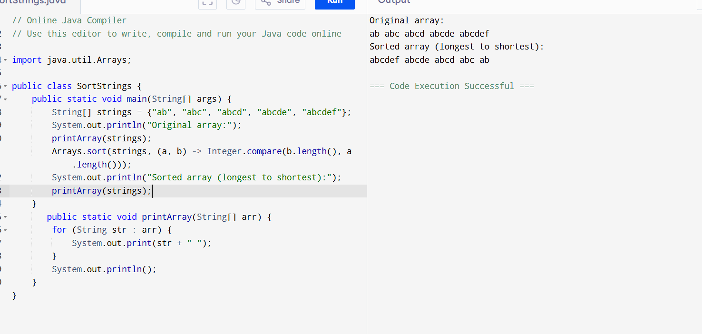
Code to print alphabetical order
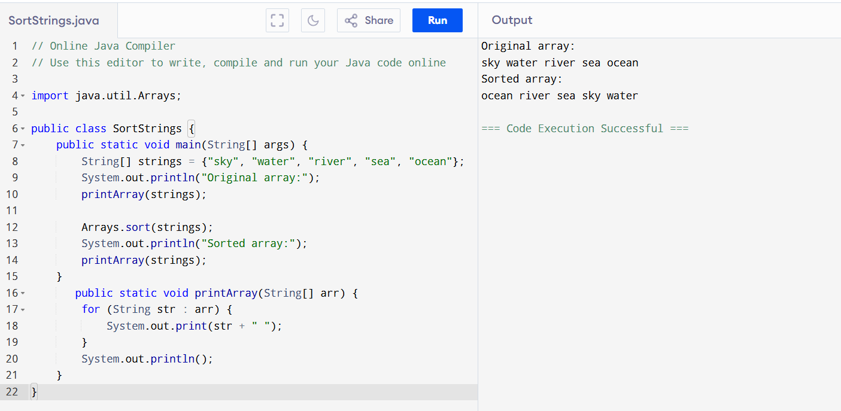
import java.util.Arrays;

public class SortStrings {
public static void main(String[] args) {
String[] strings = {"sky", "water", "river", "sea", "ocean"};
System.out.println("Original array:");
printArray(strings);

Arrays.sort(strings);
System.out.println("Sorted array:");
printArray(strings);
}
public static void printArray(String[] arr) {
for (String str : arr) {
System.out.print(str + " ");
}
System.out.println();
}
}

