AVL Tree Pseudo Code:
Node Structure
Node {
key: integer
height: integer
left: Node
right: Node
}

Insertion
Procedure Insert(node, key)
If node is null
Create a new node with key
Return new node
If key < node.key
node.left = Insert(node.left, key)
Else If key > node.key
node.right = Insert(node.right, key)
node.height = 1 + max(GetHeight(node.left), GetHeight(node.right))
balance = GetBalance(node)
If balance > 1 and key < node.left.key
Return RightRotate(node)
If balance < -1 and key > node.right.key
Return LeftRotate(node)
If balance > 1 and key > node.left.key
node.left = LeftRotate(node.left)
Return RightRotate(node)
If balance < -1 and key < node.right.key
node.right = RightRotate(node.right)
Return LeftRotate(node)
Return node

Deletion
Procedure Delete(node, key)
If node is null
Return node
If key < node.key
node.left = Delete(node.left, key)
Else If key > node.key
node.right = Delete(node.right, key)
Else
If node.left is null
Return node.right
Else If node.right is null
Return node.left
temp = GetMinValueNode(node.right)
node.key = temp.key
node.right = Delete(node.right, temp.key)
If node is null
Return node
node.height = 1 + max(GetHeight(node.left), GetHeight(node.right))
balance = GetBalance(node)
If balance > 1 and GetBalance(node.left) >= 0
Return RightRotate(node)
If balance < -1 and GetBalance(node.right) <= 0
Return LeftRotate(node)
If balance > 1 and GetBalance(node.left) < 0
node.left = LeftRotate(node.left)
Return RightRotate(node)
If balance < -1 and GetBalance(node.right) > 0
node.right = RightRotate(node.right)
Return LeftRotate(node)
Return node

Rotation
Procedure LeftRotate(x)
y = x.right
T2 = y.left
y.left = x
x.right = T2
x.height = 1 + max(GetHeight(x.left), GetHeight(x.right))
y.height = 1 + max(GetHeight(y.left), GetHeight(y.right))
Return y

Procedure RightRotate(y)
x = y.left
T2 = x.right
x.right = y
y.left = T2
y.height = 1 + max(GetHeight(y.left), GetHeight(y.right))
x.height = 1 + max(GetHeight(x.left), GetHeight(x.right))
Return x

AVL Tree Algorithm
The AVL tree algorithm - height of the tree remains relatively small by rotating nodes when the balance factor becomes too large.
Algorithm:
1. Create a new node with the given key.
2. Insert the node into the tree using the standard BST insertion algorithm.
3. Update the height of the node and its ancestors.
4. Calculate the balance factor of the node and its ancestors.
5. If the balance factor becomes too large, perform rotations to balance the tree.
Balancing:
- Left rotation: Rotate the node to the left to balance the tree.
- Right rotation: Rotate the node to the right to balance the tree.

AVL Tree Insertion:
- Insert like BST
- Update the height of current code
- Check balance factor
- Rotations:
a.left
b.right
c. left-right
d.right-left
AVL Tree Code:
class AVLTree {

class Node {
int key, height;
Node left, right;

Node(int d) {
key = d;
height = 1;
}
}

Node root;

int height(Node N) {
if (N == null)
return 0;
return N.height;
}

int getBalance(Node N) {
if (N == null)
return 0;
return height(N.left) - height(N.right);
}

Node rightRotate(Node y) {
Node x = y.left;
Node T2 = x.right;

x.right = y;
y.left = T2;

y.height = Math.max(height(y.left), height(y.right)) + 1;
x.height = Math.max(height(x.left), height(x.right)) + 1;

return x;
}
Node leftRotate(Node x) {
Node y = x.right;
Node T2 = y.left;

y.left = x;
x.right = T2;

x.height = Math.max(height(x.left), height(x.right)) + 1;
y.height = Math.max(height(y.left), height(y.right)) + 1;

return y;
}

Node insert(Node node, int key) {

if (node == null)
return new Node(key);

if (key < node.key)
node.left = insert(node.left, key);
else if (key > node.key)
node.right = insert(node.right, key);
else
return node;

node.height = 1 + Math.max(height(node.left), height(node.right));

int balance = getBalance(node);

if (balance > 1 && key < node.left.key)
return rightRotate(node);

if (balance < -1 && key > node.right.key)
return leftRotate(node);

if (balance > 1 && key > node.left.key) {
node.left = leftRotate(node.left);
return rightRotate(node);
}

if (balance < -1 && key < node.right.key) {
node.right = rightRotate(node.right);
return leftRotate(node);
}

return node;
}

void preOrder(Node node) {
if (node != null) {
System.out.print(node.key + " ");
preOrder(node.left);
preOrder(node.right);
}
}

void insert(int key) {
root = insert(root, key);
}

public static void main(String[] args) {
AVLTree tree = new AVLTree();
tree.insert(10);
tree.insert(20);
tree.insert(30);
tree.insert(40);
tree.insert(50);
tree.insert(25);

System.out.println("Preorder traversal of constructed AVL tree is:");
tree.preOrder(tree.root);
}
}

AVL CODE
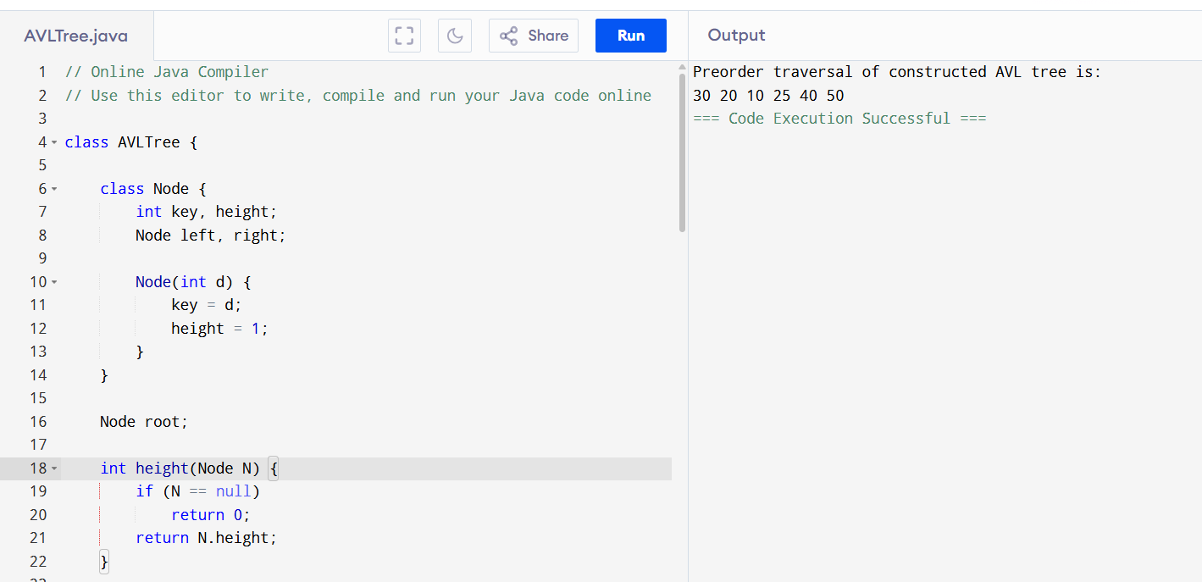
// Online Java Compiler
// Use this editor to write, compile and run your Java code online

class AVLTree {

class Node {
int key, height;
Node left, right;

Node(int d) {
key = d;
height = 1;
}
}

Node root;

int height(Node N) {
if (N == null)
return 0;
return N.height;
}

int getBalance(Node N) {
if (N == null)
return 0;
return height(N.left) - height(N.right);
}

Node rightRotate(Node y) {
Node x = y.left;
Node T2 = x.right;

x.right = y;
y.left = T2;

y.height = Math.max(height(y.left), height(y.right)) + 1;
x.height = Math.max(height(x.left), height(x.right)) + 1;

return x;
}
Node leftRotate(Node x) {
Node y = x.right;
Node T2 = y.left;

y.left = x;
x.right = T2;

x.height = Math.max(height(x.left), height(x.right)) + 1;
y.height = Math.max(height(y.left), height(y.right)) + 1;

return y;
}

Node insert(Node node, int key) {

if (node == null)
return new Node(key);

if (key < node.key)
node.left = insert(node.left, key);
else if (key > node.key)
node.right = insert(node.right, key);
else
return node;

node.height = 1 + Math.max(height(node.left), height(node.right));

int balance = getBalance(node);

if (balance > 1 && key < node.left.key)
return rightRotate(node);

if (balance < -1 && key > node.right.key)
return leftRotate(node);

if (balance > 1 && key > node.left.key) {
node.left = leftRotate(node.left);
return rightRotate(node);
}

if (balance < -1 && key < node.right.key) {
node.right = rightRotate(node.right);
return leftRotate(node);
}

return node;
}

void preOrder(Node node) {
if (node != null) {
System.out.print(node.key + " ");
preOrder(node.left);
preOrder(node.right);
}
}

void insert(int key) {
root = insert(root, key);
}

public static void main(String[] args) {
AVLTree tree = new AVLTree();
tree.insert(10);
tree.insert(20);
tree.insert(30);
tree.insert(40);
tree.insert(50);
tree.insert(25);

System.out.println("Preorder traversal of constructed AVL tree is:");
tree.preOrder(tree.root);
}
}

