Codes are uploaded separately in github
Preorder:
1.Visit Root
2. Traverse Left Subtree
3. Traverse Right Subtree
Inorder:
1. Traverse Left subtree
2.Vist Root
3. Traverse right subtree
Preorder:
1.Traverse left subtree
2. Traverse right subtree
3. visit root

Task 1:
Create a node for a tree and include a constructor.
Task 2:
Create a class named Binarty Search tree in which you have 2 insert operations

1 insert —----> for inserting if the tree is empty
1 insert —----> for inserting if the tree has 1 or more nodes
Task 3:
Ionorder travel of the above code snippets from task 1 and Task 2
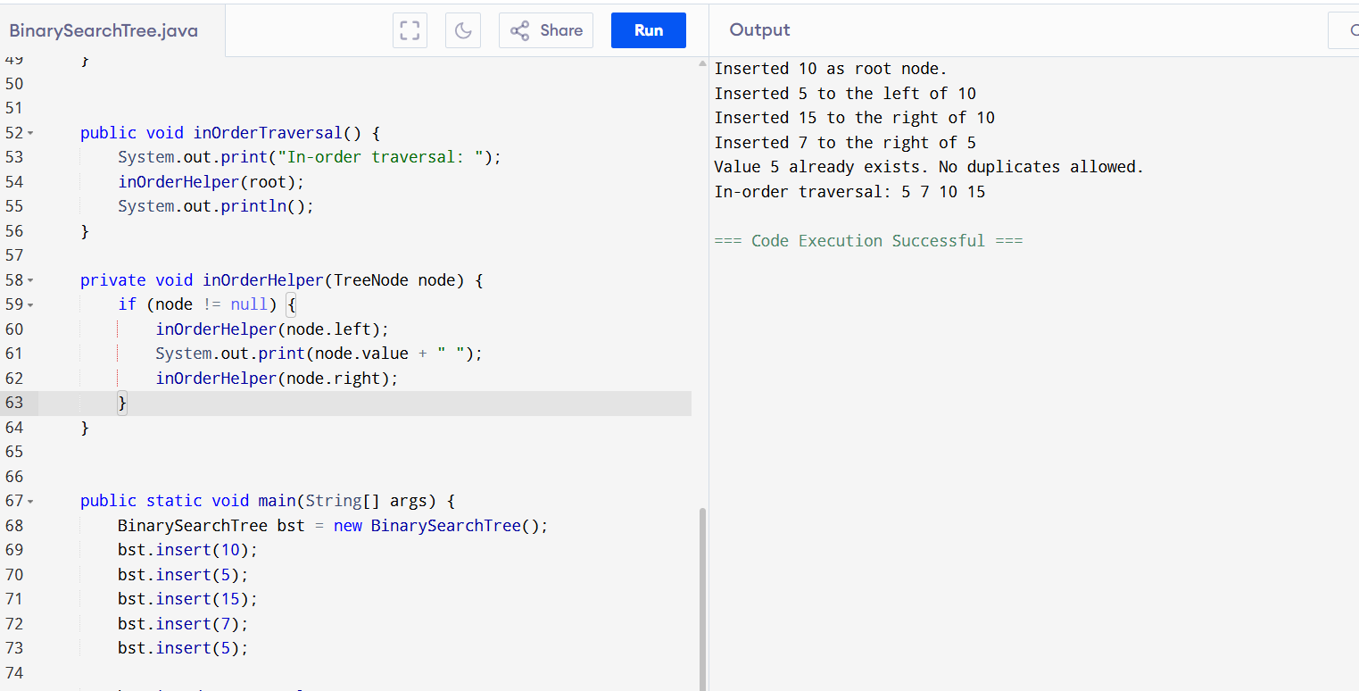public class BinarySearchTree {

static class TreeNode {
int value;
TreeNode left, right;

public TreeNode(int value) {
this.value = value;
this.left = null;
this.right = null;
}
}

private TreeNode root;

public BinarySearchTree() {
root = null;
}

public void insert(int value) {
if (root == null) {
root = new TreeNode(value);
System.out.println("Inserted " + value + " as root node.");
} else {
insertRecursively(root, value);
}
}

private void insertRecursively(TreeNode current, int value) {
if (value < current.value) {
if (current.left == null) {
current.left = new TreeNode(value);
System.out.println("Inserted " + value + " to the left of " + current.value);
} else {
insertRecursively(current.left, value);
}
} else if (value > current.value) {
if (current.right == null) {
current.right = new TreeNode(value);
System.out.println("Inserted " + value + " to the right of " + current.value);
} else {
insertRecursively(current.right, value);
}
} else {
System.out.println("Value " + value + " already exists. No duplicates allowed.");
}
}

public void inOrderTraversal() {
System.out.print("In-order traversal: ");
inOrderHelper(root);
System.out.println();
}

private void inOrderHelper(TreeNode node) {
if (node != null) {
inOrderHelper(node.left);
System.out.print(node.value + " ");
inOrderHelper(node.right);
}
}

public static void main(String[] args) {
BinarySearchTree bst = new BinarySearchTree();
bst.insert(10);
bst.insert(5);
bst.insert(15);
bst.insert(7);
bst.insert(5);

bst.inOrderTraversal();
}
}
Tree with inorder/preorder/post order

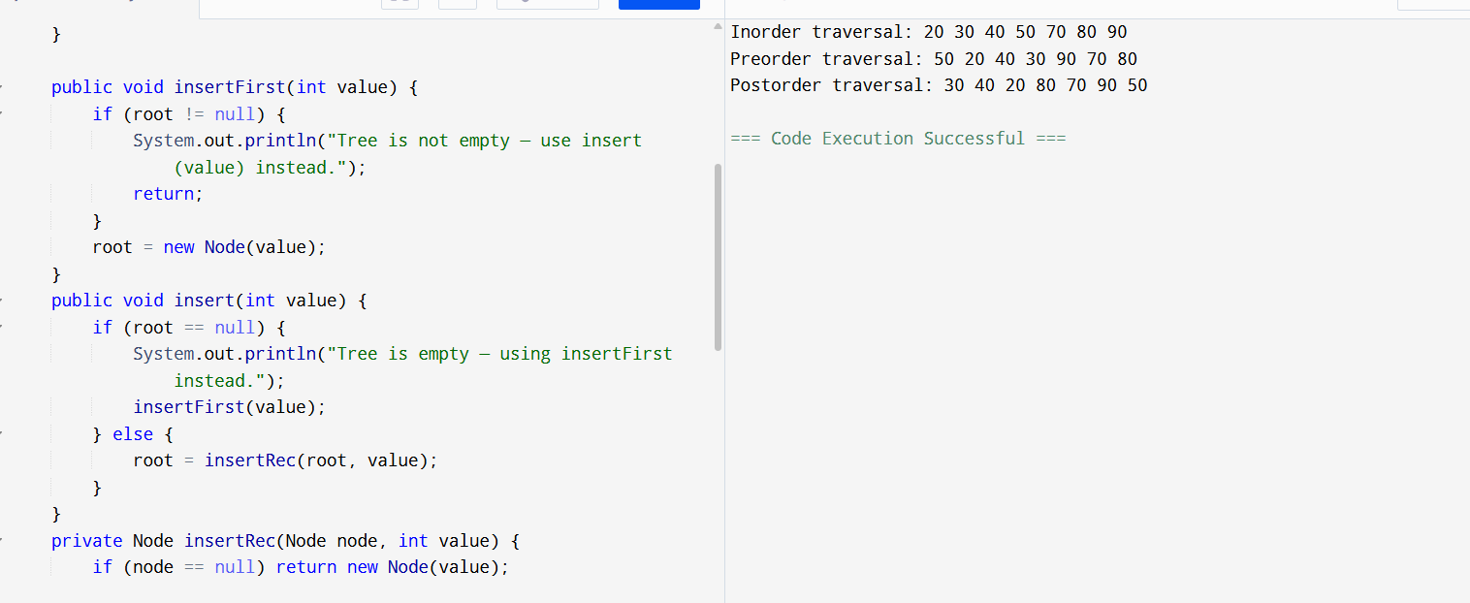
// Online Java Compiler
// Use this editor to write, compile and run your Java code online

public class BinarySearchTree {

private static class Node {
int value;
Node left, right;

Node(int v) {
value = v;
left = right = null;
}
}

private Node root;

public BinarySearchTree() {
root = null;
}

public void insertFirst(int value) {
if (root != null) {
System.out.println("Tree is not empty — use insert(value) instead.");
return;
}
root = new Node(value);
}
public void insert(int value) {
if (root == null) {
System.out.println("Tree is empty — using insertFirst instead.");
insertFirst(value);
} else {
root = insertRec(root, value);
}
}
private Node insertRec(Node node, int value) {
if (node == null) return new Node(value);

if (value < node.value) {
node.left = insertRec(node.left, value);
} else if (value > node.value) {
node.right = insertRec(node.right, value);
}

return node;
}
public void inorderTraversal() {
System.out.print("Inorder traversal: ");
inorderRec(root);
System.out.println();
}

private void inorderRec(Node node) {
if (node != null) {
inorderRec(node.left);
System.out.print(node.value + " ");
inorderRec(node.right);
}
}

public void preorderTraversal() {
System.out.print("Preorder traversal: ");
preorderRec(root);
System.out.println();
}

private void preorderRec(Node node) {
if (node != null) {
System.out.print(node.value + " ");
preorderRec(node.left);
preorderRec(node.right);
}
}

public void postorderTraversal() {
System.out.print("Postorder traversal: ");
postorderRec(root);
System.out.println();
}

private void postorderRec(Node node) {
if (node != null) {
postorderRec(node.left);
postorderRec(node.right);
System.out.print(node.value + " ");
}
}

public static void main(String[] args) {
BinarySearchTree bst = new BinarySearchTree();

bst.insertFirst(50);
bst.insert(90);
bst.insert(70);
bst.insert(20);
bst.insert(40);
bst.insert(30);
bst.insert(80);

bst.inorderTraversal();
bst.preorderTraversal();
bst.postorderTraversal();
}
}
Task 5: Applications of tree:
- Organize and manage files and directories
- Used in databases to store and retrieve data for insertion and deletion operations
- Routers and bridges to efficiently route data packets.
Task:7
Types of binary tree:
Complete binary tree
Binary search tree
Balanced binary tree
Perfect binary tree
Skewed binary tree
Rooted binary tree
Segment tree
Applications of graph:
Google Maps
Web pages
GPS
Networks
Types of graphs:
Regular Graph
Multi Graph
Connected Graph
Cyclic Graph
Directed Graph
Pseudo Graph

