Customer.java
public class Customer {
String name;
String custID;

public Customer(String name, String custID) {
this.name = name;
this.custID = custID;
}
public String getName() {
return name;
}
public String getCustID {
return custID;
}
}
ManagingFiles.java
import java.io.FileWriter;
import java.io.IOException;
public class ManagingFiles{
public void saveData() {
try{
FileWriter fw = new FileWriter(name+".txt");
fw.write("the customer name is "+ name + "\t");
fw.write("the customer id is "+ custID + "\t");
System.out.println("the data is saved in
the file with your name");
}catch(IOException ex) {
ex.printStacktrace();
}
}
}
SRP_Imple.java
public class SRP_Imple {
psvm( String[] args) {
Customer cobj = new Customer(" prasunamba" , "C001");
ManagingFiles mobj = new ManagingFiles();
mobj.saveData();
}
}
TASK:3
Task 3:
The below is violating SRP complete it and also … plz implement the SRP principle and rewrite the code.
// srp violation

public class Book {
private String title;
private String author;
private double price;

public Book(String title, String author, double price) {
this.title = title;
this.author = author;
this.price = price;
}

public String getFormattedTitle() {
return "Title: " + title.toUpperCase();
}

public double calculateDiscountedPrice(double discountPercentage) {
return price * (1 - discountPercentage);
}

// ... other methods for book details
}

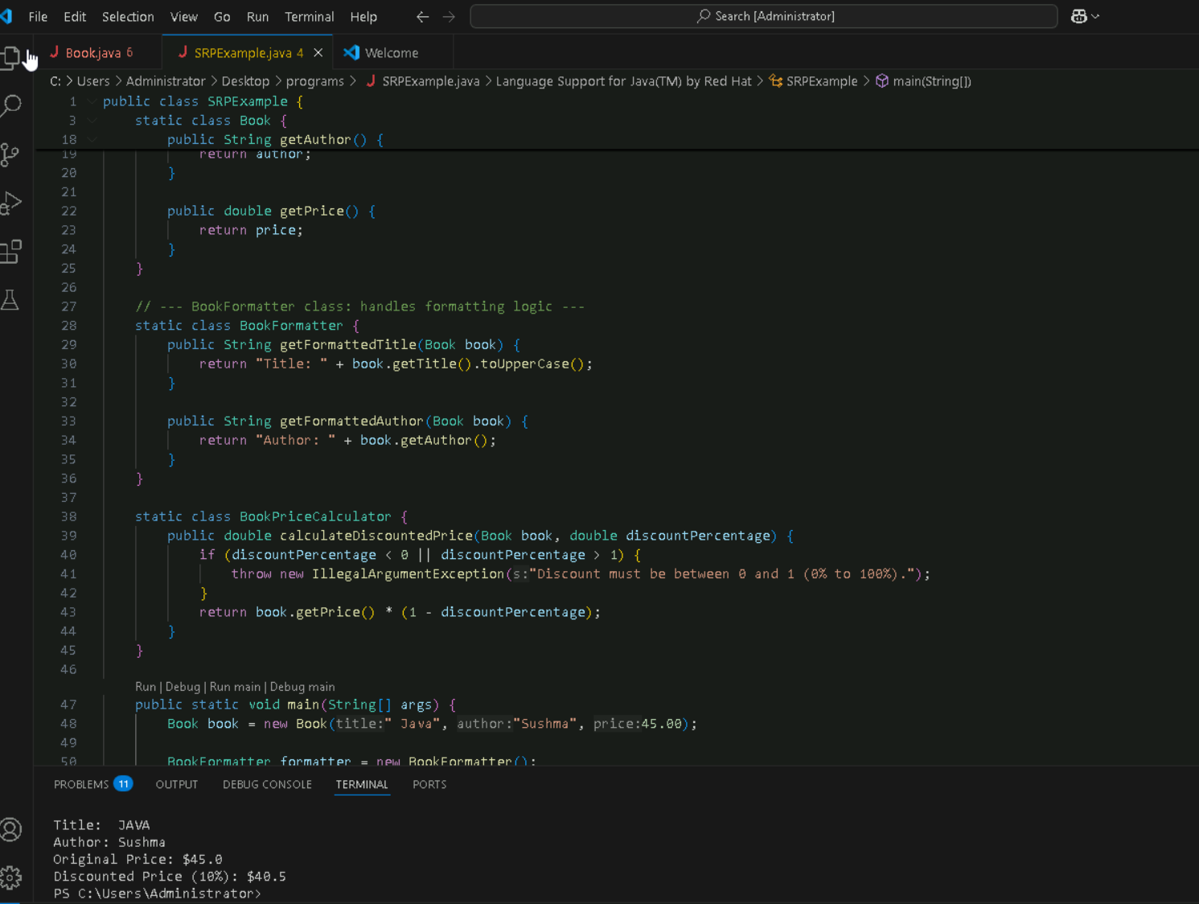
public class SRPExample {

static class Book {
private String title;
private String author;
private double price;

public Book(String title, String author, double price) {
this.title = title;
this.author = author;
this.price = price;
}

public String getTitle() {
return title;
}

public String getAuthor() {
return author;
}

public double getPrice() {
return price;
}
}

// --- BookFormatter class: handles formatting logic ---
static class BookFormatter {
public String getFormattedTitle(Book book) {
return "Title: " + book.getTitle().toUpperCase();
}

public String getFormattedAuthor(Book book) {
return "Author: " + book.getAuthor();
}
}

static class BookPriceCalculator {
public double calculateDiscountedPrice(Book book, double discountPercentage) {
if (discountPercentage < 0 || discountPercentage > 1) {
throw new IllegalArgumentException("Discount must be between 0 and 1 (0% to 100%).");
}
return book.getPrice() * (1 - discountPercentage);
}
}

public static void main(String[] args) {
Book book = new Book(" Java", "Sushma", 45.00);

BookFormatter formatter = new BookFormatter();
BookPriceCalculator calculator = new BookPriceCalculator();

System.out.println(formatter.getFormattedTitle(book)); // Output: Title in uppercase
System.out.println(formatter.getFormattedAuthor(book)); // Output: Author
System.out.println("Original Price: $" + book.getPrice());
System.out.println("Discounted Price (10%): $" + calculator.calculateDiscountedPrice(book, 0.10));
}
}
TASK4:
Task 04:

class Employee {
private String name;
private String email;
private double salary;

// Methods related to employee data

// Method to generate PDF report
public void generatePdfReport() {
// Code to generate PDF report
}

// Method to send email
public void sendEmail() {
// Code to send email
}
}
In the above example code, the Employee class violates the SRP because it has multiple responsibilities: managing employee data, generating PDF reports, and sending emails. These responsibilities are not cohesive and may change for different reasons.

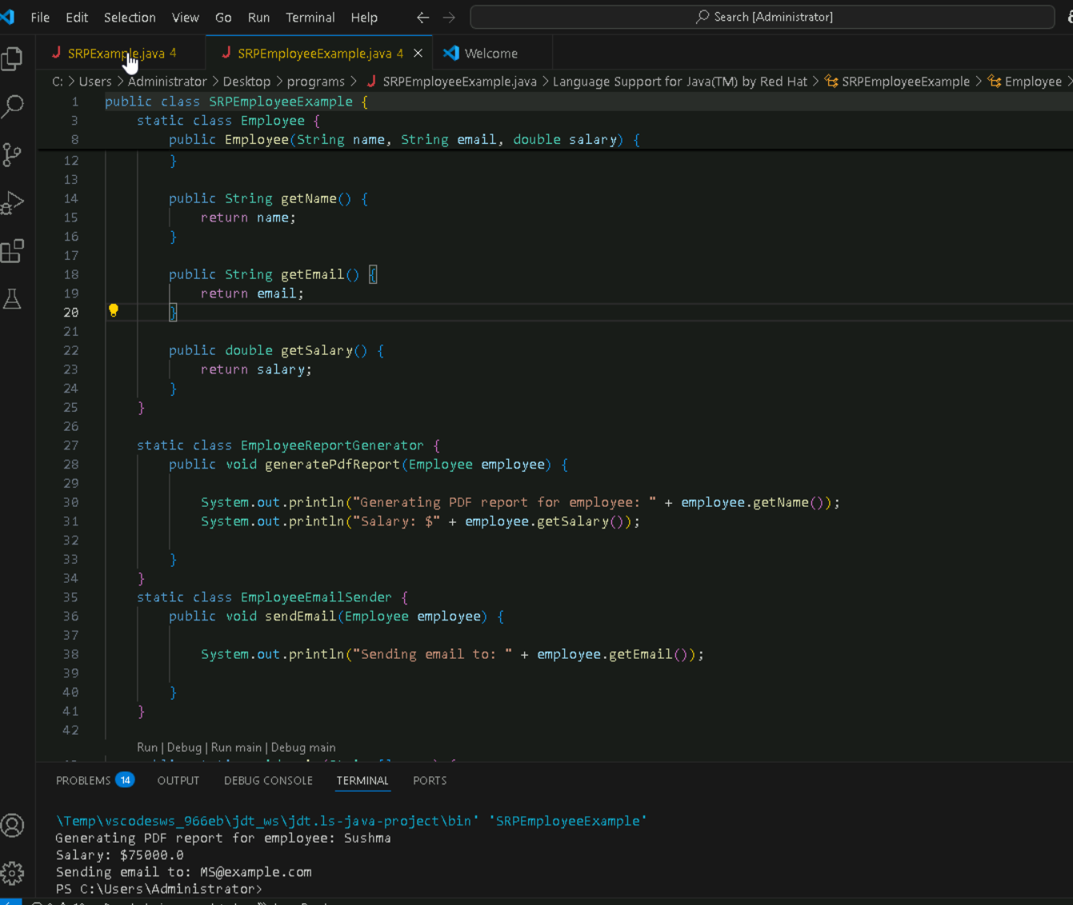
Code:
public class SRPEmployeeExample {

static class Employee {
private String name;
private String email;
private double salary;

public Employee(String name, String email, double salary) {
this.name = name;
this.email = email;
this.salary = salary;
}

public String getName() {
return name;
}

public String getEmail() {
return email;
}

public double getSalary() {
return salary;
}
}

static class EmployeeReportGenerator {
public void generatePdfReport(Employee employee) {

System.out.println("Generating PDF report for employee: " + employee.getName());
System.out.println("Salary: $" + employee.getSalary());

}
}
static class EmployeeEmailSender {
public void sendEmail(Employee employee) {

System.out.println("Sending email to: " + employee.getEmail());

}
}

public static void main(String[] args) {
Employee employee = new Employee("Sushma", "MS@example.com", 75000.00);

EmployeeReportGenerator reportGenerator = new EmployeeReportGenerator();
EmployeeEmailSender emailSender = new EmployeeEmailSender();

reportGenerator.generatePdfReport(employee);
emailSender.sendEmail(employee);
}
}

Task 05:

Open closed Principle …

class Square() {
int height;
int area() { return height * height; }
}

public class OpenOpenExample {

public int compareArea(Square a, Square b) {
return a.area() - b.area();
}

}
extension code:

class Circle {
int r;
int area() { return Math.PI*r*r*;}
}

class OpenOpenExample {

public int compareArea(Square a, Square b) {
return a.area() - b.area();
}

public int compareArea(Circle x, Circle y) {
return x.area() - y.area();
}

}
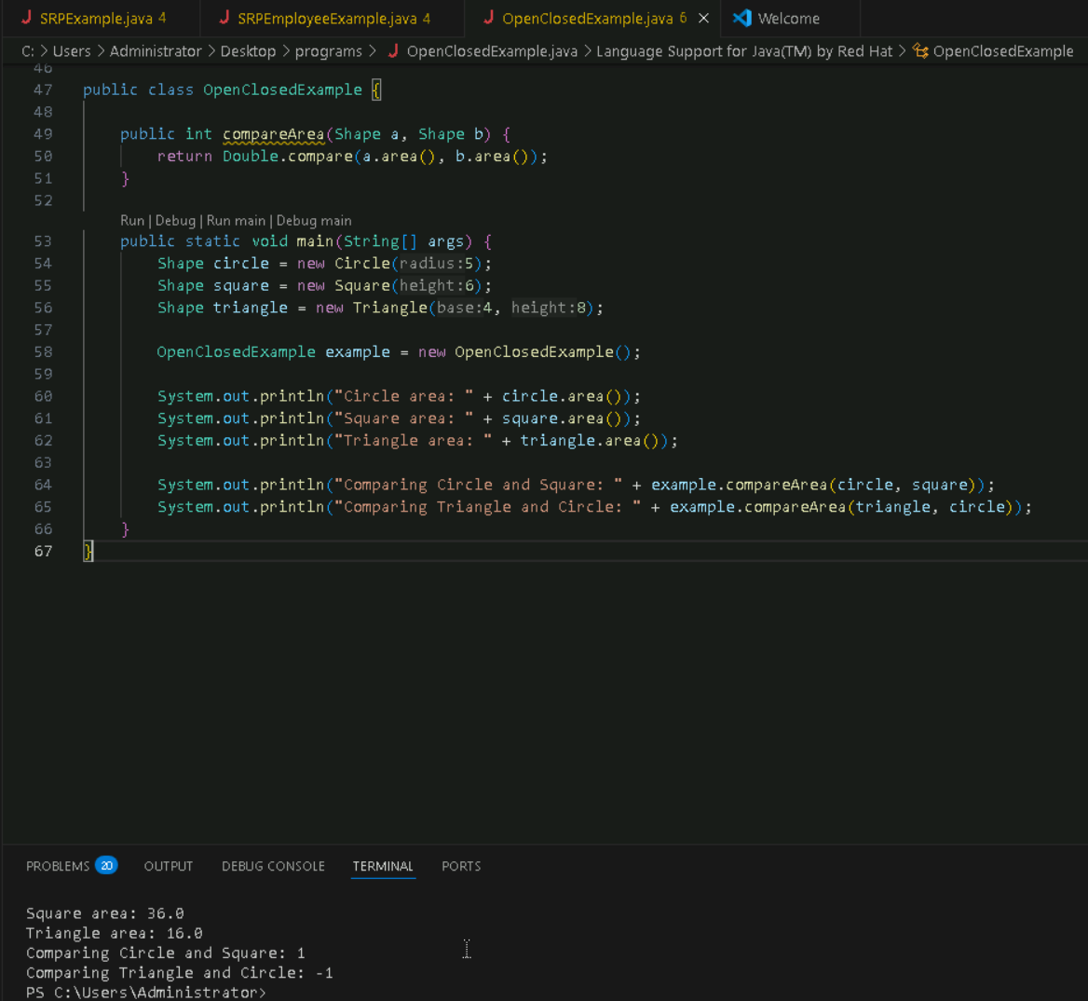

Code:
interface Shape {
double area(); // use double for precision
}

class Circle implements Shape {
private int radius;

public Circle(int radius) {
this.radius = radius;
}

@Override
public double area() {
return Math.PI * radius * radius;
}
}

class Square implements Shape {
private int height;

public Square(int height) {
this.height = height;
}

@Override
public double area() {
return height * height;
}
}

class Triangle implements Shape {
private int base;
private int height;

public Triangle(int base, int height) {
this.base = base;
this.height = height;
}

@Override
public double area() {
return 0.5 * base * height;
}
}

public class OpenClosedExample {

public int compareArea(Shape a, Shape b) {
return Double.compare(a.area(), b.area());
}

public static void main(String[] args) {
Shape circle = new Circle(5);
Shape square = new Square(6);
Shape triangle = new Triangle(4, 8);

OpenClosedExample example = new OpenClosedExample();

System.out.println("Circle area: " + circle.area());
System.out.println("Square area: " + square.area());
System.out.println("Triangle area: " + triangle.area());

System.out.println("Comparing Circle and Square: " + example.compareArea(circle, square));
System.out.println("Comparing Triangle and Circle: " + example.compareArea(triangle, circle));
}
}

TASK:06create diagrams for structural diagrams

