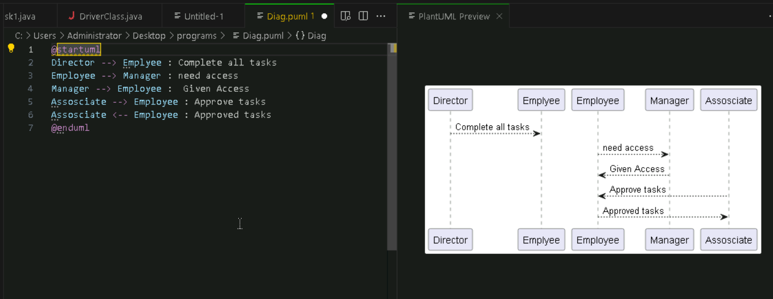
Tried UML and codes uploaded seperately

