# Code manual

This is code description for ‘[Visualisation tool NN.py](https://github.com/Kukhmay/ATLAS-visual/blob/main/Visualisation%20tool%20NN.py)’ file. The App is built in Dash framework (<https://dash.plotly.com>) and can be run in any IDE supporting Python.

This file contains all the code necessary to run the App (the other element being the *.csv data files). For convenience of navigating through and updating the file, the code is structured into 6 sections marked with Python comment lines. These sections are:

1. Scatter plot components (lines 44-120):
2. Radioitems group to choose Y-feature
3. Slider controls along X
4. Slider controls along Y
5. Tabs
6. Scatter plot Legend (events' checklist)

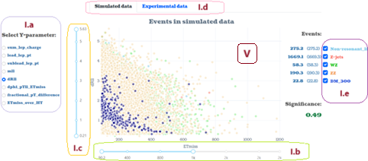

Figure . Scatter plot Components in App’s interface

1. MLP (Neural Network) model components (lines 126-339):
   1. Data selector
   2. Scaler switch
   3. Power button
   4. Number of hidden layers selector
   5. Selector for Hidden Layer 1
   6. Selector for Hidden Layer 2
   7. Selector for Hidden Layer 3
   8. Accuracy indicator
   9. F1-score indicator

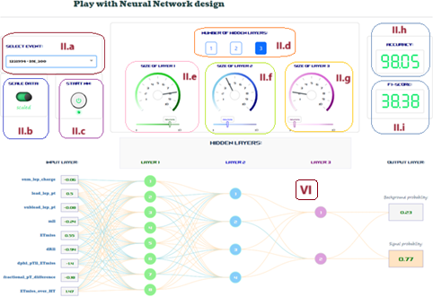

Figure . MLP components

1. Histogram components (lines 345-476):
2. Histogram slider
3. Significance score
4. Histogram's legend

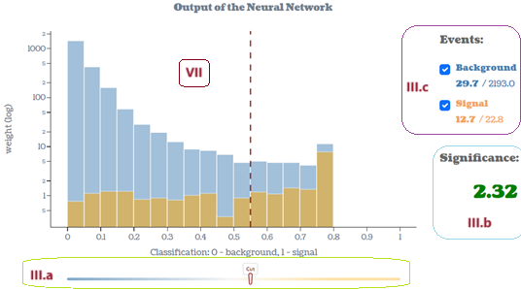

Figure . Histogram components

1. App Layout (lines 482-704):
2. Scatter plot section
3. MLP model section
4. Histogram section
5. Scatter plot (lines 710-807)
6. MLP (lines 812-1122)
7. Histogram (lines 1128-1227)

The Layout section defines how the components and graphs are organised within the user interface.

To a large extent, Dash framework is free and relatively easy to use. Comprehensive documentation for Dash components can be found here (Sections I-III):

<https://dash.plotly.com/dash-core-components>

For Dash Layout refer to this page (Section IV):

<https://dash.plotly.com/layout>

Scatter plot details (Section V):

<https://plotly.com/python/reference/scatter/>

MLP model details (Section VI):

<https://plotly.com/python/reference/sankey/>

Histogram details (Section VII):

<https://plotly.com/python/reference/histogram/>

For more advanced graph creating (Sections V-VII) follow this link:

<https://plotly.com/python/creating-and-updating-figures/>

For more details and examples of Data App development, feel free to further explore Dash and Plotly websites.