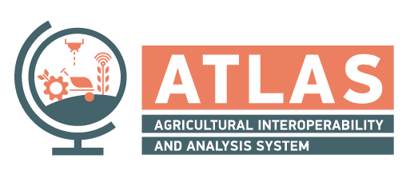

Temperature monitoring

TEMPLATE ID: temperature_monitoring   
 VERSION: 1.0

|  |  |
| --- | --- |
| Author(s) | Iphigenia Keramitsoglou (NOA)  Chris Kiranoudis (NOA) |
| Approval Date | 02/02/2022 |

# Abstract

Temperature is a major factor in determining the natural distribution of plants and the success and timing of agricultural crops. As temperature varies in space and time, it is important to monitor it continuously. The is the motivation of this micro-service.

The aim is to develop services for air temperature that will then be used together with crop-specific characteristics to evaluate the Growing Degree Days (GDD) and hours of Frost.

GDD is an indicator for assessing crop development. It is a measure of heat accumulation (based on air temperature) used to predict plant and pest development rates such as the date that a crop reaches maturity. Frost occurs when atmospheric moisture is directly crystallized on the ground and on exposed objects. In agricultural context, frost refers to the occurrence of subfreezing temperatures that affect plants and crops.

This document describes a generic abstraction for measuring GDD and frost hours on a field.

# Purpose of the document

The purpose of this service template specifications document is to provide a technology- agnostic overview of the *temperature monitoring* template. It describes a well-defined baseline of the service by clearly identifying the service version.

The document describes the shared functional aspects of any service instance implementing the *temperature monitoring* template, the operational and business context of such services, possible requirements, relations to other services and validation aspects.

# Intended audience

ATLAS software vendors and project partners, who want to consume ATLAS *temperature monitoring* service instances.

The services can be useful for the following groups: farmers, farmers associations, cooperatives, consultants, public organizations, water authorities.

# Functional overview

GDD and frost hours information derived from the Services implementing the *temperature monitoring* template can be used *per se* or as variables in irrigation management and sophisticated decision support systems.

# Operational context

Growing Degree Days are a measure of heat accumulation. They are used to predict plant and animal development rates, e.g. bloom / maturity date. They are also used to predict when an insect will emerge from dormancy. The basic concept is that development will only occur if the average daily temperature (${TA}_{daily}^{Average}$) exceeds some minimum development threshold, called the base temperature (TBASE). The base temperatures are different for each crop. If the mean temperature is at or below TBASE, then the Growing Degree Day value is zero. If the mean temperature is above TBASE, then the Growing Degree Day amount equals the mean temperature minus TBASE. GDD is a cumulative measure.

$GDD=\left(\sum_{April 1st}^{November 15th}{{TA}_{daily}^{Average}}-TBASE\right){}^{+}$

As illustrated in the figure below, a farmer, with the support of his FMIS, may choose to retrieve the timeseries of the (cumulative) GDDs from the start of the growing season until the end (most commonly) present day and/or the hours of frost in a particular field.

# Service template API

This section provides an abstract overview of the service template API. The detailed OpenAPI specifications can be found in the service registry.

Endpoints

As every crop type has different base temperatures, for the calculation of GDD the field crop type is necessary, else the user can provide a threshold value. The GDDs are assessed for a time period, normally from the start of the growing season to the present day. The output is the daily timeseries of cumulative values of positive average temperature differences from the threshold.

For the crop season, a frost threshold is required (by default it is zero degrees C). Then for a given date the output is the number of hours that the temperature was below the threshold.

Data model

The detailed data models, with examples can be found in the adjoining OpenAPI specifications.