
POWER PRO ELECTRICAL
HV / LV Electrical & Industrial Specialists
Business Portfolio
083 279 5157 | powerpro.co.za@gmail.com

About Power Pro Electrical
Power Pro Electrical is grounded in practical, on-site work across transformers, switchgear, protection relays and distribution systems. That experience covers utility-scale equipment, industrial plants and mining operations, both underground and on surface — built on real field experience, not just theory.

Core Skills
- HV & LV equipment maintenance
- Transformer testing, refurbishment and oil purification
- Switchgear installation, retrofitting and commissioning (OCB, VCB, ACB)
- Cable fault location, jointing and terminations (HT/LT)
- Relay testing and secondary injection up to 132kV
- DB board wiring, construction and fault finding
- Infrared scanning and preventive maintenance
- Mining (underground and surface) and broader industrial experience

Services
HV & LV Equipment Maintenance
Scheduled and corrective maintenance on high- and low-voltage electrical equipment to keep sites running safely and reliably.
Transformer Testing & Refurbishment
Transformer testing, refurbishment and oil purification to extend equipment life and prevent unplanned failures.
Switchgear Installation & Retrofitting
Installation, retrofitting and commissioning of switchgear, including OCB, VCB and ACB units.
Cable Jointing & Fault Location
HT/LT cable fault location, jointing and terminations, carried out with precision to minimise downtime.
Relay Testing & Protection
Relay testing and secondary injection on protection systems up to 132kV.
DB Board Wiring & Fault Finding
Distribution board construction, wiring and fault finding for commercial and industrial installations.
Infrared Scanning
Thermal/infrared scanning as part of a proactive preventive maintenance program.
Mining & Industrial Sites
Underground and surface mining experience, alongside broader industrial and commercial electrical work.

Our Work
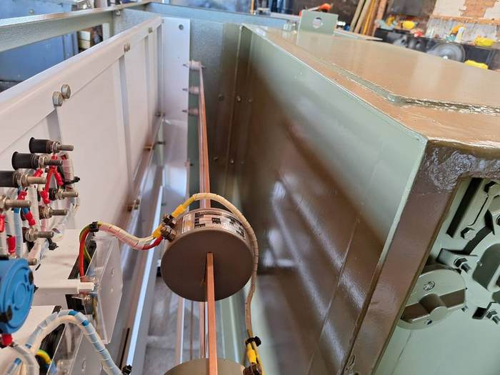  Transformer maintenance | 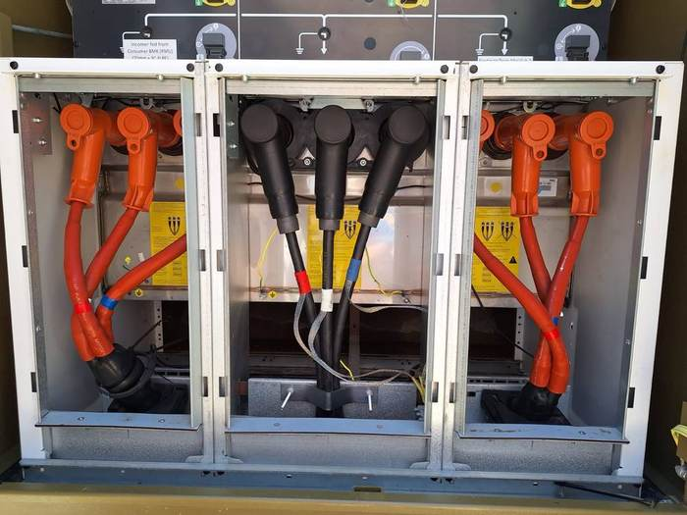  Switchgear terminations
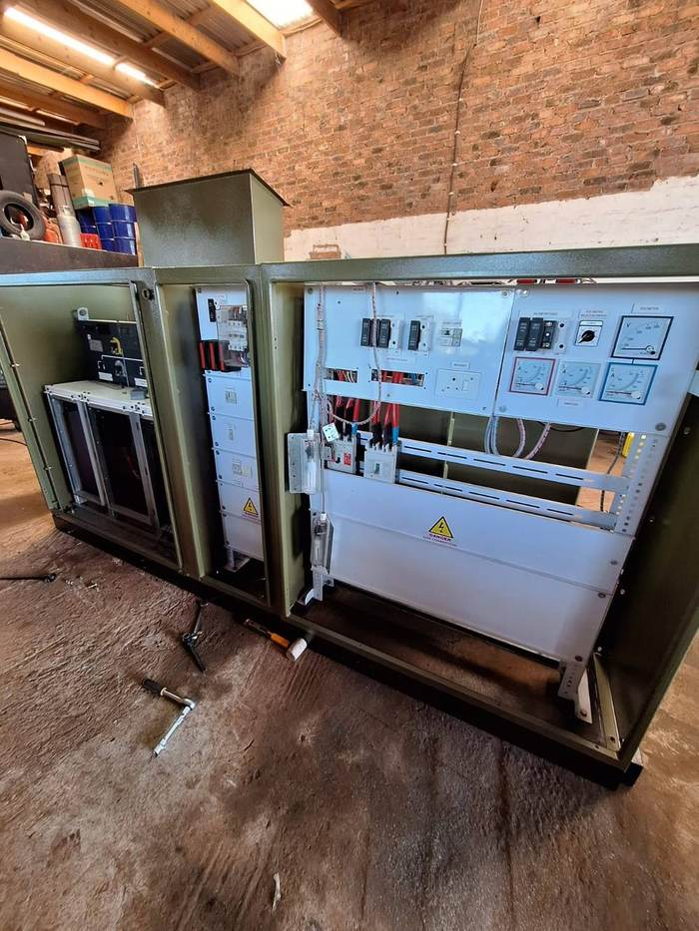  DB panel build | 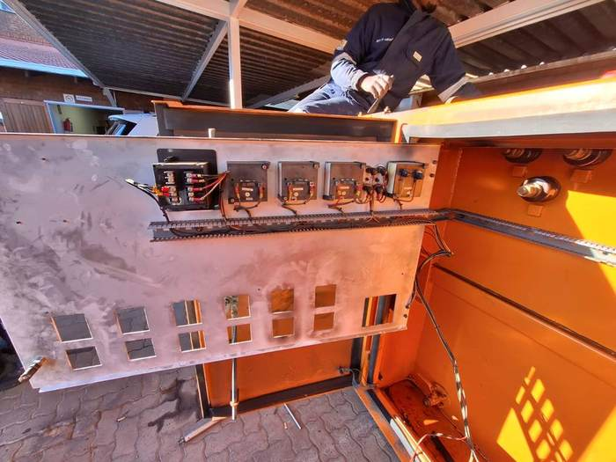  Panel wiring
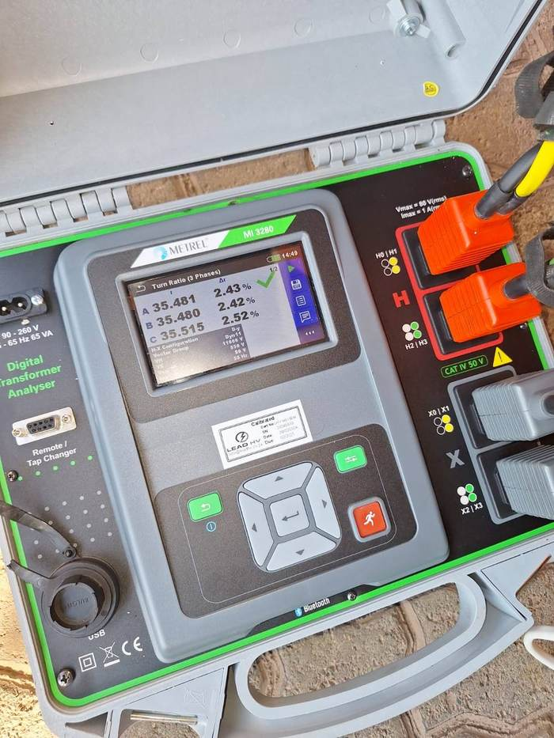  Transformer testing | 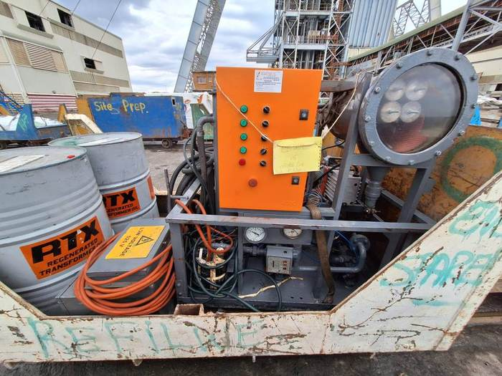  Mine site work

Get In Touch
Tell us about the job and we'll get back to you.
Phone: 083 279 5157
Email: powerpro.co.za@gmail.com
Registration No: [Company Registration Number]

