🛍️Customer Segmentation and Recommendation System

🏷️ Objective:

This project helps identify different types of customers based on how much they spend and how often they purchase.
By using clustering and analysis techniques, we can understand customer behavior, visualize trends, and make actionable business recommendations.

The goal is to help businesses improve customer engagement, retention, and sales strategies.

📁 Project Structure

customer_segmentation_project/
│
├── sample_transactions.csv # Original dataset
├── cleaned_transactions.csv # After cleaning & preparation
├── engineered_features.csv # After feature engineering
├── segmented_customers.csv # After clustering segmentation
├── segment_profile_summary.csv # Profile analysis results
│
├── data_cleaning.py # Script for cleaning raw data
├── feature_engineering.py # Script for deriving new metrics
├── customer_segmentation.py # Script for K-Means clustering
├── profile_analysis.py # Script to summarize segment traits
├── recommendations.py # Script to generate recommendations
├── visualizations.py # Script to create charts
├── report_generation.py # Script to produce summary report
├── README.md # Project documentation
│
└── /visuals/ # Folder for charts
├── scatter_segmentation.png
├── bar_segment_size.png
├── pie_segment_distribution.png
├── top_recommendations.png

🧹 Data Cleaning & Preparation (data_cleaning.py):

Load and inspect raw transactional data.

Remove duplicates and missing values.

Standardize column names for easy processing.

Export a clean version for later analysis.

🧾 output :

File: cleaned_transactions.csv

Columns: | CustomerID | ProductID | Category | PurchaseAmount | Date |

Clean, structured data ready for feature

🛒Feature Engineering (feature_engineering.py):

Create useful features that describe each customer’s purchasing behavior.

Derive new metrics such as:

TotalSpend – total amount spent by a customer

PurchaseCount – number of transactions per customer

AvgPurchaseValue – average value per transaction

PreferredCategory – most frequently purchased product category

🧾 Output:

File: engineered_features.csv

Columns: | CustomerID | TotalSpend | PurchaseCount | AvgPurchaseValue | Prefe

🎁Customer Segmentation (customer_segmentation.py):

Apply K-Means clustering on customer features (spending and frequency).

Classify customers into meaningful groups:

High Spenders

Medium Spenders

Low Spenders

⚙️ Process

1. Select features → TotalSpend and PurchaseCount

2. Run K-Means clustering (n_clusters = 3)

3. Label each cluster with meaningful segment names

4. Save the segmented dataset

🧾 Output:

File: segmented_customers.csv

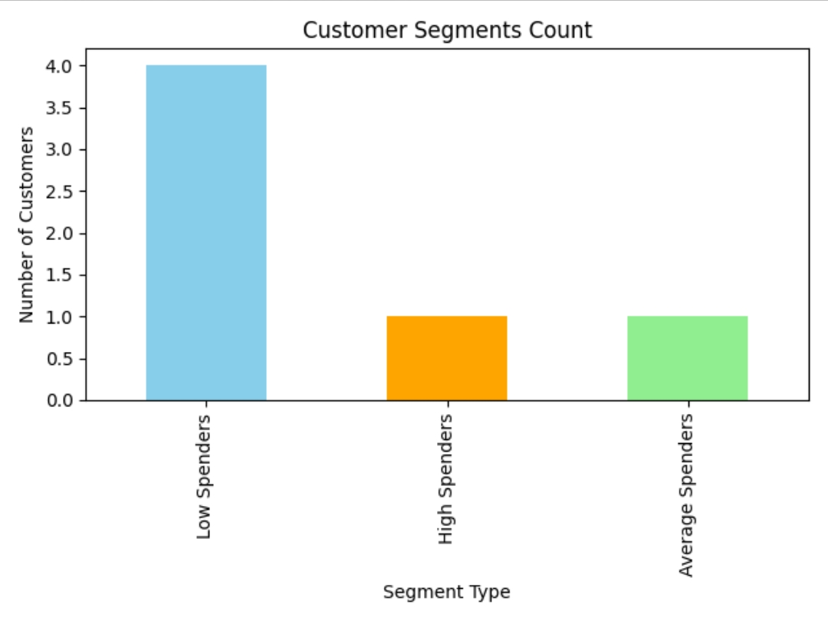Columns: | CustomerID | TotalSpend | PurchaseCount | Segment |

🧾 Profile Analysis (profile_analysis.py):

Understand and describe the behavior of each customer segment.

Compute:

Average spending

Average purchase count

Most preferred product category per segment

🧾 Output:

File: segment_profile_summary.csv

Columns: | Segment | AvgSpend | AvgPurchase | TopCategory |

💬 Recommendation System (recommendations.py):

Generate personalized recommendations for each segment.

📋 Method:

High Spenders: Offer loyalty rewards, early access to sales.

Medium Spenders: Provide combo deals and personalized discounts.

Low Spenders: Send reactivation emails with limited-time offers.

🧾 Output:

Prints top recommendations per segment.

Optionally saves summary to recommendations_summary.txt.

📊 Visualizations (visualizations.py):

Present key insights visually for better understanding.

📈 Charts:

Scatter Plot: Relationship between Total Spend and Purchase Count.

Bar Chart: Number of customers in each segment.

Pie Chart: Percentage distribution of customer segments.

Top Recommendations Chart: Visual overview of segment-specific actions.

🧾 Output:

All visuals saved in the /visuals/ folder:

scatter_segmentation.png
bar_segment_size.png
pie_segment_distribution.png
top_recommendations.png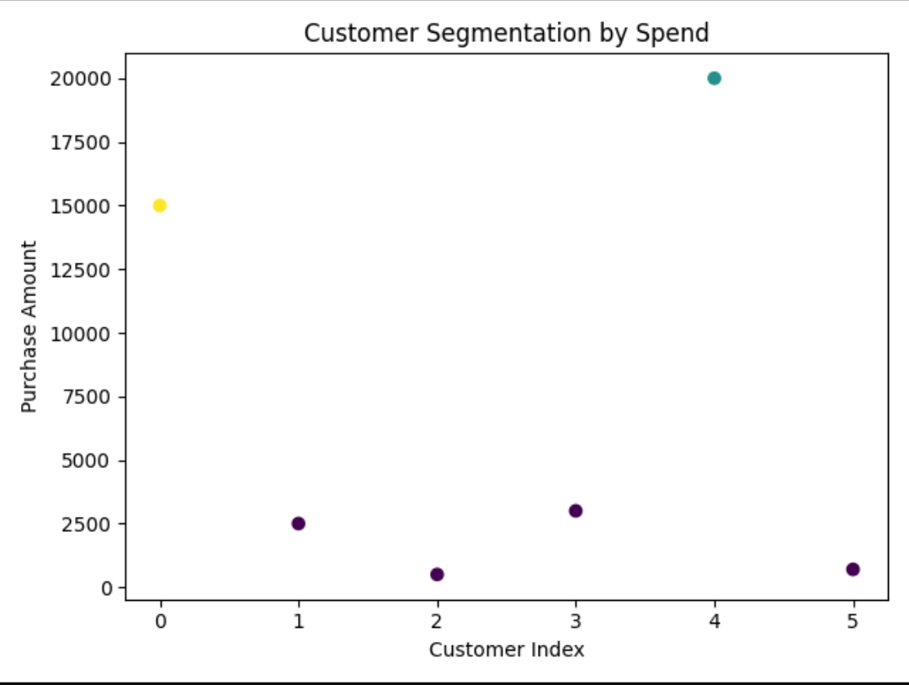

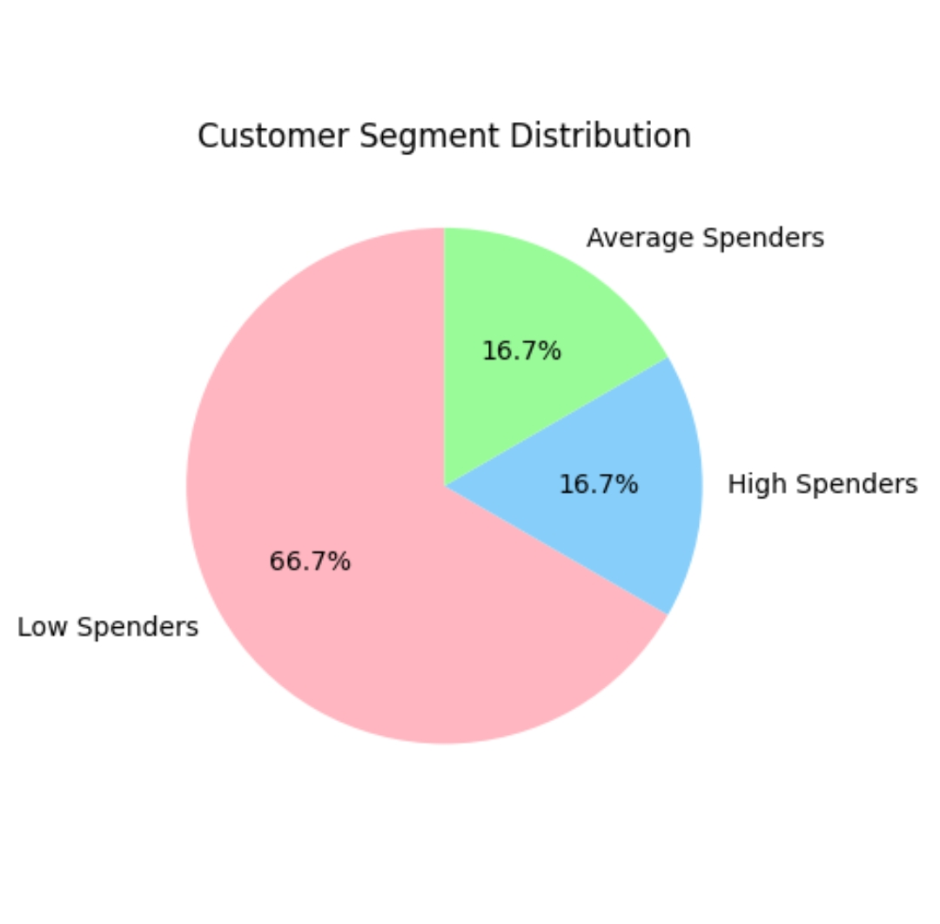

⚙️ How to Run the Project:

1.install Dependencies

pip install pandas scikit-learn matplotlib seaborn reportlab

2.Execute Scripts in Order

python data_cleaning.py
python feature_engineering.py
python customer_segmentation.py
python profile_analysis.py
python recommendations.py
python visualizations.py
python report_generation.py

💡 Key Insights:

High Spenders are small in number but contribute most to revenue.

Medium Spenders show potential for upselling.

Low Spenders are good targets for reactivation campaigns.

🧠 Tools & Technologies:

Language: Python

Libraries: Pandas, Scikit-learn, Matplotlib, Seaborn, ReportLab

Algorithm: K-Means Clustering

Deliverables: CSVs, Visualizations, Reports

🧾Conclusion :

This project was developed as part of a data analytics internship.
It demonstrates end-to-end understanding of data preprocessing, clustering, and insight generation.

