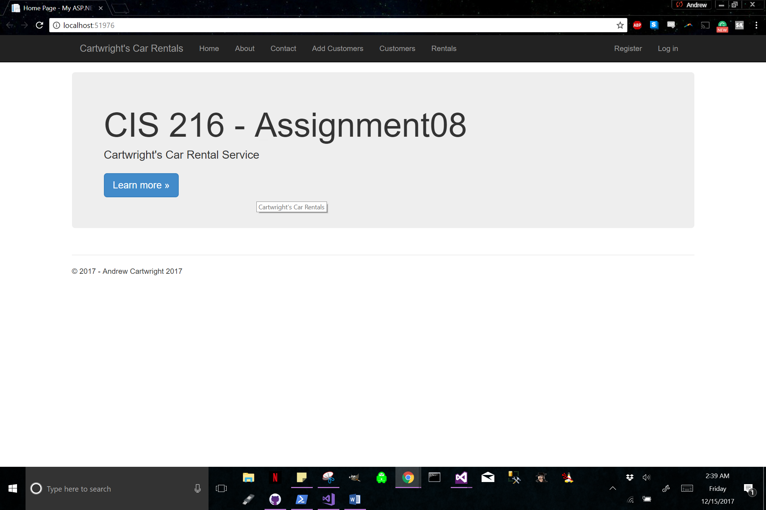

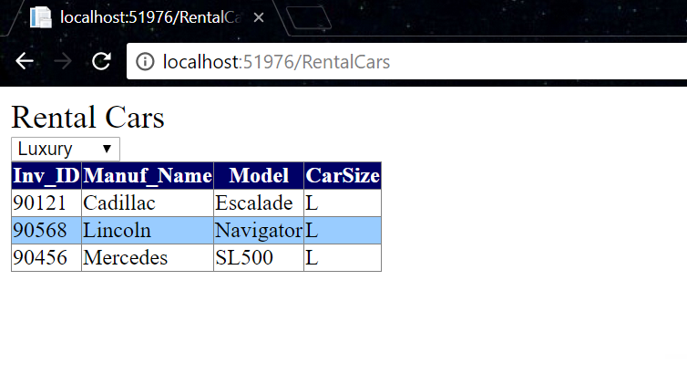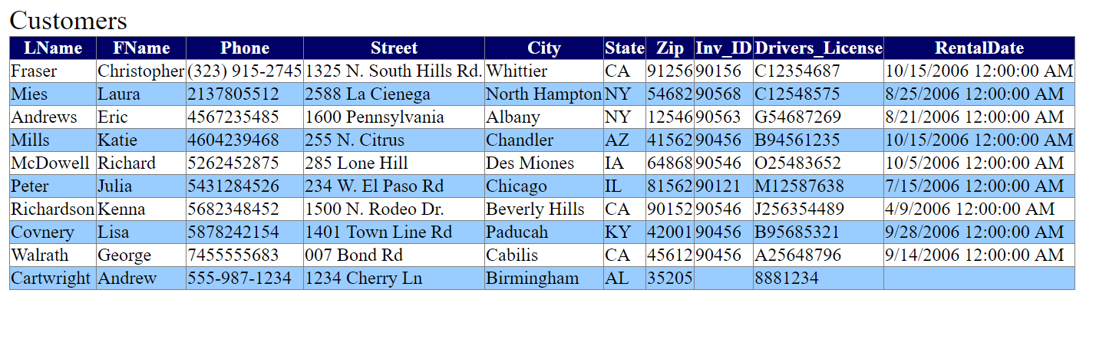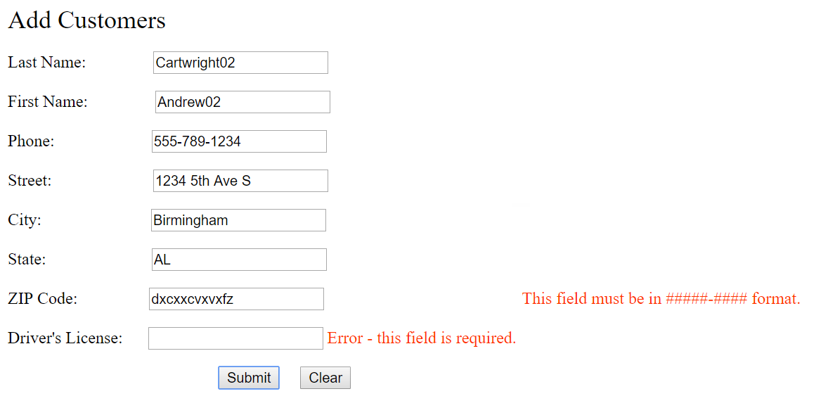

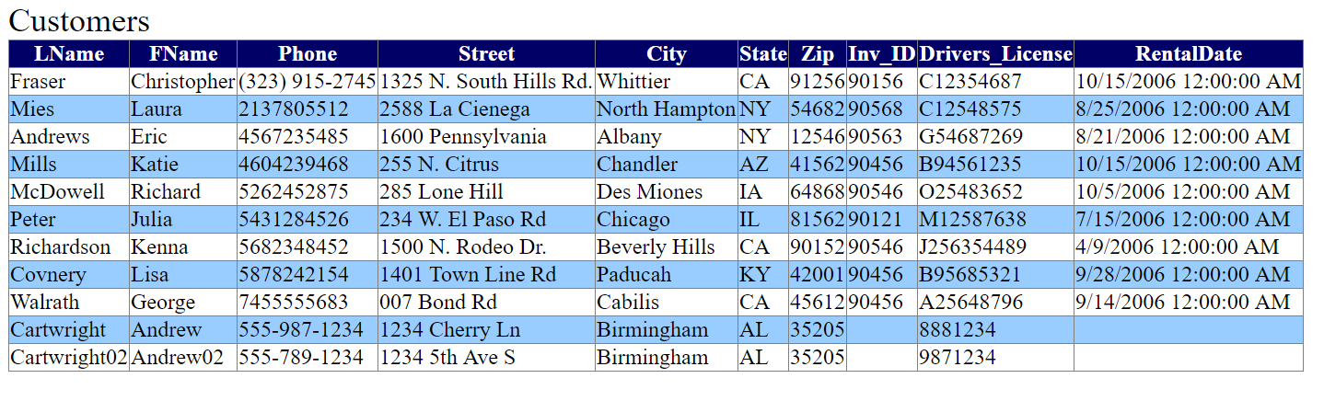

using System;

using System.Collections.Generic;

using System.Linq;

using System.Web;

using System.Web.UI;

using System.Web.UI.WebControls;

using System.Data.Entity;

public partial class AddCustomer : System.Web.UI.Page

{

private CarsEntities dbcontext = new CarsEntities();

protected void Page_Load(object sender, EventArgs e)

{

UnobtrusiveValidationMode = System.Web.UI.UnobtrusiveValidationMode.None;

if (IsPostBack)

{

Validate();

}

}

protected void SubmitButton_Click(object sender, EventArgs e)

{

if (IsValid)

{

var newCust = new Customer

{

FName = FirstNameTextBox.Text,

LName = LastNameTextBox.Text,

Phone = PhoneNumberTextBox.Text,

Street = StreetAddressTextBox.Text,

City = CityTextBox.Text,

State = StateTextBox.Text,

Zip = ZIPCodeTextBox.Text,

Drivers_License = DriversLicenseTextBox.Text

};

dbcontext.Customers.Add(newCust);

dbcontext.SaveChanges();

}

}

protected void ClearButton_Click(object sender, EventArgs e)

{

LastNameTextBox.Text = "";

FirstNameTextBox.Text = "";

PhoneNumberTextBox.Text = "";

StreetAddressTextBox.Text = "";

CityTextBox.Text = "";

StateTextBox.Text = "";

ZIPCodeTextBox.Text = "";

DriversLicenseTextBox.Text = "";

}

}

<%@ Page Language="C#" AutoEventWireup="true" CodeFile="Customers.aspx.cs" Inherits="Customers" %>

<!DOCTYPE html>

<html xmlns="http://www.w3.org/1999/xhtml">

<head runat="server">

<title></title>

<style type="text/css">

.auto-style1 {

font-size: x-large;

}

</style>

</head>

<body>

<form id="form1" runat="server">

<div class="auto-style1">

Customers</div>

<asp:GridView ID="CustomersGridView" runat="server" AutoGenerateColumns="False" DataKeyNames="Phone" DataSourceID="SqlDataSource1" EmptyDataText="There are no data records to display.">

<AlternatingRowStyle BackColor="#99CCFF" />

<Columns>

<asp:BoundField DataField="LName" HeaderText="LName" SortExpression="LName" />

<asp:BoundField DataField="FName" HeaderText="FName" SortExpression="FName" />

<asp:BoundField DataField="Phone" HeaderText="Phone" ReadOnly="True" SortExpression="Phone" />

<asp:BoundField DataField="Street" HeaderText="Street" SortExpression="Street" />

<asp:BoundField DataField="City" HeaderText="City" SortExpression="City" />

<asp:BoundField DataField="State" HeaderText="State" SortExpression="State" />

<asp:BoundField DataField="Zip" HeaderText="Zip" SortExpression="Zip" />

<asp:BoundField DataField="Inv_ID" HeaderText="Inv_ID" SortExpression="Inv_ID" />

<asp:BoundField DataField="Drivers_License" HeaderText="Drivers_License" SortExpression="Drivers_License" />

<asp:BoundField DataField="RentalDate" HeaderText="RentalDate" SortExpression="RentalDate" />

</Columns>

<HeaderStyle BackColor="#000066" ForeColor="White" />

</asp:GridView>

<asp:SqlDataSource ID="SqlDataSource1" runat="server" ConnectionString="<%$ ConnectionStrings:CarsConnectionString1 %>" DeleteCommand="DELETE FROM [Customer] WHERE [Phone] = @Phone" InsertCommand="INSERT INTO [Customer] ([LName], [FName], [Phone], [Street], [City], [State], [Zip], [Inv_ID], [Drivers_License], [RentalDate]) VALUES (@LName, @FName, @Phone, @Street, @City, @State, @Zip, @Inv_ID, @Drivers_License, @RentalDate)" ProviderName="<%$ ConnectionStrings:CarsConnectionString1.ProviderName %>" SelectCommand="SELECT [LName], [FName], [Phone], [Street], [City], [State], [Zip], [Inv_ID], [Drivers_License], [RentalDate] FROM [Customer]" UpdateCommand="UPDATE [Customer] SET [LName] = @LName, [FName] = @FName, [Street] = @Street, [City] = @City, [State] = @State, [Zip] = @Zip, [Inv_ID] = @Inv_ID, [Drivers_License] = @Drivers_License, [RentalDate] = @RentalDate WHERE [Phone] = @Phone">

<DeleteParameters>

<asp:Parameter Name="Phone" Type="String" />

</DeleteParameters>

<InsertParameters>

<asp:Parameter Name="LName" Type="String" />

<asp:Parameter Name="FName" Type="String" />

<asp:Parameter Name="Phone" Type="String" />

<asp:Parameter Name="Street" Type="String" />

<asp:Parameter Name="City" Type="String" />

<asp:Parameter Name="State" Type="String" />

<asp:Parameter Name="Zip" Type="String" />

<asp:Parameter Name="Inv_ID" Type="String" />

<asp:Parameter Name="Drivers_License" Type="String" />

<asp:Parameter Name="RentalDate" Type="DateTime" />

</InsertParameters>

<UpdateParameters>

<asp:Parameter Name="LName" Type="String" />

<asp:Parameter Name="FName" Type="String" />

<asp:Parameter Name="Street" Type="String" />

<asp:Parameter Name="City" Type="String" />

<asp:Parameter Name="State" Type="String" />

<asp:Parameter Name="Zip" Type="String" />

<asp:Parameter Name="Inv_ID" Type="String" />

<asp:Parameter Name="Drivers_License" Type="String" />

<asp:Parameter Name="RentalDate" Type="DateTime" />

<asp:Parameter Name="Phone" Type="String" />

</UpdateParameters>

</asp:SqlDataSource>

</form>

</body>

</html>

<%@ Page Language="C#" AutoEventWireup="true" CodeFile="RentalCars.aspx.cs" Inherits="RentalCars" %>

<!DOCTYPE html>

<html xmlns="http://www.w3.org/1999/xhtml">

<head runat="server">

<title></title>

<style type="text/css">

.auto-style1 {

font-size: x-large;

}

</style>

</head>

<body>

<form id="form1" runat="server">

<div class="auto-style1">

Rental Cars</div>

<asp:SqlDataSource ID="SqlDataSource1" runat="server" ConnectionString="<%$ ConnectionStrings:CarsConnectionString1 %>" DeleteCommand="DELETE FROM [Vehicle] WHERE [Inv_ID] = @Inv_ID" InsertCommand="INSERT INTO [Vehicle] ([Inv_ID], [Manuf_Name], [Model], [CarSize]) VALUES (@Inv_ID, @Manuf_Name, @Model, @CarSize)" ProviderName="<%$ ConnectionStrings:CarsConnectionString1.ProviderName %>" SelectCommand="SELECT [Inv_ID], [Manuf_Name], [Model], [CarSize] FROM [Vehicle]" UpdateCommand="UPDATE [Vehicle] SET [Manuf_Name] = @Manuf_Name, [Model] = @Model, [CarSize] = @CarSize WHERE [Inv_ID] = @Inv_ID">

<DeleteParameters>

<asp:Parameter Name="Inv_ID" Type="String" />

</DeleteParameters>

<InsertParameters>

<asp:Parameter Name="Inv_ID" Type="String" />

<asp:Parameter Name="Manuf_Name" Type="String" />

<asp:Parameter Name="Model" Type="String" />

<asp:Parameter Name="CarSize" Type="String" />

</InsertParameters>

<UpdateParameters>

<asp:Parameter Name="Manuf_Name" Type="String" />

<asp:Parameter Name="Model" Type="String" />

<asp:Parameter Name="CarSize" Type="String" />

<asp:Parameter Name="Inv_ID" Type="String" />

</UpdateParameters>

</asp:SqlDataSource>

<asp:DropDownList ID="DropDownList1" runat="server" OnSelectedIndexChanged="DropDownList1_SelectedIndexChanged1">

<asp:ListItem>Economy</asp:ListItem>

<asp:ListItem>Luxury</asp:ListItem>

<asp:ListItem>Mid-size</asp:ListItem>

</asp:DropDownList>

<asp:GridView ID="RentalCarsGridView" runat="server" AutoGenerateColumns="False" EmptyDataText="There are no data records to display." DataKeyNames="Inv_ID" DataSourceID="SqlDataSource1">

<AlternatingRowStyle BackColor="#99CCFF" />

<Columns>

<asp:BoundField DataField="Inv_ID" HeaderText="Inv_ID" ReadOnly="True" SortExpression="Inv_ID" />

<asp:BoundField DataField="Manuf_Name" HeaderText="Manuf_Name" SortExpression="Manuf_Name" />

<asp:BoundField DataField="Model" HeaderText="Model" SortExpression="Model" />

<asp:BoundField DataField="CarSize" HeaderText="CarSize" SortExpression="CarSize" />

</Columns>

<HeaderStyle BackColor="#000066" ForeColor="White" />

</asp:GridView>

</form>

</body>

</html>

<%@ Page Language="C#" AutoEventWireup="true" CodeFile="RentalCars.aspx.cs" Inherits="RentalCars" %>

<!DOCTYPE html>

<html xmlns="http://www.w3.org/1999/xhtml">

<head runat="server">

<title></title>

<style type="text/css">

.auto-style1 {

font-size: x-large;

}

</style>

</head>

<body>

<form id="form1" runat="server">

<div class="auto-style1">

Rental Cars</div>

<asp:SqlDataSource ID="SqlDataSource1" runat="server" ConnectionString="<%$ ConnectionStrings:CarsConnectionString1 %>" DeleteCommand="DELETE FROM [Vehicle] WHERE [Inv_ID] = @Inv_ID" InsertCommand="INSERT INTO [Vehicle] ([Inv_ID], [Manuf_Name], [Model], [CarSize]) VALUES (@Inv_ID, @Manuf_Name, @Model, @CarSize)" ProviderName="<%$ ConnectionStrings:CarsConnectionString1.ProviderName %>" SelectCommand="SELECT [Inv_ID], [Manuf_Name], [Model], [CarSize] FROM [Vehicle]" UpdateCommand="UPDATE [Vehicle] SET [Manuf_Name] = @Manuf_Name, [Model] = @Model, [CarSize] = @CarSize WHERE [Inv_ID] = @Inv_ID">

<DeleteParameters>

<asp:Parameter Name="Inv_ID" Type="String" />

</DeleteParameters>

<InsertParameters>

<asp:Parameter Name="Inv_ID" Type="String" />

<asp:Parameter Name="Manuf_Name" Type="String" />

<asp:Parameter Name="Model" Type="String" />

<asp:Parameter Name="CarSize" Type="String" />

</InsertParameters>

<UpdateParameters>

<asp:Parameter Name="Manuf_Name" Type="String" />

<asp:Parameter Name="Model" Type="String" />

<asp:Parameter Name="CarSize" Type="String" />

<asp:Parameter Name="Inv_ID" Type="String" />

</UpdateParameters>

</asp:SqlDataSource>

<asp:DropDownList ID="DropDownList1" runat="server" OnSelectedIndexChanged="DropDownList1_SelectedIndexChanged1">

<asp:ListItem>Economy</asp:ListItem>

<asp:ListItem>Luxury</asp:ListItem>

<asp:ListItem>Mid-size</asp:ListItem>

</asp:DropDownList>

<asp:GridView ID="RentalCarsGridView" runat="server" AutoGenerateColumns="False" EmptyDataText="There are no data records to display." DataKeyNames="Inv_ID" DataSourceID="SqlDataSource1">

<AlternatingRowStyle BackColor="#99CCFF" />

<Columns>

<asp:BoundField DataField="Inv_ID" HeaderText="Inv_ID" ReadOnly="True" SortExpression="Inv_ID" />

<asp:BoundField DataField="Manuf_Name" HeaderText="Manuf_Name" SortExpression="Manuf_Name" />

<asp:BoundField DataField="Model" HeaderText="Model" SortExpression="Model" />

<asp:BoundField DataField="CarSize" HeaderText="CarSize" SortExpression="CarSize" />

</Columns>

<HeaderStyle BackColor="#000066" ForeColor="White" />

</asp:GridView>

</form>

</body>

</html>