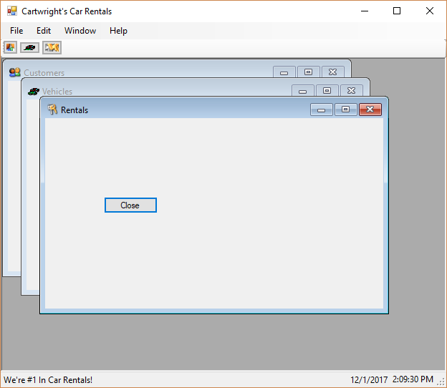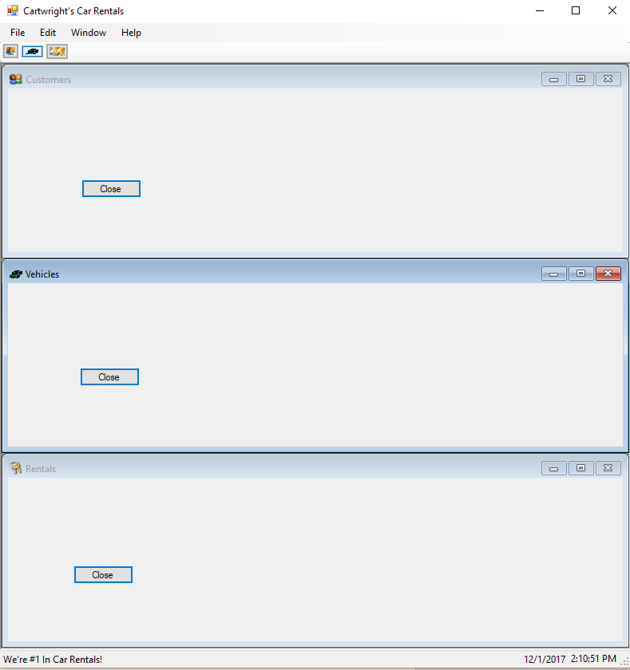

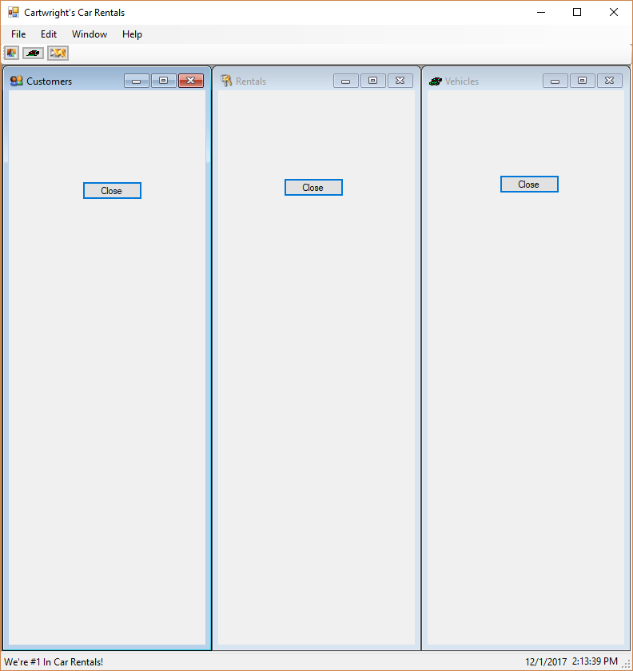

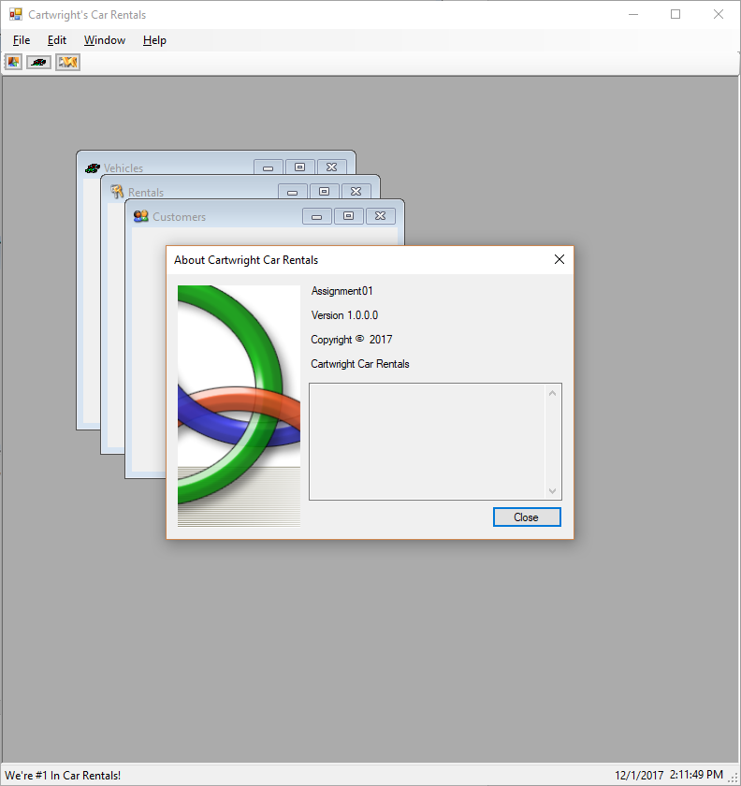

using System;

using System.Collections.Generic;

using System.ComponentModel;

using System.Data;

using System.Drawing;

using System.Linq;

using System.Text;

using System.Threading.Tasks;

using System.Windows.Forms;

namespace Assignment01

{

public partial class Form1 : Form

{

public Form1()

{

InitializeComponent();

}

private void customersToolStripMenuItem_Click(object sender, EventArgs e)

{

Form[] customerFormChildren = this.MdiChildren;

bool arePresent = false;

if (customerFormChildren.Length == 0)

{

Customers aCustomerForm = new Customers();

aCustomerForm.MdiParent = this;

aCustomerForm.Show();

aCustomerForm.Focus();

arePresent = true;

}

else

{

foreach (Form child in customerFormChildren)

{

if (child.Name == "Customers")

{

child.Activate();

arePresent = true;

break;

}

else

arePresent = false;

}

if (!arePresent)

{

Customers aCustomerForm = new Customers();

aCustomerForm.MdiParent = this;

aCustomerForm.Show();

aCustomerForm.Focus();

}

}

}

private void vehiclesToolStripMenuItem_Click(object sender, EventArgs e)

{

Form[] vehicleFormChildren = this.MdiChildren;

bool arePresent = false;

if (vehicleFormChildren.Length == 0)

{

Vehicles aVehicleForm = new Vehicles();

aVehicleForm.MdiParent = this;

aVehicleForm.Show();

aVehicleForm.Focus();

arePresent = true;

}

else

{

foreach (Form child in vehicleFormChildren)

{

if (child.Name == "Vehicles")

{

child.Activate();

arePresent = true;

break;

}

else

arePresent = false;

}

if (!arePresent)

{

Vehicles aVehicleForm = new Vehicles();

aVehicleForm.MdiParent = this;

aVehicleForm.Show();

aVehicleForm.Focus();

}

}

}

private void rentalsToolStripMenuItem_Click(object sender, EventArgs e)

{

Form[] rentalFormChildren = this.MdiChildren;

bool arePresent = false;

if (rentalFormChildren.Length == 0)

{

Rentals aRentalForm = new Rentals();

aRentalForm.MdiParent = this;

aRentalForm.Show();

aRentalForm.Focus();

arePresent = true;

}

else

{

foreach (Form child in rentalFormChildren)

{

if (child.Name == "Rentals")

{

child.Activate();

arePresent = true;

break;

}

else

arePresent = false;

}

if (!arePresent)

{

Rentals aRentalForm = new Rentals();

aRentalForm.MdiParent = this;

aRentalForm.Show();

aRentalForm.Focus();

}

}

}

private void exitToolStripMenuItem_Click(object sender, EventArgs e)

{

Close();

}

private void aboutToolStripMenuItem_Click(object sender, EventArgs e)

{

AboutBox1 aboutBox = new AboutBox1();

aboutBox.ShowDialog();

aboutBox.Focus();

}

private void tileToolStripMenuItem_Click(object sender, EventArgs e)

{

this.LayoutMdi(MdiLayout.TileHorizontal);

}

private void tileVerticalToolStripMenuItem_Click(object sender, EventArgs e)

{

this.LayoutMdi(MdiLayout.TileVertical);

}

private void cascadeToolStripMenuItem_Click(object sender, EventArgs e)

{

this.LayoutMdi(MdiLayout.Cascade);

}

private void CustomersButton_Click(object sender, EventArgs e)

{

customersToolStripMenuItem_Click(sender, e);

}

private void VehiclesButton_Click(object sender, EventArgs e)

{

vehiclesToolStripMenuItem_Click(sender, e);

}

private void RentalsButton_Click(object sender, EventArgs e)

{

rentalsToolStripMenuItem_Click(sender, e);

}

private void timer1_Tick(object sender, EventArgs e)

{

DateToolStripStatusLabel.Text = DateTime.Today.ToShortDateString();

TimeToolStripStatusLabel.Text = DateTime.Now.ToLongTimeString();

}

private void Form1_Load(object sender, EventArgs e)

{

DateToolStripStatusLabel.Text = DateTime.Today.ToShortDateString();

TimeToolStripStatusLabel.Text = DateTime.Now.ToLongTimeString();

}

}

}