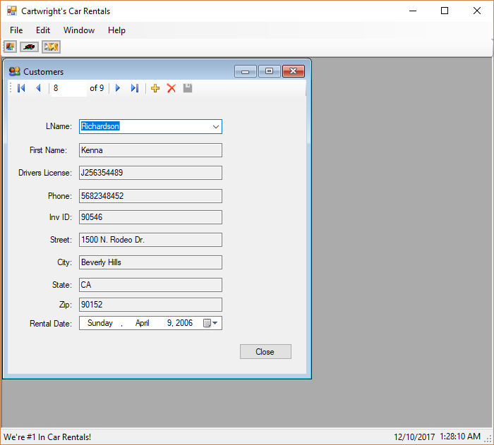 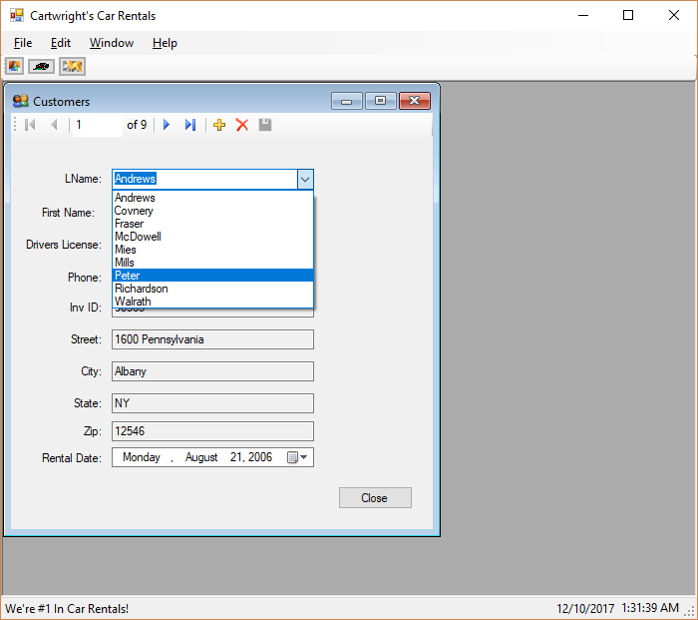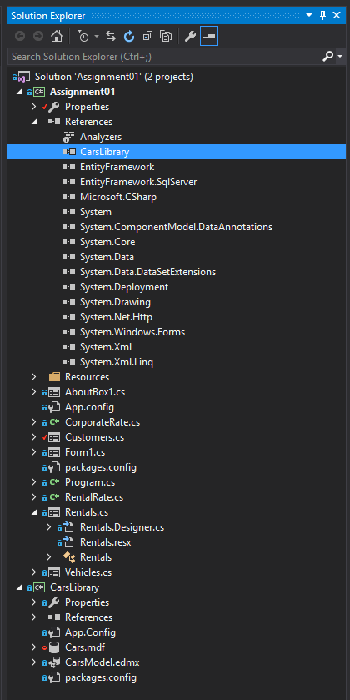

using System;

using System.Collections.Generic;

using System.ComponentModel;

using System.Data;

using System.Data.Entity; // Required for Load function call in Load method

using System.Drawing;

using System.Linq;

using System.Text;

using System.Threading.Tasks;

using System.Windows.Forms;

namespace Assignment01

{

public partial class Customers : Form

{

private CarsLibrary.CarsEntities dbcontext = new CarsLibrary.CarsEntities();

public Customers()

{

InitializeComponent();

}

private void button1_Click(object sender, EventArgs e)

{

Close();

}

private void Customers_Load(object sender, EventArgs e)

{

dbcontext.Customers.OrderBy(Customers => Customers.LName).ThenBy(Customers => Customers.FName).Load();

customerBindingSource.DataSource = dbcontext.Customers.Local;

}

}

}

<?xml version="1.0" encoding="utf-8"?>

<configuration>

<configSections>

<!-- For more information on Entity Framework configuration, visit http://go.microsoft.com/fwlink/?LinkID=237468 -->

<section name="entityFramework" type="System.Data.Entity.Internal.ConfigFile.EntityFrameworkSection, EntityFramework, Version=6.0.0.0, Culture=neutral, PublicKeyToken=b77a5c561934e089" requirePermission="false" />

</configSections>

<startup>

<supportedRuntime version="v4.0" sku=".NETFramework,Version=v4.6.1" />

</startup>

<entityFramework>

<defaultConnectionFactory type="System.Data.Entity.Infrastructure.SqlConnectionFactory, EntityFramework" />

<providers>

<provider invariantName="System.Data.SqlClient" type="System.Data.Entity.SqlServer.SqlProviderServices, EntityFramework.SqlServer" />

</providers>

</entityFramework>

<connectionStrings>

<add name="CarsEntities" connectionString="metadata=res://*/CarsModel.csdl|res://*/CarsModel.ssdl|res://*/CarsModel.msl;provider=System.Data.SqlClient;provider connection string=&quot;data source=(LocalDB)\MSSQLLocalDB;attachdbfilename=|DataDirectory|\Cars.mdf;integrated security=True;connect timeout=30;MultipleActiveResultSets=True;App=EntityFramework&quot;" providerName="System.Data.EntityClient" />

</connectionStrings>

</configuration>

<?xml version="1.0" encoding="utf-8"?>

<packages>

<package id="EntityFramework" version="6.2.0" targetFramework="net452" />

</packages>