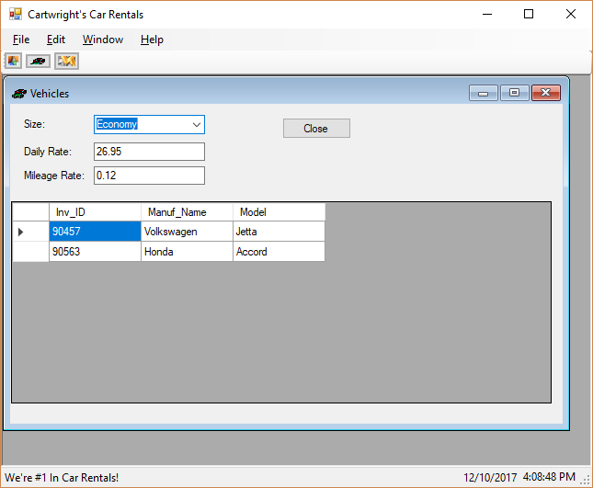

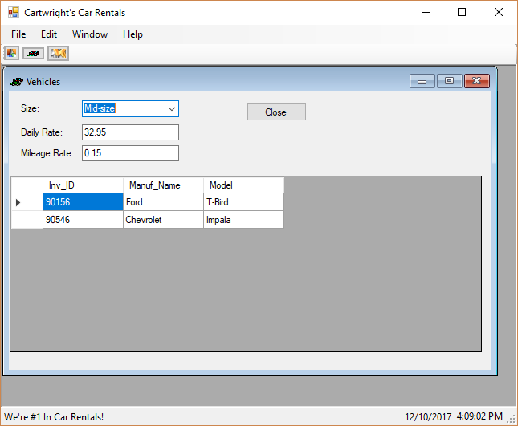

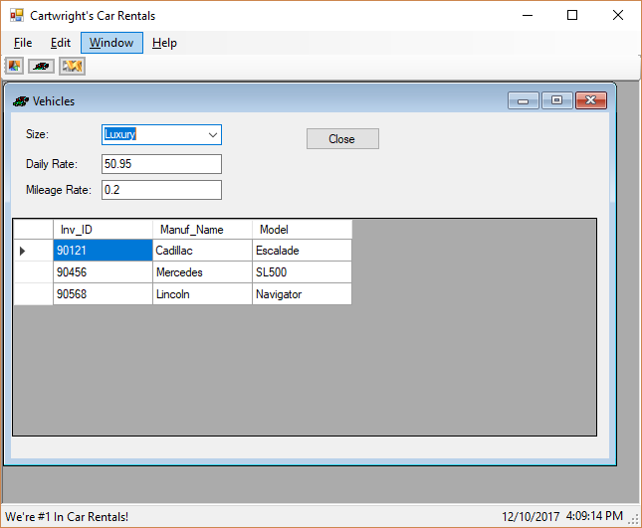

using System;

using System.Collections.Generic;

using System.ComponentModel;

using System.Data;

using System.Data.Entity;

using System.Drawing;

using System.Linq;

using System.Text;

using System.Threading.Tasks;

using System.Windows.Forms;

namespace Assignment01

{

public partial class Vehicles : Form

{

public Vehicles()

{

InitializeComponent();

}

private void button1_Click(object sender, EventArgs e)

{

Close();

}

private CarsLibrary.CarsEntities dbcontext = new CarsLibrary.CarsEntities();

private void Vehicles_Load(object sender, EventArgs e)

{

dbcontext.Vehicles.Load();

vehicleBindingSource.DataSource = dbcontext.Vehicles.Local;

}

private void sizeComboBox_SelectedIndexChanged_1(object sender, EventArgs e)

{

int index = sizeComboBox.SelectedIndex;

switch (index)

{

case 0:

vehicleBindingSource.DataSource = dbcontext.Vehicles.Local.Where(Vehicles => Vehicles.CarSize1.Size == "Economy");

break;

case 1:

vehicleBindingSource.DataSource = dbcontext.Vehicles.Local.Where(Vehicles => Vehicles.CarSize1.Size == "Luxury");

break;

case 2:

vehicleBindingSource.DataSource = dbcontext.Vehicles.Local.Where(Vehicles => Vehicles.CarSize1.Size == "Mid-size");

break;

}

vehicleBindingSource.MoveFirst();

}

}

}

//------------------------------------------------------------------------------

// <auto-generated>

// This code was generated from a template.

//

// Manual changes to this file may cause unexpected behavior in your application.

// Manual changes to this file will be overwritten if the code is regenerated.

// </auto-generated>

//------------------------------------------------------------------------------

namespace CarsLibrary

{

using System;

using System.Collections.Generic;

using System.Collections.ObjectModel;

public partial class CarSize

{

[System.Diagnostics.CodeAnalysis.SuppressMessage("Microsoft.Usage", "CA2214:DoNotCallOverridableMethodsInConstructors")]

public CarSize()

{

this.Reservations = new HashSet<Reservation>();

// this.Vehicles = new HashSet<Vehicle>();

this.Vehicles = new ObservableCollection<Vehicle>();

}

public string Size { get; set; }

public string SizeCode { get; set; }

public Nullable<double> DailyRate { get; set; }

public Nullable<double> MileageRate { get; set; }

[System.Diagnostics.CodeAnalysis.SuppressMessage("Microsoft.Usage", "CA2227:CollectionPropertiesShouldBeReadOnly")]

public virtual ICollection<Reservation> Reservations { get; set; }

[System.Diagnostics.CodeAnalysis.SuppressMessage("Microsoft.Usage", "CA2227:CollectionPropertiesShouldBeReadOnly")]

public virtual ObservableCollection<Vehicle> Vehicles { get; set; }

}

}