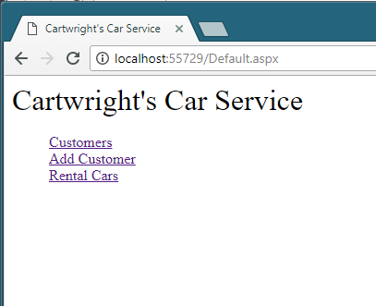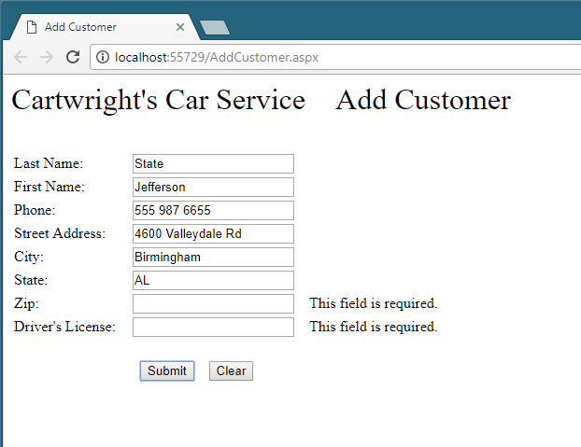

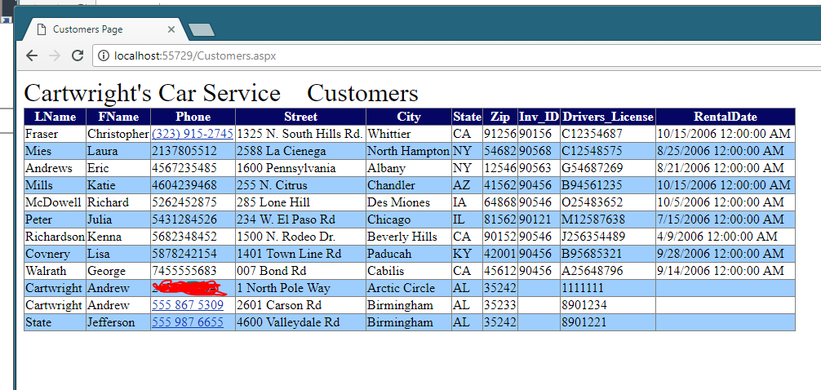

using System;

using System.Collections.Generic;

using System.Linq;

using System.Web;

using System.Web.UI;

using System.Web.UI.WebControls;

using System.Data;

using System.Data.Entity;

namespace RentalCarService

{

public partial class WebForm1 : System.Web.UI.Page

{

protected void Page_Load(object sender, EventArgs e)

{

}

}

}

using System;

using System.Collections.Generic;

using System.Data.Entity;

using System.Linq;

using System.Web;

using System.Web.UI;

using System.Web.UI.WebControls;

namespace RentalCarService

{

public partial class AddCustomer : System.Web.UI.Page

{

private RentalCarService.CarsEntities dbcontext = new RentalCarService.CarsEntities();

protected void Page_Load(object sender, EventArgs e)

{

UnobtrusiveValidationMode = System.Web.UI.UnobtrusiveValidationMode.None;

if (IsPostBack)

{

Validate();

}

}

protected void ClearButton_Click(object sender, EventArgs e)

{

LastNameTextBox.Text = "";

FirstNameTextBox.Text = "";

PhoneNumberTextBox.Text = "";

StreetAddressTextBox.Text = "";

CityTextBox.Text = "";

StateTextBox.Text = "";

ZIPCodeTextBox.Text = "";

DriversLicenseTextBox.Text = "";

}

protected void SubmitButton_Click(object sender, EventArgs e)

{

if (IsValid)

{

var newCust = new Customer

{

FName = FirstNameTextBox.Text,

LName = LastNameTextBox.Text,

Phone = PhoneNumberTextBox.Text,

Street = StreetAddressTextBox.Text,

City = CityTextBox.Text,

State = StateTextBox.Text,

Zip = ZIPCodeTextBox.Text,

Drivers_License = DriversLicenseTextBox.Text

};

dbcontext.Customers.Add(newCust);

// Didn't know if we needed persistent state beyond session or not, so wrote it to db anyway

dbcontext.SaveChanges();

}

}

}

}

<%@ Page Language="C#" AutoEventWireup="true" CodeBehind="Default.aspx.cs" Inherits="RentalCarService.WebForm1" %>

<!DOCTYPE html>

<html xmlns="http://www.w3.org/1999/xhtml">

<head runat="server">

<title>Cartwright's Car Service</title>

<style type="text/css">

.auto-style1 {

font-size: xx-large;

}

.auto-style2 {

margin-left: 40px;

}

</style>

</head>

<body>

<form id="form1" runat="server">

<div class="auto-style1">

Cartwright&#39;s Car Service</div>

<div class="auto-style2">

<br />

<asp:HyperLink ID="CustomersHyperLink" runat="server" NavigateUrl="~/Customers.aspx">Customers</asp:HyperLink>

<br />

<asp:HyperLink ID="AddCustomerHyperLink" runat="server" NavigateUrl="~/AddCustomer.aspx">Add Customer</asp:HyperLink>

<br />

<asp:HyperLink ID="RentalCarsHyperLink" runat="server" NavigateUrl="~/RentalCars.aspx">Rental Cars</asp:HyperLink>

</div>

<br />

<br />

</form>

</body>

</html>

<%@ Page Language="C#" AutoEventWireup="true" CodeBehind="AddCustomer.aspx.cs" Inherits="RentalCarService.AddCustomer" %>

<!DOCTYPE html>

<html xmlns="http://www.w3.org/1999/xhtml">

<head runat="server">

<title>Add Customer</title>

<style type="text/css">

.auto-style1 {

font-size: xx-large;

}

.auto-style2 {

width: 123px;

}

.auto-style3 {

width: 381px;

}

</style>

</head>

<body style="height: 45px">

<form id="form1" runat="server">

<div class="auto-style1">

Cartwright&#39;s Car Service&nbsp;&nbsp;&nbsp; Add Customer<br />

<br />

</div>

<table style="width:100%;">

<tr>

<td class="auto-style2">Last Name:</td>

<td class="auto-style3">

<asp:TextBox ID="LastNameTextBox" runat="server"></asp:TextBox>

&nbsp;&nbsp;

<asp:RequiredFieldValidator ID="RequiredFieldValidator1" runat="server" ControlToValidate="LastNameTextBox" ErrorMessage="This field is required."></asp:RequiredFieldValidator>

</td>

<td>&nbsp;</td>

</tr>

<tr>

<td class="auto-style2">First Name:</td>

<td class="auto-style3">

<asp:TextBox ID="FirstNameTextBox" runat="server"></asp:TextBox>

&nbsp;&nbsp;

<asp:RequiredFieldValidator ID="RequiredFieldValidator2" runat="server" ControlToValidate="FirstNameTextBox" ErrorMessage="This field is required."></asp:RequiredFieldValidator>

</td>

<td>&nbsp;</td>

</tr>

<tr>

<td class="auto-style2">Phone:</td>

<td class="auto-style3">

<asp:TextBox ID="PhoneNumberTextBox" runat="server"></asp:TextBox>

&nbsp;&nbsp;

<asp:RequiredFieldValidator ID="RequiredFieldValidator3" runat="server" ControlToValidate="PhoneNumberTextBox" ErrorMessage="This field is required."></asp:RequiredFieldValidator>

</td>

<td>&nbsp;</td>

</tr>

<tr>

<td class="auto-style2">Street Address:</td>

<td class="auto-style3">

<asp:TextBox ID="StreetAddressTextBox" runat="server"></asp:TextBox>

&nbsp;&nbsp;

<asp:RequiredFieldValidator ID="RequiredFieldValidator4" runat="server" ControlToValidate="StreetAddressTextBox" ErrorMessage="This field is required."></asp:RequiredFieldValidator>

</td>

<td>&nbsp;</td>

</tr>

<tr>

<td class="auto-style2">City:</td>

<td class="auto-style3">

<asp:TextBox ID="CityTextBox" runat="server"></asp:TextBox>

&nbsp;&nbsp;

<asp:RequiredFieldValidator ID="RequiredFieldValidator5" runat="server" ControlToValidate="CityTextBox" ErrorMessage="This field is required."></asp:RequiredFieldValidator>

</td>

<td>&nbsp;</td>

</tr>

<tr>

<td class="auto-style2">State:</td>

<td class="auto-style3">

<asp:TextBox ID="StateTextBox" runat="server"></asp:TextBox>

&nbsp;&nbsp;

<asp:RequiredFieldValidator ID="RequiredFieldValidator6" runat="server" ControlToValidate="StateTextBox" ErrorMessage="This field is required."></asp:RequiredFieldValidator>

</td>

<td>&nbsp;</td>

</tr>

<tr>

<td class="auto-style2">Zip:</td>

<td class="auto-style3">

<asp:TextBox ID="ZIPCodeTextBox" runat="server"></asp:TextBox>

&nbsp;&nbsp;

<asp:RequiredFieldValidator ID="RequiredFieldValidator7" runat="server" ControlToValidate="ZIPCodeTextBox" ErrorMessage="This field is required."></asp:RequiredFieldValidator>

</td>

<td>&nbsp;</td>

</tr>

<tr>

<td class="auto-style2">Driver&#39;s License:</td>

<td class="auto-style3">

<asp:TextBox ID="DriversLicenseTextBox" runat="server"></asp:TextBox>

&nbsp;&nbsp;

<asp:RequiredFieldValidator ID="RequiredFieldValidator8" runat="server" ControlToValidate="DriversLicenseTextBox" ErrorMessage="This field is required."></asp:RequiredFieldValidator>

</td>

<td>&nbsp;</td>

</tr>

<tr>

<td class="auto-style2">&nbsp;</td>

<td class="auto-style3">&nbsp;</td>

<td>&nbsp;</td>

</tr>

<tr>

<td class="auto-style2">&nbsp;</td>

<td class="auto-style3">

&nbsp;

<asp:Button ID="SubmitButton" runat="server" OnClick="SubmitButton_Click" Text="Submit" />

&nbsp;&nbsp;

<asp:Button ID="ClearButton" runat="server" OnClick="ClearButton_Click" Text="Clear" />

</td>

<td>&nbsp;</td>

</tr>

</table>

</form>

</body>

</html>