Supplementary Material
Pulling back before dropping out: Declining competition participation precedes exit from Norwegian youth track and field — a 14-year register study
Atle Guttormsen, Norwegian University of Life Sciences (NMBU)

Supplementary Methods
This material accompanies the main article and expands the condensed Statistical Analysis section. Citations here appear in the supplementary reference list below.

S-M1. Time-to-cessation survival analysis: full specification
We modeled time to the last active season using Cox proportional hazards regression with Efron’s tie-handling (Efron, 1977), implemented in lifelines (Davidson-Pilon, 2019). The primary Cox specification (Supplementary Tables S10 and S16) contains a baseline-only predictor set; its clock starts at the end of the age-14 season, when the predictor window closes, so the 229 athletes whose final active season was at 13 had already left and are not at risk (n = 1,908, 1,747 events). The original analysis started the clock at the baseline meet, which for athletes first seen at 13 lies inside the predictor window, so that their age-14 volume partly recorded an exit that had already happened (volume HR 0.56 with that time origin versus 0.65 here). We additionally estimated (a) a landmark analysis (van Houwelingen, 2007) restricted to athletes still in their career at age 16, that is, with a final active season at 16 or later (n = 1,148, complete-case n = 1,147; Supplementary Table S8), and (b) a post-baseline Cox specification with ages-15–16 covariates (Table 5 gives the period-specific decomposition; Supplementary Figure S4 gives its forest plot, and Supplementary Table S6 the HHI-stratified variant); the latter is interpreted with caveats about operational overlap between predictor and outcome windows. Two properties of the landmark analysis deserve note. First, the at-risk set excludes athletes who had already exited; the earlier entry rule (≥1 result at 16) admitted 71 athletes whose final active season was before 16, whose events therefore preceded time zero. Second, follow-up time is measured from age 16, so the age-16 portion of the exposure window (volume at ages 15–16) lies at the very start of the at-risk window; the version of the same question without this overlap is therefore the logistic change model of main-text Section 3.5 (level at 15 + change 15→16 among athletes active at 16, outcome at 20+), although 16 was the final active season for a quarter of these athletes. Proportional hazards were assessed via scaled Schoenfeld residuals (Grambsch & Therneau, 1994) for both specifications (Supplementary Table S1); volume violates the assumption in both, so its hazard ratios are time-averaged summaries. Pooled hazard ratios from the post-baseline specification average over the strongly time-varying pattern shown in Table 5 and are reported descriptively; no robustness quantity (e.g., E-value) is computed from that specification. Cluster-robust standard errors clustered on baseline club (Lin & Wei, 1989) and sex-stratified models are reported in Supplementary Tables S2 and S7. Kaplan–Meier curves were stratified by sex, ages-15–16 volume, and pre-17 championship types. The event is the final active season observed through 2025 (S-M10).

S-M2. Sample size and detection capacity
Classical hypothesis-testing sample-size power calculations are not directly applicable to population-based register studies where the full cohort is observed; we treat the estimates as descriptions of this population rather than inferences to a hypothetical super-population (Berk & Freedman, 2003), while retaining confidence intervals and p-values as summaries of stochastic (process) variability in who retains. We therefore replace a priori power with a detection-capacity analysis: given the observed event count, what is the smallest effect size the design could reliably detect, relative to effect sizes in prior dropout research? Following Hsieh and Lavori (2000), our d = 1,747 events in the baseline-only Cox model (clock from the end of the age-14 season) at α = .05 and 80% power yield HR_{min} ≈ 1.07 per SD (≈ 1.14 for a balanced binary covariate); the omitted variance-inflation factor for covariate correlation would move this only trivially (to ≈ 1.07–1.08 at ρ ≈ .3–.45). For the primary logistic analysis (n = 2,136, 347 retainers), the normal-covariate approximation gives a minimum detectable odds ratio of ≈ 1.18 per SD at 80% power (Supplementary Table S4). Prior work on youth-sport dropout reports small-to-moderate effects (Cohen’s d ≈ 0.2–0.5; ORs ≈ 1.4–2.5; Back et al., 2022; Espedalen & Seippel, 2024; García Calvo et al., 2010; Sarrazin et al., 2002). Detection capacity is therefore well below typical effect magnitudes, so null findings should be interpreted as substantively small rather than underpowered.

S-M3. Performance scoring, missing data, multiple imputation, and athletes without registered sex
Tyrving scoring. Every result is scored when its event and implement or hurdle specification match a row of the Tyrving table (the Norwegian Athletics Federation’s workbook, 2014 version) for the athlete’s sex and calendar age; the register codes events with their specification (e.g., shot put 3 kg, 60 m hurdles 76.2 cm), and the table gives one row per age-appropriate specification, so the events contested at the baseline meet (sprints, middle distances, hurdles, jumps, throws, race walking) are covered, except 54 hammer results (0.7% of baseline results) thrown with an implement that has no norm for the athlete’s sex and age (a 3 kg hammer on a 110 cm wire, whereas the table’s 3 kg norms are for a 119.5 cm wire, or a 2 kg hammer outside the girls’ 13-year class); each of these athletes has other scored baseline results. Take-off-zone long and triple jumps, used in these age groups, have no separate norm and are scored against the board-jump norm (a slight advantage to zone jumpers; scoring them as missing instead leaves 17 rather than 2 athletes without a baseline score and gives volume OR 2.06 [1.82, 2.34], Tyrving OR 1.78 [1.50, 2.12], and CV-AUC 0.768, essentially unchanged). Race-walk and middle-distance times recorded in minutes.seconds format are converted before scoring. Points follow the table’s own formulas, which differ by event type: a linear rate per hundredth of a second for runs up to 400 m and per tenth of a second for 600 m and longer races and race walking; a linear rate per centimetre for horizontal jumps and high jump; and, for throws and pole vault, three rates per centimetre (one above the reference, one down to 80% of it, and a steeper one below 80%). Points are truncated to whole numbers. Our implementation reproduces the workbook exactly: 1,596 of 1,596 test values, computed by the workbook itself, agree. With this scoring, 99.1% of baseline-meet results receive a score; none reaches the 1,500-point cap.
Missing data. Baseline Tyrving is missing for 2 athletes (0.1%), both without registered sex (sex-specific norms cannot be applied). HHI, volume and the outcome are complete. The primary analysis is therefore complete-case (n = 2,136); included and excluded athletes are compared in Supplementary Table S25, and the main analysis samples are mapped in Supplementary Table S12. Multiple imputation used chained equations (van Buuren & Groothuis-Oudshoorn, 2011) as implemented in scikit-learn’s iterative imputer: Bayesian ridge conditional models, draws from the posterior predictive distribution, 15 iterations, and m = 20 imputed datasets with different seeds. The imputation model contains the outcome (active senior status), sex, baseline Tyrving, HHI and pre-milestone volume; a sensitivity analysis adds auxiliary variables (primary baseline event category, region, birth cohort, club size, and the number of results at ages 13–14). Sex is never imputed (the 2 athletes without registered sex are excluded beforehand, n = 2,136). Estimates were pooled with Rubin’s rules. Predictive performance under imputation was estimated with the imputation model fitted inside each training fold, without the outcome (so no outcome information reaches the validation fold), and applied to the held-out fold; this was repeated for each of the 20 imputations and the CV-AUCs averaged (Supplementary Table S21).
In the corrected data no sex-known athlete lacks a score, so imputation and complete-case analysis coincide. Supplementary Table S21 therefore also reports the same procedures on the submitted analysis file (Tyrving missing for 395 of 2,099 sex-known athletes, 18.8%), where imputation matters: pooled estimates (volume OR 2.34 [2.07, 2.66] with the outcome-including model; 2.34 [2.06, 2.65] with auxiliary variables) and predictive performance (CV-AUC 0.751, range 0.745–0.755 across imputations) were essentially the same as complete case (2.40 [2.08, 2.76]; CV-AUC 0.753).
Athletes without registered sex. The register publishes each result under a sex-specific class (boys and girls, men and women), from which the register extract takes each athlete’s binary sex. In the submitted data 24 cohort athletes had none; after the extract’s sex coding was re-derived in July 2026 from the class headings of the federation’s meet pages, 2 (0.1%) remain. They are excluded from all models that adjust for sex (except the mean-imputation check of the post-baseline Cox model in Supplementary Table S5, which keeps every athlete and, as in the submission, codes them as male) and from Tyrving scoring, but included in cohort totals, the fixed-effects model (which has no sex term) and the full-cohort descriptive analyses (one of the two reached senior status). The same re-derivation recoded 8 athletes (6 from male to female, 2 from female to male); for all 30 athletes whose sex changed or became known, the class headings on the meet pages confirm the new value. The sex-specific implements and hurdle heights an athlete uses at ages 12–17 provide a consistency check (class and implement come from the same published result; each result is tested against the Tyrving rows for either sex at that age). Of these 30 athletes, 24 have implements that point to one sex, and all 24 agree with the new value (none with the original). Across the cohort, among the 1,296 athletes with clear evidence (at least three more results fitting one sex than the other), the implements contradict the registered sex for 2.

S-M4. Cross-validation, calibration, and comparison of discrimination
Cross-validation in the primary and all new analyses uses stratified 5-fold splits repeated 20 times with different seeds (Supplementary Tables S9, S17 and S24, re-runs of the original scripts, keep the submission’s single split, as their notes state); in each training fold the standardization of continuous covariates is re-estimated and applied to the held-out fold (a scikit-learn pipeline), and an unpenalized logistic model is fitted. The CV-AUC is the mean of the 100 fold-level AUCs. Its 95% CI, and the CIs and p-values for differences between models fitted on identical folds, use the corrected resampled t-statistic for repeated k-fold cross-validation, which multiplies the variance of the fold-level estimates by (1/J + n_{test}/n_{train}), with J = 100 fold-level estimates, to account for overlapping training sets (Nadeau & Bengio, 2003). Calibration was assessed on the out-of-fold predicted probabilities averaged over the 20 repeats: the calibration slope (logistic regression of the outcome on the linear predictor), calibration-in-the-large (intercept of a logistic model with the linear predictor as offset), and the Brier score. To test transfer across clubs, the cross-validation was repeated with stratified group folds, keeping every baseline club (287 clubs) entirely within either the training or the validation fold.
Standardizing on the full data before cross-validation, as in the original submission, cannot leak outcome information, because the standardization uses no outcome data and an unpenalized logistic regression is invariant to affine transformations of its covariates; re-running the submitted analysis with standardization inside the folds reproduced its AUC, calibration and Brier score to the third decimal (Supplementary Table S26). For the early-warning thresholds (Table 6) we computed sensitivity, specificity, positive and negative predictive value, and absolute senior-retention rates among flagged and unflagged athletes on a single denominator (the full cohort, n = 2,138) with 2,000-replicate bootstrap percentile confidence intervals.

S-M5. E-values for unmeasured confounding
E-values (VanderWeele & Ding, 2017) are computed for the primary baseline-window estimates only. Because the outcome is common (16.3%), the primary odds ratio is first converted to an approximate risk ratio via RR ≈ √OR before applying E = RR + √(RR(RR − 1)): OR 2.04 → RR ≈ 1.43 → E ≈ 2.2 (CI bound 2.0). The baseline-only Cox hazard ratio (0.65 per SD, time zero at the end of age 14; a time-averaged estimate, since volume violates proportional hazards) is converted with the common-outcome formula RR ≈ (1 − 0.5^{√HR})/(1 − 0.5^{√(1/HR)}), inverted because the association is protective, giving E ≈ 2.0 (CI bound 1.9; Supplementary Table S3). An earlier version of this analysis computed E-values from the post-baseline (ages-15–16) specification; those values are not reported because that specification overlaps the outcome window.

S-M6. Exit-aligned trajectories, change models, and the within-athlete fixed-effects model
To test the within-athlete decline claim at the individual level, each dropout’s volume history was aligned to their own final active season (last calendar year with ≥2 results). For dropouts with final seasons at ages 15–19 (n = 1,146; ages outside 13–19 are unobserved in the per-age panel), we report median volumes at T−3, T−2, T−1, and T, the share still competing (>0 meets) in the penultimate season, and, among dropouts with final seasons at 16+ (n = 800, for whom at least one season precedes the penultimate), the share whose penultimate-season volume was reduced but nonzero relative to their earlier personal peak, at their peak (abrupt profile), or zero (gap year) (Supplementary Table S19). The change model among athletes still active at 16 is a logistic regression among athletes with ≥2 results at age 16 (n = 1,088): active senior status on sex, volume at age 15 (per SD), and change in volume from 15 to 16 (per SD; volume at 16 minus volume at 15). All predictors are measured by age 16 and every athlete in the sample is, by construction, still active when measured, although for 269 of them 16 was the final active season; the outcome window begins at age 20. In both change models, change is defined as the later minus the earlier volume, so an odds ratio above 1 per SD increase is equivalent to an odds ratio below 1 (its reciprocal) per SD of decline; because the models are linear in the logit, a model with the earlier level and the change is a re-parameterization of one with the two levels, and the per-meet odds ratio for change equals that for the later level.
Fixed-effects model. The panel contains, for every cohort athlete, the number of meets (competition days) in each calendar age-year from 13 to 19 (zero when no result was registered). For athletes whose exit was observed (final active season before 2024), seasons after the final active season are excluded, because they are inactive by definition. The outcome is log(1 + meets); the model includes athlete fixed effects (estimated by the within transformation), age fixed effects, and indicators for the final active season (T) and the three preceding seasons (T−1, T−2, T−3). The reference category comprises all seasons of athletes still active and all seasons more than three seasons before an observed exit, so the indicators measure how each athlete’s volume in the seasons before exit deviates from that athlete’s own volume in earlier seasons, net of the age profile common to all athletes. Standard errors are clustered by athlete; athletes with a single season contribute nothing to the within estimates (1,909 athletes and 8,490 athlete-seasons remain). Two robustness versions were estimated: the same model with meet counts on the linear scale, and the log model restricted to exits at ages 17–19 (plus athletes still active), for whom seasons more than three years before exit are observed. A Wald test compares the T−1 and T−3 coefficients (Supplementary Table S28; Supplementary Figure S5).

S-M7. Club-level analyses
The intraclass correlation of pre-milestone volume across baseline clubs was estimated from a random-intercept linear mixed model (ICC = between-club variance / total variance). The primary logistic model was refit with club random intercepts, now by maximum likelihood with the club intercepts integrated out by Gauss–Hermite quadrature (40 nodes; the submission used a variational Bayes approximation, which understates uncertainty), with a likelihood-ratio test of no club variation (p-value halved for the boundary) (Supplementary Table S22). The model was also estimated with club-clustered (sandwich) standard errors and as a population-averaged model (generalized estimating equations with an exchangeable correlation within baseline clubs). Club fixed effects were estimated by conditional logistic regression with the baseline club as stratum; only clubs with both retained and non-retained athletes contribute (127 clubs, 1,698 athletes). Club-grouped cross-validation is described in S-M4.

S-M8. HHI window, count-dependence stress tests, and combined events
The HHI used in all models except the descriptive Supplementary Table S17 (a re-run of the original analysis) is computed from results in the age-13 and age-14 calendar years, the same window as the volume predictor. Categories are those of the register (sprint, middle distance, long distance, steeplechase, hurdles, jumps, throws, ball throws, race walking). Combined events appear in the register both as a total and as separate constituent results; constituents are counted in their natural categories (multi-event athletes register as diversified), and the totals, 0.16% of results at ages 13–14, carry the category the register assigns to the event. Because HHI ≥ 1/n for an athlete with n results, low result counts mechanically inflate apparent concentration. Three checks (Supplementary Table S20): Spearman correlations of HHI with result and meet counts at ages 13–14; refits of the primary model restricted to athletes with ≥5 and ≥8 results at ages 13–14; and a refit replacing HHI with the finite-sample-corrected index HHI* = (HHI − 1/n)/(1 − 1/n).

S-M9. Derivation and validation of early-warning thresholds across birth cohorts
Because the candidate threshold (< 10 meets) was chosen in the pooled data, cut-offs were also derived in one birth cohort and evaluated, unchanged, in the other (Supplementary Table S29). Two derivation rules, fixed before the cohorts were compared, were used: a capacity rule that flags the lowest quartile of pre-milestone volume in the derivation cohort (athletes at or below its 25th percentile), and the cut-off maximizing Youden’s J (sensitivity + specificity − 1) over 2–40 meets. Performance in the evaluation cohort is reported with 2,000-replicate bootstrap percentile CIs. Both cohorts come from the same register and national system, so this is temporal validation within one setting, not external validation. The < 10 cut-off itself was proposed in the original submission from the pooled data, so the analysis tests whether the retention contrast transfers between cohorts, not whether the cut-off would have been found independently.

S-M10. Temporary gaps, returns, and alternative event definitions
An active season is a calendar year with ≥2 results. Both outcomes use the final active season observed through 2025, so a gap followed by a return is part of a continuing career rather than an exit, and athletes active in 2024 or 2025 are censored (time-to-event) because a final season cannot yet be distinguished from a gap. To quantify how often gaps end in a return, we counted athletes with inactive seasons between baseline and their final active season, and, among athletes with an active season in 2019 or earlier followed by two missed seasons (so that at least four later seasons are observable), the share who ever competed again. The baseline-only Cox model (time zero at the end of the age-14 season; S-M1) was then re-estimated with two alternative event definitions that do not use later returns: the first sustained exit (the last active season before the first run of two or more inactive seasons) and the first inactive season (the spell ends at the first season without ≥2 results) (Supplementary Table S30).

S-M11. The cohort within the register population
To describe the target population, we extracted from the register, as it stood at the data extraction (rows registered by 18 May 2026; results through 2025), every athlete born 1998–2002 with at least one result at ages 13–14 (n = 7,266), defined cohort membership by venue and date exactly as for the analysis data (reproducing its 2,138 members), and computed, from the same register rows for members and non-members alike, the number of meets (competition days) at ages 13–14 and senior status (≥2 results in a calendar year at age 20 or later). For cohort members the register counts agree closely with the analysis data (mean 20.4 vs. 20.5 meets; senior retention 15.9% vs. 16.3%); the small differences reflect rows re-registered after the extraction, which the analysis data retain from the original extract. The sex-adjusted association between volume and senior status was estimated per 10 meets, with repeated cross-validated AUC (Supplementary Table S31).

S-M12. Data preparation and corrections made during the revision
Before the revision we audited the data pipeline, re-deriving every variable from the register; the original analysis file was exactly reproducible from the original extract. The following corrections were made:
- Extraction: a deterministic re-extraction added 334 results missed by the original pagination and removed 332 duplicates.
- Baseline meet: identified by venue and date rather than by meet name, because two venue-days are registered under other names; all 2,123 original cohort members were confirmed and 15 missed participants added.
- Follow-up: results from the partial 2026 season were removed.
- Sex: re-derived in July 2026 from the class headings of the federation’s meet pages (S-M3).
- Region and club: region is read from events other than the 600 m, 1500 m and race walk, whose results from all venues are filed under one venue in 2013–2015, and 163 baseline results that the register files under another venue’s record (found by a check against the source pages, October 2026) take the source’s venue, which changed the region of 2 athletes; club is the club at the baseline meet (for Cohort A it had been the club of the athlete’s last result).
- Volume: counted as competition days, so that one day’s results filed under two meet records count once.
- Tyrving: events registered with their implement or hurdle specification (throws, hurdles, zone jumps, race walking), which the submitted scoring left unscored, are now scored (missing baseline Tyrving 19.7% → 0.1%), with the workbook’s own formulas for 600 m and longer races, race walking, throws and pole vault (S-M3).
- Championship types (post-baseline models only): a type is counted when the athlete has a result before age 17 at a meet whose name identifies it as a district (KM, DM, FM), youth-national (UM), junior-national or senior-national championship, in an age class open to the athlete. National championships are open from age 15; at national combined-events championships athletes under 17 compete in youth classes (counted as youth-national); a district championship named for some age classes (e.g. “11–14 år”, senior) counts only for those ages (an age range of another event held alongside, such as a karusell or indoor games, does not restrict it). Not counted: relay championships (individual results there are side events), qualification, preparation, unofficial and test meets, veterans’ and school championships, meets abroad, and multi-district regional championships (e.g. North Norwegian). The submitted coding matched “UM” as letters anywhere in a meet name (e.g. Bærum, Jubileumsstevne), counted “Junior-NM” as a senior championship, and counted the excluded meets. Every matched meet name was read; corrected, the count changed for 360 athletes. For 10 athletes the district type rests only on meets with embedded district-championship events (“innlagt KM”), at which they may have entered other events.
- Secondary analyses: the time origin of the baseline-only Cox model and the at-risk set of the age-16 landmark (S-M1); club-clustered and population-averaged estimates (S-M7); the cross-validated calibration figure (Supplementary Figure S1); the register-population comparison (S-M11).

Supplementary references
Back, J., Johnson, U., Svedberg, P., McCall, A., & Ivarsson, A. (2022). Drop-out from team sport among adolescents: A systematic review and meta-analysis of prospective studies. Psychology of Sport and Exercise, 61, Article 102205. https://doi.org/10.1016/j.psychsport.2022.102205
Berk, R. A., & Freedman, D. A. (2003). Statistical assumptions as empirical commitments. In T. G. Blomberg & S. Cohen (Eds.), Punishment and social control: Essays in honor of Sheldon L. Messinger (2nd ed., pp. 235–254). Aldine de Gruyter.
Davidson-Pilon, C. (2019). lifelines: Survival analysis in Python. Journal of Open Source Software, 4(40), Article 1317. https://doi.org/10.21105/joss.01317
Efron, B. (1977). The efficiency of Cox’s likelihood function for censored data. Journal of the American Statistical Association, 72(359), 557–565. https://doi.org/10.1080/01621459.1977.10480613
Espedalen, L. E., & Seippel, Ø. (2024). Dropout and social inequality: Young people’s reasons for leaving organized sports. Annals of Leisure Research, 27(2), 197–214. https://doi.org/10.1080/11745398.2022.2070512
García Calvo, T., Cervelló, E., Jiménez, R., Iglesias, D., & Moreno Murcia, J. A. (2010). Using self-determination theory to explain sport persistence and dropout in adolescent athletes. The Spanish Journal of Psychology, 13(2), 677–684. https://doi.org/10.1017/S1138741600002341
Grambsch, P. M., & Therneau, T. M. (1994). Proportional hazards tests and diagnostics based on weighted residuals. Biometrika, 81(3), 515–526. https://doi.org/10.1093/biomet/81.3.515
Hsieh, F. Y., & Lavori, P. W. (2000). Sample-size calculations for the Cox proportional hazards regression model with nonbinary covariates. Controlled Clinical Trials, 21(6), 552–560. https://doi.org/10.1016/S0197-2456(00)00104-5
Lin, D. Y., & Wei, L. J. (1989). The robust inference for the Cox proportional hazards model. Journal of the American Statistical Association, 84(408), 1074–1078. https://doi.org/10.1080/01621459.1989.10478874
Nadeau, C., & Bengio, Y. (2003). Inference for the generalization error. Machine Learning, 52(3), 239–281. https://doi.org/10.1023/A:1024068626366
Sarrazin, P., Vallerand, R. J., Guillet, E., Pelletier, L. G., & Cury, F. (2002). Motivation and dropout in female handballers: A 21-month prospective study. European Journal of Social Psychology, 32(3), 395–418. https://doi.org/10.1002/ejsp.98
van Buuren, S., & Groothuis-Oudshoorn, K. (2011). mice: Multivariate imputation by chained equations in R. Journal of Statistical Software, 45(3), 1–67. https://doi.org/10.18637/jss.v045.i03
van Houwelingen, H. C. (2007). Dynamic prediction by landmarking in event history analysis. Scandinavian Journal of Statistics, 34(1), 70–85. https://doi.org/10.1111/j.1467-9469.2006.00529.x
VanderWeele, T. J., & Ding, P. (2017). Sensitivity analysis in observational research: Introducing the E-value. Annals of Internal Medicine, 167(4), 268–274. https://doi.org/10.7326/M16-2607

Supplementary Tables

Table S1. Proportional-hazards tests (Schoenfeld residuals) for the post-baseline (Panel A) and baseline-only (Panel B) Cox specifications
Covariate | χ²₁ | p
Female | 2.66 | .103
Tyrving (z) | 0.01 | .940
HHI, ages 13–14 (z) | 12.46 | < .001
Volume at age 15–16 (z) | 263.12 | < .001
Championship types | 8.14 | .004
Panel B: baseline-only specification (Supplementary Table S10)
Female | 0.89 | .345
Tyrving (z) | 0.16 | .686
HHI, ages 13–14 (z) | 0.80 | .371
Pre-milestone volume (z) | 133.09 | < .001
Note. Scaled Schoenfeld residuals against rank-transformed time, one degree of freedom per covariate. Panel A: the post-baseline specification (Table 5). Volume violates proportional hazards in both specifications, so its pooled hazard ratios are time-averaged summaries; Table 5 shows how the association changes over follow-up.

Table S2. Cluster-robust SE Cox (clustered on club)
Covariate | HR | Robust 95% CI | p (robust)
Female | 1.16 | [1.03, 1.31] | .016
Tyrving (z) | 0.92 | [0.86, 0.98] | .009
HHI, ages 13–14 (z) | 0.97 | [0.92, 1.04] | .400
Volume at age 15–16 (z) | 0.48 | [0.43, 0.54] | < .001
Championship types | 0.70 | [0.64, 0.76] | < .001
Note. Post-baseline specification; pooled HRs average over the strongly time-varying pattern shown in Table 5 and are descriptive. Club-clustered errors for the primary logistic model are in Supplementary Table S22.

Table S3. E-values for the primary baseline-window volume effect (VanderWeele & Ding, 2017)
Effect | Estimate | Approx. RR (common outcome; protective effects inverted) | E-value (point) | E-value (CI bound)
Pre-milestone volume, primary logistic (per SD) | OR 2.04 [1.80, 2.32] | 1.43 | 2.21 | 2.02
Pre-milestone volume, baseline-only Cox from the end of age 14 (per SD) | HR 0.65 [0.62, 0.69] | 1.34 | 2.02 | 1.90
Note. Because the outcome is common (16.3%), the odds ratio is converted to an approximate risk ratio (RR ≈ √OR) before computing E = RR + √(RR(RR − 1)); the hazard ratio uses the common-outcome conversion RR ≈ (1 − 0.5^{√HR})/(1 − 0.5^{√(1/HR)}), inverted because the association is protective (Supplementary Methods S-M5). E-values are reported for the primary baseline-window specification only; the post-baseline (ages-15–16) specification is not an admissible E-value input because it overlaps the outcome window and violates proportional hazards.

Table S4. Sample-size sensitivity: minimum detectable hazard and odds ratios
Cohort | N (Cox) | Events | Min. detectable HR | n (logistic) | Retainers | Min. detectable OR
Combined | 1,908 | 1,747 | 1.069 | 2,136 | 347 | 1.179
1998–2000 | 1,169 | 1,094 | 1.088 | 1,308 | 207 | 1.236
2001–2002 | 739 | 653 | 1.116 | 828 | 140 | 1.297
Note. 80% power, α = .05, per SD of a standardized covariate. Cox: the baseline-only model with time zero at the end of the age-14 season (Supplementary Table S10); log HR_{min} = (z₀.₉₇₅ + z₀.₈₀)/√events. Logistic: the primary model; log OR_{min} = (z₀.₉₇₅ + z₀.₈₀)/√(n·p·(1 − p)), with p the retention rate (normal-covariate approximation). Supplementary Methods S-M2.

Table S5. Complete-case vs mean-imputation sensitivity
Covariate | HR (complete case) | HR (mean imputation)
Female | 1.16 | 1.16
Tyrving (z) | 0.92 | 0.92
HHI, ages 13–14 (z) | 0.97 | 0.97
Volume at age 15–16 (z) | 0.48 | 0.48
Championship types | 0.70 | 0.70
n | 2,136 | 2,138
Note. Post-baseline Cox specification (descriptive; see Table 5 note). The principal missing-data sensitivity for the primary logistic model is multiple imputation, Supplementary Table S21. The mean-imputation model retains all 2,138 athletes; the 2 without registered sex enter with the male reference code.

Table S6. Cox model stratified on HHI tercile (sensitivity to PH violation)
Covariate | HR | p
Female | 1.15 | .002
Tyrving (z) | 0.92 | < .001
Volume at age 15–16 (z) | 0.47 | < .001
Championship types | 0.70 | < .001
Note. Post-baseline specification. HHI is one of the covariates that violate proportional hazards (Supplementary Table S1); stratifying on it leaves the other estimates essentially unchanged. The dominant violation, ages-15–16 volume, is addressed by the period-specific estimates in Table 5, not by this model.

Table S7. Sex-stratified Cox subgroup analyses
Sex | n | Covariate | HR | 95% CI | p
Male | 1,006 | Tyrving (z) | 0.99 | [0.93, 1.05] | .698
 |  | HHI, ages 13–14 (z) | 0.97 | [0.91, 1.03] | .274
 |  | Volume at age 15–16 (z) | 0.48 | [0.43, 0.55] | < .001
 |  | Championship types | 0.60 | [0.54, 0.67] | < .001
Female | 1,130 | Tyrving (z) | 0.83 | [0.78, 0.89] | < .001
 |  | HHI, ages 13–14 (z) | 0.98 | [0.92, 1.05] | .593
 |  | Volume at age 15–16 (z) | 0.48 | [0.43, 0.54] | < .001
 |  | Championship types | 0.78 | [0.71, 0.86] | < .001
Note. Post-baseline specification (descriptive; see Table 5 note). C-index = 0.851 (male) and 0.846 (female). The dominant behavioral covariate is near-identical across sexes (volume HR 0.48 vs 0.48).

Table S8. Landmark analysis at age 16 (post-baseline Cox, n = 1,148)
Covariate | HR | 95% CI | p
Female | 1.25 | [1.10, 1.42] | < .001
Tyrving (z) | 0.91 | [0.84, 0.98] | .011
HHI, ages 13–14 (z) | 0.90 | [0.84, 0.97] | .003
Volume at age 15–16 (z) | 0.71 | [0.65, 0.78] | < .001
Championship types | 0.82 | [0.74, 0.90] | < .001
n complete | 1,147
C-index | 0.696
Note. Athletes still in their career at age 16 (final active season at 16 or later), with follow-up time measured from age 16 forward (986 events). The earlier entry rule (≥1 result at 16) also admitted 71 athletes whose final active season was earlier, so that their event preceded time zero. The age-16 share of the exposure window lies at the start of the at-risk window (see Supplementary Methods S-M1). The logistic analogue among athletes still active at 16 is the change model in main-text Section 3.5 / Supplementary Table S19.

Table S9. Outcome-definition sensitivity (primary L4 specification, baseline-only predictors)
Outcome | Description | Retainer n (%) | OR (pre-milestone vol per SD) | 95% CI | CV-AUC
A | ≥1 senior-age (20+) result | 412 (19.3%) | 1.95 | [1.73, 2.20] | 0.745
B | ≥2 results in any senior-age year (primary) | 348 (16.3%) | 2.04 | [1.80, 2.32] | 0.770
C | ≥2 results in each of two distinct senior-age years | 255 (11.9%) | 1.87 | [1.64, 2.14] | 0.767
Note. All three rows re-estimate the primary L4 model (sex, Tyrving, HHI, pre-milestone volume; n = 2,136) with the alternative outcome definitions. The volume effect is stable across definitions. CV-AUC here is from a single stratified 5-fold split, as in the original analysis, so it differs slightly from the repeated cross-validation in Table 3.

Table S10. Baseline-only Cox model: predictors at ages 13–14, clock from the end of the age-14 season
Covariate | HR | 95% CI | p
Female | 1.21 | [1.10, 1.34] | < .001
Tyrving (z) | 0.82 | [0.79, 0.86] | < .001
HHI, ages 13–14 (z) | 0.91 | [0.87, 0.96] | < .001
Pre-milestone volume (z) | 0.65 | [0.62, 0.69] | < .001
Note. n = 1,908 (1,747 events); C-index = 0.690. Time zero is the end of the age-14 season, when the predictor window closes; the 229 athletes whose final active season was at 13 had left before time zero and are not at risk.

Table S11. Sensitivity excluding zero-volume athletes (post-baseline Cox)
Covariate | HR | 95% CI | p
Female | 1.23 | [1.10, 1.37] | < .001
Tyrving (z) | 0.92 | [0.87, 0.98] | .005
HHI, ages 13–14 (z) | 0.95 | [0.90, 1.01] | .088
Volume at age 15–16 (z) | 0.54 | [0.50, 0.59] | < .001
Championship types | 0.76 | [0.70, 0.83] | < .001
Note. Excludes 595 athletes with no meets at ages 15–16; remaining n = 1,541; C-index = 0.789. Follow-up starts at baseline, and having any volume at 15–16 requires remaining active to 15–16, so this restriction does not remove the survival conditioning of the post-baseline specification; descriptive only. The landmark analysis (Supplementary Table S8) is the appropriate check.

Table S12. Analysis sample flow
Analysis | n | Definition
Total cohort | 2,138 | All included athletes
Sex known | 2,136 | Sex M/F registered (2 unknown; excluded from models that adjust for sex except the mean-imputation check in Table S5; included in cohort totals, the fixed-effects model and full-cohort descriptive analyses)
Primary logistic L1–L4 | 2,136 | Complete case on sex, Tyrving, HHI, pre-milestone volume; L1–L3 fitted on the same fixed sample for AUC comparability
Level-vs-change (Table 4) | 1,925 | Of 1,926 athletes with ≥1 result at age 14; complete case on sex and Tyrving
Change model among athletes active at 16 | 1,088 | Of 1,089 athletes with ≥2 results at age 16; complete case on sex
Baseline-only Cox (Supplementary Tables S10, S16, S30) | 1,908 | Time zero at the end of the age-14 season; excludes the 229 athletes whose final active season was at 13 and 1 without registered sex; the first-inactive-season definition in Table S30 also requires an active season at 14
Landmark Cox at age 16 | 1,147 | Of 1,148 athletes still in their career at 16 (final active season at 16 or later); complete case on model covariates
Performance-trajectory comparison (Table S15) | 1,722 | Complete case on Tyrving at both age 13 and age 14
Nested predictor subsets (Table S17) | 1,501 | Complete case on all 22 candidate predictors
Multiple imputation | 2,136 | All athletes with known sex; Tyrving imputed (m = 20)
Within-athlete fixed-effects model (Table S28) | 1,909 | Athletes with ≥2 athlete-seasons at ages 13–19 up to and including the final active season (8,490 athlete-seasons)
Event-concentration confound models (S18 B/C) | 2,136 / 2,136 | Complete case on primary-category Tyrving
Note. Map of the main analysis samples; each n is derivable from the row’s definition.

Table S13. Primary logistic regression with structural controls (Panel A) and birth-quarter coding (Panel B)
Covariate | OR | 95% CI | p
Female | 0.54 | [0.42, 0.70] | < .001
Tyrving (z) | 1.83 | [1.53, 2.18] | < .001
HHI, ages 13–14 (z) | 1.16 | [1.02, 1.32] | .020
Pre-milestone volume (z) | 2.07 | [1.82, 2.37] | < .001
Q1 born | 0.73 | [0.55, 0.98] | .036
Q4 born | 1.14 | [0.80, 1.64] | .466
Region: eastern Norway | 1.29 | [0.95, 1.74] | .098
Region: mid Norway | 1.05 | [0.72, 1.52] | .803
Club size (z) | 0.94 | [0.83, 1.07] | .360
Note. n = 2,136. Panel A (as submitted): Q1 and Q4 indicators against Q2–Q3, the relative-age extremes; the 90 athletes registered with birth year but no birth date (none of whom retained) fall in the reference group. Pre-milestone volume effect unchanged: OR 2.07 with controls vs. 2.04 without. Of the structural controls only Q1 born reached p < .05 (OR 0.73 [0.55, 0.98]). Region could not be determined for 1 athlete, who falls in the reference region (western Norway).
Panel B. Birth-quarter specifications (all models include sex, Tyrving, HHI, volume, region and club size)
Specification | Covariate | OR | 95% CI | p | LR test of quarter terms | n
As submitted: Q1 and Q4 indicators vs. Q2–Q3 (unknown quarter coded to the reference) | Q1 (Jan–Mar) | 0.73 | [0.55, 0.98] | .036 | χ²(2) = 6.32, p = .042 | 2,136
 | Q4 (Oct–Dec) | 1.14 | [0.80, 1.64] | .466
 | Pre-milestone volume (z) | 2.07 | [1.82, 2.37] | < .001
Q1 and Q4 indicators vs. Q2–Q3, known quarter only | Q1 (Jan–Mar) | 0.70 | [0.53, 0.94] | .017 | χ²(2) = 7.17, p = .028 | 2,046
 | Q4 (Oct–Dec) | 1.08 | [0.76, 1.55] | .660
 | Pre-milestone volume (z) | 2.02 | [1.77, 2.31] | < .001
Full coding: Q2, Q3, Q4 vs. Q1, known quarter only | Q2 (Apr–Jun) | 1.37 | [0.99, 1.90] | .061 | χ²(3) = 7.44, p = .059 | 2,046
 | Q3 (Jul–Sep) | 1.50 | [1.06, 2.13] | .022
 | Q4 (Oct–Dec) | 1.54 | [1.04, 2.30] | .032
 | Pre-milestone volume (z) | 2.02 | [1.77, 2.30] | < .001
Linear trend across quarters 1–4, known quarter only | Quarter (linear, 1–4) | 1.16 | [1.03, 1.31] | .013 | χ²(1) = 6.10, p = .014 | 2,046
 | Pre-milestone volume (z) | 2.01 | [1.76, 2.30] | < .001
Conditional on performance and volume, relatively younger athletes were somewhat more likely to be retained (linear trend OR 1.16 per quarter [1.03, 1.31], LR p = .014; full coding p = .059); the volume coefficient is unchanged (2.01–2.07).

Table S14. Level-versus-change analysis details (athletes with ≥1 result at age 14; complete-case n = 1,925)
Model | Covariate | OR | 95% CI | p | Pseudo-R² | CV-AUC
M1: Volume at age 14 only | Female | 0.55 | [0.42, 0.71] | < .001 | 0.150 | 0.763
 | Tyrving (z) | 1.79 | [1.50, 2.13] | < .001
 | Volume at age 14 (z) | 2.05 | [1.80, 2.33] | < .001
M2: + Volume change 14→15 | Female | 0.55 | [0.42, 0.72] | < .001 | 0.245 | 0.833
 | Tyrving (z) | 1.59 | [1.33, 1.91] | < .001
 | Volume at age 14 (z) | 2.51 | [2.17, 2.89] | < .001
 | Volume change 14→15 (z) | 2.29 | [2.00, 2.62] | < .001
Note. Full coefficient detail for main-text Table 4, with repeated cross-validated AUC. Change = volume at 15 minus volume at 14.

Table S15. Baseline-window behavior versus performance (repeated 5-fold CV-AUC)
Predictor set (all ages 13–14 measurements) | n | CV-AUC
Sex + baseline Tyrving | 2,136 | 0.700
Sex + Tyrving + performance trajectory (Δ13–14) | 1,722 | 0.737
Sex + within-event percentile at the baseline meet | 2,136 | 0.689
Sex + pre-milestone volume | 2,136 | 0.740
Sex + pre-milestone volume (trajectory subsample) | 1,722 | 0.736
Sex + Tyrving + pre-milestone volume | 2,136 | 0.763
Note. Both predictors are observed during the baseline window (ages 13–14). Volume versus baseline Tyrving: difference 0.040 (95% CI 0.006–0.074); adding Tyrving to volume: 0.023 (95% CI 0.007–0.038); volume versus Tyrving with its within-baseline trajectory (subsample with Tyrving at both ages): −0.001 (95% CI −0.042 to 0.040); volume versus the within-event percentile at the meet: 0.051 (95% CI 0.019–0.083). Differences with corrected 95% CIs: Supplementary Table S27.

Table S16. Cox time-to-cessation with structural controls (baseline-only predictors)
Covariate | HR | 95% CI | p
Female | 1.23 | [1.12, 1.36] | < .001
Tyrving (z) | 0.81 | [0.77, 0.85] | < .001
HHI, ages 13–14 (z) | 0.91 | [0.87, 0.96] | < .001
Pre-milestone volume (z) | 0.65 | [0.61, 0.69] | < .001
Q1 born | 1.12 | [1.01, 1.24] | .040
Q4 born | 0.86 | [0.75, 0.98] | .026
Region: eastern Norway | 0.94 | [0.84, 1.06] | .301
Region: mid Norway | 1.00 | [0.88, 1.14] | .964
Club size (z) | 1.02 | [0.97, 1.08] | .347
Note. n = 1,908 (1,747 events); C-index = 0.691; time zero at the end of the age-14 season (Supplementary Table S10 note). Higher HHI (event concentration) associated with lower dropout hazard.

Table S17. Cross-validated AUC for nested predictor subsets predicting senior retention
Predictor set | n features | n | AUC (logistic)
Baseline only (sex + Tyrving best) | 2 | 1,501 | 0.66 (±0.02)
Event concentration only (sex + HHI + n categories) | 3 | 1,501 | 0.60 (±0.02)
Volume only (sex + meets ages 13–16) | 5 | 1,501 | 0.83 (±0.01)
Volume + event concentration (behavioral, ages 13–16) | 8 | 1,501 | 0.82 (±0.02)
Full model (all 22 predictors) | 22 | 1,501 | 0.84 (±0.02)
Note. Descriptive comparison on the subsample with complete data on all 22 candidate predictors (n = 1,501; see Supplementary Table S12). This table includes post-baseline behavioral predictors (ages 15–16) and therefore overlaps with the early portion of the at-risk window; AUCs are descriptive rather than ordinary prospective prediction quantities. The complete-case requirement (which includes HHI at age 15) keeps only athletes who competed at 15 (senior retention 22.4% vs. 16.3% in the cohort), so every row, including the baseline-only one, is computed on a sample selected on later participation. AUCs (± SD over folds) are from a single stratified 5-fold split (seed 42), as in the original analysis. Predictor sets as in the original analysis: event concentration = sex, HHI as originally defined (results up to two years after the baseline meet) and number of event categories; volume = sex and meets at ages 13, 14, 15 and 16; volume + event concentration adds HHI at 15, the change in HHI, and the number of ages 13–16 with both indoor and outdoor results. Logistic regression with the default L2 penalty and balanced class weights.

Table S18. Event concentration versus performance: does HHI proxy for performance in the primary event category?
Model | Covariate | OR | 95% CI | p
A: Primary L4 (with best baseline Tyrving) | Female | 0.56 | [0.43, 0.72] | < .001
n = 2,136 | Tyrving (z) | 1.75 | [1.47, 2.08] | < .001
 | HHI, ages 13–14 (z) | 1.18 | [1.04, 1.34] | .012
 | Pre-milestone volume (z) | 2.04 | [1.80, 2.32] | < .001
B: + Tyrving in primary category | Female | 0.56 | [0.43, 0.72] | < .001
n = 2,136 | Tyrving (z) | 1.17 | [0.92, 1.48] | .202
 | HHI, ages 13–14 (z) | 1.07 | [0.94, 1.23] | .305
 | Pre-milestone volume (z) | 1.84 | [1.61, 2.11] | < .001
 | Tyrving main category (z) | 1.81 | [1.37, 2.40] | < .001
C: Main-category Tyrving replaces best baseline Tyrving | Female | 0.56 | [0.44, 0.73] | < .001
n = 2,136 | Tyrving main category (z) | 2.07 | [1.71, 2.52] | < .001
 | HHI, ages 13–14 (z) | 1.06 | [0.93, 1.21] | .392
 | Pre-milestone volume (z) | 1.83 | [1.59, 2.09] | < .001
Note. Correlations: HHI vs. Tyrving best, r = 0.02; HHI vs. Tyrving main category, r = 0.12; Tyrving best vs. Tyrving main, r = 0.78. The HHI coefficient is not stable across the three specifications (OR 1.06–1.18; 1.07 [0.94, 1.23] once main-category Tyrving is added); main-category Tyrving has an independent association (OR 1.81–2.07).

Table S19. Exit-aligned volume trajectories among dropouts
Quantity | Value | n
Aligned volume T−3 (median [IQR]) | 12 [6–18] | 800
Aligned volume T−2 (median [IQR]) | 10 [6–16] | 1,146
Aligned volume T−1 (median [IQR]) | 9 [5–14] | 1,146
Aligned volume T (final season; median [IQR]) | 4 [2–8] | 1,146
Active (>0 meets) in penultimate season | 95.2% | 1,146
Reduced-but-nonzero penultimate season (final age ≥16) | 73.9% | 800
Penultimate season zero (gap year before final) | 6.5% | 800
Penultimate at personal peak (abrupt profile) | 19.6% | 800
Volume in final season below personal peak | 93.3% | 1,146
Change model among active at 16: volume at 15 (per SD) | OR 3.04 [2.56, 3.62] | 1,088
Change model among active at 16: change 15→16 (per SD increase) | OR 1.87 [1.60, 2.19] | 1,088
Change model among active at 16: change 15→16 (per SD decline) | OR 0.54 [0.46, 0.63] | 1,088
Note. Each dropout’s volume history aligned to their own final active season (T; last calendar year with ≥2 results); dropouts with final seasons at ages 15–19 (n = 1,146; T−3 observable only where final age ≥16). “Reduced-but-nonzero” = penultimate volume above zero but below the athlete’s earlier personal peak. The change model is a logistic regression for senior status among athletes with ≥2 results at age 16 (CV-AUC = 0.762; change = volume at 16 minus volume at 15); all predictors are measured by 16, so no predictor is measured after exit; for 269 of the 1,088, 16 was the final active season, so their change from 15 to 16 ends in that season. In the level form, volume at 15 had OR = 1.03 per meet [1.01, 1.05] once volume at 16 was known. See Supplementary Methods S-M6.

Table S20. HHI count-dependence stress tests
Model | n | HHI OR [95% CI] | Volume OR
Primary L4 (all) | 2,136 | 1.18 [1.04, 1.34] | 2.04
≥ 5 results at ages 13–14 | 2,053 | 1.17 [1.04, 1.33] | 2.03
≥ 8 results at ages 13–14 | 1,905 | 1.17 [1.03, 1.32] | 2.00
Finite-sample-corrected HHI* = (HHI − 1/n)/(1 − 1/n) | 2,124 | 1.20 [1.05, 1.35] | 2.01
Note. HHI computed from results at ages 13–14. Spearman correlations: HHI vs. result count at ages 13–14 ρ = −0.40; HHI vs. pre-milestone volume ρ = −0.22. The corrected index is undefined for the 12 athletes with a single result at ages 13–14. The HHI–retention association is unchanged under count restrictions and the corrected index; it is not a small-count artifact. See Supplementary Methods S-M8.

Table S21. Missing data: complete-case and multiple-imputation estimates and predictive performance
Data / model | n | Volume OR [95% CI] | HHI OR [95% CI] | Tyrving OR [95% CI] | CV-AUC
Corrected data: complete case (primary) | 2,136 | 2.04 [1.80, 2.32] | 1.18 [1.04, 1.34] | 1.75 [1.47, 2.08] | 0.767
Corrected data: multiple imputation (m = 20) | 2,136 | 2.04 [1.80, 2.32] | 1.18 [1.04, 1.34] | 1.75 [1.47, 2.08]
Submitted data: complete case | 1,704 | 2.40 [2.08, 2.76] | 1.36 [1.17, 1.57] | 1.12 [0.96, 1.30] | 0.753
Submitted data: MI (m = 20), outcome in imputation model | 2,099 | 2.34 [2.07, 2.66] | 1.32 [1.16, 1.49] | 1.12 [0.97, 1.29] | 0.751 (0.745–0.755)
Submitted data: MI with auxiliary variables (baseline event category, region, cohort, club size, result count) | 2,099 | 2.34 [2.06, 2.65] | 1.31 [1.16, 1.49] | 1.14 [0.99, 1.31]
Note. In the corrected data no sex-known athlete lacks a baseline score, so imputation and complete-case analysis coincide. The lower rows repeat the analysis on the submitted analysis file (n = 2,123; Tyrving missing for 395 sex-known athletes, 18.8%): chained-equation imputation (m = 20) with the outcome in the imputation model leaves the estimates essentially unchanged, and predictive performance with imputation fitted inside each training fold (outcome excluded) equals the complete-case CV-AUC. CV-AUCs use 20 cross-validation splits (with imputation, one per imputed dataset), so the submitted complete-case value differs slightly from that of the submission’s single split (0.751; Supplementary Table S26). Details: Supplementary Methods S-M3.

Table S22. Club-level analyses
Quantity | Value | n
ICC of pre-milestone volume across baseline clubs | 0.27 | 2,136 athletes, 287 clubs
Volume OR, primary (no club terms) | 2.04 | 2,136
Volume OR, club random intercepts (maximum likelihood) | 2.07 [1.80, 2.37] | 2,136
HHI OR, club random intercepts (maximum likelihood) | 1.17 [1.03, 1.34] | 2,136
SD of the club intercepts (log-odds); likelihood-ratio test of no club variation | 0.17; p = .311 | 2,136
Volume OR, club-clustered standard errors | 2.04 [1.75, 2.39] | 2,136
Volume OR, population-averaged GEE (exchangeable within club) | 2.03 [1.74, 2.38]; within-club correlation −0.003 | 2,136
Volume OR, club fixed effects (conditional logit; comparisons within clubs) | 2.28 [1.93, 2.69] | 1,698 athletes in the 127 clubs with both outcomes
CV-AUC, folds grouped by club (20 repeats) | 0.766 [0.735, 0.797] | 2,136
Note. A quarter of the variance in pre-milestone volume lies between clubs, but the within-club volume effect (club fixed effects) is, if anything, slightly larger than the pooled estimate, club-clustered and population-averaged estimates give the same odds ratio, the clubs differ little in retention itself, and discrimination is unchanged when validation clubs are held out of fitting: the association is not a club-supply artifact. The random-intercept model is fitted by maximum likelihood (club intercepts integrated out with 40-node Gauss–Hermite quadrature; Wald intervals); the submission used a variational Bayes approximation, which understates uncertainty. See Supplementary Methods S-M7.

Table S23. Calibration of the primary model (cross-validated)
Metric | Value
Calibration slope | 0.98
Calibration-in-the-large | 0.00
Brier score | 0.117
n | 2,136
Note. Out-of-fold predictions averaged over 20 repeats of stratified 5-fold cross-validation; calibration-in-the-large is the intercept of a logistic model with the linear predictor as offset.

Table S24. Fixed-window outcome (ages 20–22)
Outcome | Prevalence | Cohort A | Cohort B | Volume OR [95% CI] | CV-AUC | n
≥2 results in any season at ages 20–22 | 0.158 | 0.153 | 0.165 | 2.08 [1.83, 2.37] | 0.773 | 2,136
Note. This outcome window is fully observable for every athlete in both cohorts, removing the follow-up asymmetry of the open-ended senior definition; results are near-identical to the primary model. Prevalences are for all 2,138 athletes; the model uses the 2,136 with complete data. CV-AUC from a single stratified 5-fold split, as in the original analysis.

Table S25. Included versus excluded athletes (complete-case comparison)
Variable | Included (complete case) | Excluded (any missing)
Senior retention | 16.2% | 50.0%
Female | 52.9% | — (2 of 2 have no registered sex)
Pre-milestone volume (mean meets) | 20.5 | 12.5
HHI, ages 13–14 (mean) | 0.46 | 0.40
Note. n = 2,136 included, 2 excluded (2 without registered sex; 0 further without a baseline Tyrving score). The excluded athletes are too few to affect the estimates; multiple imputation gives identical results (Supplementary Table S21).

Table S26. Cross-validation procedure: standardization inside folds and club-grouped folds
Procedure | n | CV-AUC | Calibration slope | Calibration-in-the-large | Brier
Submitted data; standardized on full data before CV (as submitted) | 1,704 | 0.751 | 0.96 | 0.00 | 0.122
Submitted data; standardized within training folds | 1,704 | 0.751 | 0.96 | 0.00 | 0.122
Corrected data; athlete-level stratified 5-fold, 20 repeats | 2,136 | 0.767 [0.737, 0.797]; repeat range 0.762–0.769 | 0.98 | 0.00 | 0.117
Corrected data; club-grouped stratified 5-fold, 20 repeats | 2,136 | 0.766 [0.735, 0.797]; repeat range 0.761–0.772 | 0.97 | 0.00 | 0.117
Note. Rows 1–2 use the variables and the single 5-fold split (seed 42) of the original submission. Because the logistic models are unpenalized, standardizing inside the training folds is an affine re-parameterization that leaves out-of-fold predictions unchanged; the two procedures therefore agree to the third decimal. Rows 3–4 use the corrected data and revised variables (HHI from ages 13–14; complete Tyrving scoring) with 20 repeats; club-grouped folds keep every baseline club (287 clubs; largest 65 athletes) entirely in either the training or the validation fold. Calibration-in-the-large is the intercept of a logistic model with the linear predictor as offset; the submitted Table S23 reported instead the intercept estimated jointly with the slope (−0.06), a different quantity.

Table S27. Differences in cross-validated AUC between models (paired, identical folds)
Comparison (B vs. A) | n | CV-AUC A | CV-AUC B | Difference | 95% CI | p
Sex + Tyrving vs. sex | 2,136 | 0.535 | 0.700 | +0.165 | [+0.127, +0.203] | < .001
+ HHI vs. sex + Tyrving | 2,136 | 0.700 | 0.698 | −0.002 | [−0.005, +0.001] | .173
+ volume vs. sex + Tyrving + HHI (L4 vs. L3) | 2,136 | 0.698 | 0.767 | +0.069 | [+0.047, +0.091] | < .001
Sex + volume vs. sex + Tyrving (baseline window) | 2,136 | 0.700 | 0.740 | +0.040 | [+0.006, +0.074] | .022
Sex + Tyrving + volume vs. sex + volume | 2,136 | 0.740 | 0.763 | +0.023 | [+0.007, +0.038] | .005
Full L4 vs. sex + volume | 2,136 | 0.740 | 0.767 | +0.026 | [+0.008, +0.044] | .004
Sex + volume vs. sex + Tyrving + Tyrving change 13–14 | 1,722 | 0.737 | 0.736 | −0.001 | [−0.042, +0.040] | .953
Sex + volume vs. sex + within-event percentile at the meet | 2,136 | 0.689 | 0.740 | +0.051 | [+0.019, +0.083] | .002
Sex + percentile + volume vs. sex + volume | 2,136 | 0.740 | 0.757 | +0.017 | [+0.003, +0.031] | .020
Sex + Tyrving vs. sex + within-event percentile at the meet | 2,136 | 0.689 | 0.700 | +0.011 | [−0.006, +0.028] | .216
+ HHI vs. sex + Tyrving + volume (L4 vs. L4 without HHI) | 2,136 | 0.763 | 0.767 | +0.004 | [−0.003, +0.010] | .277
Note. Both models are fitted and validated on the same 100 folds (stratified 5-fold, 20 repeats); the difference is the mean of the 100 fold-level differences, with 95% CI and p from the corrected resampled t-statistic (Nadeau & Bengio, 2003), which inflates the variance for the overlap between training sets.

Table S28. Within-athlete decline before exit: athlete and age fixed-effects model
Outcome / sample | Season | Estimate | 95% CI | Effect | p | Athletes | Athlete-seasons
log(1 + meets), all athletes | T−3 | −0.069 | [−0.136, −0.002] | −7% | .044 | 1,909 | 8,490
log(1 + meets), all athletes | T−2 | −0.132 | [−0.214, −0.050] | −12% | .002 | 1,909 | 8,490
log(1 + meets), all athletes | T−1 | −0.267 | [−0.365, −0.169] | −23% | < .001 | 1,909 | 8,490
log(1 + meets), all athletes | T | −0.640 | [−0.751, −0.530] | −47% | < .001 | 1,909 | 8,490
meets (linear), all athletes | T−3 | −0.432 | [−1.093, 0.229] | −0.4 meets | .200 | 1,909 | 8,490
meets (linear), all athletes | T−2 | −1.084 | [−1.929, −0.239] | −1.1 meets | .012 | 1,909 | 8,490
meets (linear), all athletes | T−1 | −2.659 | [−3.696, −1.622] | −2.7 meets | < .001 | 1,909 | 8,490
meets (linear), all athletes | T | −6.381 | [−7.594, −5.168] | −6.4 meets | < .001 | 1,909 | 8,490
log(1 + meets), exits at ages 17–19 only (reference seasons observed) | T−3 | −0.039 | [−0.114, 0.036] | −4% | .305 | 693 | 4,244
log(1 + meets), exits at ages 17–19 only (reference seasons observed) | T−2 | −0.089 | [−0.189, 0.011] | −9% | .081 | 693 | 4,244
log(1 + meets), exits at ages 17–19 only (reference seasons observed) | T−1 | −0.296 | [−0.419, −0.172] | −26% | < .001 | 693 | 4,244
log(1 + meets), exits at ages 17–19 only (reference seasons observed) | T | −0.590 | [−0.720, −0.459] | −45% | < .001 | 693 | 4,244
Note. Linear model with athlete fixed effects (within transformation), age fixed effects (ages 13–19), and indicators for the final active season (T) and the three preceding seasons of athletes whose exit was observed (final active season before 2024); seasons after the final active season are excluded, and the seasons of athletes still active, or more than three seasons before exit, form the reference. Estimates are deviations from the athlete’s own reference-period volume net of the common age profile; for log(1 + meets) the effect column gives 100 × (exp(β) − 1). Standard errors are cluster-robust by athlete. The decline steepens towards exit (Wald test T−1 = T−3, p < .001). The final-season estimate is partly mechanical (the last season with ≥2 results is often a partial season). See Supplementary Methods S-M6 and Supplementary Figure S5.

Table S29. Early-warning thresholds derived in one birth cohort and validated in the other
Analysis | Threshold (meets) | n | Flagged % | Sensitivity | Specificity | PPV | Retention, flagged | Retention, unflagged
Lowest-quartile rule derived in Cohort A | < 10 | 1,309 | 28.1 | 0.31 [0.29, 0.34] | 0.89 [0.85, 0.93] | 0.94 [0.92, 0.96] | 6.0% [3.7, 8.5] | 19.7% [17.1, 22.2]
Cohort-A lowest-quartile cut-off applied to Cohort B (validation) | < 10 | 829 | 26.1 | 0.30 [0.27, 0.33] | 0.93 [0.89, 0.97] | 0.95 [0.92, 0.98] | 4.6% [2.0, 7.5] | 21.4% [18.2, 24.8]
Lowest-quartile rule derived in Cohort B | < 10 | 829 | 26.1 | 0.30 [0.27, 0.33] | 0.93 [0.89, 0.97] | 0.95 [0.92, 0.98] | 4.6% [2.0, 7.5] | 21.4% [18.2, 24.8]
Cohort-B lowest-quartile cut-off applied to Cohort A (validation) | < 10 | 1,309 | 28.1 | 0.31 [0.29, 0.34] | 0.89 [0.85, 0.93] | 0.94 [0.92, 0.96] | 6.0% [3.7, 8.5] | 19.7% [17.1, 22.2]
Derived in Cohort A (Youden’s J) | < 21 | 1,309 | 62.0 | 0.68 [0.65, 0.71] | 0.70 [0.63, 0.76] | 0.92 [0.90, 0.94] | 7.8% [5.9, 9.6] | 29.0% [25.0, 32.9]
Cohort-A threshold applied to Cohort B (validation) | < 21 | 829 | 55.6 | 0.61 [0.57, 0.64] | 0.70 [0.63, 0.78] | 0.91 [0.88, 0.93] | 9.1% [6.6, 11.8] | 26.9% [22.5, 31.4]
Derived in Cohort B (Youden’s J) | < 29 | 829 | 71.4 | 0.77 [0.74, 0.80] | 0.57 [0.49, 0.65] | 0.90 [0.87, 0.92] | 10.3% [7.8, 12.7] | 33.8% [27.5, 39.6]
Cohort-B threshold applied to Cohort A (validation) | < 29 | 1,309 | 76.7 | 0.82 [0.80, 0.84] | 0.51 [0.45, 0.58] | 0.90 [0.88, 0.92] | 10.1% [8.2, 11.9] | 34.8% [29.6, 40.3]
Candidate < 10 meets, Cohort A | < 10 | 1,309 | 28.1 | 0.31 [0.29, 0.34] | 0.89 [0.85, 0.93] | 0.94 [0.92, 0.96] | 6.0% [3.7, 8.5] | 19.7% [17.1, 22.2]
Candidate < 10 meets, Cohort B | < 10 | 829 | 26.1 | 0.30 [0.27, 0.33] | 0.93 [0.89, 0.97] | 0.95 [0.92, 0.98] | 4.6% [2.0, 7.5] | 21.4% [18.2, 24.8]
Note. Cohort A: births 1998–2000; Cohort B: births 2001–2002. Lowest-quartile rule: flag athletes at or below the 25th percentile of pre-milestone volume in the derivation cohort (≤ 9 meets in Cohort A, i.e. < 10; ≤ 9 in Cohort B, i.e. < 10). Youden’s J maximizes sensitivity + specificity − 1 over cut-offs 2–40. Brackets: 2,000-replicate bootstrap 95% CIs within the evaluation cohort; rows with the same cohort and cut-off are one computation (the lowest-quartile cut-off is < 10 in both cohorts, so the quartile rows and the candidate rows coincide). Sensitivity and PPV refer to identifying athletes who did not retain senior activity. See Supplementary Methods S-M9.

Table S30. Temporary gaps, returns, and alternative event definitions (baseline-only Cox model)
Event definition | n | Events | Volume HR per SD [95% CI] | HHI HR per SD | C-index
Final active season (primary; censored if active 2024+) | 1,908 | 1,747 | 0.65 [0.62, 0.69] | 0.91 | 0.690
First sustained exit (active season followed by ≥2 inactive seasons) | 1,908 | 1,768 | 0.62 [0.59, 0.66] | 0.90 | 0.698
First inactive season (any one-season gap ends the spell) | 1,867 | 1,792 | 0.62 [0.58, 0.66] | 0.92 | 0.707
Note. All models include sex, Tyrving, HHI (ages 13–14), and pre-milestone volume. An active season is a calendar year with ≥2 results. 11.8% of athletes (253) had at least one inactive season followed by a return, 4.4% (95) a gap of two or more seasons followed by a return, and 1.8% a gap of three or more. Of 1,782 athletes with an active season in 2019 or earlier followed by two missed seasons, 4.4% (78) ever returned (at least four later seasons observable). Under the primary definition such returns are part of a continuing career; the alternative definitions instead end the spell at the first two-season gap or at the first inactive season (censored if no such pattern is observed through 2025). The first-inactive-season definition also requires an active season at 14, the season before time zero, which explains its smaller n. See Supplementary Methods S-M10.

Table S31. The cohort within the register population of the same birth years
Group | n | Female % | Meets at 13–14, median [IQR] | ≥10 meets at 13–14 (%) | Senior retention % | Volume OR per 10 meets (sex-adjusted) | CV-AUC (sex + volume)
Cohort (attended the baseline meet) | 2,138 | 52.9 | 17 [9–29] | 72.5 | 15.9 | 1.70 [1.58, 1.84] | 0.740
Not in cohort (same birth years, ≥1 result at 13–14) | 5,128 | 52.9 | 2 [1–4] | 7.4 | 1.7 | 2.17 [1.70, 2.77] | 0.680
All athletes born 1998–2002 with ≥1 result at 13–14 | 7,266 | 52.9 | 3 [1–10] | 26.5 | 5.8 | 2.15 [2.02, 2.29] | 0.835
Note. All athletes born 1998–2002 with at least one registered result at ages 13–14, from the register as it stood at the data extraction (rows registered by 18 May 2026; results through 2025), with cohort membership defined as in the main analyses. The cohort comprises 29% of these athletes but 80% of those with ten or more meets at 13–14 and 80% of the 424 who later had an active senior season. Meets are competition days, as in the main analyses; for cohort members the register counts reproduce the analysis data closely (mean 20.4 vs. 20.5 meets; senior retention 15.9% vs. 16.3%), the small differences reflecting rows re-registered after the extraction. Senior retention: ≥2 results in a calendar year at age 20 or later. See Supplementary Methods S-M11.

Table S32. Senior retention by baseline performance quartile and pre-milestone volume
Baseline Tyrving quartile | Retention, volume above median | Retention, volume at or below median
Q1 (lowest) | 15.8% (n = 152) | 3.9% (n = 382)
Q2 | 18.1% (n = 221) | 6.0% (n = 315)
Q3 | 20.8% (n = 269) | 10.6% (n = 263)
Q4 (highest) | 38.1% (n = 378) | 13.5% (n = 156)
Note. Median pre-milestone volume = 17 meets. Above-median volume is associated with higher senior retention in every performance quartile.

Supplementary Figures
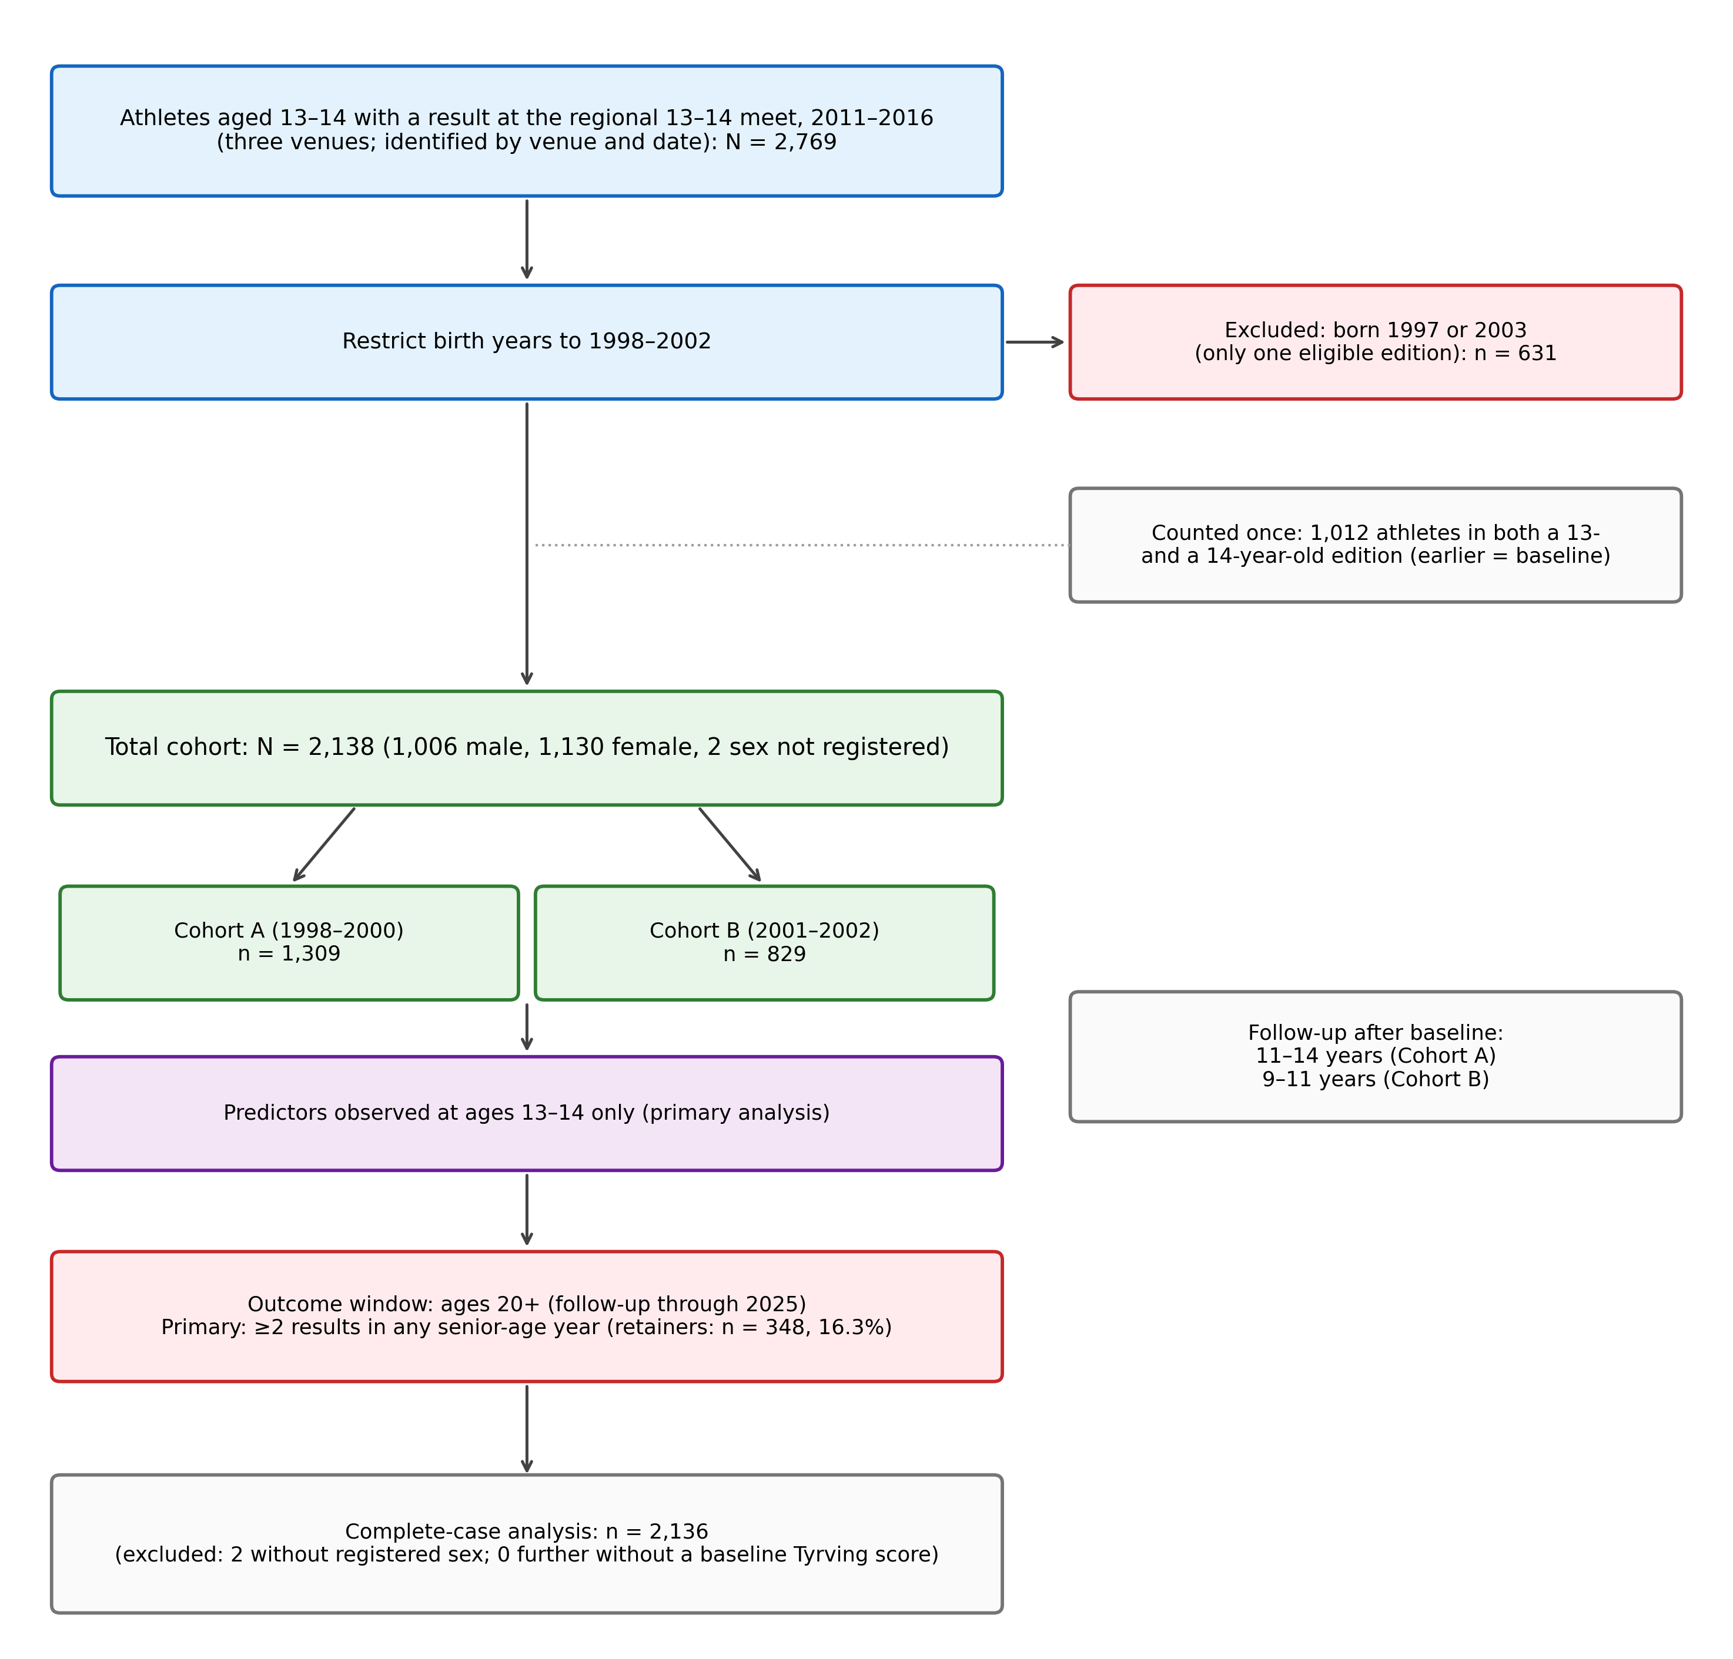
Figure S0. Cohort construction flow diagram. Participation in the baseline meet was identified by venue and date (Supplementary Methods S-M12). Boundary birth years 1997 and 2003 were excluded because they had only one possible eligible edition in the cohort window. Athletes who attended both the 13-year-old and 14-year-old editions are counted once (side note), with the earlier edition used as baseline. Complete-case analysis used 2,136 of 2,138 athletes; the 2 athletes without registered sex were excluded (Supplementary Methods S-M3).
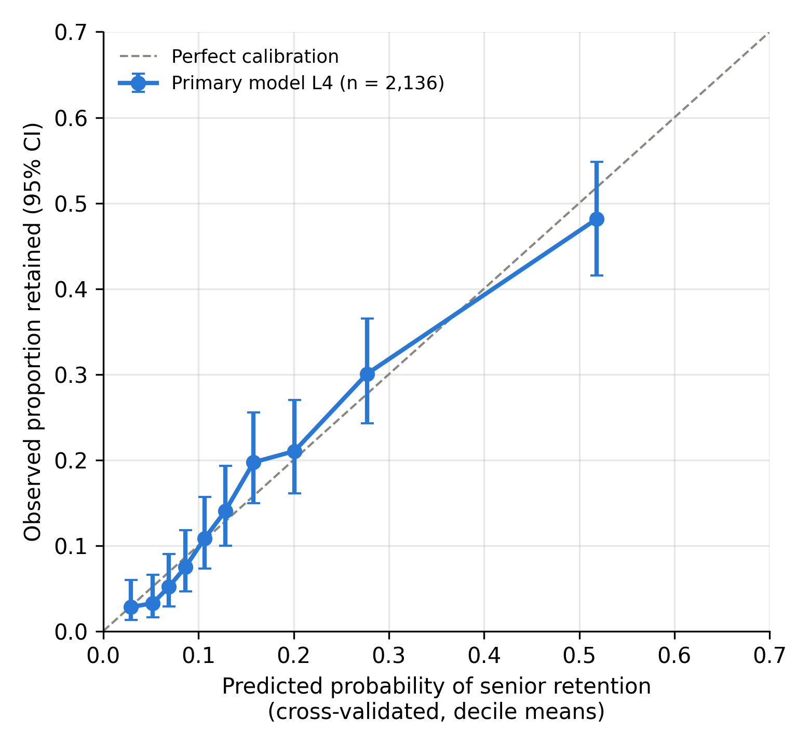
Figure S1. Calibration of the primary logistic model (L4). Cross-validated predicted probabilities of senior retention (out-of-fold predictions averaged over 20 repeats of stratified 5-fold cross-validation; n = 2,136) are binned into deciles (x-axis); the y-axis shows the observed proportion retained in each decile with 95% Wilson confidence intervals. Points on the diagonal indicate perfect calibration (calibration slope 0.98, calibration-in-the-large 0.00; Supplementary Table S23).
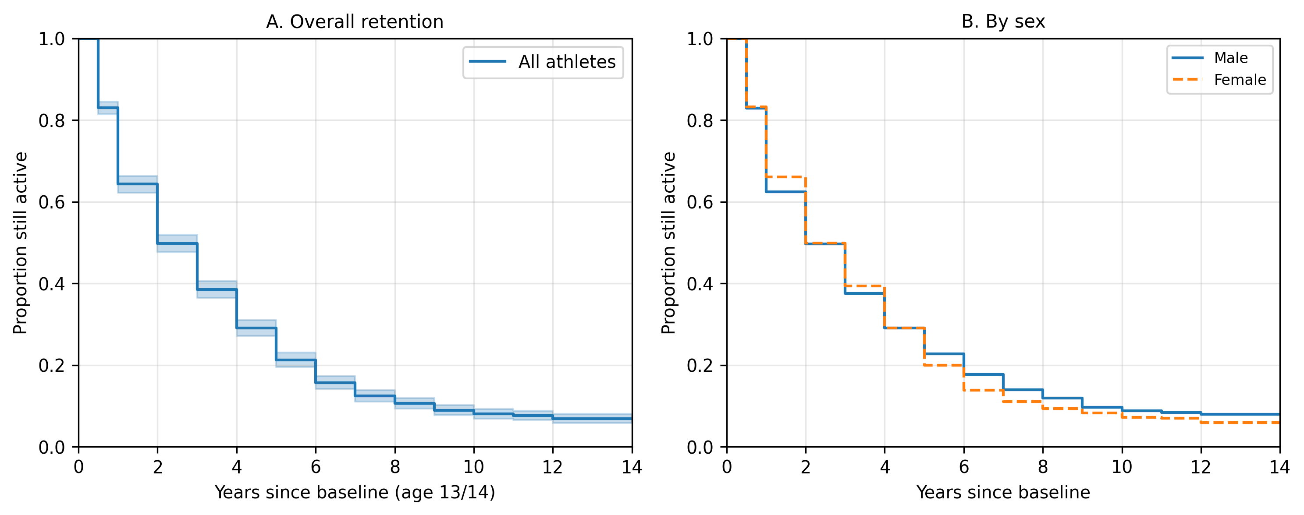
Figure S2. Kaplan–Meier retention curves: (A) overall retention from baseline (age 13/14), with 95% confidence band; (B) retention stratified by sex. Athletes whose final active season was the baseline year are plotted at 0.5 years. Log-rank test for sex difference: χ² = 0.66, p = .42.
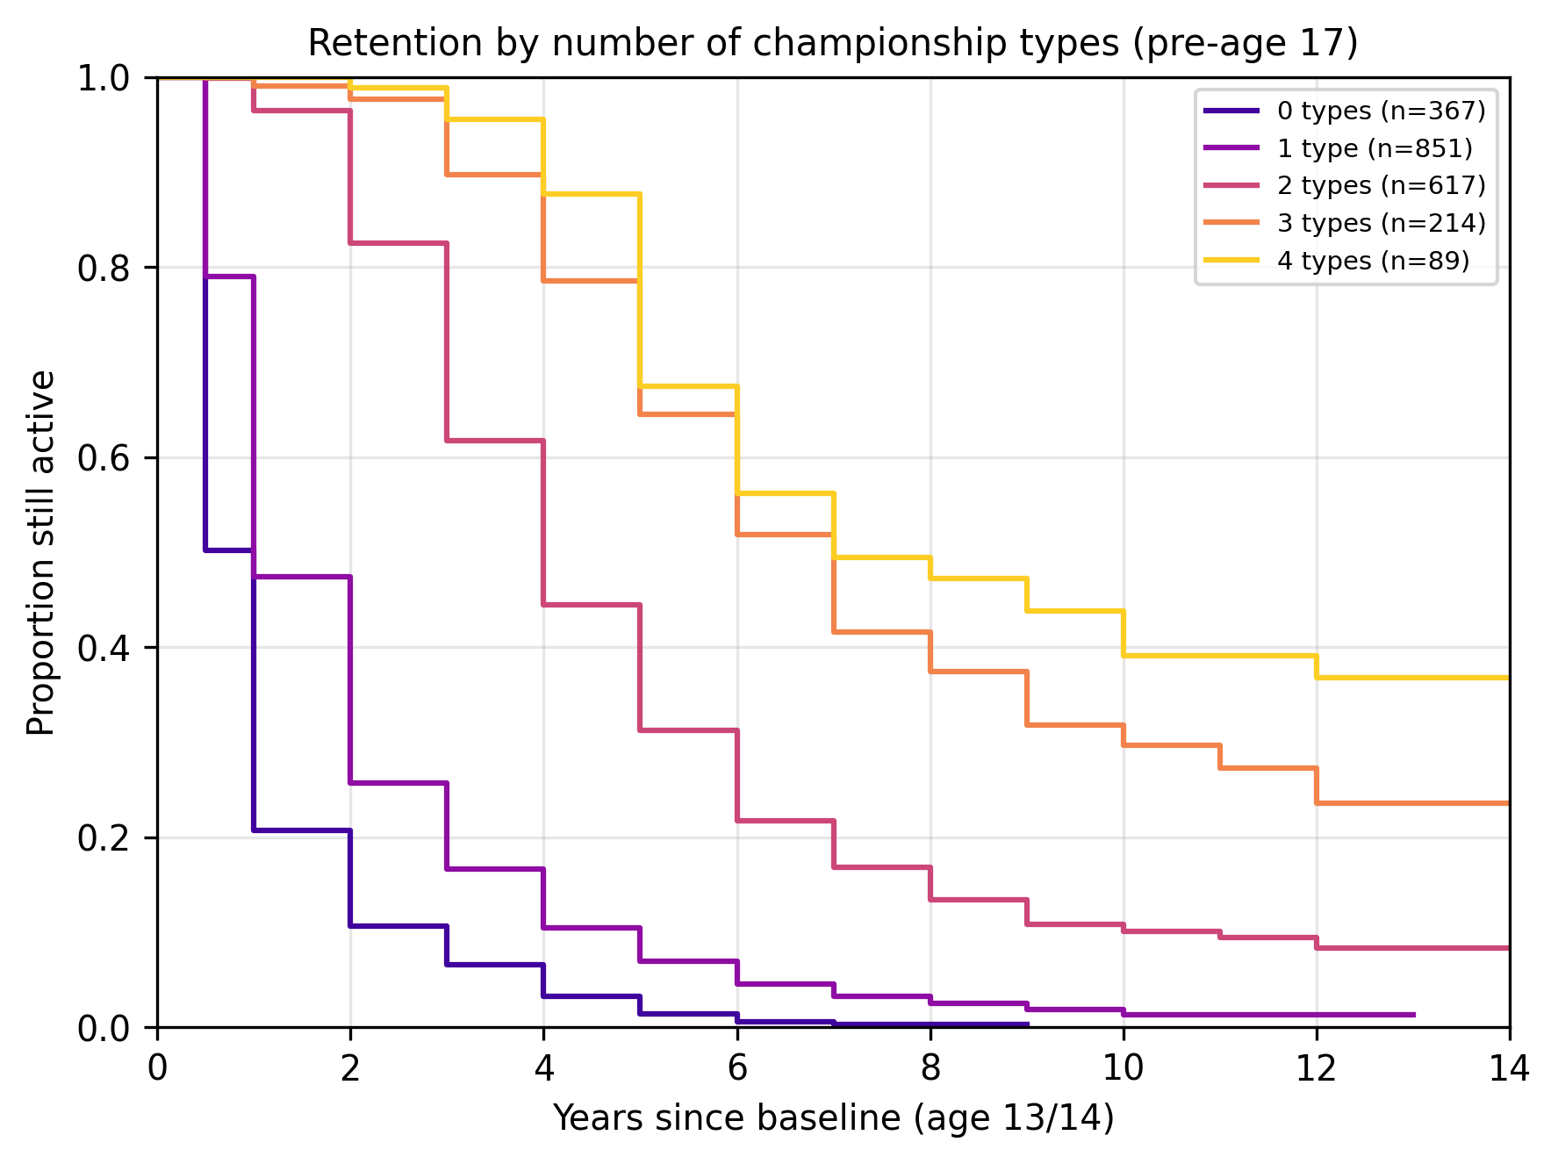
Figure S3. Kaplan–Meier retention curves stratified by the number of championship types entered before age 17 (range 0–4, comprising district, youth-national, junior-national, and senior-national championships; classification in Supplementary Methods S-M12). Retention is strongly monotonic in number of championship types. Descriptive: championship types are counted up to age 17, after baseline. Athletes whose final active season was the baseline year are plotted at 0.5 years.
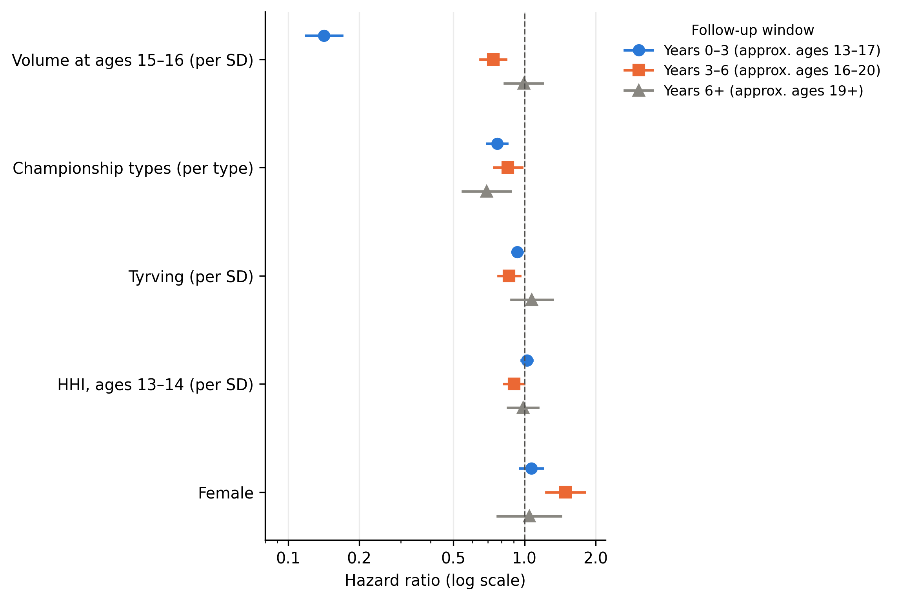
Figure S4. Time-varying hazard ratios from the secondary (post-baseline) Cox specification across three follow-up periods (years 0–3, 3–6, 6+ post-baseline), drawn from the estimates in Table 5. Hazard ratios (bars: 95% confidence intervals; marker shapes distinguish the periods) are per-SD for standardized covariates and per-unit for championship types and female. Note: the early-window HR for ages-15–16 volume partly reflects operational overlap between predictor and outcome (low milestone volume is mechanical for athletes who drop out before age 15); this estimate is descriptive of the time-varying association rather than an independent prospective effect.
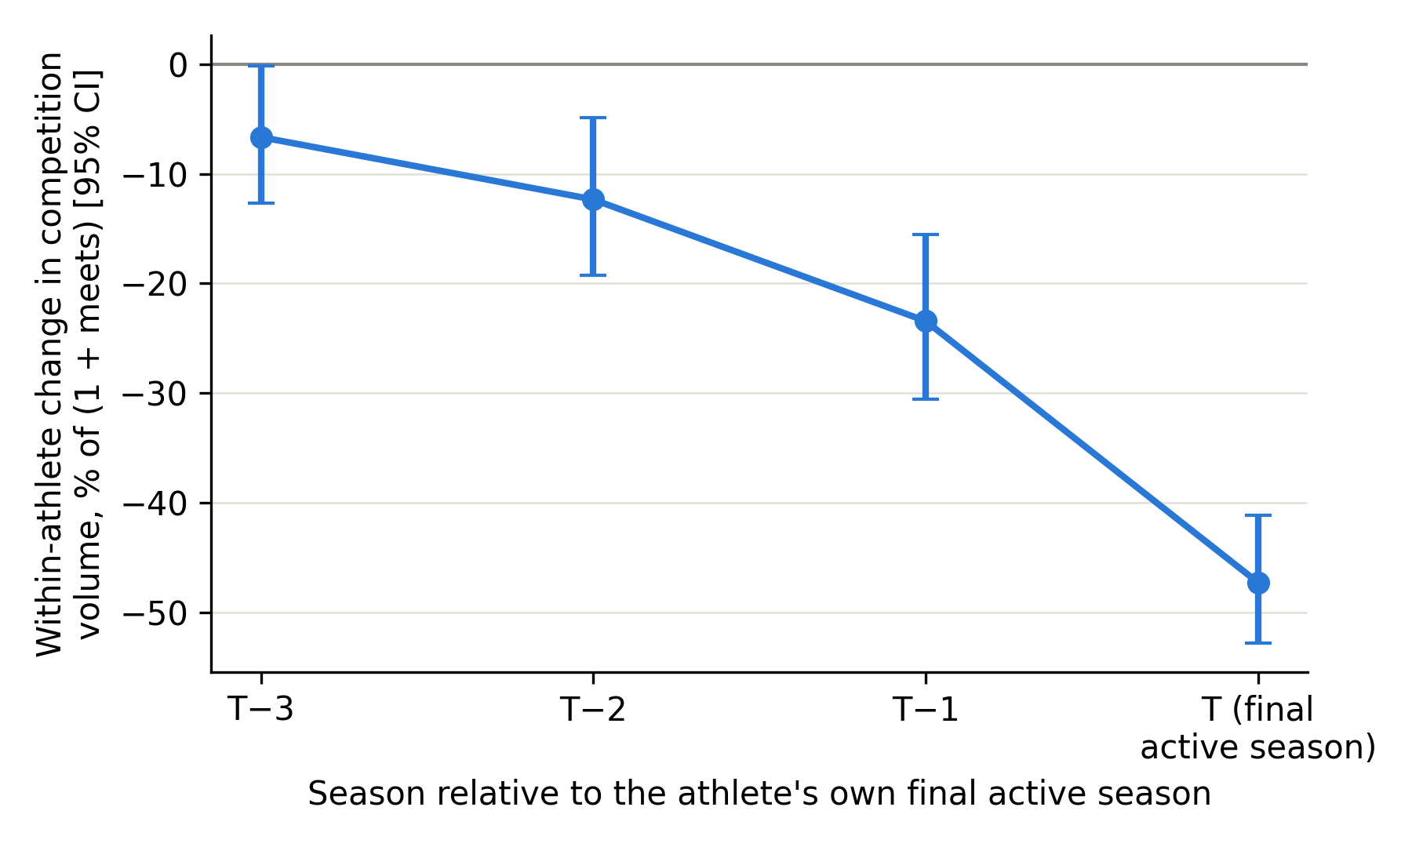
Figure S5. Within-athlete decline in competition volume before exit. Estimates from a linear model of log(1 + meets) at ages 13–19 with athlete fixed effects, age fixed effects, and indicators for the three seasons before and the season of each athlete’s own final active season (1,909 athletes, 8,490 athlete-seasons; Supplementary Table S28). Points show the percentage difference in (1 + meets) relative to the same athlete’s earlier seasons, net of the common age profile, with 95% confidence intervals (cluster-robust by athlete). The final-season estimate is partly mechanical.

STROBE Statement — Checklist for Cohort Studies
Manuscript: Pulling back before dropping out: Declining competition participation precedes exit from Norwegian youth track and field — a 14-year register study. Item locations refer to manuscript sections.
Item | Recommendation | Location
1 Title/abstract (a) | Indicate the study’s design in the title or abstract | Title (“a 14-year register study”); Abstract
1 (b) | Informative and balanced summary in the abstract | Abstract (design, n, follow-up, estimates with CIs, cross-validated discrimination and calibration, internal cohort replication, candidate threshold)
2 Background/rationale | Scientific background and rationale | §1–1.2
3 Objectives | State specific objectives, including any prespecified hypotheses | §1.3 (three hypotheses: the first with two components, the third labeled a robustness expectation)
4 Study design | Present key elements of study design early | §2.1
5 Setting | Settings, locations, relevant dates (recruitment, exposure, follow-up, data collection) | §2.2–2.3 (baseline meets 2011–2016; follow-up through 2025; register extract of May 2026, §2.2 and Supplementary Methods S-M11)
6 Participants (a) | Eligibility criteria, sources and methods of selection; follow-up | §2.2 (inclusion via baseline meet; district entry; birth years 1998–2002; de-duplication), §2.3
6 (b) | Matched studies — n/a | —
7 Variables | Define outcomes, exposures, predictors, confounders, effect modifiers | §2.4.1–2.4.5
8 Data sources/measurement | Sources of data and details of assessment methods | §2.2, §2.4 (national competition register; Tyrving scoring; HHI construction); S-M3 (performance scoring); S-M12 (data preparation)
9 Bias | Efforts to address potential sources of bias | §2.5.1 (baseline-only design), §2.5.3 (exit-aligned + active-at-16 change model + athlete fixed-effects model, S-M6), S-M1 (landmark timing), §3.4/S-M7 (club confounding; club-grouped validation, S-M4), S-M10 (temporary gaps and returns), §4.2 (alternative explanations)
10 Study size | How the study size was arrived at | §2.2 (full eligible population), §2.5.5 + S-M2 (detection capacity in lieu of a priori power)
11 Quantitative variables | How quantitative variables were handled; groupings | §2.4, §2.5.1 (z-standardization, within training folds in cross-validation; per-SD effects; threshold grid in §2.5.3/Table 6)
12 Statistical methods (a) | All statistical methods, including confounding control | §2.5.1–2.5.6; S-M1–S-M12
12 (b) | Subgroups and interactions | Table 7 (by birth cohort), Supplementary Table S7 (sex-stratified)
12 (c) | Missing data | §2.5.5, S-M3, Supplementary Tables S12/S21/S25
12 (d) | Loss to follow-up | §2.3 (complete register follow-up), §2.4.1 and S-M10 (censoring for athletes active 2024+), Supplementary Table S24 (fixed observation window); S-M10 and Supplementary Table S30 (temporary gaps and returns)
12 (e) | Sensitivity analyses | §3.10; Supplementary Tables S2, S5, S9, S11, S20, S21, S22, S24, S26, S27, S29, S30
13 Participants (a) | Numbers at each stage | Supplementary Figure S0 (flow diagram); Supplementary Table S12 (sample flow)
13 (b) | Reasons for non-participation | §2.2 (boundary birth years; de-duplication)
13 (c) | Flow diagram | Supplementary Figure S0
14 Descriptive data (a) | Characteristics of participants | Table 1
14 (b) | Missing data per variable | §2.5.5 (baseline Tyrving and sex missing for the same 2 athletes, 0.1%; HHI, volume and the outcome complete); Supplementary Table S25
14 (c) | Follow-up time | §2.3 (9–14 years)
15 Outcome data | Numbers of outcome events over time | §3.1–3.2 (retention, exit rates), Table 5 (events by period), Supplementary Figure S2
16 Main results (a) | Unadjusted and adjusted estimates with CIs; which confounders adjusted | Table 3 (nested L1–L4; volume adjusted for sex, Tyrving and HHI), Supplementary Table S31 (sex-adjusted volume OR), Supplementary Table S13
16 (b) | Category boundaries for categorized variables | Table 6 (threshold grid)
16 (c) | Absolute risk translation | §3.8/Table 6 (retention among flagged vs unflagged)
17 Other analyses | Subgroup, interaction, sensitivity analyses | §3.4–3.10; Supplementary Tables S1–S32
18 Key results | Summarize with reference to objectives | §4.1
19 Limitations | Sources of bias, imprecision, direction/magnitude | §4.9 (eight items, including applied limitations)
20 Interpretation | Cautious overall interpretation | §4.2–4.7, §4.11
21 Generalisability | External validity | §4.9 (boundary conditions), §2.2 (system description), §3.1 and Supplementary Table S31 (target population)
22 Funding | Source of funding and role | Statements and Declarations (Funding statement)

