Supplementary material
Anonymised manuscript (Brief Report). Abbreviations: CI, confidence interval; COVID-19, coronavirus disease 2019; IQR, interquartile range; OR, odds ratio; Q1 and Q4, first and fourth quarter of the birth year; SE, standard error.
Table S1. Sample flow.
Step | n
Athletes born 2001–2008 in the registry extract | 33 666
Result rows extracted (2011 – 29 Oct 2026) | 675 707
excluded: non-approved rows | 1 526
excluded: rows below age 10 | 116
Debutants with an approved result at age $≥$10 | 28 339
excluded: missing sex | 865
set aside: debut at age $≥$17 (sensitivity analyses) | 731
Debutants at ages 10–16 with known sex | 26 743
primary sample: born 2001–2005 | 17 496
descriptive only: born 2006–2008 | 9 247
Active seniors in the primary sample | 546

Table S2. Senior conversion by debut age and sex (born 2001–2005), % (Wilson 95 % CI).
Debut age | Girls, n | Girls, % (CI) | Boys, n | Boys, % (CI)
10 | 3 485 | 3.4 (2.8–4.0) | 3 141 | 4.3 (3.6–5.1)
11 | 1 860 | 2.2 (1.6–2.9) | 1 756 | 2.7 (2.1–3.6)
12 | 1 263 | 1.8 (1.2–2.7) | 1 266 | 2.3 (1.6–3.3)
13 | 879 | 2.0 (1.3–3.2) | 812 | 3.8 (2.7–5.4)
14 | 789 | 2.0 (1.3–3.3) | 958 | 2.7 (1.9–3.9)
15 | 326 | 2.5 (1.2–4.8) | 537 | 4.8 (3.3–7.0)
16 | 158 | 5.7 (3.0–10.5) | 266 | 7.1 (4.6–10.9)
Note. Sex $×$ debut-age interaction (linear): OR 0.92 per year for girls relative to boys, 95 % CI 0.82–1.02. Full coefficient tables for the primary models are available with the analysis code.
Table S3. Retention $k$ years after the debut season: proportion (Wilson 95 % CI). Denominators equal the debut-age n except debut 16 at $k$ = 5 (n = 389).
Debut age | n | $k$=1 | $k$=2 | $k$=3 | $k$=4 | $k$=5
10 | 6 626 | .512 (.500–.524) | .379 (.367–.390) | .288 (.277–.299) | .218 (.208–.228) | .169 (.160–.178)
11 | 3 616 | .398 (.382–.414) | .269 (.254–.283) | .188 (.175–.201) | .131 (.121–.143) | .097 (.087–.107)
12 | 2 529 | .372 (.353–.391) | .234 (.218–.251) | .143 (.130–.157) | .094 (.083–.106) | .071 (.061–.081)
13 | 1 691 | .378 (.356–.402) | .226 (.207–.247) | .150 (.134–.168) | .100 (.087–.115) | .068 (.057–.081)
14 | 1 747 | .340 (.318–.363) | .128 (.113–.144) | .080 (.068–.093) | .055 (.045–.067) | .033 (.025–.042)
15 | 863 | .256 (.228–.286) | .125 (.105–.149) | .080 (.064–.100) | .049 (.036–.065) | .044 (.032–.060)
16 | 424 | .349 (.305–.396) | .210 (.174–.251) | .111 (.084–.144) | .066 (.046–.094) | .059 (.040–.087)

Table S4. Competing at equal career length: proportion with at least two competition days in a single season at least 4, 5 and 6 years after the debut season, by debut age (n = athletes for whom that season was fully observable by 2025), with the adjusted OR per year of later debut (sex, birth cohort, club size).
Debut age | 4 years: % (n) | 5 years: % (n) | 6 years: % (n)
10 | 20.4 (6 626) | 15.7 (6 626) | 12.0 (6 626)
11 | 12.4 (3 616) | 8.8 (3 616) | 6.4 (3 616)
12 | 8.5 (2 529) | 6.2 (2 529) | 4.0 (2 529)
13 | 8.7 (1 691) | 6.2 (1 691) | 4.1 (1 691)
14 | 4.5 (1 747) | 2.9 (1 747) | 2.2 (1 747)
15 | 4.9 (863) | 3.8 (863) | 2.6 (779)
16 | 6.6 (424) | 5.1 (389) | 3.2 (317)
Linear trend, OR per +1 year | 0.70 (0.68–0.72) | 0.69 (0.66–0.72) | 0.66 (0.63–0.69)

Table S5. Robustness analyses. Estimates are for debut age (per +1 year, linear) unless stated; outcome is senior activity unless stated.
Analysis | n | Events | OR (95 % CI)
Primary linear trend | 17 496 | 546 | 0.99 (0.94–1.04)
Excluding debuts in 2020–2021 | 17 305 | 530 | 0.95 (0.90–1.01)
Debut at 16 vs. debut at 10 (categorical), primary | 17 496 | 546 | 1.73 (1.15–2.59)
excluding debuts in 2020–2021 | 17 305 | 530 | 1.32 (0.79–2.19)
adding the COVID-19 debut flag | 17 496 | 546 | 1.38 (0.86–2.19)
cohorts born 2001–2003 | 10 667 | 349 | 1.35 (0.80–2.26)
cohorts born 2004–2005 | 6 829 | 197 | 3.08 (1.59–5.96)
Excluding the 2001 cohort (debut at 10 in 2011) | 14 077 | 434 | 0.99 (0.94–1.05)
Including athletes without registered sex | 18 045 | 547 | 0.99 (0.94–1.04)
Outcome: $≥$1 result at age $≥$20 | 17 496 | 694 | 1.00 (0.96–1.05)
Outcome: any result at age $≥$17 (debuts 10–14) | 16 209 | 1 621 | 0.97 (0.93–1.00)
Adding debut-season competition days | 17 496 | 546 | 0.94 (0.89–1.00)
Cohorts born 2001–2003 | 10 667 | 349 | 0.98 (0.92–1.05)
Cohorts born 2004–2005 | 6 829 | 197 | 0.99 (0.91–1.08)
Debut at 17–19 vs. debut at 10 (categorical) | 17 898 | 595 | 3.36 (2.42–4.67)
Adding the COVID-19 debut flag (linear trend) | 17 496 | 546 | 0.95 (0.90–1.01)
Club-clustered robust SE (trend) | 17 496 | 546 | 0.99 (0.92–1.06)

Table S6. Characteristics of the primary sample (born 2001–2005, debut at ages 10–16), by debut group.
Characteristic | Debut 10–11 | Debut 12–13 | Debut 14–16
n | 10 242 | 4 220 | 3 034
Female, % | 52.2 | 50.8 | 42.0
Exact birth date available, % | 38.6 | 63.8 | 88.5
Born Q1, % of those with birth date | 29.2 | 26.1 | 27.1
Born Q4, % of those with birth date | 19.9 | 21.9 | 19.8
Competition days in debut season, median (IQR) | 1 (1–3) | 1 (1–3) | 1 (1–2)
Career length, seasons, median (IQR) | 2 (1–4) | 1 (1–3) | 1 (1–2)
Debut season 2020–2021, % | 0.0 | 0.0 | 6.3
Note. By construction, cohorts born 2001–2005 could only experience a 2020–2021 debut at ages 15 and 16.
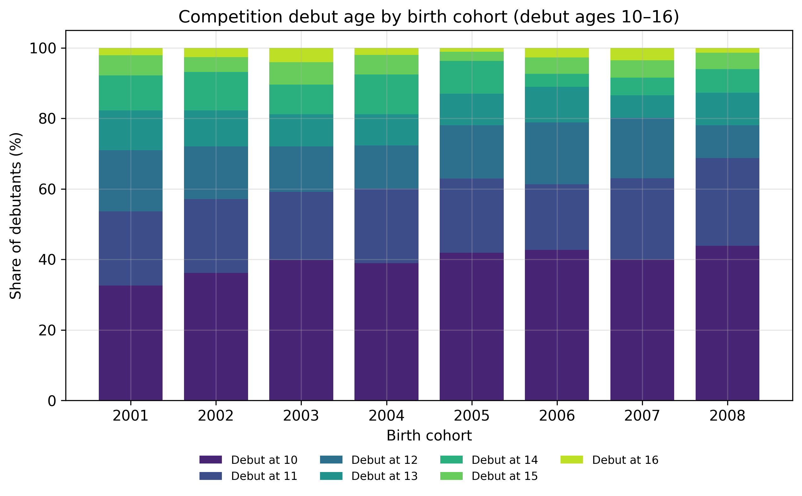
Figure S1. Competition debut age by birth cohort (all debutants born 2001–2008, debut ages 10–16).
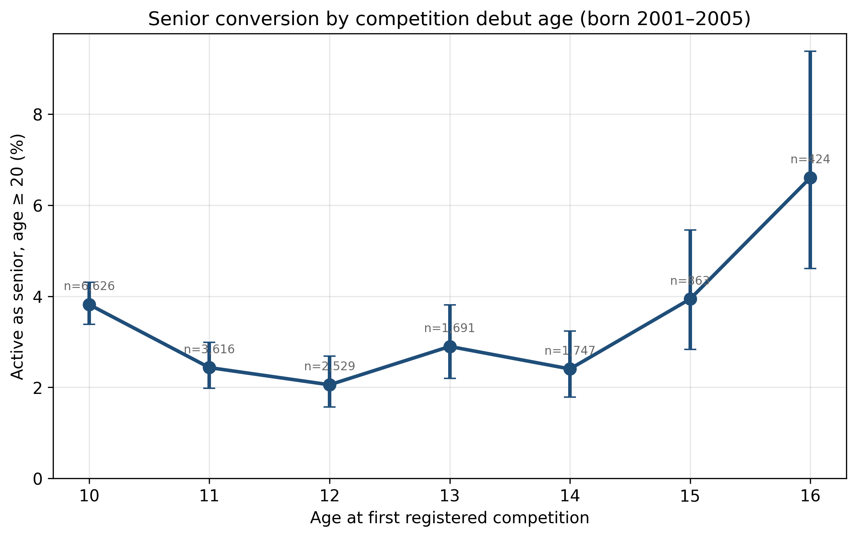
Figure S2. Senior conversion by competition debut age, with Wilson 95 % confidence intervals (born 2001–2005).
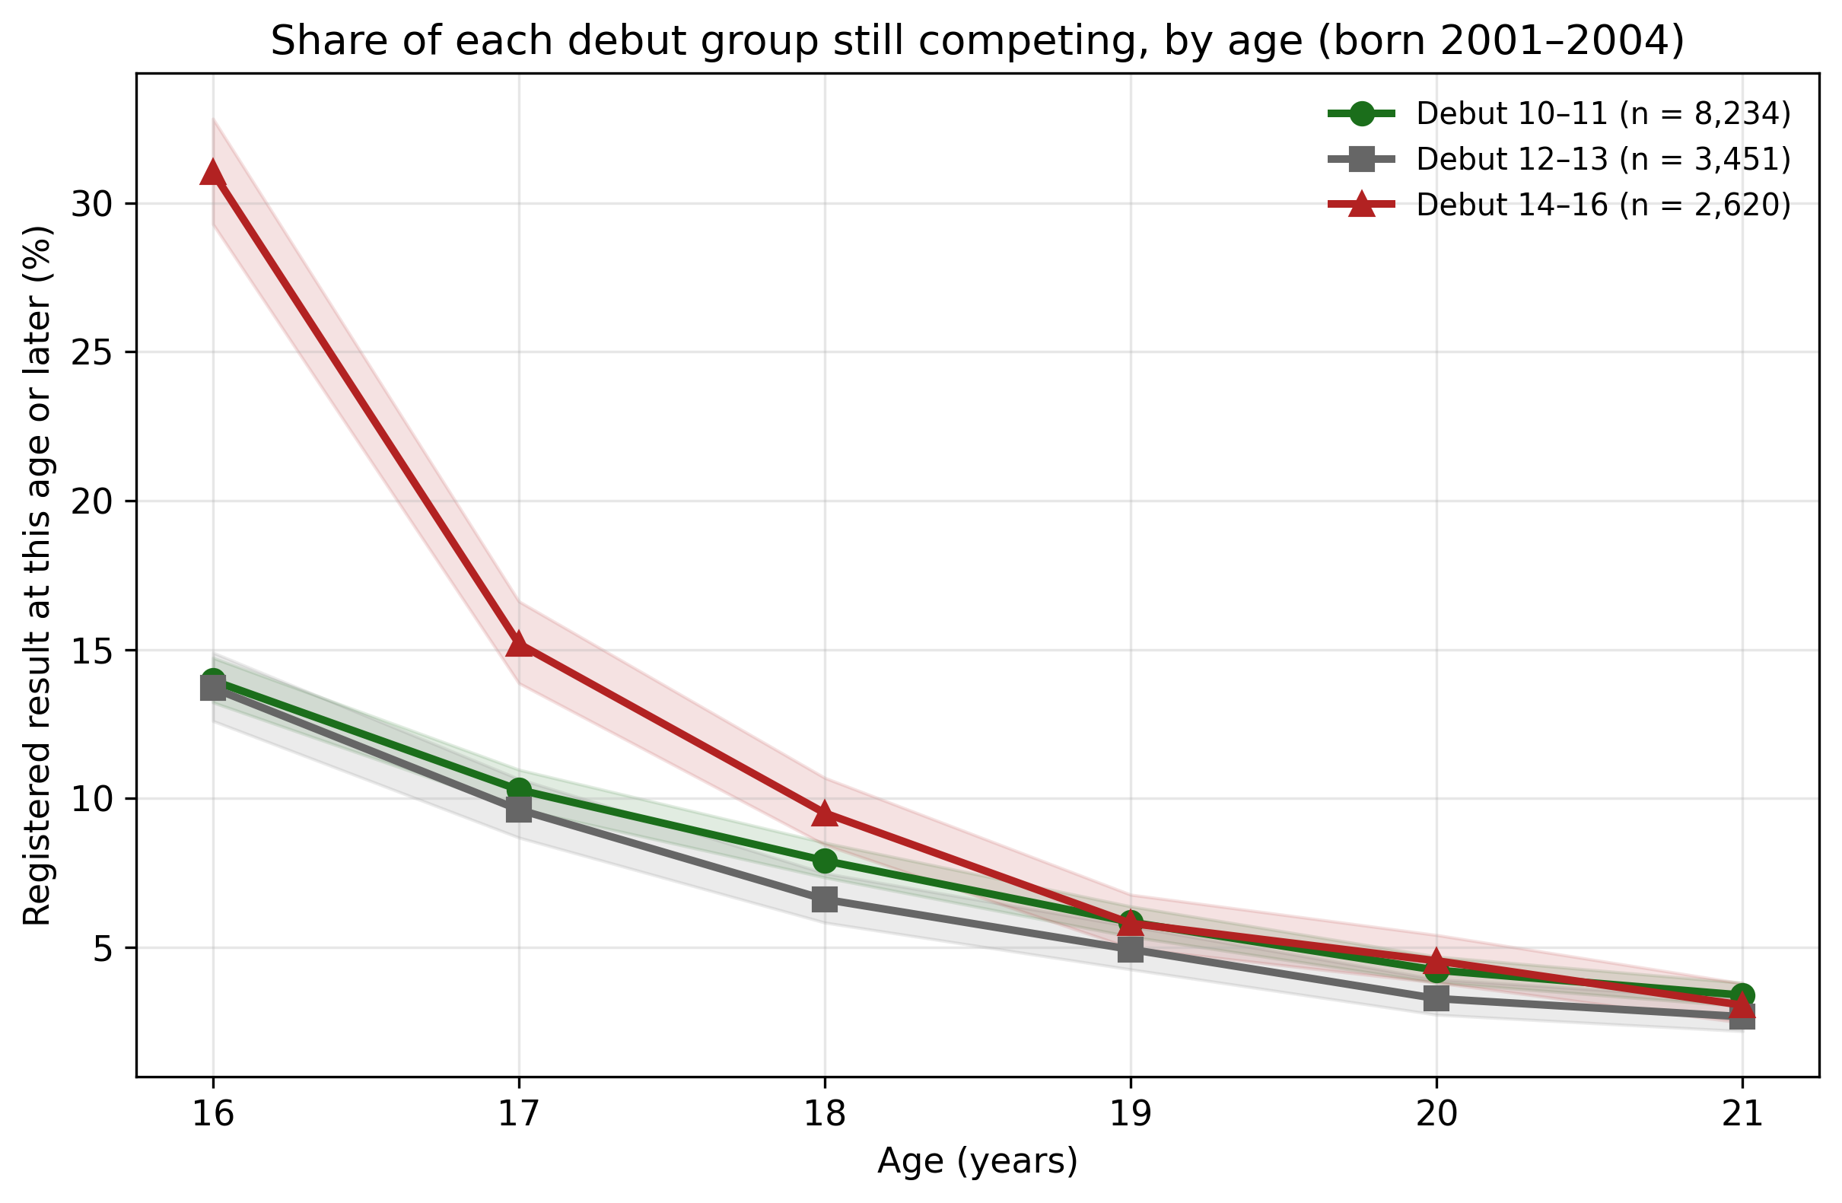
Figure S3. Share of each debut group with a registered result at that age or later, cohorts born 2001–2004 (followed to age 21 for everyone), with Wilson 95 % confidence bands. At 16 the late group includes the athletes who debuted at that age.

