AtluriIn E2E QA Report
Verdict: PASS
Generated: 2026-02-17T16:12:27.466Z

Environment
Frontend: http://localhost:3001
Backend: http://localhost:9010
Node: v24.13.1
OS: win32
Browser: chromium 145.0.7632.6
Headless: true

Determinism
Offer Probability repeat-call variance: 0.0000 (threshold 0.01) → PASS
Determinism is validated by repeating the offer endpoint call twice for the same user state.

Steps

Load landing page + validate hero — PASS
Duration: 894ms
Landing page loaded and hero messaging is present.
AI Validate: Landing • Hero Tag → PASS (confidence 1)
AI Validate: Landing • Hero Title → PASS (confidence 0.95)
AI Validate: Landing • Brand → PASS (confidence 1)
Screenshot: 2026-02-17T16-11-14-119Z__landing__landing.png
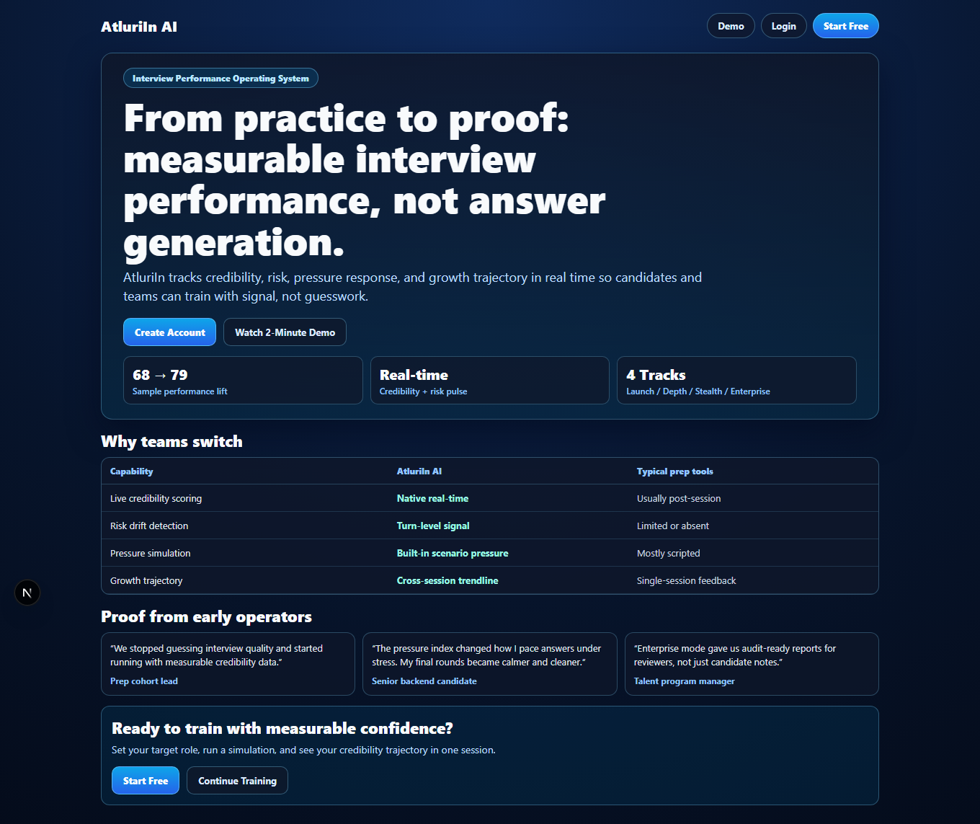

Open /app + one-click onboarding visible — PASS
Duration: 615ms
AppShell loaded with QuickStart panel.
AI Validate: App • QuickStart → PASS (confidence 1)
AI Validate: App • Run First Pressure Round → PASS (confidence 1)
Screenshot: 2026-02-17T16-11-14-827Z__app__quickstart.png
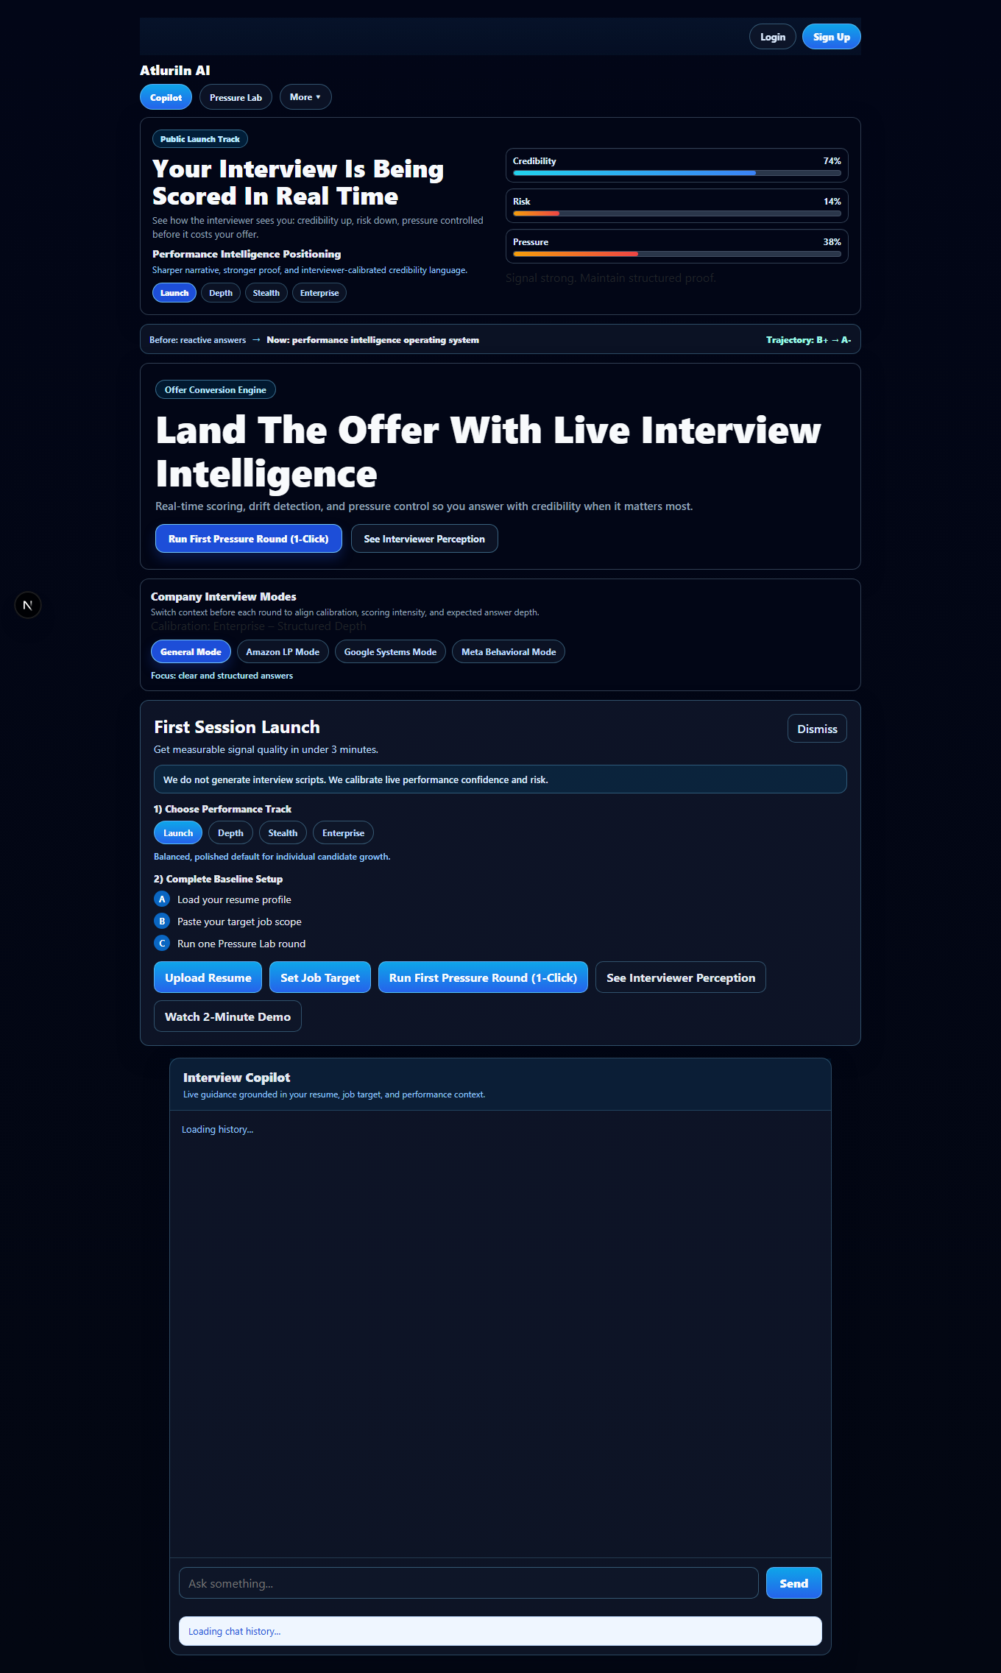

Trigger one-click onboarding → interview starts — PASS
Duration: 2711ms
Interview started. TTFQ=2528ms.
Perf: time_to_first_question = 2528ms (<=6000ms) PASS
Screenshot: 2026-02-17T16-11-17-625Z__interview__started.png
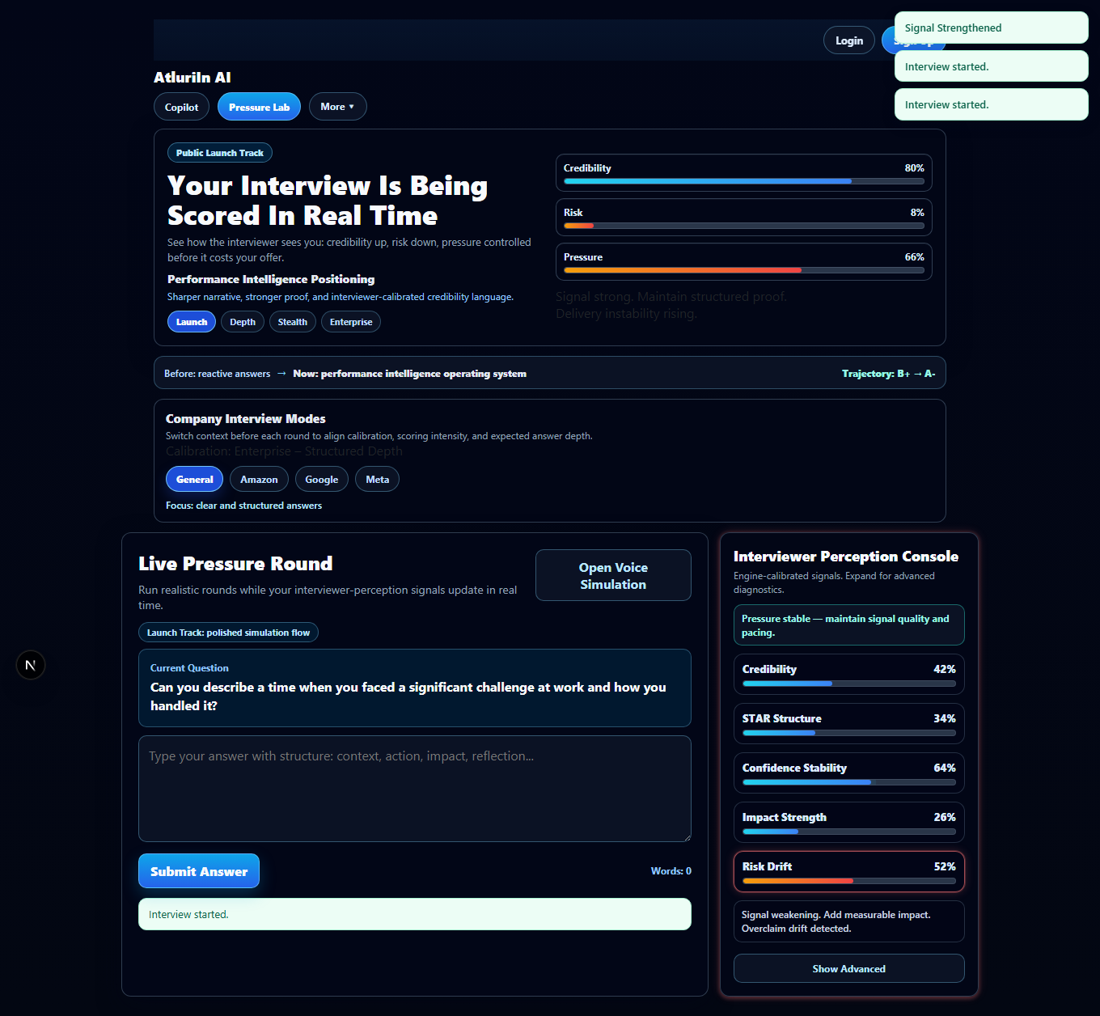

Verify live perception meters + transcript tagging — PASS
Duration: 319ms
Live meters present and transcript tagging rendered.
AI Validate: Interview • Perception Console → PASS (confidence 1)
AI Validate: Interview • Transcript Tagging → PASS (confidence 1)
Screenshot: 2026-02-17T16-11-17-879Z__interview__meters-tagging.png
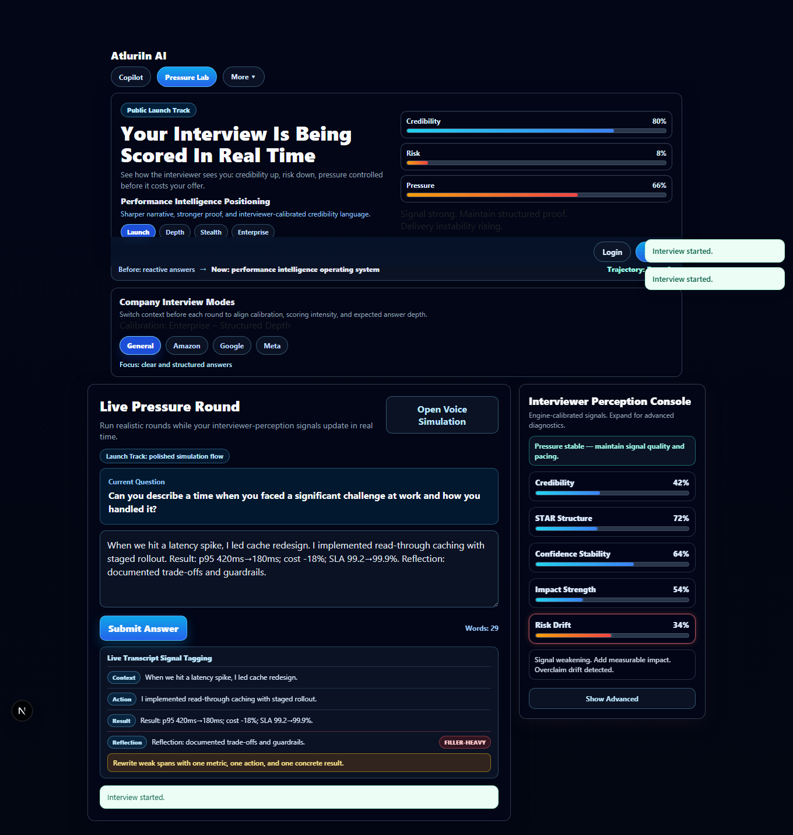

Complete full interview round + validate session-end delta — PASS
Duration: 27008ms
Session completed: b3325468-3cd0-4e41-b8f1-951a7882f554. Offer fields: baseline=true ladder=true velocity=true plateau=false testimonial_expected=false.
Perf: answer_latency_1 = 4621ms (<=7000ms) PASS
Perf: answer_latency_2 = 4864ms (<=7000ms) PASS
Perf: answer_latency_3 = 5227ms (<=7000ms) PASS
Perf: answer_latency_4 = 4365ms (<=7000ms) PASS
Perf: answer_latency_5 = 6433ms (<=7000ms) PASS
AI Validate: Delta • Offer Probability → PASS (confidence 1)
AI Validate: Delta • Velocity → PASS (confidence 0.95)
AI Validate: Delta • Target 70%+ → PASS (confidence 0.95)
Screenshot: 2026-02-17T16-11-44-778Z__interview__session-end.png
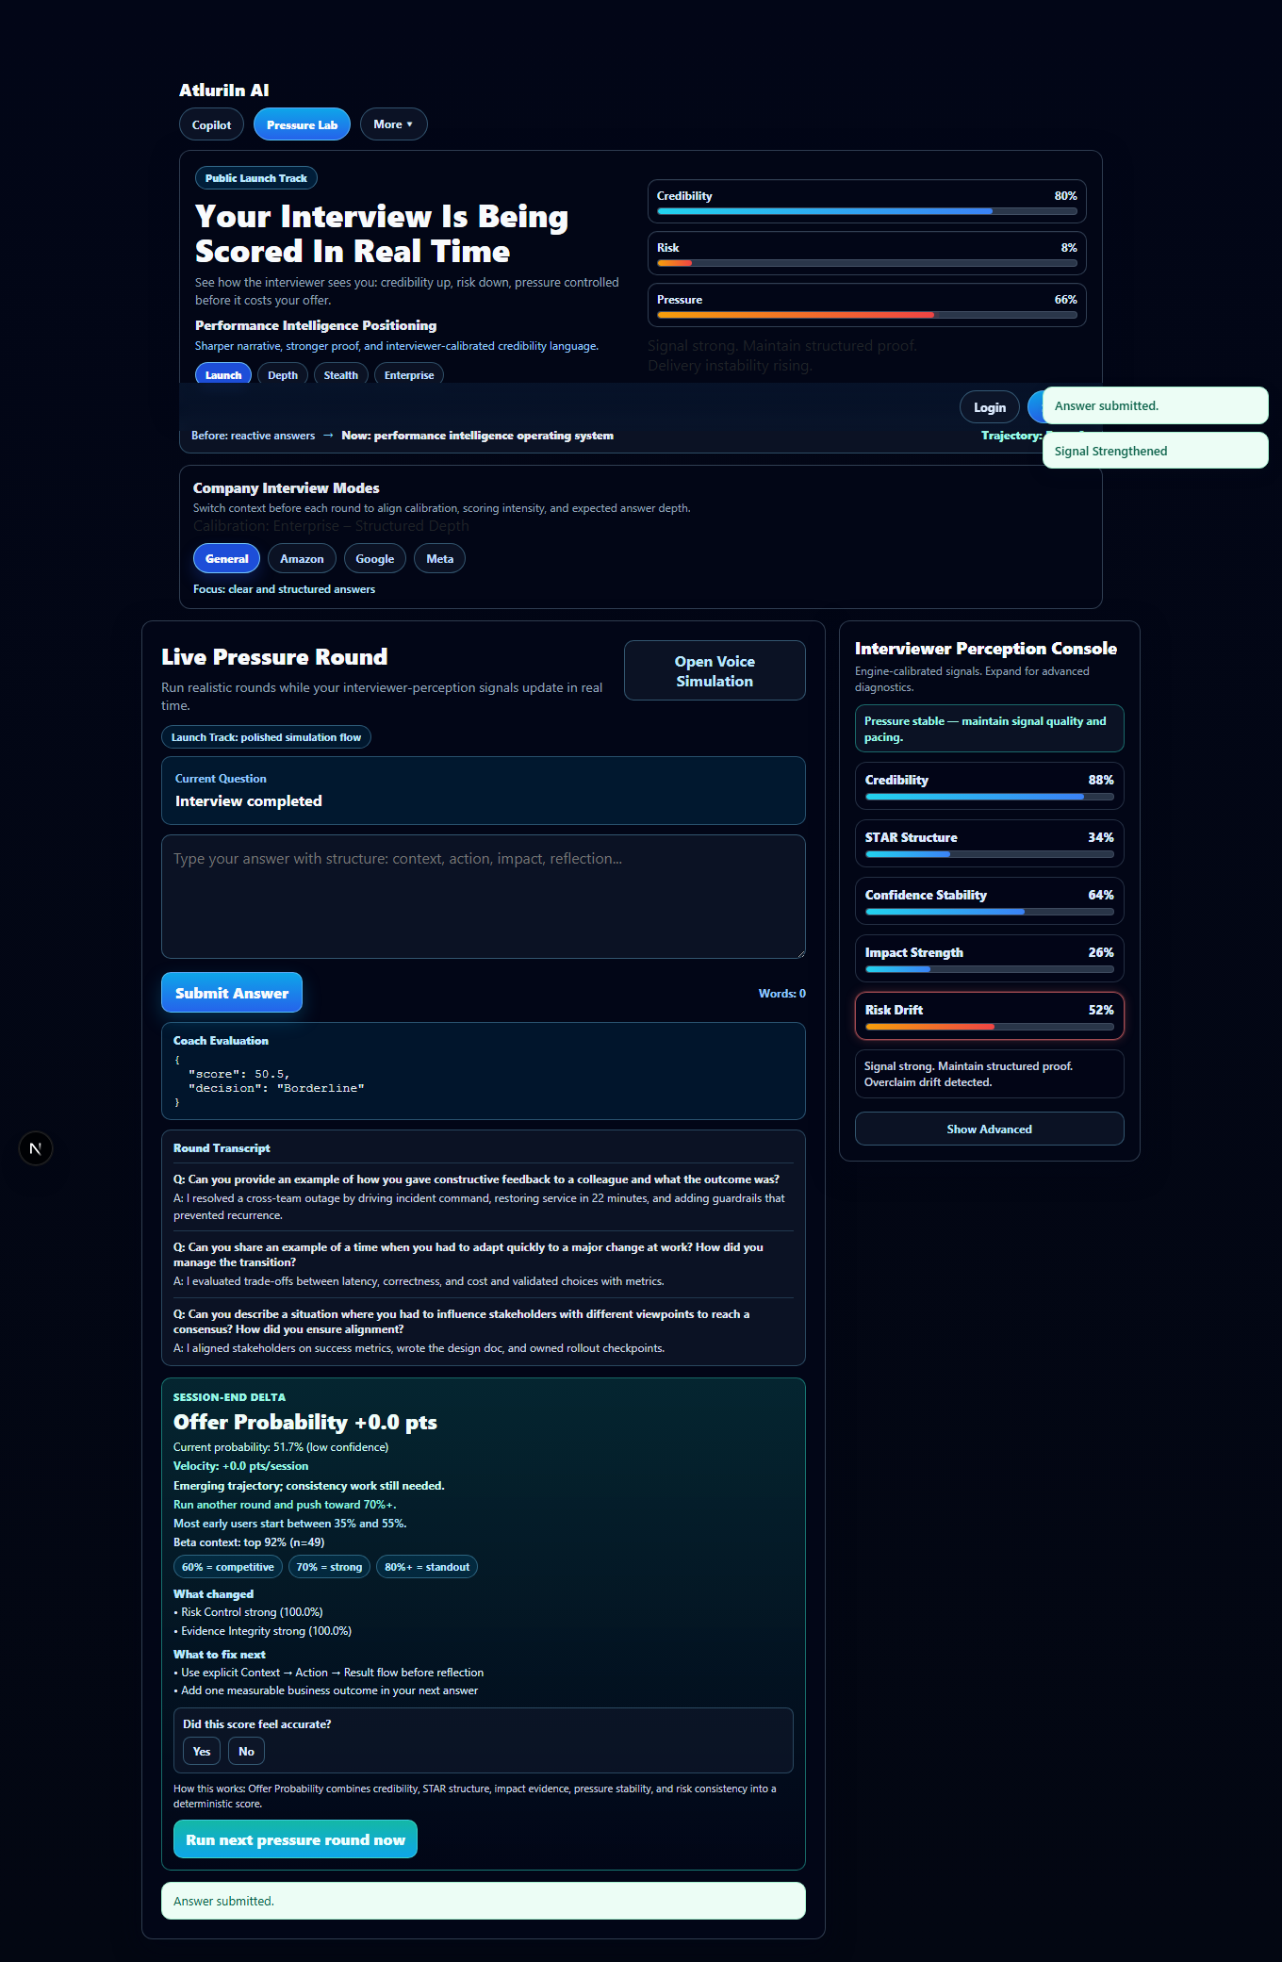

Navigate to dashboard + validate KPI card — PASS
Duration: 490ms
Dashboard loaded.
AI Validate: Dashboard • Offer Probability → PASS (confidence 1)
AI Validate: Dashboard • Velocity → PASS (confidence 0.95)
Screenshot: 2026-02-17T16-11-45-348Z__dashboard__dashboard.png
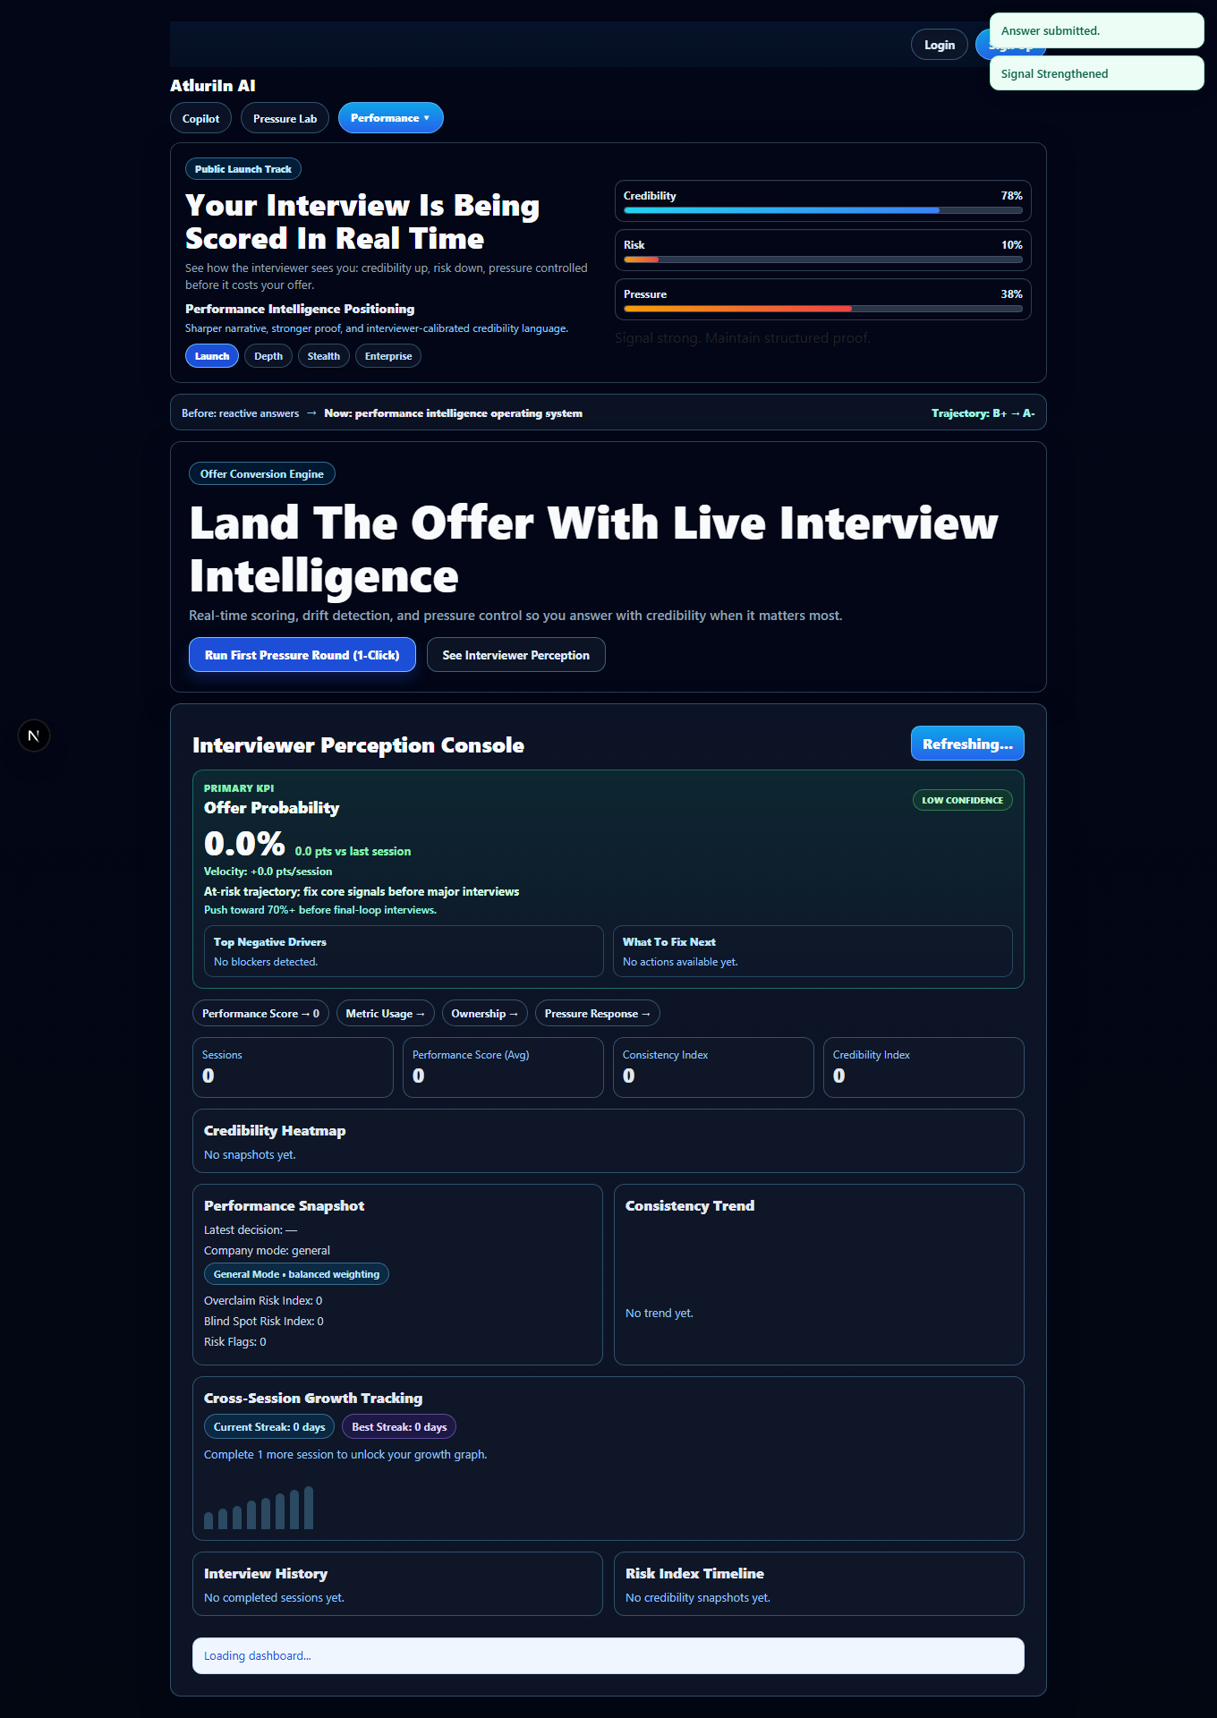

Share snapshot + open public snapshot — PASS
Duration: 1502ms
Public snapshot loaded: http://localhost:3001/interview/public/b3325468-3cd0-4e41-b8f1-951a7882f554?share=ZMSuQ2Zs9g_jNutq1zb91hj3gf7ksOzQ
AI Validate: Public • Offer Probability → PASS (confidence 1)
AI Validate: Public • What This Means → PASS (confidence 1)
Screenshot: 2026-02-17T16-11-47-026Z__public__public.png
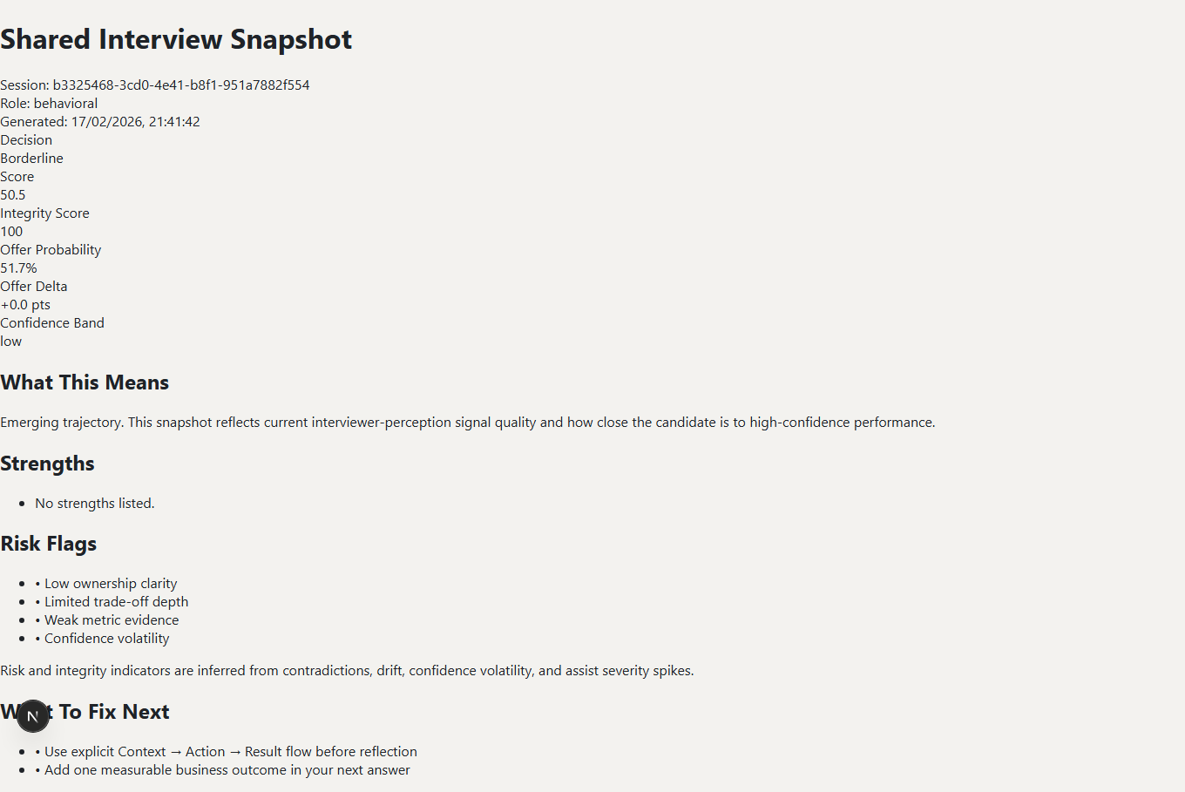

Export endpoint — PASS
Duration: 741ms
Export includes offer_probability_snapshot.

Resume upload (PDF) — PASS
Duration: 1902ms
Resume uploaded.
Screenshot: 2026-02-17T16-11-49-638Z__resume__uploaded.png
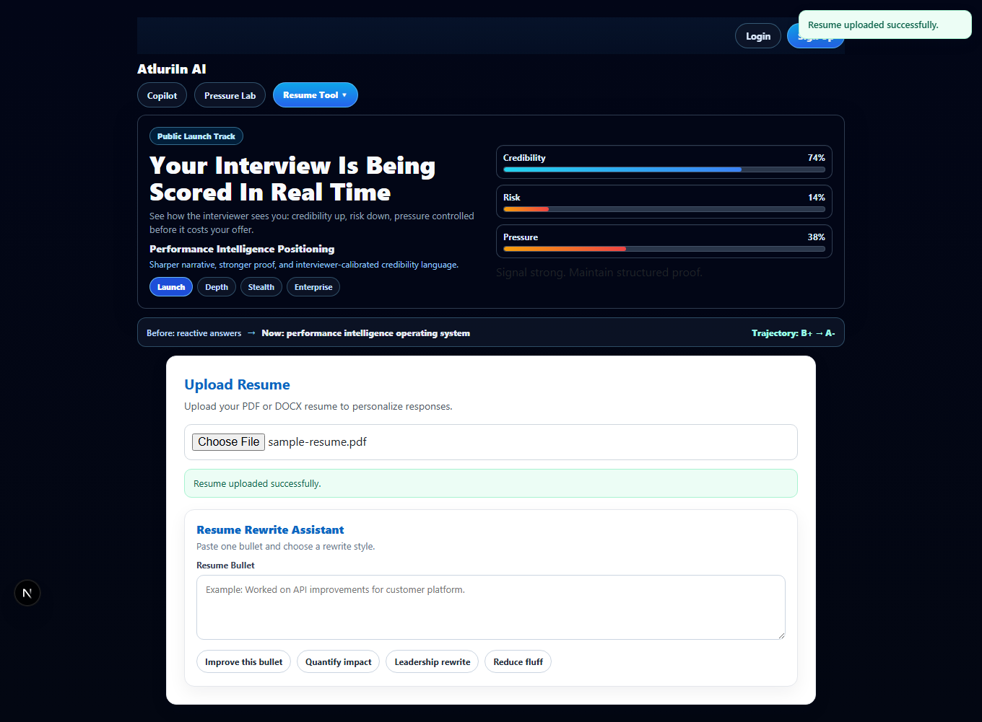

Coding assistant — PASS
Duration: 11181ms
Coding coach returned output.
Screenshot: 2026-02-17T16-12-00-772Z__coding__coach.png
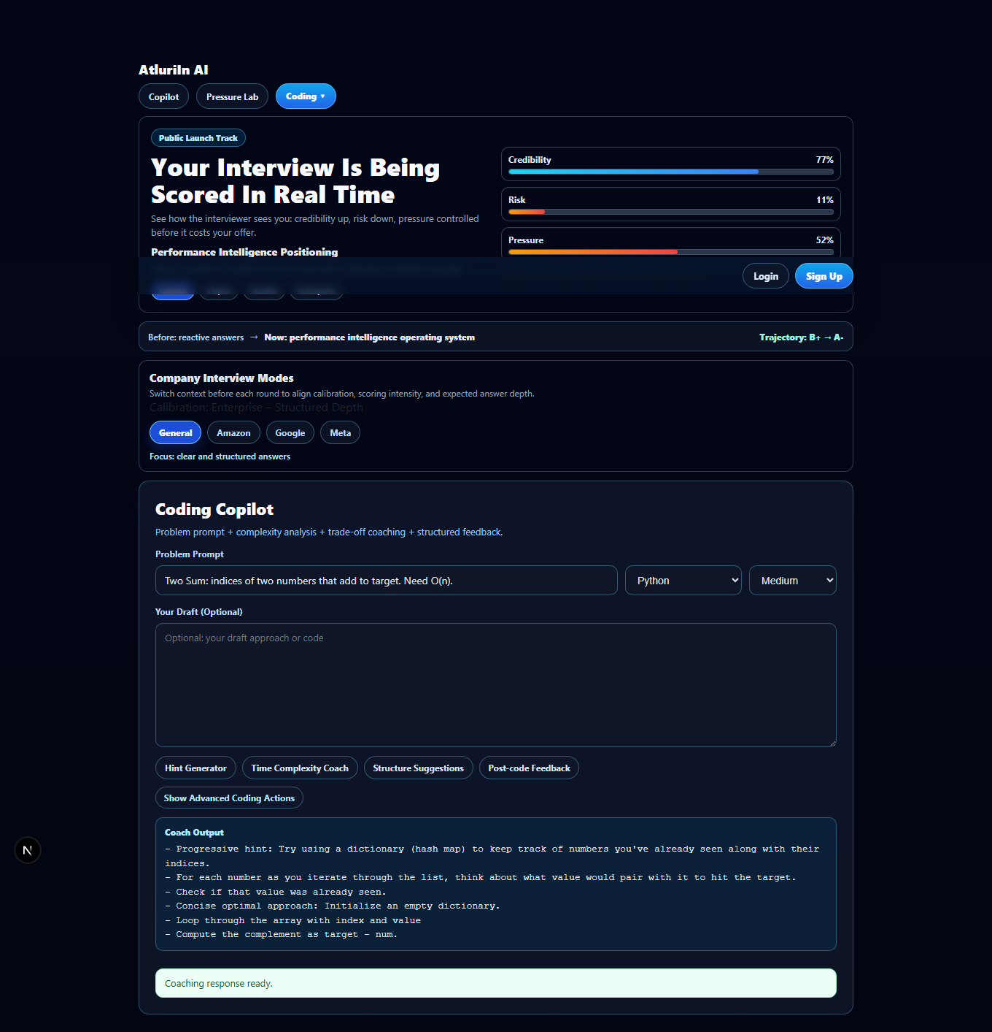

Switch company mode — PASS
Duration: 2430ms
Company mode switched to Google and persisted.
Screenshot: 2026-02-17T16-12-03-191Z__mode__google.png
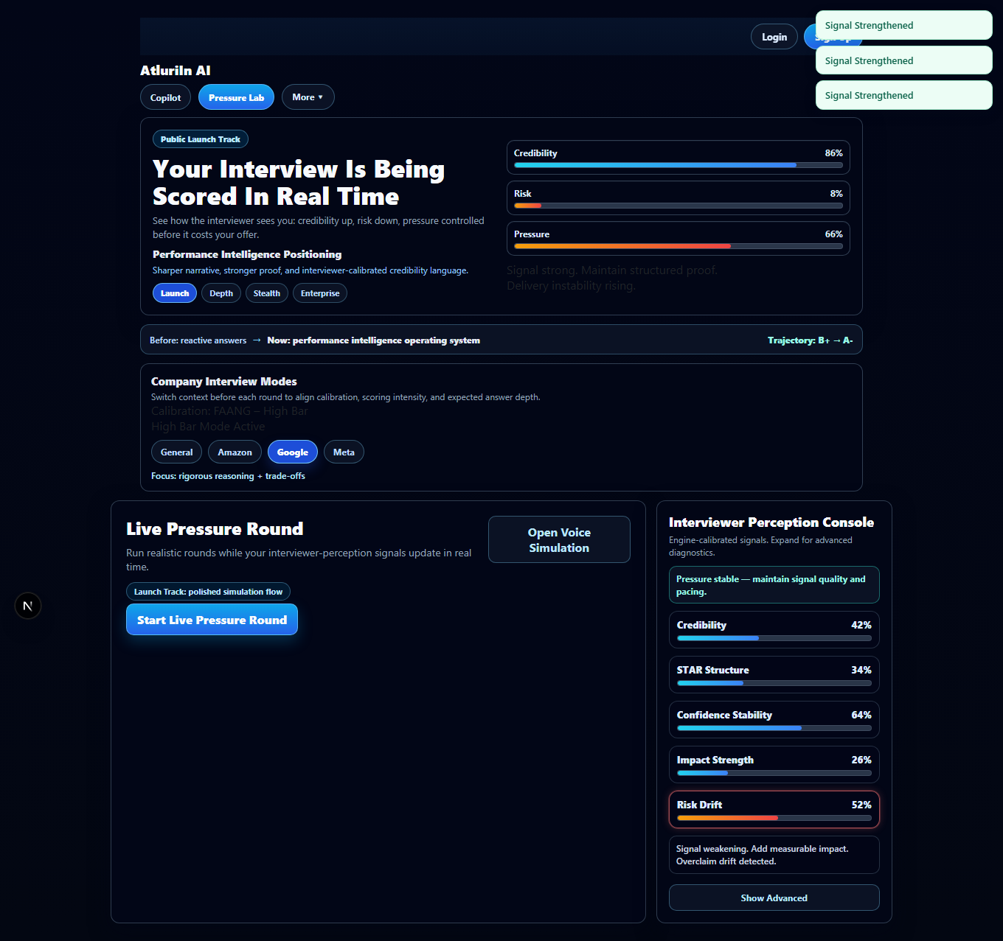

WebSocket validation — PASS
Duration: 1897ms
WS probe PASS. Received at least one server message.
AI Validate: Voice • Live Status → PASS (confidence 0.95)
Screenshot: 2026-02-17T16-12-04-986Z__ws__voice.png
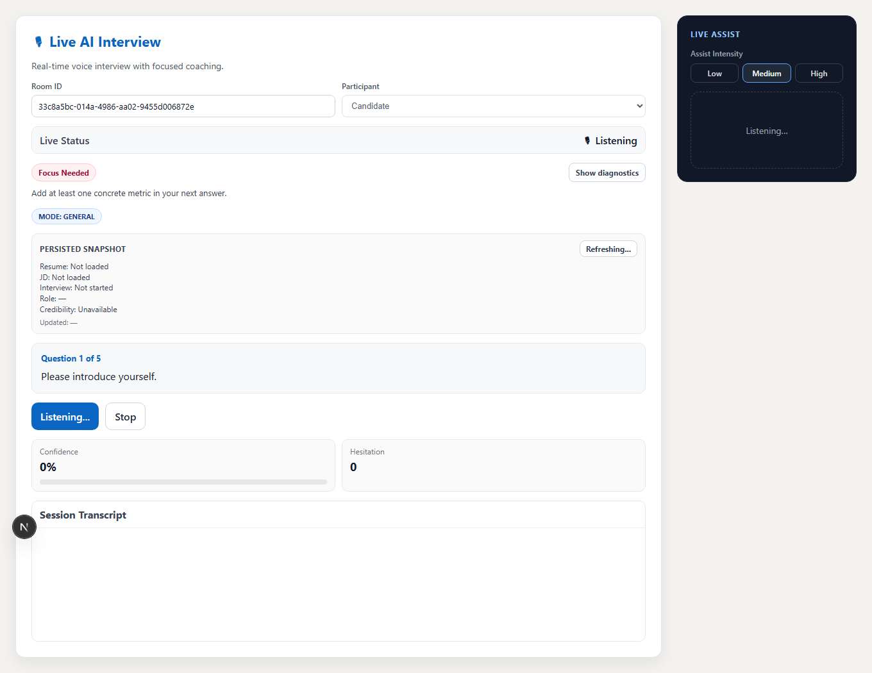

Offer Probability determinism (variance <= threshold) — PASS
Duration: 17581ms
Determinism PASS (variance=0.0000).

Multi-session progression + velocity/plateau — PASS
Duration: 4401ms
Seeded progression/plateau OK: velocity_prog=8.00 velocity_plateau=0.00 plateau_note=present

Errors
Console errors: 0
Network failures: 0

