1. What are the main Sections usually described in the Test Plan Document?

1.1 Test plan identifier (Unique number)

1.2 Introduction

1.3 Test items

1.4. Features in scope of testing

1.5 Features out of scope of testing

1.6 Test strategy

1.7 Exit criteria (test pass/ fail criteria)

1.8 Environmental needs

1.9 Personnel and staff needs

1.10 Schedule and tasks

1.11 Risks and contingencies (Product and Project)

2. Describe what entry are and exit criteria described in the Test Plan and how they are being defined?

Both entry and exit criteria are decided during the Test planning process by the business owner, Product/Project manager.

Entry criteria are a set of conditions that allow the testing process to start, and without any criteria in this set, the testing process cannot be started.

Exit criteria are a set of conditions that allow the testing process to end, because without that criteria test process can go on endlessly

3. Mention and describe the different types of software testing (the most important once).

3.1 By code execution: Static testing, Dynamic testing

3.2 By access to application code: White box, Black box (Equivalence partitioning, Boundary value analysis, Decision table, State transition analysis, Orthogonal array testing, Use case testing)

3.2 By automation Level: Manual, Automated

3.3 By testing level: Unit testing, Integration testing, System testing, Acceptance testing

3.4 By functionality: Functional testing (re-test, regression), Non-functional testing (Performance, Load/Stress testing, Accessibility testing, Maintainability testing)

3.5 By importance: Smoke testing, Critical path testing (user main path), Extended testing

3.6 By end user participation: Alpha, Beta testing

3.7 By QA manager experience: Exploratory, Error guessing, Ad-hoc testing

4. What’s the difference between re-testing and regression testing?

During re-test QA manager verifies once more fixed by developer item, during regression testing QA manager test once more all previous tested items, to ensure that fixed bug or new functionality doesn't cause problems (mostly automated).

5. What non-functional testing types exist?

Performance testing, load/ stress testing, security testing, recoverability testing, maintainability testing, usability testing, and accessibility testing.

6. During that testing it is checked what max amount of users can the application handle without crashing based on declared in requirements amount of users.

7. How would you understand that application is ready for release to live?

If the application corresponds to exit criteria, and maybe has very few, not serious bugs.

8. What is a bug/defect in the application?

A flaw in a component or system that causes that component or system fail, or that component or system can’t perform its required function.

9. What is a bug priority?

Bug priority is importance of one bug against another and according to that importance bug should be fixed: Critical, High, Medium, And Low

10. What is the severity of the bug?

Bug Severity in testing is a degree of impact a bug or has on the application under test: Critical, Major, Moderate, And Low

11. Give an example of a bug with High priority but low severity, bring another example of vice versa.

11.1 On the main page of the site the logo of the company is crashed.

11.2 Link to site’s page, which isn’t very often used by the user, is broken.

12. **I’ve written test cases in another excel file.**

13. Describe a Bug Life Cycle by mentioning all States and Transitions (feel free to use graphical representation).   
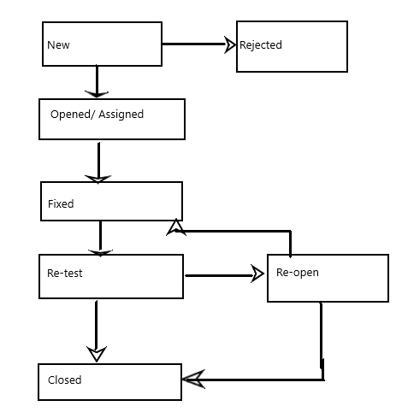

14. Please describe phases of Software Development Life Cycle (SDLC)

Test Planning and control ------> Test analysis and Design -----> Test implementation and Execution --->Evaluating exit criteria and Reporting ----->Test closure activities

15. Please name activities that being done within and after sprint, while working in agile environment

Sprint planning; sprint backlog;

 Sprint (in average lasts  2 weeks: include daily, weekly scrum meeting)

 Sprint might repeat until all goals have achieved

Sprint review;

Sprint retrospective.

16. How would you know that it's time to stop testing, and consider the application tested and ready for release?

Main functionalities declared in the requirements perform as required, test coverage is nearly 100%, and all critical and high priority bugs are fixed and re-tested (including regression testing

17 ???

18. What is Negative testing? How is it different from Positive testing?

A negative test case is such kind of case when the application shouldn't perform that way.

On the contrary, a positive test case is such kind of case, when the application should perform that way.

19. What is meant by [Verification and Validation](https://www.softwaretestinghelp.com/what-is-verification-and-validation/)?

Verification is a more internal process, it occurs during the application development process, validation is a more external process and we perform it when the application is fully developed.

20. What do you mean by table and field in SQL?

Tables contain rows and columns, where the rows we call  records and the columns we call  fields.

21. What are joins in SQL?

We use JOINs to combine two and more tables in SQL.

We can select one field from one table and another field  from another table, based on related field.

There is INNER JOIN, RIGHT JOIN, RIGHT JOIN, FULL JOIN.