CREATE DATABASE Company_Employees;
SHOW DATABASES
USE Company_Employees;

TABLE 1
CREATE TABLE Employees
(
ID numeric (5),
FirstName varchar (100),
LastName varchar (100)
);
SELECT * FROM Employees;

INSERT INTO Employees (ID, FirstName, LastName)
VALUES
(10001, 'Anna', 'Poghosyan'),
(10002, 'Armen', 'Aloyan'),
(10003, 'Gurgen', 'Vardanyan'),
(10004, 'David', 'Simonyan'),
(10005, 'Eliza', 'Abrahamyan'),
(10006, 'Zaruhi', 'Kirakosyan'),
(10007, 'Vardan', 'Sedrakyan'),
(10008, 'Karen', 'Petrosyan'),
(10009, 'Tamara', 'Isahakyan'),
(10010, 'Alisa', 'Hakobyan'),
(10011, 'Ani', 'Stepanyan'),
(10012, 'Tigran', 'Galstyan');

SELECT * FROM Employees;
ALTER TABLE Employees
CHANGE ID EmployeeID numeric (5);
SELECT * FROM Employees;
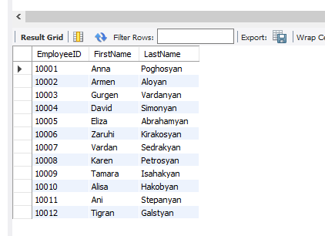

TABLE 2
CREATE TABLE Orders
(
OrderID numeric (6),
EmployeeID numeric (5),
OrderType varchar (100)
);
SELECT * FROM Orders;

INSERT INTO Orders (OrderID, EmployeeID, OrderType)
VALUES
(300001, 10005, 'Basic'),
(300002, 10002, 'Basic'),
(300003, 10003, 'Prime'),
(300004, 10011, 'Basic'),
(300005, 10001, 'Prime'),
(300006, 10002, 'Prime'),
(300007, 10006, 'Basic'),
(300008, 10005, 'Basic'),
(300009, 10007, 'Basic'),
(300010, 10012, 'Prime'),
(300011, 10011, 'Prime'),
(300012, 10014, 'Basic'),
(300013, 10004, 'Basic'),
(300014, 10010, 'Prime'),
(300015, 10009, 'Prime'),
(300016, 10007, 'Basic'),
(300017, 10001, 'Basic'),
(300018, 10006, 'Basic'),
(300019, 10003, 'Prime'),
(300020, 10015, 'Prime');
SELECT * FROM Orders;

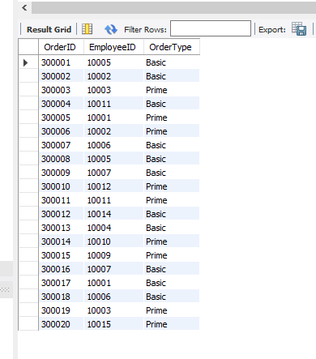

INNER JOIN
SELECT Orders.OrderID, Employees.FirstName, Employees.LastName
FROM Orders
INNER JOIN Employees ON Orders.EmployeeID = Employees.EmployeeID;

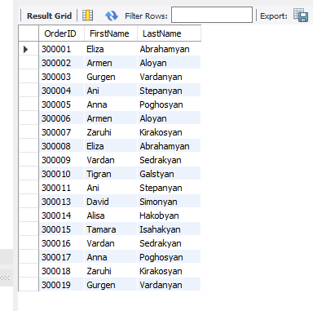
RIGHT JOIN
SELECT Orders.OrderID, Employees.FirstName, Employees.LastName
FROM Orders
RIGHT JOIN Employees ON Orders.EmployeeID = Employees.EmployeeID;
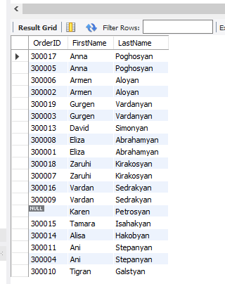
LEFT JOIN
SELECT Orders.OrderID, Employees.FirstName, Employees.LastName
FROM Orders
LEFT JOIN Employees ON Orders.EmployeeID = Employees.EmployeeID;
