ShurjoPay library Setup Codeigniter
The Base_url feature can be globally enabled/disabled by setting the following item in the application/config/config.php file:

if (!ini_get('date.timezone')) {

date_default_timezone_set('GMT');

} else {

date_default_timezone_set('Asia/dhaka');

}

$config['sess_driver'] = 'memcached';

$config['base_url'] = ((isset($_SERVER['HTTPS']) && $_SERVER['HTTPS'] == "on") ? "https" : "http");

$config['base_url'] .= "://" . $_SERVER['HTTP_HOST'];

$config['base_url'] .= str_replace(basename($_SERVER['SCRIPT_NAME']), "", $_SERVER['SCRIPT_NAME']);

The Base_url feature can be globally enabled/disabled by setting the following item in the application/config/autoload.php file:
- $autoload['helper'] = array('url');
The Base_url feature can be globally enabled/disabled by setting the following item in the application/config/route.php file:
$route['check-out'] = 'chackoutcontroller/Checkout';
$route['response'] = 'chackoutcontroller/response';
$route['canceled'] = 'chackoutcontroller/canceled';

Credentials Setup:
Credentials Setup change chackoutcontroller page and shurjopay libraries file.

application/ libraries/ Shurjopay.php file:

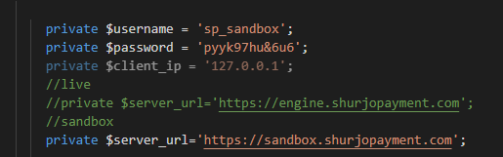

application/ Controller/ Chackoutcontroller.php file:

Call library file Your Checkout Controller file:

function __construct() {
parent::__construct();
$this->load->library('Shurjopay');
}

Response:
[{"id":817,"order_id":"NOK61949aead482e",
"currency":"BDT",
"amount":5,
"payable_amount":5,
"discsount_amount":null,
"disc_percent":0,
"usd_amt":0,
"usd_rate":0,
"card_holder_name":null,
"card_number":null,
"phone_no":"01717302935",
"bank_trx_id":"61949b00",
"invoice_no":"NOK61949aead482e",
"bank_status":"Success",
"customer_order_id":"NOK61949adfdc912",
"sp_code":1000,
"sp_massage":"Success",
"name":"Abu tayeb md fahim",
"email":null,
"address":"Gulshan 1,Dhaka 1212",
"city":"Dhaka",
"value1":null,
"value2":null,
"value3":null,
"value4":null,
"transaction_status":null,
"method":"Nagad",
"date_time":"2021-11-17 12:02:40"}]

