The Base_url feature can be globally enabled/disabled by setting the following item in the application/config/config.php file:

if (!ini_get('date.timezone')) {

date_default_timezone_set('GMT');

} else {

date_default_timezone_set('Asia/dhaka');

}

$config['sess_driver'] = 'memcached';

$config['base_url'] = ((isset($_SERVER['HTTPS']) && $_SERVER['HTTPS'] == "on") ? "https" : "http");

$config['base_url'] .= "://" . $_SERVER['HTTP_HOST'];

$config['base_url'] .= str_replace(basename($_SERVER['SCRIPT_NAME']), "", $_SERVER['SCRIPT_NAME']);

The Base_url feature can be globally enabled/disabled by setting the following item in the application/config/autoload.php file:
- $autoload['helper'] = array('url');
The Base_url feature can be globally enabled/disabled by setting the following item in the application/config/route.php file:
$route['check-out'] = 'chackoutcontroller/Checkout';
$route['response'] = 'chackoutcontroller/response';

Shurjopay Credentials Setup:
application/ libraries/ Shurjopay.php file:

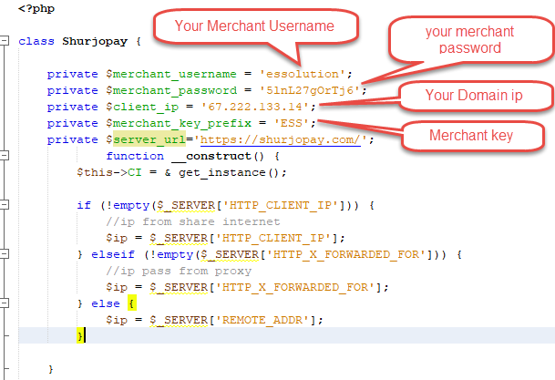

Call library file Your Check out Controller file:

function __construct() {
parent::__construct();
$this->load->library('Shurjopay');
}

public function Checkout() {
$data = array();
$amount = $this->input->post('amount', true);
$this->shurjopay->sendPayment($amount);
}

public function response() {
$response_encrypted = $this->input->post('spdata', true);
$curl = curl_init();
curl_setopt_array($curl, [
CURLOPT_URL => "https://shurjopay.com/merchant/decrypt.php?data=" . $response_encrypted,
CURLOPT_RETURNTRANSFER => true,
CURLOPT_ENCODING => "",
CURLOPT_MAXREDIRS => 10,
CURLOPT_TIMEOUT => 30,
CURLOPT_HTTP_VERSION => CURL_HTTP_VERSION_1_1,
CURLOPT_CUSTOMREQUEST => "GET",
CURLOPT_POSTFIELDS => "",
]);

$response = curl_exec($curl);
$err = curl_error($curl);
curl_close($curl);
if ($err) {
echo "cURL Error #:" . $err;
} else {
$data = array();
$sp_data = simplexml_load_string($response) or die("Error: Cannot create object");
$data['tx_id'] = $sp_data->txID;
$data['bank_tx_id'] = $sp_data->bankTxID;
$data['amount'] = $sp_data->txnAmount;
$data['bank_status'] = $sp_data->bankTxStatus;
$data['sp_code'] = $sp_data->spCode;
$data['sp_code_des'] = $sp_data->spCodeDes;
$data['sp_payment_option'] = $sp_data->paymentOption;
echo json_encode($data);
}
}

