A WD Course Project Report on
“A Responsive Web Application for Finance Department of Government of India”
SUBMITTED IN PARTIAL FULFILLMENT OF THE REQUIREMENTS FOR THE DEGREE OF
BACHELOR OF TECHNOLOGY IN
“Computer Engineering”

OF
VISHWAKARMA INSTITUTE OF TECHNOLOGY

Savitribai Phule Pune University

Pratyay Patel (12413267)
Prathmesh Tiwari (12414231)
Satyam Rahane (12414636)
Pushkar Unaune (12414106)
Pratik Pawar (12412621)

UNDER THE GUIDANCE OF
“XYZ”

DEPARTMENT OF ENGINEERING SCIENCES AND HUMANITIES

BANSILAL RAMNATH AGARWAL CHARITABLE TRUST’S
VISHWAKARMA INSTITUTE OF TECHNOLOGY
(An Autonomous Institute affiliated to Savitribai Phule Pune University)
2025-26

BANSILAL RAMNATH AGARWAL CHARITABLE TRUST’S

VISHWAKARMA INSTITUTE OF TECHNOLOGY
(An Autonomous Institute affiliated to Savitribai Phule Pune University)

PUNE – 411037

CERTIFICATE

This is to certify that the Course Project titled “A Responsive Web Application for Finance Department of Government of India” submitted by
Pratyay Patel (12413267), Prathmesh Tiwari (12414241), Satyam Rahane (12414636), Pushkar Unaune (12414106), Pratik Pawar (12412621) is in partial fulfillment for the award of Degree of Bachelor of Technology in Computer Engineering of Vishwakarma Institute of Technology, Savitribai Phule Pune University. This project report is a record of Bonafide work carried out by him under my guidance during the academic year 2025-26.

Guide HOD, DESH
Prof. Prof. Dr. S. M. Lambor

Place: VIT, Pune
Date:

Bansilal Ramnath Agarwal Charitable Trust’s

Vishwakarma Institute of Technology, Pune-37
Department of Engineering Sciences and Humanities

PROJECT SYNOPSIS

Group No: 2
Members: 5
Roll No. | G.R.No. | Name of Student | Contact No. | Email ID

Academic Year : 2025-26
Project Title : A Responsive Web Application for Finance Department of Government of India
Project Area : E-Governance, Financial Management, Web Application Development
Internal Guide : Mr. Sachin Madhukar Kolekar

Signature of Internal Guide

ACKNOWLEDGEMENT

We would like to express our sincere gratitude to everyone who contributed to the successful completion of this project, "Responsive Web Application for the Finance Department of the Government of India."
First and foremost, we extend our heartfelt thanks to our internal guide, Prof. Sachin Madhukar Kolekar, for his invaluable guidance, continuous support, and constructive feedback throughout the project. His expertise and encouragement have been instrumental in shaping this work.
We are also grateful to our faculty members and mentors at Vishwakarma Institute of Technology for providing us with the necessary knowledge and resources to undertake this project. Their insights and encouragement have been a constant source of motivation.
Furthermore, we would like to acknowledge the contributions of our peers and friends who provided suggestions and feedback that helped enhance the quality of the project.
Lastly, we express our deep appreciation to our families for their unwavering support and encouragement throughout this journey.
This project has been a great learning experience, and We sincerely appreciate the opportunity to work on a real-world application as part of our web development course.
Pratyay Patel, Prathmesh Tiwari, Satyam Rahane, Pushkar Unaune, Pratik Pawar
Vishwakarma Institute of Technology, Pune

Introduction

In today’s digital age, government departments are adopting technology to improve efficiency, transparency, and accessibility. This project, "Responsive Web Application for the Finance Department of the Government of India," is designed to streamline financial management by providing a secure, user-friendly, and mobile-responsive platform.

The main objective of this project is to facilitate financial data handling, transaction tracking, and report generation. The web application ensures accessibility across devices, enabling officials to manage financial operations efficiently. Key features include secure authentication, real-time data access, and an intuitive interface.

By automating financial processes, this application enhances transparency and decision-making while reducing manual workload. It aligns with the Indian government’s push toward e-governance, making financial operations more efficient and accessible.

In this project we have used HTML, CSS, JavaScript, jQuery and Bootstrap for the development of our web application.

Codes of main modules used in project

<!DOCTYPE html>
<html lang="en">
<head>
<meta charset="UTF-8">
<meta name="viewport" content="width=device-width, initial-scale=1.0">
<title>Ministry of Finance - Government of India</title>
<link rel="stylesheet" href="https://cdnjs.cloudflare.com/ajax/libs/font-awesome/5.15.4/css/all.min.css">
<script src="https://code.jquery.com/jquery-3.6.0.min.js"></script>
<style>
* {
margin: 0;
padding: 0;
box-sizing: border-box;
font-family: 'Arial', sans-serif;
}

#video-container {
position: fixed;
right: 0;
bottom: 0;
min-width: 100%;
min-height: 100%;
z-index: -1;
}

#bg-video {
width: 100%;
height: 100%;
object-fit: cover;
}

.overlay {
position: absolute;
top: 0;
left: 0;
width: 100%;
height: 100%;
background: rgba(0, 0, 0, 0.5);
}

header {
padding: 20px;
background: rgba(0, 0, 0, 0.7);
color: white;
text-align: center;
}

.logo {
width: 80px;
vertical-align: middle;
}

nav {
background: rgba(0, 51, 102, 0.9);
padding: 15px;
position: sticky;
top: 0;
z-index: 100;
}

nav ul {
list-style: none;
display: flex;
justify-content: center;
}

nav ul li {
margin: 0 20px;
}

nav ul li a {
color: white;
text-decoration: none;
font-weight: bold;
transition: color 0.3s;
}

nav ul li a:hover {
color: #ffd700;
}

.content-section {
padding: 50px 20px;
color: white;
background: rgba(0, 0, 0, 0.7);
margin: 20px;
border-radius: 10px;
}

footer {
background: rgba(0, 0, 0, 0.9);
color: white;
padding: 20px;
text-align: center;
}

.news-ticker {
background: #002366;
color: white;
padding: 10px;
margin: 10px 0;
}

.section-heading {
color: #ffd700;
margin-bottom: 20px;
text-align: center;
}

.responsive-table {
width: 100%;
overflow-x: auto;
}

.download-btn {
background: #002366;
color: white;
padding: 10px 20px;
border: none;
border-radius: 5px;
cursor: pointer;
transition: background 0.3s;
}

.download-btn:hover {
background: #001a33;
}
</style>
</head>
<body>
<div id="video-container">
<video autoplay muted loop id="bg-video">
<source src="https://cdn.pixabay.com/video/2022/08/22/128734-742053565_tiny.mp4" type="video/mp4">
</video>
<div class="overlay"></div>
</div>

<header>
<img src="https://wallpapercave.com/wp/wp7870042.png" alt="National Emblem" class="logo">
<h1>Ministry of Finance</h1>
<p>Government of India</p>
</header>

<nav>
<ul>
<li><a href="#home">Home</a></li>
<li><a href="#about">About</a></li>
<li><a href="#budget">Budget</a></li>
<li><a href="#contact">Contact</a></li>
</ul>
</nav>

<div class="news-ticker">
<marquee>Latest Update: Union Budget 2024-25 released | Economic Survey published | GST collections rise by 12%</marquee>
</div>

<div style="text-align: center; position: relative;">
<iframe id="youtube-video" width="560" height="315"
src="https://www.youtube.com/embed/877x8bvwXKQ"
frameborder="0"
allow="accelerometer; autoplay; clipboard-write; encrypted-media; gyroscope; picture-in-picture; web-share"
allowfullscreen
onerror="showFallback()">
</iframe>

<!-- Fallback message -->
<div id="video-fallback" style="display: none; padding: 20px; background: rgba(0, 0, 0, 0.7); color: white; border-radius: 10px;">
<p>Video not available. <a href="https://www.youtube.com/watch?v=877x8bvwXKQ" target="_blank" style="color: #ffd700; font-weight: bold;">Watch on YouTube</a></p>
</div>
</div>

<script>
function showFallback() {
document.getElementById("youtube-video").style.display = "none";
document.getElementById("video-fallback").style.display = "block";
}
</script>

<section id="home" class="content-section">
<h2 class="section-heading">Welcome to the Ministry of Finance</h2>
<p>Official portal for financial governance and economic management of India</p>
</section>

<section id="about" class="content-section">
<h2 class="section-heading">About Us</h2>
<p>The Ministry of Finance is responsible for the economic policy of the Government of India.</p>
<!-- Add more content -->
</section>

<section id="budget" class="content-section">
<h2 class="section-heading">Union Budget 2023-24</h2>
<button class="download-btn">Download Budget PDF</button>
<!-- Add budget documents -->
</section>

<section id="contact" class="content-section">
<h2 class="section-heading">Contact Us</h2>
<p>North Block, New Delhi</p>

<!-- Add after Contact Section -->

<section id="services" class="content-section">
<h2 class="section-heading">Online Services</h2>
<div class="services-grid">
<div class="service-card">
<i class="fas fa-file-invoice-dollar"></i>
<h3>Tax Portal</h3>
<p>File your income tax returns online</p>
<button class="service-btn">Access Portal</button>
</div>
<div class="service-card">
<i class="fas fa-coins"></i>
<h3>GST Services</h3>
<p>GST registration and filing</p>
<button class="service-btn">GST Portal</button>
</div>
<div class="service-card">
<i class="fas fa-chart-line"></i>
<h3>Economic Survey</h3>
<p>Download latest economic reports</p>
<button class="service-btn">View Reports</button>
</div>
</div>
</section>

<section id="news" class="content-section">
<h2 class="section-heading">Latest News</h2>
<div class="news-carousel">
<div class="news-item active">
<h3>New Tax Regulations Released</h3>
<p>Updated income tax rules for FY 2023-24</p>
<small>Posted: 2023-07-15</small>
</div>
<div class="news-item">
<h3>Digital Currency Initiative</h3>
<p>RBI announces new digital rupee framework</p>
<small>Posted: 2023-07-14</small>
</div>
<button class="carousel-btn prev">❮</button>
<button class="carousel-btn next">❯</button>
</div>
</section>

<section id="data" class="content-section">
<h2 class="section-heading">Economic Indicators</h2>
<div class="indicator-container">
<div class="indicator-box">
<h4>GDP Growth Rate</h4>
<div class="indicator-value">6.5%</div>
<small>Q1 2023-24</small>
</div>
<div class="indicator-box">
<h4>Inflation Rate</h4>
<div class="indicator-value">4.8%</div>
<small>June 2023</small>
</div>
<div class="indicator-box">
<h4>Fiscal Deficit</h4>
<div class="indicator-value">5.9%</div>
<small>of GDP</small>
</div>
</div>
</section>

<style>
/* Additional CSS Styles */
.services-grid {
display: grid;
grid-template-columns: repeat(auto-fit, minmax(250px, 1fr));
gap: 20px;
margin-top: 30px;
}

.service-card {
background: rgba(255, 255, 255, 0.1);
padding: 20px;
border-radius: 10px;
text-align: center;
transition: transform 0.3s;
}

.service-card:hover {
transform: translateY(-5px);
}

.service-card i {
font-size: 2.5em;
color: #ffd700;
margin-bottom: 15px;
}

.service-btn {
background: #002366;
color: white;
padding: 8px 15px;
margin-top: 10px;
border: none;
border-radius: 5px;
cursor: pointer;
}

.news-carousel {
position: relative;
max-width: 800px;
margin: 20px auto;
min-height: 150px;
}

.news-item {
display: none;
padding: 20px;
background: rgba(255, 255, 255, 0.1);
border-radius: 8px;
}

.news-item.active {
display: block;
}

.carousel-btn {
position: absolute;
top: 50%;
transform: translateY(-50%);
background: rgba(0, 0, 0, 0.5);
color: white;
padding: 10px;
border: none;
cursor: pointer;
}

.prev { left: 10px; }
.next { right: 10px; }

.indicator-container {
display: flex;
justify-content: center;
gap: 30px;
flex-wrap: wrap;
}

.indicator-box {
background: rgba(255, 255, 255, 0.1);
padding: 20px;
border-radius: 10px;
text-align: center;
min-width: 150px;
}

.indicator-value {
font-size: 2em;
color: #ffd700;
margin: 10px 0;
}

@media (max-width: 768px) {
nav ul {
flex-wrap: wrap;
gap: 10px;
}

.content-section {
margin: 10px;
padding: 20px;
}
}
</style>

<script>
// Additional JavaScript
// News Carousel Functionality
let currentNewsIndex = 0;
const newsItems = $('.news-item');

function showNews(index) {
newsItems.removeClass('active');
$(newsItems[index]).addClass('active');
}

$('.next').click(() => {
currentNewsIndex = (currentNewsIndex + 1) % newsItems.length;
showNews(currentNewsIndex);
});

$('.prev').click(() => {
currentNewsIndex = (currentNewsIndex - 1 + newsItems.length) % newsItems.length;
showNews(currentNewsIndex);
});

// Auto-advance carousel every 10 seconds
setInterval(() => $('.next').click(), 10000);

// Form Validation Example (Add to Contact Section)
$('#contact-form').submit(function(e) {
e.preventDefault();
const email = $('#email').val();
if (!validateEmail(email)) {
alert('Please enter a valid email address');
return;
}
// Add form submission logic
});

function validateEmail(email) {
const re = /^[^\s@]+@[^\s@]+\.[^\s@]+$/;
return re.test(email);
}

// Economic Indicators Animation
$('.indicator-value').each(function() {
$(this).prop('Counter', 0).animate({
Counter: $(this).text()
}, {
duration: 2000,
easing: 'swing',
step: function(now) {
$(this).text(Math.ceil(now) + '%');
}
});
});
</script>
<section id="contact" class="content-section">
<h2 class="section-heading">Contact Us</h2>
<form id="contact-form">
<input type="text" placeholder="Name" required>
<input type="email" id="email" placeholder="Email" required>
<textarea rows="5" placeholder="Message" required></textarea>
<button type="submit" class="download-btn">Send Message</button>
</form>
<div class="contact-info">
<p><i class="fas fa-map-marker-alt"></i> North Block, New Delhi</p>
<p><i class="fas fa-phone"></i> +91-11-23092332</p>
<p><i class="fas fa-envelope"></i> contact-finance@gov.in</p>
</div>
</section>
</body>
</html>

Explanation of the Above Code

1. Layout and Structure (HTML)
The HTML (HyperText Markup Language) defines the structure of the webpage. It includes fundamental elements such as headers, navigation, sections, and footers to organize the content efficiently. The <header> contains the logo, ministry name, and purpose, while the <nav> element provides a sticky navigation bar with internal links (<a> tags) for smooth navigation. Various <section> elements are used to create distinct content blocks such as Home, About, Budget, Services, News, and Contact.
A news ticker is implemented using the <marquee> tag, which scrolls government updates across the screen. Additionally, a <video> element is embedded inside a <div> container to display a full-screen background video, creating an engaging visual effect.
2. Styling and Aesthetic Design (CSS)
The CSS (Cascading Style Sheets) defines the appearance of the webpage, ensuring a professional and visually appealing design. Key CSS techniques used include:
- Fixed Full-Screen Background Video: The #video-container is styled with position: fixed to cover the entire viewport, and object-fit: cover ensures the video scales properly.
- Overlay Effect: A semi-transparent overlay (.overlay) with background: rgba(0, 0, 0, 0.5) is placed on top of the video to improve text readability.
- Navigation Bar Styling: The <nav> bar uses position: sticky; top: 0 to ensure it remains visible during scrolling. The color transitions (color: white; text-decoration: none; transition: color 0.3s;) enhance the user experience.
- Content Sections & Cards: Sections like economic indicators, services, and news updates use grid and flexbox layouts for responsive design. Card hover effects (transform: translateY(-5px); transition: 0.3s;) enhance interactivity.
3. Interactive Features (JavaScript)
The JavaScript (JS) elements in the webpage add interactivity and dynamic behavior, enhancing user experience. Key JS functionalities include:
- YouTube Video Fallback: A function showFallback() is triggered when the embedded video fails to load, replacing it with a fallback message containing a YouTube link.
- News Carousel Animation: The news section dynamically cycles through headlines using setInterval() to auto-scroll every 10 seconds. Buttons (prev and next) manually cycle through news items.
- Form Validation: A simple email validation function checks the user’s input before allowing form submission. If the email format is incorrect, an alert notifies the user.
- Animated Economic Indicators: The GDP growth rate, inflation, and fiscal deficit values animate from 0 to their actual values using .animate() to create a smooth counting effect.
4. Responsive and Accessible Design
The website is made responsive using CSS media queries to ensure a smooth experience on both desktop and mobile devices. For example, the navigation bar items adjust in a flexible layout (flex-wrap: wrap) on smaller screens, and content sections use auto-fit grid layouts to adapt to different screen sizes. The text contrast, font sizes, and color scheme improve accessibility for users with visual impairments.

Screenshots of results

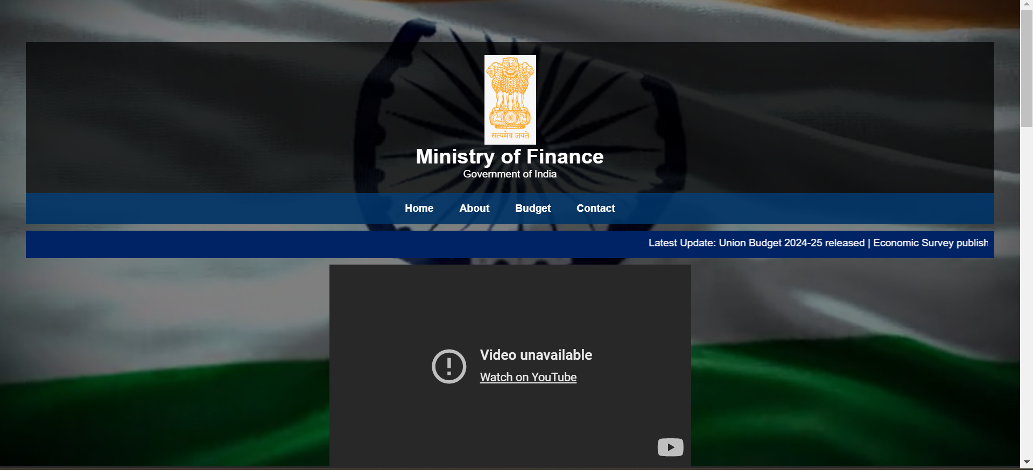
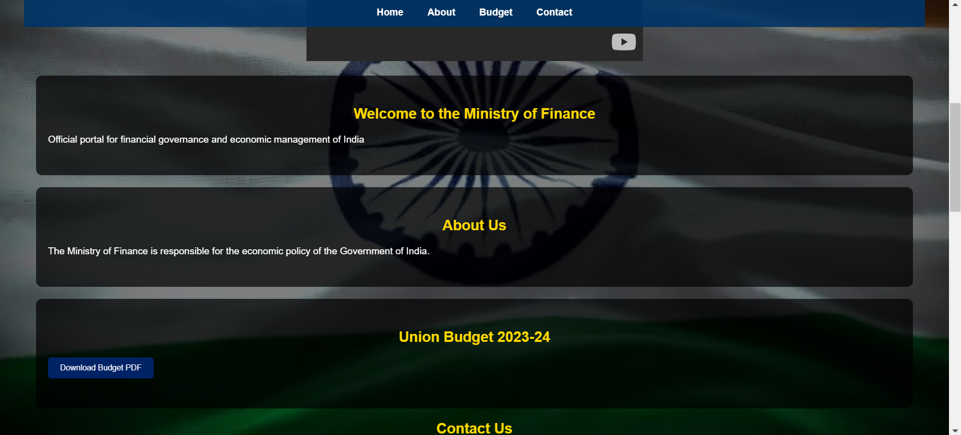

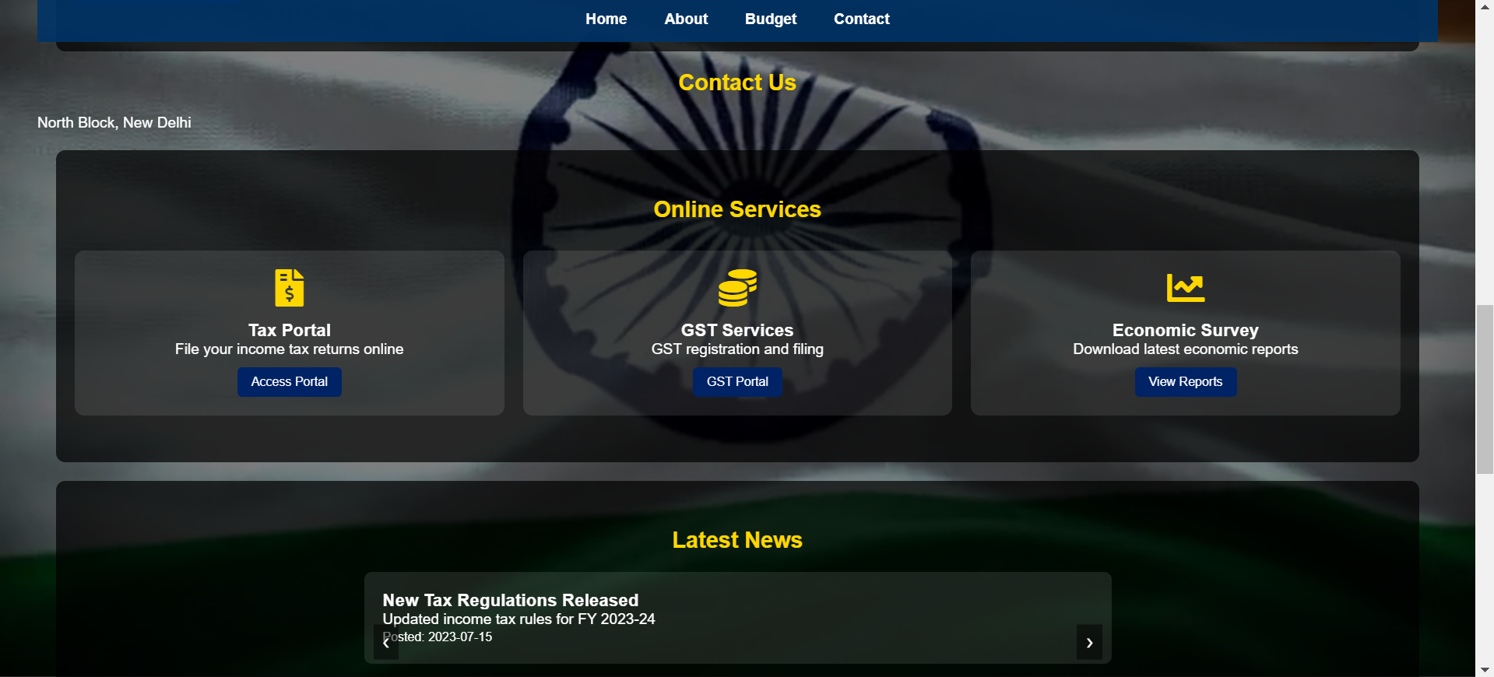
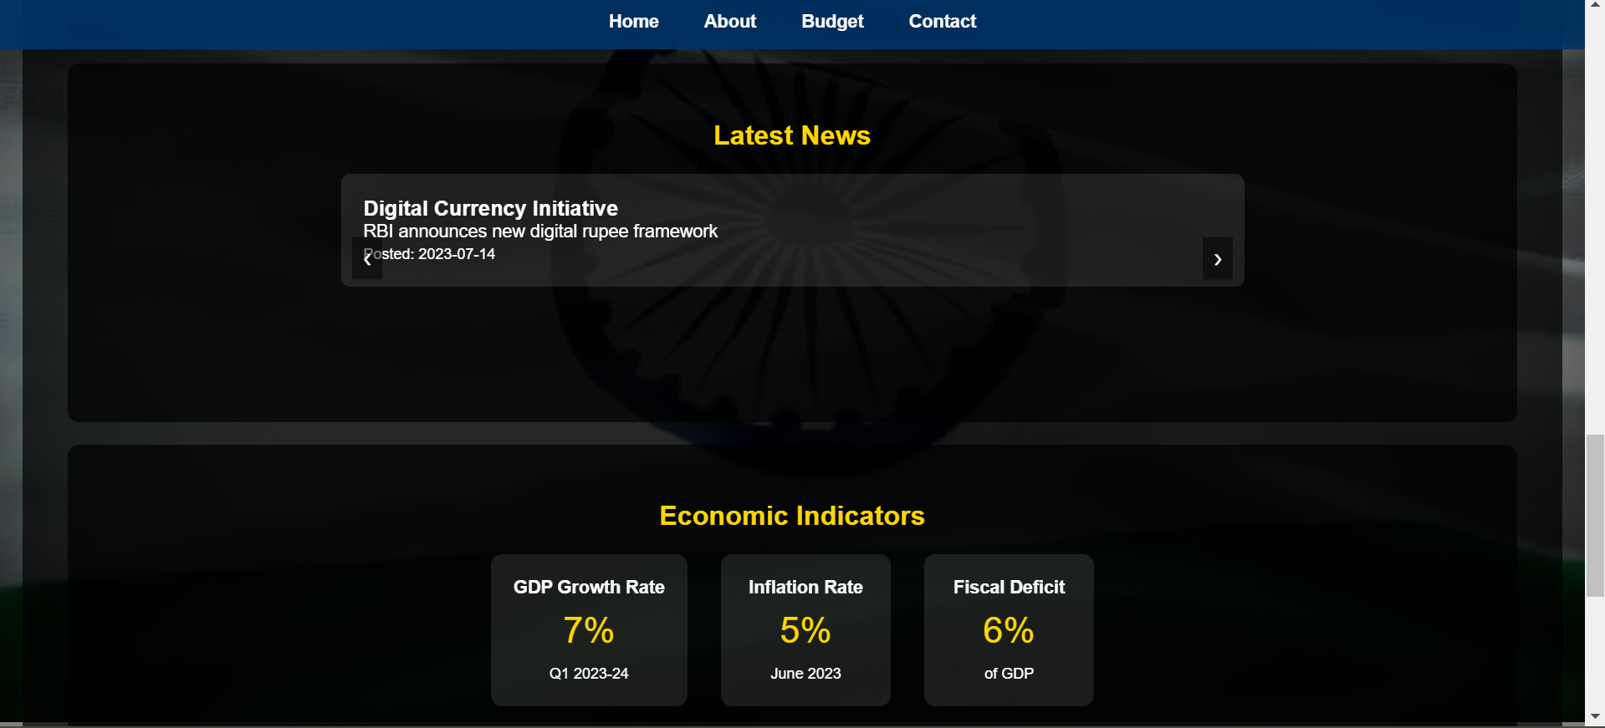

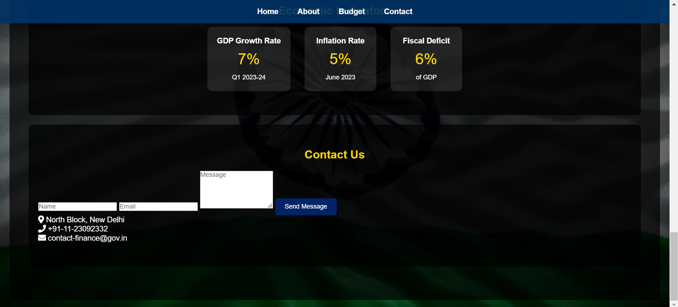

Explanation of the Above Output

1. Full-Screen Background Video and Overlay Effect
One of the most striking visual elements of the website is the full-screen background video, which plays automatically without sound. This video, sourced from Pixabay, gives a modern and professional look, enhancing user engagement.
- The overlay effect (semi-transparent dark layer) improves readability by ensuring that text and interactive elements stand out against the video background.
- The background remains fixed (position: fixed), covering the entire screen regardless of scrolling, creating a seamless immersive experience.

2. Header and Sticky Navigation Bar
At the top of the page, the header section contains:
- The National Emblem logo to establish government authenticity.
- The Ministry’s Name and Tagline, centrally aligned to maintain focus.
Below the header, a sticky navigation bar provides quick access to different sections of the website:
- Menu options include Home, About, Budget, Contact for ease of navigation.
- Links change color (color: #ffd700;) when hovered over, indicating interactivity.
The sticky effect ensures that the menu remains visible even when scrolling, improving user accessibility.

3. Scrolling News Ticker for Latest Updates
A news ticker (implemented using <marquee>) continuously scrolls important updates such as:
- Union Budget Release
- Economic Survey Publications
- GST Collection Growth Data
This feature ensures that visitors are always informed about the latest financial developments without needing to navigate elsewhere.

4. Embedded YouTube Video with Fallback Option
A YouTube video iframe is embedded to provide users with multimedia content related to government initiatives. If the video fails to load:
- A fallback message is displayed with a clickable link to watch the video directly on YouTube.
This improves user experience and accessibility, ensuring no information is lost due to network or browser restrictions.

5. Informational Content Sections
The website has multiple content sections, each styled with rounded borders, white text, and a semi-transparent background for readability.
a) Home Section
- Introduces the Ministry of Finance and its role.
- Provides a brief mission statement for visitors.
b) About Section
- Outlines the responsibilities of the Ministry.
- Educates users about the ministry's role in economic policy, budgeting, and taxation.
c) Budget Section
- Displays Union Budget details for the latest financial year.
- Provides a download button for users to access budget documents in PDF format.
Each section ensures that visitors can quickly access essential financial information.

6. Interactive Online Services Section
A grid-based services section provides links to important financial services:
- Income Tax Portal for tax filing.
- GST Portal for tax registration and compliance.
- Economic Survey Reports for financial insights.
Each service card includes:
- Icons for quick identification.
- Hover effects (transform: translateY(-5px);) to indicate interactivity.
- CTA buttons (Access Portal, GST Portal, View Reports) guiding users to respective portals.
These elements make it easy for visitors to navigate government services.

7. Dynamic News Carousel
A news carousel dynamically displays latest financial updates. The carousel:
- Auto-rotates every 10 seconds (setInterval()).
- Has manual navigation buttons (❮ ❯) to switch between news items.
News items are enclosed in a card-like design with a posting date for authenticity.
This section ensures users remain informed about financial news without overwhelming them.

8. Economic Indicators Display
A real-time financial data section displays key economic statistics:
- GDP Growth Rate
- Inflation Rate
- Fiscal Deficit
Each indicator is shown inside a boxed container with:
- Bold numerical values in golden color (#ffd700) to highlight importance.
- Animated counter effect (.animate()) that gradually increases the numbers for a smooth visual experience.
This section visually represents the country’s economic performance, making it easy for users to interpret financial trends.

9. Contact Section with Form and Government Details
The contact section includes:
- A user-friendly form for inquiries (Name, Email, Message).
- Email validation ensures correct input before submission.
- Contact details:
  - Office Address: North Block, New Delhi
  - Phone Number: Government helpline
  - Official Email: For financial queries.
Icons (fas fa-map-marker-alt, fas fa-phone, fas fa-envelope) visually differentiate the contact methods.
This section facilitates communication between citizens and the Ministry.

10. Responsive and Mobile-Friendly Design
The website is fully responsive, adapting to different screen sizes:
- Navigation bar adjusts using flex-wrap: wrap on smaller screens.
- Grid layout ensures service cards and indicators are displayed properly on all devices.
- Sections are well-spaced (margin: 20px; padding: 50px 20px;) for readability.
This ensures that users on mobile, tablet, and desktop have a consistent browsing experience.

Conclusion

The development of the Responsive Web Application for the Finance Department of the Government of India has been a valuable learning experience, integrating web development principles with real-world financial management needs. This project successfully achieves its objectives by providing a secure, responsive, and user-friendly platform for handling financial data, transaction tracking, and report generation.

By leveraging modern web technologies, the application enhances efficiency, transparency, and accessibility for government officials. It also aligns with the broader vision of e-governance, contributing to the digital transformation of financial operations.

Overall, this project demonstrates the potential of web applications in improving administrative processes and can be further expanded with additional features to meet evolving requirements. The knowledge and skills gained during this project will be instrumental in future web development endeavours.

References

- Books & Academic Resources
- Jon Duckett, HTML & CSS: Design and Build Websites, Wiley, 2011.

- Web Development Documentation & Tutorials
- W3Schools, Web Technologies Tutorials, https://www.w3schools.com/
- Government & Finance-Related Sources
  - Ministry of Finance, Government of India, https://finmin.gov.in/

