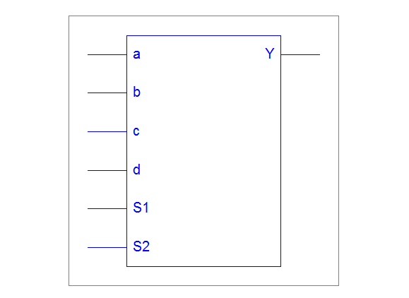

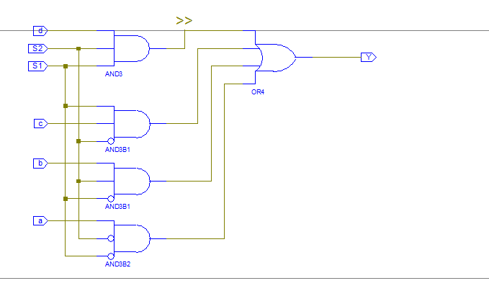

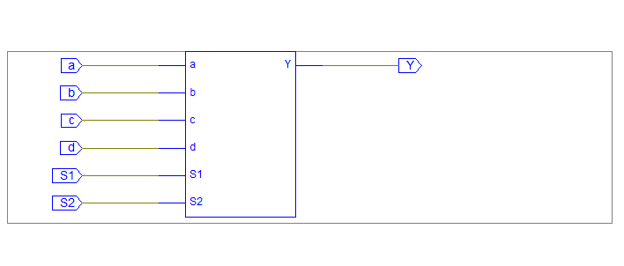

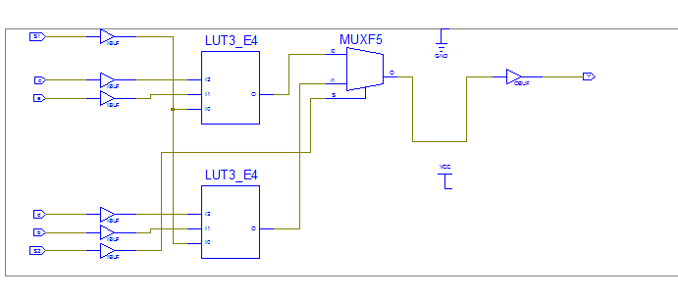

Waveform:

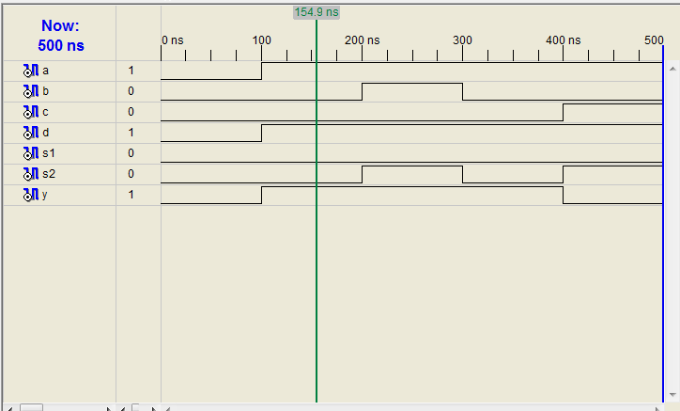

Behavioral:

Rtl:

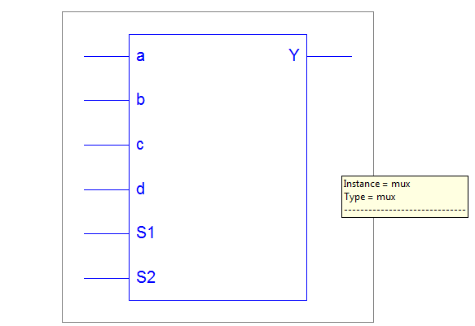

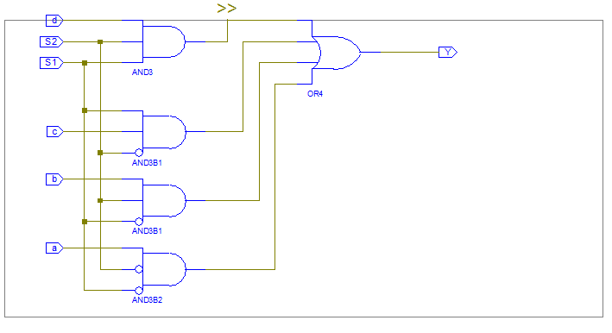

Technological:

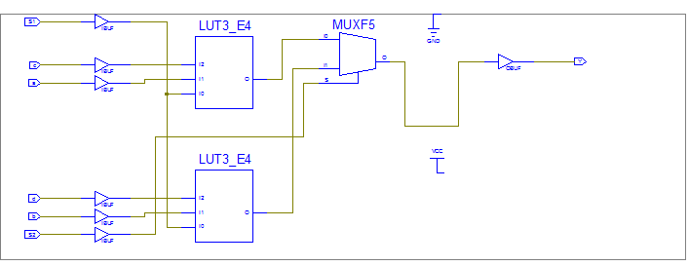

Waveform:

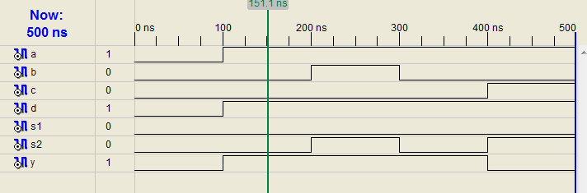

ENCODER 3:8-

RTL View:

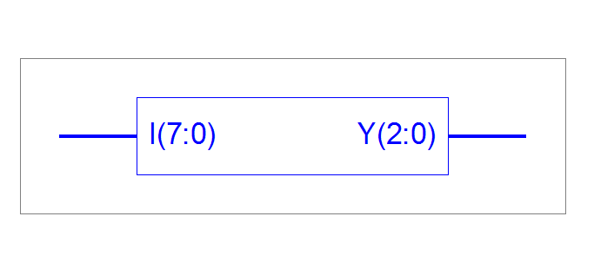

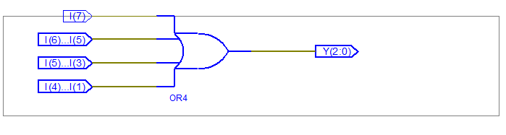

TECHNOLOGICAL:

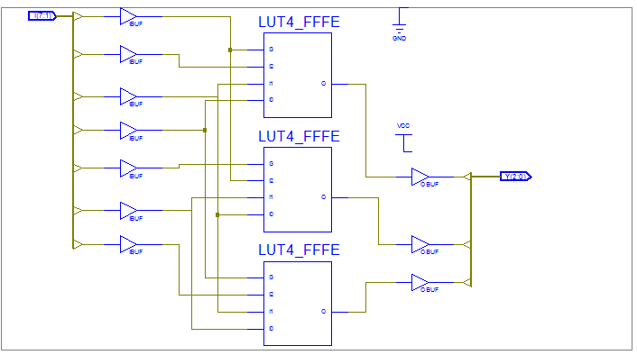

OUTPUT WAVEFORM:

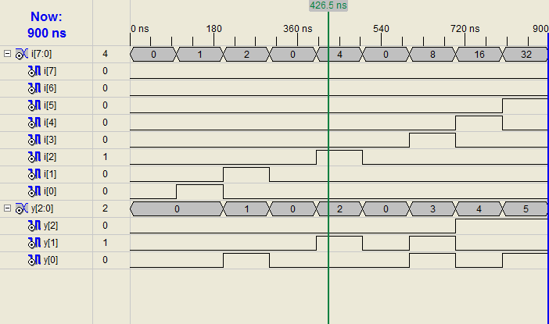

Proirity encoder

library IEEE;

use IEEE.STD_LOGIC_1164.ALL;

use IEEE.STD_LOGIC_ARITH.ALL;

use IEEE.STD_LOGIC_UNSIGNED.ALL;

---- Uncomment the following library declaration if instantiating

---- any Xilinx primitives in this code.

--library UNISIM;

--use UNISIM.VComponents.all;

entity priority_1 is

Port ( I : in STD_LOGIC_VECTOR (7 downto 0);

Y : out STD_LOGIC_VECTOR (2 downto 0));

end priority_1;

architecture Behavioral of priority_1 is

begin

begin process(I)

if (I(7)='1')then

Y <= "111";

elsif(I(6) ='1')then

Y <= "110";

elsif(I(5) = '1')then

Y <= "101";

elsif(I(4) = '1')then

Y <= "100";

elsif(I(3) = '1')then

Y <= "011";

elsif(I(2) = '1')then

Y <= "010";

elsif(I(1) = '1')then

Y <= "001";

elsif(I(0) ='1')then

Y <= "000";

else

NULL;

end if;

end process;

end Behavioral;

RTL view:

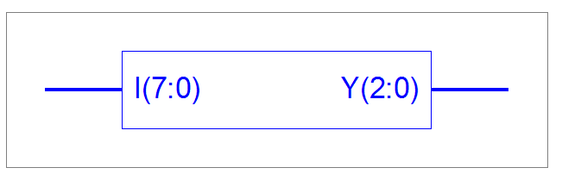

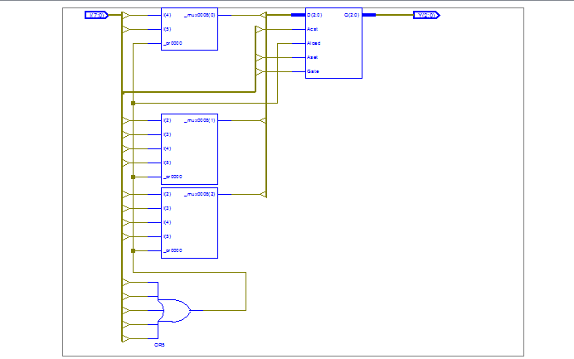

Technological view:

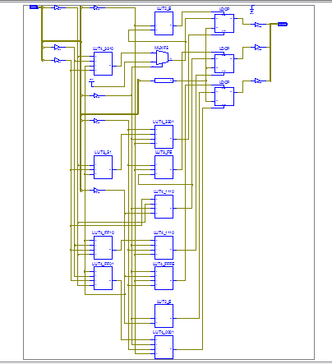

Output waveform:

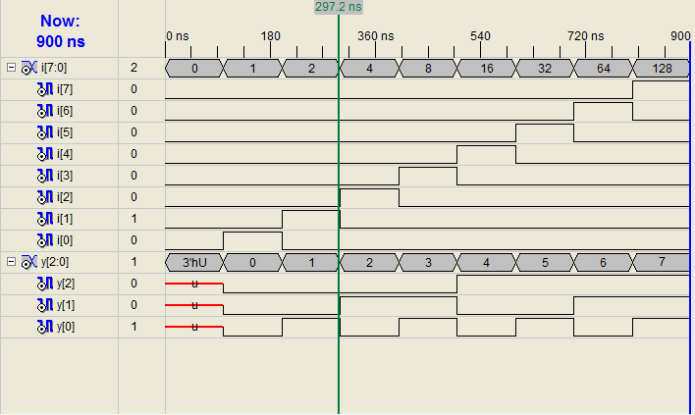

Decoder

RTL view: