Department of Computer Science and Technology

MANAV RACHNA UNIVERSITY, FARIDABAD



Subject : O.S. Lab (CSE-313-F)

Under the Supervision of: Submitted by:

Faculty Name Student Name: ADITYA NARAYAN
Designation Roll No. 2K15CSUN01065
Department of Computer Science
& Technology

Batch (Group)
Lab Days:

Student Signature
Acknowledgment

I wish to express my sincere gratitude to our Vice Chancellor Dr. Sanjay Srivastava, and Ms. Hanu Bhardwaj, H.O.D of Computer Science of Manav Rachna University for providing me an opportunity to do my practical work on “Unix and Shell Programming”.

This work bears an imprint of many people. I sincerely thank to my faculty members Mr. Ram Chatterjee for their guidance, patience and encouragement in carrying out this work.

I also wish to express my gratitude to the officials and other staff members for their kind co-operation in the completion of my practical work.

Last but not least I wish to express my thanks for this opportunity to my beloved parents and friends for their support, strength and cooperation.

Place:
Date:

Student Signature:

Table of Contents

S.No. | Assignment Number | Description of question | Pg No. | Date of assignment | Date of submission | Signature of the Faculty | Remarks
1 | Lab Assignment - 1 | Exercise on General Purpose Utility Commands | 4 | 016/01/2017 | 23/01/2017
2 | Lab Assignment  -2 | To learn and implement General Purpose Utility Commands in Linux | 8 | 23/01/2017 | 30/01/2017
3 | Lab Assignment  -3 | To check status of user and change permission of files  and Back up of home directory | 9 | 30/01/2017 | 06/02/2017
4 | Lab Assignment -4 | Students should be able to learn and implement basic shell programming concepts using editor | 12 | 06/02/2017 | 13/02/2017
5

Lab: 1

Name: Ayush Sharma Roll No. 2k15CSUN01041 Group No. G1

Date of Performance : Faculty’s Signature_________________________
Laboratory Objective: To implement Basic commands of Unix and Handling Ordinary Files
Learning Outcome: Familiarity with the use of basic command of Unix and Handling Ordinary Files

  - Obtain the following results
  - To print the name of operating system
Ans: Uname –a
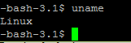

  - To print the version of the operating system
Ans: Uname –r
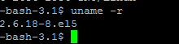

  - To print the name of the machine
Ans: uname -n
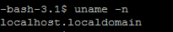
  - To print the login name
Ans: 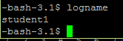
  - To print the host name
Ans: hostname
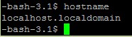

  - Write commands to:
- Find out the users who are currently logged in and find the particular user too.
Ans: who
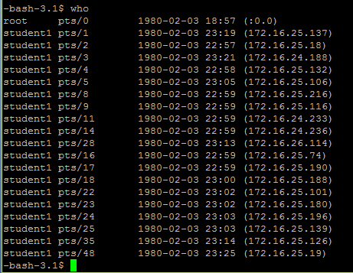

- Find out the detailed list of users who are currently logged in with column headings in the output.
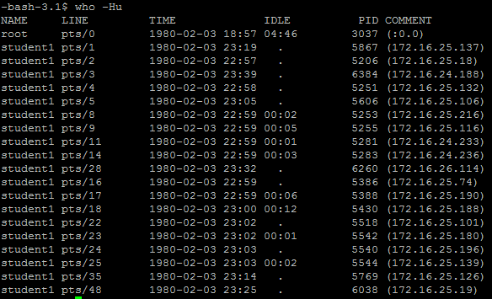

  - Display the calendar for
- Jan 2000
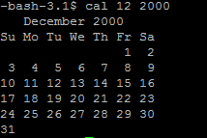
- Feb 1999
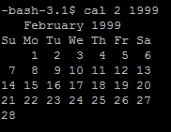
- 9th month of the year 7 A.D
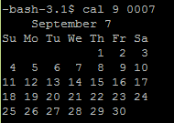
- For the current month
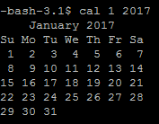
- Current Date: Day Abbreviation , Month Abbreviation along with year
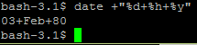

  - Display the time in 12-Hour and 24 Hour Notations.
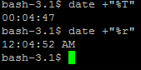

  - Display the Current Date and Current Time.
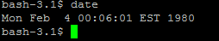
  - Display the message “Manav Rachna College of Engineering” on screen.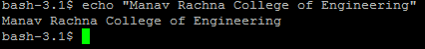
  - Write a command to count the output of “who” command.
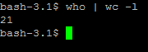
  - Write a command to know your terminal name.
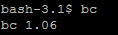

  - Obtain the following results:
    - Calculate result of 14*14.
    - Calculate result of 2 to the power 32.
    - Calculate result of 12/5.
    - Calculate decimal equivalent of 1100101001.
    - Calculate binary equivalent of 151.
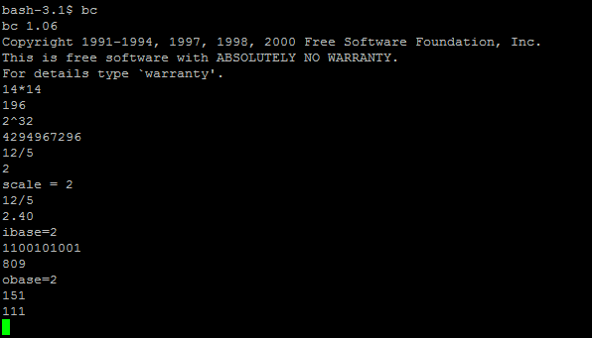

Learned Aspects
a) Syntactical Observation
With bc command we can perform any mathematical calculations’ easily except scientific calculations.

b) Semantic Observation

The date command give the date with time followed by time zone but don’t give only date with date command but it give the date with format specifier.

c) Runtime Observation

The bc command has its inputs and outputs with binary and decimal with o-base and i-base assignments so both mathematical operations are different when we run the command bc with the sethings.

Lab Assignment No.-2

Aim: To learn and implement General Purpose Utility Commands in Linux

File Handling
1. Create a directory SAMPLE under your home directory.
Command : mkdir

2. Create a sub-directory by name TRIAL under SAMPLE.
Command : cd sample
Mkdir trial
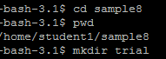

3. Change from home directory to TRIAL by using absolute and relative pathname.
Command : Cd ./sample8/trial-RELATIVE
Cd /home/student1/sample8/trial

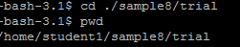

- Remove directory TRIAL.
Command : rmdir trial

- Create a directory TEST using absolute pathname.
Command : mkdir /home/student1/sample8/test

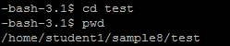

- Using a single command change from current directory to home directory.
Command : Cd

7. Remove a directory using absolute pathname.
Command : rmdir /home/student1/sample8/test

8. Create files myfile and yourfile under Present Working Directory and display them.
Command : Cat >myfile
Cat >yourfile
Cat myfile
Cat yourfile
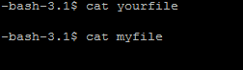

- Append more lines in the myfile and yourfile files.
Command : Cat >>myfile
Cat >>yourfile

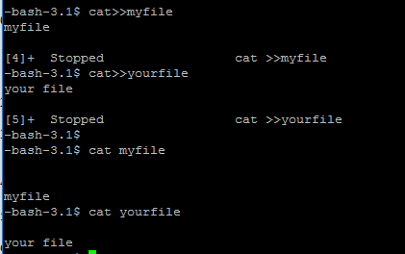

- How will you create a hidden file
Command : Cat > .afile

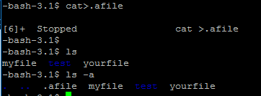

- Copy myfile file to emp.
Command : Cp myfile emp
Cat emp

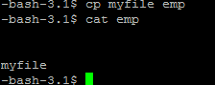

- Write the command to create alias name for a file.

- Move yourfile file to dept.
Command : Mv yourfile dept
Cat emp
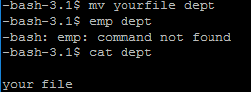

- Copy emp file and dept file to TRIAL directory
Command : cp emp trial;cp dept trial

- Compare myfile file and emp file.
Command : Cmp myfile emp

- Append two more lines in emp file existing in TRIAL directory.
Command : Cat >>emp

17. Find difference between employee file with emp file in TRIAL directory.
Command : Diff emp trial/emp
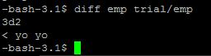

Learned Aspects
a) Syntactical Observation

When changing from current directory to home directory we provide cd command to return to home directory.
Cat command can be used to display the contents of file.

b) Semantic Observation

It is not required to provide after writing the full path when we move from home directory to current directory. egcd/home/sanyo/SAMPLE

c) Runtime Observation

diff <fil1> <file2> will tell whether both files are similar or different but give some key points to make another file similar when we see different.

Date: Page No.

Lab Assignment No.-3

Learning Outcomes:
- The status of user currently logged in.
- Lost and change permission of files
- Back up of home directory

  - Introductory Commands
    - Write the command to know who has currently logged into the system, but split the command in 3 lines and execute.
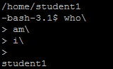
  - Files and Directories:
    - Write the command to see how much space has been occupied by your home directory
du -h
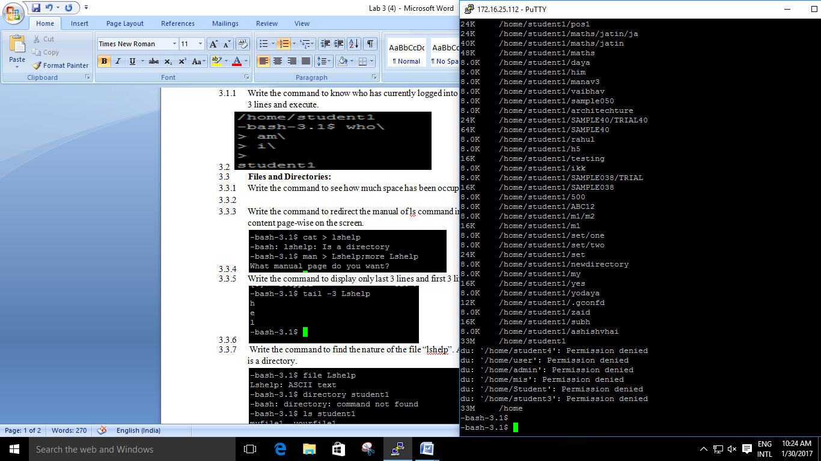
    - Write the command to redirect the manual of ls command into file “lshelp” and display its content page-wise on the screen.
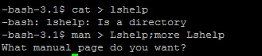
    - Write the command to display only last 3 lines and first 3 lines of “lshelp”.
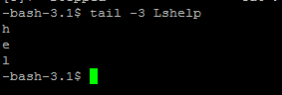
    - Write the command to find the nature of the file “lshelp”. Also show the output if the argument is a directory.
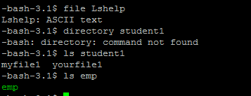
    - Write the command to list all the files by the name SAMPLE, irrespective of the case.
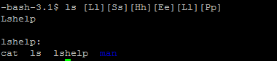

    - Write the command to list all files starting with lowercase letters.
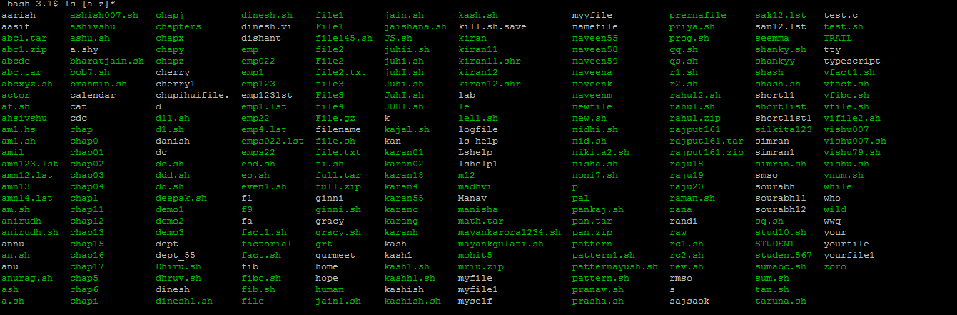
    - Write the command to change the permission of “myfile” to 555. After this write the command to remove the file “myfile” and explain the output.
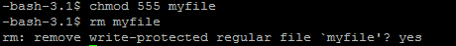
  - General Utilities:
    - Write the command to display the status of active processes and explain the output.
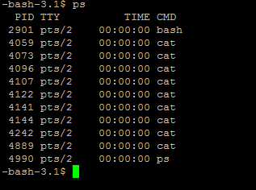
    - Write the command to create the backup of your home directory into “backup” such that the execution takes place in background.
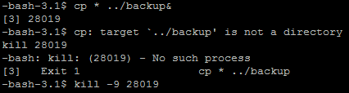
    - Write the command to kill the above process forcibly and remove the directory “backup”.
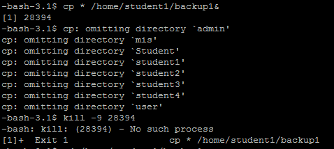

Learned Aspects
a) Syntactical Observation

chmod command must be used to provide permission for accessibility of a particular file.

b) Semantic Observation

ls command can be used to show the file starting with some particular initials and ls ? Will show the file with 1 character long only.
c) Runtime Observation

Backing up data may run for a long time depending on how big the files and
Directories are and we may want to forcibly stop that. Kill command may be used to end
a process using its ID.

Date: Page No.

Lab Assignment No.-4

- To print the name, address and date of birth of a student
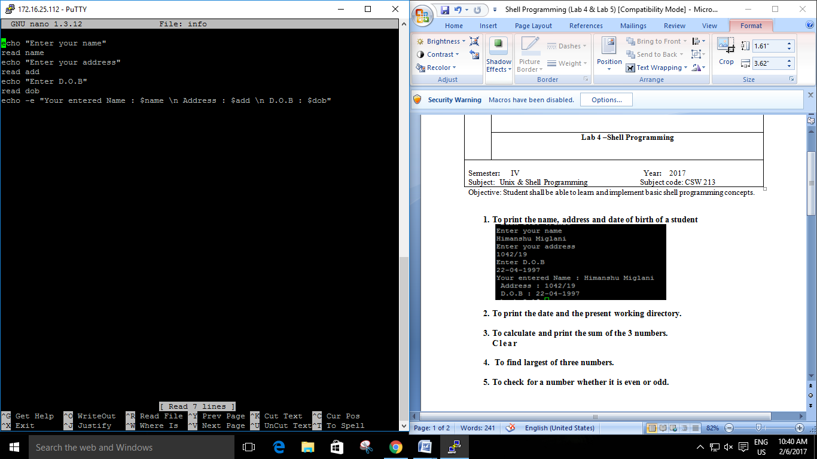

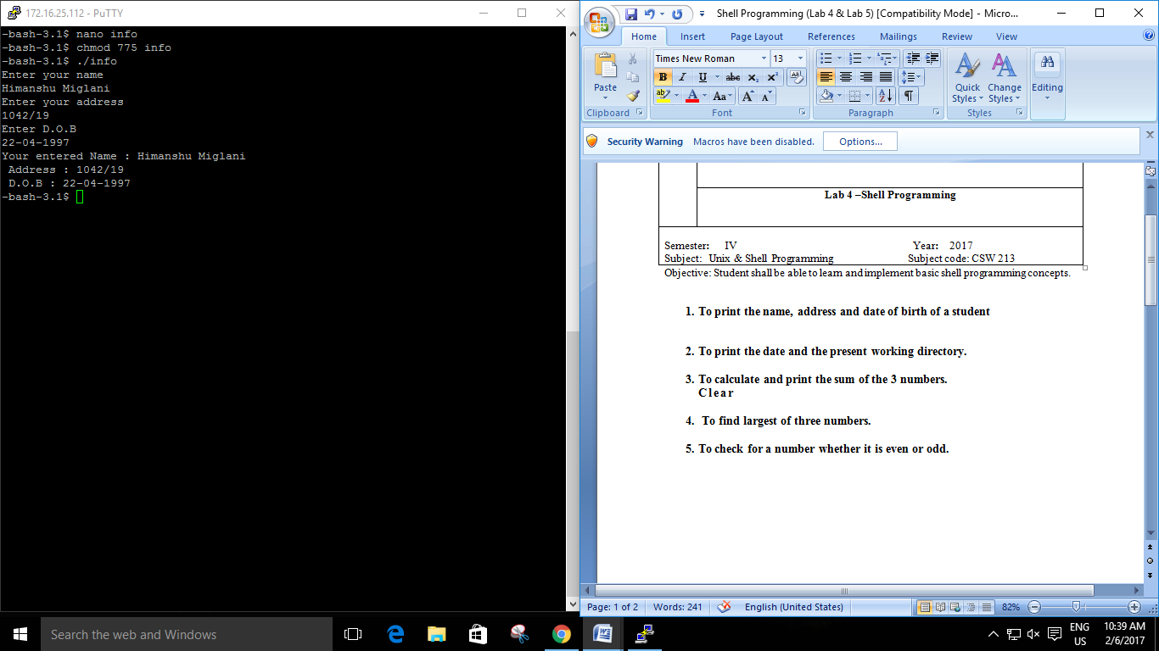

- To print the date and the present working directory.
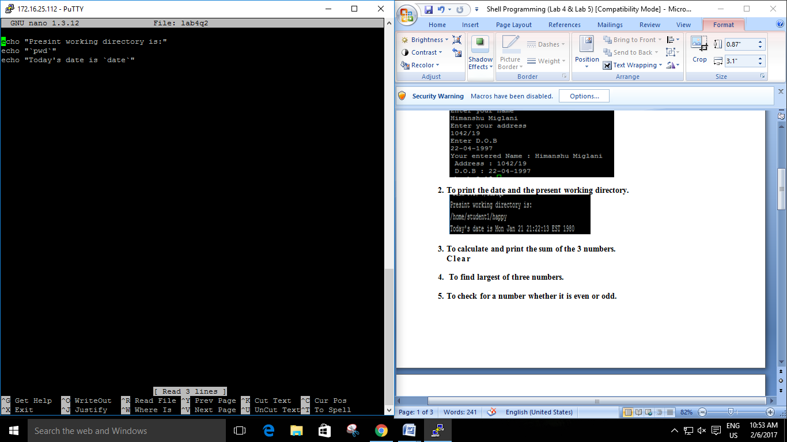

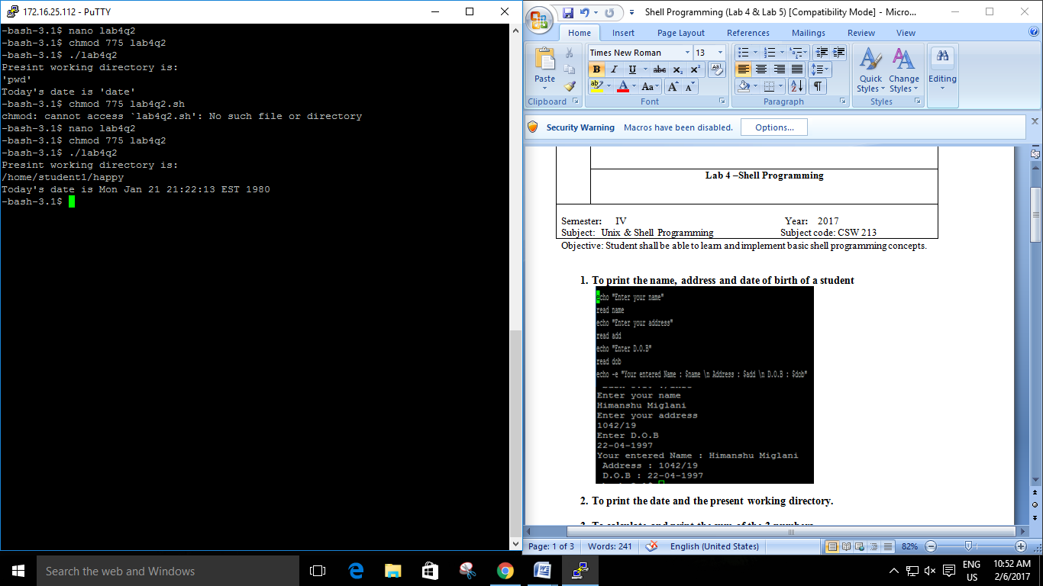

- To calculate and print the sum of the 3 numbers.
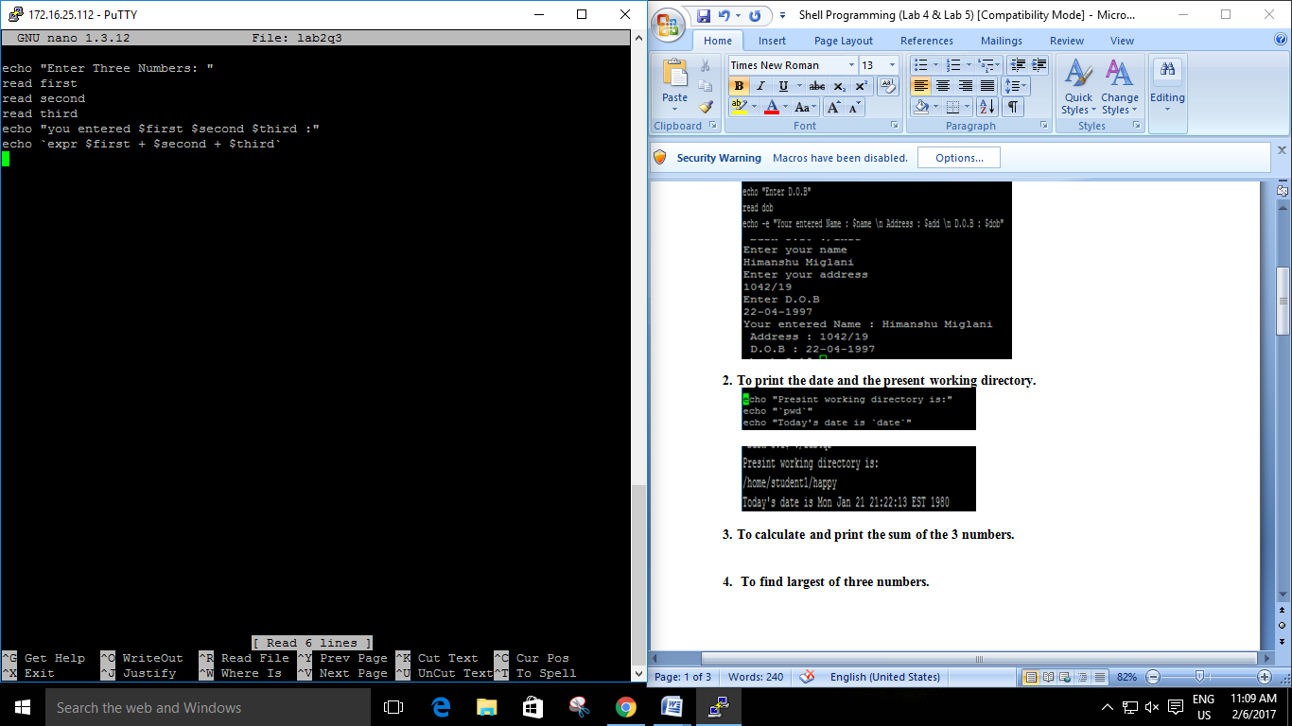

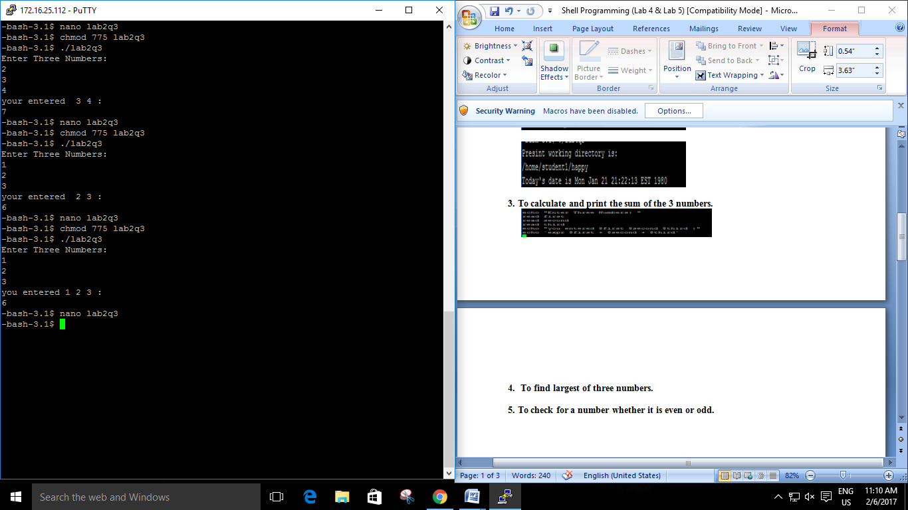

- To find largest of three numbers.
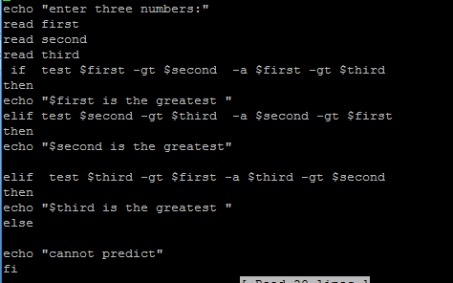

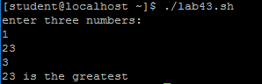

- To check for a number whether it is even or odd.
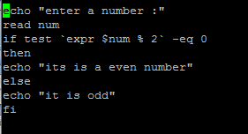

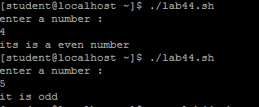

Learned Aspects
a) Syntactical Observation
Test command is used when we write if statement to compare any integers for some particular conditioned pending up on the question we provided.

b) Semantic Observation
We use echo command for printing strings but we can’t use escape sequence commands, at new line which we use only with echo-e command.
c) Runtime Observation
Whenever we run our program providing with if else statement init we can’t write too much arguments init which provide an error when we run it.

Lab Assignment No.-5

- Write a shell Script to reverse a given positive integer.

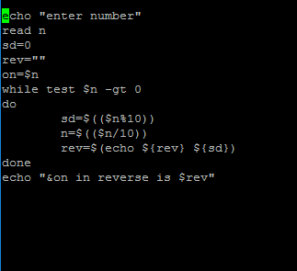

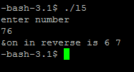

- Write a shell script to find out whether the entered number is prime or not.
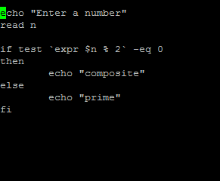

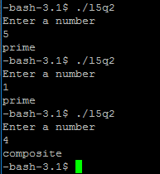

- Write a shell script to accept the basic salary of 10 employees. Calculate HRA as 30% of basic salary, DA as 40% of basic salary & combine three to display their respective gross salaries.
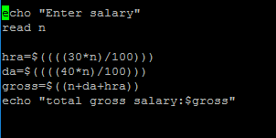
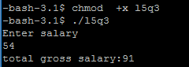

- Write a shell script that takes to command line arguments as a number and a word. It then prints that word n times (one word per line).

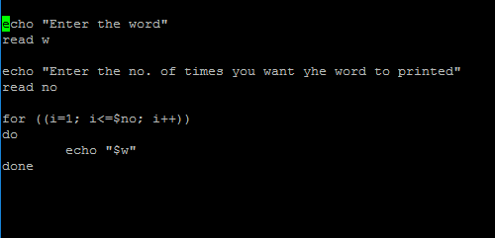

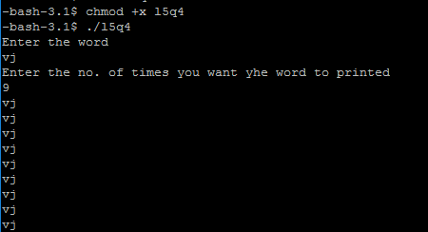

- Write a shell script to check whether the entered year is leap or not.

Lab Assignment No.-7

Outcome: Familiar with basics of shell Programming with strings.

Q.1 Write a shell script that accepts a string from the terminal and echo a suitable message if
it doesn’t have at least 5 characters including the other symbols.
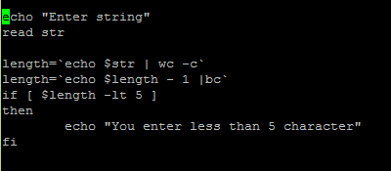
Q.2 Write a shell script program to input a string from keyboard & then determine Length of
the string.
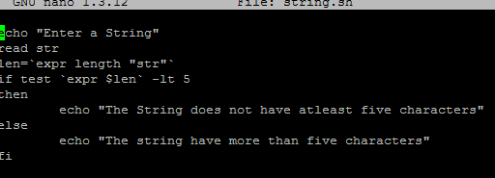

Q.3 Write a shell script to check whether the entered string is a palindrome or not.
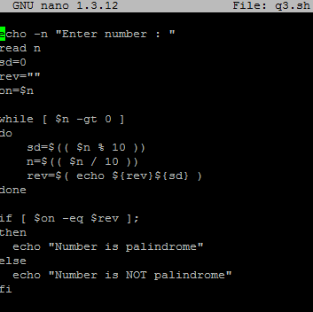

Q.4 Write a shell script that deletes all lines containing a specified word in one or more files
supplied as arguments to it.
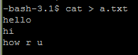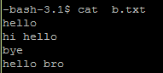

Q.5 Write a shell script that searches for a single word pattern recursively in the current
directory and displays the no. of times it occurred.
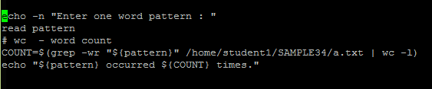
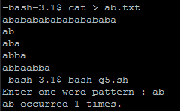

Lab Assignment No.-8

Outcome: Familiar with advance of shell Programming.

Q.1 Write a shell script that prints the 15th argument on the command line.

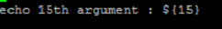

Q.2 Sort the given five integer numbers in ascending order (using array).

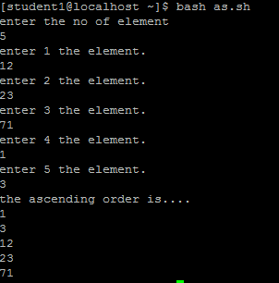

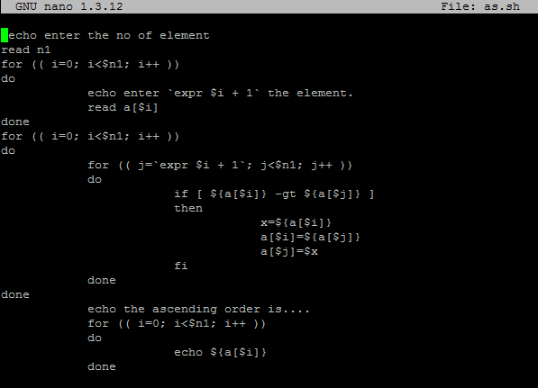
Q.3 Calculating factorial of a given integer number.

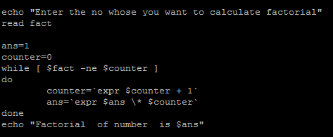
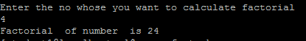

Q.4 Write a shell script to display the alternate digit in a given 7 digit number starting from the first digit.
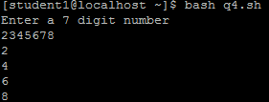

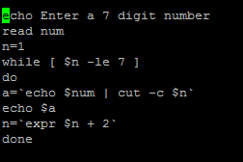

Q.5 Write a program using date that prints the usual date outputs as default but which has
options for printing just time, just day, just month, year, or just data of week.
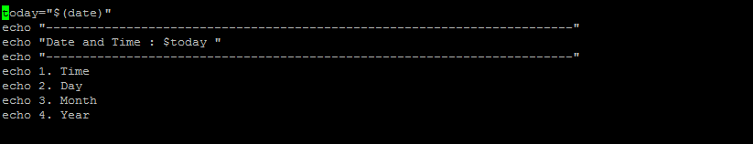
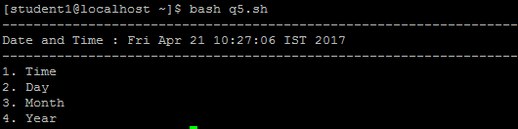

Note: You may label the screen snap-shot as shown above with pen/pencil as well.

Learned Aspects

Syntactical Observation:
There should be no semicolon after the for statement. For loop statement should have semicolon and commas in between.

Semantic Observation:

There can be only one condition testing for the “for” loop whereas multiple initializations and increments/decrements are allowed. The loop terminates when counter exceeds the specified length

Runtime Observation:

Multiple executions of this program for different values had caused wrong execution at times.
This was because of the reason that old values residing in the memory have been interfering with the current execution. To solve this problem we need to clear the input buffer of its old value using the function fflush(stdin)

Lab: 9

Name_Akash Sharma___ Roll No. 2K15CSUN01035______Group No._____G1_____

Date of Performance _______________ Faculty’s Signature_________________________
Laboratory Objective: To implement basic sed programming concepts
Learning Outcome: Familiar with sed programming

Q.1. Write a command to replace the word "bad" with "good" in file?
Ans: sed s/bad/good/ < filename
Q.2. Write a command to replace the word "bad" with "good" globally in a file?
Ans:sed s/bad/good/g < filename
Q.3. Write a command to replace the word "apple" with "(apple)" in a file?
Ans: sed s/apple/(&)/ < filename
Q.4. Write a command to switch the two consecutive words "apple" and "mango" in a file?
Ans: sed 's/\(apple\) \(mango\)/\2 \1/' < filename
Q.5. Write a command to replace the second occurrence of the word "bat" with "ball" in a file?
Ans: sed 's/bat/ball/2' < filename
Q.6. Write a command to remove all the occurrences of the word "jhon" except the first one in a line with in the entire file?
Ans: sed 's/jhon//2g' < filename
Q.7. Write a command to remove the first number on line 5 in file?
Ans: sed '5 s/[0-9][0-9]*//' < filename
Q.8. Write a command to remove the first number on all lines that start with "@"?
Ans: sed '\,^@, s/[0-9][0-9]*//' < filename
Q.9. Write a command to replace the word "gum" with "drum" in the first 100 lines of a file?
Ans: sed '1,00 s/gum/drum/' < filename
Q.10. Write a command to remove the first 10 lines from a file?
Ans: sed '1,10 d' < filename
Q.11. Write a command to duplicate each line in a file?
Ans: sed 'p' < filename
Q.12. Write a command to duplicate empty lines in a file?
Ans: sed '/^$/ p' < filename
Q.13. Write a sed command to print the lines that do not contain the word "run"?
Ans: sed -n '/run/!p' < filename
Q.14. Write a Command to delete all the blank lines in file old.txt?
Ans: sed ‘/^$/d’ old.txt
Q.15. Which command is used to replace word ‘cat’ (already present in the file) with ‘mouse’ at all places in a file ‘old.txt’ and save the result in a new file ‘new.txt’?
Ans: sed ‘s/cat/mouce/g’ old.txt > new.txt
Q.16. How to Print only Blank Line of File.
Ans: sed –n ‘/./{p;q;}’ file
Q.17. To Print First and Last Line using Sed Command
Ans: sed-n ‘1p;$p’ file
Q.18. To print all line Except First Line
Ans: sed-n ‘!1p,$p’ file

