# Chaos in Cornelia

## Summary

Map 2

Journey to Cornelia 3

Cornelia Port District 4

Cornelia Downtown 5

Cornelia Castle 8

Big Bridge 10

Chaos Shrine 11

Epilogue 13

Bestiary 14

Premade Characters - Warriors of Light 16

Chaos in Cornelia is a pre-prepared adventure for Game Masters. It was originally made for the Omega Fantasy RPG. Its goal is to offer new GMs and players a quick and easy introduction into game. This adventure uses all official rules and content from the Final Fantasy 4th Edition rules, make sure you are familiar with it before continuing.

### Plot Summary

In this adventure the party will be tasked by the King of Cornelia with finding his abducted daughter Princess Sarah and bringing her home safely. The main antagonist is Garland, a powerful former knight of Cornelia who has kidnapped the princess. In order to rescue her, the adventurers will have to travel to the Chaos Shrine to face and defeat Garland in battle. This plot is based on the beginning of Final Fantasy (1987), but many things have been added to or changed from the original.

### Getting Started

The players can create their characters by following the character creation rules of the Core Book. In the beginning the party will be travelling to Cornelia, so every player should also think of a reason why their character wants to go there. Every character starts with 200 XP and 200 Gil, as usual. If you do not want to create the group, you can use the pre-generated characters in pages 16 and 17.

### Guidelines

Since this may be your first time as a GM, here are a few guidelines that could help you:

• Regard the following content as suggestions rather than rules. Sometimes you will want to or even have to change things up and we encourage you to do so.

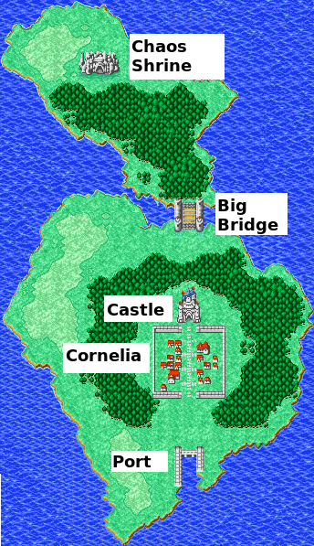• Players will often come up with creative solutions, ones that you and even we have not thought of. We encourage this in general, but this does not mean that the players always succeed in anything they attempt. Make clear that actions have consequences and reckless behavior such as attacking the crew of the ship or the guards in Cornelia could mean death.

### Map

A map of the playable area is shown below with all locations of interest being marked. Depending on your needs, feel free to add or change things on it.

## Journey to Cornelia

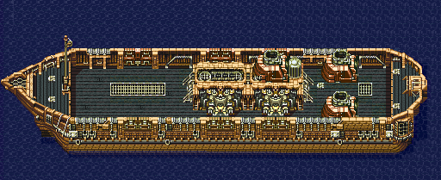The adventure starts on a small transport ship named Tiny Bronco, which is on its way to deliver cargo to Cornelia. Below, you can see a top view of the ship. The captain has agreed to let the player characters board the ship.

### Crew

The crew consists of only 3 members: Biggs, Wedge and Captain Cid. The sailors are wearing light blue bandanas and shorts and orange shirts with black stripes. While Biggs is fairly athletic, Wedge is on the shorter and heavier side, but both are friendly towards the party. The same cannot be said of the older captain, who usually retreats to his cabin and prefers to be left alone.

### Day

If the adventurers are not familiar beforehand, they should introduce each other first. Then, they can freely explore the ship and talk to the sailors. The two tell them about recent monster and pirate attacks on sea, which seem to have increased recently. Furthermore, they may also tell the party about Cornelia, they know that the princess has disappeared, but no further details. The party might also ask about Cid, in which case the sailors tell them about his past as a former soldier.

### Night

Some time after the crew retreats to their cabins to sleep, they hear loud noises around the ship. When they move to the deck, they notice that several pirates have boarded the ship and the first battle begins!

### Battle!

We recommend using one pirate for each party member, spread them on the deck as you see fit. Meanwhile, the crew of the Tiny Bronco is out of sight, fighting other pirates that have entered the ship below deck. If things end up not looking good for our heroes during battle, you can have Biggs and Wedge come up to help them. Their combat details are shown are the same as for the pirates, save for having double HP.

### Aftermath

After the battle, the crew comes together with the party to ensure everyone is fine and the captain thanks them for their help. He explains that this is not the first time they have been attacked by these pirates, who are part of Captain Bikke’s crew.  
If any of the pirates is interrogated, they reveal that Bikke and the rest of the pirate crew is raiding Cornelia’s port district. Should the players have the **Nemesis** Trait, Captain Bikke should be a known henchmen for the Nemesis. The party may now go to sleep below deck to fully recover their HP and MP.

### Arrival

Shortly after they wake up in the morning, the ship arrives at a secluded harbor, minutes away from Cornelia’s port district. Once there, the crew of the Tiny Bronco starts unloading their goods and departs shortly after. Here, the party parts ways with the crew and are now on their own. From the harbor, they can go to the port district or directly to downtown Cornelia.

## Cornelia Port District

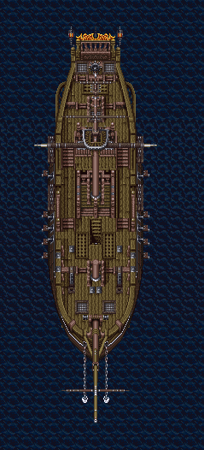The port district is fairly small and can accommodate only a handful of ships at most. Accordingly, there are only a few other small cargo ships, most like the Tiny Bronco. Other sailors are loading and unloading cargo boxes from the ships and to either store them in warehouses or carry them directly to Cornelia. If the party ask around to find the way to Cornelia, they are pointed to a path at the other end of the port. They are also warned to be careful on the way of monsters and bandits, as the palace is not paroling it anymore. Cornelia is not very far from the port, roughly a couple of hours by foot and the way mostly leads through grasslands and fields.

### Dyce

Other than the sailors, the party can also meet the travelling merchant Dyce at the port. Dyce is a well built, tall man, bald with beard and wears a dark outfit, he also has a Chocobo at his side that he travels on. He can give the party more information on the troubles in Cornelia, he has heard rumors about the princess being abducted and the castle being completely in chaos. Dyce is a traveler, so there is a good chance the party will meet him again eventually. We do not mention this in the following, but you are free to have the party meet him at other locations throughout this adventure (even in dangerous ones). His prices are usually 25% higher compared to regular stores though.

### Attack on the Port

When talking with Dyce or other sailors, the party also finds out that the port has been attacked by pirates multiple times recently. Usually, the port is protected by Cornelia’s guards, but since the dis- appearance of the princess, the king has called all troops to the palace. The pirates usually attack at night and if the party waits around the port until after dark on any day, they will witness a raid. As the party knows about their plan, they can try to take defensive measures like setting up an ambush or traps beforehand. The attack commences with a large pirate ship, shown below, docking the port and pirates storm out to steal goods.

### Battle!

The party notices that it is again Captain Bikke’s crew that is attacking, but this time Bikke himself is present as well. In the ensuing fight, Bikke mostly stays in the backlines, and would rather defend than attack. He immediately runs to his ship once he receives any damage. Apart from him, there are also some of his men beside him, again roughly one for each party member. As Bikke runs away from this battle, the party might meet him again at some point in the future.

## Cornelia Downtown

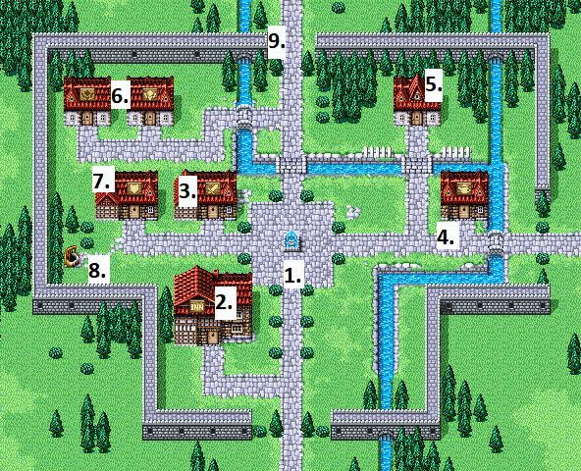Below you can see a map of the town of Cornelia, but there are also some farms and smaller buildings outside the city walls that are not shown. All buildings are marked with a number and you can find more details about them and their inhabitants in the accordingly numbered paragraphs.

The party arrives in Cornelia from the southern gate, where two guards stop them as they do not recognize the adventurers. They tell the party to stay clear of the palace and leave the town as soon as they are finished with their business. The guards do not answer any further questions of the party. Most of the townspeople are too scared to leave their homes since the princess has disappeared so barely anyone is walking around Cornelia.

### 1. Fountain

The party immediately notices the beautiful fountain which stands out in the otherwise unremarkable town. If they inspect it closer and peek at their reflection it the water, they only notice that they are in urgent need of a bath. Nearby is a blue-haired cheerful young woman with a red dress who seems to be practicing dancing moves, her name is Arylon. If the party talks to her, she introduces herself as a dancer and ask if the party wants to see a dance. If asked about the princess or the palace she reveals some rumors she has heard: princess Sarah has been kidnapped and her kidnapper is asking for a hefty ransom. Accordingly, Cornelia and the palace are in complete chaos and the palace is locked off to regular folk. She also reveals that there were some unsuccessful attempts at rescuing her, so the king has become quite desperate. She notices the weapons on the adventurers and asks if they would be interested in helping, the king would surely listen to them and also offer a great reward.

### 2. Inn

The Inn is one of the largest buildings in Cornelia and upon entering the party finds themselves in a small room with a rug on the ground and a counter at the end. A bouquet of roses stands on the counter as well as a basket with fruits. Behind the counter stands a young woman with dark blue hair wearing a long green dress named is Elia. To the left is a large room with multiple beds and some minor decorations on the walls where the guests sleep. To the right is another large room, with some wooden chairs and tables, guests can sit down here to drink and eat. There is usually an old drunken man sitting there named Argus and some- times also a few guards. The party might wish to sleep in the inn. They can also talk to Elia for information, as she overhears a lot from visitors. She can point the party towards various people in town that might need their help like the smith, the mages and the chapel. Furthermore, the party can try to speak to Argus, who is usually not very coherent and babbles stories about a great soldier named Garland who he used to know from when he was a guard.

### 3. Smith

The inside of the shop contains a small forge and multiple weapons and armor are being displayed. Behind the counter is an older man with brown hair and a full beard, his name is Todo. He tells the party the store is closed, because he cannot work due to not receiving shipments from the port. If they want to help him, the party must talk to Dyce at Cornelia Port, who is looking after the shipments. The shipments consist of a large wooden box on a small wagon, which slightly slows down the party while travelling. If they agree to escort the shipment, a bizarre monster named PuPu makes an attempt to steal the shipment!

PuPu is sitting in the trees, and tries to teleport the cargo away, slowly making the box disappear. If the players look for him in the trees while he is doing this, he is easy to spot, because the top of his head is glowing. After that he is be difficult to spot: a player must succeed on a Difficulty 80 Perception check to see him, which is reduced to Difficulty 40 during daytime. Note that the party may fail to find PuPu, however he will be nearby if they come around the same spot at a later time and might even try to abduct something again. If detected, PuPu only fights if attacked, but first he non-verbally asks for Tonics (see Tonics Please!) and returns the stolen goods if the party complies.

If the party solves this peacefully, Todo rewards them with PuPu’s Spoils in addition to the normal rewards. The party may of course just attack him, in this case the shipment reappears after he is defeated. Upon successfully bringing back the shipments, Todo rewards the party with 500 Gil. Furthermore, the smith can begin working again, but he will be busy completing orders on backlog for some time. After the party returns from the Chaos Shrine they may visit again to buy new equipment or upgrade their weapons or armor.

### 4. Store

This is a general goods store, that is dominated by a large counter in the center and heaps of various wares and items around it. Behind the counter is a young man with dark hair and a green bandana, his name is Guston. He is not particularly concerned about the princess, but he is annoyed that the troubles have dampened his sales. Accordingly, he is very accommodating towards potential customers and sells battle items, as well as potions and other healing items. He can have pretty much have any other item you want in his inventory in addition, if the party asks for something specific, he probably sells it.

### 5. Chapel

The chapel is very small and cozy with few wooden banks, however it is completely empty except for once person, father Gregory. Gregory is an old man with a long white beard wearing a dark red hooded robe, he speaks very slowly and quietly. He laments that nobody has been visiting the chapel since the disappearance of the princess. Apparently, most townspeople believe that her disappearance is some sort of divine punishment and they are too scared to visit the chapel. The father asks the adventurers to restore the faith of the people of Cornelia, so that more people attend the chapel again. The party can for example convince people by clearing up some details about Sarah’s disappearance (she was kidnapped) that many are unaware of as the palace has been very secretive about the whole incident. The townspeople may require Intimidation (difficulty 70), Bluff (difficulty 60) or Charisma (difficulty 50) Challenges to be convinced. Repeated failure can attract the distrust of the population and/or the guards. If the party manages to convince at least any 3 people in Cornelia to attend the chapel, Gregory is satisfied and rewards each character with 100 Gil.

### 6. The Mages

These two buildings are essentially identical, each consists of a single large room inside with a bed and shelves and heaps of magic and alchemy goods and books. They are inhabited by the eccentric and stubborn twin brothers Gilles and Noah. Gilles is a Black Mage who wears a blue robe and a pointed hat, while Noah wears a white hooded robe with red accents. The other townspeople usually avoid the brothers, except for when they require their services as mages. Getting annoyed by this, the mages have decided to develop a flask, which allows them to store their magic inside that others can use without them having to be present. However, something went wrong during its development, causing the item to break apart in a violent explosion, the result of which the party can see in the back yard. Out of pride, both give the fault of the accident to their brother and they have stopped talking to each other since. The party can resolve the dispute by convincing the mages that they were both at fault, they can for example achieve this as follows: First they must repair the broken flask either through mechanical or magical means, a Technology (Difficulty 20) or Magic (Difficulty 60) Challenge. Then they have to study the flask as well as the recipe for creating it, which they can get from the mages. By doing this and succeeding in a Wisdom (Difficulty 50) Challenge, the character that can understands the issue: The flask broke because after its creation, because both mages each cast a spell into it, causing the flask overload as it can only hold one spell at most. This can be demonstrated by casting only one spell into the flask, which works fine. If the party manages to convince the mages, they accept their wrongdoing and apologize to each other. They gift the flask to the party as a token of gratitude and the party may visit them in the future to buy accessories.

#### Magic Flask

Accessory. Can store one spell cast into it. The wearer can use an action to unleash a stored spell’s effect on a chosen target. A character with **!Runic** may store the spell deflected as part of a successful **!Runic** reaction. At the start of each day, the flask becomes empty. If a second spell is cast into it, the flask detonates, causing each character in the party to lose 25% of its maximum HP. The Flask may be sold for 400 Gil.

### 7. Abandoned Building

This building has been left purposefully empty in case you may need it. It may for example related to one of the characters backgrounds or it may have content or characters that you want to add to the adventure. If you have no use for it, the house is empty, and the players can ask around the town to find out that it used to be a shop that has been abandoned due to not being profitable.

### 8. Well

It’s a well. It looks like you could climb down it, but you can’t. Really.

### 9. Castle Entrance

This entrance directly leads to Castle Cornelia and is guarded by at least 4 guards day and night who do not let anyone pass. However, they let the adventurers through if they tell them that they want to help find the princess. The guards then ask them to report to the chancellor in the upper floor for further information.

## Cornelia Castle

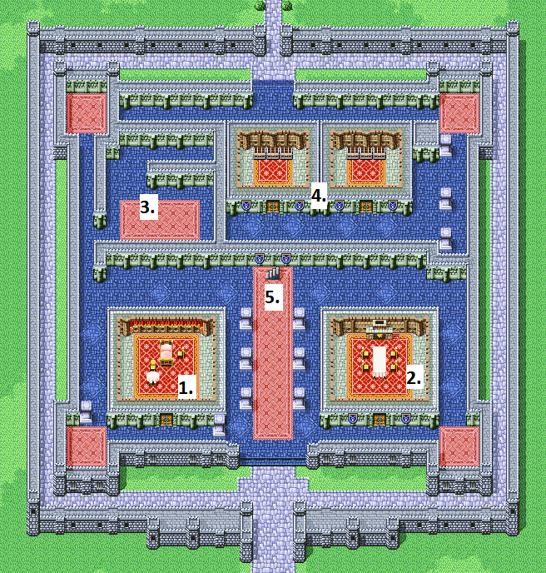A map of the ground floor is shown below, and relevant locations are numbered according to their paragraphs. The stairs in the center lead to the Throne Room, while entrance in the back leads to the palace garden, which is closed off by guards. The palace is always also full of armed guards since the kidnapping.

### 1. Queen’s Room

Queen Jayne is a middle-aged women with turquoise colored hair, blue eyes, wearing a well- made long red dress and a golden tiara. She has been very depressed since her daughter has been kidnapped and only talks to the party if they have won the king’s trust. Once the party gets her to talk, they can find out some things about the kid- napping, part of which the queen has witnessed firsthand. On that night she woke up to the noises and encountered Garland who was leaving the palace while carrying the unconscious princess in his arms. Garland shortly confronted her, telling her to hand over control Cornelia to him if she wants to see her daughter alive again. Then he disappeared with Sarah through the back entrance of the palace before the guards could arrive. The Queen is very traumatized by this event, as she blames herself for not being able to save her daughter that night.

### 2. Sisters’ Room

This room is inhabited by Sarah’s sister Alison who is a very emotional teenager, that looks very alike to her mother. The guards at the door tell the party that she has locked herself into her room 3 days ago and won’t open the door. If the party is very convincing (e.g. by assuring her that they will save her sister), they might get her to open the door and talk to the party. She cannot directly help them, but she can tell them a lot about her sister Sarah, who she looks up to very much. She can for example tell them about Sarah’s passion for music and that her most precious possession is her special lute, which is gone as well. Apart from this, if the party manages to calm her down a bit, they might have a better chance at convincing the king who is worried about Alison as well.

### 3. Captain

The captain of the guard is a young man with long blond hair named Ian, he is wearing a decorated heavy armor and a longsword on his back. The party may meet him in various places around the palace where he is wandering around. He is very reluctant to talk the party and they immediately notice that he is missing his left arm. If the party has convinced the king, the captain is willing to talk to them about the mission to rescue Sarah, which was led by him. Right after Sarah disappeared, him and 5 of his best men followed Garland and confronted him at the Big Bridge north of Cornelia. However, Garland bested all of them in ensuing battle and the captain was the only one to make it out alive, albeit without his arm. He is obviously ashamed of his failure and seems deeply disturbed and scared about Garland’s power.

### 4. Treasure Room

The treasury consists of 2 rooms, the one to the left contains the palace’s gold while the right one contains various expensive items and equipment. Both doors are guarded by two very well armed with heavy armor, if the party has no business here, they quickly request them to leave at once. If the party has obtained the letter from the king, they are given the following items from the guards: 1 large Tent that fits the entire party as well as a Tonic and 200 Gil for every party member.

### 5. Throne Room

The door to the throne room is guarded by two royal guards wielding glaives and heavier armor than the rest. Upon stating their business, they let the party pass through to the throne room, inside is the king on his throne and beside him stands the chancellor. The king is a middle-aged man with light blue eyes and brown hair with a long brown beard, wearing a golden crown and long red robes. The chancellor is slightly younger with dark hair, also wearing noble clothing.

While the king is be happy to see the adventurers, as he is very desperate to find his daughter, the chancellor has a strong distrust of the party. In the following conversation the party may try to convince the king that they can be trusted, but the chancellor convinces him that the party has not proven that they are good-willed and trustworthy. The king then has an idea: he laments that Cornelia is in chaos because he has put all his resources into finding his daughter and neglected his people in the process. He asks the party to help the people of Cornelia to prove that they can save his daughter, in return he promises to provide them with travel supplies before they head off. If the party asks for further details on the kidnapping, they do not reveal anything until the party have won their trust.

#### Convincing the King

To convince the king, the party has to fulfil several tasks that help the people of Cornelia, how many, exactly, depends on you as the GM. Below is a list of tasks that may convince the king if taken care of, you can of course add any relevant content that you have created to it as well:

* Help the smith to receive his shipments;
* Resolve the dispute between the two mages;
* Defend the port against an ambush by pirates;
* Help the chapel regain its members;
* Not earning the guards’ distrust.

After the party manages to win the kings trust, he is convinced that they can save his daughter and reveals further details on the kidnapping: Sarah was kidnapped 3 weeks ago by a former knight of Cornelia named Garland, who is regarded as the most powerful swordsman in the entire kingdom. Garland used to be very close to the king, but power has corrupted him, and he demanded to become the successor to the king. When the king did not comply, Garland abducted his daughter Sarah as ransom for control over the kingdom. Many other knights of Cornelia have tried to save her since and even though they failed, they found out that Garland keeps Sarah in the Chaos Shrine, north of Cornelia past the Big Bridge. The king also keeps his promise and writes a letter that confirms that they were officially given the task of rescuing his daughter. This letter also allows the party to retrieve some items from the treasury and other members of the palace might be more willing to talk to them after they have earned the king’s trust. If the players cannot or don’t want to earn the king’s favor, they can bully and threaten the Chancellor or the Queen for this information.

## Big Bridge

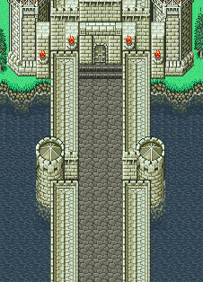When departing from Cornelia and heading north, the party finds themselves in the forests and grass- lands surrounding the city. After about 4 hours of travel through the mostly quiet nature, they arrive at the Big Bride, which is massive but also very old and brittle. When they reach its end, they notice someone who seems to have been awaiting them.

### Gilgamesh

Gilgamesh is not necessarily good or evil, he travels the world to find powerful weapons to add to his collection. Garland has convinced Gilgamesh to work for him and lets him guard the bridge from anyone who tries to cross. In return, Garland gifted him the legendary sword Excalibur or at least that is what Gilgamesh believes. Upon meeting the party, Gilgamesh will recognize them as potentially worthy opponents and draw his weapons.

### Battle!

The battle against Gilgamesh takes place at the end of the bridge as shown on the map. His combat details are shown below, tailored for a 4-man party, but if the party is bigger or smaller than that you might want to adjust his HP. When Gilgamesh is reduced to 0 HP he does not immediately suffer KO, instead he finally pulls out Excalipor for one last attack. He tries to attack the closest party member with it, but the sword deals no damage and immediately breaks in half. Gilgamesh realizes that Garland has tricked him and becomes angry, seeing no other option, he runs away (he can jump down the bridge if necessary). As he remains alive, the party might meet Gilgamesh again later in the adventure.

### Aftermath

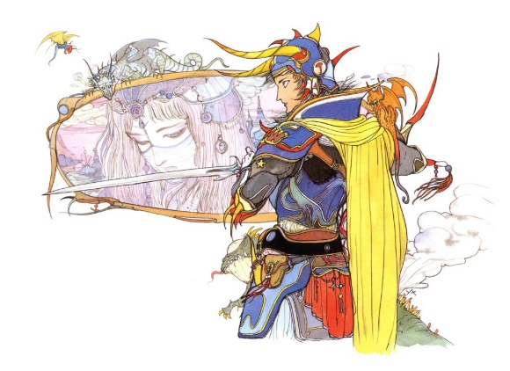After defeating Gilgamesh, the party can finally cross the bridge to reach the dark forest before the Chaos Shrine. The forest is unusually quiet and most of its trees and plants seem to have died out. The adventurers will very likely not be able to reach the Shrine before sunset, so they probably will need to rest the night somewhere in the forest. **3**

## Chaos Shrine

When the party reaches the grasslands at the edge of the dark forest, they can see the menacing Chaos Shrine in the distance. As they move closer, they notice that the shine has been claimed by nature for the most part, as its walls are damaged and overgrown, and the foundation has begun to sink into the ground. An unnatural serenity surrounds the area with no other living being in sight and the only entrance is a set of brittle stairs that lead down into darkness. After going down the stairs, the party arrives at the south of the map shown below and can barely see the anything due to the lack of light sources. They notice that the way north is blocked from rubble that is a product of the three pillars and large rocks that have broken off from the ceiling. Upon closer inspection, the party realizes that this blockade has been created by someone on purpose.

### 1. Traps

Both marked locations contain a magical trap on the ground that has been placed by Garland not only to impede intruders, but also to alert him. A character that is actively looking for traps or taking similar precautions can notice it by passing a Thievery (Difficulty 60) Challenge. Otherwise, the trap explodes shortly after stepping on it, dealing 15 physical fire damage to everyone near it.

### 2. Mimic

Inside this room are chests that once touched reveal themselves to be vicious Mimics. There are three Lesser Mimics in the room for each 4 players. A character can notice that something is wrong with the chest beforehand by passing a Wisdom (Difficulty 75) Challenge. If they fail to do so, the Mimic performs one action before the initiative check in the ensuing battle.

### 3. Healing Spring

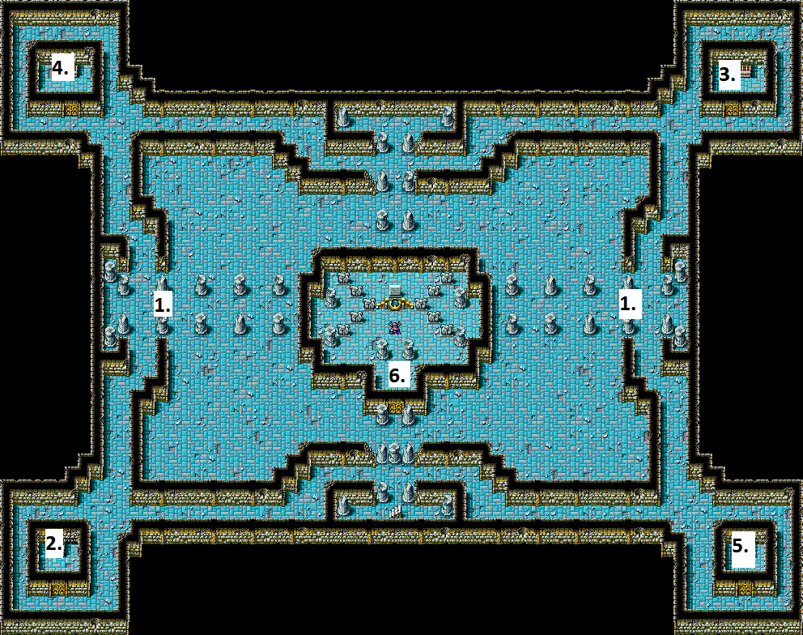The heavy door of this room is locked and can be broken or lockpicked, by passing a Strength (Difficulty 60) or Infiltration (Difficulty 40) Challenge. Inside the room, the party finds a large chalice that stands on a stone pedestal and is filled with what seems to be water. Upon closer inspection, a character can understand that the liquid is of magical nature and a character that drinks it, fully recovers his HP and MP immediately. However, the chalice itself has no magical properties and contains only 5 portions of the healing water.

### 4. Chests

This room contains 2 chests, one can be opened easily and contains 3 Potions and a Phoenix Down. The other one contains Sarah’s Lute and can only be lockpicked by passing an Infiltration (Difficulty 70) Challenge. It can also be opened by with a key that Garland carries with himself, but the chest is too robust to be broken through force.

### 5. Secret Door

This room is empty except for a large stone tablet on the left wall with multiple different symbols on it. Upon closer inspection, the party can understand that the symbols describe a short music piece. The wall next to it contains a secret door which is revealed by playing the piece on Sarah’s Lute, which Sarah herself should able to perform properly enough. Another character may try to perform the music by rolling a Performance (Difficulty 90) challenge, but the runes warn the party that they deactivate themselves should the performer fail. The secret door leads into a small room with a Guard Ring on it.

### 6. Garland

At the very center of the temple, the party finally confronts Garland. Sarah is also in this room, locked in a large cage that stands in the corner. Garland is a tall, well-built man in full heavy armor wearing a purple cape and carrying a sword in his hand and a two keys in his pocket. He is very arrogant and believes that he deserves to rule Cornelia because he is the strongest warrior in the kingdom. Garland has studied the dark secrets of the Chaos Shrine since his arrival to further expand his power. When meeting the party, he does not take them seriously and sees them as just another annoyance standing in the way of his grand plans.

### Battle!

Garland draws his weapon to commence the fight and he also summons multiple bats to aid him, one for each party member. During the battle, he focuses on his positioning to pick off weaker party members.

### Aftermath

In the original story, Garland uses a magical artifact to escape the party after being defeated and goes on to become the main antagonist. If you want to continue the adventure in a different manner, he may also simply die at hand of the adventurers. You can also let the players decide his fate. After being freed from her prison (Garland’s key opens it), Sarah is understandably still very scared and traumatized. She thanks the party for rescuing her and asks them to also find her precious lute, which Garland has taken from her. The party can refuse her request to quickly return to Cornelia, which Sarah will understand but not be happy about.

**Bat Level 1**

## Epilogue

After rescuing Sarah, the party must return her safely to Cornelia and therefore, they have to travel back the long path they came from, passing the Big Bridge on the way. The journey should be uneventful for the most part, but you can feel free add a few surprises of your own.

### Sarah

Sarah is a fairly young princess with turquoise hair like her mother and wears a long gold colored dress as well as a golden pendant with red jewels. She is generally polite but also very quiet and absent, because she is still suffering from the physical and mental scars of the kidnapping. Sarah is not very capable of looking after herself, so she requires the adventurers’ assistance and guidance during the journey. While travelling, she frequently asks about the state of Cornelia and her family as she blames herself for what has happened.

### Arrival

When entering Cornelia with the princess at their side, the adventurers are hailed by the townspeople and guards. They may be seen as heroes or as sinister vigilantes, based on the king’s trust; Accordingly, they are recognized by everyone in the town as such from now on. The inhabitants of the palace are surprised when meeting the party, as they had already given up hope of ever seeing the princess again. The king of Cornelia’s reaction, either being very grateful to the adventurers or grudgingly accepting them depends on his trust. Either way, he rewards the characters with a banquet.

### Rewards

The king offers the party very generous rewards for rescuing his daughter as he had promised. In the original story, the king commands his men to rebuild an old broken bridge, that leads to another large continent for the adventurers to explore. His gift depends on how you want to continue the game, and should be something that greatly aids the party and moves the plot forward. He could for example gift them a ship and ask for them to not return or he could gift them a house in Cornelia if the city is still going to be relevant.

In addition to any extra challenge or situation you may add, grant the players the following XP rewards based on their traits:

* **Monster Hunter**: 80 XP if they kill PuPu, 20 XP if they resolve it peacefully; 40 XP for defeating the mimics; 20 XP for defeating Garland and his minions
* **Sense of Duty (Cornelia):** 80 XP if they save Sarah; 40 XP for repealing the pirate attack on the port district
* **People’s Hero**: 40 XP (each) for helping the smith and helping the mages
* **Mercenary**: 1 XP for each 8 gil earned (either in direct gains or by selling items)
* **Nemesis**: 80 XP for defeating Bikke
* **Reputation**: 40 XP for helping the priest by bluffing or using charisma; 40 XP if the King trusts the party
* **Bad Reputation**: 40 XP for helping the priest by bluffing or using intimidation; 80 XP if they save Sarah without the King trusting the party.

### Outlook

By rescuing princess Sarah and defeating Garland, the party has grown together and developed their individual skills. Even though they still have a lot to learn, they have proven themselves to be capable adventurers that can stand up against the evil in the world. From here, you can continue the adventure by building on the presented content and creating your own locations, characters and challenges. Before departing, the party may choose to spend some more time in Cornelia to rest and stock up on items and equipment.

## Bestiary

#### **Bikke’s Pirates**

5th level Humanoid **Minion**

Earth 12 Air 29 Fire 14 Water 18

HP 20 MP 10 ARM 03 MARM 03

Spoils: Tonic (dif 60) Initiative – 2 die

*Cutlass:* Quick physical action, Air vs Air, dif 40, 6 damage (Cut)

*Parry:* Reaction, Air vs Air, dif 40, avoids a physical attack

**Vulnerable (Poison), Vulnerable (Shadow)**

*Bikke’s pirates will do anything they can to get their hand on the sweet loot, except throw their life away. They are more prone to running than to fighting to the death.*

#### Captain Bikke

16th level Humanoid **Elite**

Earth 48 Air 35 Fire 25 Water 74

HP 200 MP 45 ARM 06 MARM 18

Spoils: None Initiative – 4 die

*Hook:* Quick physical action, Earth vs Earth, dif 40, 8 damage (Puncture)

*Dodge:* Reaction, Air vs Earth, dif 40, avoids a physical attack

*Arrow Guard:* Reaction, Air vs Air, dif 30, avoids a ranged attack

*Thunder*: Black Spell, 9 MP, Fire vs Water, dif 0, 10 damage (Thunder)

**Vulnerable (Poison), Vulnerable (Shadow)**

*Bikke is a coward who relies on his crew to do the heavy lifting. He prefers to dodge rather than attack. He will flee from combat as soon as he is dealt any damage.*

#### **PuPu**

11th level Elemental **Minion**

Earth 20 Air 32 Fire 45 Water 22

HP 50 MP 40 ARM 2 MARM 7

Spoils: 100 Gil, Electro Marble (dif 20)

Initiative – 2 die

*Tonic Please*: Pupu uses his actions to ask for a Tonic. The player who gives a Tonic or Potion spends it and roll Water vs Water, dif 30. If successful, PuPu is satisfied and teleports away.

*Mind Blast*: Quick magical action, Fire vs Fire, dif 40, 16 damage (Light)

*Nightsong,* Blue Spell*,* 20 MP. Fire vs Water, dif 70. If successful, inflict the **Sleep** status on a group until the end of the next round

*Split the Pain,* FreeReaction, Earth vs Earth, dif 70. If successful, split physical damage done between PuPu and the original attacker. Pupu uses this each time he’s hit by a physical attack.

**Light Immune, Fatal Immune, Mental Immune, Auto-Float**

 *PuPu is a mischievous being, who is trying to steal the smith’s cargo. He will never attack unless provoked and will keep using Tonic Please in all actions. If the players deal any damage to him, he will stop asking for a Tonic and will fight normally.*

#### Gilgamesh

10th level Humanoid **Common**

Earth 38 Air 35 Fire 31 Water 13

HP 120 MP 45 ARM 06 MARM 02

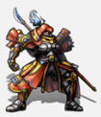Spoils: None Initiative – 3 die

*Gungnoir:* Quick physical action, Earth vs Earth, dif 40, 9 damage (Puncture)

*Blade Dance:* Slow (3) physical action, Air vs Air, dif 40, 9 damage to a group (Cut)

*Black Cleave:* Slow (2) physical action, Earth vs Air, dif 40, 6 damage (Crush); then Air vs Earth, dif 40, 6 damage (Crush) to the same target; If both hit, inflicts **Immobilize** until end of next turn

*Excalipor*: Reaction, auto-hits every enemy, 1 damage (Cut). Uses after being reduced to 0 HP

**Vulnerable (Blind), Vulnerable (Sleep), Bio Resist, SoS-Strengthen (Physical)**

*Gilgamesh is arrogant and brash. He will challenge any worthy opponent for a duel in his quest to become even more legendary than he is.*

#### Lesser Mimic

8th level Aberration **Common**

Earth 38 Air 11 Fire 20 Water 28

HP 40 MP 45 ARM 10 MARM 03

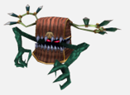Spoils: 150 Gil (Dif 80) Initiative – 3 die

*Bite:* Quick physical action, Earth vs Earth, dif 40, 6 damage (Cut)

*Latch:* Slow (2) physical action, Earth vs Air, dif 40, 3 damage (Cut), turns into *Rend*

*Rend:* Quick physical action, Earth vs Earth dif 0, 9 damage (Cut), ignore target’s ARM, turns into *Latch*

*These aberrations look like chests and eat the flesh of their unsuspecting and greedy victims. They bite viciously, attaching themselves to their victims, then rending with their sharp teeth.*

#### Shadow Bat

7st level Beast **Minion**

Earth 20 Air 23 Fire 20 Water 12

HP 32 MP 20 ARM 02 MARM 01

Spoils: None Initiative – 2 die

*Bite:* Quick physical action, Earth vs Air, dif 40, 6 damage (Cut)

*Arrow Guard:* Reaction, Air vs Air, dif 30, avoids a *Ranged* physical attack

*Red Feast*: Blue Spell, 10 MP, Earth vs Air, dif 40, 6 damage (Puncture). The Shadow Bat heals itself half of the damage dealt.

**Vulnerable (Light and Air), Shadow Absorb, Auto-Float, Blind Immune, Mental Immune,** *Small blood-sucker bats, summoned by the power of the Chaos Shrine. Garland can control these beasts at will, and they will flee and scatter if Garland is defeated.*

#### Garland

12th level Humanoid **Elite**

Earth 48 Air 35 Fire 15 Water 40

HP 240 MP 45 ARM 05 MARM 5

Spoils: Shadow Staff Initiative – 4 die

*Slash:* Quick physical action, Earth vs Earth, dif 40, 8 damage (Cut)

*Shadow Strike:* As Adept, deals 12 damage (Shadow)

*Lesser Drain: Ranged* Magical action, 5 MP, Fire vs Water, dif 0, 8 damage (Shadow), Garland heals 8 HP

*Third Eye*: As Phalanx

**Resist (Shadow), Vulnerable (Light)**

*The mastermind between the kidnapping, Garland works for mysterious and sinister motives. What secrets does he hide?*

## Premade Characters - Warriors of Light

**Zest, 8th level Warrior/Defender**

|  |  |  |  |
| --- | --- | --- | --- |
| **Stat** | **Level** | **Value** | **XP Spent** |
| **Earth** | 3 | 30 | 90 |
| **Air** | 1 | 10 | 10 |
| **Fire** | 1 | 10 | 10 |
| **Water** | 3 | 30 | 90 |

**Skills**: Strength 1 and Charisma 1.

**Traits & Quirks**: Mercenary, People's Hero, Monster Hunter; Straight Arrow, Amnesia and Emphatic.

**HP** 70/70; **MP** 30/30; **ARM** 3; **MARM** 0

**Equipment**: Twilight Steel (Earth vs Earth, dif 40, 6 damage, **Blind** Touch), Leather Plate

**Abilities**: Master of Arms [Pommel Strike]; Power Attack; Cover

**Actions**: !Mighty Strike (wpn, dif 70, 12 dmg), !Pommel Strike (wpn, 3 dmg) !Block, !Cover

He leads the Warriors of Light and bears the Fire Crystal. He has short red hair and is righteous and courageous in nature. Honest, straightforward and prone to tunnel vision, unlike the other three, he has no memories of his past.

**Sauber, 8th level Rogue/Dervish**

|  |  |  |  |
| --- | --- | --- | --- |
| **Stat** | **Level** | **Value** | **XP Spent** |
| **Earth** | 1 | 10 | 10 |
| **Air** | 3 | 30 | 90 |
| **Fire** | 3 | 30 | 90 |
| **Water** | 1 | 10 | 10 |

**Skills**: Infiltration 1 and Thievery 1.

**Traits & Quirks**: Mercenary, People's Hero, Monster Hunter; Bottomless Pockets, Paranoid and Fast.

**HP** 42/42; **MP** 10/10; **ARM** 1; **MARM** 1

**Equipment**: Baselard (Air vs Air, dif 40, 9 damage, **Weaken Armor** Touch), Leather Outfit

**Abilities**: Survivalist [Treasure Hunter]; Clinical Eye; Ambidexterity

**Actions**: !Detect

He has long golden hair, holds the Wind Crystal and tends to keep the rest of the party grounded in reality with his realist attitude. Apparently a cynical worrier, in battles he tends to be a bit gung-ho and gets in a lot of conflict with Zest.



**Floe, 8th level White Mage/Alchemist**

|  |  |  |  |
| --- | --- | --- | --- |
| **Stat** | **Level** | **Value** | **XP Spent** |
| **Earth** | 2 | 20 | 40 |
| **Air** | 1 | 10 | 10 |
| **Fire** | 2 | 24 | 60 |
| **Water** | 3 | 30 | 90 |

**Skills**: Technology 1 and Performance 1.

**Traits & Quirks**: Mercenary, People's Hero, Monster Hunter; Intuitive Magic (Forces), Uncommon Beauty and Naïve Idealist.

**HP** 44/44; **MP** 54/54; **ARM** 0; **MARM** 3

**Equipment**: Cypress Rod (*Ranged,* Fire vs Fire, dif 40, 4 damage), Cotton Robe

**Abilities**: Arcane Devotion; Heavenly Magic; Quick Hands

**Spells**: *Cure* (Fire vs Water, dif 0, heals 10 HP), *Banish* (Fire vs Water, dif 0, 10 damage [Light])

**Inventory:** 1x Tonic

The only female in the group of four, she has a shard of the Water Crystal. She is a kind, gentle and motherly youth, but is apparently scary and ferocious when angered.



**Daewoo, 8th level Black Mage/Wizard**

|  |  |  |  |
| --- | --- | --- | --- |
| **Stat** | **Level** | **Value** | **XP Spent** |
| **Earth** | 2 | 24 | 60 |
| **Air** | 1 | 10 | 10 |
| **Fire** | 3 | 30 | 90 |
| **Water** | 2 | 20 | 40 |

**Skills**: Magic 1 and Wisdom 1.

**Traits & Quirks**: Mercenary, People's Hero, Monster Hunter; Intuitive Magic (Elemental), Caustic and Focused (nature).

**HP** 48/48; **MP** 44/44; **ARM** 0; **MARM** 3

**Equipment**: Oak Staff (Fire vs Water, dif 40, 9 damage), Cotton Robe

**Abilities**: Arcane Power; Elemental Magic; Transmutation; Arcane Adept

**Spells**: *Fire* (Fire vs Water, dif 0, 15 damage [Fire]), *Poison* (Fire vs Water, dif 40, 15 damage [Bio], Inflicts **Poison**), *Blind* (Fire vs Water, dif 70, inflicts **Blind**)

**Inventory:** 1x Tonic

He carries the Earth Crystal and is a silent type whose every word counts. He is a kindhearted and quiet man, who also seems to be highly intelligent and in tune with beasts and other aspects of nature.