

REVISED EDITION ERRATA

LAST UPDATED – JUNE 24th, 2019

[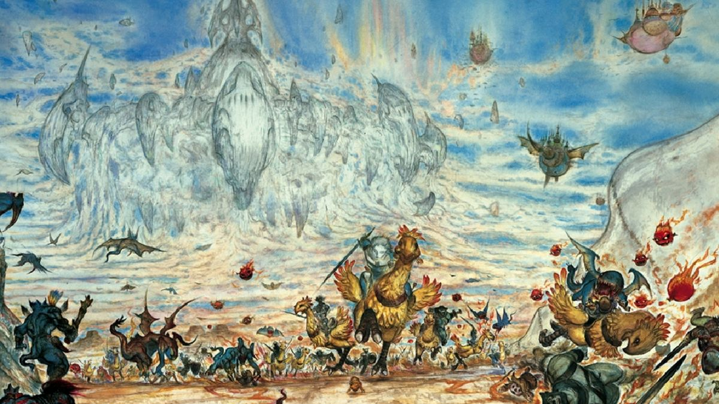](https://www.google.com.br/url?sa=i&rct=j&q=&esrc=s&source=images&cd=&ved=2ahUKEwjD9Mj1x4LjAhVpK7kGHXOVBiAQjRx6BAgBEAU&url=https%3A%2F%2Fkotaku.com%2Fthe-beautiful-final-fantasy-art-of-yoshitaka-amano-30782112&psig=AOvVaw3OV5RRiArBjYhWXHorgeo9&ust=1561480894332112)

# Summary

Summary 2

Small Adjustements 3

Status Effects 3

Artist 3

Druid 3

Job Reworks 4

Main Jobs 4

Adept 4

Monk 7

Secondary Jobs 10

Dervish 10

Fencer 11

# Small Adjustements

### Status Effects

This change is intended to open more status possibilities and speed up play.

* **Blind** changes to "Whenever you attack, roll your attack roll twice and take the worst roll."
* New Status Effect: **Curse:** "Whenever you get attacked, the attacker may reroll once."

**Curse** is a Negative Weaken-type status. In regard to Invention, it is a level 1 status.

* The Curse Spell (black magic) inflicts the **Mute**, **Curse** and **Immobilize** statuses instead of its original effects.
* Darkness Dance (performance) inflicts the **Curse** status, not the **Blind** status.
* Change Bad Breath and Diabolo's effects to:

1-2: **Immobilize, Mute, Poison, Meltdown.**  
3-4: **Blind, Disable, Curse, Slow.**  
5-6: **Curse, Slow, Virus, Toad.**  
7-8: **Confuse, Condemn, Slow, Poison.**  
9-0: **Berserk, Blind, Poison, Zombie.**

### Artist

Artist's versatility is too high, so I'm taking it down a peg by changing some of its specialties:

* Ecletic Artist changes to "Choose one first level Dance, Song or Mimicry. You may use it, even without the required action."
* Perfectionism changes to "Choose one second level Dance, Song or Mimicry. You may use it, even without the required action."
* Multitalented changes to "Choose one third level Dance, Song or Mimicry. You may use it, even without the required action."
* Artistic Mastery changes to "Choose one fourth level Dance, Song or Mimicry. You may use it, even without the required action."

### Druid

* Druid's *Primal Music* Specialty should read "Increase your HP and MP bonus multipliers by 1 each. You may equip the Instruments weapon type."

This was in the playtest packet but somehow didn't made it to the final book. The version on the book is wrong and makes no sense with the intended meaning.

There is an unintended interaction between Martial Channeling and **!Kuuton**, so I'm adding this caveat to Martial Channeling:

* Martial Channeling may not increase the damage of multi-attack actions like **Branch Spear** and **!Kuuton**.

Also, Supernova (Blue Magic) is a tad underpowered, so I'm changing it to this:

* Supernova costs 175 MP. Roll (Fire or Water) vs Water, difficulty 70, against the enemy group. Should you hit all targets, regain the MP spent, up to 100 MP, and you may act again. Should you miss at least one target, instead, deal 9 x character level non-elemental magical damage to all targets you missed. This Spell ignores the **Reflect, Blind, Premonition, Curse, Shell** and **Blink** statuses.

# Job Reworks

These Job reworks completely overwrite the original Job description and abilities from the Revised Edition Core Rulebook.

### Main Jobs

#### Adept

A mystic who uses his own vital energy to trigger magical effects. Several Adept actions enable you to spend HP based on your maximum or current HP. In these cases, you lose current hit points equal to the value listed in ability, but it does not diminish your maximum HP. Its main Stats are Fire and Earth. All Adept’s abilities deal damage based on weapon damage, so equipping a strong weapon is a must.

**Representatives**: General Beatrix (FFIX), Agrias Oaks (FFT), Goffard Gafgarion (FFT), Dark Knight Job (FFX-2, FFXI), Fell Knight Job (FFT), Mystic Knight Job (FFV), Adelbert Steiner (FFIX), Warrior Dressphere (FFX-2)

**Abilities**

*Martial Discipline*: Core Ability acquired at level 1. You can equip heavy armor, and the following weapons: Claws / Gloves; Heavy Weapon & Shield; Heavy Weapon; Katana; Wands and Staves. Your HP bonus is 4 times your level, the multiplier increasing by 1 at levels 15, 30 and 60. Your MP bonus is 1 times your level, the multiplier increasing by 1 at level 30. Whenever you use an Adept ability, you may spend 10%, 20% or 30% of your current HP to decrease the Slow (X) value by 2, 4 or 6, respectively. This can reduce the Slow (X) value to a minimum of 0, turning it into a Quick action. The action modified by this ability turns into a magical action. Specialties:

*Arcane Connection:* Requires Fire level 3. You gain one of the following Spell groups: **Fire, Ice, Lightning, Light or Cosmic.**

*Spirit Strength*: Requires Water level 3. Whenever you need to spend HP to use an action, you may spend an equal amount of MP to prevent the HP loss.

*Arcane Fury*: Requires Earth level 3. While your current MP is greater than zero and you have the **Berserk** status, your **!Attack** action deal 150% weapon damage.

*Arcane Discipline*: Core Ability acquired at level 1. You earn one of the three following actions:

**!Elemental Strike** is a Slow (1) magical action. To use it, choose Fire, Lightning or Ice. You concentrate the chosen element and strike a weapon attack causing normal damage, using the chosen element.

**!Holy Strike** is a Slow (4) action. Using your own vital energy as sacred power, you attack with the force of Light. Your attack deals 150% weapon damage, Light-elemental.

**!Shadow Strike** is a Slow (4) action. Sacrificing your own life force to profane powers, you use the forces of Shadow to attack. Your attack deals 150% weapon damage, Shadow-elemental.

Regardless of the chosen action, the Specialties are:

*Dualism*: Requires Air and Water level 5. You gain one of the following actions: **!Elemental Strike**, **!Holy Strike** or **!Shadow Strike**.

*Will Shield*: Requires Earth level 6 and Air level 4. You gain the reaction **!Will Shield**. You can use this reaction whenever you suffer damage. Conjuring up a protective magical shield, you avoid injuries. Perform a Water vs (the greater of Earth or Fire) attack, difficulty 30. If successful, negate all effects of the attack and spend MP equal 10% of your maximum MP. If you do not have enough MP to spend, this ability fails.

*Quick Channeling*: Requires Fire level 7. When using an ability, you may reduce its Slow (X) rating by 1. This can make the ability a Quick action.

*Blade Magic*: Core Ability acquired at level 15. You gain one of the three following actions:

**!Snake Fang** is a *Ranged* Slow (2) magical action. You create a snake-shaped wave of energy. The snake then attacks a target of your choice, a Fire vs Earth attack, difficulty 40. If successful, the target suffers Bio-elemental weapon damage, and the **Poison** status until the end of next round.

**!Hallowed Bolt** is a *Ranged* Slow (2) magical action. You create a luminous energy sphere and send that ball spiraling against a target of your choice, a Fire vs Fire attack, difficulty 40. If successful, the target suffers Lightning-elemental weapon damage, and the **Curse** status until the end the next round.

**!Black Sky** is a *Ranged* Slow (2) magical action. You invoke a black energy beam from the sky that strikes a target of your choice, a Fire vs Air attack, difficulty 40. If successful, the target suffers Shadow-elemental weapon damage, and the **Blind** status until the end of next round.

Regardless of the chosen action, the Specialties are:

*Shadow Blade*: Requires Air level 6 and Fire level 9. You earn the Slow (2) magical action **!Shadow Blade**. Conjuring a tornado of souls, perform a weapon attack against all other combatants, enemies and allies. You deal 150% weapon damage, Shadow-elemental, to all characters hit.

*Stasis Strike*: Requires Earth level 9 and Air level 6. You gain the *Ranged* Slow (5) action **!Stasis Strike**. You summon a lightning bolt from heavens to strike your target. If you are successful in a weapon attack, difficulty 30, deal 150% weapon damage, Light-elemental. If your attack overcomes difficulty 70 or is a critical hit, inflict the **Immobilize** status until the end of your next round on the target.

*Fury Brand*: Requires Air level 6 and Water level 9. You gain the Slow (5) action **!Fury Brand**. Create a rune of fury in your weapon and strike. If you are successful in a weapon attack, difficulty 30, deal 150% weapon damage, Fire-elemental. If your attack overcomes difficulty 70 or is a critical hit, inflict the **Mute** status until the end of your next round on the target.

*Elemental Soul*: Core Ability acquired at level 24. Select an element other than Cut, Crush or Puncture. You become **Immune** to all damage of the chosen element. In addition, choose one of the following Specialties to augment: Reduce *Will Shield*'s difficulty to 10, *Stasis Strike* may inflict **Stop** instead of **Immobilize**, *Fury Brand* may inflict **Berserk** instead of **Mute** or *Light's Judgment* may inflict **Toad** instead of **Disable**. Specialties:

*Night Sword*: Requires Fire level 10. You gain the Slow (2) action **!Night Sword**. Using dark energies in your favor, you drain the life energy of your target. If successful, deal weapon damage, Shadow-elemental, and you heal HP equal to the damage dealt, after reducing by Armor or Magical Armor.

*Light’s Judgement*: Requires Earth level 10. You gain the Slow (5) action **!Cleansing Strike**. This action creates an arcane seal in the air, and then you attack a target with your weapon, destroying the seal and dealing 150% weapon damage, Ice-elemental. If your attack overcomes difficulty 70 or is a critical hit, inflict the **Disable** status until the end of your next round on the target.

*Reckless Sacrifice:* Requires Water level 10. When using an Adept action that inflicts a negative status on a single target, you can choose to automatically hit without performing an attack roll. If you do, you suffer the same status for the same duration.

*Arcane Shock*: Core Ability acquired at level 42. You gain the *Ranged* Slow (3) magical action **!Demi Shock** . Concentrating the arcane forces, you try to break the enemy. Do a Fire vs Earth attack, difficulty 40. If successful, the target loses 50% of their current HP. This counts as a **Gravity-**type status effect. The Specialties are:

*Mana Safe*: Requires Earth level 8 and Water level 10. You can spend any amount of MP and an action to heal the same amount of MP to an ally. Any ally can spend any amount of MP and an action to heal on you half that amount of MP.

*Dark Pact*: Requires Earth and Fire level 11. Whenever you spend HP to use a Quick Adept action that deals Shadow-elemental damage, you may spend extra 10% of your max HP to deal extra 50% weapon damage. You must declare this Ability before rolling the attack, spending the extra HP regardless of hitting or missing.

*Elemental Overload*: Requires Air level 7 and Fire level 12. Whenever you spend HP to use a Quick Adept action that deals Fire-, Ice- or Lightning-elemental, you may spend extra 10% of your max HP to attack all opponents, rather than just one target.

*Staggering Blow*: Core Ability acquired at level 60. Whenever you damage a target preparing a Slow action with an action, the target loses the prepared action. Specialties:

*Shellburst Stab*: Requires Earth level 20. You gain the *Ranged* Slow (6) magical action **!Shellburst Stab**. You overload the target with magical energy. Perform an Earth vs Water attack, difficulty 40. If successful, the target takes Puncture-elemental damage equal to the lesser between its current MP or 999.

*Soul Eater:* Requires Air level 20. You gain the *Ranged* Slow (6) magical action **!Soul Eater**. Opening a portal to the underworld, you try to drag their opponents into eternal sleep. Do an Air vs Water attack against all enemies, difficulty 50. All opponents hit are reduced to 0 HP. Treat this as a **Fatal** type status. If any of the targets is immune to this effect, you deal 150% weapon damage to it, Shadow-elemental.

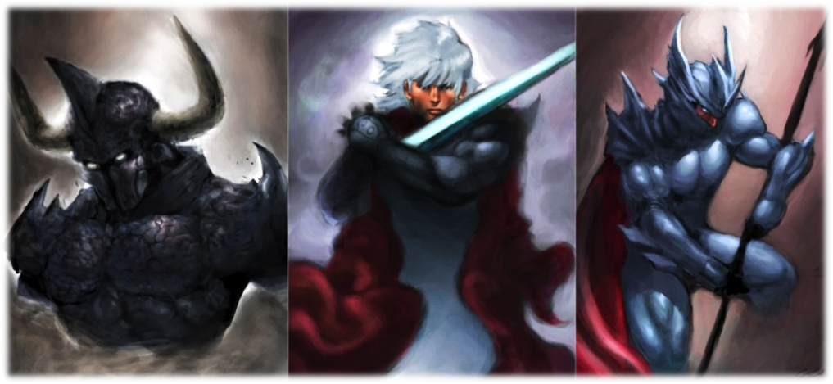*Divine Ruination:* Requires Water level 20. You gain the *Ranged* Slow (6) magical action **!Divine Ruination**. You show the light of glory to your opponents, who are tempted to follow you. Do a Water vs Water attack against all enemies, difficulty 50. All opponents hit receive the **Charm** status. If any of the targets is immune to this effect, you deal 150% weapon damage to it, Light-elemental.

#### Monk

A mystic who battle with the power of their fists and spirit. They have many hit points and can evoke elemental powers. Its main stats are Earth and Fire. Most monks either devote themselves to the martial arts or to spiritual and magical pursues, however some masters try to balance these two paths.

**Representatives**: Amarant Coral (FFIX), Monk Job (FFI, FFIII, FFV, FFT), Sabin Rene Figaro (FFVI), Tifa Lockheart (FFVII), Yang Fang Leiden (FFIV), Zell Dincht (FFVIII)

**Abilities**

*Martial Artist:* Core Ability acquired at level 1. You can equip medium armor and the following weapons: Claws / Gloves; Wands and Throwing Weapons. Your HP bonus is 6 times your level, the multiplier increasing by 1 at levels 15, 30 and 60. Your MP bonus is zero, and increases by 1 times your level at level 30. Specialties:

*Brawler:* Requires Earth level 3. Whenever you use the **!Attack** action while equipped with Claws or Gloves, you may re-roll the attack once.

*Drunken Dance:* Requires Air level 3. Whenever you perform a physical action, reduce your next action's Slow(x) rating by 2, to a minimum of zero, if it is magical. Whenever you perform a magical action, reduce your next action's Slow(x) rating by 2, to a minimum of zero, if it is physical. This ability may make a Slow(x) action turn into Quick.

*Spirit Power:* Requires Fire level 3. Whenever one of your abilities’ effects change based on your character level, consider it as being four levels higher than it is. Reduce all Stat level of your Specialties’ (both earned and unearned) requirements by one.

*Elemental Arts:* Requires Water level 3. Your MP bonus becomes equal to your level (if not already higher). In addition, you gain access to one of the following Spell groups: **Gravity, Healing, Poison or Purify**

*Jutsu:* Core Ability acquired at level 1. You earn one of the four types of Jutsu below:

**!Katon** is a *Ranged* Slow (3) magical action*.* Using it, you invoke elemental spirits. Do a Fire vs Fire attack, difficulty 40. If successful, deal 4x Fire level Fire-elemental damage on a target. This ability can achieve critical hits; in this case, besides the damage, the target receives the **Curse s**tatus until the end of the next round. At level 20 or greater, critical hits also inflict the **Sleep** status until the end of the next round.

**!Suiton** is a *Ranged* Slow (3) magical action*.* Using it, you invoke elemental spirits. Do a Fire vs Water attack, difficulty 40. If successful, deal 4x Fire level Water-elemental damage on a target. This ability can achieve critical hits; in this case, besides the damage, the target receives the **Weaken (Mental)** status until the end of the next round. At level 20 or greater, critical hits also inflict the **Mute** status until the end of the next round.

**!Doton** is a *Ranged* Slow (3) magical action*.* Using it, you invoke elemental spirits. Do a Fire vs Earth attack, difficulty 40. If successful, deal 4x Fire level Earth-elemental damage on a target. This ability can achieve critical hits; in this case, besides the damage, the target receives the **Poison** status until the end of the next round. At level 20 or greater, critical hits also inflict the **Virus** status until the end of the next round.

**!Fuuton** is a *Ranged* Slow (3) magical action*.* Using it, you invoke elemental spirits. Do a Fire vs Air attack, difficulty 40. If successful, deal 4x Fire level Air-elemental damage on a target. This ability can achieve critical hits; in this case, besides the damage, the target receives the **Blind** status until the end of the next round. At level 20 or greater, critical hits also inflict the **Confuse** status until the end of the next round.

Regardless of the chosen Jutsu, at level 15 the damage becomes 6x Fire level, at level 22 the damage becomes 8x Fire Level, at level 31 the damage becomes 11x Fire Level and at level 40 the damage becomes 14x Fire level. The Specialties are:

*Elan:* Requires Air level 4 and Fire level 6. Your Jutsu targets a group instead of just one target.

*Vengeful Spirits:* Requires Fire level 6 and Water level 4. Whenever your Jutsu are successful, consider that they had a critical hit.

|  |  |
| --- | --- |
| **Jutsu** | **Opposing Elements** |
| **!Katon** | Ice or Water |
| **!Suiton** | Fire or Light |
| **!Doton** | Air or Ligthning |
| **!Fuuton** | Earth or Shadow |

*Lightning Jutsu:* Requires Earth level 4 and Fire level 6. You gain the reaction **!Raiton.** Use it when you are hit by a magical action or spell. You conjure the spirits defensively to interfere with it. Perform a Fire vs Fire attack, difficulty 40. A successful reaction means you ignore the action's damage. You may also use this reaction to negate all effects of the magical action or spell, when you or an ally is hit by a magical action or spell that deals elemental damage opposed to one of your earned Jutsu, according to the table to the right.

*Punch Rush:* Core Ability acquired at level 15. You gain the Slow (3) action **!Punch Rush.** Perform a weapon attack, difficulty 30, dealing 100% weapon damage and ignoring half of the target's Armor or Magical Armor. Reduce by 10 the difficulty if your weapon deals physical damage. Reduce by 10 the difficulty if your weapon is not Ranged. **!Punch Rush** attacks with Claws/Gloves ignores the target's Armor. Specialties:

 *Jutsu Acolyte:* Requires Fire level 7. You gain one of the following Jutsu: **!Katon, !Suiton, !Doton** or **!Fuuton.**

*Zen Awareness:* Requires Air level 8. You may use reactions while preparing Slow actions by discarding your lowest initiative die other than the die used to prepare the Slow action (instead of a current phase initiative die).

*Flurry of Blows:* Requires Earth level 7. Your attacks other than the first action or reaction each round hit when you roll doubles, even if the attack didn’t overcome the difficulty. Your **!Punch Rush** can critical hit, dealing double damage and inflicting the **Weaken (Armor)** status effect until the end of the round.

*Zen Evasion:* Core Ability acquired at level 24. You gain the **!Zen Evasion** reaction. Use it after you're hit with a Slow action. You ignore the action's effects on a successful Air vs Fire roll, difficulty 40. Specialties:

* Soul Volley:* Requires Fire and Water level 10. Choose and gain either **!Aura Bolt** or **!Dark Bolt**. Both are Ranged Slow (4) magical actions. Release your inner Chi in a bolt of light or darkness to perform a Fire vs Water attack, difficulty 50. If successful, the target takes 14 x Fire level damage, and you may discard any number of initiative dice to repeat the attack against a different target, once per die discarded. **!Aura Bolt** deals Light-elemental damage and **!Dark Bolt** deals Shadow-elemental damage. At level 45 the damage increases to 16 x Fire level damage, at level 52 it increases to 20x Fire level damage, and at level 59 it increases to 22x Fire level damage.

***Timeless Body:* Requires Earth, Air, Fire and Water level 8. You resist **Mental**-type and **Time**-type status effects.

*Suplex:* Requires Earth level 10. When using the **!Punch Rush** action, you may discard an extra initiative die to deal 300% weapon damage on normal and critical hits. The damage is only 200% weapon damage if you're equipped with any weapon other than Claws/Gloves.

*Awaken Chakra:* Core Ability acquired at level 42. Choose one of the three advantages below:

*Balanced Chakras:*Whenever you use an action or reaction which Offensive Stat is Earth or Fire, you may use the highest of either Earth or Fire;

*Spiritual Chakras:*When using a Jutsu or Soul Volley, you may increase its Slow(X) rating by 1 to increase the damage by 3x Fire level on a single target, or by 1x Fire level on all targets.

*Material Chakras:*You gain the Slow (2) action **!Kick**. When using it, attack all opponents with your weapon, dealing 100% weapon damage. When equipped with Claws/Gloves, ignore the target's Protect status.

Regardless of the choice, the Specialties are:

*Pressure Points:* Requires Earth level 6 and Water level 12. You gain the Slow (2) physical action **!Atemi.** This action allows you to deliver blows to the correct points to close the chakra of the target. Do an Earth vs Earth attack, difficulty 70. If successful, inflict the **Immobilize** status until the end of the next round. At level 50, reduce the difficulty to 50. You may spend 30 MP to make your **!Atemi** action targets all enemies instead of only one.

*Release Chakra:* Requires Air level 6 and Water level 12. You gain the Slow (5) magical action **!Chakra.** When using it, you release the healing power of your chakras to end any negative statuses affecting you. However, until level 50, you can’t use this Ability while under the effect of any **Mental** type or **Time** type negative statuses. You may spend any amount of MP to recover HP equal to double of that amount, in addition to its effects.

*Chi Blast:* Requires Fire level 6 and Water level 12. You gain the Slow (2) magical action **!Chi Blast.** This action allows you to directly attack the enemy's fighting spirit. Do an Fire vs Fire attack, difficulty 70. If successful, inflict the **Disable** status until the end of the next round. At level 50, reduce the difficulty to 50. You may spend 30 MP to make your **!Chi Blast** action targets all enemies instead of only one.

*Zen Mind:* Core Ability acquired Base at level 60. Your attacks and reactions against enemies suffering any negative status effects may be rerolled once. Specialties:

*Jutsu Master:* Requires Fire level 20. You gain two of the following actions**: !Katon, !Suiton, !Doton** or !**Fuuton.** You also gain the *Ranged* Slow (5) magical action **!Kuuton.** Using your mastery of the four elements, roll 1d100 and add your Fire value, comparing this result to all opponents’ stats. If the result is greater than Earth plus 20, the opponent takes 6x Fire level Earth-elemental damage. If the result is greater than Air plus 20, the opponent takes 6x Fire level Air-elemental damage. If the result is greater than Fire plus 20, the opponent takes 6x Fire level Fire-elemental damage. If the result is greater than Water plus 20, the opponent takes 6x Fire level Water-elemental damage. This attack always ignores targets’ Magic Armor.

*Elemental Union:* Requires Air and Water level 10. Increase your MP bonus by 1 times your level. You gain one of the following Spell groups: **Mage Bane, Regeneration, Enchantment** or **Divination.**

*Phantom Rush:* Requires Earth level 20. You gain the Slow (6) physical action **!Phantom Rush**, a martial arts secret known as the supreme blow. Using it, do an Earth vs Air attack, difficulty 30. If successful, deal 33x Earth level Crush-elemental damage on a target, ignoring its Armor.

### Secondary Jobs

#### Dervish

Offensive Job focused on fighting with two weapons to strike fast and often. Its main Stat is Air. Be a Dervish if you want to increase the amount and speed of your actions and be a great physical damage dealer.

**Representatives:** Edward Geraldine “Edge” Eblan (FFIV), Clyde “Shadow” Arrowny (FFVI), Ninja Job (FFI, FFIII, FFV, FFXI, FFT, FFTA

**Abilities**

*Ambidexterity*: Core Ability acquired at level 1. You may equip Twin Weapons. Specialties:

*Quick Draw:* Requires level Air 3. Once per round as a free action, you can draw and switch weapons.

*Killer’s Garments:* Requires level 1. You may equip medium armor, Bows and Throwing Weapons.

*Deadly Dance:* Requires Air level 5 and Fire level 4. Whenever you hit the **!Attack** action, you may lower the value of one of your initiative dice by 1, to a minimum of the current phase.

*Critical Speed*: Core Ability acquired at level 19. You may add your Air level to your Armor and your Fire level to your Magic Armor. While your current HP is 25% of your max HP or less, you gain the **Haste** status**.** You lose this status if your current HP is more than 25% of your max HP for any reason. Specialties:

*Zen Focus*: Requires Earth and Water level 7. At the beginning of each round, you may roll one fewer initiative dice to gain one extra die in a phase you have no initiative dice (you choose which phase after all enemies have rolled initiative).

*Danger Zone*: Requires Air and Fire level 6. At the beginning of each round, you may spend HP equal to 25% of your max HP to receive the **Haste** status during this round.

*Two-Weapon Defense:* Requires Fire level 9 and Water level 5. You gain the reaction **!Double Parry**. Use when hit by a Melee physical attack. Do an (the greater of Air or Earth) vs Earth attack, difficulty 40. If successful, you ignore the attack’s effects.

*Deadly Accuracy*: Core Ability acquired at level 35. Once per action, after rolling an attack, you may reduce or increase by 1 the d100 result. Specialties:

*Deep Cut:* Requires Air level 15. When you attain a critical hit with an action that deals damage, ignore the target’s Armor and Magical Armor.

*Lethal Precision*: Requires Water level 14. If you discard an initiative dice after rolling an attack that may not have critical hits, you deal double damage in case of a critical hit. This ability may not be used with Spells.

*Fierce Assault:* Core Ability acquired at level 50. After you deal physical damage to a target, your subsequent physical attacks against that target in this phase ignore Armor. After you deal magical damage to a target, your subsequent magical attacks against that target in this phase ignore Magic Armor. Specialties:

*Rain of Blows:* Requires level 18 in Earth. Once per round, after being successful with the **!Attack** action, you may repeat the action as a free action.

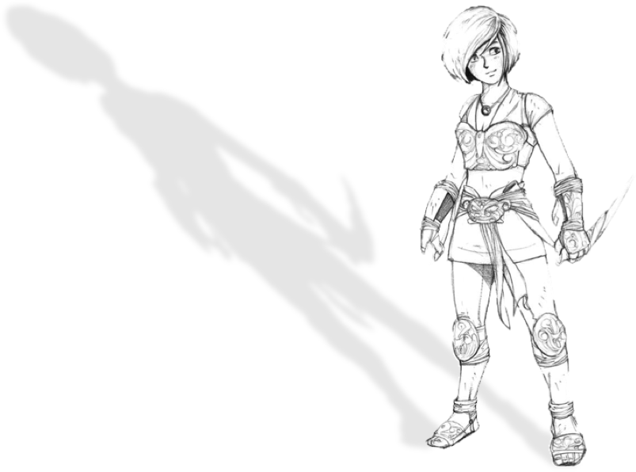*Precise Hits*: Requires Fire level 18. Once per round, you may re-roll an attack when using a physical or magical action.

#### Fencer

Defensive job that believes that the best way of not dying is being out of the way of attacks. Its main Stat is Air. Be a Fencer if you want to dodge the attacks of your opponents, especially their missiles, and manipulate the flow of actions in battle, thus increasing your and your allies’ survival.

**Representatives**: Fencer Job (FFTA)

**Abilities**

*Block Projectiles:* Core Ability acquired at level 1. You may equip medium armor and gain the reaction **!Arrow Guard**. When you are hit by a *Ranged* attack, make an Air vs Air attack, difficulty 30. If successful, you don’t attack’s effects. This does not affect Spells. Specialties:

*Lightning Strike:* Requires Fire level 3. Opponents cannot use interrupt actions to react to your attacks. In addition, choose one: Bows or Light Sword / Knives. You may equip the chosen.

*Slim Target:* Requires Air level 4. Once per round, you can use interrupt actions by spending only one initiative die.

*Surprise Assault:* Requires Earth level 3. Whenever you declare a Slow (X) action, you may turn it into a Quick action by increasing another of your initiative dice's value by X. This ability fails if it would increase a die to a value of 11 or greater.

*Preemptive Attack:* Core Ability acquired at level 19. After rolling initiative, you may change one of your dice’s value to 1. You may add your Air level to your Armor and your Water level to your Magic Armor. Specialties:

*Just a Scratch*: Requires Earth and Fire level 10. The first time in each round you suffer a critical hit, ignore the effects of critical hit (if any). The attack does its normal effects. You may still count as if it had been a critical hit for the purposes of other Abilities.

*Magical Reflexes:* Requires Fire level 8. You may use **!Arrow Guard** to avoid Spells.

*False Weakness:* Requires Earth level 7. Whenever an opponent misses an attack against you or you avoid its effects by reacting, you may force the opponent to discard one initiative die and immediately repeat the attack against only you (even if the attack targets a Group, it will only target you when you use *False Weakness*).

*Total Defense*: Core Ability acquired at level 35. You may delay any number of actions, instead of only one. Specialties:

*Impromptu Cover:* Requires Air and Water level 13. Increase by 30 the difficulty of all Group attacks that include you as its targets.

*Blade Barrier*: Requires Earth and Fire level 13. Add your Earth level to your Armor and your Fire level to your Magic Armor.

*Air Dancer*: Core Ability acquired at level 50. Whenever an opponent misses an attack against you or you avoid its effects by reacting, you may discard one initiative die of any value to perform the **!Bobbing** free *Ranged* physical action. Roll Air vs Water, difficulty 40. If sucessful, the enemy loses its highest Initiative die and you gain it (with the same value) . Treat this as a **Weaken**-type status effect. Specialties:

*Water Dancer*: Requires Water level 18. Melee actions cannot target you unless you acted in the last 3 phases.

*Fire Dancer*: Requires Air level 18. Reduce the difficulty of all actions and reactions you perform on second or third phase by 5. Reduce the difficulty of all actions you perform on fourth or fifth phase by 10. Reduce the difficulty of all actions you perform on sixth or seventh phase by 15. Reduce the difficulty of all actions you perform on eighth or ninth phase by 20. Reduce the difficulty of all actions you perform on tenth phase by 25.

*(Using the simplified rules, reduce the difficulty of actions and reactions on fourth, fifth and sixth phase by 1, on seventh, eighth or ninth by 2 and on tenth by 3)*

