DETAILED DESIGN DOCUMENT
Reyvo
Staffing Agency Outbound Growth Platform
Technical design for a multi-tenant SaaS platform that helps staffing agencies find employer clients, run compliant outbound email campaigns with AI-assisted personalization, and turn replies into sales conversations.

Document | Detailed Design Document (DDD)
Version | 1.1 — Implementation-aligned
Date | November 12, 2026
Source | Reyvo Developer Requirements, Project brief v1.0 (November 8, 2026) and the implemented codebase in this repository (reviewed November 12, 2026).
Prepared by | [Developer / vendor name]
Classification | Confidential

Document Control
Revision history
Version | Date | Author | Description
0.1 | November 8, 2026 | Product owner | Developer Requirements brief v1.0 issued (source document).
1.0 | November 9, 2026 | [Developer] | Initial Detailed Design Document covering all brief sections, with architecture, data, module, compliance and delivery design.
1.1 | November 12, 2026 | [Developer] | Implementation alignment with the delivered codebase: Python/FastAPI stack, SQLAlchemy/Alembic, Redis/Arq jobs, WorkOS SSO, per-user rate limiting, chat retention and the database-backed knowledge-base assistant (FR-11, §7.11).

Review and approval
Role | Name | Signature | Date
Product owner / sponsor
Technical lead
Security reviewer
Legal / compliance reviewer

How to read this document
Sections 1–3 set out purpose, product context and full requirement traceability. Sections 4–6 define the architecture, tenant isolation and data model. Section 7 designs each MVP module. Sections 8–10 cover deliverability, compliance, security and non-functional targets. Sections 11–16 cover services, delivery, acceptance, commercials, deliverables and open decisions.
Items marked Proposed are design choices made where the brief left the decision to the developer and should be confirmed in review. Where the delivered codebase differs from the original proposal, the as-built behaviour is recorded as an implementation delta.

Contents
1. Introduction 5
1.1 Purpose 5
1.2 Scope 5
1.3 Intended audience 5
1.4 Conventions 5
1.5 Definitions and acronyms 6
2. Product Overview 7
2.1 Project objective 7
2.2 Target customers and users 7
2.3 Reference use case 7
2.4 Design principles 8
3. Requirements and Traceability 9
3.1 Functional requirements (MVP scope) 9
3.2 Compliance, security and deliverability requirements 10
4. System Architecture 11
4.1 System context 11
4.2 Logical architecture 12
4.3 Technology stack (proposed) 13
4.4 Environments and deployment 13
5. Multi-Tenancy, Identity and Access 15
5.1 Tenant isolation model 15
5.2 Authentication 16
5.3 Roles and permissions 16
5.4 Platform owner and support access 16
6. Data Design 18
6.1 Entity-relationship model 18
6.2 Entity catalogue 19
6.3 Lead record fields 19
6.4 Data retention and deletion 20
7. Functional Module Design 21
7.1 Accounts and tenant isolation (FR-01) 21
7.2 Lead and company management (FR-02) 21
7.3 Email account connections (FR-03) 22
7.4 Campaign builder (FR-04) 23
7.5 AI personalization with human control (FR-05) 24
7.6 Sending engine and safety controls (FR-06) 25
7.7 Unified replies and pipeline (FR-07) 27
7.8 Reporting dashboard (FR-08) 27
7.9 Platform owner admin (FR-09) 28
7.10 Subscription billing (FR-10) 29
8. Deliverability and Sending Capacity 30
8.1 Domain authentication guidance 30
8.2 Default limits and ramp-up (proposed) 30
8.3 Provider sending limits 30
8.4 Capacity planning for 1,000 emails per day 31
8.5 Monitoring and automatic pause thresholds (proposed) 31
9. Compliance and Security Design 32
9.1 CAN-SPAM controls (CR-01) 32
9.2 Provider policies and anti-abuse (CR-03) 32
9.3 Security controls (CR-04) 33
9.4 Pause controls and do-not-contact lists (CR-05) 33
10. Non-Functional Requirements 34
11. Third-Party Services and Account Ownership 35
12. Delivery Plan 36
12.1 Phased delivery 36
12.2 Phase 1 milestones (proposed sequence) 37
12.3 Testing strategy 37
13. Acceptance Criteria and Verification 38
14. Commercial Assumptions 39
14.1 Cost drivers to model 39
15. Developer Estimate and Deliverables 40
16. Open Decisions, Assumptions and Risks 41
16.1 Decisions to confirm before build 41
16.2 Key risks 42
Appendix A — Merge Fields 43
Appendix B — Default Configuration Values 44
Appendix C — Sources 44

1. Introduction

1.1 Purpose
This Detailed Design Document (DDD) translates the Reyvo Developer Requirements brief (Version 1.0, November 8, 2026) into a buildable technical design. It describes the system architecture, data model, module behaviour, sending and deliverability controls, compliance and security measures, delivery phasing and acceptance testing for the Reyvo platform.
Every requirement in the source brief is carried into this document, either restated verbatim (marked Brief requirement) or traced to a design section. Where the brief leaves a choice to the developer, this document records a proposed decision and the reasoning so it can be validated before build.

1.2 Scope
In scope (this DDD) | The MVP required for first launch (brief §3), mandatory compliance, security and deliverability controls (brief §4), the phased delivery plan (brief §5), proposed architecture (brief §6), commercial assumptions (brief §7), acceptance criteria (brief §8), requested estimate deliverables (brief §9) and open decisions (brief §10).
Implemented extension | Knowledge-base assistant (FR-11): database-backed ingestion of this design document, hybrid retrieval with server-validated citations, conversation context, access gating, rate limiting and scheduled reindexing. Delivered alongside the MVP and documented in §7.11; it does not replace or defer any MVP item in this table.
Designed for, built later | Phase 2 and Phase 3 features are described at the level needed to keep the MVP architecture compatible with them.
Out of scope | Third-party lead sourcing (a separate integration per the brief), purchased or scraped lists, guaranteed inbox placement, and legal advice for jurisdictions beyond CAN-SPAM.

1.3 Intended audience
- Product owner / business sponsor — confirm scope, decisions and commercial assumptions.
- Development team — implement modules, data model and infrastructure as specified.
- QA and security reviewers — derive test cases from the acceptance criteria and controls.
- Legal / compliance reviewer — validate CAN-SPAM controls and advise on other jurisdictions.

1.4 Conventions
Marker | Meaning
Brief requirement | Text carried over from the source brief. It is binding unless changed through change control.
Proposed | A design decision made in this DDD where the brief left the choice to the developer. Must be validated before build.
FR-xx / CR-xx / AC-xx | Identifiers for functional requirements, compliance and security requirements, and acceptance criteria, used for traceability.
MVP / P1 / P2 / P3 | Required for first launch / Phase 1 working MVP / Phase 2 commercial launch / Phase 3 optional expansion.

1.5 Definitions and acronyms
Term | Definition
Tenant / Workspace | One customer staffing agency. All of its data is isolated from every other tenant.
Platform owner | The business operating Reyvo, which creates, suspends and bills tenants.
Mailbox / Inbox | A customer-owned Google Workspace or Microsoft 365 email account connected by OAuth.
Campaign / Sequence | An outreach program: an audience, a set of timed message steps and sending rules.
Enrollment | One contact's progress through one campaign's sequence.
Suppression list | Addresses or domains that must never be emailed (opt-outs, hard bounces, do-not-contact).
DNC | Do-not-contact. Kept at global (platform) and tenant level.
SPF / DKIM / DMARC | DNS-based email authentication standards that prove a domain authorised a message.
DSN | Delivery Status Notification, the automated message a mail server returns when a message bounces.
OOO | Out-of-office automatic reply.
RLS | PostgreSQL Row-Level Security: database-enforced filtering of rows per tenant.
RBAC | Role-based access control.
RPO / RTO | Recovery point objective (maximum data loss) / recovery time objective (maximum downtime).
CAN-SPAM | The U.S. CAN-SPAM Act, which sets rules for commercial email.

2. Product Overview

2.1 Project objective
Brief requirement · §1
Build a web-based, multi-tenant SaaS platform that helps staffing agency owners identify prospective employer clients, manage compliant outbound email campaigns, personalize outreach with AI, and turn responses into sales conversations. The product should be simple enough for nontechnical agency owners and scalable to independently onboard and bill multiple client agencies.

2.2 Target customers and users
Primary users: staffing agency owners, business development representatives and small recruiting teams. The design assumes users are not technical: every setup step (connecting an inbox, verifying a domain, importing a CSV) has a guided flow with plain-language status and errors.
User type | Role in Reyvo | Primary goals
Agency owner | Agency Admin | Set up the workspace, connect inboxes, approve AI copy, watch results and billing.
Business development rep | Agency Member | Import and segment leads, run campaigns, work replies, book meetings.
Small recruiting team | Admins and Members | Share lead lists and the reply inbox; assign follow-up tasks.
Platform owner / support | Platform Owner, Support | Onboard and bill agencies, set limits, monitor health, give permissioned support.

2.3 Reference use case
The brief's example, a construction staffing agency targeting general contractors in Texas, is the reference scenario used throughout this design and in end-to-end testing:
- The agency selects its target: general contractors in Texas.
- It imports (or, in a later phase, discovers) appropriate business contacts and companies.
- It sends personalized introductions from its own connected inbox, using AI-suggested copy it has reviewed.
- Reyvo tracks replies, stops follow-ups automatically and highlights interested contacts.
- The team books introductory calls and moves the lead through the pipeline to Meeting and Won.

2.4 Design principles
Principle | What it means in the design
Isolation by default | Tenant boundaries are enforced in the database (RLS), not only in application code.
Safe-by-default sending | Conservative caps, gradual ramp-up and automatic pausing are on unless an authorised user changes them within plan limits.
Compliance is built in | Unsubscribe links, a physical address and suppression checks cannot be switched off.
Human control over AI | AI suggests; people approve. AI may only use facts present in the supplied fields.
Honest metrics | Reporting is based on events Reyvo can measure (sent, bounced, replied). Opens are not treated as reliable.
Simple first | One modular application with background workers. No microservices until volume justifies them.
Grounded AI, not prompt stuffing | Product knowledge is stored in the database and retrieved per question with citations. The assistant refuses when the sources do not support an answer, and conversation history is never treated as evidence.

3. Requirements and Traceability
The tables below list every requirement from the brief, its identifier, the delivery phase and the section of this document that designs it.

3.1 Functional requirements (MVP scope)
ID | Module | Brief requirement (summary) | Phase | Design
FR-01 | Accounts and tenant isolation | Secure signup/login; one workspace per customer; admin/member roles; strict separation of contacts, email accounts, campaigns, analytics and billing. | P1 | §5, §7.1
FR-02 | Lead and company management | CSV import/export; lead fields; duplicate detection; suppression lists; filters and segmentation; imported leads first. | P1 | §6.3, §7.2
FR-03 | Email account connections | Connect Google Workspace / Microsoft 365 via OAuth/API; show connection health; no mailbox passwords. | P1 | §7.3
FR-04 | Campaign builder | Audience, editing, merge fields, multi-step follow-ups, time-zone send windows, pause/resume, auto-stop on reply, opt-out or hard bounce. | P1 | §7.4
FR-05 | AI personalization with human control | Suggested subjects and short copy from fields; editable templates; preview each variation; configurable approval; no fabricated facts. | P1 | §7.5
FR-06 | Sending engine and safety controls | Per-inbox daily caps, ramp-up, queueing, throttling, bounce and unsubscribe handling, deliverability monitoring; 1,000/day is a target, not a guarantee. | P1 | §7.6, §8
FR-07 | Unified replies and pipeline | Detect and categorize replies; view conversations; flag interested leads; tasks; stages New → Won / Not Interested. | P1 | §7.7
FR-08 | Reporting dashboard | Daily/weekly queued, sent, delivered (where measurable), bounced, replied, positive, opt-outs, meetings, campaign performance; opens not relied on. | P1 | §7.8
FR-09 | Platform owner admin | Create/suspend tenants; usage and system health; subscription limits and feature access; audit log; permissioned support access. | P1 | §7.9
FR-10 | Subscription billing | Payment provider (e.g., Stripe): monthly plans, invoices, failed payments, cancellation, per-tenant usage tracking. | P2* | §7.10
FR-11 | Knowledge-base assistant (implemented extension) | Answer questions about the platform from a database-backed, cited design corpus, with conversation context and refusal outside the corpus. | P1 (ext.) | §7.11

Scope note — billing timing
The brief lists subscription billing in the MVP scope (§3) but places Stripe subscriptions in Phase 2 (§5). This design treats it as required before commercial launch: the billing data model and usage metering are built in Phase 1, and the Stripe integration is completed in Phase 2. Confirm this reading before quoting (see §16).

3.2 Compliance, security and deliverability requirements
ID | Brief requirement (mandatory) | Design
CR-01 | Support applicable CAN-SPAM requirements: accurate sender identity, nondeceptive subjects, physical mailing address, functional unsubscribe mechanism, and prompt opt-out processing. Developer should obtain legal review for other jurisdictions and privacy laws. | §9.1
CR-02 | Provide domain authentication guidance (SPF, DKIM, DMARC), sender reputation monitoring, bounce suppression, and safe volume limits; no guarantee of inbox placement or avoidance of spam filtering. | §8
CR-03 | Respect provider API policies, sending limits, and anti-abuse rules. No unauthorized scraping, purchased-list assumptions, or bypassing provider restrictions. | §9.2
CR-04 | Encrypt credentials/tokens at rest and in transit; use least-privilege access, backups, retention/deletion controls, logging, and tenant-level data isolation. | §5, §9.3
CR-05 | Ensure every campaign can be paused quickly; honor global and tenant-specific do-not-contact lists; maintain unsubscribe/audit records. | §9.4

4. System Architecture
Brief requirement · §6 Proposed architecture (developer to validate)
Responsive web app (e.g., React/Next.js); API/backend (e.g., Node.js or Python); relational database with tenant-scoped records (e.g., PostgreSQL); background job queue for schedules; approved email-provider APIs; AI API for drafting; Stripe billing; cloud hosting with monitoring, backups, and secrets management. Developer may propose alternatives with cost and maintenance tradeoffs.

This design validates the brief's proposed architecture with one Python stack end to end: a FastAPI modular monolith plus Arq background workers that share the same code. Module boundaries, the data model and the multi-tenant controls are unchanged; the language choice keeps a small team productive and lowers maintenance cost. Each module can later be split out if load demands it.

4.1 System context
Figure 1 shows who uses Reyvo and which external systems it depends on. Outreach email is always sent from the agency's own mailbox through the provider's official API; Reyvo never relays outreach through its own mail servers.
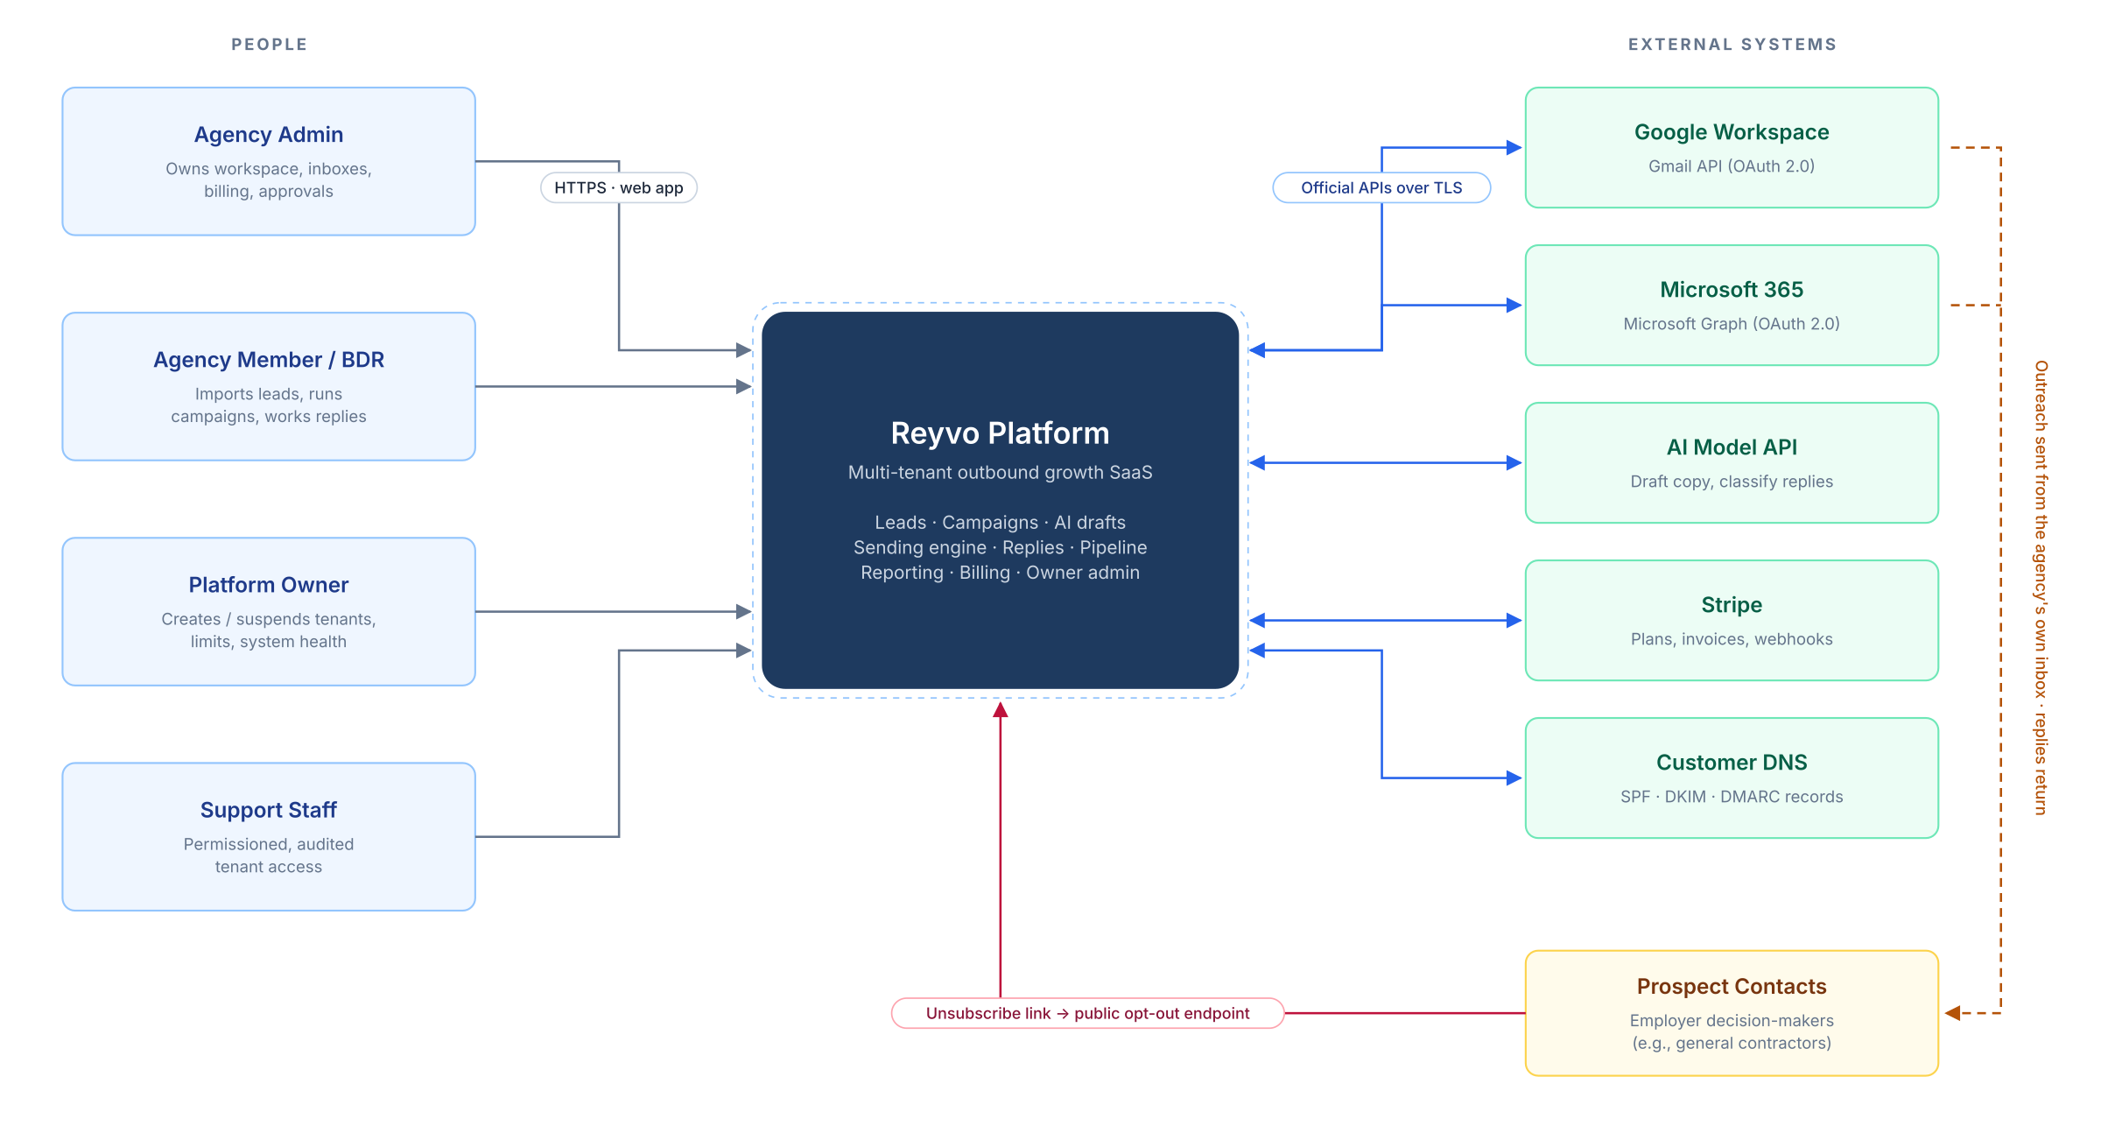
Figure 1. System context: users, the Reyvo platform and external services

4.2 Logical architecture
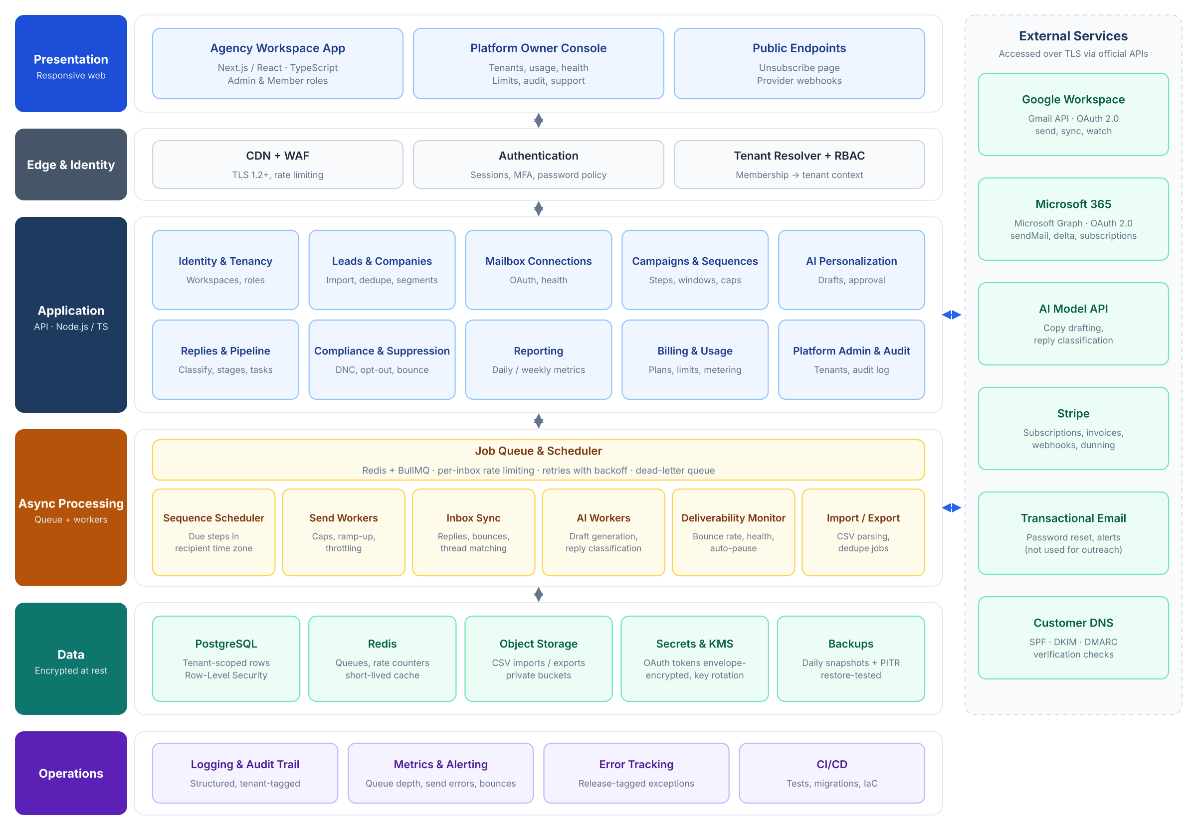
Figure 2. Logical architecture: layers, application modules, workers and data stores
Layer | Responsibility | Key components
Presentation | Responsive UI for agencies and the platform owner; public pages for recipients. | Agency workspace app, owner console, unsubscribe page, webhook endpoints
Edge and identity | TLS, bot and abuse protection, authentication, tenant resolution and RBAC. | CDN + WAF, auth provider, tenant resolver middleware
Application (API) | Business rules for each module; synchronous requests from the UI. | Ten domain modules (Figure 2), REST/JSON API with OpenAPI schema
Async processing | Anything scheduled, slow or rate-limited runs as a job. | Scheduler, send workers, inbox sync, AI workers, deliverability monitor, import/export
Data | Durable state, queues, files, secrets. | PostgreSQL with RLS, Redis, object storage, KMS + secrets manager, backups
Operations | Visibility and safe change. | Structured logs, metrics and alerts, error tracking, CI/CD with migrations and infrastructure-as-code

4.3 Technology stack (as built and proposed)
Concern | Proposed choice | Why | Alternative considered
Web app | Next.js (React, TypeScript) — proposed | Matches the brief; server rendering for fast dashboards. The delivered repository is API-first, so the UI remains a build item. | React SPA + Vite
API | Python 3.12 + FastAPI (modular monolith) | One typed codebase for API and workers; async I/O matches provider and database calls. Module boundaries map 1:1 to this design. | Node.js + TypeScript (NestJS)
Database | PostgreSQL 16 (production); SQLite for tests | Relational integrity, transaction-scoped tenant context and point-in-time recovery; SQLite keeps the test suite fast and portable. | Supabase / Neon (managed Postgres)
Data access | SQLAlchemy 2.0 async ORM + Alembic | Explicit transactions for set_config and RLS; Alembic gives reviewed, reversible migrations and drift checks in CI. | Drizzle / Prisma
Queue and scheduling | Redis + Arq | Delayed jobs, per-user rate limiting, retries and cron; rate limits fall back to an in-process window when Redis is absent. | BullMQ / AWS SQS + EventBridge Scheduler
Authentication | Local JWT authentication (Argon2) + WorkOS SSO | Email/password signup, refresh tokens and enterprise SSO without a per-seat auth dependency. | Clerk or another managed auth provider
Email providers | Gmail API; Microsoft Graph | Official APIs with OAuth; no passwords (FR-03). | None — SMTP with stored passwords is excluded
AI | Semantic Kernel + OpenAI-compatible API behind provider adapters | Drafting, grounded chat and embeddings share one adapter; models can be swapped on cost or quality. | Self-hosted open model (higher ops cost)
Billing | Stripe Billing + Customer Portal | Named in brief; handles invoices, dunning and cancellations. | Paddle (merchant of record)
Hosting | AWS (ECS Fargate, RDS, ElastiCache, S3, KMS, Secrets Manager); Docker Compose locally | Managed services cover backups, encryption and secrets (brief §6); Compose gives contributors a one-command local stack. | Render / Fly.io (simpler, less control)
Observability | CloudWatch logs and metrics + Sentry | Alerting on queues, send errors and bounces; release-tagged errors. | Datadog (higher cost)
Delivery | GitHub Actions + Terraform | Repeatable deploys and environment parity. | AWS CDK

4.4 Environments and deployment
Environment | Purpose | Data | Sending
Local | Developer machines (Docker Compose) | Synthetic seed data | Disabled; messages captured locally
Staging | Integration, QA, client demos | Synthetic and test-cohort data only | Test mailboxes and allow-listed recipients only
Production | Live tenants | Customer data, encrypted, backed up | Live, subject to all safety controls

- Web, API and each worker type run as separate container services so sending load never slows the UI.
- Database migrations run automatically in the pipeline before new code is released; every change is reversible.
- A platform-wide sending kill switch is a configuration flag checked by every send worker (see §9.4).

5. Multi-Tenancy, Identity and Access

5.1 Tenant isolation model
Reyvo uses a shared database with tenant-scoped rows. Every tenant-owned table carries a tenant_id column, and PostgreSQL Row-Level Security policies make the database itself refuse to return another tenant's rows, even if application code has a bug. Figure 3 shows the path every request takes.
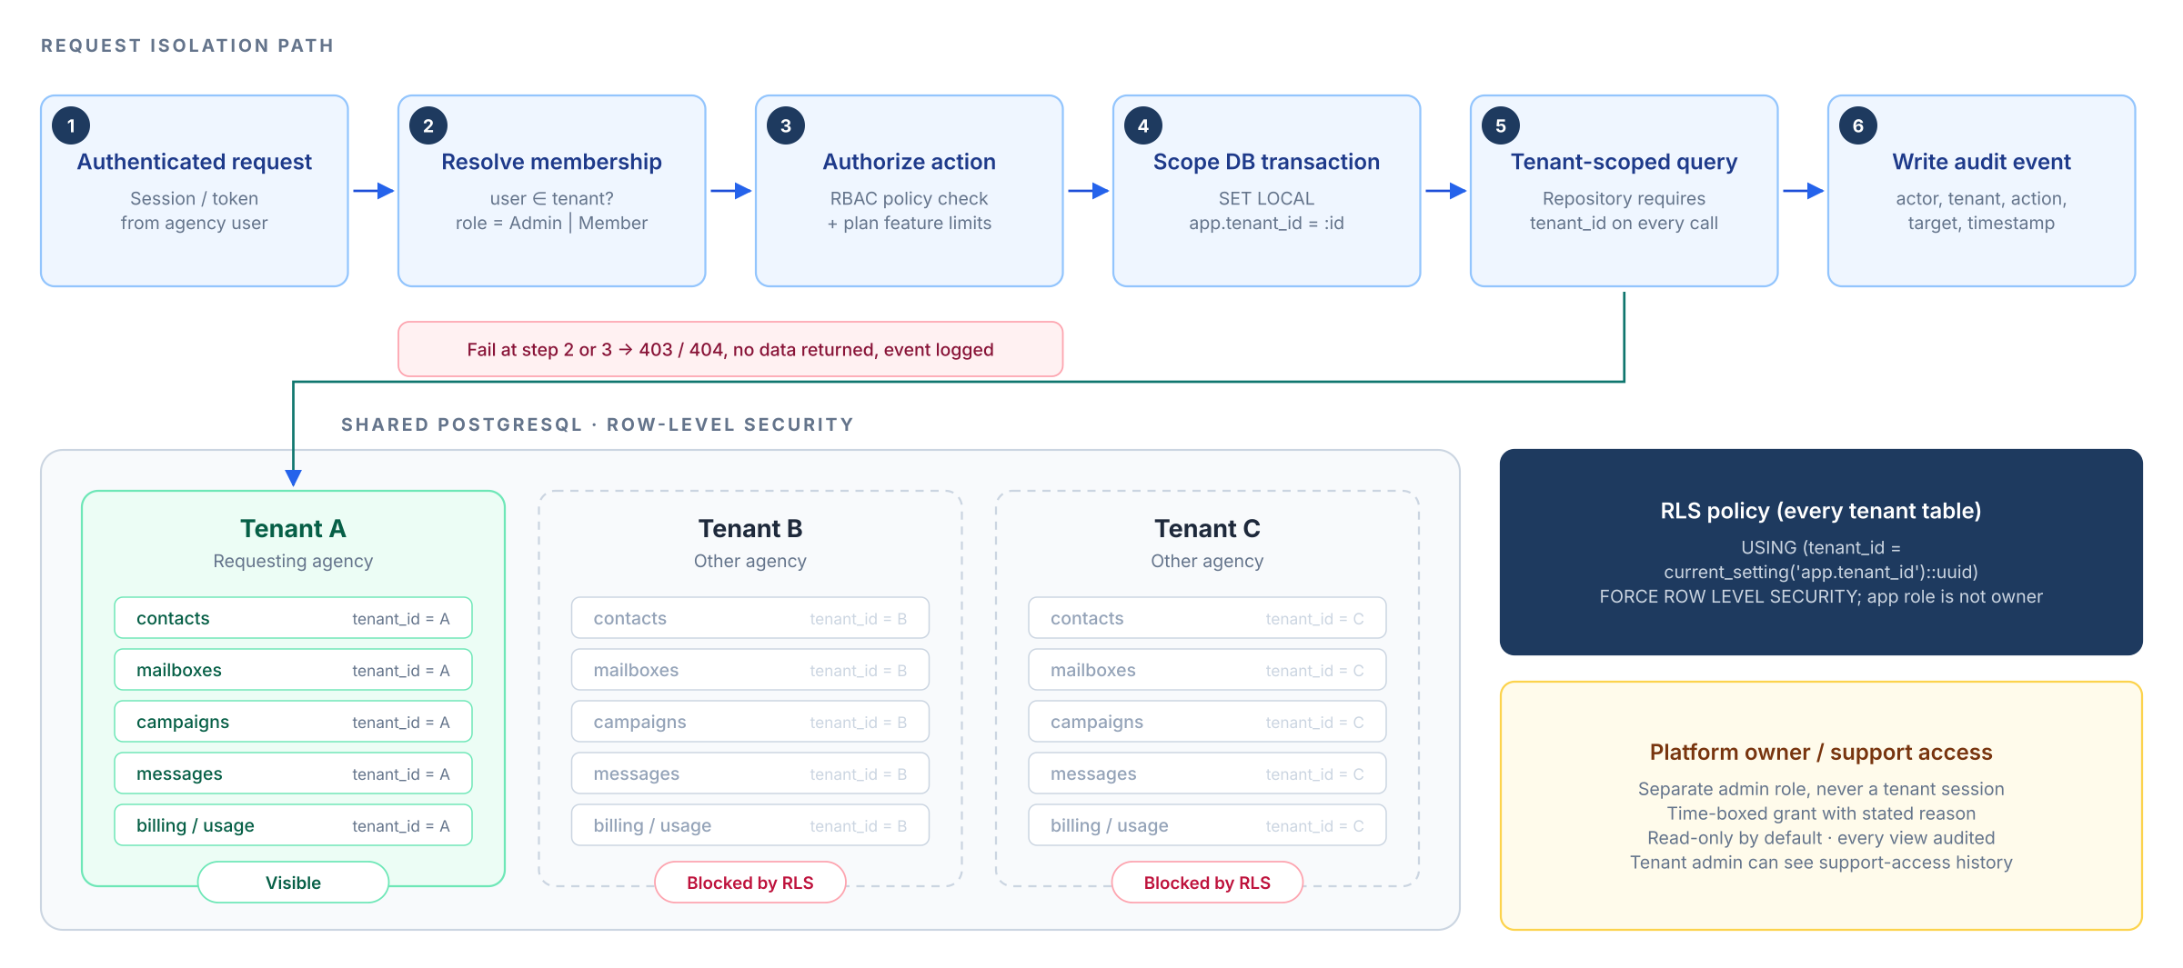
Figure 3. Tenant isolation: request path and database-enforced row-level security
- The application connects with a database role that is not the table owner, and RLS is forced on every tenant table, so policies cannot be bypassed.
- Each request opens a transaction and sets app.tenant_id; the setting is discarded when the transaction ends, so a pooled connection can never carry one tenant's context into another request.
- Background jobs carry tenant_id in their payload and open the same scoped transaction before touching data.
- Object storage keys are prefixed by tenant (tenants/{id}/imports/...) and accessed only through short-lived signed URLs.
- Automated cross-tenant tests in CI try to read, update and delete another tenant's records through every API endpoint and must fail (AC-01).

5.2 Authentication
Control | Design
Signup | Email + password or Google/Microsoft sign-in; email verification required before connecting a mailbox or sending.
Passwords | Handled by the auth provider; minimum length and breached-password checks; no passwords stored by Reyvo.
MFA | Available to all users; tenant admins can require it for their workspace; mandatory for platform owner and support staff.
Sessions | Secure, HTTP-only, SameSite cookies; idle timeout; revoke all sessions on password change or member removal.
Invitations | Admins invite members by email; invitations expire after 7 days and are single-use.
Brute-force protection | Rate limiting at the edge and by the auth provider; lockout notices to the account owner.

5.3 Roles and permissions
The brief requires admin and member roles for agencies, plus permissioned platform support access. The matrix below is the proposed default.
Capability | Agency Member | Agency Admin | Platform Support | Platform Owner
View and work leads, campaigns, replies | ✓ | ✓ | Read* | Read*
Import / export CSV | ✓ | ✓ | — | —
Create and launch campaigns | ✓ | ✓ | — | —
Approve AI-generated messages | If allowed | ✓ | — | —
Connect / disconnect mailboxes | — | ✓ | — | —
Manage members and roles | — | ✓ | — | —
Billing, plan and invoices | — | ✓ | — | ✓
Edit tenant suppression / DNC list | Add only | ✓ | — | —
Pause any campaign (kill switch) | ✓ | ✓ | ✓ | ✓
Create / suspend tenants, set limits | — | — | — | ✓
Global DNC list, platform sending halt | — | — | — | ✓
View audit log | — | Own tenant | Own actions | All

* Support and owner access to tenant data is never implicit. It requires an explicit, time-boxed grant (below).

5.4 Platform owner and support access
- Platform staff use a separate admin console and role; they never log in as a tenant user.
- Viewing a tenant's data requires a support-access grant: a stated reason, a fixed duration (default 2 hours) and read-only scope unless write access is approved by the platform owner.
- Every grant and every record viewed under a grant is written to the audit log, and the tenant admin can see this history.

6. Data Design

6.1 Entity-relationship model
Figure 4 shows the core relational model. Tables are grouped by domain colour. Every tenant-owned table carries tenant_id; those foreign-key lines are omitted so the business relationships stay readable.
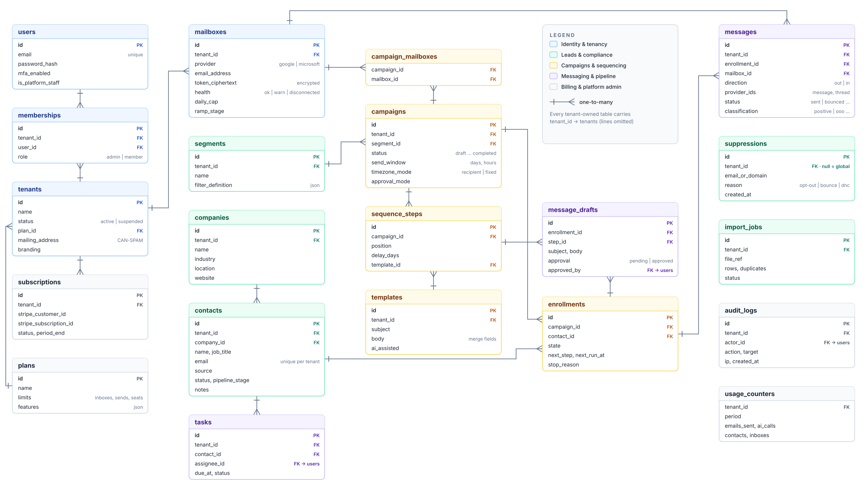
Figure 4. Entity-relationship diagram (core MVP schema)

6.2 Entity catalogue
Entity | Purpose | Key rules
tenants | One agency workspace. | Holds the CAN-SPAM physical mailing address; status active or suspended; plan reference.
users, memberships | People and their role in a tenant. | A user can belong to more than one tenant; role is per membership.
mailboxes | Connected Google / Microsoft inboxes. | OAuth tokens stored encrypted; health state; daily cap and ramp stage per mailbox.
companies, contacts | Lead records. | Email unique per tenant (normalised); contact stage drives the pipeline.
segments | Saved filters over contacts. | Evaluated when a campaign launches and re-checked at each send.
suppressions | Never-email list. | Tenant-scoped or global (null tenant); by full address or by domain; checked before every send.
import_jobs | CSV import runs. | Row counts, duplicates found, errors; original file kept 30 days.
campaigns, campaign_mailboxes | Outreach programs and the inboxes they send from. | Send window, time-zone mode and approval mode per campaign.
sequence_steps, templates | Ordered messages with delays. | Templates hold subject and body with merge fields.
enrollments | A contact inside a campaign. | Single state machine (Figure 5); stop reason recorded.
message_drafts | Per-contact rendered or AI-assisted copy. | Approval status and approver kept for audit.
messages | Every outbound and inbound email. | Provider message and thread IDs; status; reply classification.
tasks | Follow-up actions on contacts. | Assignee, due date, status.
plans, subscriptions, usage_counters | Commercial limits and billing state. | Stripe IDs; usage counted per tenant per period.
audit_logs | Who did what, when. | Append-only; retained at least 1 year.
knowledge_documents | Platform-wide source corpus (currently this design document). | Unique slug; SHA-256 checksum and parser version make ingestion idempotent; active/inactive status; chunk and embedding counts.
knowledge_chunks | Heading-scoped slices of a knowledge document. | Unique document/ordinal; heading path and anchor for citations; optional JSON embedding ranked in Python.
chat_conversations | A tenant- and user-scoped assistant conversation. | Tenant and user ownership; title, archived flag and last activity; deleted by the retention job or by the user.
chat_messages | One user or assistant turn. | Role user/assistant; content; server-resolved citations; model, token counts and latency.
Implementation note: the shipped schema names some entities differently from the catalogue above. Current tables are tenants, users, memberships, email_accounts, companies, contacts, contact_lists, contact_list_members, segments, suppressions, campaigns, campaign_steps, campaign_enrollments, messages, replies, opportunities, tasks, imports, audit_logs, plans, subscriptions, usage_counters and webhook_events. The assistant adds knowledge_documents, knowledge_chunks, chat_conversations and chat_messages. scripts/enable_rls.sql applies row-level security, including conversation-scoped access to chat_messages.

6.3 Lead record fields
The brief specifies the lead fields below. These are the canonical import columns; extra CSV columns can be stored as custom fields and used as merge fields.
Field | Type | Validation and handling | Required
Company | Text | Trimmed; creates or links a company record. | Yes
Industry | Text (picklist + free text) | Normalised to a picklist where possible for segmentation. | No
Location | City, state/region, country | Used for filters and to infer recipient time zone. | No
Website | URL | Normalised; domain extracted for duplicate and domain-suppression checks. | No
Contact name | First and last name | Split on import if given as one column. | Yes
Job title | Text | Free text; available as a merge field. | No
Business email | Email | Syntax and MX check; lower-cased; free-mail domains flagged for review. | Yes
Source | Text | Where the lead came from (e.g., file name, event). Required for compliance record keeping. | Yes
Status | Pipeline stage | Defaults to New on import. | Auto
Notes | Long text | Free text; never sent to the AI unless the user includes it. | No

6.4 Data retention and deletion
Data | Retention (proposed default) | Deletion behaviour
Contacts, campaigns, messages | While the tenant is active | Users can delete individual records; deleted contacts keep a hashed suppression entry if they opted out.
Uploaded CSV files | 30 days | Automatically purged from object storage.
Suppression and unsubscribe records | Life of the tenant + 3 years | Kept to prove opt-out compliance; hashed after tenant deletion.
Audit logs | At least 1 year | Append-only; exported on request.
Closed tenant | 30-day grace for export | Then all tenant data deleted; backups age out within 35 days.
OAuth tokens | Until mailbox is disconnected | Revoked at the provider and destroyed on disconnect.
Knowledge documents and chunks | Life of the deployment; replaced on reindex | Platform-wide corpus. Re-ingestion replaces chunks in place; a retired document is deactivated or deleted by an operator.
Chat conversations and messages | 90 days since last activity (CHAT_RETENTION_DAYS; 0 keeps indefinitely) | The daily cleanup job deletes inactive conversations and cascades to messages; users can delete a conversation immediately.

7. Functional Module Design
Each subsection restates the brief requirement, then specifies the design, the business rules and the main screens. §7.11 records the knowledge-base assistant, an implemented extension that is not part of the brief's MVP scope.

7.1 Accounts and tenant isolation (FR-01)
Brief requirement
Secure signup/login; one agency workspace per customer; admin/member roles; strict separation of contact lists, email accounts, campaigns, analytics, and billing.

- Signup creates a tenant, an admin membership and a trial or pending plan in one transaction.
- The onboarding checklist guides the admin through: company details and physical mailing address → connect a mailbox → verify domain authentication → import leads → first campaign.
- Isolation design is specified in §5. Analytics are computed per tenant; no cross-tenant aggregates are visible to tenants.

Main screens
Sign up / sign in · Onboarding checklist · Workspace settings (company, address, branding) · Members and roles.

7.2 Lead and company management (FR-02)
Brief requirement
CSV import/export; company, industry, location, website, contact name, job title, business email, source, status, and notes; duplicate detection; suppression lists; filters and segmentation. Start with user-provided/imported leads; third-party lead sourcing is a separate integration.

CSV import pipeline
- Upload a CSV (up to 50,000 rows / 20 MB per file, proposed) to private storage.
- Map columns to Reyvo fields; the mapping is auto-suggested from header names and can be saved as a template.
- Validate each row: required fields, email syntax, domain MX record, free-mail and role-address flags (e.g., info@).
- Detect duplicates within the file and against existing contacts (rules below).
- Check suppression: rows matching global or tenant suppression are imported as suppressed and cannot be enrolled.
- Preview a summary (new, updated, duplicates, invalid, suppressed) and let the user choose skip / update / keep both for duplicates.
- Commit in a background job; an error file of rejected rows is available for download.

Duplicate detection rules
Rule | Match | Default action
Exact email | Lower-cased, trimmed email (Gmail dots and +tags normalised for consumer domains) | Treat as same contact: update empty fields only
Same person, new email | Same first + last name and same company domain | Flag for review
Same company | Same website domain, or same normalised company name | Link to existing company

Segmentation and export
- Filters on any field, including stage, source, industry, location, tags, last-contacted date and campaign history.
- Saved filters become segments that campaigns target; the segment is re-evaluated at launch and suppression is re-checked at every send.
- CSV export of any filtered view; exports are logged in the audit log.

7.3 Email account connections (FR-03)
Brief requirement
Connect customer-owned Google Workspace or Microsoft 365 inboxes through supported OAuth/API methods, where feasible; show connection health; do not require sharing mailbox passwords.

Aspect | Google Workspace | Microsoft 365
Connection | OAuth 2.0 consent (offline access for refresh tokens) | OAuth 2.0 via Microsoft Entra ID (delegated permissions, offline_access)
Send | Gmail API users.messages.send | Microsoft Graph sendMail
Read replies and bounces | Gmail API history + push notifications (watch), polling fallback | Graph change notifications (subscriptions) + delta queries
Permissions requested | Send, and read limited to what is needed to detect replies and bounces | Mail.Send, Mail.Read, offline_access, User.Read
Approval to watch for | Reading mail uses a Google restricted scope, which requires Google's OAuth app verification and an independent security assessment before public launch. | Some customer tenants require an IT administrator to grant consent to the Reyvo app.

Schedule and cost risk
Google's verification and security assessment for restricted Gmail scopes can take several weeks and has a cost. Start it during Phase 1 so it does not delay commercial launch. Until it is complete, the app can be used only by a limited number of test users.

Connection health
State | Trigger | Effect
Connected | Token valid, recent sends succeeding, DNS checks passing | Sends normally within cap
Warning | Rising error rate, missing DMARC, or bounce rate approaching threshold | Banner to admin; sends continue at reduced pace
Paused | Cap reached, threshold exceeded, or admin paused | No sends from this mailbox; queue held
Disconnected | Token revoked or expired, password reset, consent withdrawn | All jobs for this mailbox paused; admin asked to reconnect

7.4 Campaign builder (FR-04)
Brief requirement
Select audience, draft/edit messages, use merge fields, create multi-step follow-ups, schedule sending windows by timezone, pause/resume, and automatically stop follow-ups on replies, opt-outs, or hard bounces.

Builder steps
- Audience — choose a segment or list; Reyvo shows how many contacts are eligible after suppression and duplicate-enrollment checks.
- Senders — choose one or more connected mailboxes; contacts are spread across them within each mailbox's cap.
- Sequence — add steps (e.g., Day 0 intro, Day 3 follow-up, Day 7 final), each with a delay, a template and optional AI assistance. Follow-ups send in the same thread by default.
- Messages — edit subject and body with merge fields and fallbacks (Appendix A). Preview any contact.
- Schedule — choose sending days and hours, and whether hours follow each recipient's time zone (inferred from location, falling back to the campaign default) or a fixed zone.
- Review and launch — a pre-flight check confirms the mailing address, unsubscribe link, domain authentication and approval status before the campaign can start.
Figure 5 defines the campaign and per-contact enrollment state machines, including the automatic stop rules required by the brief.
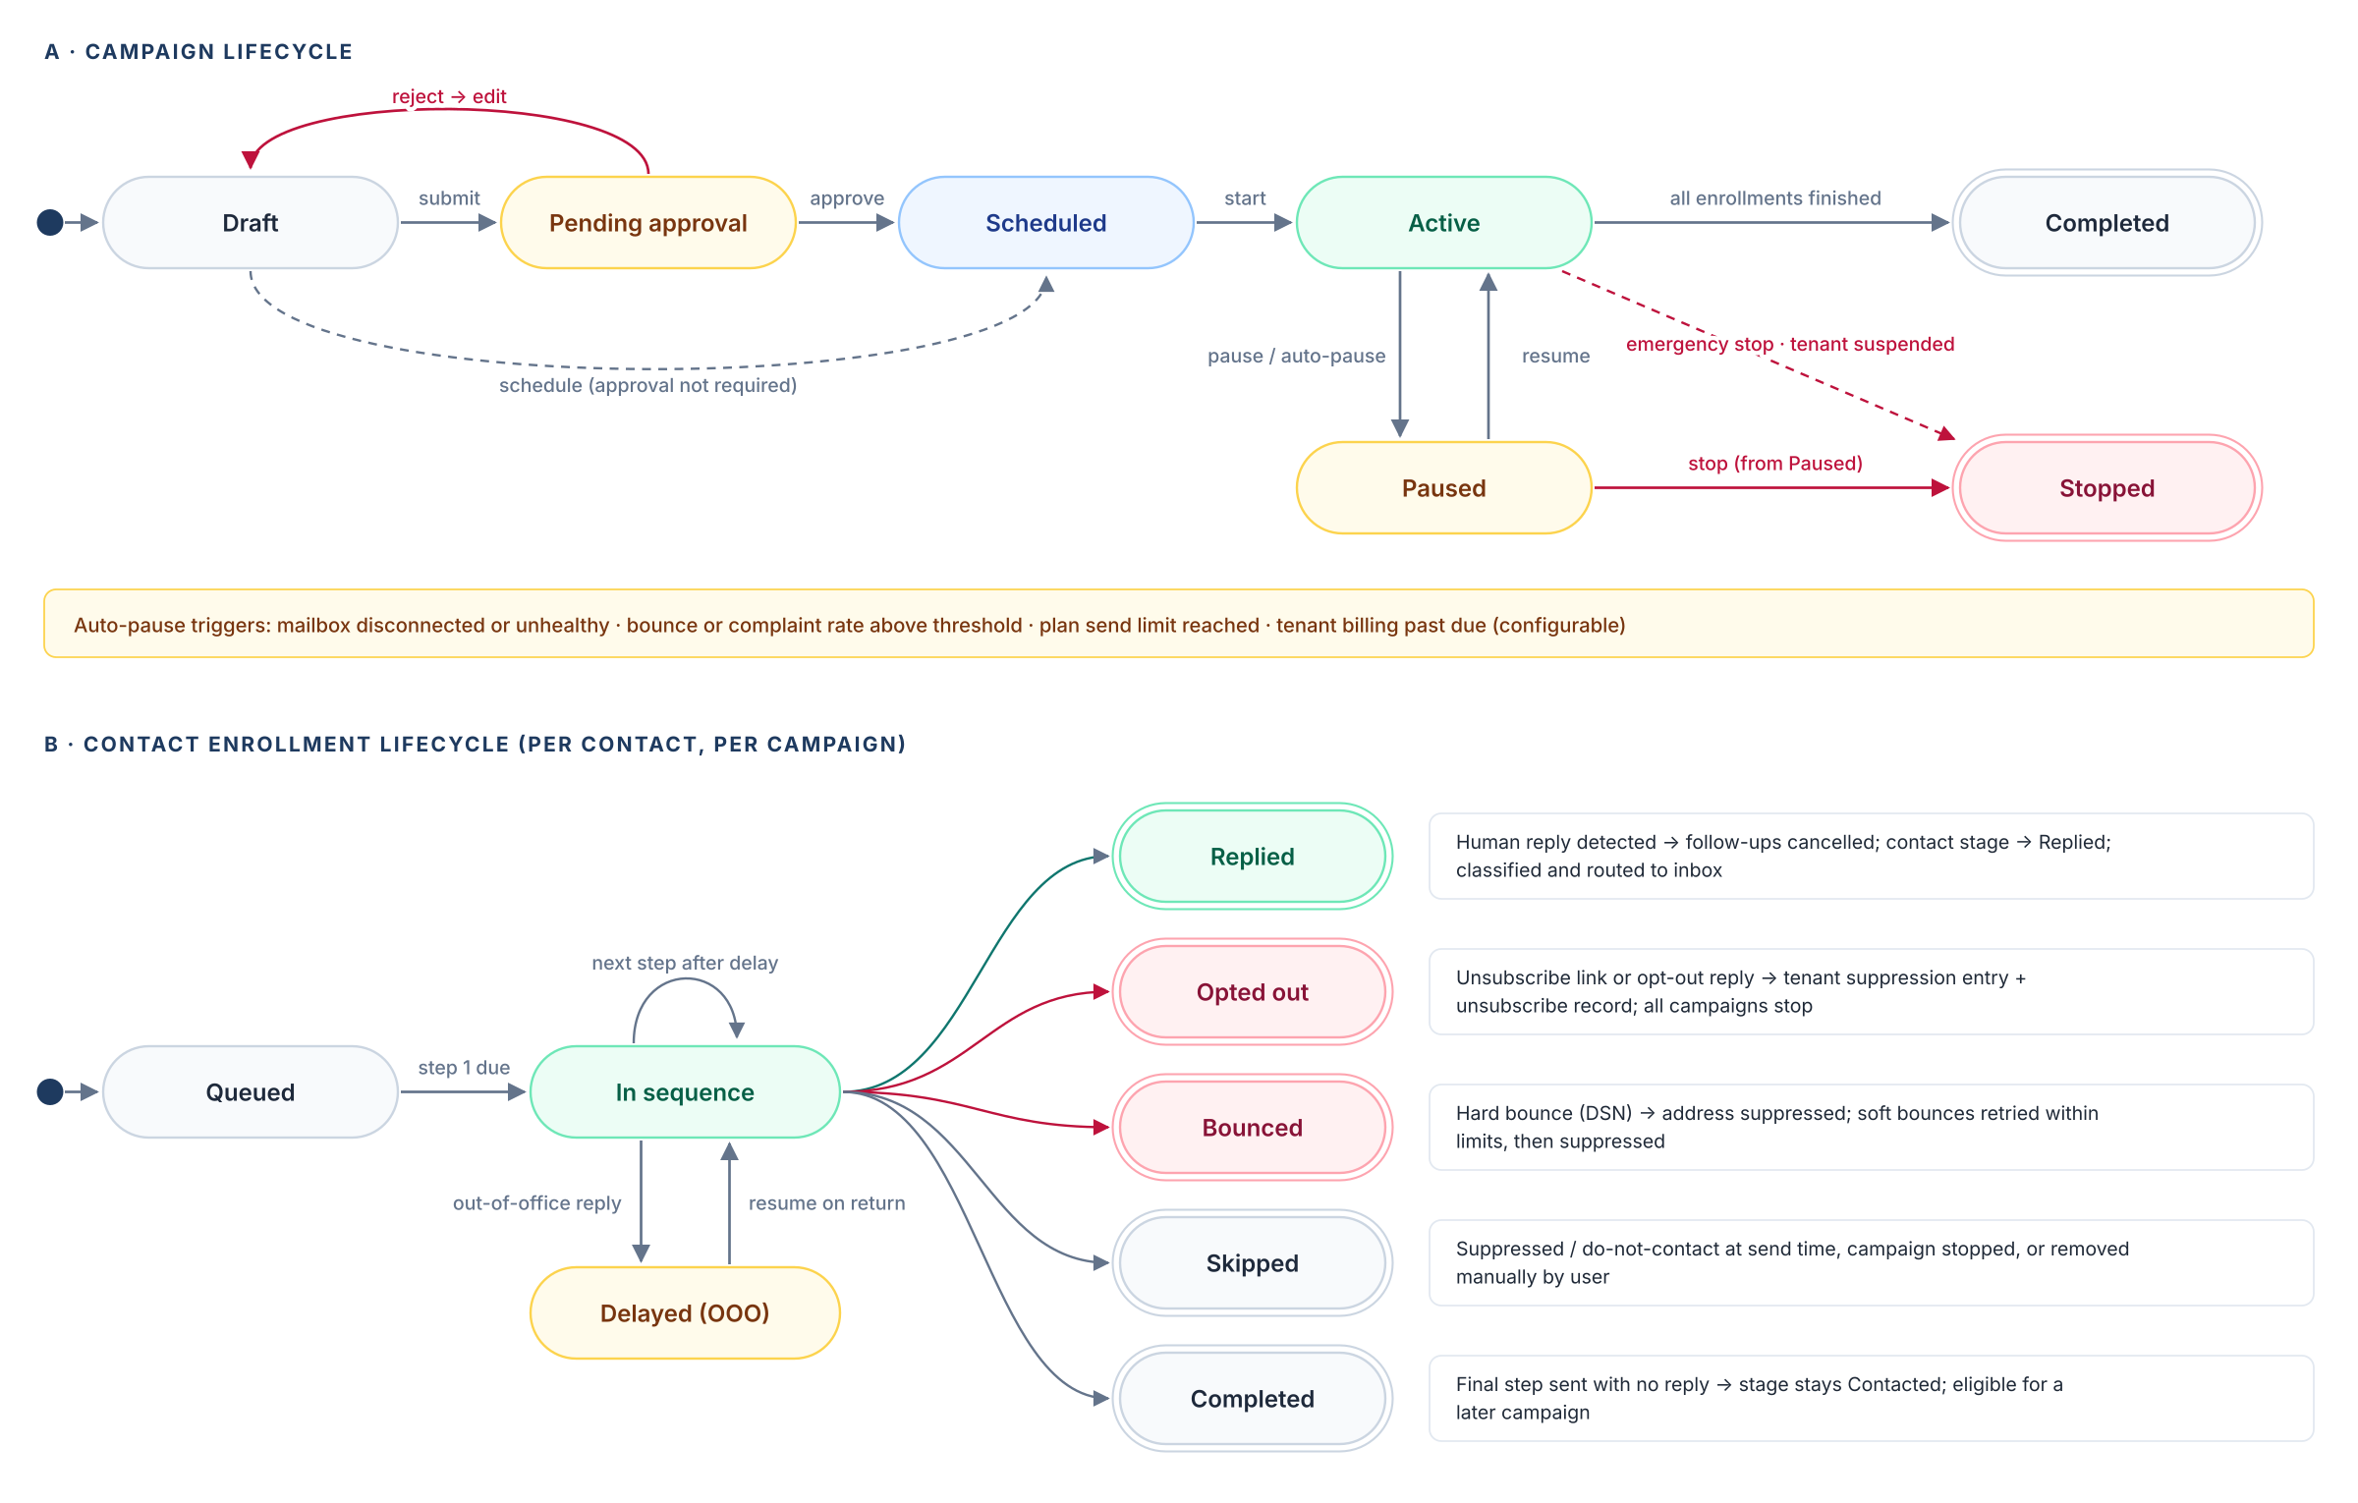
Figure 5. Campaign and enrollment state machines
- Pause takes effect within one scheduler cycle (target under 60 seconds); jobs already handed to a worker re-check campaign state immediately before calling the provider.
- Resume recalculates remaining step times so paused days do not cause a burst of sends.
- A contact can be active in only one campaign at a time per tenant (proposed default) to avoid double-mailing.

7.5 AI personalization with human control (FR-05)
Brief requirement
Generate suggested subject lines and brief email copy from company/industry/contact fields; editable templates; preview each variation; configurable approval before sending; prevent fabricated company facts.

How generation works
- The user picks a template or asks for a new draft and sets tone and length (brief by default: under 120 words).
- Reyvo sends the model only the selected fields (company, industry, location, contact name, job title, plus the agency's own offer description). Notes and other fields are excluded unless the user opts in.
- The model returns subject options and body copy that may contain merge fields, never hard-coded facts about the prospect.
- A fact guard checks the output: any company-specific claim (numbers, projects, awards, locations, names) that is not present in the supplied fields is highlighted and blocks approval until edited or removed.
- A spam-language check flags deceptive or misleading subjects (CAN-SPAM) and common spam triggers.
- The user previews each variation against real contacts, edits freely and approves.

Approval modes (configurable per workspace and per campaign)
Mode | What needs approval | Best for
Template approval (proposed default) | Each template and AI variation once; merge fields fill per contact | Most agencies — fast and controlled
Per-message approval | Every rendered message before it is queued | New users, sensitive accounts, first campaigns
Admin-only approval | Members draft; only admins approve | Teams with junior reps

All AI requests and responses are logged per tenant (prompt, model, tokens, approver) for audit and cost tracking. AI usage counts toward plan limits.

7.6 Sending engine and safety controls (FR-06)
Brief requirement
Configurable daily caps per connected inbox, gradual ramp-up, queueing, throttling, bounce handling, unsubscribe handling, and deliverability monitoring. 1,000 emails/day is a target across appropriately provisioned mailboxes, NOT a guaranteed safe capacity or a promise that one inbox can send 1,000/day.

Figure 6 shows how one scheduled step becomes a sent email. The Policy Guard runs immediately before every provider call, so a pause, suppression or cap change made a second earlier is always honoured.
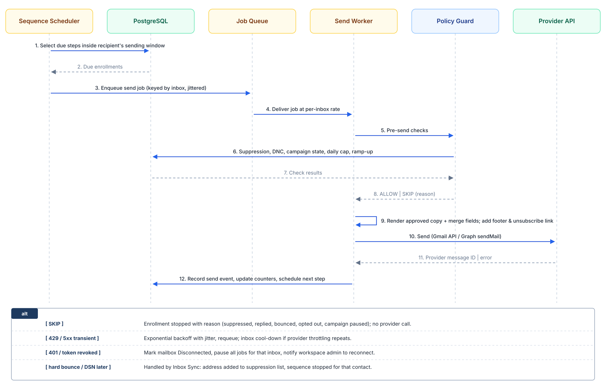
Figure 6. Scheduled send: sequence of checks and calls for one message
Control | Design
Daily cap | Per mailbox, counted over a rolling 24 hours, including follow-ups. Default and ceiling set by plan (§8.2).
Ramp-up | New mailboxes start low and increase weekly while bounce and error rates stay healthy; any breach drops back one stage.
Queueing | One logical queue per mailbox; jobs scheduled inside the send window only.
Throttling | Sends are spread evenly across the window with random jitter; minimum 90 seconds between sends from the same mailbox.
Bounce handling | Hard bounces suppressed immediately; soft bounces retried up to 2 times over 48 hours, then suppressed.
Unsubscribe handling | Every message carries an unsubscribe link and List-Unsubscribe headers; opt-outs are suppressed immediately.
Deliverability monitoring | Bounce rate, provider errors and DNS authentication tracked per mailbox, domain and campaign; automatic pause on thresholds (§8.5).

7.7 Unified replies and pipeline (FR-07)
Brief requirement
Detect and categorize replies (positive, negative, out-of-office); view conversations; flag interested leads; assign follow-up tasks; simple stages: New, Contacted, Replied, Meeting, Won, Not Interested.

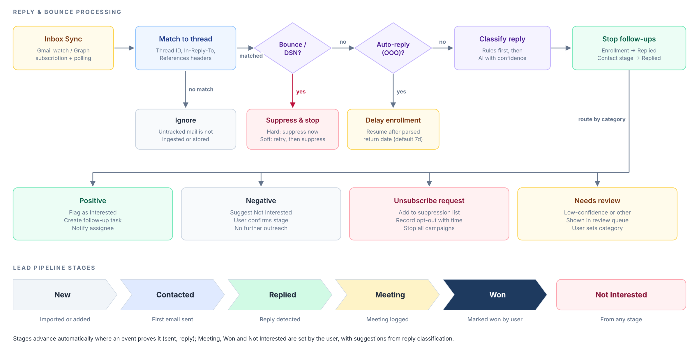
Figure 7. Reply and bounce processing, and lead pipeline stages
- Only replies in threads Reyvo started are ingested; the rest of the mailbox is never stored.
- Classification uses rules first (unsubscribe phrases, DSN and auto-reply headers), then an AI classifier. Low-confidence results go to a review queue rather than being guessed.
- The unified inbox shows all replies across the tenant's mailboxes, filterable by category, campaign, mailbox and assignee. Users reply from Reyvo and the message is sent from the original mailbox in the same thread.
- Pipeline view: a board and a list of contacts by stage; drag to change stage; meetings can be logged with date and notes.

7.8 Reporting dashboard (FR-08)
Brief requirement
Daily/weekly emails queued, sent, delivered where measurable, bounced, replied, positive replies, opt-outs, meetings logged, and campaign performance. Avoid treating opens as reliable due to privacy protections.

Metric | Definition | Source
Queued | Messages scheduled for the period and not yet sent | Job queue + enrollments
Sent | Messages accepted by the provider API | Provider response
Delivered (where measurable) | Sent minus bounced; labelled as an estimate because providers do not confirm inbox delivery | Derived
Bounced | Hard and soft bounces, shown separately | DSN parsing
Replied | Unique contacts with a human reply (excludes OOO and DSN) | Reply classification
Positive replies | Replies classified or confirmed as positive | Reply classification + user
Opt-outs | Unsubscribe clicks plus opt-out replies | Unsubscribe endpoint + classification
Meetings logged | Contacts moved to Meeting in the period | Pipeline events
Rates | Reply, positive and bounce rate per campaign, step, mailbox and domain | Derived

Open tracking is off by default and, if enabled later, is shown only as a secondary, clearly labelled indicator. Daily and weekly views are computed from event tables and cached; the dashboard reads summary tables, not raw events.

7.9 Platform owner admin (FR-09)
Brief requirement
Create/suspend customer tenants; view usage and system health; configure subscription limits and feature access; basic audit log and support access with permissions.

Console area | Capabilities
Tenants | Search, create, suspend and reactivate tenants; suspension pauses all sending and blocks logins except billing.
Usage | Per-tenant sends, AI calls, contacts, mailboxes and seats against plan limits; trends.
Account health | Per-tenant bounce rate, disconnected mailboxes, auto-pauses, failed payments.
System health | Queue depth and age, worker error rates, provider API errors, database and Redis health.
Plans and features | Define plans, limits and feature flags; override limits per tenant with a reason.
Compliance | Global DNC list; platform-wide sending halt.
Audit and support | Searchable audit log; request and use time-boxed support-access grants.

7.10 Subscription billing (FR-10)
Brief requirement
Integrate a payment provider (e.g., Stripe) for recurring monthly plans, invoices, failed-payment handling, cancellation, and per-tenant usage tracking.

Event | Reyvo behaviour
Checkout completed | Activate the plan; apply its limits and features.
Invoice paid | Record payment; clear any past-due flags.
Payment failed | Notify admin; Stripe retries; after 7 days past due, new campaign launches are blocked; after 14 days, sending pauses; after 30 days, tenant is suspended (proposed timeline).
Subscription updated | Apply new limits at once (upgrade) or at period end (downgrade).
Subscription cancelled | Sending stops at period end; read-only access and export for 30 days.

Invoices, payment methods and cancellation are handled through the Stripe Customer Portal. All Stripe webhooks are verified by signature and processed idempotently. Usage counters are maintained in Reyvo for limit enforcement whether or not metered pricing is used.

7.11 Knowledge-base assistant (FR-11, implemented extension)
Reyvo also ships an assistant that answers questions about the platform itself — architecture, tenancy, campaigns, deliverability, compliance and the commercial model — from this design document. It is an approved extension: it is documented because it is already implemented, but it is not a customer-facing requirement of the brief and it does not replace any MVP module. The implementation lives in reyvo.services.knowledge_service, reyvo.api.v1.ai, reyvo.integrations.knowledge and reyvo.integrations.ai.

Design approach
The document is not inserted into the prompt. It is ingested once into the database and retrieved per question. Ingestion parses the .docx with heading-aware chunking (~1,200 characters with 200-character overlap), keeps a heading breadcrumb and stable anchor, renders table text, and stores one knowledge_documents row plus ordered knowledge_chunks rows. The document slug is reyvo-design-document; the SHA-256 checksum and parser version make ingestion idempotent, and --force re-chunks after an edit. Embeddings are stored as portable JSON and are optional.

Retrieval and citation
Search combines BM25 lexical ranking (k1 = 1.5, b = 0.75) with cosine similarity over stored embeddings, fused by Reciprocal Rank Fusion (k = 60). The API accepts top_k between 1 and 12 (default KNOWLEDGE_TOP_K = 6), caps the assembled context at 12,000 characters and ignores vector matches below 0.25. If no embedding key is configured the lexical path still works. The model receives numbered sources and must cite [n]; citations are rebuilt server-side from the retrieved chunks, never trusted from the model, and filtered to the markers the answer actually uses.

Conversation context and answer boundaries
Conversations are persisted per tenant and user in chat_conversations and chat_messages, with token usage, latency and the citations used. A follow-up resolves against the most recent standalone user question; chained follow-ups skip earlier follow-ups so “tell me more” → “why?” stays on topic. A topic shift is searched as a new question, and a follow-up sent as the first message is refused. History is used only to resolve references, never as evidence. If retrieval returns nothing, the API refuses without calling the model. After generation the answer is validated: a model refusal, an invented citation number or an uncited answer gets one repair attempt and is then replaced with the canonical refusal; refused responses carry no citations and used_context = false. Prompt wording and version (knowledge-chat-v2) live in reyvo.integrations.ai.prompts.

Access, rate limiting and operations
Chat and search are gated by KNOWLEDGE_CHAT_ACCESS. The default platform_admin keeps commercial assumptions, estimates and security design internal; members opens the assistant to every authenticated tenant member once the corpus is curated. Reindex is platform-admin only. Each user is limited to AI_CHAT_RATE_LIMIT_PER_MINUTE calls (default 20) across chat and search; the limiter is an atomic sliding window shared through Redis, with an in-process fallback when Redis is unavailable. Background work runs on Arq: cleanup_chat_history runs daily at 03:00 and deletes conversations inactive for CHAT_RETENTION_DAYS (default 90; 0 keeps them), and reindex_design_document runs at 00:05, 06:05, 12:05 and 18:05. POST /api/v1/ai/knowledge/reindex with background = true enqueues a reindex when Redis is configured and otherwise runs it inline.

Endpoints
POST /api/v1/ai/chat; GET /api/v1/ai/conversations; GET and DELETE /api/v1/ai/conversations/{id}; POST /api/v1/ai/knowledge/search; GET /api/v1/ai/knowledge/status; POST /api/v1/ai/knowledge/reindex.

Limitations
Images and figures are not extracted, so questions about diagrams are answered from captions and surrounding prose. Embeddings are ranked in Python for portability with the SQLite test suite; a large corpus should move to pgvector with an HNSW index behind the same service boundary. The corpus is platform-wide and deliberately not tenant-scoped; only conversations and messages are tenant-scoped.

8. Deliverability and Sending Capacity
No guarantees
Reyvo provides guidance, monitoring and safe limits. It does not guarantee inbox placement or that messages will avoid spam filtering (CR-02). This wording should also appear in customer-facing terms and onboarding.

8.1 Domain authentication guidance
Record | What Reyvo does
SPF | Looks up the sending domain's SPF record and confirms it authorises Google or Microsoft; shows the exact record to add if missing.
DKIM | Checks that DKIM signing is enabled for the domain in Google Admin or Microsoft 365 and links to the provider's instructions.
DMARC | Checks for a DMARC record; recommends starting at p=none with reporting, then moving to quarantine; warns when absent.
Sending domains | Recommends using a secondary domain (e.g., getagency.com) for cold outreach so the agency's main domain reputation is protected.

DNS checks run when a mailbox is connected and daily afterwards. Mailboxes with failing authentication cannot exceed the first ramp-up stage.

8.2 Default limits and ramp-up (proposed)
Mailbox age / stage | Daily cap per mailbox | Condition to advance
Week 1 | 10 | Bounce rate below 2% and no provider errors
Week 2 | 20 | Same
Week 3 | 30 | Same
Week 4 onward | 40 (default target) | Stays here unless an admin raises it
Plan ceiling | 50 | Raised only by the platform owner, per tenant, with a recorded reason

8.3 Provider sending limits
Providers publish account-level limits that apply to all mail from a mailbox. They are ceilings, not safe cold-outreach volumes, and they can change without notice. Reyvo's caps sit far below them.
Provider | Published limit (checked November 2026) | Notes
Google Workspace | 2,000 messages per user per day (500 for trial accounts), over a rolling 24 hours | Exceeding limits can suspend sending for up to 24 hours or the account itself.
Microsoft 365 (Exchange Online) | 10,000 recipients per day and 30 messages per minute per mailbox | Microsoft states Exchange Online is not intended for bulk mail; an additional external-recipient limit is being introduced and must be checked before launch.

8.4 Capacity planning for 1,000 emails per day
The brief's 1,000 emails/day target is met by spreading volume across enough mailboxes and domains, never by pushing one inbox. Follow-ups count toward the total.
Planning case | Per-mailbox volume | Mailboxes needed | Domains needed (3 mailboxes each)
Conservative (recommended) | 40 / day | 25 | 9
At plan ceiling | 50 / day | 20 | 7
During ramp-up (week 2) | 20 / day | 50 | 17

Mailbox license’s and domains are customer-owned costs under this design. For a single agency, 1,000/day is a mature-state figure reached after roughly four weeks of ramp-up, not a day-one capacity.

8.5 Monitoring and automatic pause thresholds (proposed)
Signal | Warn | Auto-pause | Scope
Hard bounce rate (last 100 sends) | 2% | 3% | Mailbox and campaign
Provider send errors (last hour) | 5% | 15% | Mailbox
Opt-out rate (last 200 sends) | 1% | 2% | Campaign
Spam complaint rate (domain owners using Google Postmaster Tools) | 0.1% | 0.3% | Domain
DNS authentication failing | Any | — | Domain (caps held at stage 1)

The complaint-rate figures follow Google's published sender guidelines, which ask senders to keep spam rates below 0.1% and never reach 0.3%.

9. Compliance and Security Design

9.1 CAN-SPAM controls (CR-01)
Requirement | Implementation in Reyvo
Accurate sender identity | From name and address are the connected mailbox's real identity; the From address cannot be overridden; reply-to must be a mailbox the tenant owns.
Nondeceptive subjects | AI guardrails and a subject-line check block misleading patterns (fake "Re:" or "Fwd:", false urgency) before approval.
Physical mailing address | Required tenant field, captured at onboarding; automatically inserted in every message footer; campaigns cannot launch without it.
Functional unsubscribe mechanism | Every message has a unique unsubscribe link and List-Unsubscribe / one-click headers. The link works without login and stays valid for at least 30 days after sending (CAN-SPAM minimum); Reyvo keeps it valid indefinitely.
Prompt opt-out processing | Opt-outs are suppressed immediately (CAN-SPAM allows up to 10 business days). Opt-out replies are detected by classification and suppressed the same way.
Record keeping | Each opt-out is stored with time, source (link or reply) and message ID.

Legal review required
CAN-SPAM is the baseline. Recipients outside the United States may be covered by stricter laws (for example Canada's CASL or the EU/UK GDPR and ePrivacy rules), and U.S. state privacy laws may apply. Per the brief, the developer should obtain legal review before supporting other jurisdictions. Until then, the proposed default is to warn when a contact's location is outside the United States.

9.2 Provider policies and anti-abuse (CR-03)
- Only official, documented provider APIs are used; no browser automation, IMAP/SMTP password access or attempts to evade rate limits.
- Caps are always set below provider limits; provider throttling responses are obeyed with backoff, never retried aggressively.
- No scraping of websites, LinkedIn or other sources in the MVP. Third-party lead data will be added only through licensed integrations (Phase 3).
- Imports require a Source for each lead, and the import screen asks users to confirm they have a lawful basis to contact these businesses. Reyvo does not assume purchased lists are permitted.
- Platform terms prohibit abusive use; the platform owner can suspend a tenant immediately.

9.3 Security controls (CR-04)
Control area | Design
Encryption in transit | TLS 1.2+ everywhere: browser to edge, service to service, and to the database, Redis and providers.
Encryption at rest | Database, backups, Redis and object storage encrypted with AWS KMS keys.
Credentials and tokens | OAuth refresh tokens are envelope-encrypted (a per-record data key protected by a KMS key) before being stored; decrypted only inside send and sync workers; never logged or shown in the UI.
Secrets | API keys and database credentials held in AWS Secrets Manager and rotated; none in code or environment files in the repository.
Least privilege | Separate IAM roles per service; database role without table ownership; production access limited to named engineers with MFA and audited sessions.
Tenant isolation | RLS plus scoped transactions (§5); automated cross-tenant tests in CI.
Backups | Daily automated snapshots kept 30 days plus point-in-time recovery; quarterly restore drill into a separate environment.
Logging | Structured, tenant-tagged application logs (90 days); audit log (at least 1 year); personal data and email bodies excluded from application logs.
Application security | Dependency scanning, static analysis and secret scanning in CI; OWASP Top 10 review; external penetration test before commercial launch.
Retention and deletion | As in §6.4, with tenant-initiated export and deletion.
Knowledge assistant | Chat and search are gated by KNOWLEDGE_CHAT_ACCESS (default platform_admin); reindex is platform-admin only. Per-user sliding-window limit (default 20/min) shared through Redis with an in-process fallback. Retrieved context is capped at 12 chunks / 12,000 characters and citations are resolved server-side.

9.4 Pause controls and do-not-contact lists (CR-05)
Control | Who | Effect | Target time
Pause campaign | Any tenant user | Stops all further sends for that campaign | Under 60 seconds
Pause mailbox | Tenant admin | Stops all sends from that mailbox across campaigns | Under 60 seconds
Pause workspace | Tenant admin | Stops all sending for the tenant | Under 60 seconds
Suspend tenant | Platform owner | Stops sending and blocks access except billing | Under 60 seconds
Platform sending halt | Platform owner | Global kill switch checked by every send worker | Under 60 seconds

- Global DNC (platform owner) and tenant DNC lists accept full addresses and whole domains, and are checked at import, at enrollment and immediately before every send.
- Unsubscribe and audit records are append-only and retained as in §6.4.

10. Non-Functional Requirements
The brief does not set numeric targets. The values below are proposed for agreement before build.
Attribute | Target (proposed) | How it is met
Availability | 99.5% monthly for the web app and API | Multi-AZ database, at least 2 instances per service, health checks
Sending resilience | No lost or duplicated sends during outages | Durable queue, idempotency key per send job, retry with backoff
Recovery | RPO 5 minutes; RTO 4 hours | Point-in-time recovery; documented, rehearsed restore runbook
Performance | 95% of page loads under 2 s; CSV import of 10,000 rows under 2 minutes | Summary tables, pagination, background import jobs
Scalability | 100 tenants and 100,000 sends/day without redesign | Horizontal scaling of workers; per-mailbox queues
Usability | A nontechnical owner can launch a first campaign in under 30 minutes | Onboarding checklist, guided fixes, plain-language errors
Accessibility | WCAG 2.1 AA for core flows | Accessible component library; automated checks in CI
Browser support | Latest two versions of Chrome, Edge, Safari and Firefox; responsive down to tablet width | Cross-browser tests
AI cost and abuse control | 20 chat/search requests per user per minute (configurable); no answer without retrieved evidence | Redis-backed atomic sliding-window limiter; retrieval caps; the model call is skipped when retrieval is empty; at most one repair attempt.

11. Third-Party Services and Account Ownership
The brief asks who owns each account. The proposal is that the Reyvo business owns all platform accounts from day one, with the developer added as a user, so ownership never needs to be transferred. Customers own their own mailboxes and domains.
Service | Purpose | Account owner | Cost basis
AWS | Hosting, database, cache, storage, encryption, secrets, logs | Reyvo business | Usage-based monthly
Redis (ElastiCache in production) | Shared rate limiting and Arq job queue | Reyvo business | Usage-based monthly
Google Cloud project (OAuth app) | Gmail API access and app verification | Reyvo business | Free API; security assessment fee
Microsoft Entra app registration | Microsoft Graph access | Reyvo business | Free
Stripe | Subscriptions, invoices, payments | Reyvo business | Per-transaction fees
AI model provider | Drafting, reply classification, grounded knowledge-base chat and embeddings | Reyvo business | Per-token usage
WorkOS (enterprise SSO) | SSO sign-in alongside the built-in email/password authentication | Reyvo business | Per-connection or per-user pricing
Transactional email (e.g., Amazon SES) | Password resets, alerts, invitations — not outreach | Reyvo business | Per-message, very low
Error tracking (Sentry) | Exceptions and releases | Reyvo business | Free tier, then per event volume
GitHub | Source code, CI/CD | Reyvo business | Per-seat
Domain registrar / DNS (reyvo app domain) | Product domain | Reyvo business | Annual
Customer mailboxes and sending domains | Outreach | Each customer agency | Customer's Google / Microsoft licences

Exact prices are to be itemised in the developer's quote (brief §9), at 1, 10, 50 and 100 customers.

12. Delivery Plan

12.1 Phased delivery
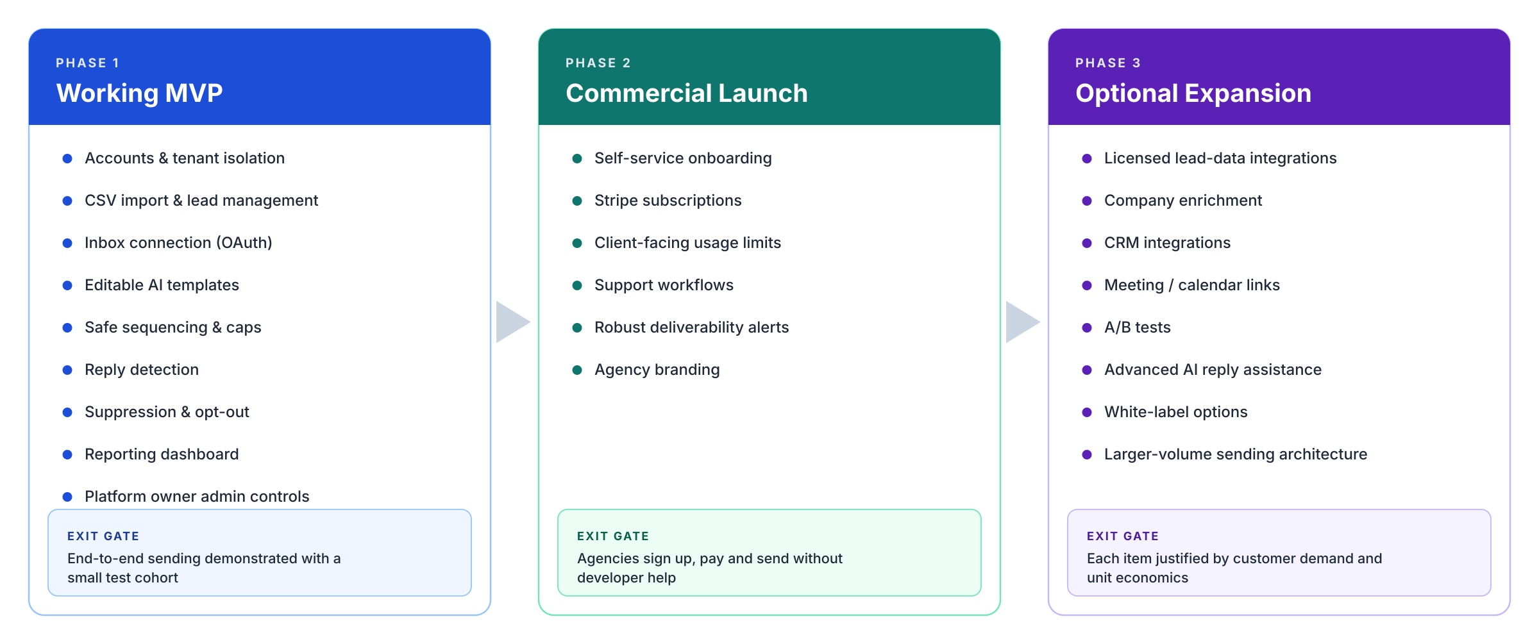
Figure 8. Phased delivery plan with exit gates
Phase | Brief scope | Exit gate
Phase 1 — working MVP | Accounts, CSV import, inbox connection, editable AI templates, safe sequencing, replies, suppression, dashboard, admin controls. | Demonstrate end-to-end sending with a small test cohort; acceptance criteria AC-01 to AC-07 pass.
Phase 2 — commercial launch | Self-service onboarding, Stripe subscriptions, client-facing usage limits, support workflows, robust deliverability alerts, and agency branding. | Agencies can sign up, pay and send without developer help; Google verification and penetration test complete.
Phase 3 — optional expansion | Licensed lead-data integrations, company enrichment, CRM integrations, meeting/calendar links, A/B tests, advanced AI reply assistance, white-label options, and larger-volume sending architectures. | Each item justified by customer demand and unit economics.

12.2 Phase 1 milestones (proposed sequence)
Milestone | Deliverables | Demo
M1 Foundations | Infrastructure as code, CI/CD, auth, tenants, roles, RLS, audit log | Two agencies sign up; neither can see the other's data
M2 Leads | CSV import, duplicates, suppression, segments, export | Import 100 sample contacts, find duplicates, build a segment
M3 Mailboxes | Google and Microsoft OAuth, health states, DNS checks | Connect one inbox of each type; see health and DNS status
M4 Campaigns and AI | Builder, merge fields, sequence steps, AI drafts, fact guard, approvals | Preview personalised drafts and approve a campaign
M5 Sending engine | Scheduler, workers, caps, ramp-up, policy guard, bounce and unsubscribe handling | Scheduled sequence runs within cap; pause/resume works
M6 Replies, dashboard, admin | Inbox sync, classification, pipeline, reports, owner console | Reply stops follow-ups and appears in dashboard; owner sees usage
M7 Hardening | Security tests, backup/restore drill, load test, documentation | Formal acceptance against §13

12.3 Testing strategy
Test type | Coverage
Unit | Business rules: duplicate matching, cap and ramp calculations, state transitions, merge-field rendering.
Integration | API endpoints against a real PostgreSQL with RLS on; provider APIs against sandbox or test mailboxes.
Tenant isolation | Automated suite that attempts cross-tenant access through every endpoint and job type.
End-to-end | Browser tests of the reference use case from signup to a logged meeting.
Sending pipeline load | Simulated 10× expected volume with a fake provider to verify caps, throttling and no duplicate sends.
Security | Dependency and static scans in CI; OWASP checks; external penetration test before Phase 2 launch.
Recovery | Backup restore into a clean environment with data verification.
Deliverability (test cohort) | Small allow-listed cohort of real mailboxes to confirm placement, threading, unsubscribe and reply detection.
Knowledge assistant | Idempotent ingestion, heading-aware chunking, BM25/RRF retrieval, tenant isolation of conversations, chained follow-up resolution, off-topic and first-message refusal, citation filtering and one-attempt repair. Covered by the API and service test suites.

13. Acceptance Criteria and Verification
ID | Brief acceptance criterion | Verification method
AC-01 | A new agency can register and cannot access another agency's data. | Register two tenants; run the cross-tenant test suite; manual attempt via API with swapped IDs returns 404.
AC-02 | A user can import 100 sample contacts, identify duplicates, segment a list, and preview personalized drafts. | Import supplied 100-row CSV with planted duplicates; confirm counts; build segment; preview AI drafts for 5 contacts.
AC-03 | A connected inbox can run a scheduled sequence within a configured sending cap; pause/resume and stop-on-reply work. | Set cap to 10; schedule 3-step sequence to 30 test contacts; verify no more than 10 per 24 h; pause and resume; reply from one contact and confirm follow-ups stop.
AC-04 | Opt-outs and bounces are suppressed from all future sends as applicable. | Click unsubscribe; send to an invalid address; confirm both suppressed and skipped in a new campaign.
AC-05 | Replies appear in the dashboard and positive leads can be moved into a pipeline. | Send positive, negative and OOO replies; confirm classification, dashboard counts and stage moves.
AC-06 | Owner admin can view tenants, usage, account health, and subscription state. | Walk through the owner console with seeded tenants in different states.
AC-07 | Developer demonstrates error handling, backup/restore, and basic security tests. | Simulate provider outage and token revocation; restore a backup into staging; present scan and test reports.
AC-08 | An authorised user can ask a question about Reyvo and receive an answer whose citations point to real sections; an unsupported or off-topic question is refused rather than answered from general knowledge. | Ingest the DDD; ask architecture, campaign and pricing questions and confirm citations resolve to headings and anchors. Ask an off-topic question and a first-message follow-up; confirm refusal, no citations and used_context=false. Run the knowledge test suite.

14. Commercial Assumptions
Brief · §7 — not confirmed costs
These are initial business planning assumptions. They must be validated through a detailed cost model; email infrastructure, AI usage, enrichment and staffing may materially change them.

Item | Assumption per customer per month
Customer subscription | approximately $500
Variable operating cost | approximately $200
Gross contribution | approximately $300, before support, payment processing, sales, taxes, development amortization, and overhead

14.1 Cost drivers to model
Driver | Effect of this design
Mailboxes and domains | Customer-owned, so they sit outside Reyvo's variable cost; this materially improves the $200 assumption but must be clear in pricing.
AI usage | Short drafts and template-level approval keep token use low; per-message generation and reply classification are the main variables.
Infrastructure | Largely fixed at low tenant counts (database, Redis, containers); falls sharply per tenant as customers are added.
Third-party tools | Auth, error tracking and monitoring move from free tiers to paid tiers as users grow.
Compliance | Google security assessment and penetration testing are periodic fixed costs.
Support | Onboarding help with DNS and mailbox setup is the most likely support cost.

15. Developer Estimate and Deliverables
The brief requests the following from the developer. This DDD supplies the technical basis for each; the commercial figures belong in the quote.
Requested in brief (§9) | Basis in this document
Fixed-scope MVP quote, expected development hours, calendar timeline, and phased milestones. | Scope §3; milestones M1–M7 in §12.2.
Itemize one-time development cost and monthly costs per tenant at 1, 10, 50, and 100 customers. | Services and cost basis §11; cost drivers §14.1.
Specify assumptions for 1,000 daily emails, number of mailboxes/domains needed, and realistic provider-specific limits. | §8.2–§8.4.
List third-party services, licensing costs, API fees, and who owns each account. | §11.
Deliver source code/repository access, deployment instructions, technical documentation, admin credentials transfer, testing plan, and 30-day post-launch bug-fix support. | Repository and accounts owned by Reyvo from day one (§11); testing plan §12.3; this DDD forms the technical documentation baseline.
Identify any scope exclusions and change-request rates before development begins. | Exclusions §1.2; open decisions §16.

16. Open Decisions, Assumptions and Risks

16.1 Decisions to confirm before build
Decision (brief §10) | Recommendation | Impact if changed
Brand name Reyvo is provisional. | Proceed with Reyvo as the working name; keep name, logo and domain in configuration. | Low — rename is a configuration and DNS change.
Does the initial release need built-in prospect discovery, or only lead import? | Lead import only for the MVP, as the brief suggests; discovery via a licensed provider in Phase 3. | High — discovery adds licensing cost, compliance review and weeks of work.
Which mailbox providers to support first? | Both Google Workspace and Microsoft 365 in Phase 1, building Google first because its verification has the longest lead time. | Medium — dropping one provider shortens Phase 1.
Desired approval workflow for AI messages. | Template approval by default, with per-message and admin-only modes available (§7.5). | Low — modes are configuration.
Billing tiers. | Tiers by connected mailboxes, seats and monthly sends, aligned to the $500/month assumption. | Medium — affects limits and Stripe products.
Is white-label branding required at launch? | No. Agency branding in Phase 2; full white-label in Phase 3. | High — white-label at launch adds custom domains and theming.
Billing timing (MVP vs Phase 2) — see §3.1. | Data model in Phase 1, Stripe integration in Phase 2. | Medium.
Should the MVP include a platform knowledge assistant? | Yes, as an internal extension for platform administrators (KNOWLEDGE_CHAT_ACCESS=platform_admin). Tenant-wide access only after the corpus is curated. | Medium — exposing commercial and security content to tenants needs a curated corpus and an access review.
Which implementation stack should be used? | Python 3.12 + FastAPI, SQLAlchemy/Alembic, Semantic Kernel/OpenAI and Arq/Redis. Module boundaries and the data model in this DDD are unchanged. | High — porting now would discard tested tenancy, auth, sending and knowledge services.

16.2 Key risks
Risk | Likelihood | Impact | Mitigation
Google restricted-scope verification delays launch | Medium | High | Start in Phase 1; minimise scopes; prepare security documentation early.
Customer domains damaged by poor sending practice | Medium | High | Conservative caps, ramp-up, auto-pause, secondary-domain guidance.
AI invents facts about a prospect | Medium | Medium | Restricted inputs, fact guard, human approval.
Provider policy or limit changes | Medium | Medium | Provider adapter layer; limits held in configuration; monitor provider announcements.
Legal exposure outside CAN-SPAM | Low–Medium | High | Legal review; location warnings; suppression by default.
Cost assumptions do not hold | Medium | Medium | Usage metering from day one; review unit economics at 10 customers.
Cross-tenant data leak | Low | Very high | RLS, scoped transactions, automated isolation tests, penetration test.
Assistant answers from stale design content | Medium | Medium | Checksum-based idempotent ingestion; scheduled reindex four times daily; /knowledge/status reports chunk, embedding and staleness data.
Sensitive internal content exposed through the assistant | Low | High | Default platform_admin gate; corpus limited to ingested documents; conversations tenant- and user-scoped; no cross-tenant retrieval.
AI provider outage or missing embedding key | Medium | Medium | Lexical BM25 retrieval still works without embeddings; empty retrieval short-circuits to refusal; rate limiting bounds cost.

Appendix A — Merge Fields
Merge fields use double braces. A fallback after a vertical bar is used when the field is empty, and a step cannot be approved if a field without a fallback is empty for any recipient.
Merge field | Source | Example
{{first_name|there}} | Contact first name | Hi Maria / Hi there
{{last_name}} | Contact last name | Lopez
{{job_title}} | Contact job title | Project Manager
{{company}} | Company name | Lone Star Builders
{{industry}} | Company industry | General contracting
{{city}}, {{state}} | Location | Austin, TX
{{website}} | Company website | lonestarbuilders.example
{{sender_name}} | Mailbox display name | Jordan Reyes
{{sender_signature}} | Mailbox signature in Reyvo | Jordan Reyes · Apex Staffing
{{custom.<field>}} | Any custom CSV column | {{custom.trade}} → Electrical

Appendix B — Default Configuration Values
Setting | Default (proposed) | Changeable by
Send window | Mon–Fri, 08:00–17:00 recipient local time | Tenant user
Daily cap per mailbox | Ramp 10 → 40; ceiling 50 | Admin within plan; owner above
Minimum gap between sends (one mailbox) | 90 seconds with random jitter | Platform owner
Soft-bounce retries | 2 over 48 hours | Platform owner
OOO delay when no return date found | 7 days | Tenant admin
Auto-pause: hard bounce rate | 3% of last 100 sends | Platform owner
Support-access grant duration | 2 hours, read-only | Platform owner
Uploaded file retention | 30 days | Platform owner
AI approval mode | Template approval | Tenant admin
Open tracking | Off | Tenant admin (when available)
Knowledge retrieval depth (top_k) | 6, maximum 12 | Platform owner (KNOWLEDGE_TOP_K); caller per request within the cap
Knowledge assistant access | Platform administrators only | Platform owner (KNOWLEDGE_CHAT_ACCESS)
AI chat rate limit | 20 requests per user per minute; 0 disables | Platform owner (AI_CHAT_RATE_LIMIT_PER_MINUTE)
Chat retention | 90 days since last activity; 0 keeps indefinitely | Platform owner (CHAT_RETENTION_DAYS)

Appendix C — Sources
- Reyvo Developer Requirements, Project brief, Version 1.0, November 8, 2026 (source document).
- Google Workspace Admin Help — Gmail sending limits in Google Workspace: https://support.google.com/a/answer/166852
- Microsoft Learn — Exchange Online limits: https://learn.microsoft.com/office365/servicedescriptions/exchange-online-service-description/exchange-online-limits
- Microsoft Learn — Outbound spam sending limits: https://learn.microsoft.com/defender-office-365/outbound-spam-sending-limits-troubleshoot
- Google — Email sender guidelines: https://support.google.com/a/answer/81126
- U.S. Federal Trade Commission — CAN-SPAM Act: A Compliance Guide for Business: https://www.ftc.gov/business-guidance/resources/can-spam-act-compliance-guide-business

