Quantum particles in fractal external potential

GEP Deliverable 1: Context and scope of the project

Marc Amorós Trepat

Thesis supervisor: Grigori Astrakharchik

Content table

Theoretical context of the project 3

Quantum mechanics 3

Schrödinger equation 3

Bose–Einstein condensate and Gross–Pitaevskii equation 3

Fractals 4

Sierpiński carpet 4

General objective 5

Scope of the Project 5

How the project will be developed 5

Reason for selecting the subject area (relevance and justification) 5

# Theoretical context of the project

## Quantum mechanics

Quantum mechanics is the physics theory that describes the physical properties of nature at the scale of atoms and subatomic particles. When it was first formulated during the early decades of the 20th century, it introduced some ground-breaking concepts such as energy quantization, the uncertainty of position and momentum of a particle and the wave-particle duality of matter.

In classical physics we have Newton’s second law, which given a set of initial conditions it can make a mathematical prediction of what path a given physical system will take over time. Its quantum analogous would be the Schrödinger equation.

## Schrödinger equation

As we said, quantum mechanics tells us how all the particles behave over time. This is done using the Schrödinger equation, which can describe the wavefunction ($Ψ$) of a particle. The wavefunction is a mathematical description of the quantum state of the system, and with it, you can obtain the distribution of probability of the measurements that you can do over the it.

The Schrödinger equation is a differential equation described as follows:

$$iℏ\frac{∂}{∂t}Ψ\left(r,t\right)=\hat{H}Ψ\left(r,t\right)$$

Here we define the Hamiltonian operator $\hat{H}$, which is an operator corresponding to the total energy of that system, including both kinetic (T) and potential energy (V).

$$\hat{H}=\hat{T}+\hat{V}=-\frac{ℏ^{2}}{2m}∇^{2}+V\left(r,t\right)$$

The kinetic energy is described using the Laplace operator $∇^{2}$, which is the addition of the second partial derivatives of the wavefunction. The potential energy is in function of the time and position of the particle.

To solve the equation, we can take the time-independent version of the Schrödinger equation:

$$\hat{H}|Ψ⟩=E|Ψ⟩$$

When solving it, the set of energy eigenvalues that gives us (also called energy spectrum) is the set of possible energies obtained when measuring the system’s total energy. Here we find the ground state of the system, which is its lowest energy state. This energy, sometimes called zero-point energy, is present in every system, even in absolute zero temperature conditions.

## Bose–Einstein condensate and Gross–Pitaevskii equation

Bose–Einstein condensate (BEC) is a state of matter which occur when a gas of bosons is cooled down to nearly the absolute zero. Under such conditions, a large fraction of bosons occupy their ground state and their wavefunctions interfere in such a way that the hole system can be described by the same wavefunction. These wavefunction satisfies the Gross–Pitaevskii equation, which describes the ground state of a quantum system of identical bosons.

## Fractals

A fractal is a subset of the Euclidean space that illustrates a property called self-similarity, which mean that appear the same at different scales and exhibit similar patterns at increasingly smaller scales.

## Sierpiński carpet

The Sierpiński carpet is a plane fractal that was first described by Wacław Sierpiński in 1916, as a two dimensions generalization of the Cantor set, that was discovered in 1874 by Henry John Stephen Smith and introduced by German mathematician Georg Cantor in 1883.

The Cantor ternary set is created by iteratively deleting the open middle third from a set of line segments.



Figure 1: First six steps of Cantor ternary set

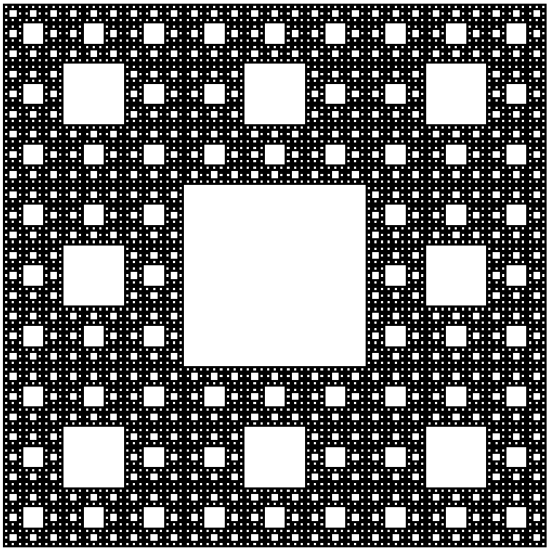

Figure 2: Sierpiński with 5 levels of recursion

# General objective

The aim of the project is to study the effect and the properties of applying an external potential field with a fractal shape to a quantum system. The main properties of interest are the ground state energy and the density profile.

The external field can take the shape of Sierpiński carpet, so we can study the relation between the recursion number of the fractal and the properties that we are calculating.

One of our goals is to verify the existence of a simple scaling law between the recursion number of the zero-point energy of the system and the number of iterations of the fractal.

This is an interdisciplinary problem, based on application of mathematical concepts to the field of quantum physics, and relies on the use of numerical methods. This project requires carrying out a scientific investigation and a priori it is not clear which quantum system is going to be the best to study these properties.

# Scope of the Project

We plan to execute this study considering different types of systems:

* One single particle in a box
* An ultracold quantum gas confined to two dimensions (Bose-Einstein Gas)??
* ???

# How the project will be developed

As our goal is to study the effect of the external potential field on a quantum system, we must compute the ground state energy of the quantum system that we present.

To do so, for the case of a single particle in an infinite external potential box (or with zero boundary conditions, which is equivalent) we must solve the Schrödinger equation while we apply the external potential field to the box. We implement some Matlab code that generates a Sierpiński carpet given a recursion number and we apply the field to the particle by defining the potential energy part of the Hamiltonian operator using the fractal. This potential is described by the function $V\left(x,y\right)$, which checks if the position $\left(x,y\right)$ of the fractal is filled or empty. With this done, we solve the time-independent Schrödinger equation on a discretized two-dimensional space, and we obtain the ground state energy and the wavefunction of the particle.

We are going to repeat this process using a different number of iterations of the fractal, so we can deduce the relation that this parameter has with the zero-point energy.

We want to obtain a result, and as memory and computation resources are limited, we must define some discretization of the space that reflects in a computable problem. An option is to solve the problem with different values for N (being N the number of fractions the space is divided in) and study how this evolves when N goes to infinity, or analogously, when 1/N goes to 0.

# Reason for selecting the subject area (relevance and justification)