Quantum particles in fractal external potential

GEP Deliverable 1: Context and scope of the project

Marc Amorós Trepat

Thesis supervisor: Grigori Astrakharchik

Content table

Theoretical context of the project 3

Quantum mechanics 3

Schrödinger equation 3

Bose–Einstein condensate and Gross–Pitaevskii equation 3

Fractals 4

Sierpiński carpet 4

General objective 5

Scope of the Project 5

How the project will be developed 5

Reason for selecting the subject area (relevance and justification) 5

# Theoretical context of the project

## Quantum mechanics

Quantum mechanics is the theory that describes the physical properties of Nature at the scale of atoms and subatomic particles. When it was first formulated during the early decades of the 20th century, it introduced some ground-breaking concepts such as energy quantization, the uncertainty of position and momentum of a particle and the wave-particle duality of matter.

In classical physics we have Newton’s second law, which given a set of initial conditions it can make a mathematical prediction of what path a given physical system will take over time. Its quantum analogous would be the Schrödinger equation which instead requires a statistical interpretation.

## Schrödinger equation

Quantum mechanics tells us how the particles behave over time. The description is s done using the Schrödinger equation, which provides the time evolution of the wavefunction ($Ψ$) of particles. The wavefunction is a mathematical description of the quantum state of the system, and with it, you can obtain the distribution of probability of the measurements that you can do over the it.

The Schrödinger equation is a differential equation of the following form:

$$iℏ\frac{∂}{∂t}Ψ\left(r,t\right)=\hat{H}Ψ\left(r,t\right)$$

Here we define the Hamiltonian operator $\hat{H}$, which is an operator corresponding to the total energy of that system, including both kinetic (T) and potential energy (V). For a single particle it takes the form

$$\hat{H}=\hat{T}+\hat{V}=-\frac{ℏ^{2}}{2m}∇^{2}+V\left(r,t\right)$$

The kinetic energy in quantum mechanics is proportional to the Laplace operator $∇^{2}$, which is the addition of the second partial derivatives of the wavefunction. The potential energy is a function of the position of the particle, similarly to the classical case.

We are interested in the stationary properties, so we take the time-independent version of the Schrödinger equation:

$$\hat{H}|Ψ⟩=E|Ψ⟩$$

When solving it, the set of energy eigenvalues that provides (also called energy spectrum) is the set of possible energies obtained when measuring the system’s total energy. Here we are interested in finding the ground state of the system, which is its lowest energy state. Differently from the classical systems where the energy of a single particle at zero temperature is finite due to zero-point motion, present in the quantum system, even in absolute zero temperature conditions.

## Bose–Einstein condensate and Gross–Pitaevskii equation

Bose–Einstein condensate (BEC) is a state of matter which occur when a gas of bosons is cooled down to nearly the absolute zero. Under such conditions, a macroscopic fraction of bosons occupy the ground state and the whole system can be described by the same wavefunction. Such a wavefunction satisfies the Gross–Pitaevskii equation, which describes the ground state of a quantum system of identical bosons.

## Fractals

A fractal is a subset of the Euclidean space that illustrates a property called self-similarity, which mean that appear the same at different scales and exhibit similar patterns at increasingly smaller scales.

## Sierpiński carpet

The Sierpiński carpet is a plane fractal that was first described by Wacław Sierpiński in 1916, as a two dimensions generalization of the Cantor set, that was discovered in 1874 by Henry John Stephen Smith and introduced by German mathematician Georg Cantor in 1883.

The Cantor ternary set is created by iteratively deleting the open middle third from a set of line segments.



Figure 1: First six steps of Cantor ternary set

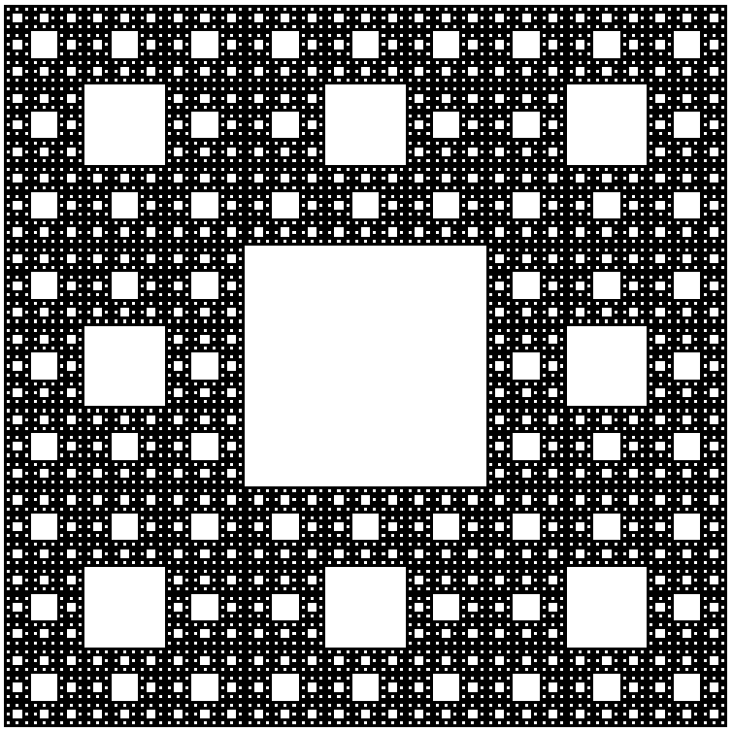

Figure 2: Sierpiński with 5 levels of recursion

# General objective

The aim of the project is to study the properties of quantum particles in a fractal external potential. The main goal is to obtain a detailed description of such a system in terms of energetic, structural and dynamic properties. In particular, the energetic properties can be quantified by evaluation of the ground state energy and the excitation spectrum. The structural property of interest is the density profile. The dynamic property to be calculated is the diffusion coefficient.

We consider the external in the shape of Sierpiński carpet. It has a fractal structure with the fractal dimensionality between 1 (i.e. a line) and 2 (i.e. a plane). The strength of the external potential is considered to be infinite (i.e. hard walls) in the positions where the fractal is present. It means that the particles cannot diffuse freely in the system. At the same time, the phase space is joined, that is the particle is allowed to move between any two points where the external field is absent. The fractal shape is defined in simple recursive procedure and depends on the recursion level.

One of our goals is to provide a detailed description of the properties of quantum particles in fractal external potential. In particular we plan to verify the existence of a simple scaling law between the recursion number of the zero-point energy of the system and the number of iterations of the fractal.

This is an interdisciplinary problem, based on application of mathematical concepts to the field of quantum physics, and relies on the use of numerical methods. This project requires carrying out a scientific investigation and a priori it is not clear which quantum system is going to be the best to study these properties.

In the last few years, new experimental techniques have been developed and it became feasible to create two-dimensional Fermi or Bose gas in highly controllable external potential. The projected potential can be chosen essentially in any desired shape, fractal shapes included.

# Scope of the Project

We plan to execute this study considering different types of atoms confined to an external fractal potential. In particular we will consider

1. One quantum particle
2. Ideal Fermions
3. Interacting Bosons

In this way we cover the major typical experimental conditions. In experiments with ultracold atoms, the atoms obey either Bose-Einstein statistics (bosons) or Fermi-Dirac statistics (fermions). A proper simulation of the properties requires implementation of different methods used to address the system properties such as

1. Exact diagonalization technique, applicable to one particle and many-body system composed of fermions
2. Random Walk stochastic method, applicable to one particle
3. Gross-Pitaevskii equation, applicable to many-body system composed of bosons.

Method (a) allows to obtain energetic and structural properties, while method (b) the structural and dynamic ones. Method (c) can be used to obtain energetic, structural and dynamic properties of the system.

# How the project will be developed

As our goal is to study the effect of the external potential field on a quantum system, we must compute the ground state energy of the quantum system that we present.

To do so, for the case of a single particle in an infinitely high external potential box mathematically described by zero boundary conditions. We must solve the Schrödinger equation while we apply the external potential field to the box. We implement a Matlab code that generates a Sierpiński carpet given a recursion number and we apply the field to the particle by defining the potential energy part of the Hamiltonian operator using the fractal. This potential is described by the function $V\left(x,y\right)$, which checks if the position $\left(x,y\right)$ of the fractal is filled or empty. With this done, we solve the time-independent Schrödinger equation on a discretized two-dimensional space, and we obtain the ground state energy and the wavefunction of the particle.

We are going to repeat this process using a different number of iterations of the fractal, so we can deduce the relation that this parameter has with the zero-point energy.

We want to obtain a result, and as memory and computation resources are limited, we must define some discretization of the space that reflects in a computable problem. An option is to solve the problem with different values for ***N*** (being ***N*** the number of fractions the space is divided in) and study how this evolves when N goes to infinity, or analogously, when 1/***N*** goes to 0.

# Reason for selecting the subject area (relevance and justification)