# Vault Dragon coding assessment

## Scope & Purpose

The purpose of this document is to provide details of the source code submitted on github and HTTP api and scope of this document is limited to these instructions provided in this document.

## Requirements:

This is a Django web app, developed in python 2.7. Since the code is already deployed on free hosting website, the below mentioned urls can be used to test the application. However, if you wish to run the code on the local system, please ensure that you are running the latest version of Django and Python 2.7

The below are the url details of the Web APP:

## To post the key:value

<http://navibhp.pythonanywhere.com/object/>

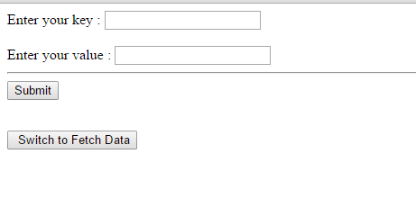

## To fetch the value for a corresponding key or key and time stamp:

<http://navibhp.pythonanywhere.com/object/fetch>

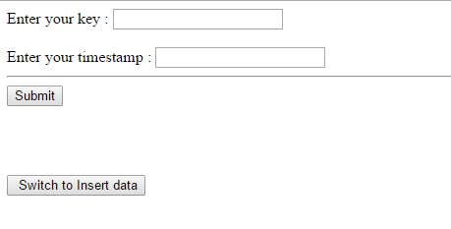

Endpoint: /object/ fetch/mykey?

Or

Endpoint : /object/fetch/mykey?timestamp= xyz [ xyz is the unix timestamp]

[Note: If time stamp not provided in the query, then the latest value is fetched]