Assignements
Question [1] : Data exploration
R-Code
>> library(dplyr)
## load data
>> data<-read.csv("creditworthiness.csv")
## extract rated lines
>> filter_data <- data %>% filter(credit.rating %in% c(1,2,3))
## split data
>> set.seed(25)
>> dt = sort(sample(nrow(filter_data), nrow(filter_data)*.5))
>> train_data <-filter_data[dt,]
>> test_data <-filter_data[-dt,]
Interpretations
Of the 1962 observations with a credit rating, we randomly split 50% into train_data and the rest of the data into test_data.
They each have 981 rows and 46 columns

Question [2] : Decision Trees
(a)-
R-Code
>> library(rpart)
>> library(rpart.plot)
### Convert credit.rating column in factor
>> train_data$credit.rating = factor(train_data$credit.rating,labels=c("A","B","C"))
### Train
>> DT.rpart <- rpart(credit.rating ~. , train_data)
>> rpart.plot(DT.rpart)
R-Output
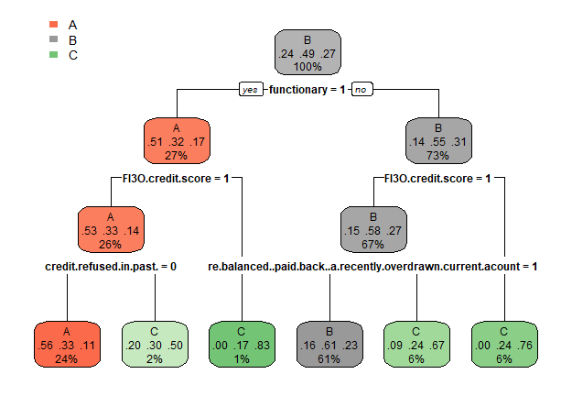

Interpretations
We can notice that only 4 features are used by the decision tree : functionary, FI3O credit score, credit refused in past? And re-balanced (paid back) a recently overdrawn current acount.

(b)- Median person class
R-Code
>> med = c(0,1,1,0,3,0,3,3,0,3,3,3,3,3,3,3,3,3,3,3,3,3,3,3,3,3,3,3,3,3,3,3,3,3,3,3,3,3,3,3,3,3,3,3,3)
>> med_df <- setNames(
data.frame( t(data.frame(med)) ,row.names = NULL,stringsAsFactors = FALSE),
colnames(data)[1:45]
)
>> print(predict(DT.rpart, med_df, type="class"))
R-Output
1
B
Levels : A B C
Interpretations
The median person credit rating category predict by decision trees model is B (2).

(c)- Confusion matrix
R-Code
>> library(caret)
>> pred = predict(DT.rpart, test_data[,1:45], type="class")
>> print(confusionMatrix(pred,train_data$credit.rating))
R-Output
Confusion Matrix and Statistics
Predict A B C
A 77 121 75
B 127 301 157
C 31 59 33
Overall Statistics:
Accuracy : 0.419
Statistics by Class:
Class: A Class: B Class: C
Sensitivity 0.32766 0.6258 0.12453
Specificity 0.73727 0.4320 0.87430
Pos Pred Value 0.28205 0.5145 0.26829
Neg Pred Value 0.77684 0.5455 0.72960
Prevalence 0.23955 0.4903 0.27013
Detection Rate 0.07849 0.3068 0.03364
Detection Prevalence 0.27829 0.5963 0.12538
Balanced Accuracy 0.53246 0.5289 0.49941
Interpretations
The confusion matrix allows us to say that only 28% of items A(1), 51% of B(2) and 26% of C(3) were predicted accurately. which explains the Accuracy which is equal to 0.419

(d)- Entropy
- Total entropy in root node
$$-\frac{481}{981}\log_{2}{\frac{481}{981}}-\frac{500}{981}\log_{2}{\frac{500}{981}}≈0.9997294$$
- After the first split, total entropies within daughter nodes are :
$$-\frac{136}{269}\log_{2}{\frac{136}{269}}-\frac{133}{269}\log_{2}{\frac{133}{269}}≈0.9999103$$
and
$$-\frac{395}{712}\log_{2}{\frac{395}{712}}-\frac{317}{712}\log_{2}{\frac{317}{712}}≈0.9913255$$
The total entropy after the first split is :
$$\frac{269}{981}*0.9999103+\frac{712}{981}*0.9913255≈0.9936795$$
The information gain following this split is : 0.0060499

(e)- Random forest
R-Code
>> library(randomForest)
>> RF <- randomForest(credit.rating~., data=train_data, proximity=TRUE)
>> print(RF)
R-Output
Call:
randomForest(formula = credit.rating ~ ., data = train_data, proximity = TRUE)
Type of random forest: classification
Number of trees: 500
No. of variables tried at each split: 6
OOB estimate of error rate: 43.93%
Confusion matrix:
A B C class.error
A 75 158 2 0.6808511
B 48 398 35 0.1725572
C 18 170 77 0.7094340

(f)- Confusion matrix with RF
R-Code
>> p <- predict(RF, test_data[,1:45], type="class")
>> print(confusionMatrix(p,train_data$credit.rating))

R-Output
Confusion Matrix and Statistics
Predict A B C
A 47 69 44
B 163 364 195
C 25 48 26
Overall Statistics :
Accuracy : 0.4455
Statistics by Class:
Class: A Class: B Class: C
Sensitivity 0.20000 0.7568 0.09811
Specificity 0.84853 0.2840 0.89804
Pos Pred Value 0.29375 0.5042 0.26263
Neg Pred Value 0.77101 0.5483 0.72902
Prevalence 0.23955 0.4903 0.27013
Detection Rate 0.04791 0.3710 0.02650
Detection Prevalence 0.16310 0.7360 0.10092
Balanced Accuracy 0.52426 0.5204 0.49808
Interpretations
The confusion matrix allows us to say that only 29% of items A(1), 50% of B(2) and 26% of C(3) were predicted accurately. which explains the Accuracy which is equal to 0.4455

Question[3] : SVM
(a)- Median person class
R-Code
>> model.svm <- svm(credit.rating~., data=train_data)
>> print(predict(model.svm, med_df, decision.values=TRUE))
R-Output
B
Decision values
B/A B/C A/C
1.205159 1.465489 0.09940877
Levels: A B C
Interpretations
The median person class predict by SVM model is B(2) and the decision values are : 1.205159 for (B/A), 1.465489 for (B/C) and 0.09940877 for (A/C).

(b)- Test data prediction and Confusion Matrix
R-Code
>> p2 <- predict(model.svm, test_data[,1:45], type="class")
>> print(confusionMatrix(p2, train_data$credit.rating))
R-Output
Confusion Matrix and Statistics
Predict A B C
A 70 106 69
B 136 310 162
C 29 65 34
Overall Statistics
Accuracy : 0.422
Statistics by Class:
Class: A Class: B Class: C
Sensitivity 0.29787 0.6445 0.12830
Specificity 0.76542 0.4040 0.86872
Pos Pred Value 0.28571 0.5099 0.26563
Neg Pred Value 0.77582 0.5416 0.72919
Prevalence 0.23955 0.4903 0.27013
Detection Rate 0.07136 0.3160 0.03466
Detection Prevalence 0.24975 0.6198 0.13048
Balanced Accuracy 0.53164 0.5242 0.49851
Interpretations
The confusion matrix allows us to say that only 28% of items A(1), 51% of B(2) and 26% of C(3) were predicted accurately. which explains the Accuracy which is equal to 0.422

(c)-
R-Code
set.seed(5)
>> tmodel <- tune.svm(credit.rating ~ ., data = train_data, kernel="radial",
gamma = 10^(-1:1), cost = 10^(2:7))
>> plot(tmodel)
>> best.svm <- tmodel$best.model
>> p3 <- predict(best.svm, test_data[,1:45], type="class")
>> print(confusionMatrix(p3,train_data$credit.rating))
R-Output
Confusion Matrix and Statistics
Predict A B C
A 0 0 0
B 235 481 265
C 0 0 0
Overall Statistics
Accuracy : 0.4903
Interpretations
We can see that the Accuracy has been improved and is now 0.49

Question[4] : Naive Bayes Model
(a)- Median person class
R-Code
>> m <- naiveBayes(credit.rating ~., data = train_data)
>> print(predict(m, med_df, type="raw"))
R-Output
A B C
[1,] 0.9900937 0.009179851 0.0007264147
Interpretations
The median person class predict by Naive Bayes Model is A and the probabity equal to 0.9900937.

(c)- Confusion Matrix
R-Code
>> p4 <- predict(m, test_data[,1:45])
>> print(confusionMatrix(p4,train_data$credit.rating))
R-Output
Confusion Matrix and Statistics
Predict A B C
A 182 374 217
B 9 11 3
C 44 96 45
Overall Statistics
Accuracy : 0.2426
Statistics by Class:
Class: A Class: B Class: C
Sensitivity 0.7745 0.02287 0.16981
Specificity 0.2078 0.97600 0.80447
Pos Pred Value 0.2354 0.47826 0.24324
Neg Pred Value 0.7452 0.50939 0.72362
Prevalence 0.2396 0.49032 0.27013
Detection Rate 0.1855 0.01121 0.04587
Detection Prevalence 0.7880 0.02345 0.18858
Balanced Accuracy 0.4911 0.49943 0.48714
Interpretations
The Accuracy of this model equal to 0.24

Question[5] : Summary
(a)-
Based on the accuracy of the models, we can say that the best model is SVM. Because the improved model made it possible to reach an accuracy of 0.49 against 0.44 for the Random Forest, 0.419 for Decision Trees, 0.24 for Naive Bayes Model.
(b)-
For this database the least appropriate model is the Naive Bayes. Because it offers an accuracy well below what other models offer.
(c)-
Models have a little trouble with class C.
None of the models could achieve an accuracy per class of more than 0.5 for class C.

Question[6] :
(a)- Logistic regression
R-Code
### Modify data
>> modif_data <- data %>% filter(credit.rating %in% c(1,2,3))
>> modif_data$credit.rating = factor(modif_data$credit.rating,labels=c("A","0","0"))
### Splitting
>> set.seed(25)
>> dt = sort(sample(nrow(modif_data), nrow(modif_data)*.5))
>> train <- modif_data[dt,]
>> test <- modif_data[-dt,]
>> model.glm <- glm(credit.rating~., data = modif_data, family = binomial("logit"))

(b) – Summary
R-Code
>> print(summary(model.glm))
R-Output
Call:
glm(formula = credit.rating ~ ., family = binomial("logit"), data = modif_data)
Deviance Residuals:
Min 1Q Median 3Q Max
-2.6713 0.0374 0.4896 0.6629 1.7451
Coefficients:
Estimate Std. Error z value Pr(>|z|)
(Intercept) 6.0121555 1.3361986 4.499 6.81e-06 ***
functionary -1.8741960 0.1224896 -15.301 < 2e-16 ***
re.balanced..paid.back..a.recently.overdrawn.current.acount -1.4070276 0.3877674 -3.629 0.000285 ***
FI3O.credit.score -3.8540397 1.0167520 -3.791 0.000150 ***
gender -0.2490538 0.1211526 -2.056 0.039811 *
X0..accounts.at.other.banks -0.0099134 0.0426317 -0.233 0.816121
credit.refused.in.past. 1.4661625 0.2761522 5.309 1.10e-07 ***
years.employed -0.8169599 0.1970028 -4.147 3.37e-05 ***
savings.on.other.accounts 0.6830682 0.1504409 4.540 5.61e-06 ***
self.employed. 0.0849632 0.1537030 0.553 0.580417
max..account.balance.12.months.ago 0.0218468 0.0432665 0.505 0.613604
min..account.balance.12.months.ago -0.0074200 0.0432257 -0.172 0.863707
avrg..account.balance.12.months.ago 0.0416446 0.0432166 0.964 0.335235
max..account.balance.11.months.ago 0.0254666 0.0426534 0.597 0.550467
min..account.balance.11.months.ago 0.0359852 0.0427166 0.842 0.399554
avrg..account.balance.11.months.ago -0.0308794 0.0439104 -0.703 0.481908
max..account.balance.10.months.ago -0.0077705 0.0423387 -0.184 0.854380
min..account.balance.10.months.ago 0.0830239 0.0430846 1.927 0.053980
avrg..account.balance.10.months.ago 0.0246114 0.0436359 0.564 0.572742
max..account.balance.9.months.ago 0.0187064 0.0418195 0.447 0.654649
min..account.balance.9.months.ago -0.0049961 0.0428569 -0.117 0.907195
avrg..account.balance.9.months.ago 0.0218344 0.0424771 0.514 0.607233
max..account.balance.8.months.ago 0.0351537 0.0422945 0.831 0.405881
min..account.balance.8.months.ago 0.0001937 0.0431901 0.004 0.996422
avrg..account.balance.8.months.ago 0.0489074 0.0431212 1.134 0.256716
max..account.balance.7.months.ago 0.0241330 0.0424279 0.569 0.569492
min..account.balance.7.months.ago 0.0373246 0.0430404 0.867 0.385833
avrg..account.balance.7.months.ago -0.0054111 0.0423912 -0.128 0.898428
max..account.balance.6.months.ago -0.0454208 0.0430721 -1.055 0.291641
min..account.balance.6.months.ago -0.0625492 0.0423875 -1.476 0.140037
avrg..account.balance.6.months.ago -0.0260228 0.0428536 -0.607 0.543686
max..account.balance.5.months.ago -0.0210934 0.0420628 -0.501 0.616038
min..account.balance.5.months.ago 0.0495026 0.0432329 1.145 0.252200
avrg..account.balance.5.months.ago 0.0002196 0.0425007 0.005 0.995878
max..account.balance.4.months.ago 0.0344934 0.0425250 0.811 0.417289
min..account.balance.4.months.ago 0.0099002 0.0430133 0.230 0.817962
avrg..account.balance.4.months.ago -0.0030445 0.0428564 -0.071 0.943366
max..account.balance.3.months.ago 0.0629136 0.0419049 1.501 0.133267
min..account.balance.3.months.ago 0.0323577 0.0436146 0.742 0.458148
avrg..account.balance.3.months.ago -0.0282515 0.0427952 -0.660 0.509154
max..account.balance.2.months.ago 0.0018851 0.0429374 0.044 0.964981
min..account.balance.2.months.ago 0.0301368 0.0427172 0.705 0.480502
avrg..account.balance.2.months.ago -0.0155856 0.0429528 -0.363 0.716714
max..account.balance.1.months.ago -0.0118168 0.0434917 -0.272 0.785852
min..account.balance.1.months.ago -0.0205693 0.0429921 -0.478 0.632333
avrg..account.balance.1.months.ago 0.0120819 0.0431479 0.280 0.779468
Signif. codes: 0 ‘***’ 0.001 ‘**’ 0.01 ‘*’ 0.05 ‘.’ 0.1 ‘ ’ 1

(Dispersion parameter for binomial family taken to be 1)
Null deviance: 2190 on 1961 degrees of freedom
Residual deviance: 1740 on 1916 degrees of freedom
AIC: 1832
Number of Fisher Scoring iterations: 7

(c)- Significants predictors
The coefficient that seems to be the most significant at the 5% level is the coefficient of the " min..account.balance.10.months.ago" variable because Pr(>|Z|)= 0.053980

(d)- SVM model
R-Code
>> svm.model <- svm(credit.rating~., data=train)
>> p5 <- predict(svm.model, test[,1:45], type="class")
>> print(confusionMatrix(p5,test$credit.rating))
R-Output
Confusion Matrix and Statistics
Predict A 0
A 53 44
0 195 689
Accuracy : 0.7564
95% CI : (0.7283, 0.7829)
Sensitivity : 0.21371
Specificity : 0.93997
Pos Pred Value : 0.54639
Neg Pred Value : 0.77941
Prevalence : 0.25280
Detection Rate : 0.05403
Detection Prevalence : 0.09888
Balanced Accuracy : 0.57684
'Positive' Class : A

(e)- ROC
R-Code
>> library(ROCR)
>> pred.svm <- predict(svm.model, newdata = test[,1:45],decision.values = TRUE)
>> pred.reg <- predict(model.glm, newdata = test[,1:45],type="response")
>> y.svm <- attr(pred.svm, "decision.values")
>> classifier.svm <- prediction(y.svm, test$credit.rating =="0")
>> classifier.reg<- prediction(pred.reg, test$credit.rating =="0")
>> perf.svm <- performance(classifier.svm, "tpr","fpr")
>> perf.reg <- performance(classifier.reg, "tpr","fpr")
>> plot(perf.svm, col = 1, print.cutoffs.at=seq(0,1,0.1))
>> plot(perf.reg, col = 4, add = TRUE)
>> legend("bottomright", c("SVM", "Logistic Regressor"),lty = 1, col = 1:4)
R-Output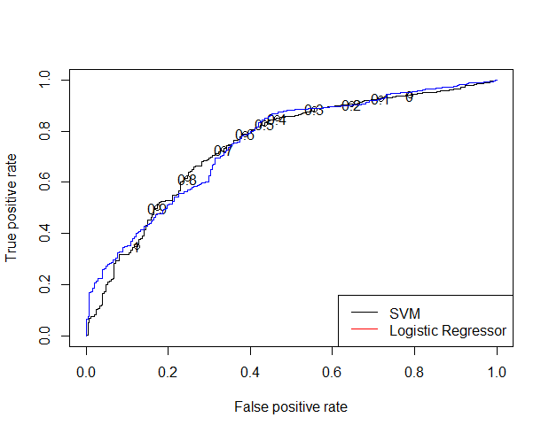
Interpretations
By observing this graph we can say the two models seem to have a fairly similar performance. But the SVM model is still better in some cases since its curves at the point of inflection are closer to the axis of true positives

