Exercise # 1:
The database (Sellin_Product.csv) comes from the database provided during the Fossil-Stock-Forecasting-Challenge machine learning competition. It gives the monthly sales quantity of three different products over the period 2016-01 to 2021-10. It has 4 columns and 58 rows. We can also notice the presence of some missing data. The three products are respectively named: "YOSHHAELVICT", "YOSHELLYCATH" and "YOSHLROYARTI".
We represent the price distributions of each of the products.
- YOSHHAELVICT
The average price of this product is 1029841 and the median is 938038.
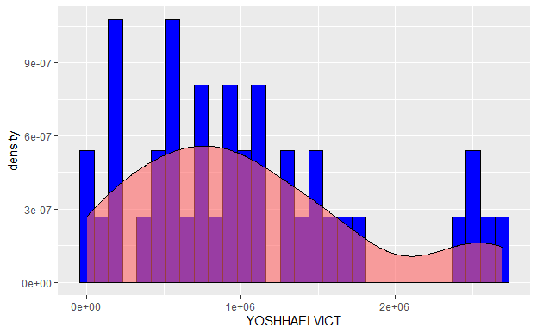
- YOSHELLYCATH
The average price of this product is 561733.8 and the median is 433564.
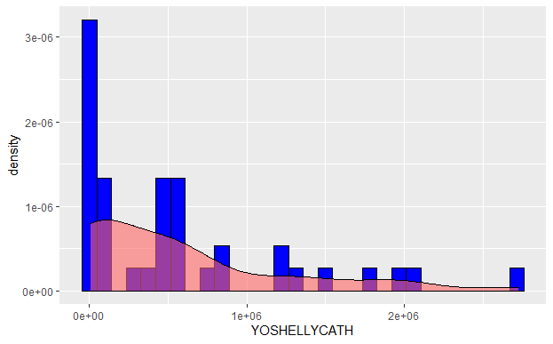
- YOSHLROYARTI
The average price of this product is 103756.5 and the median is 7091.
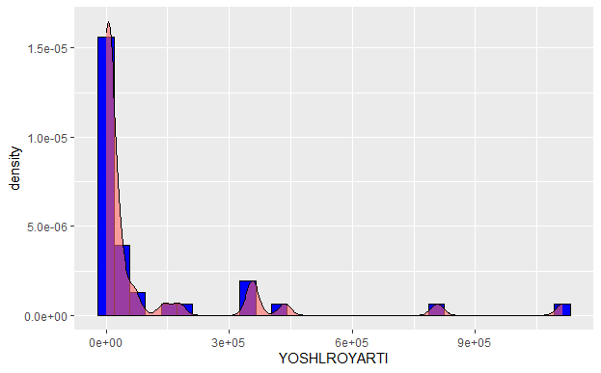
We notice that the distributions of the three variables are very different from each other.

Exercise # 2:
- Binomial distribution
We choose to use the following values: $p=\left\{0.2;0.6\right\}$ and $n=\left\{50;100\right\}$
- For $p=0.2$and $n=50$
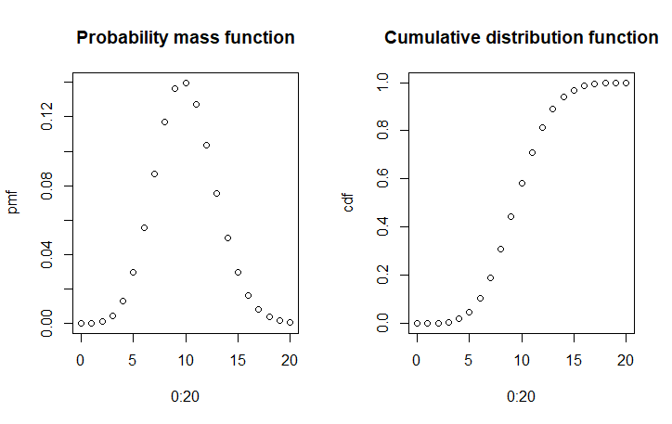
- For $p=0.2$and $n=100$
- For $p=0.6$and $n=100$
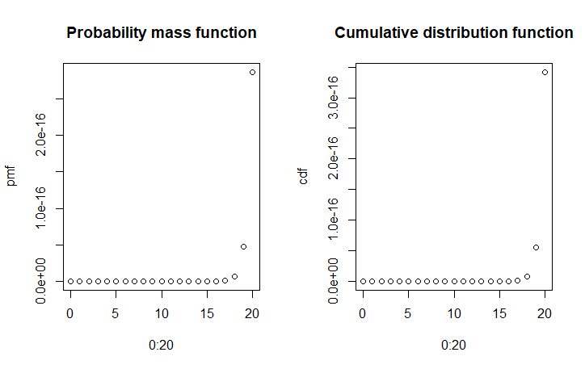
- For $p=0.6$and $n=50$
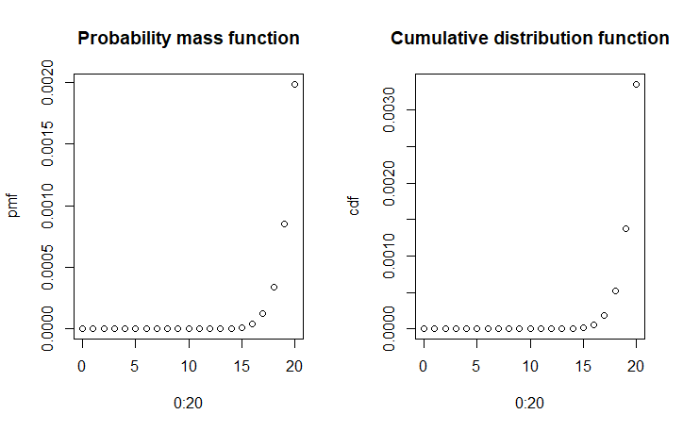

- Geometric Distribution
We choose to use the following values: $p1=0.2$ and $p2=0.6$
- $p1=0.2$
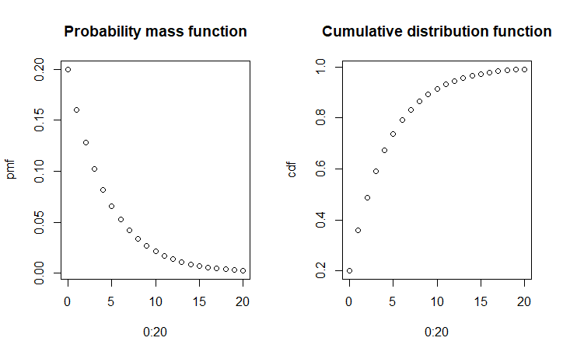
- $p2=0.6$
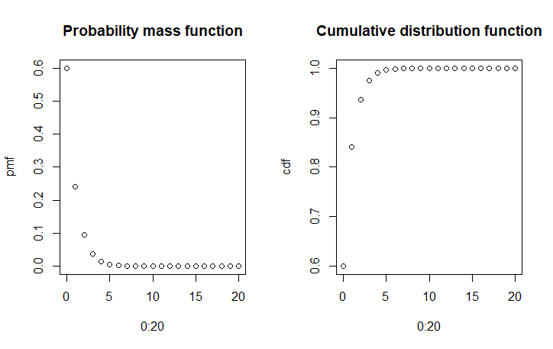

- Poisson Distribution
We choose to use the following values: $λ1=0.3$ and $λ2=1$
- $λ1=0.3$
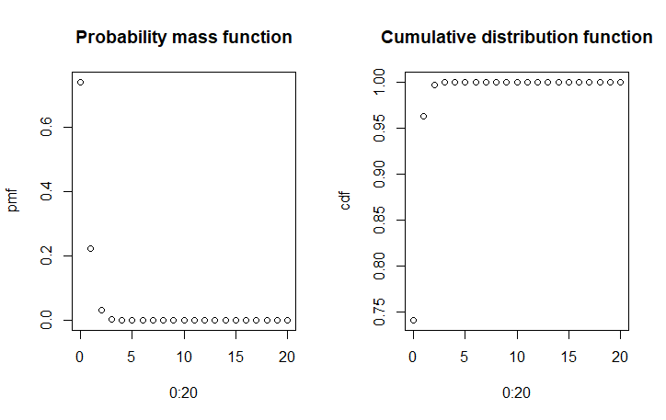
- $λ2=1$
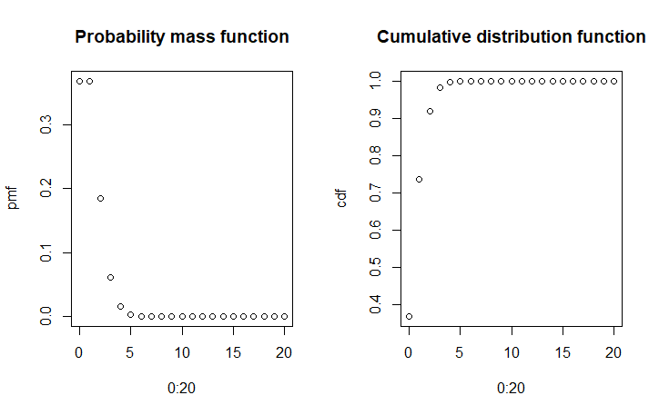
There is a big difference in the distributions. But we can note that the binomial distribution varies much more by modifying the parameter p which is the probability of success.

Notice:
This work was carried out using the RStudio software and the R programming language. The source codes of each exercise respectively named "Exercise_1.R" and "Exercise_2.R" are attached to this report.

