Project/Homework 2
install.packages(“tidyverse”)
install.packages(“rlang”)
## Read data on tibble format
library(tidyverse)
## ── Attaching packages ─────────────────────────────────────── tidyverse 1.3.2 ──
## ✔ ggplot2 3.4.1 ✔ purrr 1.0.1
## ✔ tibble 3.1.8 ✔ dplyr 1.1.0
## ✔ tidyr 1.3.0 ✔ stringr 1.5.0
## ✔ readr 2.1.4 ✔ forcats 1.0.0
## ── Conflicts ────────────────────────────────────────── tidyverse_conflicts() ──
## ✖ dplyr::filter() masks stats::filter()
## ✖ dplyr::lag() masks stats::lag()
Project02_SuperStoreOrders<- read_csv("Project02_SuperStoreOrders.csv")
## Rows: 51290 Columns: 21
## ── Column specification ────────────────────────────────────────────────────────
## Delimiter: ","
## chr (15): order_id, order_date, ship_date, ship_mode, customer_name, segment...
## dbl (5): quantity, discount, profit, shipping_cost, year
## num (1): sales
##
## ℹ Use `spec()` to retrieve the full column specification for this data.
## ℹ Specify the column types or set `show_col_types = FALSE` to quiet this message.

Question 1:

Create a summary statistic and provide youranalysis/observations.
summary(Project02_SuperStoreOrders)
## order_id order_date ship_date ship_mode
## Length:51290 Length:51290 Length:51290 Length:51290
## Class :character Class :character Class :character Class :character
## Mode :character Mode :character Mode :character Mode :character
##
##
##
## customer_name segment state country
## Length:51290 Length:51290 Length:51290 Length:51290
## Class :character Class :character Class :character Class :character
## Mode :character Mode :character Mode :character Mode :character
##
##
##
## market region product_id category
## Length:51290 Length:51290 Length:51290 Length:51290
## Class :character Class :character Class :character Class :character
## Mode :character Mode :character Mode :character Mode :character
##
##
##
## sub_category product_name sales quantity
## Length:51290 Length:51290 Min. : 0.0 Min. : 1.000
## Class :character Class :character 1st Qu.: 31.0 1st Qu.: 2.000
## Mode :character Mode :character Median : 85.0 Median : 3.000
## Mean : 246.5 Mean : 3.477
## 3rd Qu.: 251.0 3rd Qu.: 5.000
## Max. :22638.0 Max. :14.000
## discount profit shipping_cost order_priority
## Min. :0.0000 Min. :-6599.98 Min. : 0.00 Length:51290
## 1st Qu.:0.0000 1st Qu.: 0.00 1st Qu.: 2.61 Class :character
## Median :0.0000 Median : 9.24 Median : 7.79 Mode :character
## Mean :0.1429 Mean : 28.64 Mean : 26.38
## 3rd Qu.:0.2000 3rd Qu.: 36.81 3rd Qu.: 24.45
## Max. :0.8500 Max. : 8399.98 Max. :933.57
## year
## Min. :2011
## 1st Qu.:2012
## Median :2013
## Mean :2013
## 3rd Qu.:2014
## Max. :2014
The database at our disposal represents the sales data of a company over the period from 2011 to 2014. It presents 51290 observations and 21 variables. Above are the values of the descriptive statistics for each of the variables (average, median or mode, quantile etc..)

Question 2:

Analyze how the orders are made over the years and by segments. Plot the below graph. Make sure the name of “X-axis” should match. Colors could vary.
library(ggplot2)
library(dplyr)
df <- Project02_SuperStoreOrders %>%
group_by(year,segment) %>%
summarise(total_count=n(),.groups = 'drop') %>%
as.data.frame()
ggplot(df, aes(x = year, y = total_count, fill =
segment)) + geom_bar(stat = "identity", position = "stack") + labs(x = "Year of Order", y = "Count", fill = "segment")
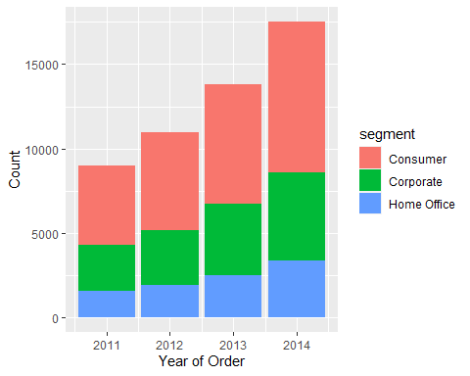
From the analysis of the graph, it can be seen that orders have increased proportionally each year in all segments

Question 3:

Which segment is the best seller in the entire dataset?

How do you compare the segments? Provide a plot to confirm your claim about the best seller.
### Calculate total orders by segment
total_orders <-
aggregate(Project02_SuperStoreOrders$quantity, by=list(segment=Project02_SuperStoreOrders$segment),
FUN=sum)
colnames(total_orders) <- c("segment", "quantity")
### Determine the best-selling segment
best_seller <- total_orders[which.max(total_orders$quantity),"segment"]
### Create a plot to confirm my claim
ggplot(total_orders, aes(x=segment, y=quantity, fill=segment))+geom_bar(stat="identity")
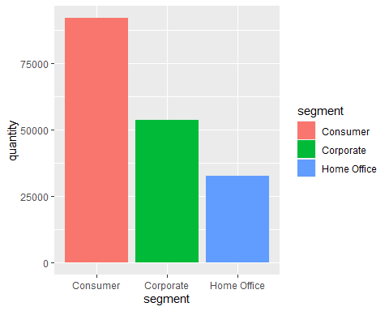
We have the best segment using the amount of product ordered per segment. So we made a sum per segment of the quantity. This allowed us to conclude that the best sales segment is “Consumer”. The graph above illustrates this conclusion.

Question 4:

Create a bar chart of regional orders. Provide your analysis of which region receives the most orders and which region receives the fewest. Ensure you provide the numbers to validate that the longer bar corresponds to the maximum #number of orders. Invert the axis coordinates and display the bars in the reverse order of the number of orders by region. #Replace the bars’ color with the color of your choosing. I used the color blue in the graph I made. Additionally, ensure that the axis is labeled “Region.”
order_count <- as.data.frame(table(Project02_SuperStoreOrders$region))
colnames(order_count) <- c("region", "count")
#order_count <- order_count[order(order_count$count),]
ggplot(order_count, aes(y=reorder(region, count), x=count))+
geom_bar(stat="identity",fill="blue")+
geom_text(aes(label = count), hjust = -0.50)+
labs(y = "Region", x = "Count")
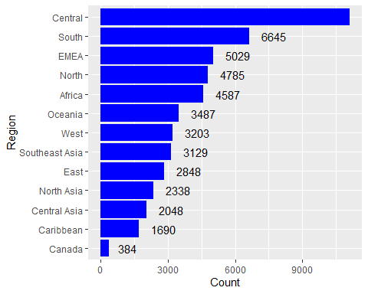
We notice that the region with the most sales is “Central” with 11117 orders and the one with the least sales is “Canada” with 384 orders.

Question 5:

Use the below code snippet and complete the rest to create the profits graph by region.

Hint: You are creating a bar plot in a polar coordinate system.
library(dplyr)
Project02_SuperStoreOrders %>%
mutate(total_profit = sum(profit)) %>%
group_by(region) %>%
summarize(total_profit = sum(profit)) %>%
ggplot(., aes(x=region, y=total_profit, fill=region)) +
geom_bar(stat="identity") +
coord_polar()
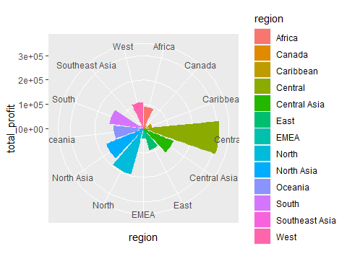

Question 6:

Include a density plot to infer the total profit made. Include the orders that have profits within the range of [-125, 125].
library(dplyr)
Project02_SuperStoreOrders %>%
filter(profit<125 , profit>-125) %>%
select("profit") %>%
ggplot(., aes(x=profit)) + geom_density()
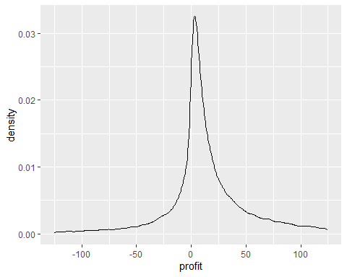
The density function represents the realized profit over a certain period of time and the observed peak represents my profit concentration area. The area below the density function curve represents the total realized profit.

