EDA
2023-03-03

Exploratory_Data_Analysis - Melbourne Housing Prices

To create a PDF output, make sure that you have the latex installed. You need to run tinytex::install_tinytex()

Q1. Read the file and print summary
library(tidyverse)
## ── Attaching packages ─────────────────────────────────────── tidyverse 1.3.2 ──
## ✔ ggplot2 3.4.1 ✔ purrr 1.0.1
## ✔ tibble 3.1.8 ✔ dplyr 1.1.0
## ✔ tidyr 1.3.0 ✔ stringr 1.5.0
## ✔ readr 2.1.4 ✔ forcats 1.0.0
## ── Conflicts ────────────────────────────────────────── tidyverse_conflicts() ──
## ✖ dplyr::filter() masks stats::filter()
## ✖ dplyr::lag() masks stats::lag()
data <- read_csv("melbourne_housing_prices.csv", show_col_types = FALSE)
summary(data)
## Suburb Address Rooms Type
## Length:13580 Length:13580 Min. : 1.000 Length:13580
## Class :character Class :character 1st Qu.: 2.000 Class :character
## Mode :character Mode :character Median : 3.000 Mode :character
## Mean : 2.938
## 3rd Qu.: 3.000
## Max. :10.000
##
## Price Method SellerG Date
## Min. : 85000 Length:13580 Length:13580 Length:13580
## 1st Qu.: 650000 Class :character Class :character Class :character
## Median : 903000 Mode :character Mode :character Mode :character
## Mean :1075684
## 3rd Qu.:1330000
## Max. :9000000
##
## Distance Postcode Bedroom2 Bathroom
## Min. : 0.00 Min. :3000 Min. : 0.000 Min. :0.000
## 1st Qu.: 6.10 1st Qu.:3044 1st Qu.: 2.000 1st Qu.:1.000
## Median : 9.20 Median :3084 Median : 3.000 Median :1.000
## Mean :10.14 Mean :3105 Mean : 2.915 Mean :1.534
## 3rd Qu.:13.00 3rd Qu.:3148 3rd Qu.: 3.000 3rd Qu.:2.000
## Max. :48.10 Max. :3977 Max. :20.000 Max. :8.000
##
## Car Landsize BuildingArea YearBuilt
## Min. : 0.00 Min. : 0.0 Min. : 0 Min. :1196
## 1st Qu.: 1.00 1st Qu.: 177.0 1st Qu.: 93 1st Qu.:1940
## Median : 2.00 Median : 440.0 Median : 126 Median :1970
## Mean : 1.61 Mean : 558.4 Mean : 152 Mean :1965
## 3rd Qu.: 2.00 3rd Qu.: 651.0 3rd Qu.: 174 3rd Qu.:1999
## Max. :10.00 Max. :433014.0 Max. :44515 Max. :2018
## NA's :62 NA's :6450 NA's :5375
## CouncilArea Lattitude Longtitude Regionname
## Length:13580 Min. :-38.18 Min. :144.4 Length:13580
## Class :character 1st Qu.:-37.86 1st Qu.:144.9 Class :character
## Mode :character Median :-37.80 Median :145.0 Mode :character
## Mean :-37.81 Mean :145.0
## 3rd Qu.:-37.76 3rd Qu.:145.1
## Max. :-37.41 Max. :145.5
##
## Propertycount
## Min. : 249
## 1st Qu.: 4380
## Median : 6555
## Mean : 7454
## 3rd Qu.:10331
## Max. :21650
##

Q2. Which variables/vectors have missing data
print(colSums(is.na(data)))
## Suburb Address Rooms Type Price
## 0 0 0 0 0
## Method SellerG Date Distance Postcode
## 0 0 0 0 0
## Bedroom2 Bathroom Car Landsize BuildingArea
## 0 0 62 0 6450
## YearBuilt CouncilArea Lattitude Longtitude Regionname
## 5375 1369 0 0 0
## Propertycount
## 0
print("--------------Percentage Of missing values--------------")
## [1] "--------------Percentage Of missing values--------------"
# percentage of missing value
print(colSums(is.na(data))*100/nrow(data))
## Suburb Address Rooms Type Price
## 0.0000000 0.0000000 0.0000000 0.0000000 0.0000000
## Method SellerG Date Distance Postcode
## 0.0000000 0.0000000 0.0000000 0.0000000 0.0000000
## Bedroom2 Bathroom Car Landsize BuildingArea
## 0.0000000 0.0000000 0.4565538 0.0000000 47.4963181
## YearBuilt CouncilArea Lattitude Longtitude Regionname
## 39.5802651 10.0810015 0.0000000 0.0000000 0.0000000
## Propertycount
## 0.0000000
Here are the columns that have missing values are: car, CounciArea, BuildingArea and YearBuilt.
It would be more interesting to remove the BuildingArea and YearBuilt columns. Since each of these columns has respectively 47.49% and 39.58% of missing value. However, for the variables car and CouncilArea we can fill in the missing values by the mean.

How is the price distributed? Create a histogram using ggplot2
library(ggplot2)
ggplot(data, aes(x=Price))+
geom_histogram(color="darkblue", fill="lightblue", bins = 30)
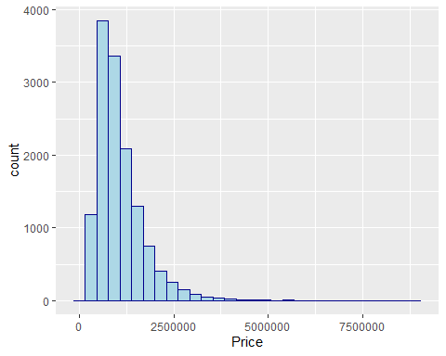
library(ggplot2)
ggplot(data, aes(x=Price))+
geom_histogram(color="darkblue", fill="lightblue", bins = 30)+
scale_x_log10(expand = c(0.09, 0.03))
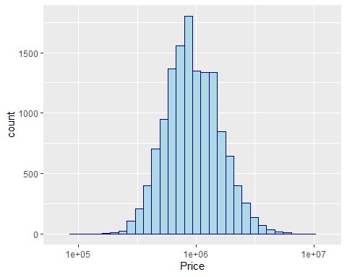

Q4. Will the number of bedrooms impact the price of the house?

First graph
ggplot(data, aes(x=Price, group=Rooms, fill=Rooms)) +
geom_histogram(color="darkblue",fill="lightblue",bins=30)+
scale_x_log10(limits=c(1e5, 3e6), expand = c(0.1, 0))+
facet_wrap(~Rooms)
## Warning: Removed 222 rows containing non-finite values (`stat_bin()`).
## Warning: Removed 18 rows containing missing values (`geom_bar()`).
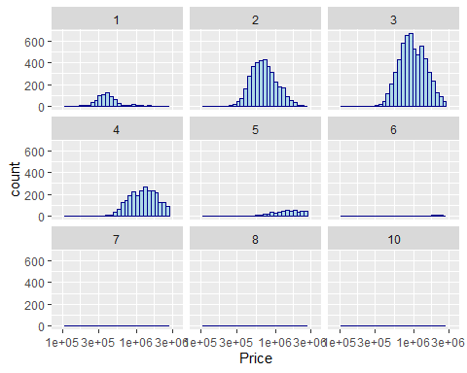

Second graph
ggplot(data, aes(x=Price, group=Rooms, fill=Rooms)) +
geom_histogram(color="darkblue",fill="blue",bins=30,position = "identity")+
scale_x_log10(limits=c(1e5, 3e6), expand = c(0.1, 0))+
facet_wrap(~Rooms, scales = "free_y")
## Warning: Removed 222 rows containing non-finite values (`stat_bin()`).
## Warning: Removed 18 rows containing missing values (`geom_bar()`).
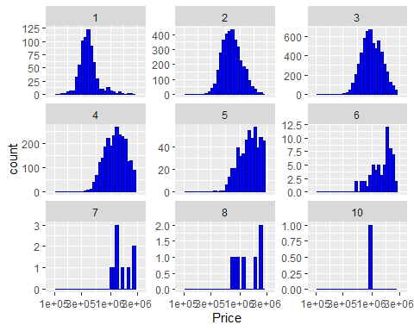

Create a correlation matrix for the numeric variables included below (Do not include any character variable for correlation analysis) and display the correlation matrix. Additional information is provided for your reference. INTERPRET THE CORRELATION ANALYSIS IN YOUR OWN WORDS AND IN A DETAILED MANNER TO RECEIVE FULL CREDIT FOR THIS QUESTION
library(corrplot)
## corrplot 0.92 loaded
data <- na.omit(data)
M = cor(select(data, -c("Suburb","Address","Type","Method", "SellerG", "Date", "CouncilArea", "Regionname")))
corrplot(M, method = "circle")


