Section A :

Question I :
- We decided to use the variable "Politicians don't care what people like me think" as the variable expressing people's level of satisfaction with political parties or politicians, since it reflects how people feel about the way politicians treat them. It can therefore be translated as the level of concern the politician feels about his or her concerns.

A variable that reflects the respondent's level of income is "Income - gross household (represents the total income of your household from all sources before tax - including benefits, savings and so on?)".

A variable representing the voter's attitude to voting is "Talking with people about the general election on May 7th, we have found that a lot of people didn't manage to vote. How about you, did you manage to vote in the general election?" because it expresses whether the respondent is in the habit of voting. Its association with the other two could explain whether the respondent's refusal to vote is due to his level of satisfaction with politicians or his income level.

- Review :

- Variable 1: Politicians don't care what people like me think
This variable has 05 measurement levels, ranging from "1 = Strongly disagree" to "5 = Agree" to "3 = Neither disagree nor agree", plus the options "-999 = Not stated" and "-1 = Don't know".
These measurement levels provide a little more information. But I think the number could have been reduced to make it easier to interpret. For example, the modalities "Disagree and Totaly disagree" or "Agree and Totaly agree" could have been only two modalities instead of four.
- Variable 2: Income - gross household (represents the total income of your household from all sources before tax - including benefits, savings and so on?)
This variable has 15 measurement levels, ranging from "1 = Under GBP 2,600" to "15 = GBP 100,000 or more", plus the options "-999 = Not stated", "-2 = Refused" and "-1 = Don't know".
The large number of revenue categories provides more specific information, but does not facilitate an overall interpretation of the results. As the saying goes, too much information takes us away from the essential.
Also, the "Refused" and "I don't know" modalities could have been represented as one. For a person who declares that he or she doesn't know his or her income level could be seen as someone who doesn't want to divulge this information.
- Variable 3: Talking with people about the general election on May 7th, we have found that a lot of people didn't manage to vote. How about you, did you manage to vote in the general election?
This variable has just four possibilities: "-999 = Not stated", "-2 = Refused", "-1 = Don't know", "1 = Yes, voted" and "2 = No, did not vote".
Here, two important modalities: "Yes, voted" and "No, did not vote". In addition, as in the case of variable 2, a person who doesn't know whether they voted or not can be equated with someone who doesn't want to talk about it. So reduce the "I don't know" modality.

- The variables we have chosen have already been encoded in the database to facilitate the calculation of the most common descriptive statistics. However, this encoding will not be used in the tables and graphs, to allow the reader to directly understand the information presented, without having to refer to a dictionary of encodings before being able to understand the information represented.

We have tried to give an overview of the encoding used for the three variables in the previous question.
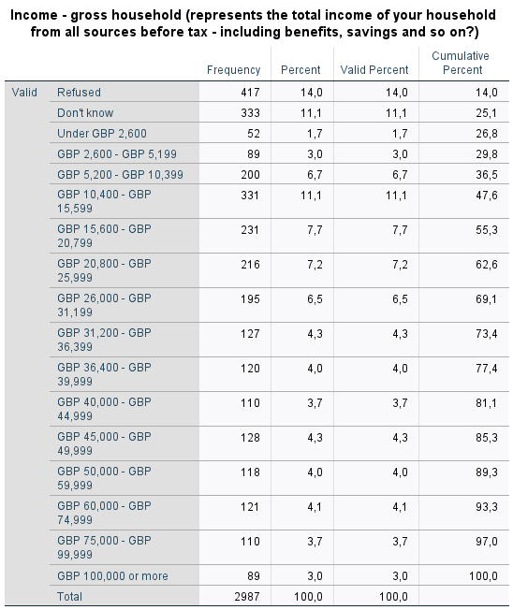
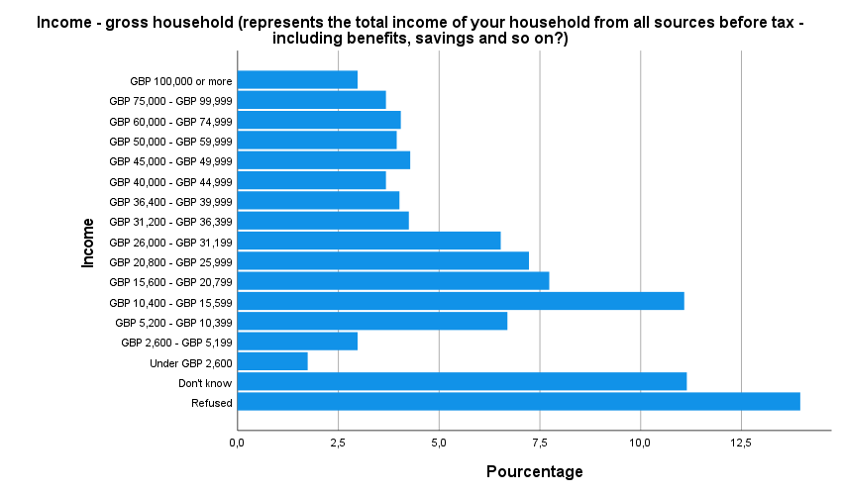

From the analysis of the graph and table, we can say that most respondents are not comfortable with disclosing their income level and 11.1% of respondents have an income between GBP 10,400 - GBP 15,599.

Only 3% have an income level above GBP 100,000 and 1.7% for people with an income level below GBP 2,600.

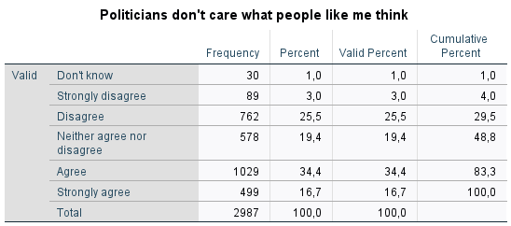
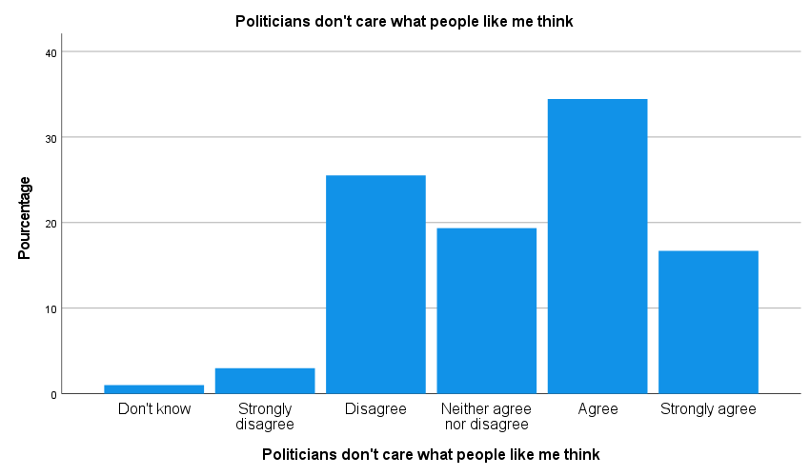

34.4% of respondents agree that politicians do not care what they think, which indicates a fairly low level of satisfaction on the part of politicians, and 16.7% totally agree.

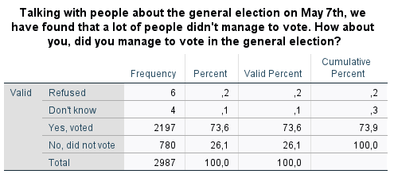
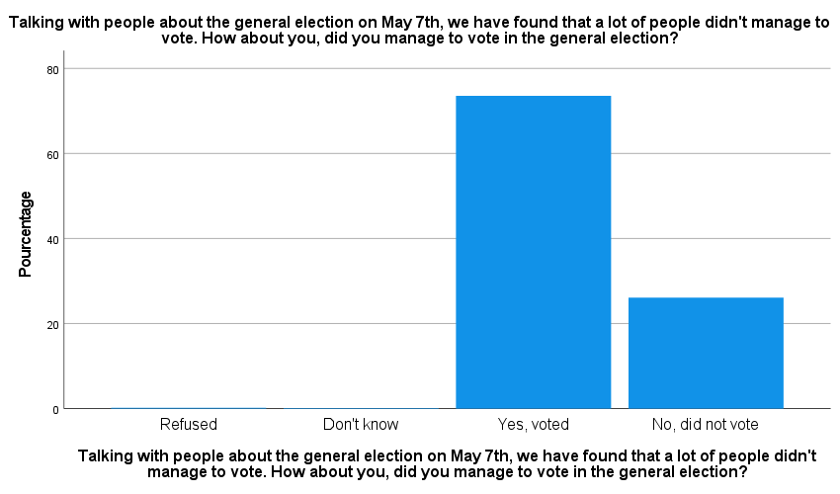
Despite this high rate of dissatisfaction with political parties, 73.6% of respondents voted in the May 07 elections.
On the other hand, 26.1% of respondents did not vote, and abstention rates were very low.

Question II :
Hypotheses:
H₀: The variables "Politicians don't care what people like me think" and "Talking with people about the general election on May 7th, we have found that a lot of people didn't manage to vote. How about you, did you manage to vote in the general election?" are independent.
H_{a}: The variables "Politicians don't care what people like me think" and "Talking with people about the general election on May 7th, we have found that a lot of people didn't manage to vote. How about you, did you manage to vote in the general election?" are dependent.
- Our dependent variable is the one with the wording "Talking with people about the general election on May 7th, we have found that a lot of people didn't manage to vote. How about you, did you manage to vote in the general election?" and the independent variable is the one labelled "Politicians don't care what people like me think".

- Let's create a cross tab
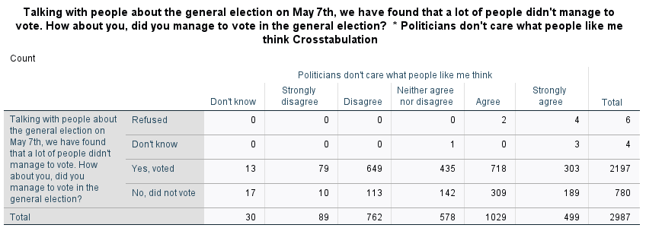
We note that 718 respondents think that politicians don't care about them, but still voted in the May 07 elections. And 113 think the opposite but were unable to vote.

- Chi-square test for independence
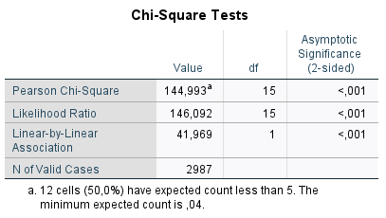
With an α of 0.05, Pearson Chi-square of 144.993 and p-value < 0.01, we reject the null and state that we have sufficient evidence to support that two variables are dependent.
- The p-value<0.01, the strength of association between these two variables is highly significant at an α threshold of 0.05.

Question III :
Hypotheses:
H₀: Income levels and attitude to voting are independent
H_{a}: Income levels and attitudes to voting are dependent on

- The dependent variable is voting attendance, the variable labelled "Talking with people about the general election on May 7th, we have found that a lot of people didn't manage to vote. How about you, did you manage to vote in the general election?" and the independent variable is income level.

- Let's create a cross tab
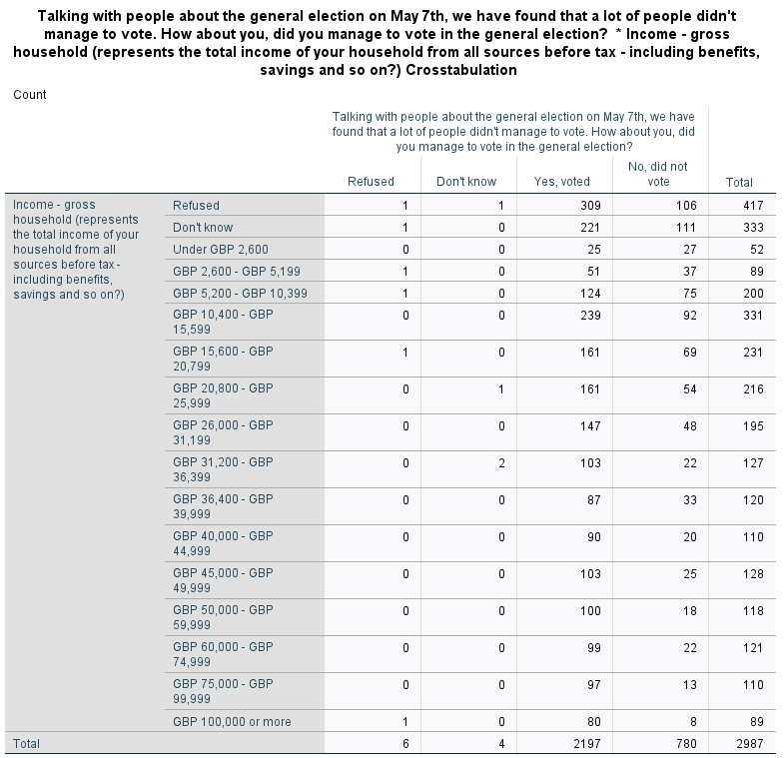
27 people with an income below GBP 2,600 did not vote in the May 07 elections and 80 of those with an income above GBP 100,000 did.

- Chi square test
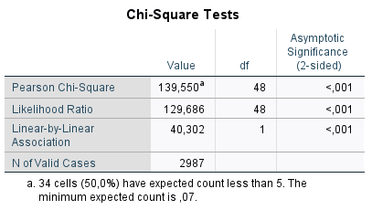

With an α of 0.05, Pearson Chi-square of 139.550 and p-value < 0.01, we reject the null and state that we have sufficient evidence to support that two variables are dependent.
- The p-value<0.01, the strength of association between these two variables is highly significant at an α threshold of 0.05.

- Both tests have a p-value<0.01, But looking at the Pearson Chi-Square values, which are 144.993 for the test on satisfaction with politicians and 139.550 for the test on income level, we can conclude that respondents' level of satisfaction with politicians has a greater impact on voting behaviour. We can conclude that respondents' level of satisfaction with politicians has a greater impact on voting behavior.

Question IV:

- Hypotheses:

H₀: All variables are independent of each other.
H_{a}: Not all variables are independent. There is at least one association that is dependent on.

- Let's create a cross tab

- 12 respondents with an income level below GBP 2,600 and agreeing that politicians don't care what they think agreed to vote on May 07.

- 45 respondents with an income above GBP 100,000 and who don't think that politicians don't care about them, voted on May 07.

- With Pearson Chi square of 144.993 and p-value < 0.01, we conclude that not all variants are independent and that there is at least one significantly dependent association.

- By considering each modality of the variable representing the level of income only at the "Don't Know" level, we are able to reject the H0 hypothesis of non-dependence, since p-value<0.01. We can therefore conclude that the variables are significantly dependent, since each of the modalities influences the dependence.

NB: Three-way crosstabs and chi-square tests are available in the .spv source file.

Question V:
The selected scale variable is "Selection weight (including capping)". This variable is chosen because it is a scale variable and therefore a quantitative variable.
- Distribution
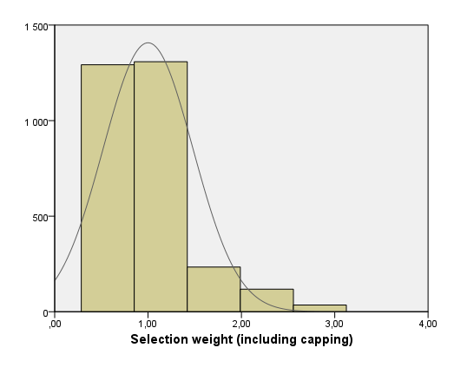

This is an asymmetrical distribution and most selection weights are between 0.5 and 1.4.
Selection weights between 2.0 and 3.0 represent a minority.

- Descriptive Statistics

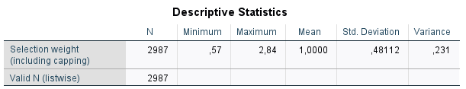

The mean value is 1.0, with a standard deviation of 0.48112 and a variance of 0.231.

Interpretation

- The average weight of the selection is 1.0
- The smallest selection weight is 0.57 and the largest is 2.84
- With a standard deviation of 0.48112, we can conclude that the values are clustered around the mean.

