Class 4 R Intro
Amy Nguyen
January 15th, 2026
x <- 1:50
plot(x)
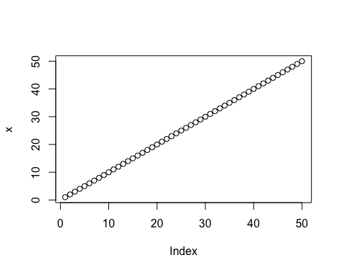
plot(x,sin(x))
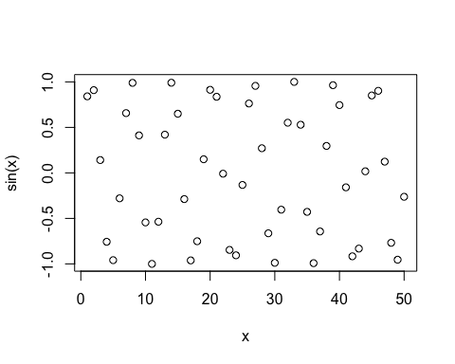
plot(x,sin(x), typ="l")
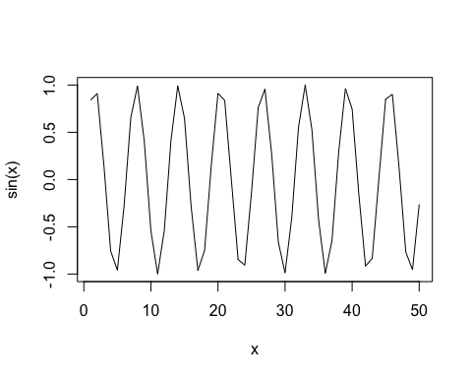
plot(x, sin(x), typ="l", col="pink", lwd=4)
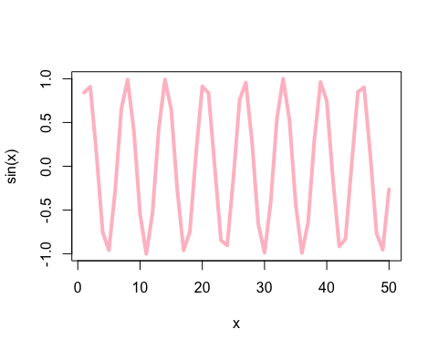
log(10)
## [1] 2.302585
log(10, base = 10)
## [1] 1

