Scenario: FEMA Worker responding to natural disaster in Terre Haute, Indiana which has killed all internet connection in the area.

Objectives:

The worker is given an Android device currently running the Situational Awareness App and wants to view the Terre Haute area on the map to find out what areas need help. The operative pans around the map by dragging his/her finger across the screen [FR0], using the on-screen zoom buttons [FR1], using a pinching gesture [FR2], or double tapping the screen [FR3].

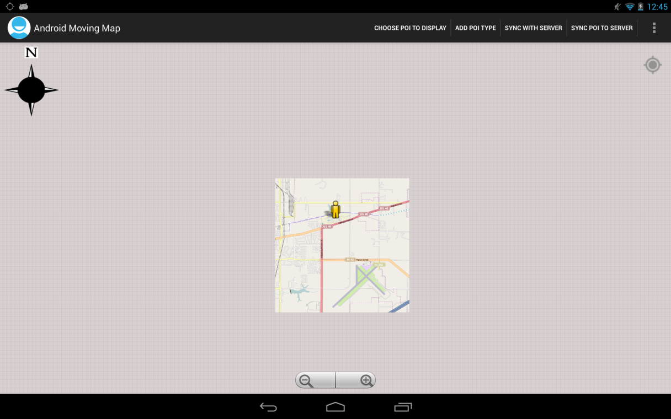

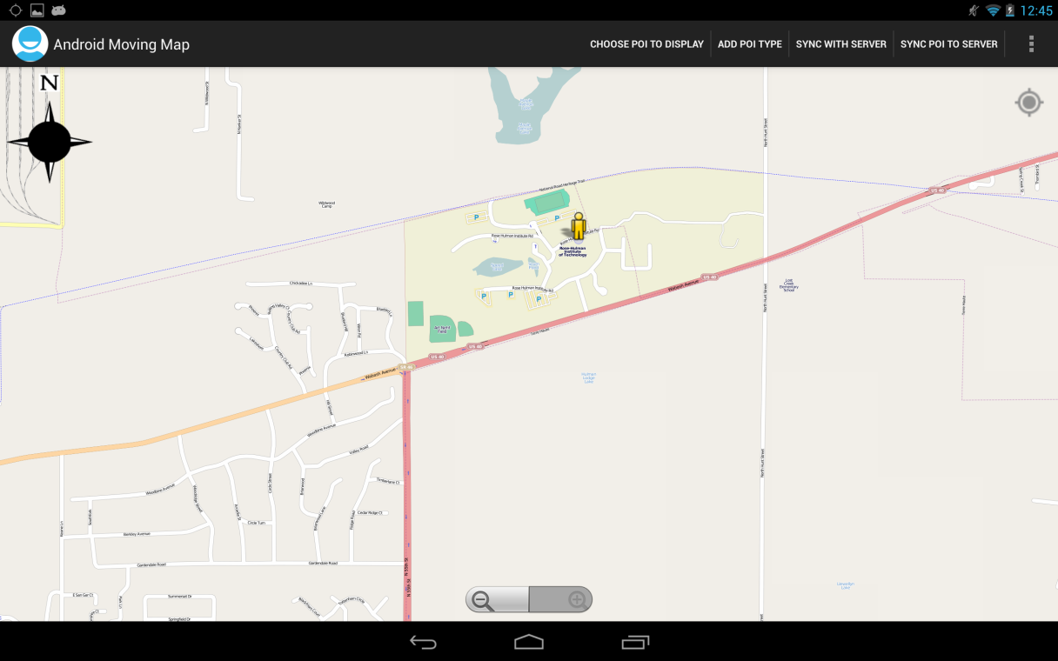

While the worker is within the wireless network range near the FEMA Base Camp, they will have the ability to view any information currently stored by the local server [FR6]. Once the worker leaves the wireless network, they will only have access to that data which was stored on their device by the application [FR4 & FR5].

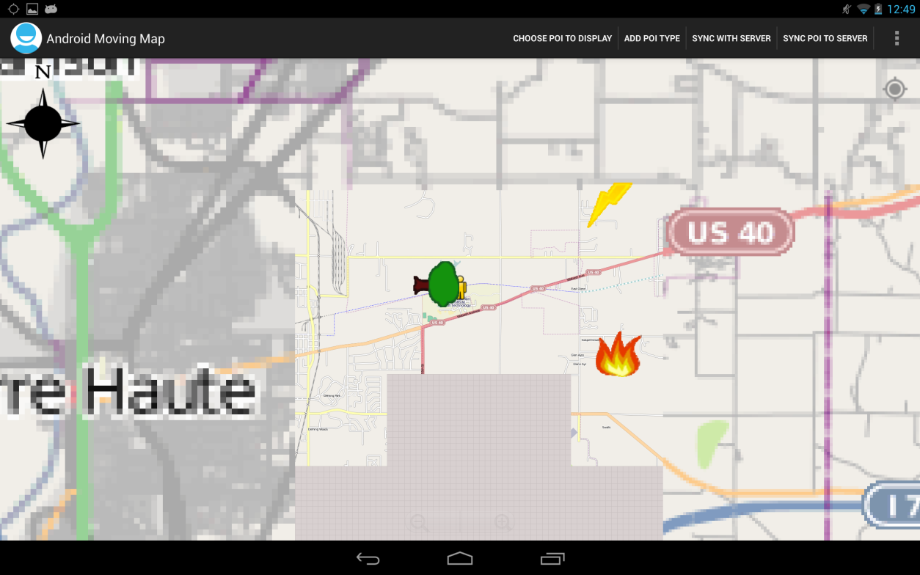

If the worker has a GPS enabled device, the application will display the device’s current location [FR7]. While stationary, the device will be displayed as a yellow person on the map. When moving, the person will be replaced with a green arrow pointed in the traveling direction. A user can then select themself as the point that the screen should center on [FR8].

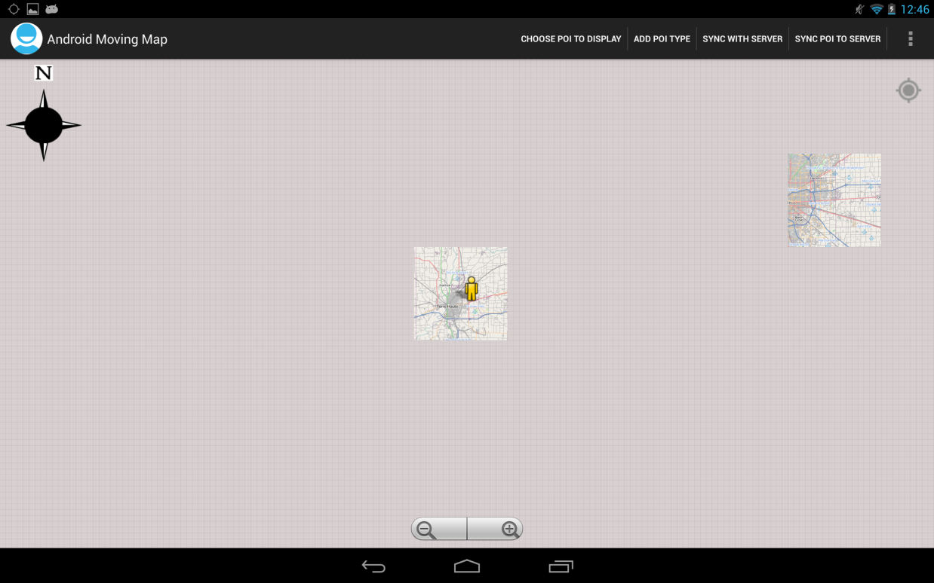

The application also supports storing multiple map types [FR9] and can be cycled by clicking on the ‘Cycle map type’ button in the menu bar [FR10].

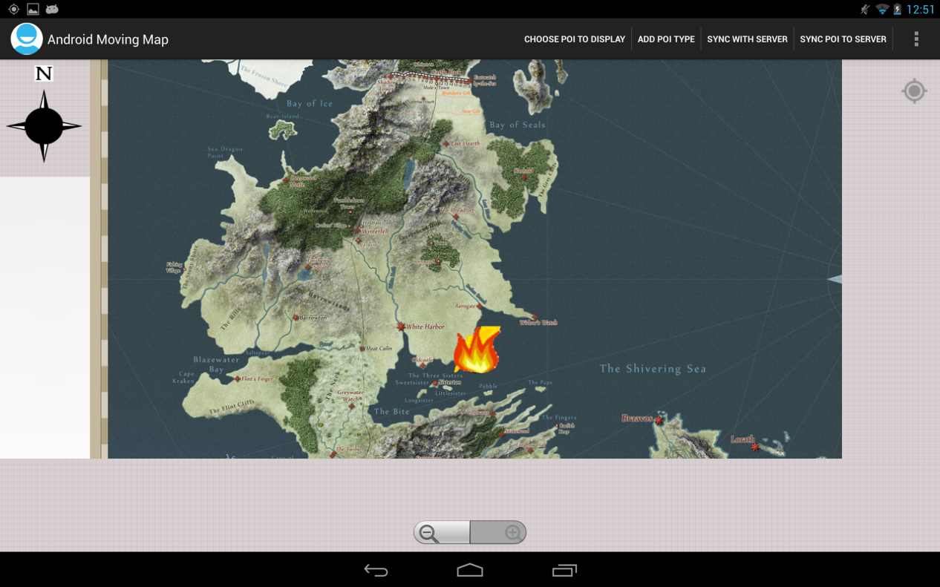

Once a user has added a point of interest (such as a new downed tree) it will then be displayed on the map [FR11 & FR12].

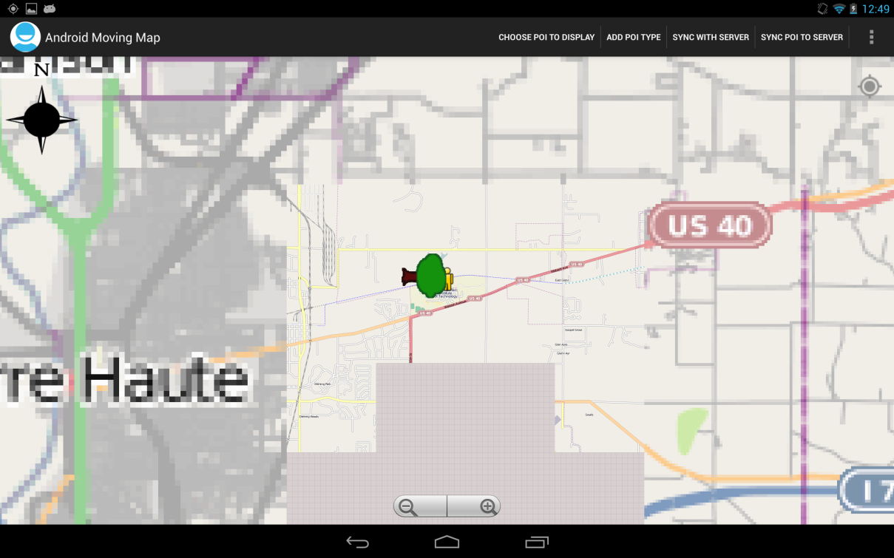

The worker can choose which types of points of interest are displayed if they only care about certain markers. They can do this by pressing the ‘Choose POI to Display’ icon on the Action Bar [FR13]. A popup menu of available POI types will be displayed allowing the user to select (checkmark) which ones they want. When they press ok, the dialog will close and only selected POI types will be displayed on the screen.

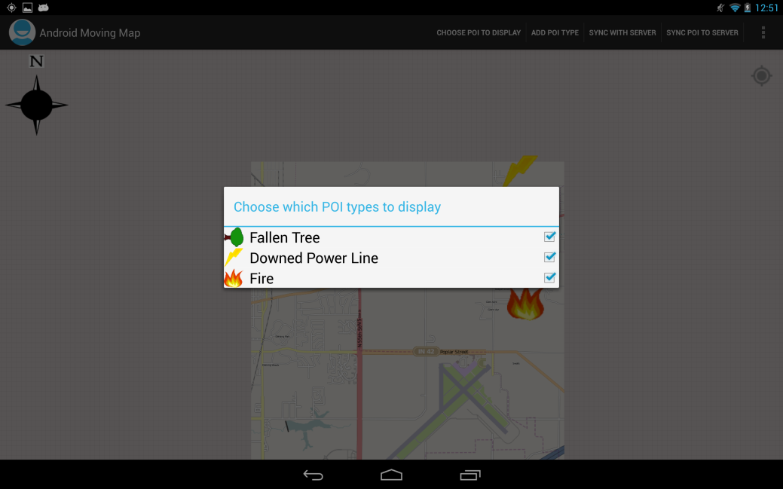

To add a new POI the worker should long press on the map where they want the point to be located. A popup will then be displayed asking for name, type, and optional description [FR14 & FR15]. Once ‘Create’ is selected, the point will appear on the map.

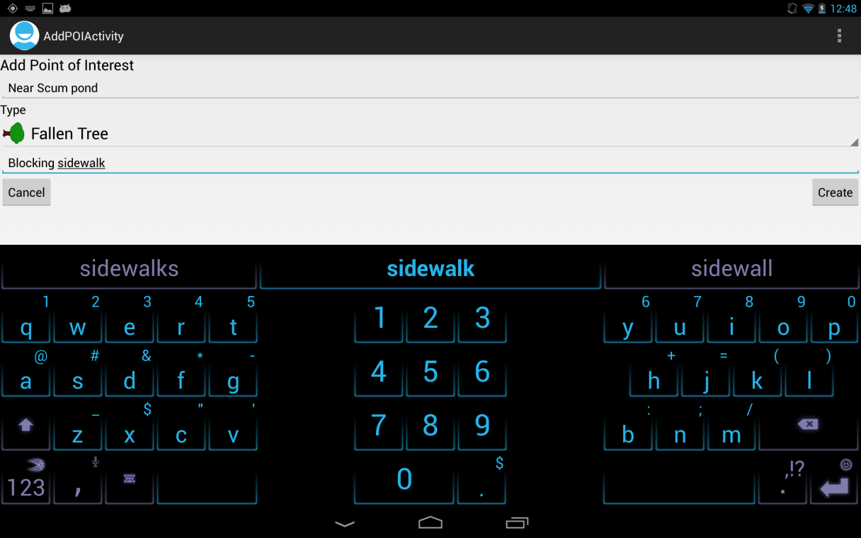

Once the worker has added a POI to his/her local device they can press ‘Sync With Server’ on the Action Bar to synchronize their points with the server, while in range of the network [FR21 & FR22].

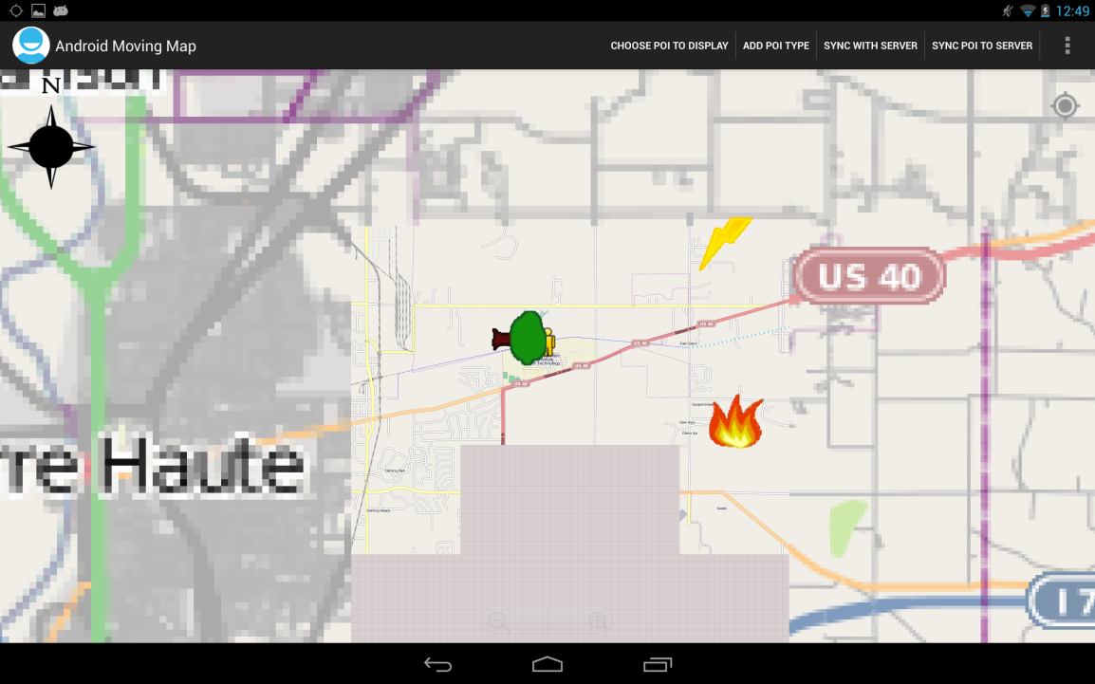

If a type of POI does not exist the user can create a new type of overlay that can store related items [FR16]. To create a new overlay (representing a new type of POI) the user would press ‘Add POI Type’ on the Action Bar. They will then choose an image, enter a name, and click ‘Okay’.

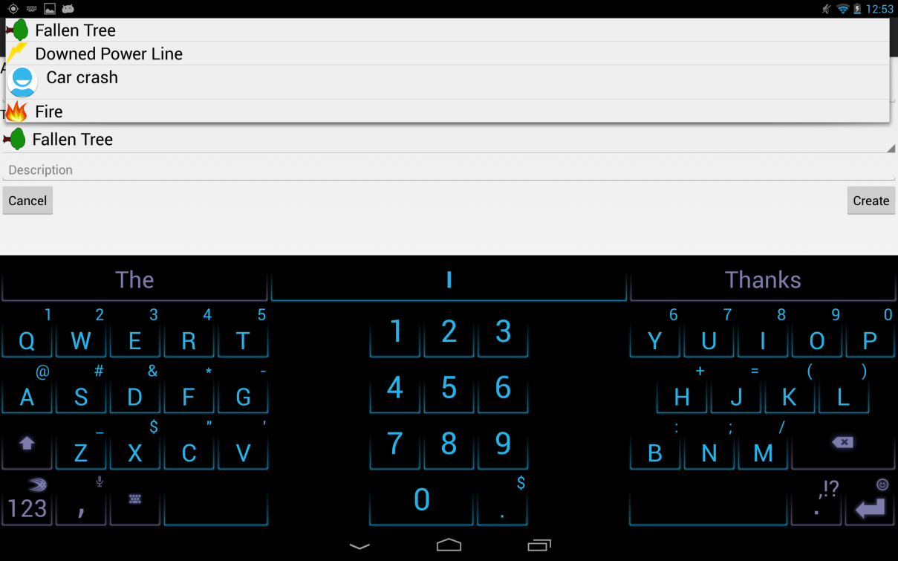

The settings menu and the help menu are located from the menu bar [FR19 & FR20]. Settings will be applied when worker goes back to the map screen.

