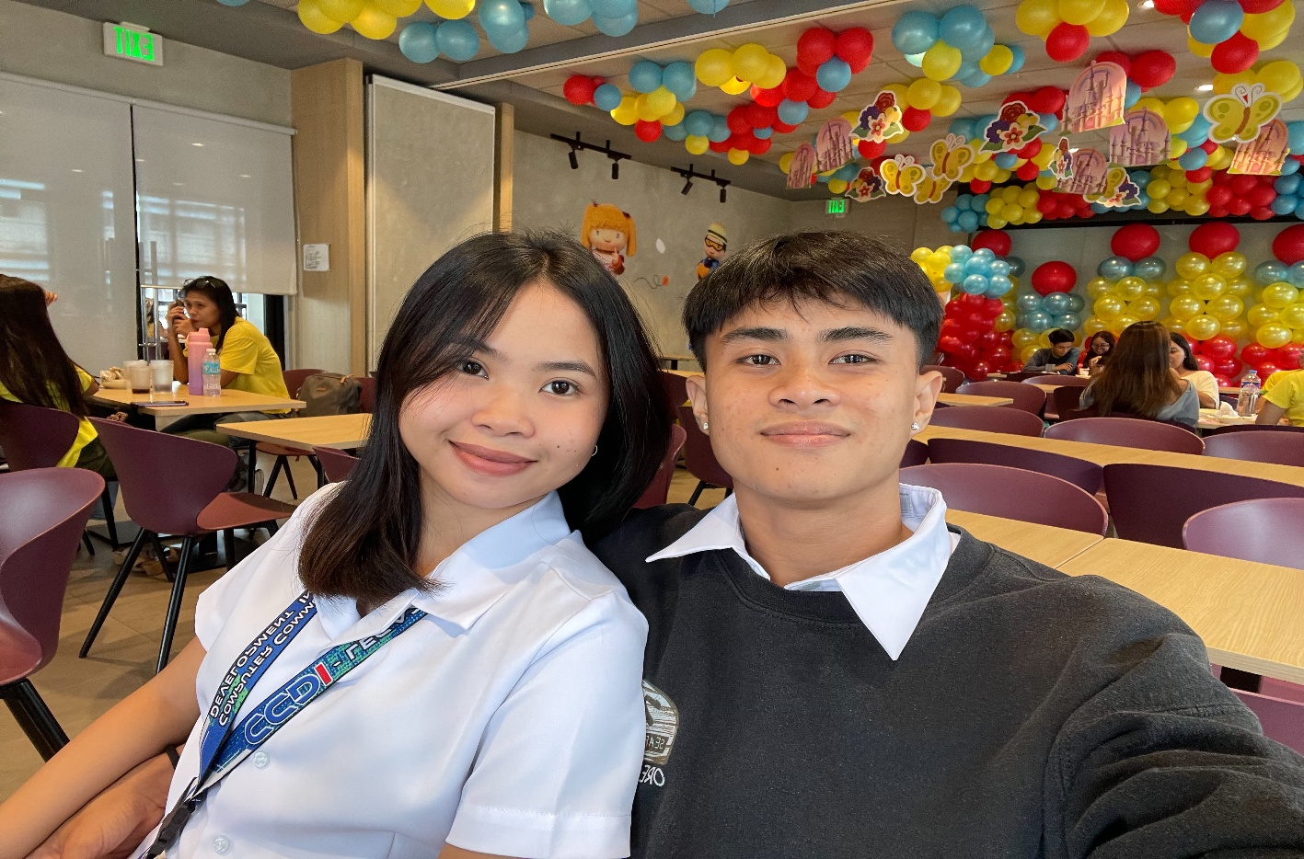
Hey bebe I just want to say that Iloveyousomuch you’re the only girl who wins in my heart you want to know it later na. For now on I would like to say that HAPPY 4TH MONTHSARRY to us bebe.
First of all, I just want to say thank you for staying with me and for being part of my life. Four months might not seem like a long time for other people, but for me, these four months have been so special because I got to experience what it's like to love someone like you. I'm so happy and grateful that I have you in my life, someone who makes my days brighter and my heart happier just by being there.
I know that our relationship isn't always perfect. There might be times when we misunderstand each other, have arguments, or struggle to understand what the other person is feeling. But despite all of that, I want you to know that I will always choose to understand you, listen to you, and work things out with you. I don't want us to give up on each other just because things get difficult. Instead, I want us to grow together, learn from our mistakes, and become better for each other. Like now we’ve facing a serious problem but don’t be afraid mybebe I’ll always here for you to listen to your rant sabay nating haharapin ang problema natin sabay nating sosolusyon yan okay hindi lang ikaw ang nagiisip pati din po ako hindi kita hahayaan na maging ganyan ka.

I know that our relationship isn't always perfect. There might be times when we misunderstand each other, have arguments, or struggle to understand what the other person is feeling. But despite all of that, I want you to know that I will always choose to understand you, listen to you, and work things out with you. I don't want us to give up on each other just because things get difficult. Instead, I want us to grow together, learn from our mistakes, and become better for each other.
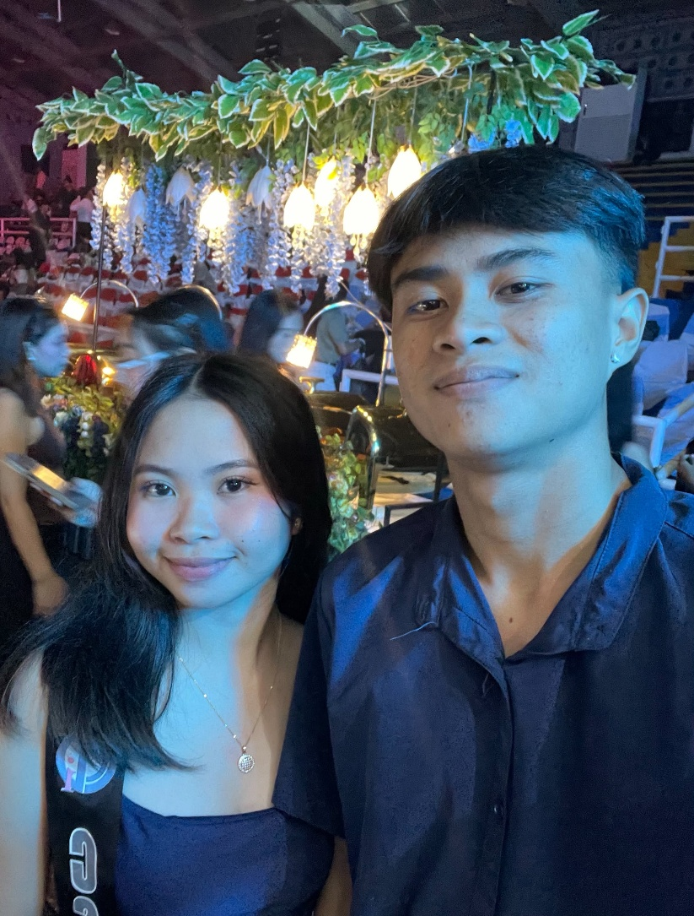
Thank you for all the little things you do, for your time, your effort, your patience, and for making me feel loved in your own special way. Even the simplest moments with you mean so much to me. You don't have to do anything grand to make me happy because sometimes, just talking to you, hearing your voice, or knowing that you're there is already enough to make my day better. Also thankyou for the times na nandyan ka para tulungan moko sa mga struggles ko sa buhay, sa panlilibre mo sakin pag walang wala ako and also thankyou kase kahit anong pasaway ko andyan ka palagi sakin. Mahaba naba hahaha d payan papasawain kita magbasa neto walang iiyak ahh simple lang ito pero galing to sa puso.
As we celebrate our fourth month together, I hope this is just the beginning of a much longer journey for us. I want more monthsaries, more memories, more laughter, more late-night conversations, more adventures, and even more moments where we learn how to love each other better. I know we still have so much to discover about each other, and I'm excited to experience all of it with you.
I can't promise that I'll always be perfect, but I can promise that I'll do my best to love you sincerely, respect you, and make you feel that you're important to me. When things get difficult, I hope we choose communication over silence, understanding over pride, and love over giving up. I want us to be the kind of couple who can face problems together instead of letting those problems pull us apart.

Happy 4th monthsary again, baby! ❤️💋 Thank you for these four beautiful months of love and happiness. If I could go back to the day we started, I would still choose to take that chance with you because meeting you and having you in my life is something I'm truly thankful for.
I love you so much, more than these words can fully explain. I hope I can continue to make you happy, give you the love you deserve, and remind you every day that you're special to me. Here's to us, to our love, and to all the beautiful moments that are still waiting for us. No matter how many months or years pass, I hope we never forget the love that brought us together in the first place.
I love you always, my love. Here's to more monthsaries and hopefully many more years together. You will always have a special place in my heart. I LOVE YOU SO MUCH, BABYYYY! 😘❤️🫶🏻💋

Your always pasaway na bebe.

