# 3-Temperatures Data Acquisition System

**Schematic diagram of the DAQ system:**

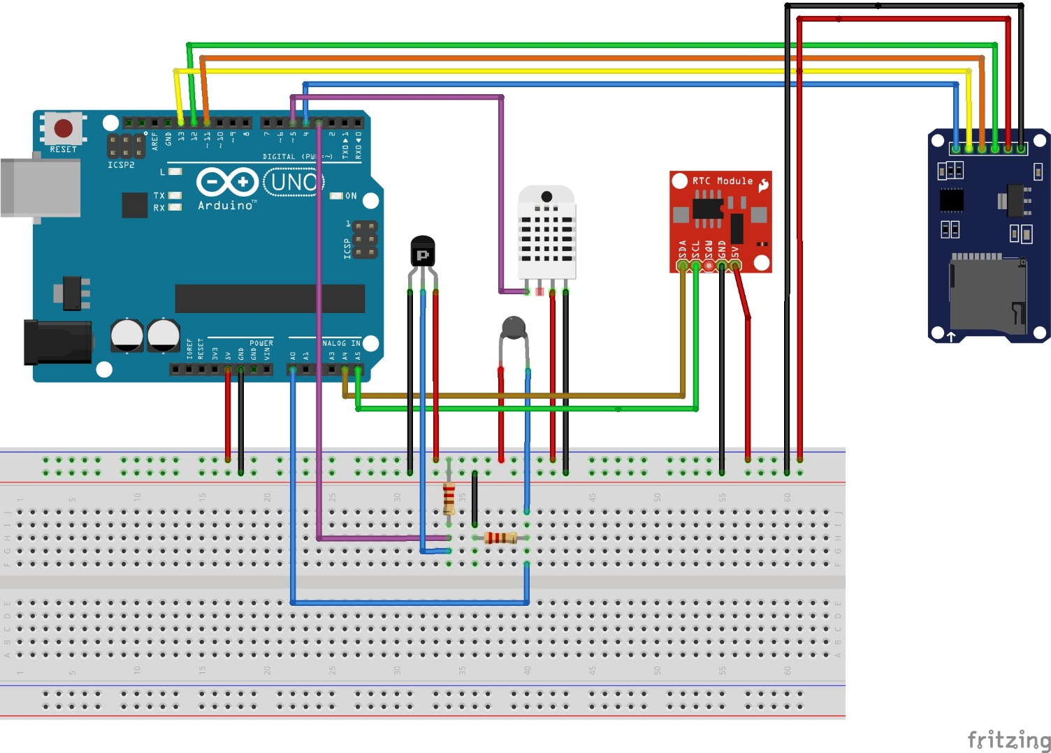

Fig: Arduino circuit diagram for three temperature sensors with RTC and SD card persistent data storage

**Note:**

* Thermistor should be connected to Analog pin in contrast to the digital pins connected to DHT11 and Probe Temperature sensor.
* Uploading the code without inserting SD card into the SD card module, fails.
* For the Probe sensor use the resistor that came with the module and for the thermistor, use one of the 10K resistors in the kit.

**RTC or DS1307 connection:**

* Connect the Real time clock module to Arduino UNO as per the connection diagram below.
  + VDD -> 5V
  + GND -> GND
  + SDA -> A4
  + SCL -> A5

**SD Card module with Arduino UNO:**

* Format the SD Card into FAT32
* Connect the SD Card module with Arduino with appropriate pins
  + VDD -> 5V
  + GND -> GND
  + MISO -> 12
  + MOSI -> 11
  + SCK -> 13
  + CS(Chip Select) – Digital Pin 4
* Test the SD Card setup
  + File->Examples->SD->CardInfo (Baud rate – 9600)

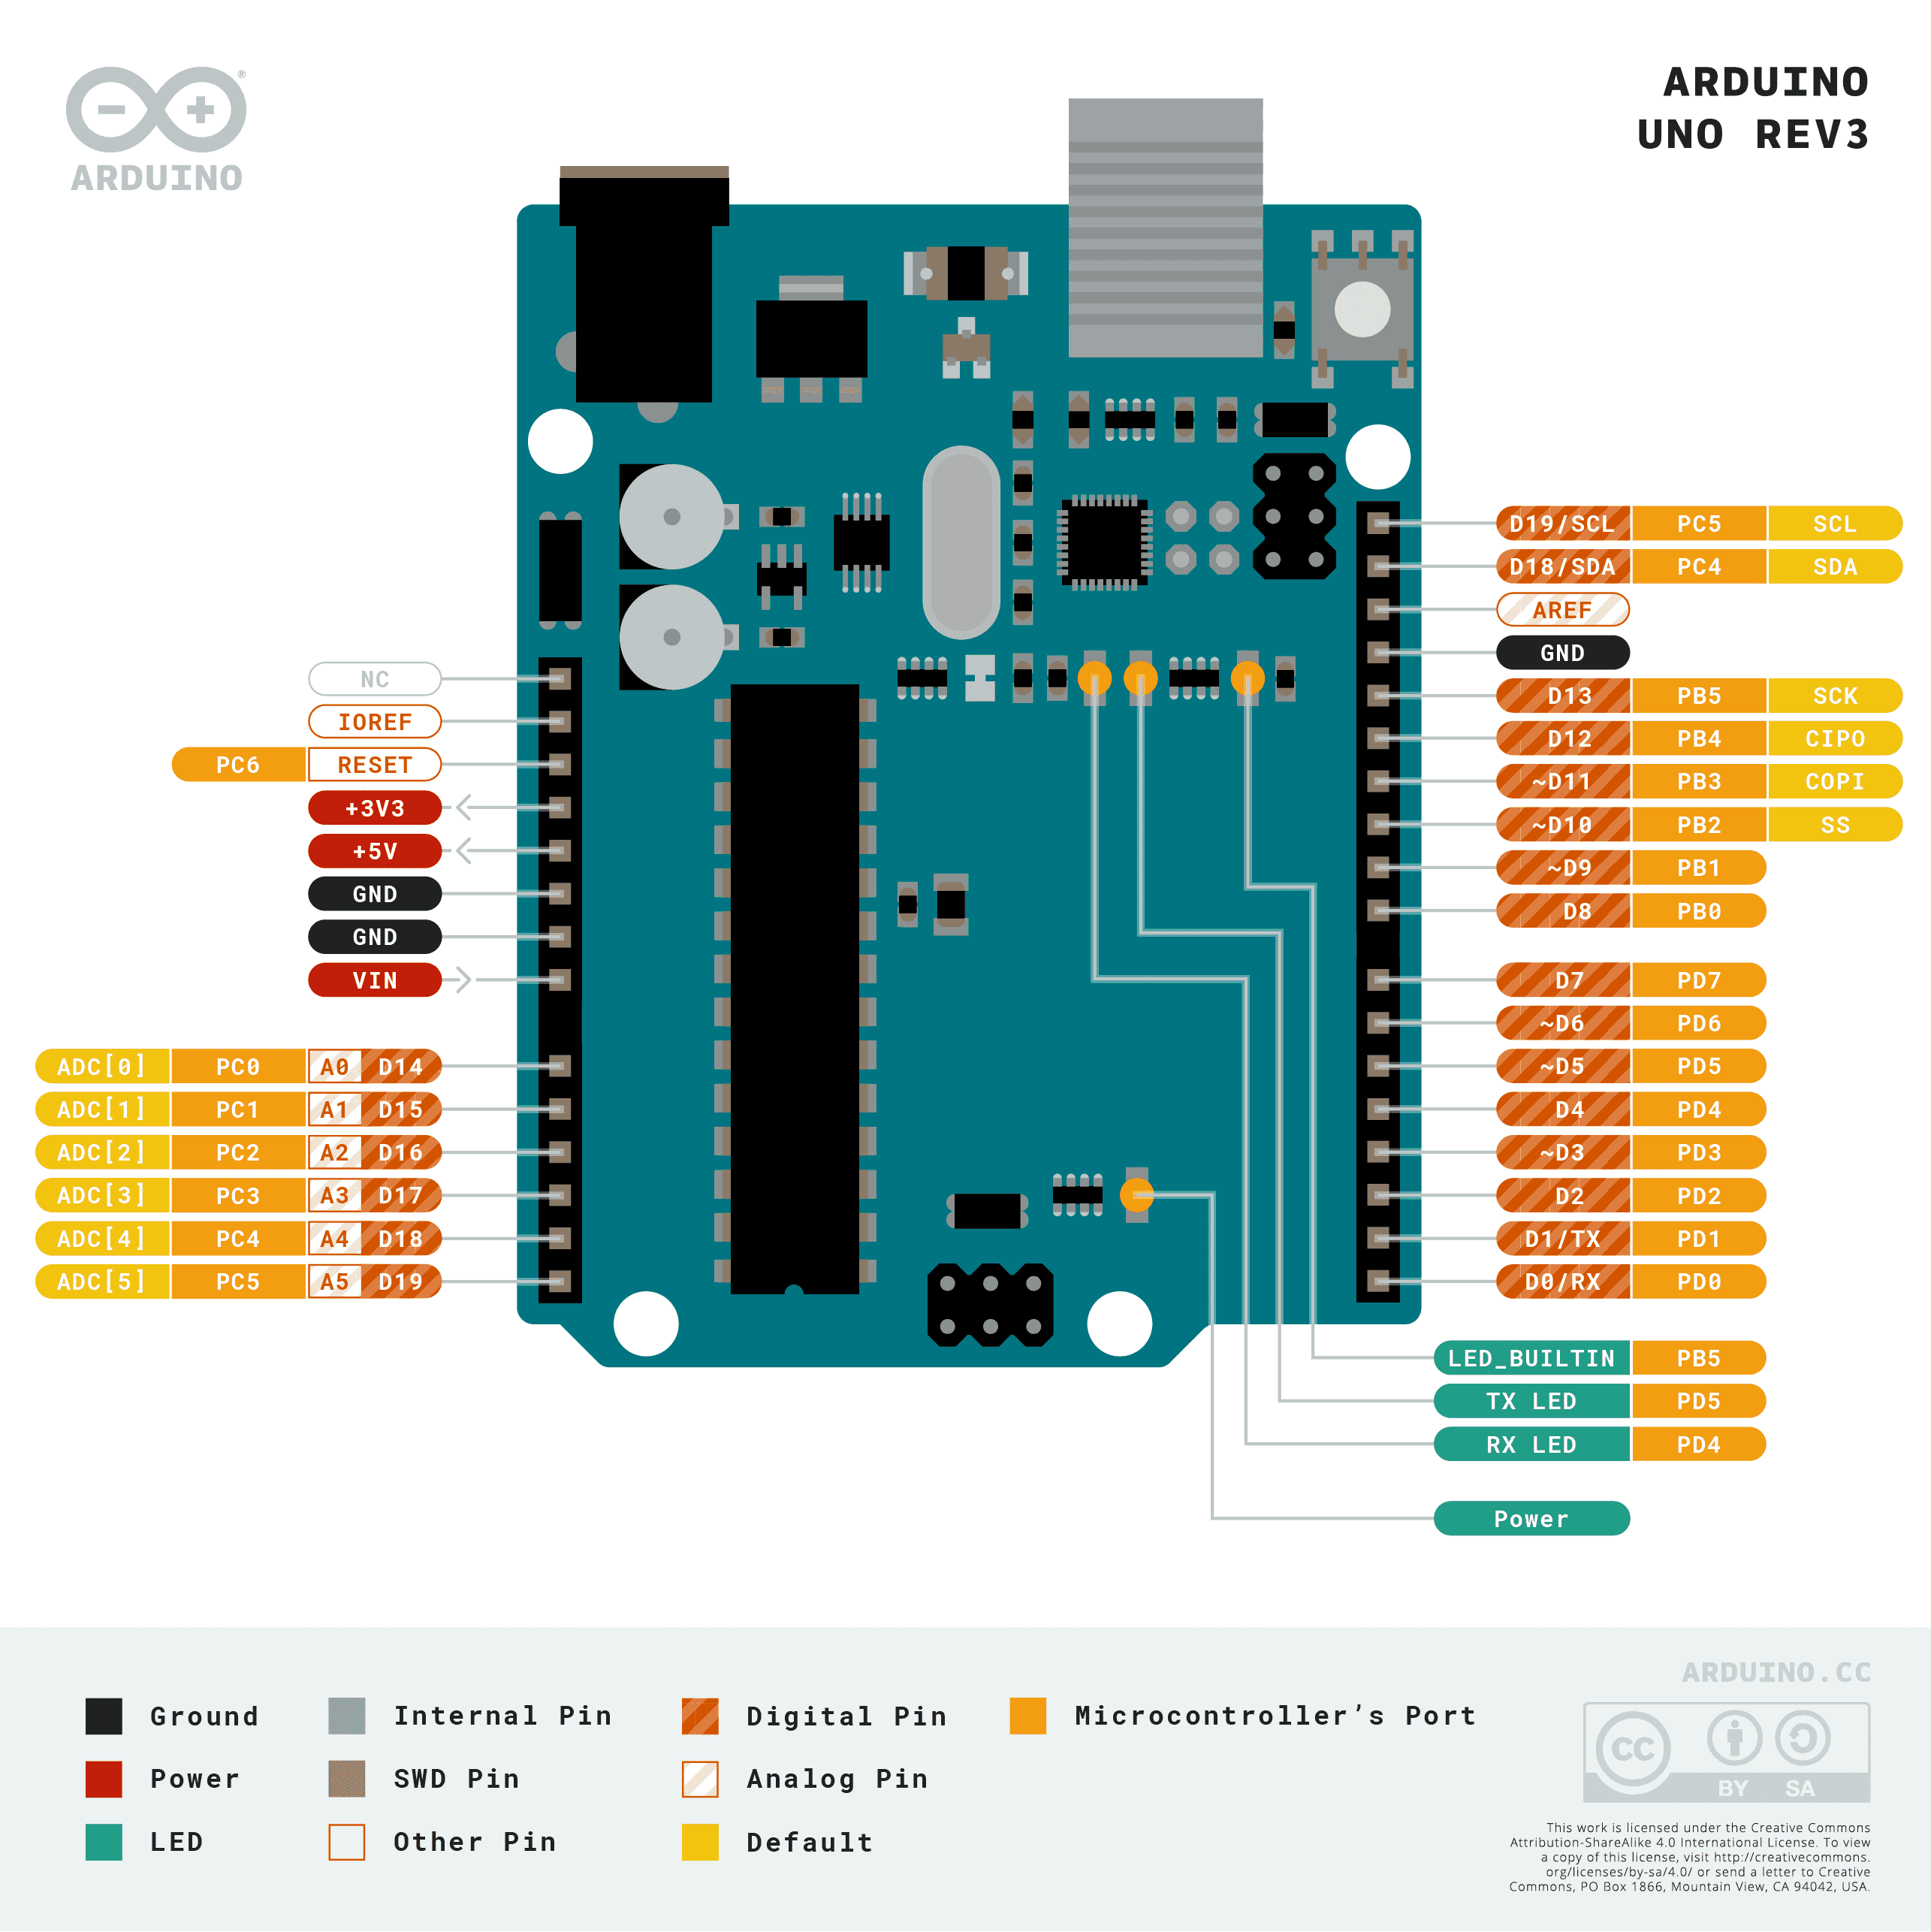

Fig: Arduino Pinout for SCK, MISO, MOSI pins reference